Supplementary Information

Context-dependent effect of glucocorticoid receptor activity shapes ovarian cancer cell plasticity and therapy response

Micaela De Girolamo¹*, Eduardo Ibello²*, Teresa Improda¹, Ilaria Tedesco³, Carmela Dell’Aversana^{4,5}, Silvia Buonaiuto^{2,6}, Salvatore Arbucci², Cristina D’Aniello², Dario De Cesare², Renato Franco³, Concetta Ambrosino^{7,8}, Lucia Altucci^{1,8}, Luigi Cobellis⁹, Eduardo J. Patriarca², Gabriella Minchiotti²^ and Gilda Cobellis¹^

Supplementary Table 4. Antibodies and reagents used in this study

List of primary antibodies
Name | Source | Catalog Number
COL1A1 | Sigma-Aldrich | ab34710
EIF2α | Cell Signaling | #9722
FIBRONECTIN 1 | Sigma-Aldrich | F3648
GAPDH | Abcam | ab8245
GLUCOCORTICOID RECEPTOR | Cell Signaling | #3660
HISTONE H3 (PHOSPHO S10)-PHH3 | Sigma-Aldrich | 06-570
Ki-67 | Invitrogen | MA5-14520
N-CADHERIN (3B9) | Invitrogen | 33-3900
P57/KIP2 | Cell Signaling | #2757S
PHOSPHO-EIF2α (SER51) | Cell Signaling | #9721

List of secondary antibodies
Name | Source | Catalog Number
Alexa Fluor 488 goat anti-mouse | Invitrogen | A21121
Alexa Fluor 594 donkey anti-rabbit | Invitrogen | A21207
Alexa Fluor 488 donkey anti-rat | Invitrogen | A21208
Goat Anti-Rabbit Immunoglobulins/HRP | Dako | P0448
Goat Anti-Mouse Immunoglobulins/HRP | Dako | P0447

List of reagents
Name | Source | Catalog Number
Annexin V FITC Apoptosis detection kit | Dojindo Laboratories | AD10
CCK-8 | Dojindo Laboratories | CK04-01
Click-IT EdU Alexa Fluor 488 Flow Cytometry Assay Kit | Invitrogen | C10420
Click-IT EdU Alexa Fluor 647 Imaging Kit | Invitrogen | C10640
Click-IT Plus OPP Alexa Fluor 488 Protein Synthesis Assay Kit | Invitrogen | C10456
Collagen from rat tail tendon | Roche | 11179179001
Corning 96-well Clear Round Bottom Ultra-Low Attachment | Corning | 7007
Crystal violet | Euroclone | EMR029500
Cyto3D® Live-Dead Assay Kit | TheWell Bioscience | BM01
Killik O.C.T. | Bio-Optica | 05-9801
Lipofectamine RNAiMAX | Invitrogen | 13778-100
Matrigel Growth Factor Reduced Basement Membrane Matrix, LDEV-free | Corning | 354230
PHALLOIDIN 594 | Sigma-Aldrich | P1951
PHALLOIDIN 488 | Sigma-Aldrich | 49409
Seahorse XF Cell Mito Stress Test Kit | Agilent | 103015-100
Silencer Select CDKN1C siRNA | Thermo Fischer | S2840
Silencer Select Negative Control siRNA | Thermo Fischer | 4390843
TMRE Mitochondrial membrane potential | Abcam | ab113852

List of drugs
Name | Source | Catalog Number
2-Deoxy-D-Glucose | Sigma-Aldrich | D8375
Budesonide | Sigma-Aldrich | B7777-250MG
Cisplatin | Sigma-Aldrich | 232120
Dexamethasone | Sigma-Aldrich | D2915
Fluticasone | Sigma-Aldrich | F9428
Hydrocortisone | Sigma-Aldrich | H0888
Metformin | Sigma-Aldrich | 317240-5GM
Relacorilant - CORT125134 | BLDpharm | BD765637

Supplementary Table 5. Primers used for qPCR in this study

Gene | Forward primer (5´-3´) | Reverse primer (5´-3´)
CDKN1C | GCGGCGATCAAGAAGCTG | GCTTGGCGAAGAAATCGGAGA
GAPDH | TGCACCACCAACTGCTTAGC | TCTTCTGGGTGGCAGTGATG

Supplementary Figures
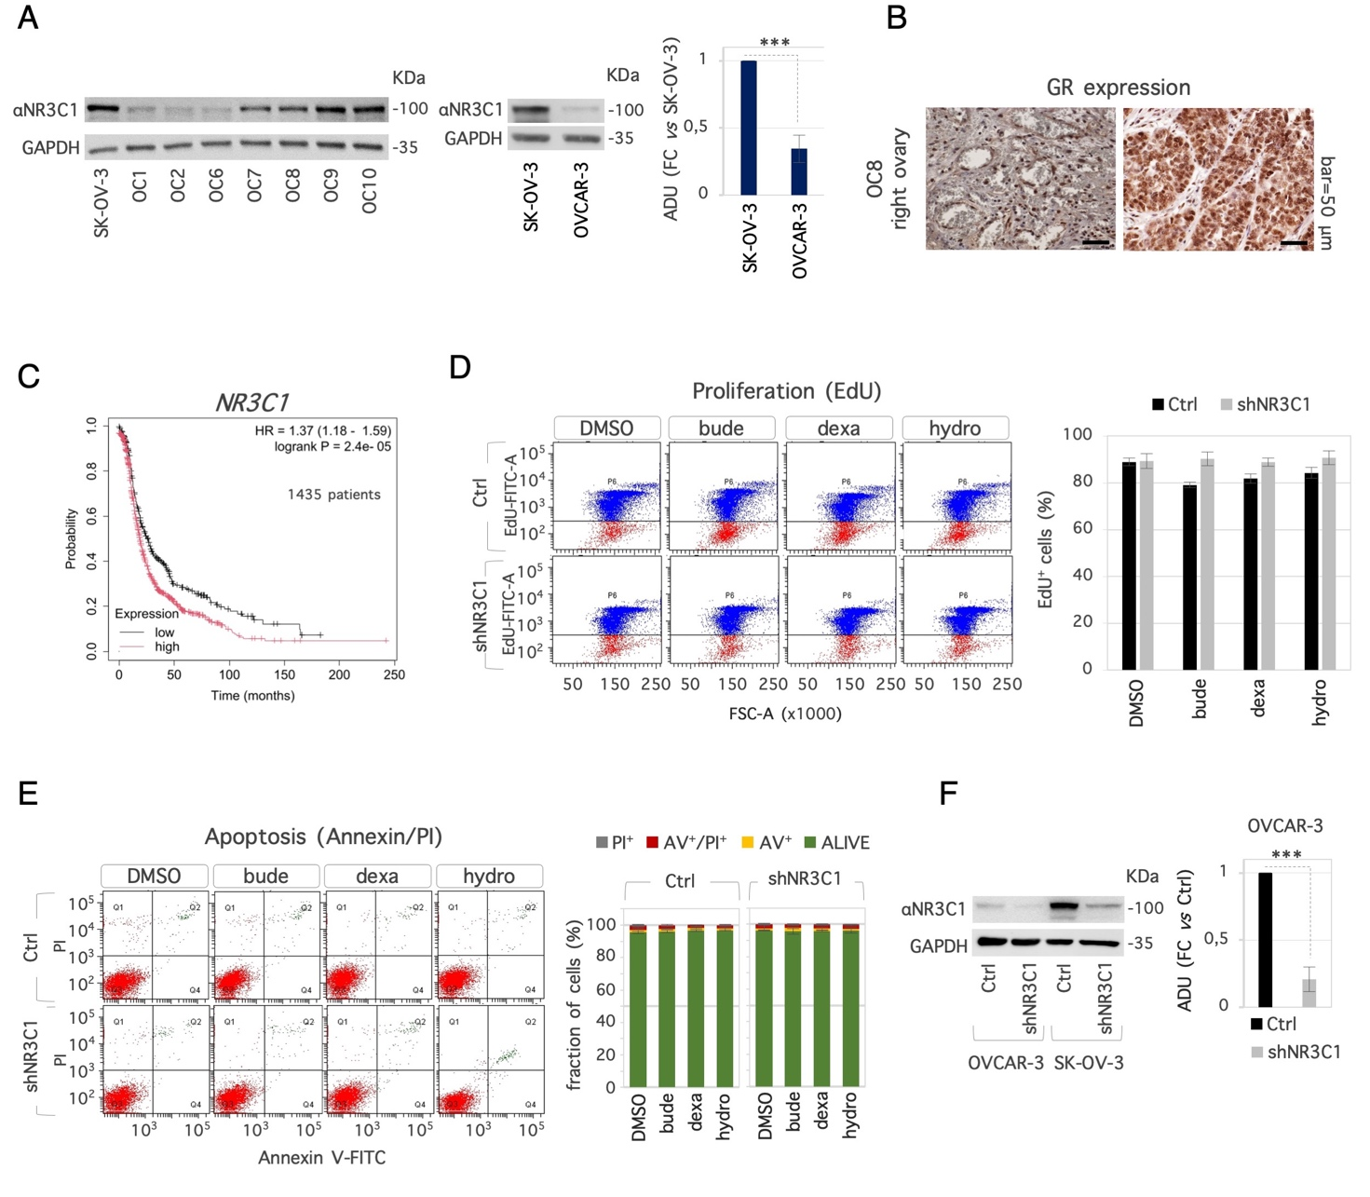
Figure S1. Characterization of NR3C1 expression and function in ovarian cancer cells. A) Western blot analysis (left) of NR3C1 expression in SK-OV-3, in patient-derived OC, and in OVCAR-3 cells. ADU is shown as FC vs SK-OV-3 cells after normalization to GAPDH. B) Representative images of GR staining in OC8 patient. C) Kaplan-Meier plot of progression-free-survival of OC patients with high vs low NR3C1 expression. D) Flow cytometric plots of EdU incorporation in Ctrl and shNR3C1 SK-OV-3 cells treated with GCs (20 μM) or DMSO as control (left). Quantification analysis shown the fraction (%) of EdU⁺ cells (right). E) Flow cytometric plots of Annexin V/PI staining in Ctrl and shNR3C1 SK-OV-3 cells treated with GCs (20 μM) or DMSO as control (left). The fraction (%) of Annexin V±/PI± cells are shown. F) Western blot analysis of NR3C1 in Ctrl and shNR3C1 OVCAR-3 and SK-OV-3 cells (left) and densitometric analysis reported as FC vs Ctrl after normalization to GAPDH. Data are presented as mean (± SD) from n≥3 independent experiments. Significance was determined by one-way ANOVA with Tukey pairwise multiple comparison testing. (***p< 0.001).

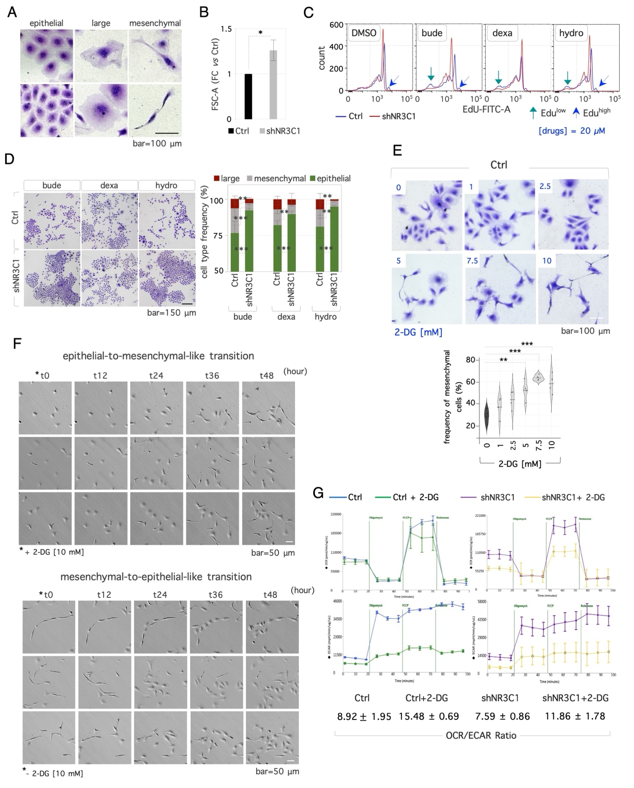
Figure S2. GR expression and morphological heterogeneity in OC cells. A) High magnification images of SK-OV-3 cells stained with crystal violet, showing the epithelial-like (left), large giant (middle) and mesenchymal-like (right) cells. B) Quantification of flow cytometric forward scatter (FSC-A) plots of Ctrl and shNR3C1 cells, plated as described in (2A). C) Flow cytometric plots of EdU incorporation in Ctrl (blue line) and shNR3C1 (red line) cells treated with GCs or DMSO as described in (2A). Peaks corresponding to high and low EdU intensity are indicated. D) Representative images of Ctrl and shNR3C1 SK-OV-3 cells stained with crystal violet (left), and histograms showing the quantification of the 3 cell types identified (right) after GC treatment. E) Representative images of Ctrl SK-OV-3 cells ± 2-DG stained with crystal violet (top), and quantification of mesenchymal cell frequency after dose-dependent 2-DG treatment (%, bottom). F) Representative time-lapse frames of epithelial-to-mesenchymal-like transition (top) and mesenchymal-to-epithelial-like transition (bottom) in SK-OV-3 cells. G) Oxygen consumption rate (OCR) (top) and extracellular acidification rate (ECAR) (bottom) in Ctrl (left) and shNR3C1 (right) SK-OV-3 cells ± 2-DG. Data are presented as mean (± SD) from n≥3 independent experiments. Significance was determined by one-way ANOVA with Tukey pairwise multiple comparison testing. (*p < 0.05; **p < 0.005; ***p < 0.001).

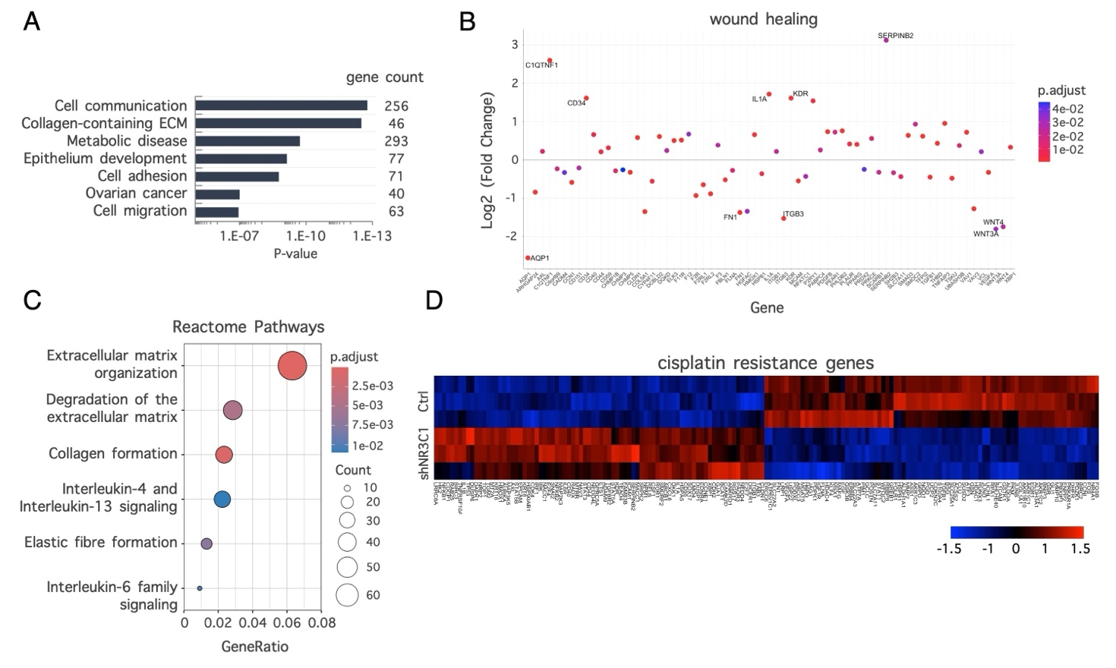
Figure S3. Effect of GR on the gene expression profile of OC cells. A) David Ontology analysis of DEGs between shNR3C1 vs Ctrl SK-OV-3 cells. B) Dot plot of genes related to wound healing that are up- or down-regulated in shNR3C1 vs Ctrl SK-OV-3 cells. C) Reactome pathways of DEGs between shNR3C1 vs Ctrl cells. D) Heatmaps of DEGs related to cisplatin resistance between Ctrl and shNR3C1 cells.

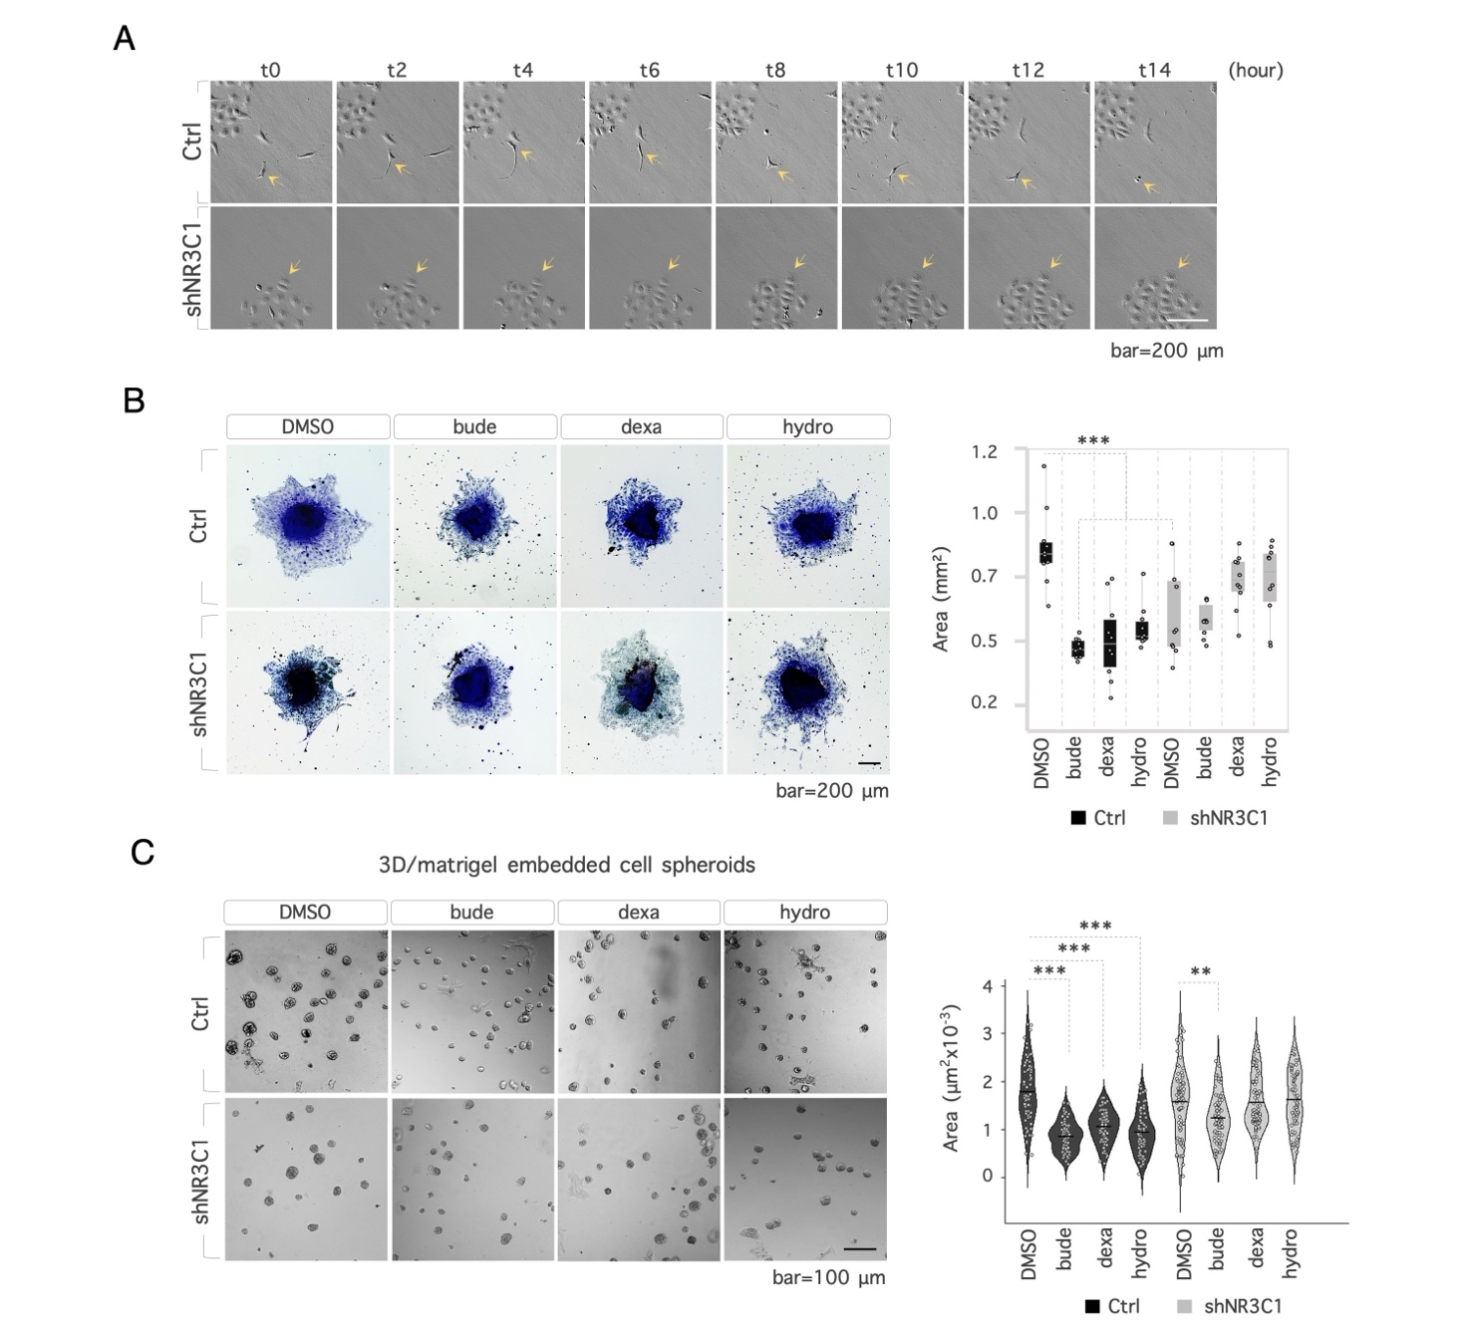
Figure S4. Effect of GC pre-treatment on migration ability of OC cells. A) Representative time-lapse frames of cell motility in Ctrl (top) and shNR3C1 (bottom) SK-OV-3 cells. Arrows indicate representative cells selected for single cell tracking analysis. B) 3D/2D shift assay. Representative images of migrating cells spreading from spheroids of Ctrl and shNR3C1 SK-OV-3 cells treated with GCs (20µM) or DMSO (vehicle) (left), and quantification of the migrating/wetting area (right). C) Representative images (left) of 3D-matrigel embedded Ctrl and shNR3C1 SK-OV-3 spheroids treated ± GCs (20 µM) or DMSO (vehicle). Violin plot (right) showing the quantification of spheroids area. Data are presented as mean (± SD) from n≥3 independent experiments. Significance was determined by one-way ANOVA with Tukey pairwise multiple comparison testing. (**p < 0.005; ***p < 0.001).

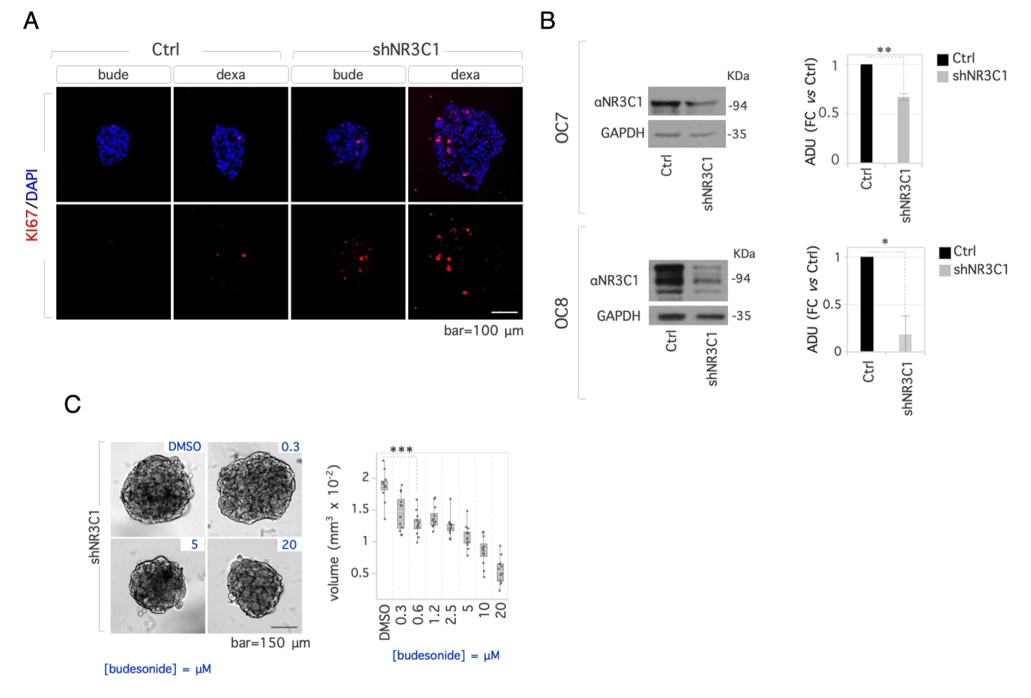
Figure S5. The GC-GR axis delays the proliferation of OC cells under 3D conditions. A) Representative IF images of cryosections from Ctrl and shNR3C1 SK-OV-3 spheroids treated with GCs (20 µM) stained for Ki67 (red). Nuclei were counterstained with DAPI (blue). B) Western blot analysis and quantification of NR3C1 KD in patient-derived OC7 (top) and OC8 (bottom) cells. Data are shown as FC vs Ctrl after normalization to GAPDH. C) Dose-dependent effect of budesonide on spheroid growth. Representative images of shNR3C1 spheroids treated with budesonide (0.3-20 µM) or DMSO (vehicle) (left), and quantification of the spheroid volume (right). Data are presented as mean (± SD) from n≥3 independent experiments. Significance was determined by one-way ANOVA with Tukey pairwise multiple comparison testing. (*p<0.05; **p < 0.005; ***p < 0.001).

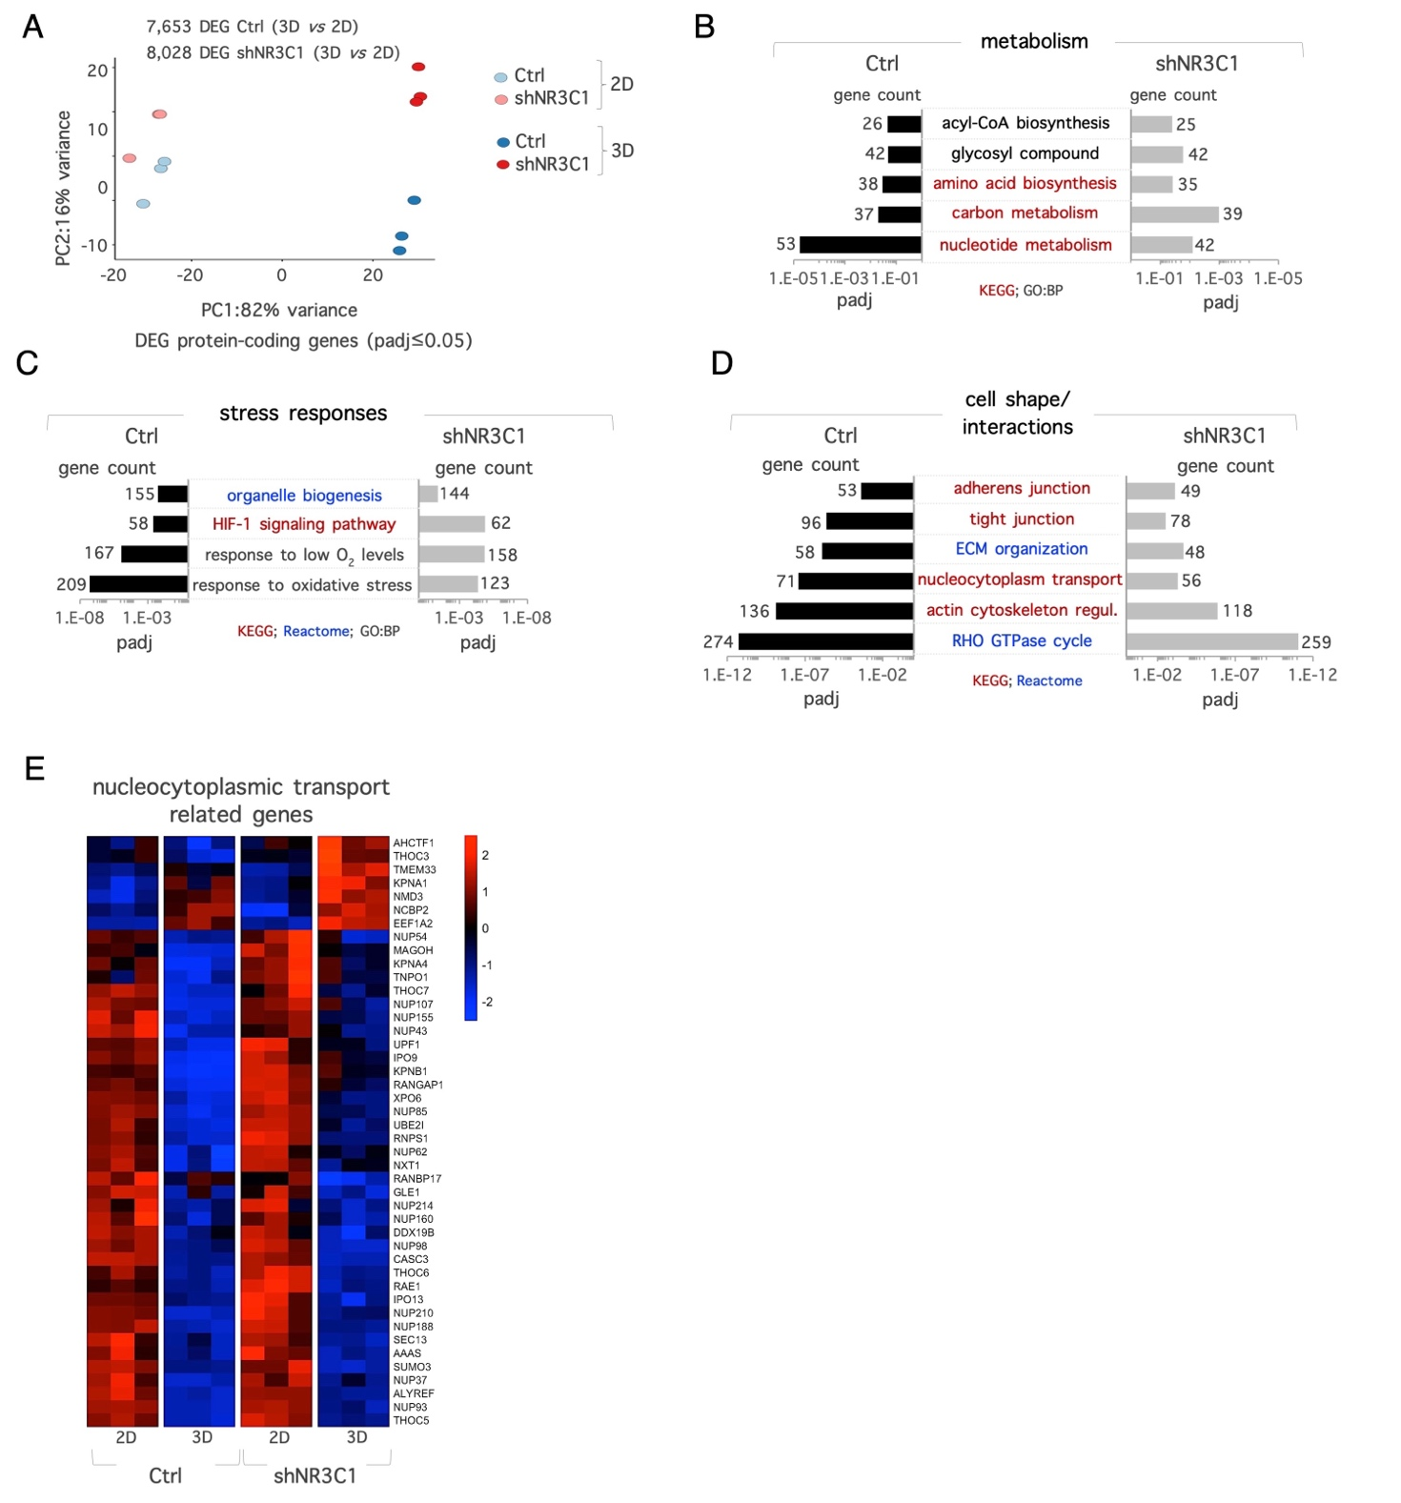
Figure S6. Effect of 2D-to-3D transition on gene expression profile of SKOV-3 cells. A) Principal component analysis (PCA) of Ctrl (light blue) and shNR3C1 (orange) cells. Gene Ontology analysis (KEGG, Reactome, Biological Process) showing the enrichment in genes/pathways related to metabolism (B), stress responses (C) and cell morphology/interactions (D), in Ctrl and shNR3C1 cells. E) Heatmap of DEGs related to nucleocytoplasmatic transport.

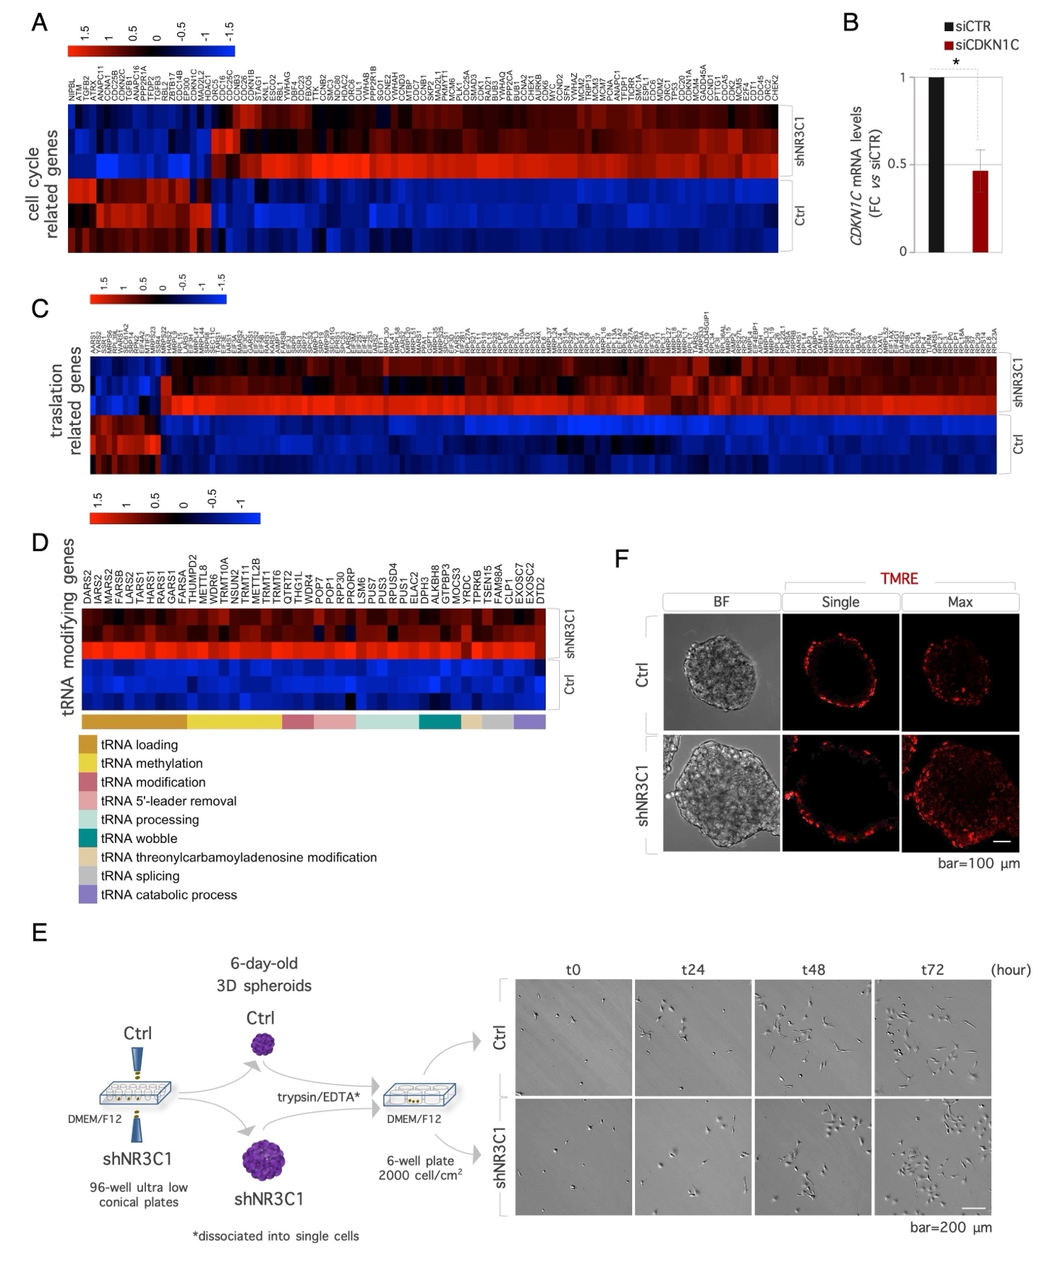
Figure S7. The GR rewires the transcriptome and reversibly restricts proliferation in SKOV-3 spheroids. A) Heatmap of DEGs related to cell cycle in Ctrl vs shNR3C1 SK-OV-3 spheroids. B) qPCR analysis of CDKN1C mRNA levels in siRNA treated cells. Data are shown as FC vs siCTR cells. C) Heatmap of DEGs related to protein translation between Ctrl and shNR3C1 spheroids. D) Heatmap of tRNA modifying genes between Ctrl and shNR3C1 spheroids. E) Representative time-lapse video microscopy images illustrating the proliferative capacity of cells derived from six-day-old Ctrl and shNR3C1 KD spheroids F) Representative confocal images of TMRE staining (red) in Ctrl and shNR3C1 spheroids. Brightfield (BF), TMRE single plane, and Maximum intensity projection (Max-IP) images are shown. Data are presented as mean (± SD) from n≥3 independent experiments. Significance was determined by one-way ANOVA with Tukey pairwise multiple comparison testing. (*p<0.05).

