Table S1 Characteristics of different transduction systems.
Method |  | Advantages | Disadvantages | Refs
Viral transduction | Lentiviral vectors | Safer and less genetically toxic than retroviral vectors; high transduction efficiency; non-cell cycle dependent. | Insertional mutagenesis; high cost; low transfection efficiency in primary NK cells | [1–3]
Viral transduction | Retroviral vectors | High transduction efficiency | Insertional mutagenesis; adverse impact on NK cell vitality; suitable for dividing cells | [4,5]
Non-Viral transduction | mRNA electroporation | Low risk of insertional mutagenesis; higher transduction efficiency than viral vectors; minimal impact on cell viability | Require repeated administration | [4,6]
Non-Viral transduction | LNPs | Low cost, easy to prepare, high purity, high transduction efficiency, strong cell toxicity | Require repeated administration | [6,7]
Non-Viral transduction | Transposons (PiggyBac, Sleeping Beauty and TcBuster) | High safety; low cost; stable expression; able to transduce large gene fragments | risk of insertional mutagenesis | [8–10]
Non-Viral transduction | CRISPR/Cas9 | Precise genetic modification | Complex design; difficult to control efficiency | [2]

References
1. Carlsten M, Childs RW. Genetic Manipulation of NK Cells for Cancer Immunotherapy: Techniques and Clinical Implications. Front Immunol [Internet]. 2015 [cited 2025 Sept 15];6. https://doi.org/10.3389/fimmu.2015.00266
2. Gong Y, Klein Wolterink RGJ, Wang J, Bos GMJ, Germeraad WTV. Chimeric antigen receptor natural killer (CAR-NK) cell design and engineering for cancer therapy. J Hematol Oncol. 2021;14:73. https://doi.org/10.1186/s13045-021-01083-5
3. Papayannakos C, Daniel R. Understanding lentiviral vector chromatin targeting: working to reduce insertional mutagenic potential for gene therapy. Gene Ther. 2013;20:581–8. https://doi.org/10.1038/gt.2012.88
4. Carlsten M, Childs RW. Genetic Manipulation of NK Cells for Cancer Immunotherapy: Techniques and Clinical Implications. Front Immunol. 2015;6:266. https://doi.org/10.3389/fimmu.2015.00266
5. Vargas JE, Chicaybam L, Stein RT, Tanuri A, Delgado-Cañedo A, Bonamino MH. Retroviral vectors and transposons for stable gene therapy: advances, current challenges and perspectives. J Transl Med. 2016;14:288. https://doi.org/10.1186/s12967-016-1047-x
6. McErlean EM, McCarthy HO. Non-viral approaches in CAR-NK cell engineering: connecting natural killer cell biology and gene delivery. J Nanobiotechnology. 2024;22:552. https://doi.org/10.1186/s12951-024-02746-4
7. Golubovskaya V, Sienkiewicz J, Sun J, Zhang S, Huang Y, Zhou H, et al. CAR-NK Cells Generated with mRNA-LNPs Kill Tumor Target Cells In Vitro and In Vivo. Int J Mol Sci. 2023;24:13364. https://doi.org/10.3390/ijms241713364
8. Yang R, Yang Y, Liu R, Wang Y, Yang R, He A. Advances in CAR-NK cell therapy for hematological malignancies. Frontiers in Immunology. 2024;15:1414264. https://doi.org/10.3389/fimmu.2024.1414264
9. Rostovskaya M, Fu J, Obst M, Baer I, Weidlich S, Wang H, et al. Transposon-mediated BAC transgenesis in human ES cells. Nucleic Acids Res. 2012;40:e150. https://doi.org/10.1093/nar/gks643
10. Skeate JG, Pomeroy EJ, Slipek NJ, Jones BJ, Wick BJ, Chang J-W, et al. Evolution of the clinical-stage hyperactive TcBuster transposase as a platform for robust non-viral production of adoptive cellular therapies. Mol Ther. 2024;32:1817–34. https://doi.org/10.1016/j.ymthe.2024.04.024

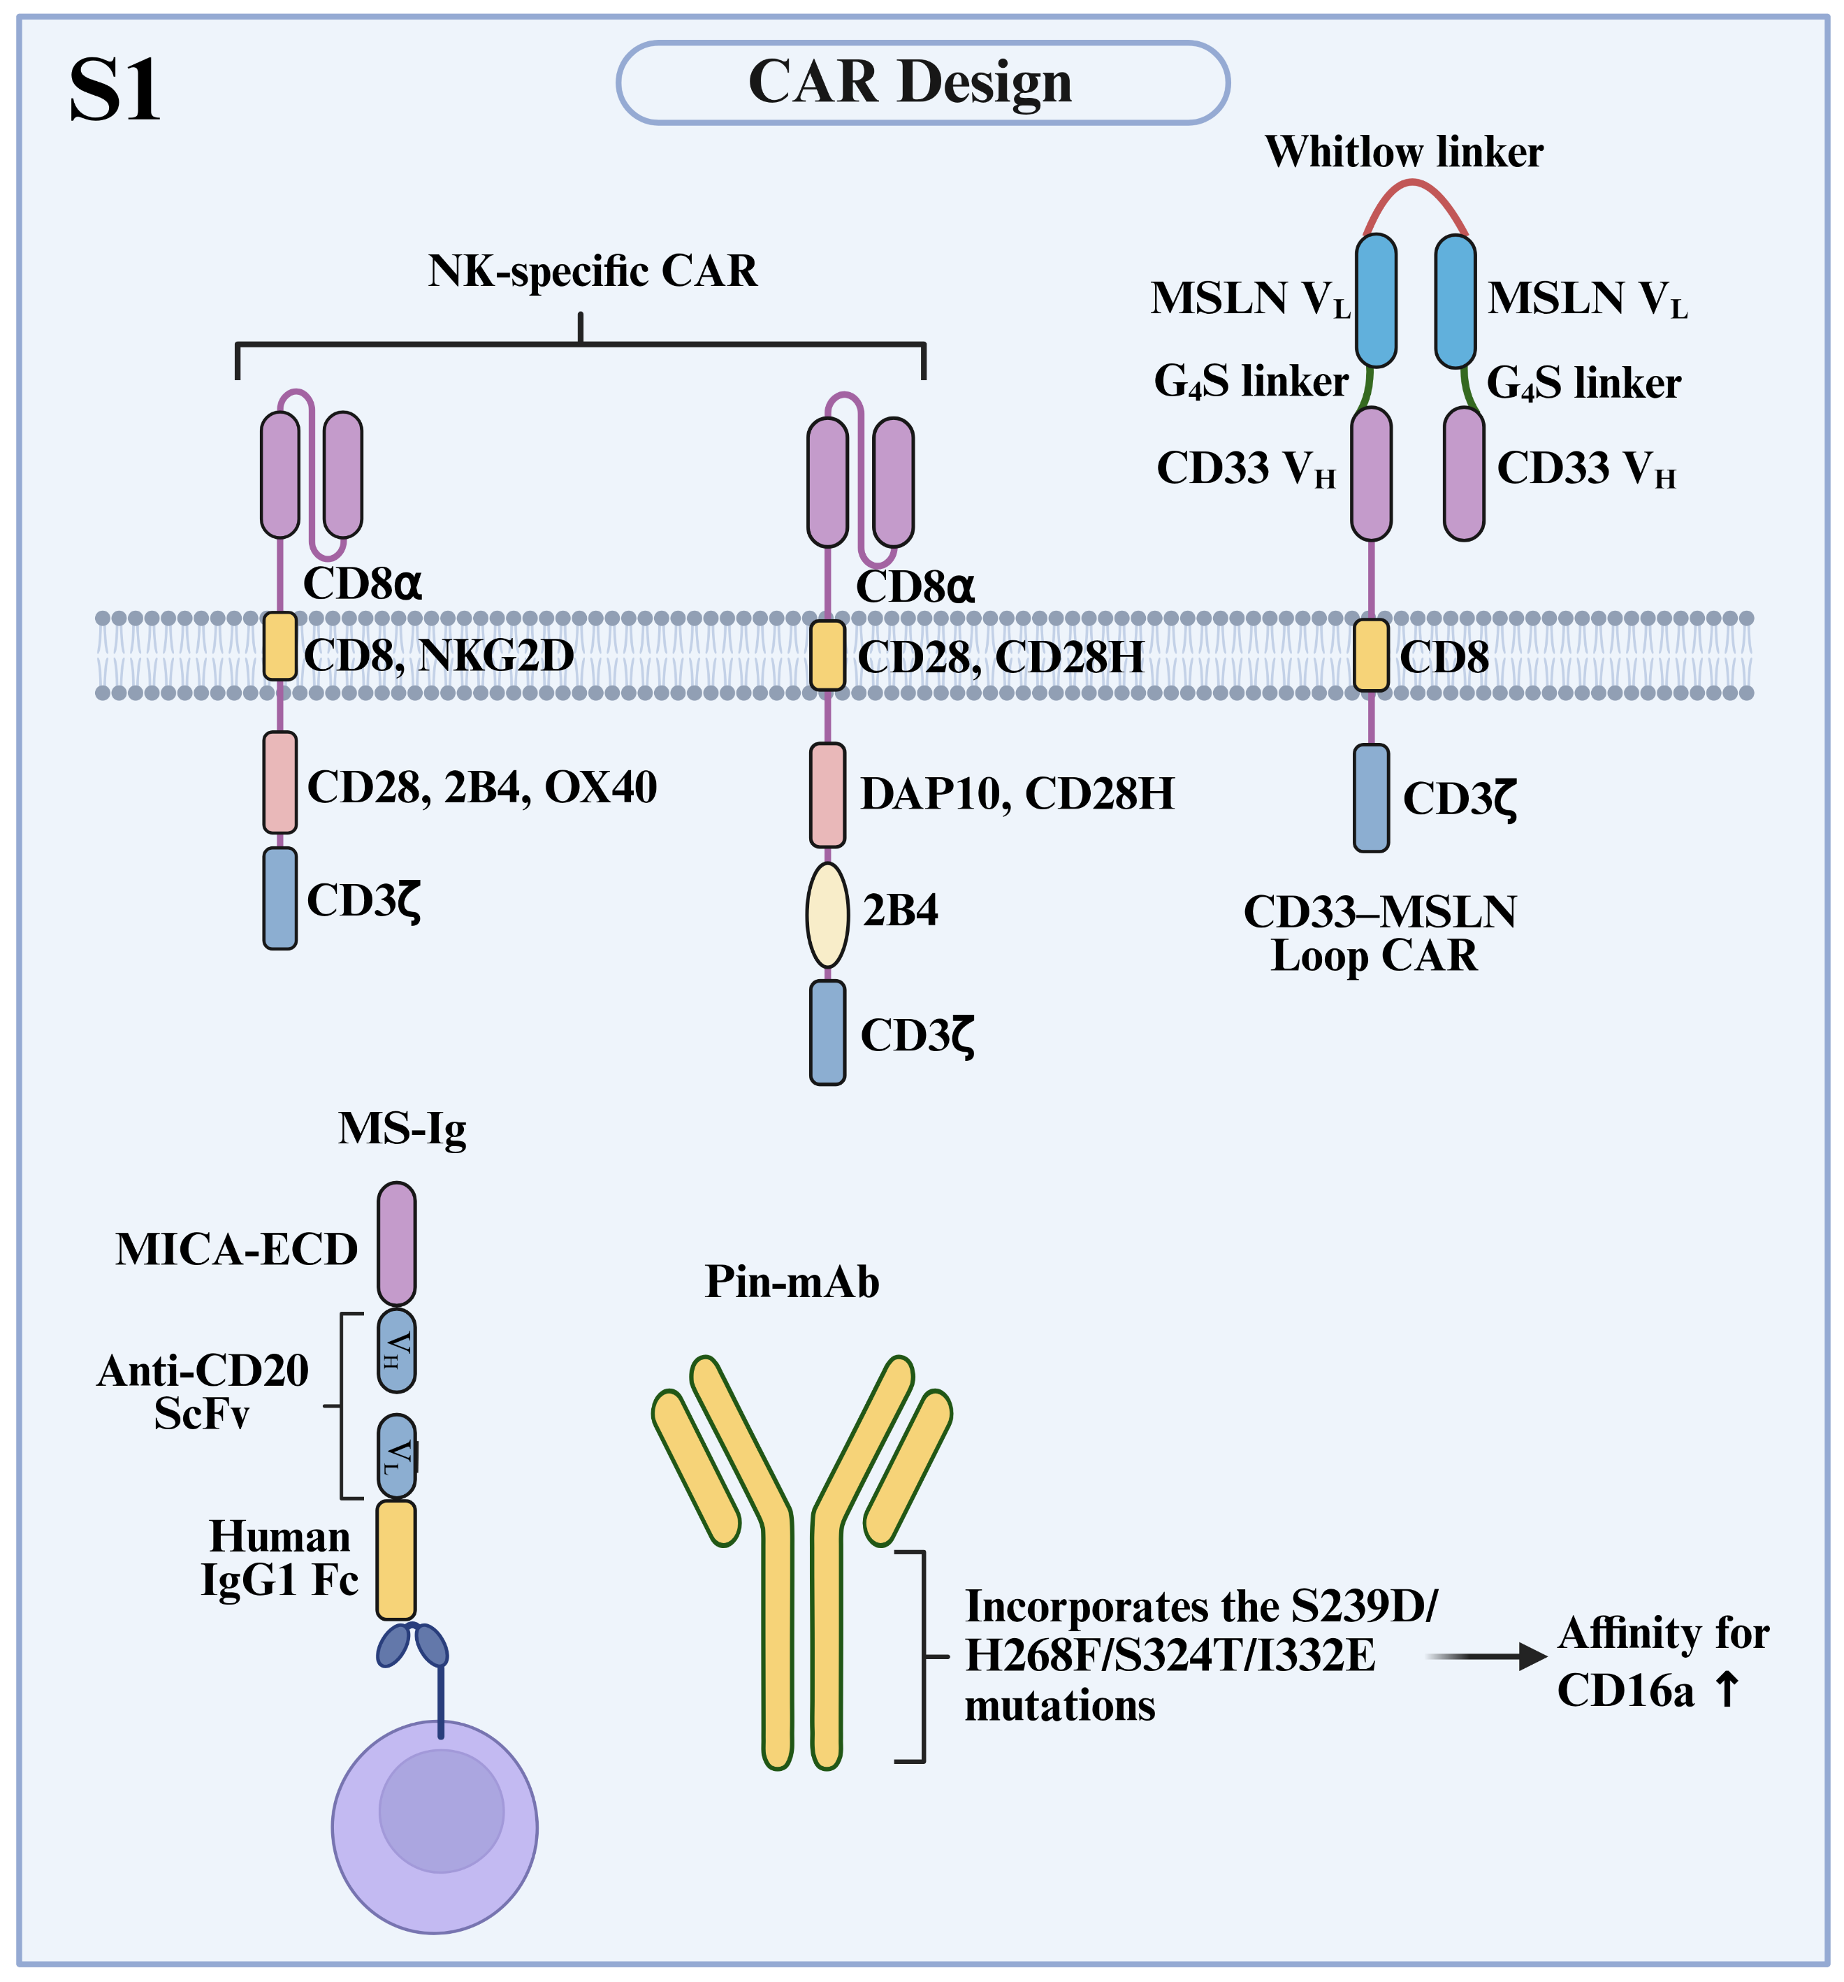
Fig. S1 Innovative CAR Designs. NK-specific CARs incorporate NK-derived domains (e.g., NKG2D, 2B4, DAP10, CD28H). The CD33-MSLN loop CAR uses a circular scFv topology for dual-antigen targeting. Soluble bispecific adapter (MS-Ig) and affinity-enhanced monoclonal antibodies (Pin-mAbs) mediate NK cell activation. Abbreviations: MSLN, mesothelin; ECD, extracellular domain; scFv, single-chain variable fragment.

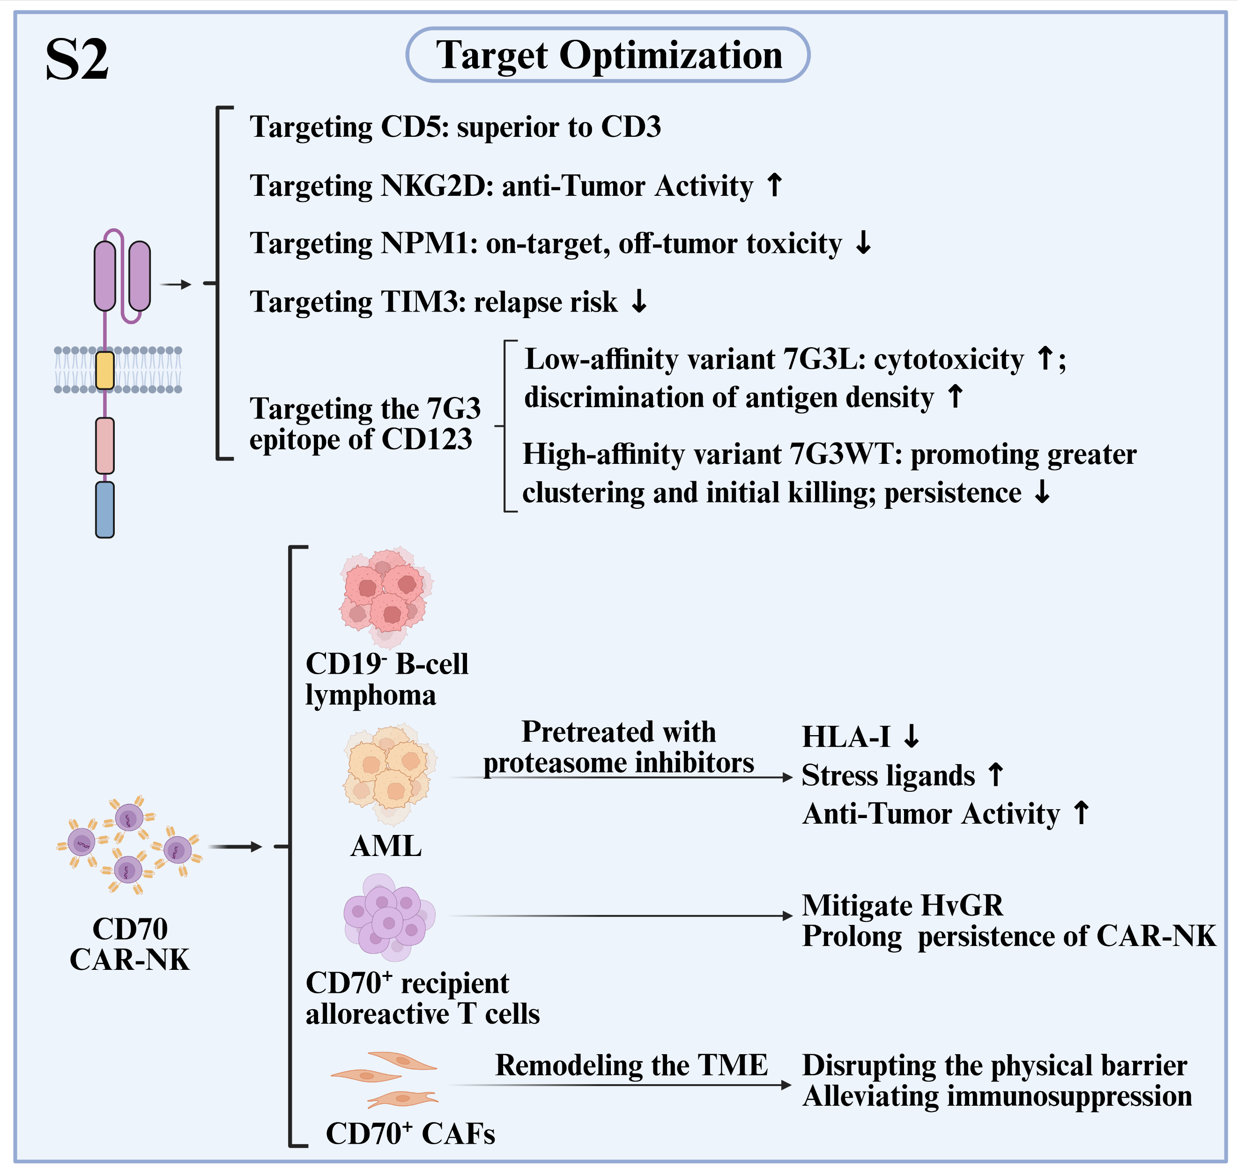
Fig. S2 Strategies for Target Optimization. This schematic outlines key antigen-targeting strategies, including CD5, NKG2D, NPM1, TIM3, CD70 and the 7G3 epitope of CD123. CD70 CAR-NK cells exert multiple effector functions: they eliminate CD70⁺ tumors such as B-cell lymphoma and acute myeloid leukemia (AML), while also depleting alloreactive T cells and cancer-associated fibroblasts (CAFs). These combined actions help mitigate host-versus-graft rejection and counteract immunosuppression within the tumor microenvironment (TME).

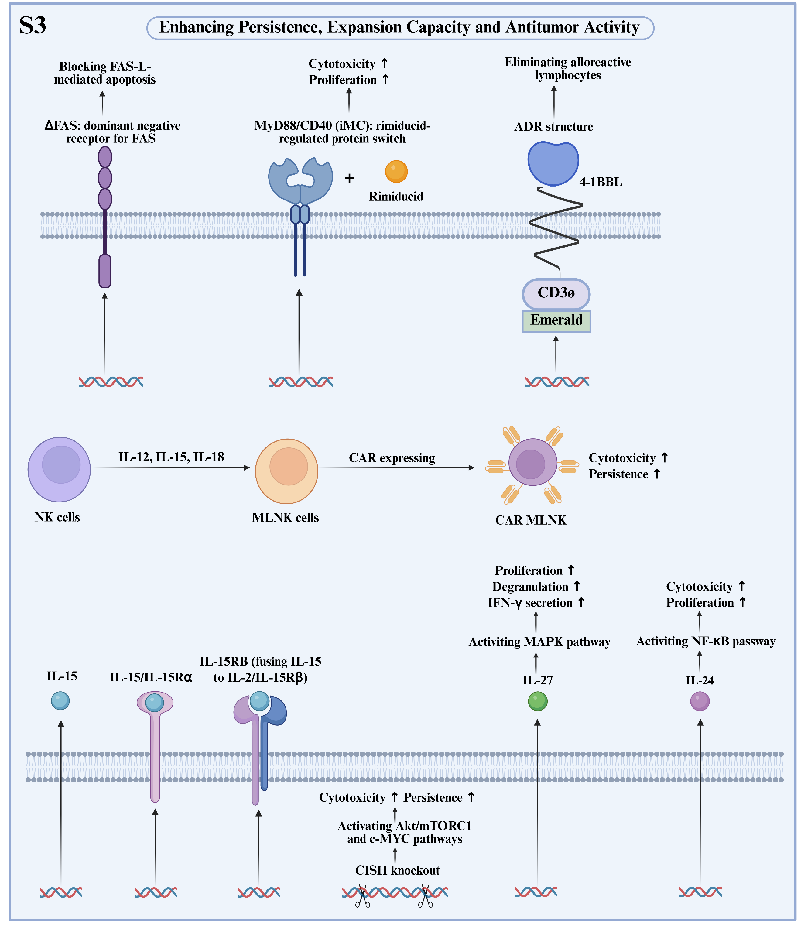
Fig. S3 Strategies to Enhance CAR-NK Persistence, Expansion and Antitumor Activity. This schematic summarizes key engineering approaches: ΔFAS blocks FAS-L-mediated apoptosis; the rimiducid-inducible MyD88/CD40 (iMC) switch enhances cytotoxicity and proliferation; and the alloimmune defense receptor (ADR) eliminates alloreactive lymphocytes while promoting functional persistence and antitumor activity. Additional strategies to enhance CAR-NK function involve generating memory-like NK (MLNK) cells and optimizing IL-15 signaling through methods such as co-expressing membrane-bound IL-15 (mbIL-15) with IL-15Rα, fusing IL-15 to IL-2/IL-15Rβ (IL-15RB), or knocking out CISH. Activating pathways mediated by IL-27 or IL-24 offers further potential to augment these cells.

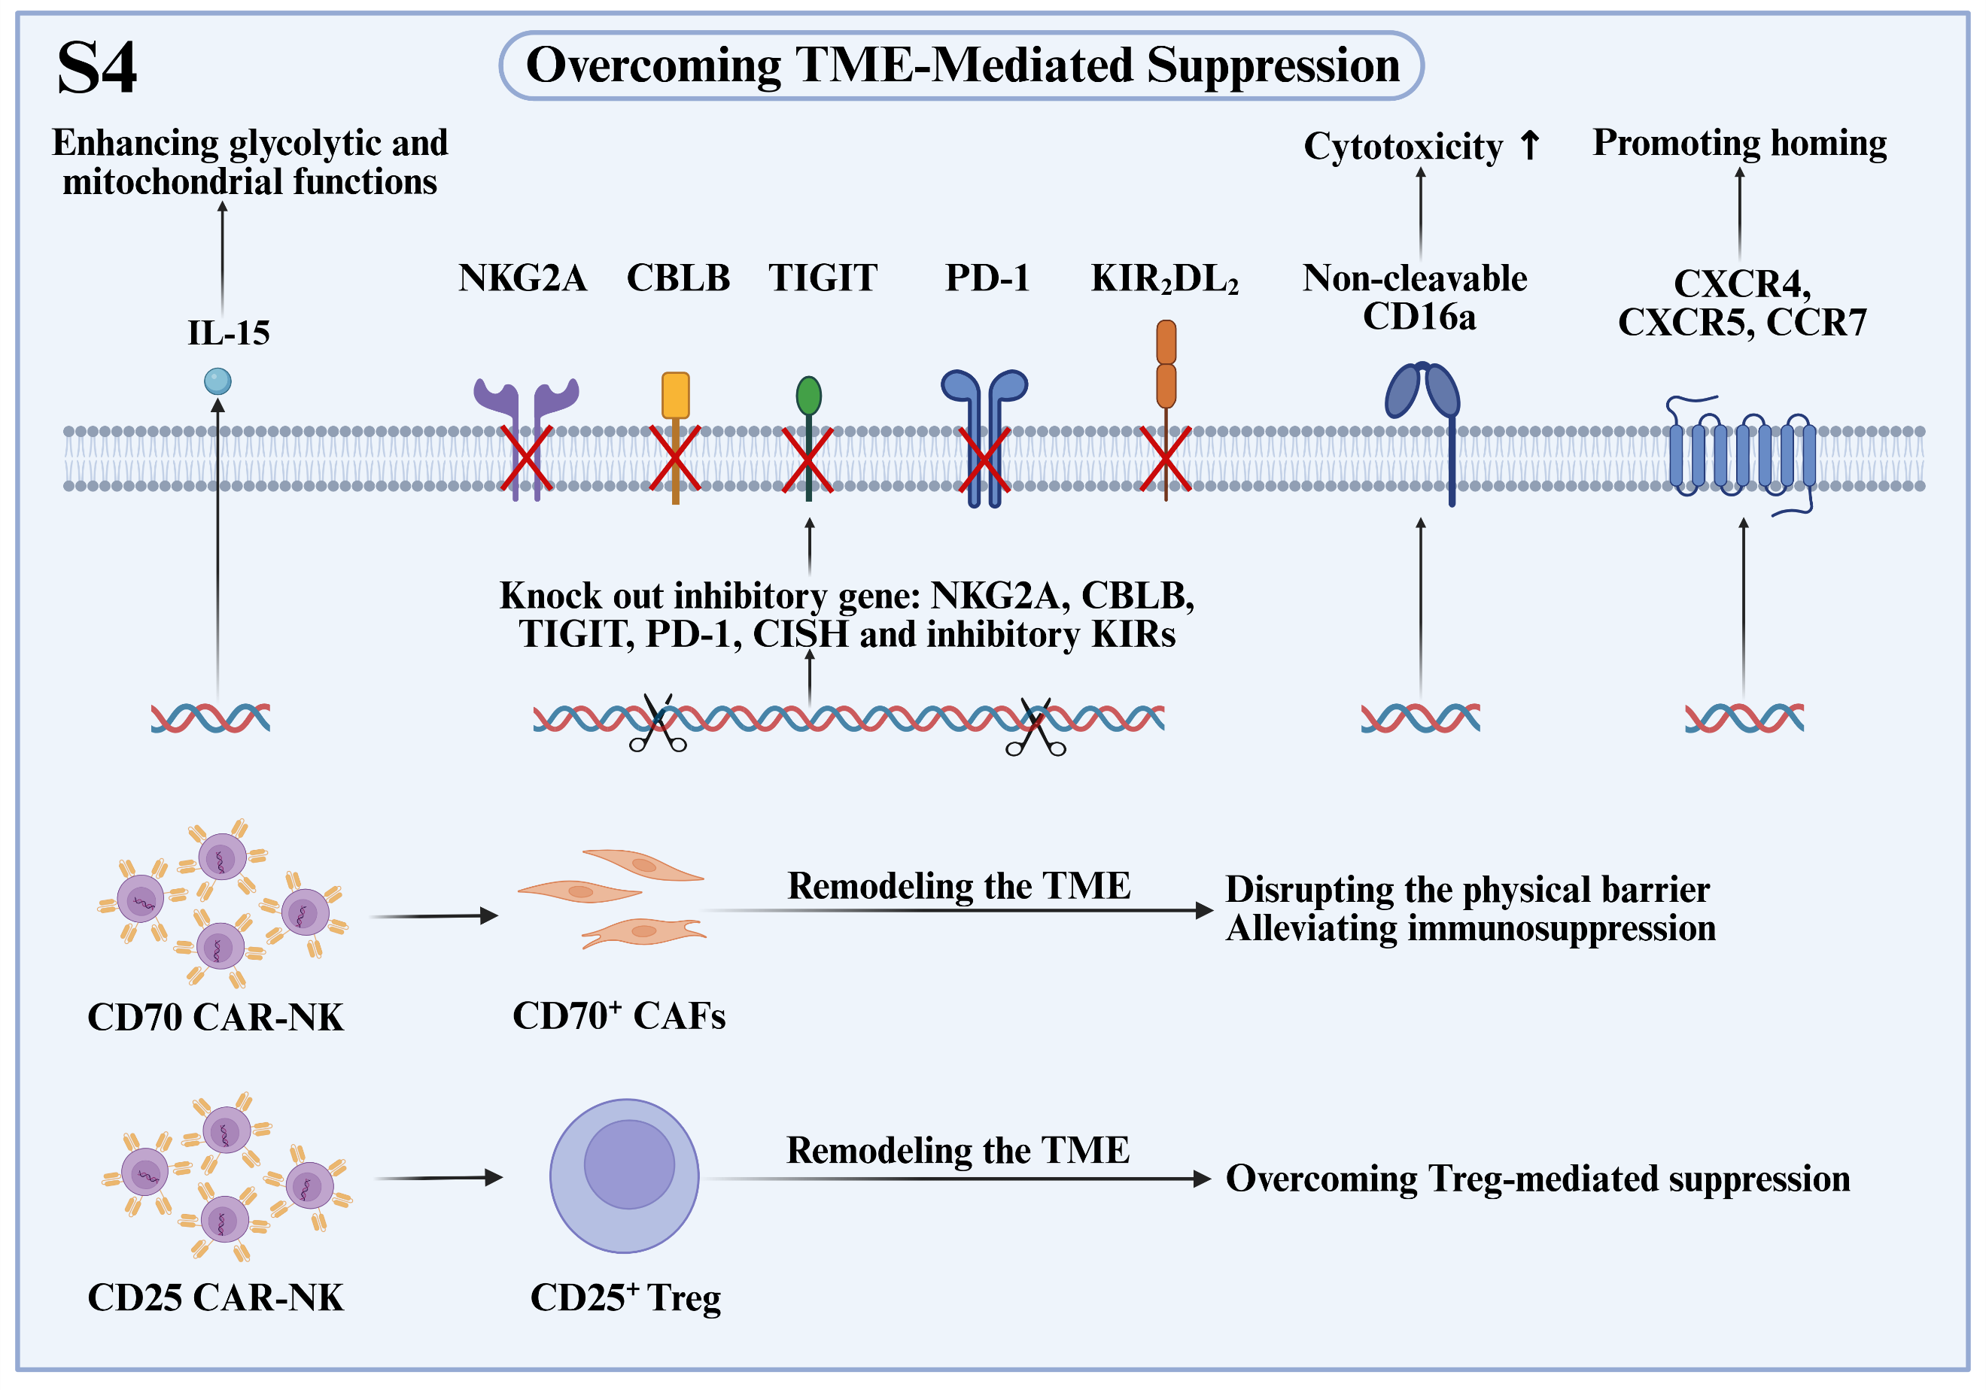
Fig. S4 Strategies to Overcome Tumor Microenvironment (TME)-mediated Suppression. This schematic illustrates key approaches: knockout of inhibitory receptors (NKG2A, CBLB, TIGIT, PD-1, KIR₂DL₂) and non-cleavable CD16a expression boost cytotoxicity. IL-15 enhances metabolic fitness, while CXCR4/CXCR5/CCR7 improve homing. CD70/CD25 CAR-NK cells deplete cancer-associated fibroblasts (CAFs) and regulatory T cells (Tregs), remodeling the immunosuppressive TME.

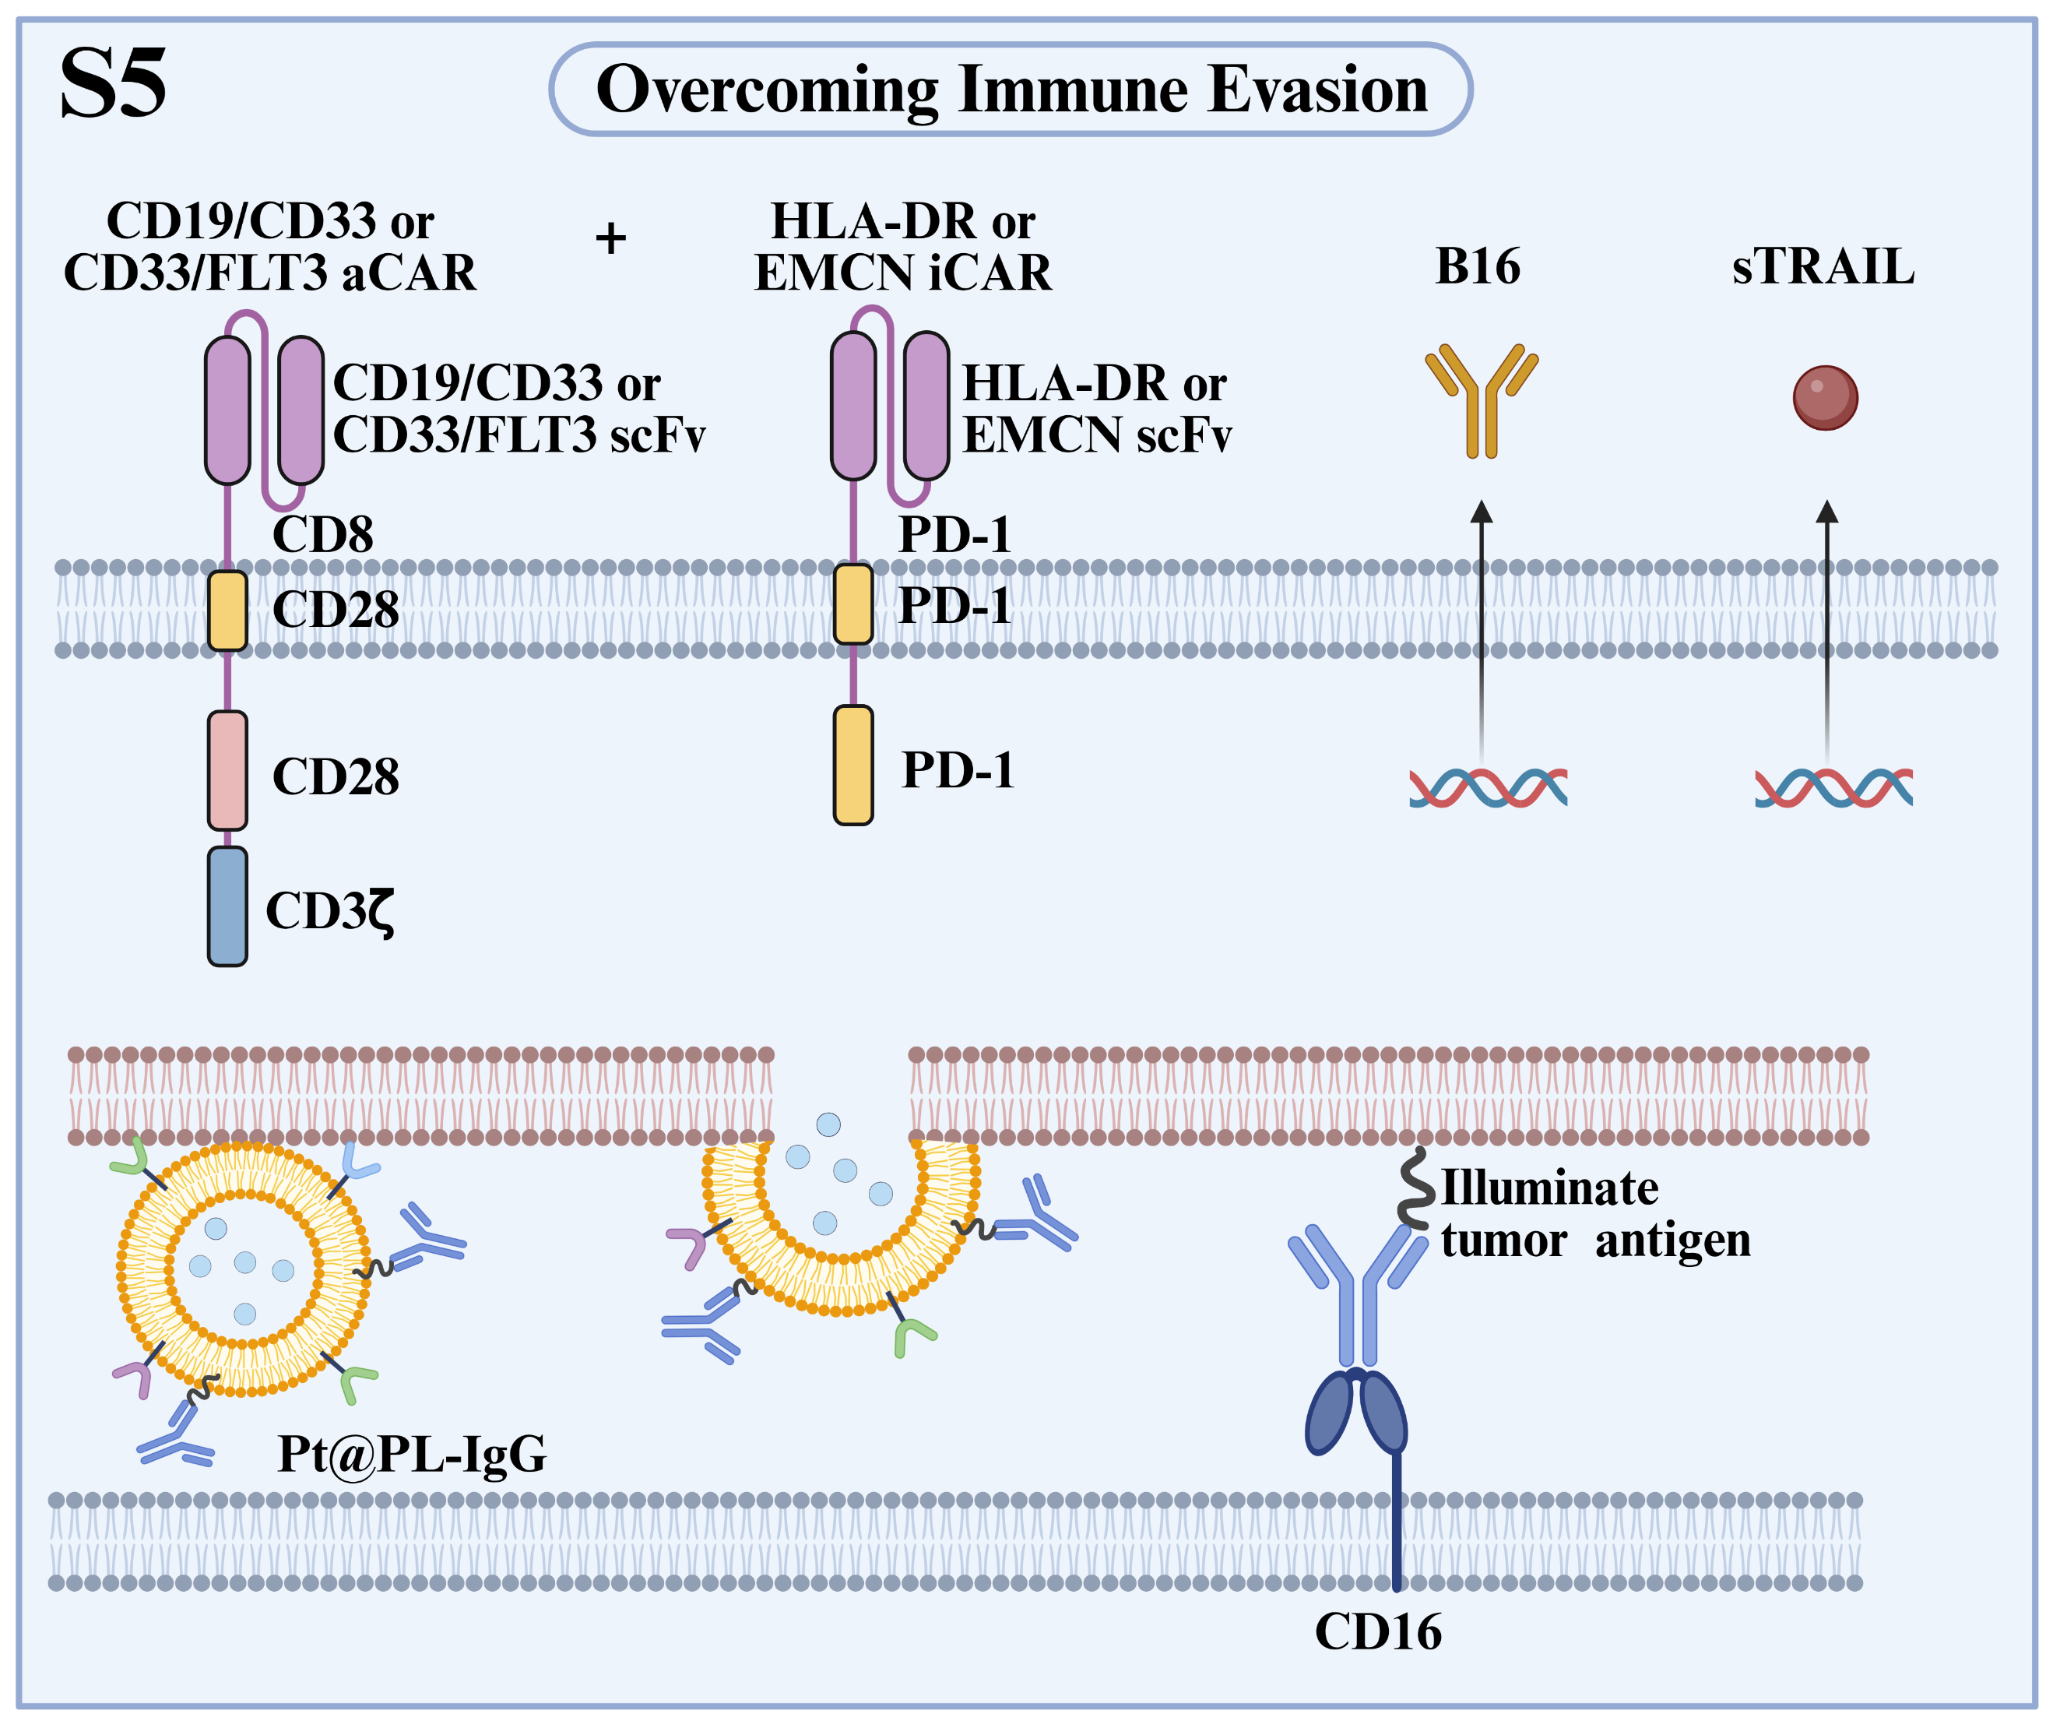
Fig. S5 Strategies to Overcome Tumor Immune Evasion. This schematic illustrates key approaches: dual activating CAR/inhibitory CAR (aCAR/iCAR) systems for selective targeting of malignant cells; platelet membrane–liposome biohybrids (Pt@PL-IgG) that anchor IgG to illuminate tumor antigens for enhanced recognition; expression of an anti-CD16 antibody (B16) to sustain antibody-dependent cellular cytotoxicity (ADCC); and secretion of soluble TNF-related apoptosis-inducing ligand (sTRAIL) to eliminate resistant subpopulations. Collectively, these strategies address challenges related to antigen loss, downregulation, and heterogeneity. Abbreviations: scFv, single-chain variable fragment.

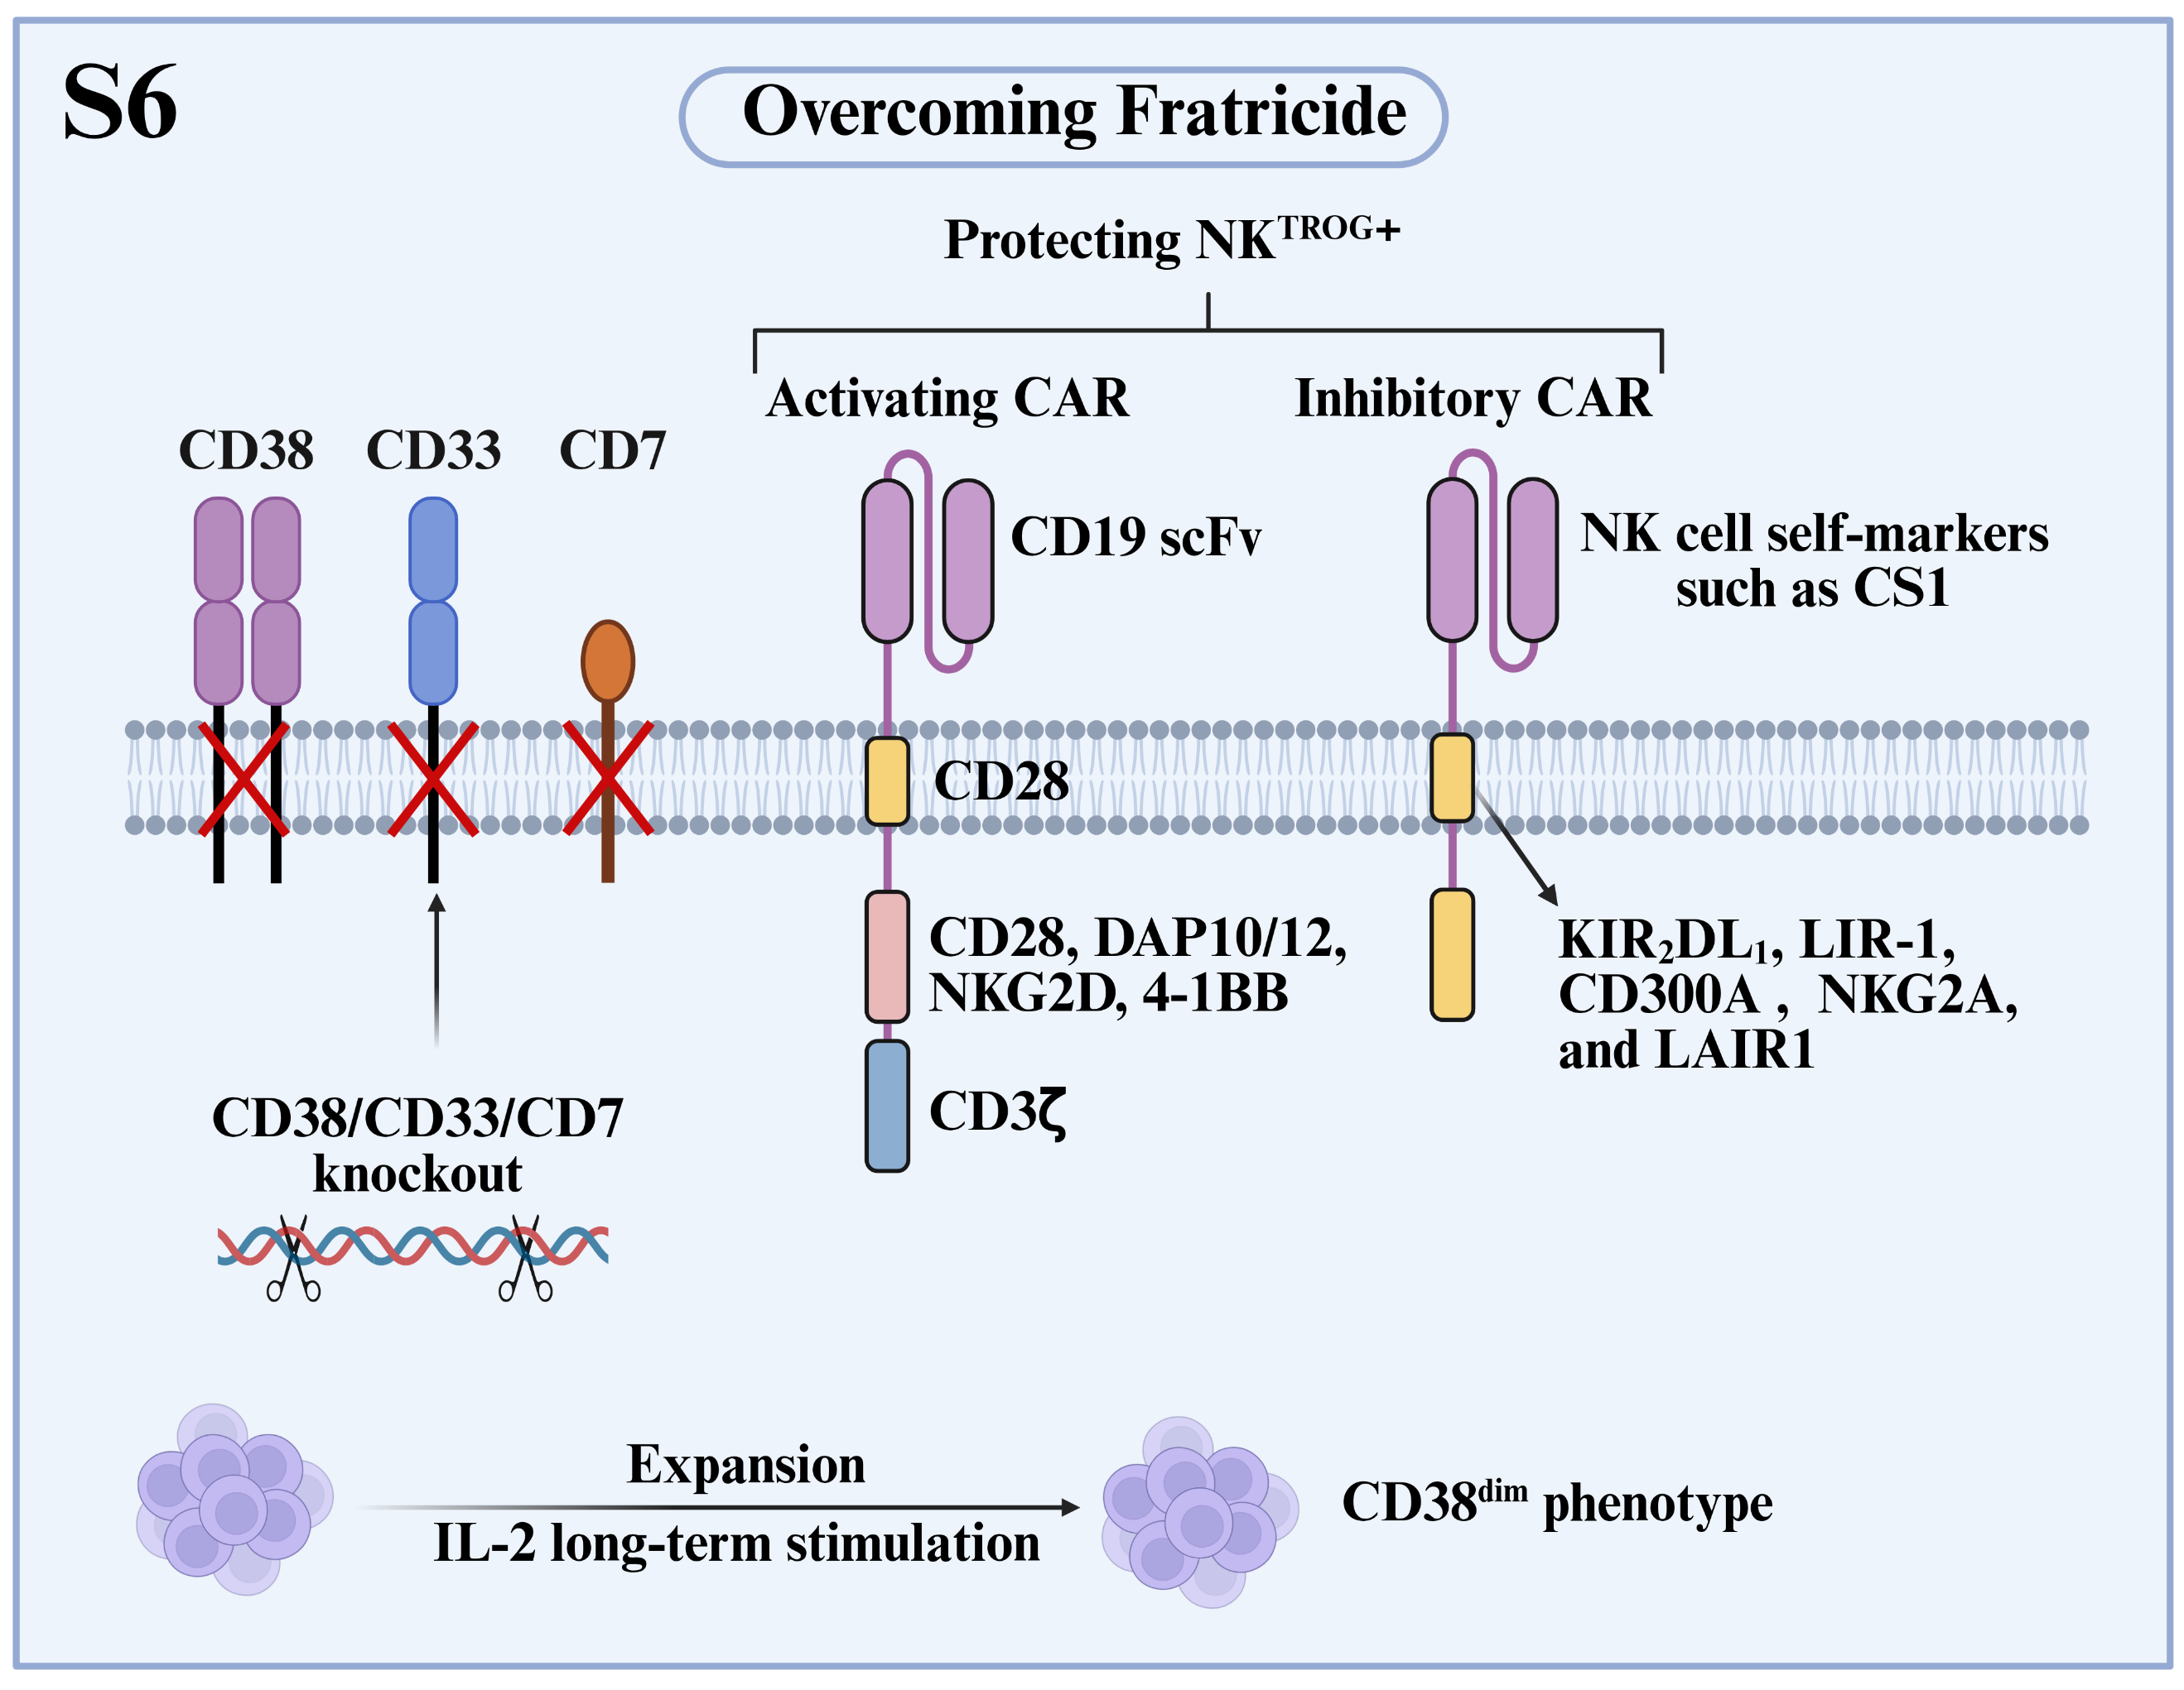
Fig. S6 Strategies to Overcome Fratricide. This schematic illustrates key approaches: knockout of target antigens (CD38, CD33, CD7) to eliminate self-targeting; prolonged IL-2 stimulation to induce a CD38^{dim} phenotype and reduce fratricide risk; and a dual activating CAR (aCAR)/inhibitory CAR (iCAR) system, where the iCAR recognizes NK cell self-markers (e.g., CS1) to protect trogocytic antigen-expressing NK cells (NK^{TROG⁺}) from aCAR-mediated killing. Abbreviations: scFv, single-chain variable fragment.

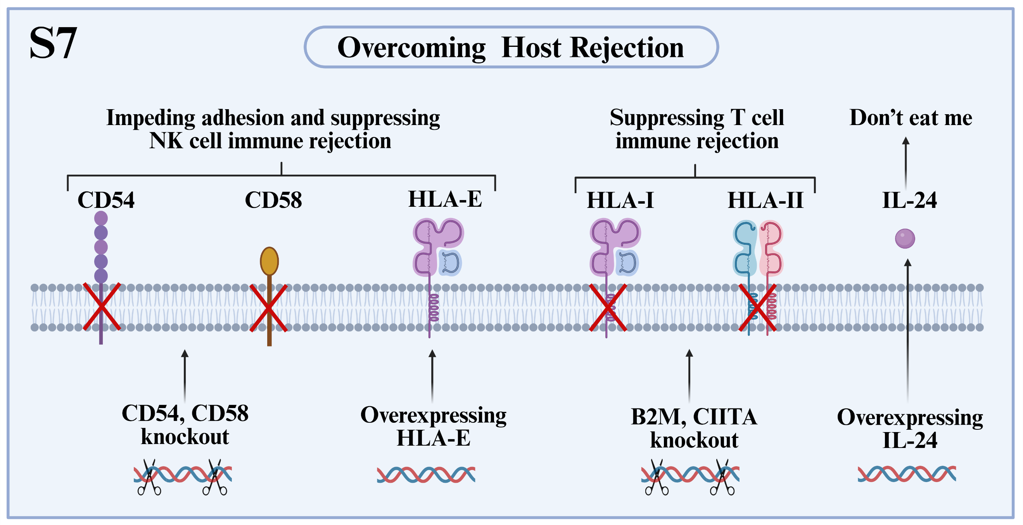
Fig. S7 Strategies to Overcome Host Rejection. This schematic outlines core gene-editing and expression strategies: knockout of CD54/CD58 impairs immune synapse formation to reduce NK cell rejection; B2M/CIITA deletion ablates HLA-I/II expression, evading T cell-mediated rejection. Additionally, HLA-E overexpression suppresses host NK cell activity, while IL-24 overexpression acts as a “don’t eat me” signal to inhibit phagocytic clearance.

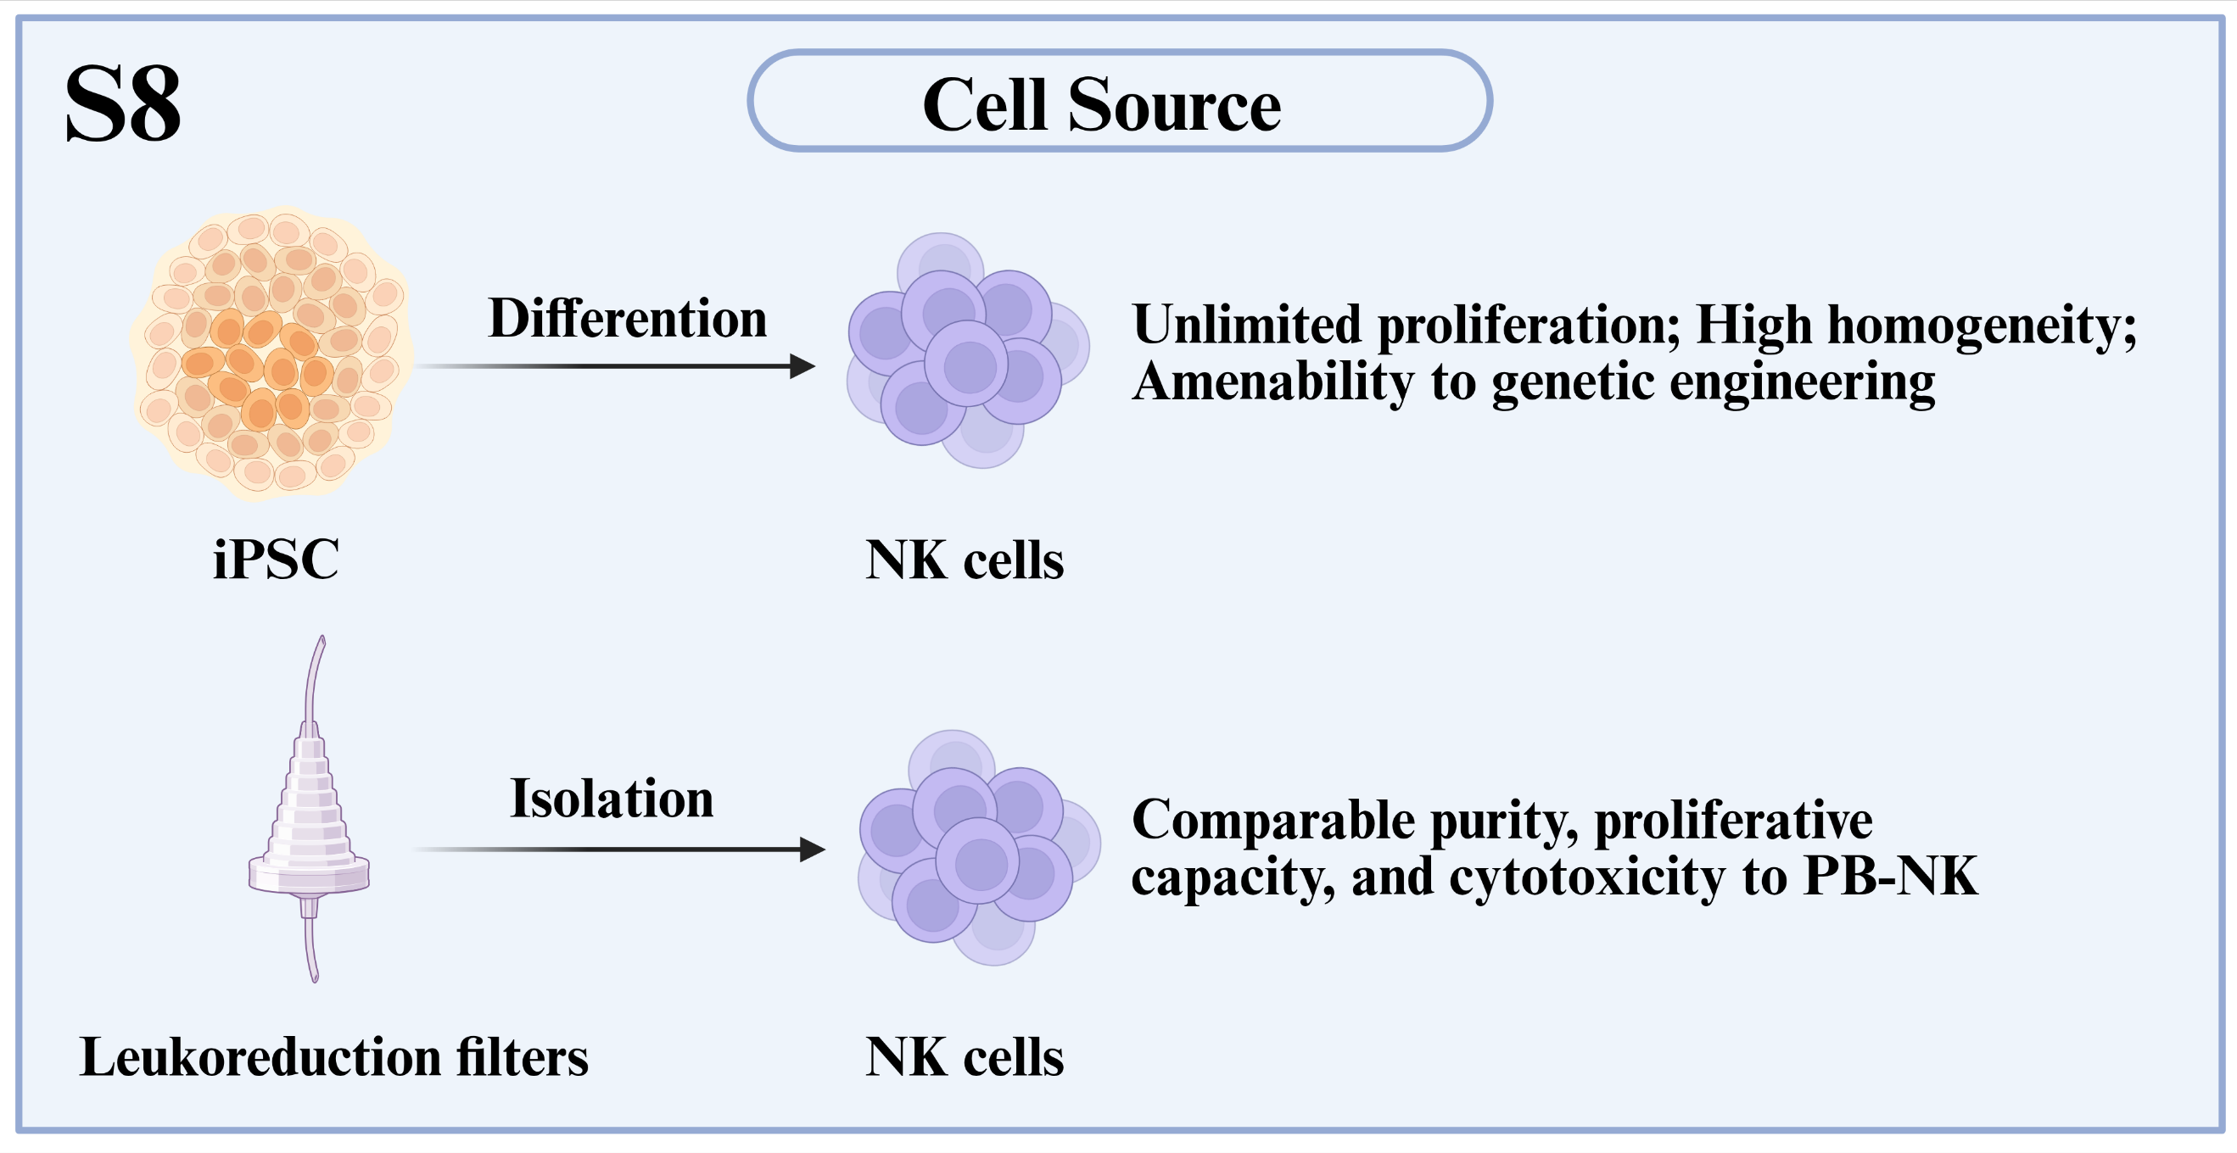
Fig. S8 Alternative Cell Sources for CAR-NK Therapy. This schematic highlights iPSC-derived NK cells (unlimited proliferation, high homogeneity, and genetic engineering amenability) and NK cells isolated from leukoreduction filters (comparable to peripheral blood [PB]-NK cells, accessible and cost-effective).

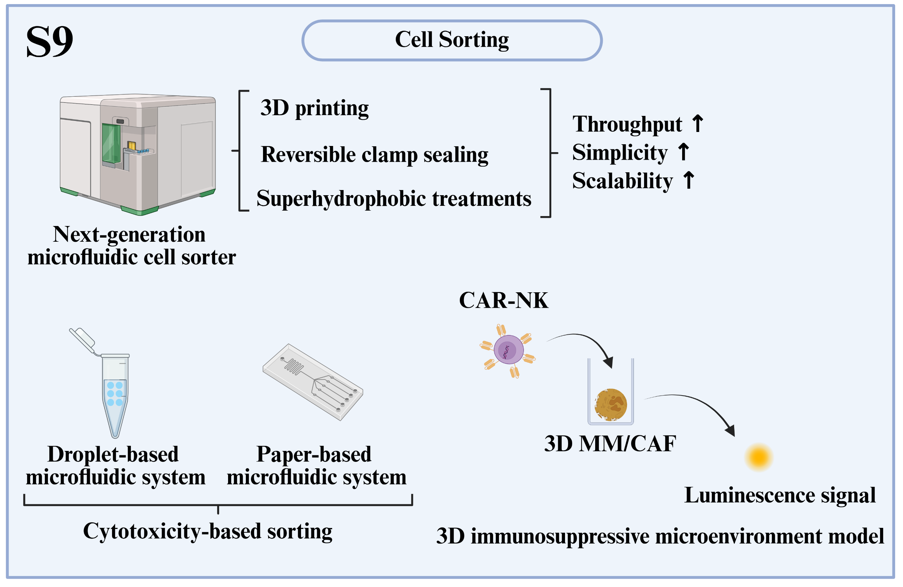
Fig. S9 Advanced NK cell Sorting Strategies. This schematic illustrates innovative approaches: a next-generation microfluidic cell sorter for high throughput and scalability; droplet- and paper-based microfluidic systems for cytotoxicity-based and label-free sorting; and a 3D immunosuppressive microenvironment model for high-throughput CAR-NK cell evaluation. Abbreviations: MM, multiple myeloma; CAF, cancer-associated fibroblast.

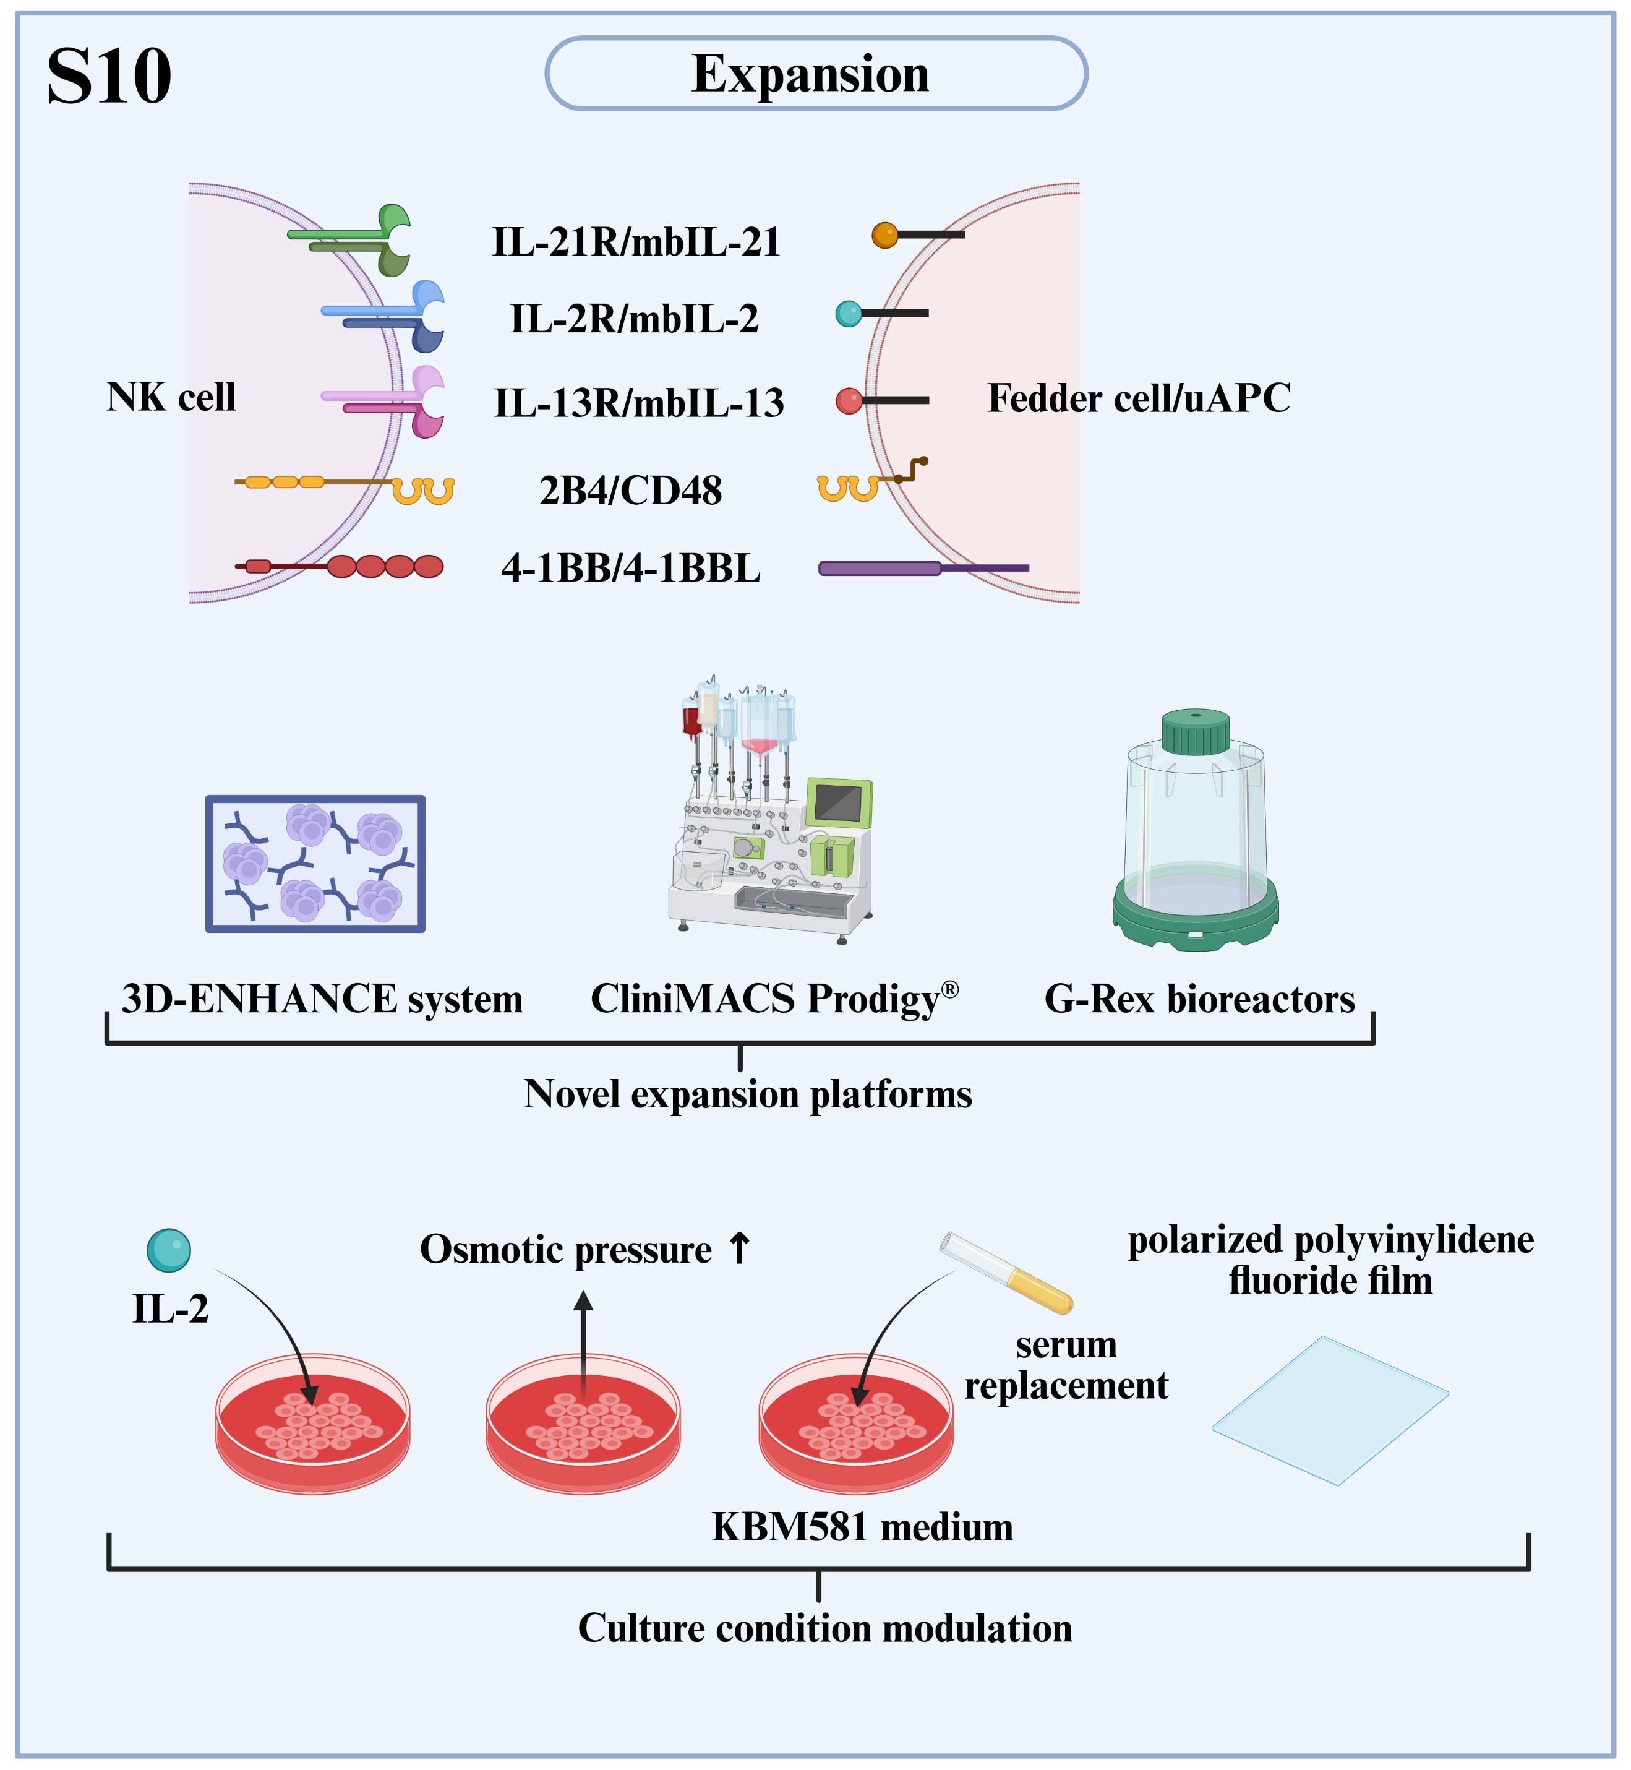
Fig. S10 Strategies for In Vitro Expansion of CAR-NK Cells. This schematic outlines optimized feeder cell systems or universal antigen-presenting cells (uAPC) co-expressing membrane-bound IL-21 (mbIL-21), mbIL-2, mbIL-13, 4-1BBL, and CD48, alongside novel expansion platforms (3D-ENHANCE, CliniMACS Prodigy®, G-Rex bioreactors) and culture condition modulation (IL-2, osmotic pressure, KBM581 medium with serum replacement, polarized polyvinylidene fluoride film) to enhance expansion efficiency, cytotoxicity, and antitumor function.

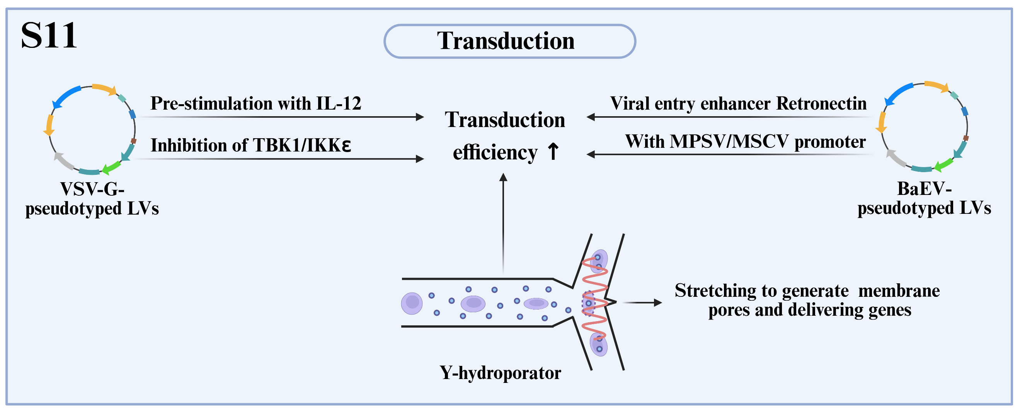
Fig. S11 Strategies to Enhance CAR-NK Cell Transduction Efficiency. This schematic details optimized lentiviral transduction approaches: VSV-G-pseudotyped LVs (aided by IL-12 pre-stimulation or TBK1/IKKε inhibition) and BaEV-pseudotyped LVs (boosted by viral entry enhancer Retronectin and MPSV/MSCV promoters). It also features the Y-hydroporator, which uses hydrodynamic stretching for efficient, viable non-viral gene delivery. Abbreviations: LVs, Lentiviral vectors; VSV-G, vesicular stomatitis virus G glycoprotein; BaEV, baboon endogenous virus.

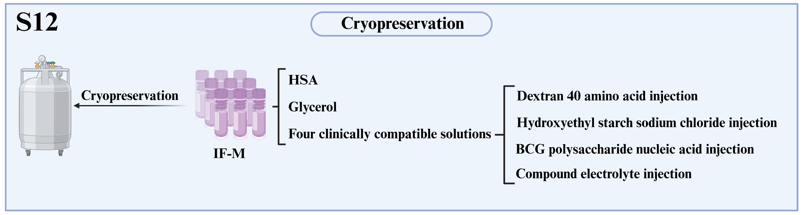
Fig. S12 Cryopreservation Strategies for CAR-NK Cells. This schematic illustrates the IF-M cryopreservation formulation, which uses human serum albumin (HSA) and glycerol, supplemented with four clinically compatible solutions, to enhance post-thaw viability and preserve NK cell function.

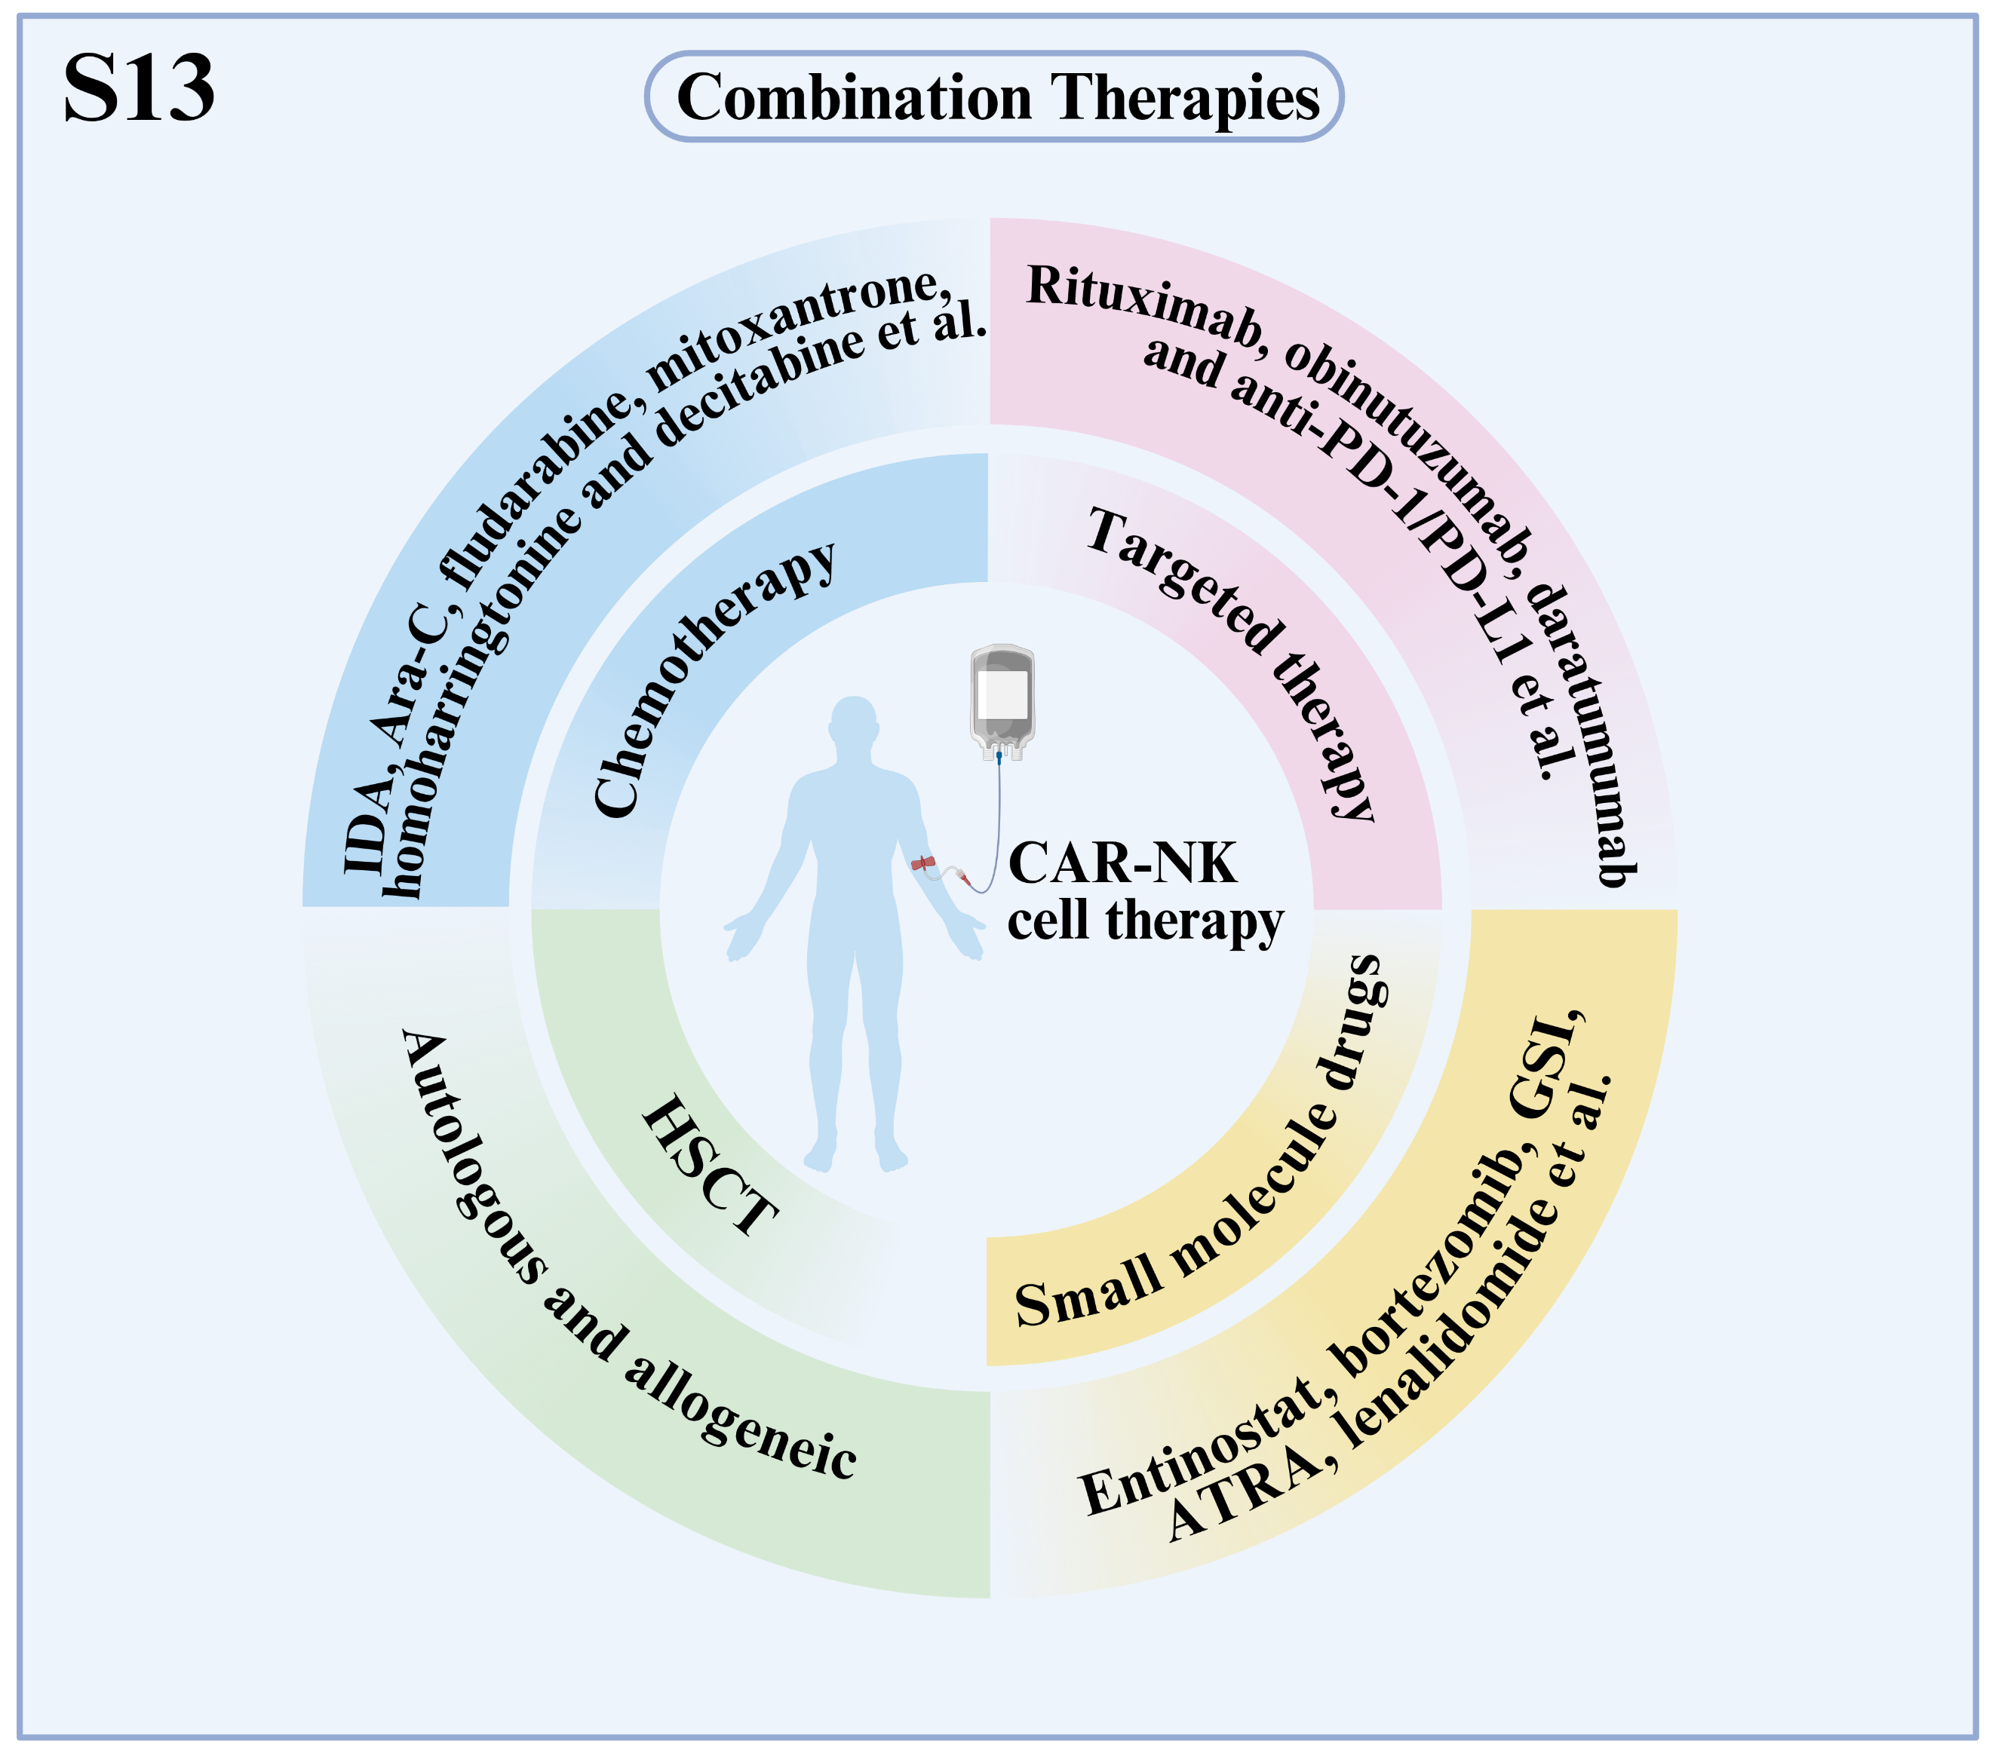
Fig. S13 Combination Strategies to Enhance CAR-NK Cell Therapy Efficacy. This schematic illustrates key therapeutic combinations: targeted therapy (e.g., rituximab, obinutuzumab, daratumumab, and anti-PD-1/PD-L1 antibodies), small molecules (e.g., entinostat, γ-secretase inhibitors [GSI], bortezomib, all-trans retinoic acid [ATRA], and lenalidomide), chemotherapy (e.g., idarubicin [IDA], cytarabine [Ara-C], fludarabine, mitoxantrone, homoharringtonine, and decitabine), and hematopoietic stem cell transplantation (HSCT), all of which synergize with CAR-NK cells to enhance antitumor activity and clinical outcomes in hematologic malignancies.

