Supplementary information for

Zhang et al. Targeting MORC2 Activates Transposable Element-Mediated Viral Mimicry and Potentiates Immune Checkpoint Blockade in Triple-Negative Breast Cancer

The supplementary information contains:
Supplementary Figures 1-15
Supplementary Tables 1-9

Supplementary Figures and Legends
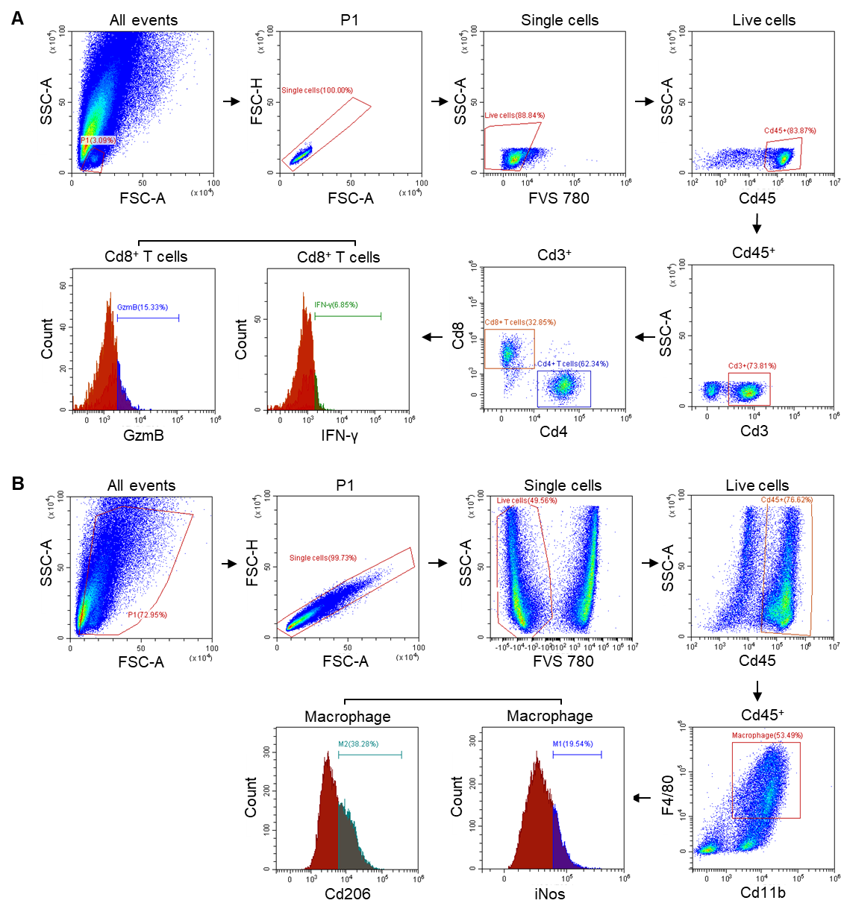

Figure S1. MORC2 depletion remodels the tumor immune microenvironment in TNBC.
(A) Representative flow cytometry gating plots showing the proportions of CD4⁺, CD8⁺, IFN-γ⁺CD8⁺, and GzmB⁺CD8⁺ T cells among tumor-infiltrating lymphocytes.
(B) Representative flow cytometry gating plots showing the proportions of total macrophages (CD11b⁺F4/80⁺), M1 macrophages (iNOS⁺), and M2 macrophages (CD206⁺) among tumor-infiltrating myeloid cells.
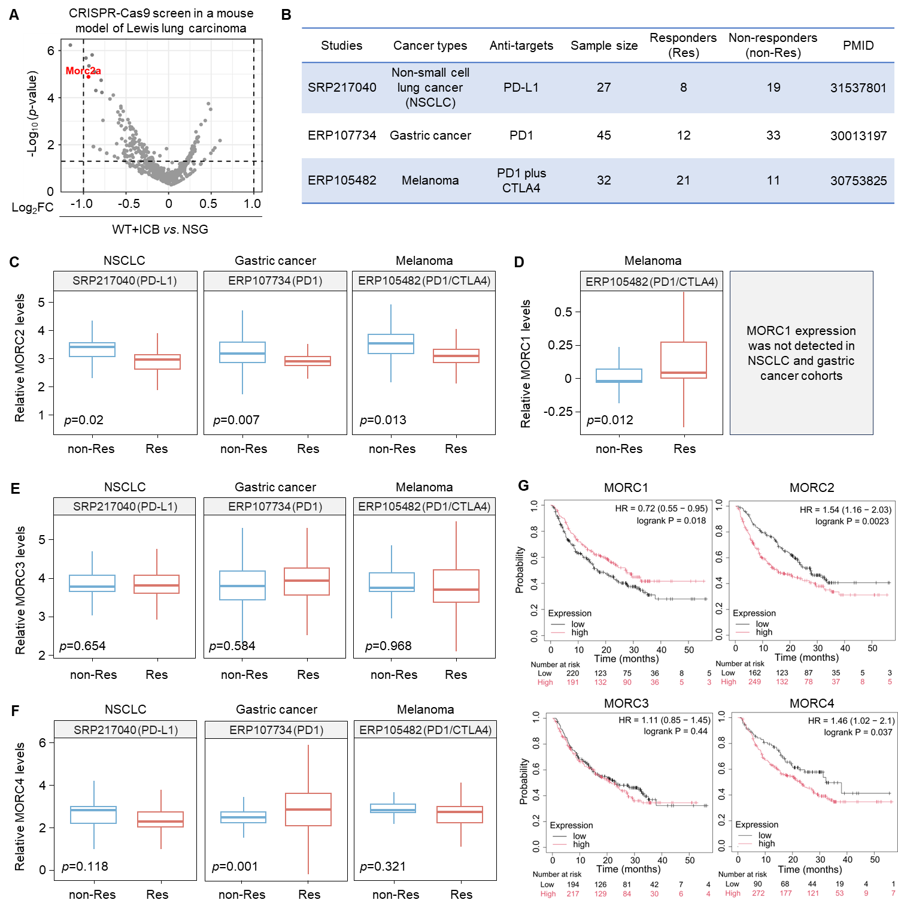

Figure S2. MORC2 is a negative predictor of response to ICB therapy in cancer.
(A) Gene set enrichment results from a recent in vivo CRISPR-Cas9 screen targeting 936 chromatin regulators in Lewis lung carcinoma (LLC)-bearing wild-type versus NSG (NOD-scid-IL2Rg^{null}) mice treated with ICB [1]. Among these hits, Morc2a (highlighted in red) is identified as a potential negative regulator of the tumor-cell response to ICB therapy.
(B-F) Expression patterns of MORC family members (MORC1-4) between responders (Res) and non-responders (non-Res) to ICB therapy in three publicly available datasets from the Immune Checkpoint Blockade Therapy Atlas (ICBatlas; https://guolab.wchscu.cn/ICBatlas/) [2]. These datasets include SRP217040 (non-small cell lung cancer patients treated with anti-PD-L1) [3], ERP107734 (gastric cancer patients treated with anti-PD1) [4], and ERP105482 (melanoma patients treated with anti-PD1 plus anti-CTLA4) [5] (B). The expression levels of MORC2 (C), MORC1 (D), MORC3 (E), and MORC4 (F) in these datasets are shown.
(G) Kaplan–Meier analysis of overall survival stratified by MORC1-4 expression levels in a pan-cancer anti-PD-1 treatment cohort (n = 411) from KMplot. HR, hazard ratio; logrank p values are indicated.

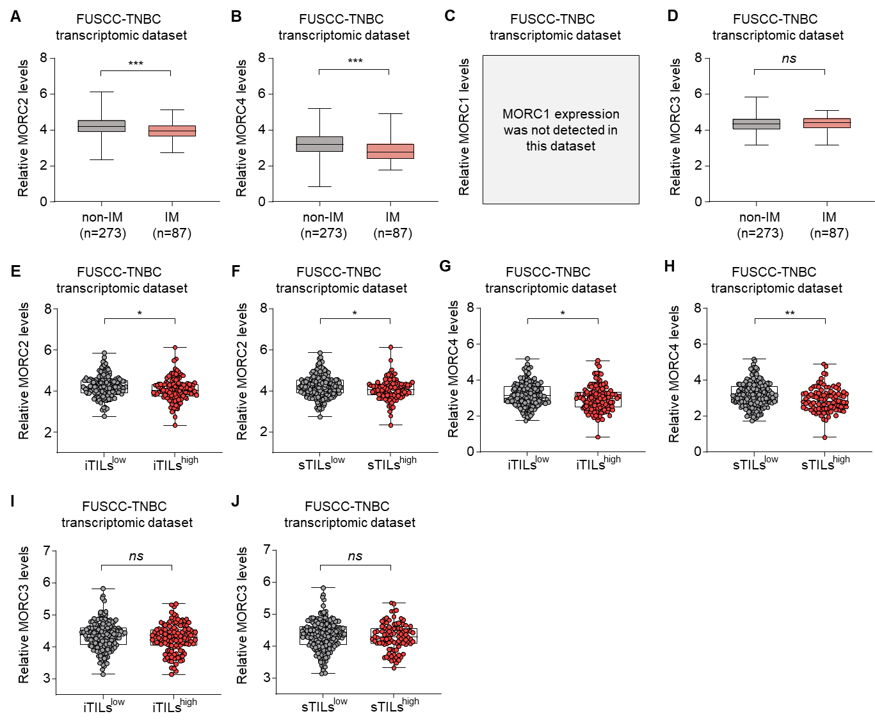

Figure S3. Expression profiles of MORC family genes in TNBC samples with distinct immune characteristics.
(A-D) The relative expression levels of MORC2 (A), MORC4 (B), MORC1 (C), and MORC3 (D) in the immunomodulatory (IM) subtype and the combined non-IM subtypes (BLIS, LAR, and MES) of TNBC in the FUSCC-TNBC transcriptomic dataset.
(E-J) The relative expression levels of MORC2 (E, F), MORC4 (G, H), and MORC3 (I, J) in TNBC tissues with low versus high levels of tumor-infiltrating lymphocytes (TILs), assessed in both intratumoral (iTILs) and stromal (sTILs) compartments, in the FUSCC-TNBC transcriptomic dataset.
Notes: P-values were calculated by the Welch’s t-test. Significance levels are denoted as follows: *p<0.05, **p<0.01, ***p<0.001; "ns" indicates no significance.

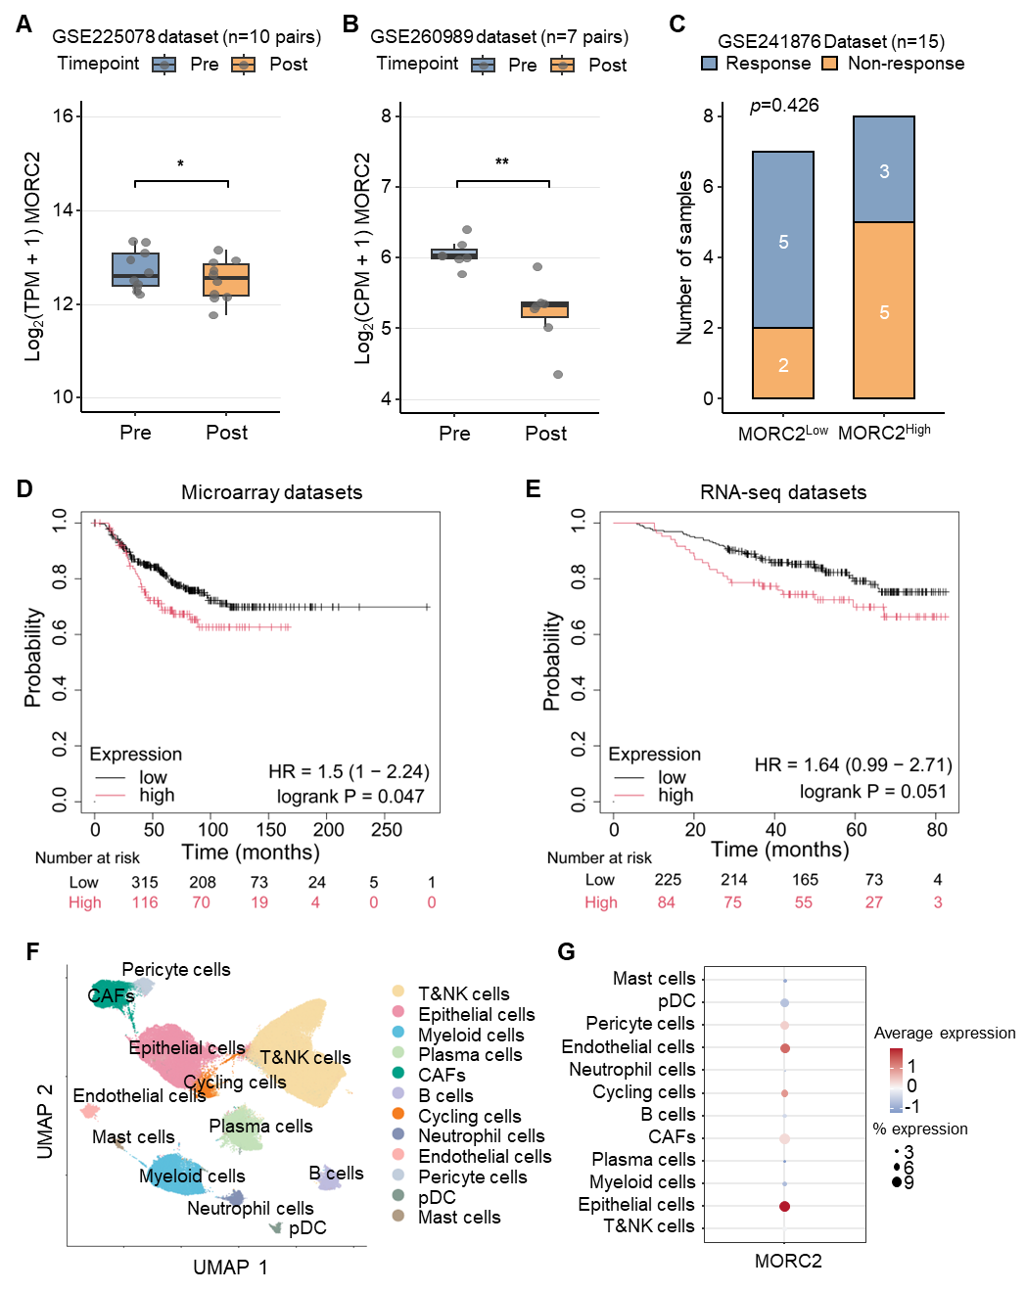

Figure S4. Clinical and single-cell characterization of MORC2 expression in TNBC.
(A) Box plots showing MORC2 expression levels before and after anti-PD-1 combined with paclitaxel or capecitabine treatment in paired TNBC samples from the GSE225078 dataset (n = 10 paired samples).
(B) Box plots showing MORC2 expression levels before and after neoadjuvant chemotherapy plus chemokine-modulating therapy in paired TNBC samples from the GSE260989 dataset (n = 7 paired samples).
(C) Stacked bar chart showing objective response rates in TNBC patients from GSE241876 (n = 15) stratified by median MORC2 expression. Low-MORC2 group: 5/7 responders; high-MORC2 group: 3/8 responders.
(D) Kaplan-Meier analysis of overall survival in the PAM50-defined basal-like subtype microarray cohort (n = 401) from KMplot, stratified by MORC2 expression level. HR = 1.50 (95% CI: 1.00–2.24); log-rank p= 0.047.
(E) Kaplan-Meier analysis of overall survival in the PAM50-defined basal-like subtype RNA sequencing cohort (n = 309) from KMplot, stratified by MORC2 expression level (high vs. low), showing a trend toward worse overall survival in the high-MORC2 group, though this did not reach statistical significance (HR = 1.64, 95% CI: 0.99–2.71; log-rank p = 0.051).
(F-G) Feature plot (F) and dot plot (G) showing MORC2 expression across annotated cell types in a publicly available TNBC scRNA-seq dataset from GEO (32 samples), demonstrating predominant enrichment of MORC2 expression in epithelial cells relative to immune cell subsets.

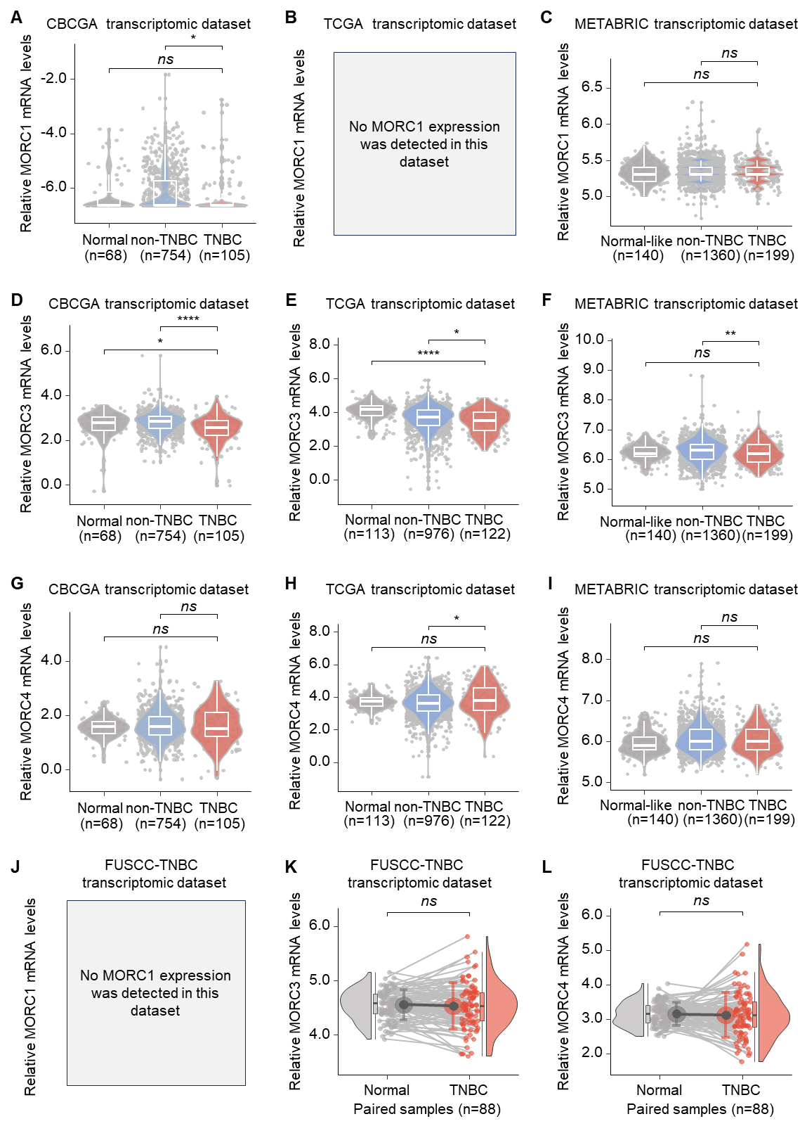

Figure S5. Expression profiles of MORC family genes in multiple TNBC cohorts.
(A-I) The relative mRNA levels of MORC1 (A-C), MORC3 (D-F), and MORC4 (G-I) in the CBCGA (A, D, and G), TCGA (B, E, and H), and METABRIC (C, F, and I) transcriptomic dataset.
(J-L) The relative mRNA levels of MORC1 (J), MORC3 (K), and MORC4 (L) in 88 paired TNBC tissues versus matched normal breast samples from the FUSCC-TNBC transcriptomic dataset.
Notes: P-values were calculated using the Kruskal-Wallis test (A-I) and Wilcoxon test (J-L). Significance levels are denoted as follows: *p<0.05, **p<0.01, ****p<0.0001; "ns" indicates no significance.

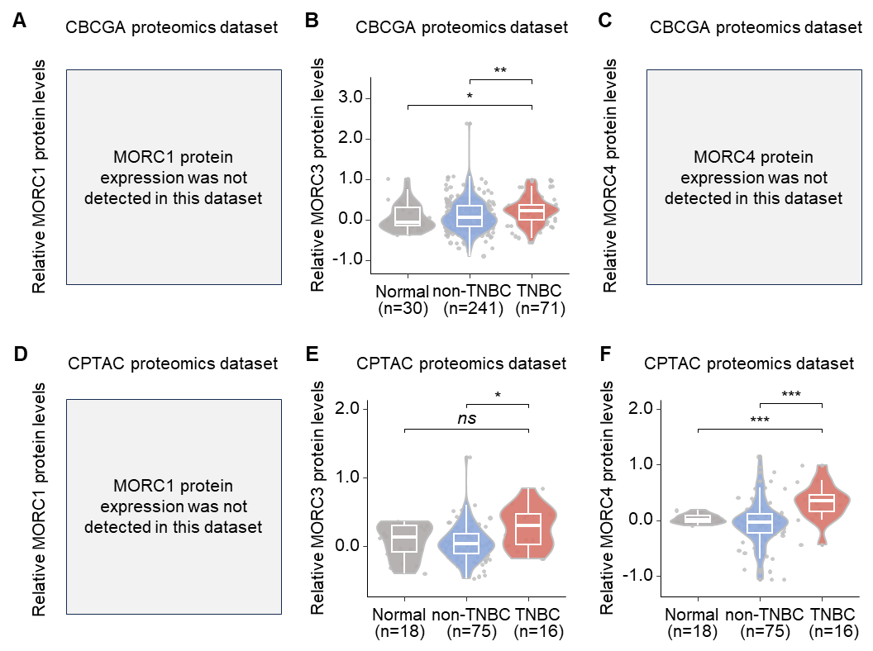

Figure S6. Expression profiles of MORC family proteins in normal breast, non-TNBC, and TNBC samples.
(A-F) The relative protein levels of MORC1 (A, D), MORC3 (B, E), and MORC4 (C, F) across normal breast, non-TNBC, and TNBC samples in the CBCGA (A-C) and CPTAC (D-F) proteomic datasets.
Notes: P-values were determined by the Kruskal-Wallis test. Significance levels are denoted as follows: *p<0.05, **p<0.01, ***p<0.001; "ns" indicates no significance.

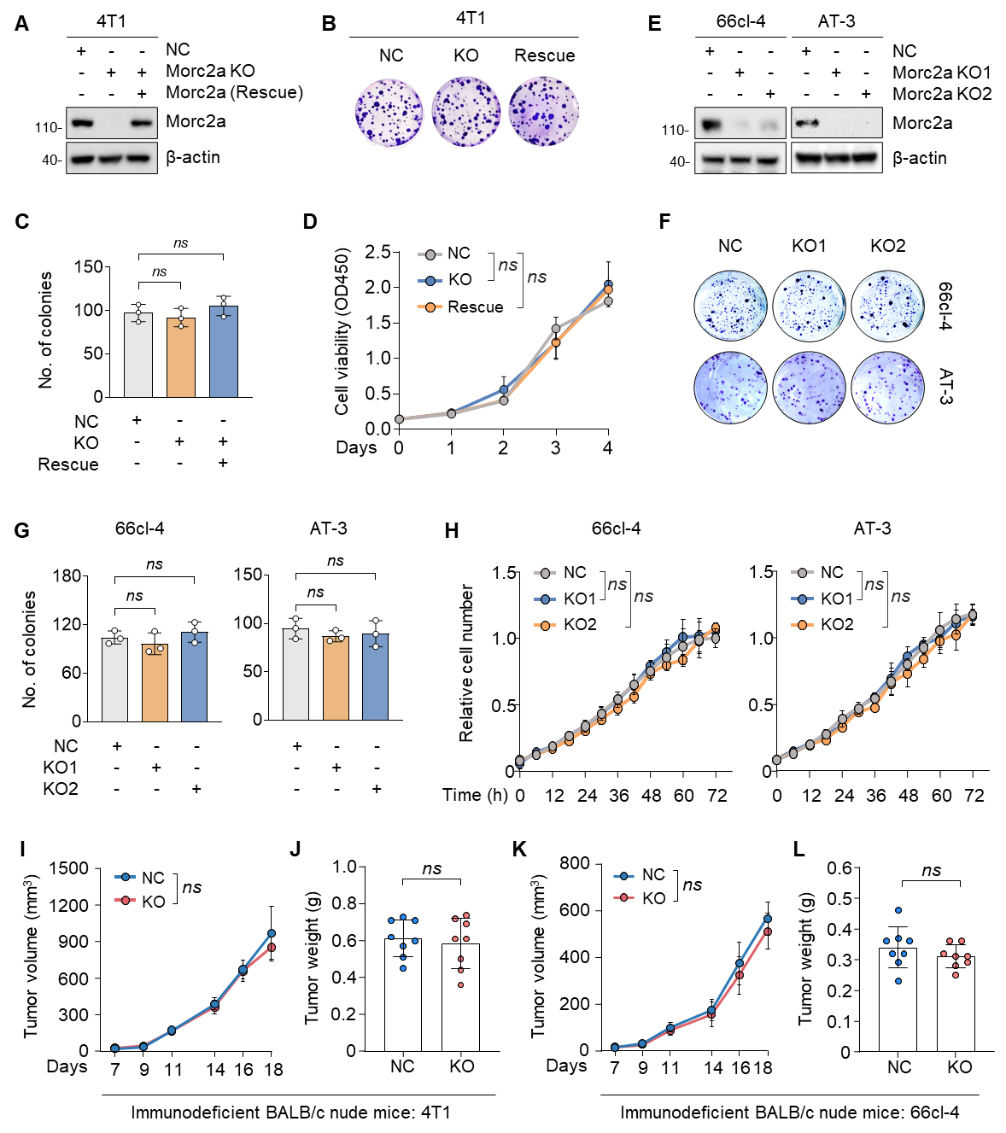

Figure S7. Depletion of MORC2 does not affect TNBC cell proliferation in vitro or tumor growth in immunodeficient mice.
(A) Immunoblotting analysis of Morc2a expression levels in NC, Morc2a-KO, and rescued 4T1 cells.
(B-C) NC, Morc2a-KO, and rescued 4T1 cells were subjected to colony formation assays. Representative images of survival colonies (B) and corresponding quantitative results (C) are shown.
(D) NC, Morc2a-KO, and rescued 4T1 cells were subjected to cell proliferation assays by CCK8.
(E) Immunoblotting analysis of Morc2a expression levels in NC and Morc2a-KO 66cl-4 and AT-3 cells.
(F-G) NC and Morc2a-KO 66cl-4, and AT-3 cells were subjected to colony formation assays. Representative images of survival colonies (F) and corresponding quantitative results (G) are shown.
(H) NC and Morc2a-KO 66cl-4, and AT-3 cells were subjected to cell proliferation assays. The proliferative kinetics are shown.
(I-L) NC and Morc2-KO 4T1 (I, J) and 66cl-4 (K, L) cells were orthotopically inoculated into the mammary fat pads of 5-week-old female BALB/c nude mice (n=8). At the end of the experiments, all the mice were euthanized, and the xenograft tumors were excised and weighed. Tumor volume (I, K) and tumor weight (J, L) are shown.
Note: "ns" indicates no significance.

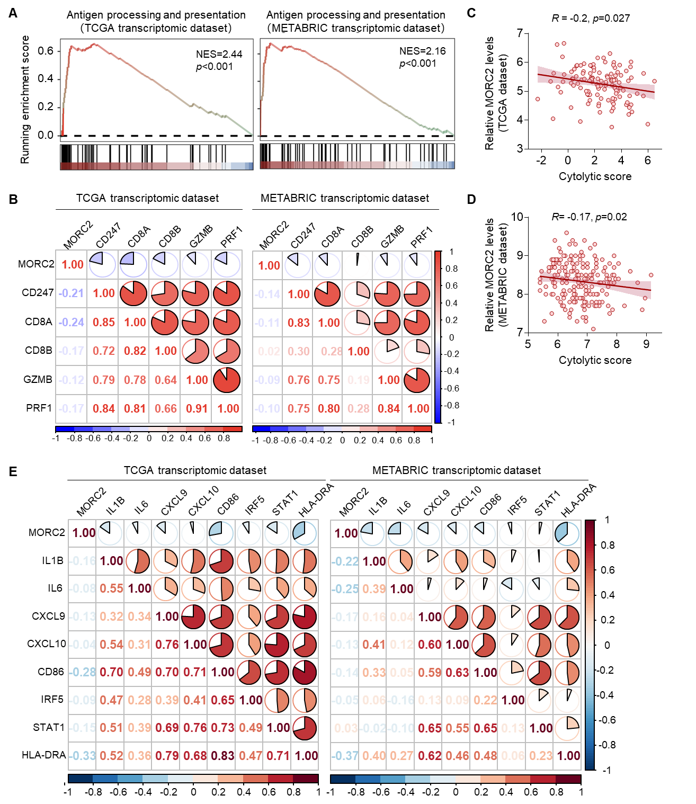

Figure S8. MORC2 expression is negatively correlated with anti-tumor immunity in TNBC.
(A) GSEA showing significant enrichment of the antigen processing and presentation pathway in MORC2-low tumors, based on the TNBC transcriptome data from the TCGA and METABRIC datasets. The normalized enrichment score (NES) and nominal p-value are indicated.
(B) Spearman correlation analysis of the expression levels between MORC2 and selected T cell activation-related genes in TNBC transcriptomic data from the TCGA and METABRIC cohorts.
(C-D) Spearman correlation analysis between MORC2 expression levels and the cytolytic score, which is calculated as the geometric mean of the expression levels of GZMA (Granzyme A) and PRF1 (Perforin 1), in the TCGA (C) and METABRIC (D) TNBC datasets.
(E) Spearman correlation analysis of the expression levels between MORC2 and selected genes strongly linked to inflammation and immune activation, using the TNBC transcriptomic data from the TCGA and METABRIC datasets.

Figure S9. TE subfamily enrichment and functional validation of representative ERV elements upon MORC2 loss.
(A) Violin plot showing differential expression of TE subfamilies upon MORC2 loss, categorized by class (ERV1, ERVK, ERVL, LINE, SINE).
(B-C) RT-qPCR analysis of ISGs expression following knockdown of representative ERV elements LTR22C2 (ERVK family) (B) and MER74C (ERVL family) (C) in MORC2-deficient cells. The p-values were determined using one-way ANOVA, and significance levels are denoted as follows: ***p<0.001; "ns" indicates no significance.
(D) Kernel density distributions of log₂FC (KO/NC) for each ERV subclass and LINE elements, with SINE+DNA as reference (permutation sign-flip test, p=0.018).
(E) Ranked waterfall plot of log₂FC for all ERV and LINE elements (ERV, p= 0.018; LINE, p= 0.71).

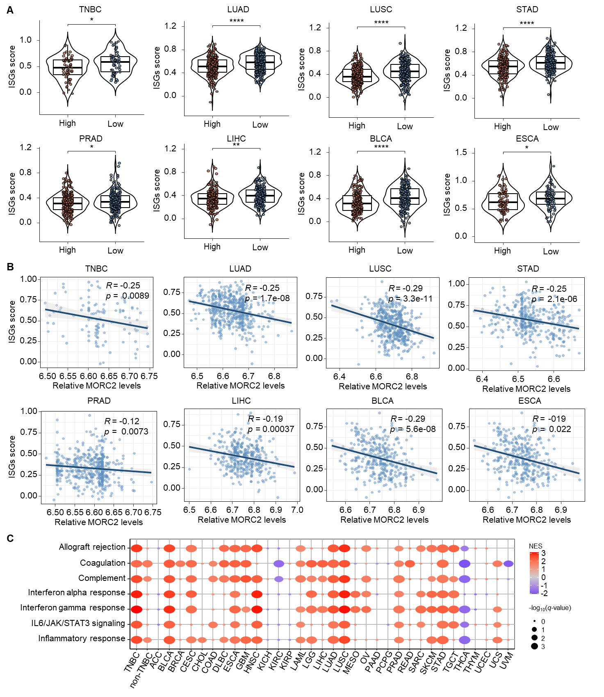

Figure S10. MORC2 expression levels are inversely correlated with interferon response in cancer patients.
(A) Distribution of the interferon-stimulated gene (ISG) score between MORC2-low and MORC2-high tumors across multiple common cancer types. The ISG score was derived from TCGA RNA-seq data using single-sample GSEA (ssGSEA), with the MsigDB Hallmark "Interferon Alpha Response" and "Interferon Gamma Response" gene sets defining the signature. P-values were calculated by the Wilcoxon test. Significance levels are denoted as follows: *p<0.05, **p<0.01, ****p<0.0001.
(B) Spearman correlation analysis between MORC2 expression levels and the ISG score across indicated cancer types, based on TCGA RNA-seq dataset. LUAD, lung adenocarcinoma; LUSC, lung squamous cell carcinoma; STAD, stomach adenocarcinoma; PRAD, prostate adenocarcinoma; LIHC, liver hepatocellular carcinoma; BLCA, bladder urothelial carcinoma; ESCA, oesophageal carcinoma.
(C) GSEA illustrating the enrichment of MsigDB Hallmark gene sets related to cancer immunity in MORC2-low tumors based on TCGA RNA-seq dataset. Circle size corresponds to the enrichment significance (-log₁₀(q-value)), and color represents the NES for each gene set in the respective cancer type. BLCA, bladder urothelial carcinoma; BRCA, breast invasive carcinoma; CESC, cervical squamous cell carcinoma and endocervical adenocarcinoma; CHOL, cholangiocarcinoma; COAD, colon adenocarcinoma; DLBC, lymphoid neoplasm diffuse large B-cell lymphoma; ESCA, oesophageal carcinoma; GBM, glioblastoma multiforme; HNSC, head and neck squamous cell carcinoma; KICH, kidney chromophobe; KIRC, kidney renal clear cell carcinoma; KIRP, kidney renal papillary cell carcinoma; LAML, acute myeloid leukemia; LGG, brain lower grade glioma; LIHC, liver hepatocellular carcinoma; LUAD, lung adenocarcinoma; LUSC, lung squamous cell carcinoma; MESO, mesothelioma; OV, ovarian serous cystadenocarcinoma; PAAD, pancreatic adenocarcinoma; PCPG, pheochromocytoma and paraganglioma; PRAD, prostate adenocarcinoma; READ, rectum adenocarcinoma; SARC, sarcoma; SKCM, skin cutaneous melanoma; STAD, stomach adenocarcinoma; TGCT, testicular germ cell tumors; THCA, thyroid carcinoma; THYM, thymoma; UCEC, uterine corpus endometrial carcinoma; UCS, uterine carcinosarcoma; UVM, uveal melanoma.

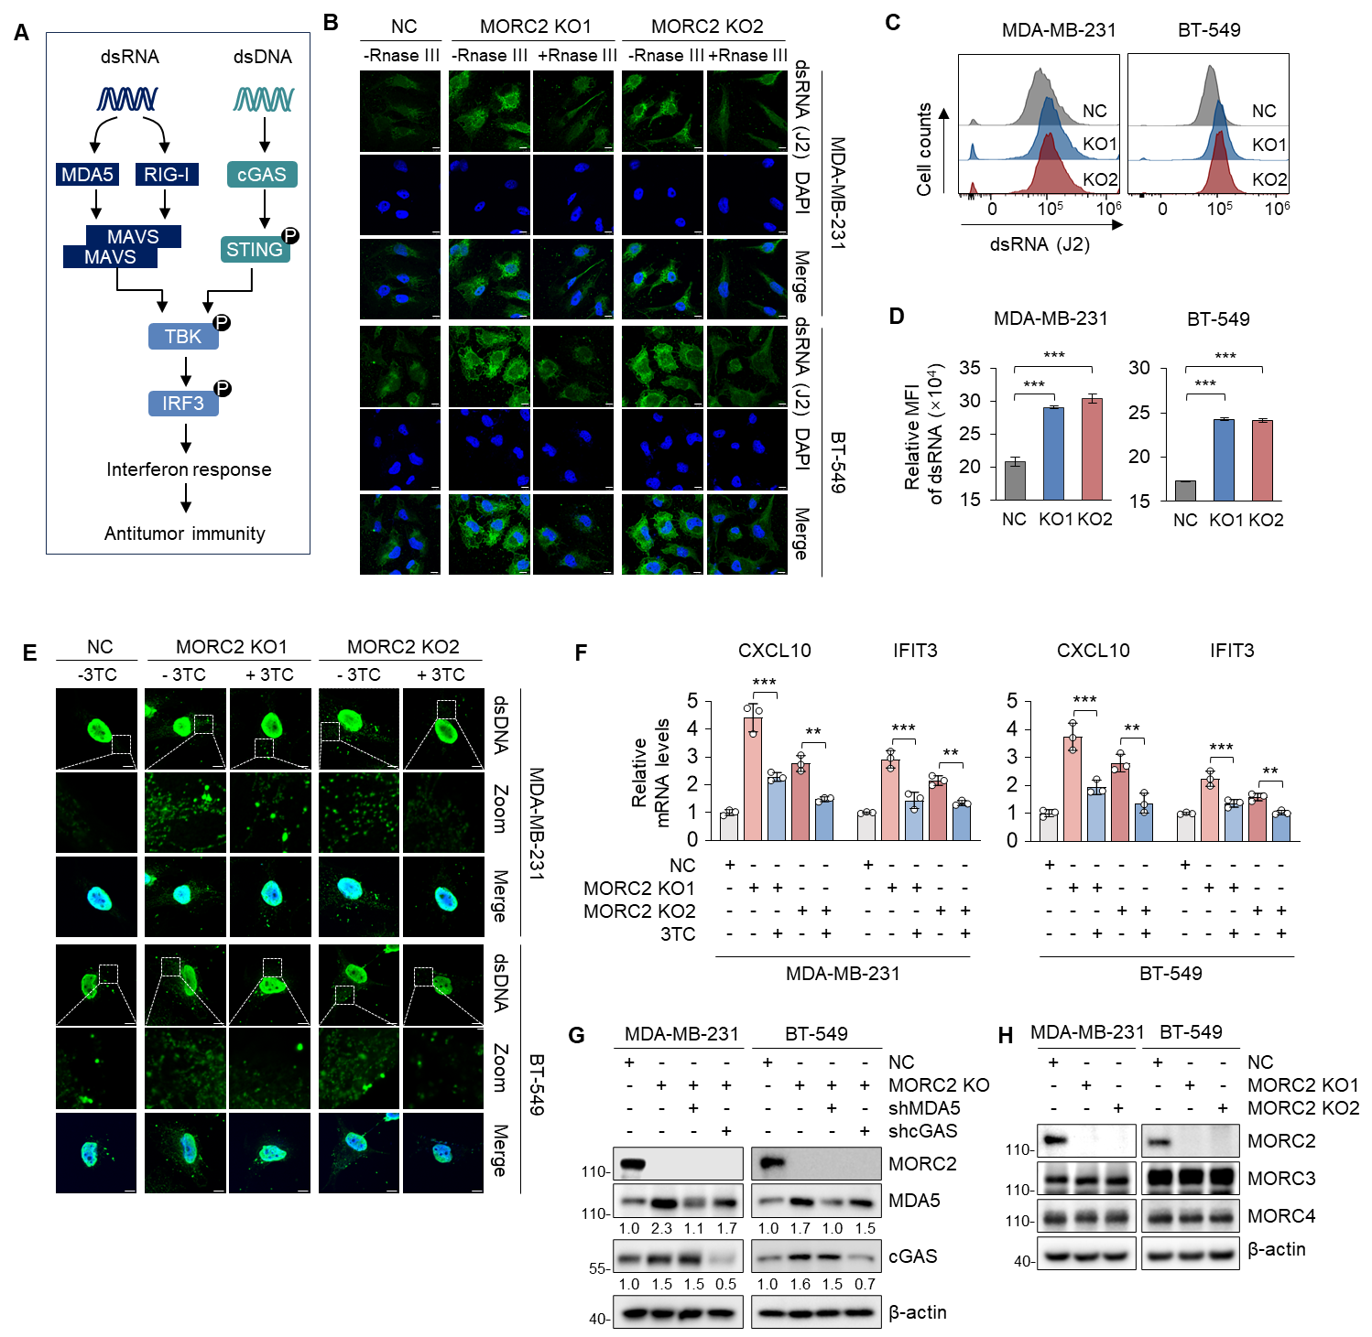

Figure S11. Deletion of MORC2 activates interferon responses via endogenous nucleic acid-sensing pathways.
(A) Schematic diagram illustrating the signaling pathways of pattern recognition receptors involved in endogenous nucleic acid sensing.
(B) Representative immunofluorescent images of NC and MORC2-KO MDA-MB-231 and BT-549 cells stained with the J2 anti-dsRNA antibody (green) and DAPI (blue). Scale bar: 10 μm.
(C-D) Flow cytometric analysis of dsRNA levels in NC and MORC2-KO MDA-MB-231 and BT-549 cells. Representative histograms (C) and quantitative results (D) are shown.
(E) Representative immunofluorescent images of NC and MORC2-KO MDA-MB-231 and BT-549 cells stained for cytosolic dsDNA (green) and DAPI (blue). DAPI staining was used to delineate nuclei and aid in the identification of cytoplasmic dsDNA. Scale bar: 7.5 μm.
(F) RT-qPCR analysis of ISGs expression in MORC2-KO cells following lamivudine (3TC) treatment.
(G) Validation of the knockdown efficiency of key RNA (MDA5) and DNA (cGAS) sensors in MORC2-KO MDA-MB-231 and BT-549 cells by immunoblotting assays.
(H) Immunoblotting analysis of MORC3 and MORC4 expression in MORC2-KO cells.

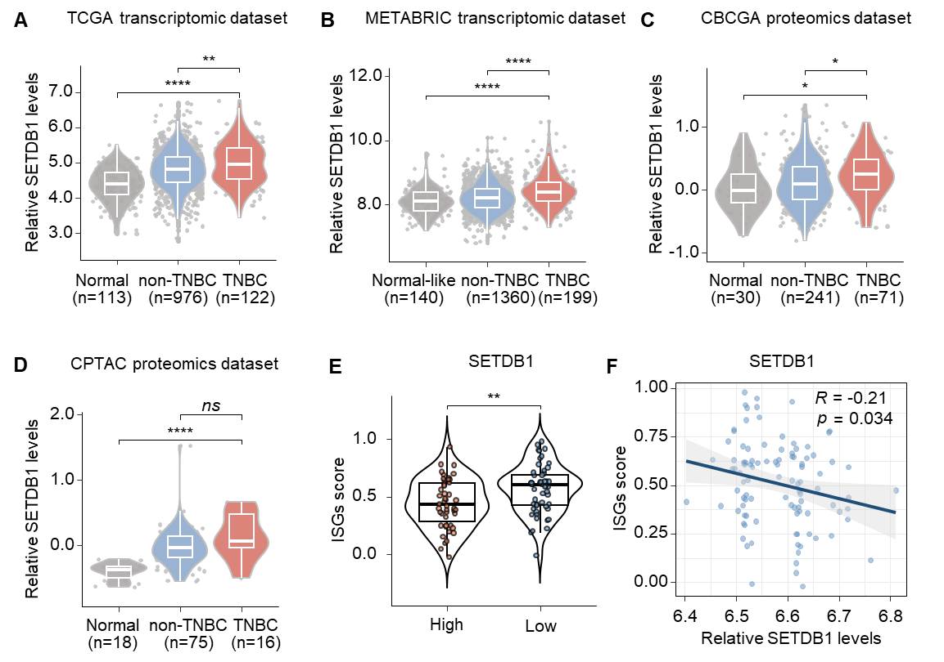

Figure S12. SETDB1 is upregulated in TNBC and inversely correlated with interferon response.
(A-B) SETDB1 mRNA expression levels in TNBC samples from the TCGA (A) and METABRIC (B) transcriptomic datasets.
(C-D) SETDB1 protein expression levels in TNBC samples from the CBCGA (C) and CPTAC (D) proteomic datasets.
(E) Distribution of the ISG score between SETDB1-low and SETDB1-high TNBC tumors based on the TCGA RNA-seq dataset.
(F) Spearman correlation analysis between SETDB1 expression levels and the ISG score in TNBC based on the TCGA RNA-seq dataset.
Notes: P-values were determined by the Kruskal-Wallis test (A-D) and the Wilcoxon test (E). Significance levels are denoted as follows: *p<0.05, **p<0.01, ****p<0.0001; "ns" indicates no significance.

Figure S13. MORC2 collaborates with SETDB1 to transcriptionally repress TEs.
(A) Immunofluorescence staining analysis detecting the colocalization of MORC2 and SETDB1 in both MDA-MB-231 and BT-549 cells (Figure 5C). Quantitative results of fluorescence intensity of MORC2 and SETDB1 in these cells are shown.
(B) MDA-MB-231 and BT-549 cells stably expressing pCDH or Flag-MORC2 alone or in combination with shSETDB1 (#1) were subjected to immunoblotting assays with the indicated antibodies.
(C) Stacked bar chart showing the proportion of peaks overlapping TE loci. CUT&RUN peaks called with MACS3 (broad mode, signalValue > 2) were intersected with RepeatMasker-annotated TE regions. Bars represent the percentage of peaks overlapping TE loci (teal) or non-TE loci (gray) for MORC2 peaks, SETDB1 peaks, and MORC2&SETDB1 co-occupied peaks (Co-occupied), respectively. Numbers above bars indicate total peak counts per group.
(D) Heatmap of CUT&RUN signal at MORC2&SETDB1 co-occupied TE loci. Signal intensity (RPKM) was computed using deepTools computeMatrix (reference-point mode, ±3 kb around peak center, bin size = 50 bp) at MORC2&SETDB1 co-occupied peaks overlapping TE regions. Rows represent individual peaks sorted by mean signal in descending order. Color scales are shown independently for each sample.
(E-F) Aggregate signal profiles at MORC2&SETDB1 co-occupied TE loci. Mean RPKM signal was plotted ±3 kb around the center of MORC2&SETDB1 co-occupied peaks overlapping TE regions for MORC2 antibody signal (D), and SETDB1 antibody signal (E).
(G) CUT&RUN-qPCR analysis of MORC2 and SETDB1 occupancy at representative TE loci (LTR22C2 and MER74C).

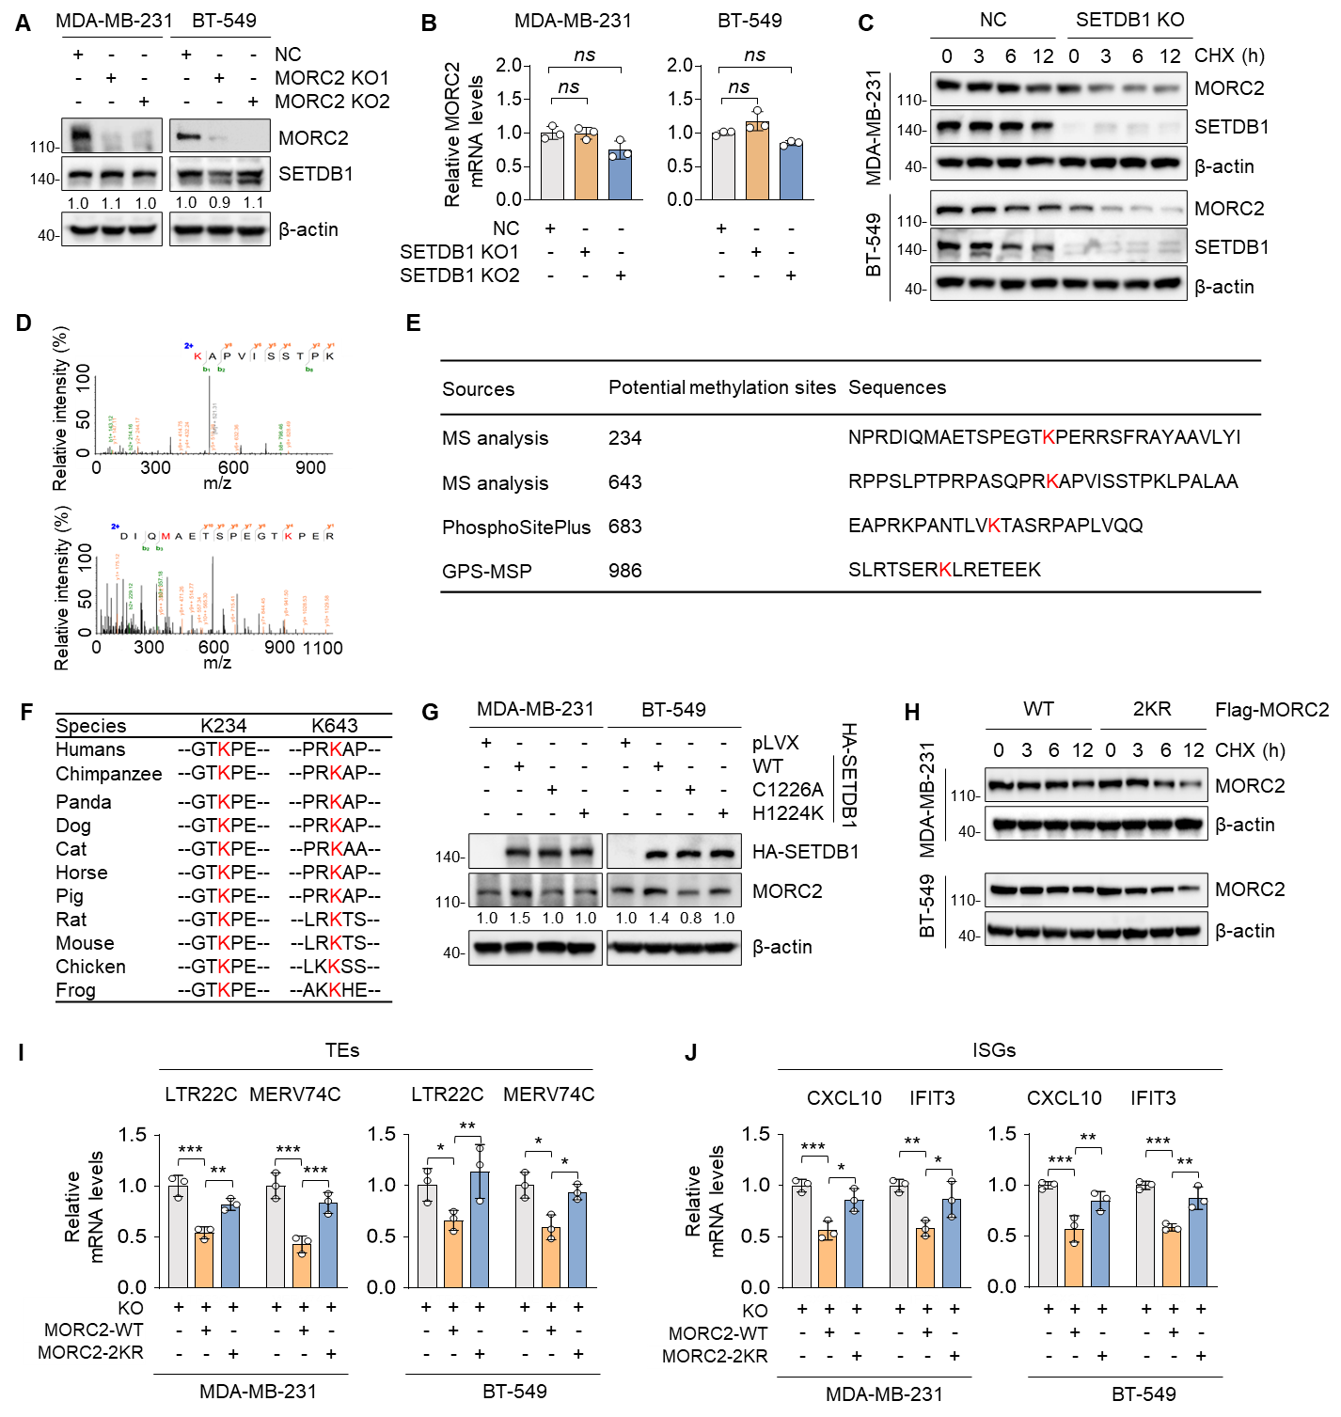

Figure S14. SETDB1-mediated methylation of MORC2 enhances its protein stability.
(A) NC and MORC2-KO MDA-MB-231 and BT-549 cells were subjected to immunoblotting assays with the indicated antibodies.
(B) RT-qPCR analysis of MORC2 mRNA levels in NC and SETDB1-KO MDA-MB-231 and BT-549 cells. The p-values were determined using one-way ANOVA, and “ns” represents no significance.
(C) NC and SETDB1-KO MDA-MB-231 and BT-549 cells were treated with or without 100 μg/mL CHX for the indicated times and then subjected to immunoblotting assays with the indicated antibodies
(D) LC-MS/MS spectrum identifying two tryptic peptides of MORC2 carrying methyl modifications at lysine residues K234 and K643.
(E) Schematic representation of potential methylation sites on MORC2. Sites identified by mass spectrometry (MS) and those predicted by the PhosphoSitePlus (http://www.phosphosite.org) or the computational tool GPS-MCP (Group-based Prediction System-Methyl-group Specific Predictor) (http://msp.biocuckoo.org/) are indicated. Lysine (K) residues predicted or confirmed as methylation sites are highlighted in red.
(F) Multiple sequence alignment of the MORC2 protein across different species, highlighting the evolutionary conservation of the K234 and K643 methylation sites.
(G) MDA-MB-231 and BT-549 cells stably expressing pLVX and HA-SETDB1 (WT, C1226A, or H1224K catalytic mutants) were subjected to immunoblotting assays with the indicated antibodies.
(H) MDA-MB-231 and BT-549 cells stably expressing Flag-MORC2 (WT and 2KR mutant) were treated with or without 100 μg/mL CHX for the indicated durations and then subjected to immunoblotting with the indicated antibodies. Relative MORC2 protein levels were quantified using ImageJ.
(I-J) RT-qPCR analysis of TE activation (I) and ISG expression (J) in MORC2-KO MDA-MB-231 and BT-549 cells following reintroduction of WT or 2KR mutant MORC2.

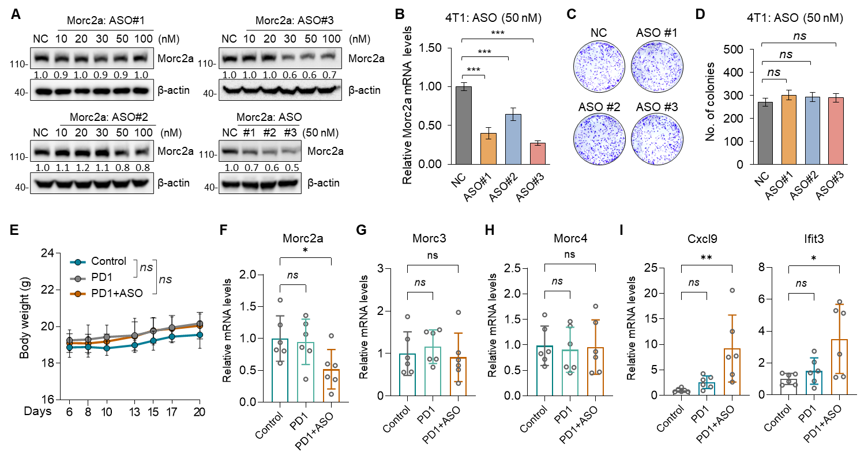

Figure S15. Depletion of MORC2 enhances the efficacy of anti-PD-1 therapy in TNBC.
(A) 4T1 cells were treated with non-targeting control (NC) or increasing concentrations of ASOs targeting Morc2 and then subjected to immunoblotting assays with the indicated antibodies.
(B) RT-qPCR analysis of Morc2 mRNA expression levels in 4T1 cells treated with 50 nM Morc2-targeting ASOs or control ASOs.
(C-D) Colony formation assays of 4T1 cells treated with Morc2-targeting or control ASOs. Representative images (C) and quantitative results (D) are shown.
(E) Body weight measurements across all treatment groups throughout the study.
(F-H) RT-qPCR analysis of Morc2a (F), Morc3 (G), and Morc4 (H) expression in harvested tumor tissues from each treatment group.
(I) RT-qPCR analysis of ISG expression in harvested tumor tissues.
Notes: P-values were calculated by one-way ANOVA (B, D, and F–I). Significance levels are indicated as follows: *p<0.05 and **p<0.01; "ns" denotes no significance.

Supplementary Tables
Table S1. Chemical reagents used in this study
Chemical reagents | Vendors | Cat# | Working concentration
Cycloheximide (CHX) | CST | 2112S | 100 μg/ml
Mithramycin A(MMA) | MCE | HY-A0122 | 100 or 200nM
Lamivudine(3TC) | Selleck | S1706 | 30 µM
Rnase III | MCE | HY-KE7056 | 20 U/mL
Recombinant IFN-γ Protein | Yeasen | 91207ES20 | 20 ng/mL
Protease inhibitor cocktail | Bimake | B14002 | 1×
Phosphatase inhibitor cocktail | Bimake | B15001 | 1×

Table S2. Targeting sequences for ASOs
ASOs | Sequences
Morc2a #1 | CTGCTGTGAGACCGTACTTT
Morc2a #2 | CATAGACAGCTCTGACCGGT
Morc2a #3 | AGAAAGGCACGAGCTTCATC

Table S3. Targeting sequences for sgRNAs
sgRNAs | Primers | Sequences
sgMORC2 #1 | Forward | CACCGAGTAGACTCAGGTGTTCGCT
 | Reverse | AAACAGCGAACACCTGAGTCTACTC
sgMORC2 #2 | Forward | CACCGCCTCATGAAACGTGCGAGAC
 | Reverse | AAACGTCTCGCACGTTTCATGAGGC
sgMorc2a #1 | Forward | CACCGAAGATACTTACGAATTTGTG
 | Reverse | AAACCACAAATTCGTAAGTATCTTC
sgMorc2a #2 | Forward | CACCGTACTCACGTGCCCTCTGGCG
 | Reverse | AAACCGCCAGAGGGCACGTGAGTAC
sgSETDB1 #1 | Forward | CACCGGGTAATACAGAAAGAATCTG
 | Reverse | AAACCAGATTCTTTCTGTATTACCC
sgSETDB2 #2 | Forward | CACCGATACCGGGACAGTAGCTCTG
 | Reverse | AAACCAGAGCTACTGTCCCGGTATC

Table S4. Targeting sequences for shRNAs
shRNAs | Primers | Sequences
shSETDB1 #1 | Forward | CCGGGCTCAGATGATAACTTCTGTACTCGAGTACAGAAGTTATCATCTGAGCTTTTTG
 | Reverse | AATTCAAAAAGCTCAGATGATAACTTCTGTACTCGAGTACAGAAGTTATCATCTGAGC
shSETDB1 #2 | Forward | CCGGAGTTAGAGACATGGGTAATACCTCGAGGTATTACCCATGTCTCTAACTTTTTTG
 | Reverse | AATTCAAAAAAGTTAGAGACATGGGTAATACCTCGAGGTATTACCCATGTCTCTAACT
shMDA5 | Forward | CCGGCCAACAAAGAAGCAGTGTATACTCGAGTATACACTGCTTCTTTGTTGGTTTTTG
 | Reverse | AATTCAAAAACCAACAAAGAAGCAGTGTATACTCGAGTATACACTGCTTCTTTGTTGG
shcGAS | Forward | CCGGCAACTACGACTAAAGCCATTTCTCGAGAAATGGCTTTAGTCGTAGTTGTTTTTG
 | Reverse | AATTCAAAAACAACTACGACTAAAGCCATTTCTCGAGAAATGGCTTTAGTCGTAGTTG

Table S5. Information for expression vectors used in this study
Plasmids | Sources | Vectors
HA-MORC2 | Subcloned | pLVX-IRES-Neo
HA-MORC2 | Subcloned | pCDH-CMV-MCS-EF1-Puro
Flag-MORC2 | Subcloned | pCDH-CMV-MCS-EF1-Puro
Flag-Morc2a | Subcloned | pLVX-IRES-Neo
Flag-MORC2-T1  (Δ1-420AA) | Zhang et al., 2023[6] | pCDH-CMV-MCS-EF1-Puro
Flag-MORC2-T2  (Δ490-544AA) | Zhang et al., 2023[6] | pCDH-CMV-MCS-EF1-Puro
Flag-MORC2-T3  (Δ794-854AA) | Zhang et al., 2023[6] | pCDH-CMV-MCS-EF1-Puro
Flag-MORC2-K234R | Subcloned | pCDH-CMV-MCS-EF1-Puro
Flag-MORC2-K643R | Subcloned | pCDH-CMV-MCS-EF1-Puro
Flag-MORC2-K683R | Subcloned | pCDH-CMV-MCS-EF1-Puro
Flag-MORC2-K986R | Subcloned | pCDH-CMV-MCS-EF1-Puro
Flag-MORC2-2KR  (K234/ K643R) | Subcloned | pCDH-CMV-MCS-EF1-Puro
HA-SETDB1 | Subcloned | pLVX-IRES-Neo
HA-SETDB1-T1  (Δ1-671AA) | Subcloned | pLVX-IRES-Neo
HA-SETDB1-T2  (Δ667-1291AA) | Subcloned | pLVX-IRES-Neo
HA-SETDB1-C1226A | Subcloned | pLVX-IRES-Neo
HA-SETDB1-H1224K | Subcloned | pLVX-IRES-Neo

Table S6. Antibodies used in this study
Antibodies | Vendors | Cat# | Hosts | Working concentration
MORC2 | Bethyl | A300-149 | Rabbit | 1:3000
β-actin | CST | 3700S | Mouse | 1:5000
HA | CST | 3724S | Rabbit | 1:3000
Flag | Sigma | F1804 | Mouse | 1:3000 (WB)/1:200 (IF)
Morc2a | Abnova | PAB15729 | Rabbit | 1:500
cGAS | CST | 15102 | Rabbit | 1:1000
STING | CST | 13647 | Rabbit | 1:1000
Phospho-STING | CST | 50907 | Rabbit | 1:1000
MDA5 | ABclonal | A2419 | Rabbit | 1:1000
RIG-I | Proteintech | 67556-1-Ig | Mouse | 1:1000
MAVS | ABclonal | A25005 | Rabbit | 1:1000
IRF3 | CST | 11904 | Rabbit | 1:1000
Phospho-IRF3 | CST | 29047 | Rabbit | 1:1000
TBK | CST | 3504 | Rabbit | 1:1000
Phospho-TBK | CST | 5483 | Rabbit | 1:1000
SETDB1 | Proteintech | 11231-1-AP | Rabbit | 1:1000(WB) /1:200 (IF)
Lys-methyl | Novus | NB600-824 | Rabbit | 1:1000

Notes: WB, western blotting; IF, immunofluorescent staining.

Table S7. Flow cytometry antibodies used in this study
Antibodies | Vendors | Cat# | Fluorescence | Working concentration
FVS 780 | BD Pharmingen | 565388 | APC-CY7 | 1:100
CD45 | BD Pharmingen | 550994 | percpcy5.5 | 1:100
CD3e | BD Pharmingen | 557984 | AF700 | 1:100
CD8a | BD Pharmingen | 553030 | FITC | 1:100
CD4 | BD Pharmingen | 562285 | PE-CF594 | 1:100
GzmB | Thermo Fisher | 25-8898-82 | PE-CY7 | 1:100
CD11b | BD Pharmingen | 561688 | FITC | 1:100
F4/80 | BD Pharmingen | 565410 | PE | 1:100
iNOS | Thermo Fisher | 25-5920-80 | PE-CY7 | 1:100
CD206 | BD Pharmingen | 565250 | APC | 1:100
H-2K^{b}/H-2D^{b} | BioLegend | 114606 | FITC | 1:50

Table S8. Primers for qPCR analyses
Genes | Primers | Sequences
Cxcl9 | Forward | GGAGTTCGAGGAACCCTAGTG
 | Reverse | GGGATTTGTAGTGGATCGTGC
Ifit3 | Forward | CCTACATAAAGCACCTAGATGGC
 | Reverse | ATGTGATAGTAGATCCAGGCGT
Ifi207 | Forward | TCTACCAACAGCATCCAGCA
 | Reverse | GCTGAAGGCACTGGAATAGC
Ifitm1 | Forward | GACAGCCACCACAATCAACAT
 | Reverse | CCCAGGCAGCAGAAGTTCAT
Bst2 | Forward | TGTTCGGGGTTACCTTAGTCA
 | Reverse | ACCCGTCTCTACAGGCCAC
Oas3 | Forward | TCTGGGGTCGCTAAACATCAC
 | Reverse | GGCAATCCTTATCACTCTTGGTC
B2m | Forward | TTCTGGTGCTTGTCTCACTGA
 | Reverse | CAGTATGTTCGGCTTCCCATTC
LTR53-int | Forward | ACACCTGTGGTTTCATTTGTGA
 | Reverse | CAACAGCTAGCCTTTGGTCA
RLTR26D | Forward | TACCAGCTCTGGACCATGAC
 | Reverse | GAAGGGCTTCAGGTGCTTTC
RLTR9A3B | Forward | AACAGACCTTGAACGCTTGC
 | Reverse | CAAGGTCAGTGGGCTGTCTA
RLTR6C | Forward | CCGAGACTCGTACACCTCTG
 | Reverse | CCCTCCCAGTTTGTGGTTT
CXCL9 | Forward | CCAGTAGTGAGAAAGGGTCGC
 | Reverse | AGGGCTTGGGGCAAATTGTT
CXCL10 | Forward | GTGGCATTCAAGGAGTACCTC
 | Reverse | TGATGGCCTTCGATTCTGGATT
BST2 | Forward | CACACTGTGATGGCCCTAATG
 | Reverse | GTCCGCGATTCTCACGCTT
IFIT3 | Forward | TCAGAAGTCTAGTCACTTGGGG
 | Reverse | ACACCTTCGCCCTTTCATTTC
LTR06 | Forward | GCAGTGGTGAAATCCACCTG
 | Reverse | GTCGTGAACCCTTGAACTGG
LTR22C0 | Forward | GGGAGGGAGCAACCATGTTA
 | Reverse | TGCTCACAGACACTGAGGAG
LTR22C2 | Forward | AAGCGCGTTAGACAAACTCC
 | Reverse | GTTCAGTCAGGGTGGAGGAA
MER74C | Forward | GGGTATCCATGGCAAGCAAG
 | Reverse | CCCAGACAATTAGGCACAGC
SETDB1 | Forward | GGGCAAGGGTGTTTTCATTAAC
 | Reverse | GTTAGTTGATGGCAGGCACACTT
MORC2 | Forward | TATGCCGCTGTGCTCTAT
 | Reverse | TTCTTCACCTCCTGCTCC
GAPDH | Forward | CAACAGCGACACCCACTCCTCC
 | Reverse | ATGTGGGCCATGAGGTCCACC
Morc2a | Forward | TGGCATCCTTGATCCTTTTC
 | Reverse | AAGTACGCATGGGTGGAGAC
Setdb1 | Forward | CAACTTGCACAATCACGGAAAC
 | Reverse | CAAAGGTGACCGATATGTCTGG
Gapdh | Forward | GACTTCAACAGCAACTCCCAC
 | Reverse | TCCACCACCCTGTTGCTGTA

Table S9. Primers for ChIP-qPCR analyses
Genes | Primers | Sequences
LTR22C2 | Forward | ATCATTCGCAGGACTGCTCT
LTR22C2 | Reverse | CTGCGGGCATTTATTCAGCA
MER74C | Forward | GGGAGTTGTACCAGAGGACA
 | Reverse | CCTAGCTAACCCTCCCTTCC

Supplementary References
1. Griffin GK, Wu J, Iracheta-Vellve A, Patti JC, Hsu J, Davis T, Dele-Oni D, Du PP, Halawi AG, Ishizuka JJ, et al: Epigenetic silencing by SETDB1 suppresses tumour intrinsic immunogenicity. Nature 2021, 595:309-314.
2. Yang M, Miao YR, Xie GY, Luo M, Hu H, Kwok HF, Feng J, Guo AY: ICBatlas: A Comprehensive Resource for Depicting Immune Checkpoint Blockade Therapy Characteristics from Transcriptome Profiles. Cancer Immunol Res 2022, 10:1398-1406.
3. Jung H, Kim HS, Kim JY, Sun JM, Ahn JS, Ahn MJ, Park K, Esteller M, Lee SH, Choi JK: DNA methylation loss promotes immune evasion of tumours with high mutation and copy number load. Nat Commun 2019, 10:4278.
4. Kim ST, Cristescu R, Bass AJ, Kim KM, Odegaard JI, Kim K, Liu XQ, Sher X, Jung H, Lee M, et al: Comprehensive molecular characterization of clinical responses to PD-1 inhibition in metastatic gastric cancer. Nat Med 2018, 24:1449-1458.
5. Gide TN, Quek C, Menzies AM, Tasker AT, Shang P, Holst J, Madore J, Lim SY, Velickovic R, Wongchenko M, et al: Distinct Immune Cell Populations Define Response to Anti-PD-1 Monotherapy and Anti-PD-1/Anti-CTLA-4 Combined Therapy. Cancer Cell 2019, 35:238-255 e236.
6. Zhang FL, Yang SY, Liao L, Zhang TM, Zhang YL, Hu SY, Deng L, Huang MY, Andriani L, Ma XY, et al: Dynamic SUMOylation of MORC2 orchestrates chromatin remodelling and DNA repair in response to DNA damage and drives chemoresistance in breast cancer. Theranostics 2023, 13:973-990.

