Supplementary materials
Supplemental information includes Supplemental Figure S1-S8 and Table S1-S7.
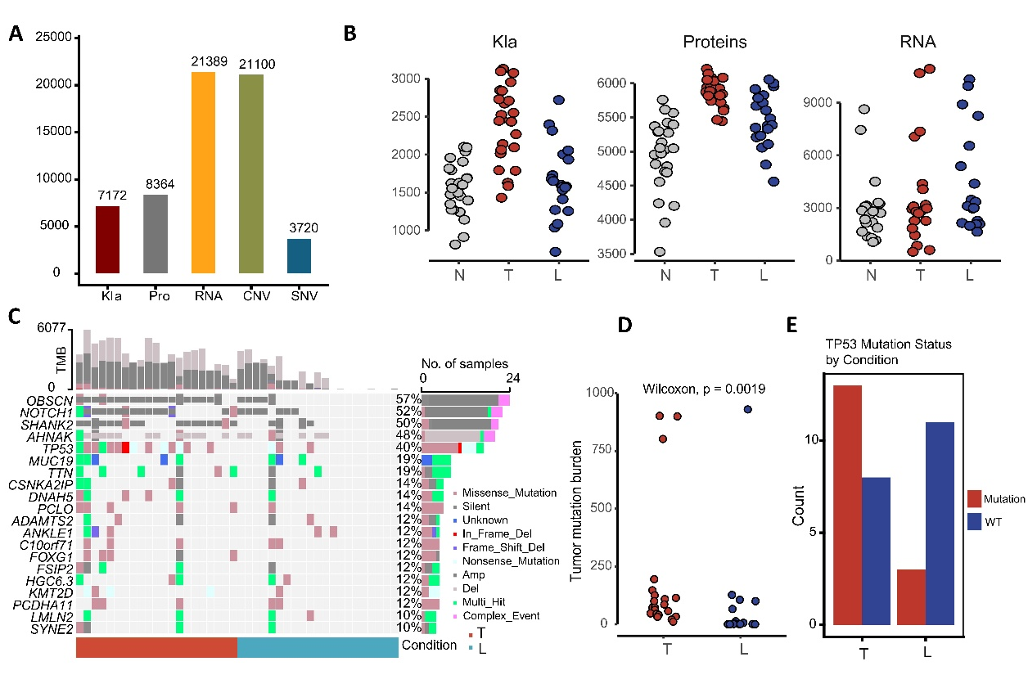
Figure S1. Total number of Kla sites, proteins, RNAs, CNVs and SNVs identified in our cohort, and the genomic profile of ESCC progression, related to Figure 1.
(A) Quantification of detected molecular features. Boxplots showed the total numbers of Kla sites, proteins, RNAs, CNVs and SNVs identified in our cohort. (B) Feature distribution across tissue groups. Dot plots present the counts of Kla sites, proteins, and RNAs stratified in group N, T and L. (C) Comprehensive mutational profile. Upper section: Sample-wise tumor mutation burden (TMB) in groups T and L. Lower section: Oncoplot characterizing all somatic mutations; the adjacent bar plot details the corresponding mutation frequencies and types. (D) TMB comparison between groups T and L. The dot plot visualizes the difference in TMB between primary tumors and metastases, with the p value calculated using a two-sided Wilcoxon rank-sum test. (E) TP53 mutation comparison. The bar plot illustrates the frequency of TP53 mutation in groups T and L.
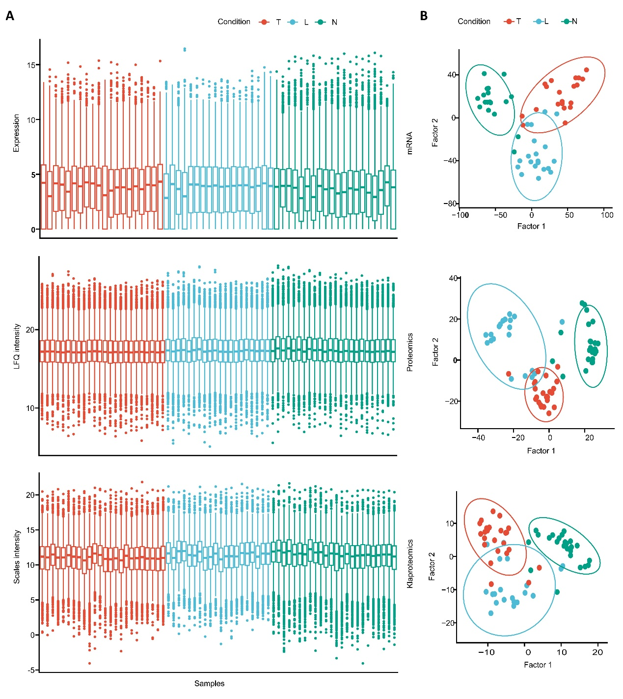
Figure S2. Quality control (QC) for transcriptome, proteome and lactylome profiling in our cohort, related to Figure 1.
- Data quality assessment. Boxplots show the distribution of key QC metrics for the transcriptomic, proteomic and lactylomic datasets within groups N, T and L. (B) Principal component analysis (PCA) scatterplot showed the global similarity and separation among samples from each group at transcriptomic, proteomic and lactylomic levels.
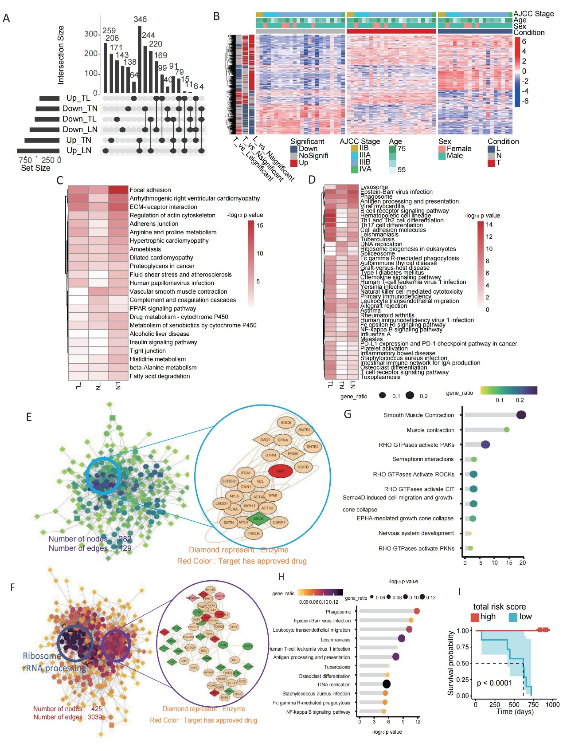
Figure S3. Systematic analysis of the dysregulated proteins in ESCC metastasis, related to Figure 2.
(A) Overlap analysis of differentially expressed proteins (DEPs) among groups N, T and L. Bar plots in the left panel exhibited the total number of DEPs in those data types. Bar plots in the right and top panel exhibited the total number of DEPs indicated by the dots below. (B) Hierarchical clustering of all 99 samples in groups N, T and L based on significant DEPs. The top annotation bar indicates the AJCC stage, age, and sex for the 36 metastatic ESCC patients. (C-D) Heatmaps depicting KEGG pathway enrichment for up-regulated (C) and down-regulated (D) DEPs in groups T and L. (E-F) Protein-protein interaction (PPI) networks constructed from down-regulated (E) and up-regulated (F) DEPs common to groups T and L. Network statistics (nodes/edges) are shown; key pathways are highlighted. Diamond nodes denote enzymes; red nodes represent proteins with approved drug. (G-H) Lollipop diagrams showing the significantly enriched pathways for the down-regulated (G) and up-regulated (H) DEPs in groups T and L; (I) Kaplan-Meier survival curves stratified by the immunogenetic risk score (log-rank test, p<0.0001).
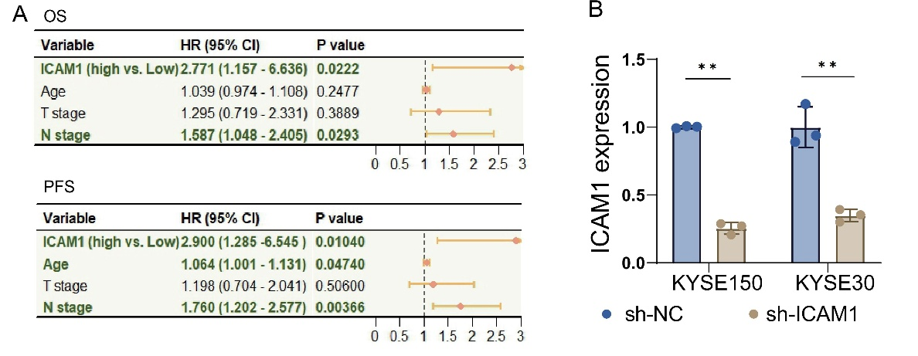
Figure S4. Higher ICAM1 expression level associated with poor prognosis of ESCC patients and ICAM1 knocking down ESCC cell lines was established, related to Figure 3.
(A) Kaplan-Meier analysis showing the association between ICAM1 expression and clinical outcomes (OS and PFS) in 116 ESCC patients. (B) Validation of ICAM1 knockdown at the mRNA level. Quantitative analysis of ICAM1 expression in KYSE150 and KYSE30 cells after transfection with sh-ICAM1 (mean ± SD, n = 3). Quantitative RT-PCR was performed with three independent replicates (n=3).
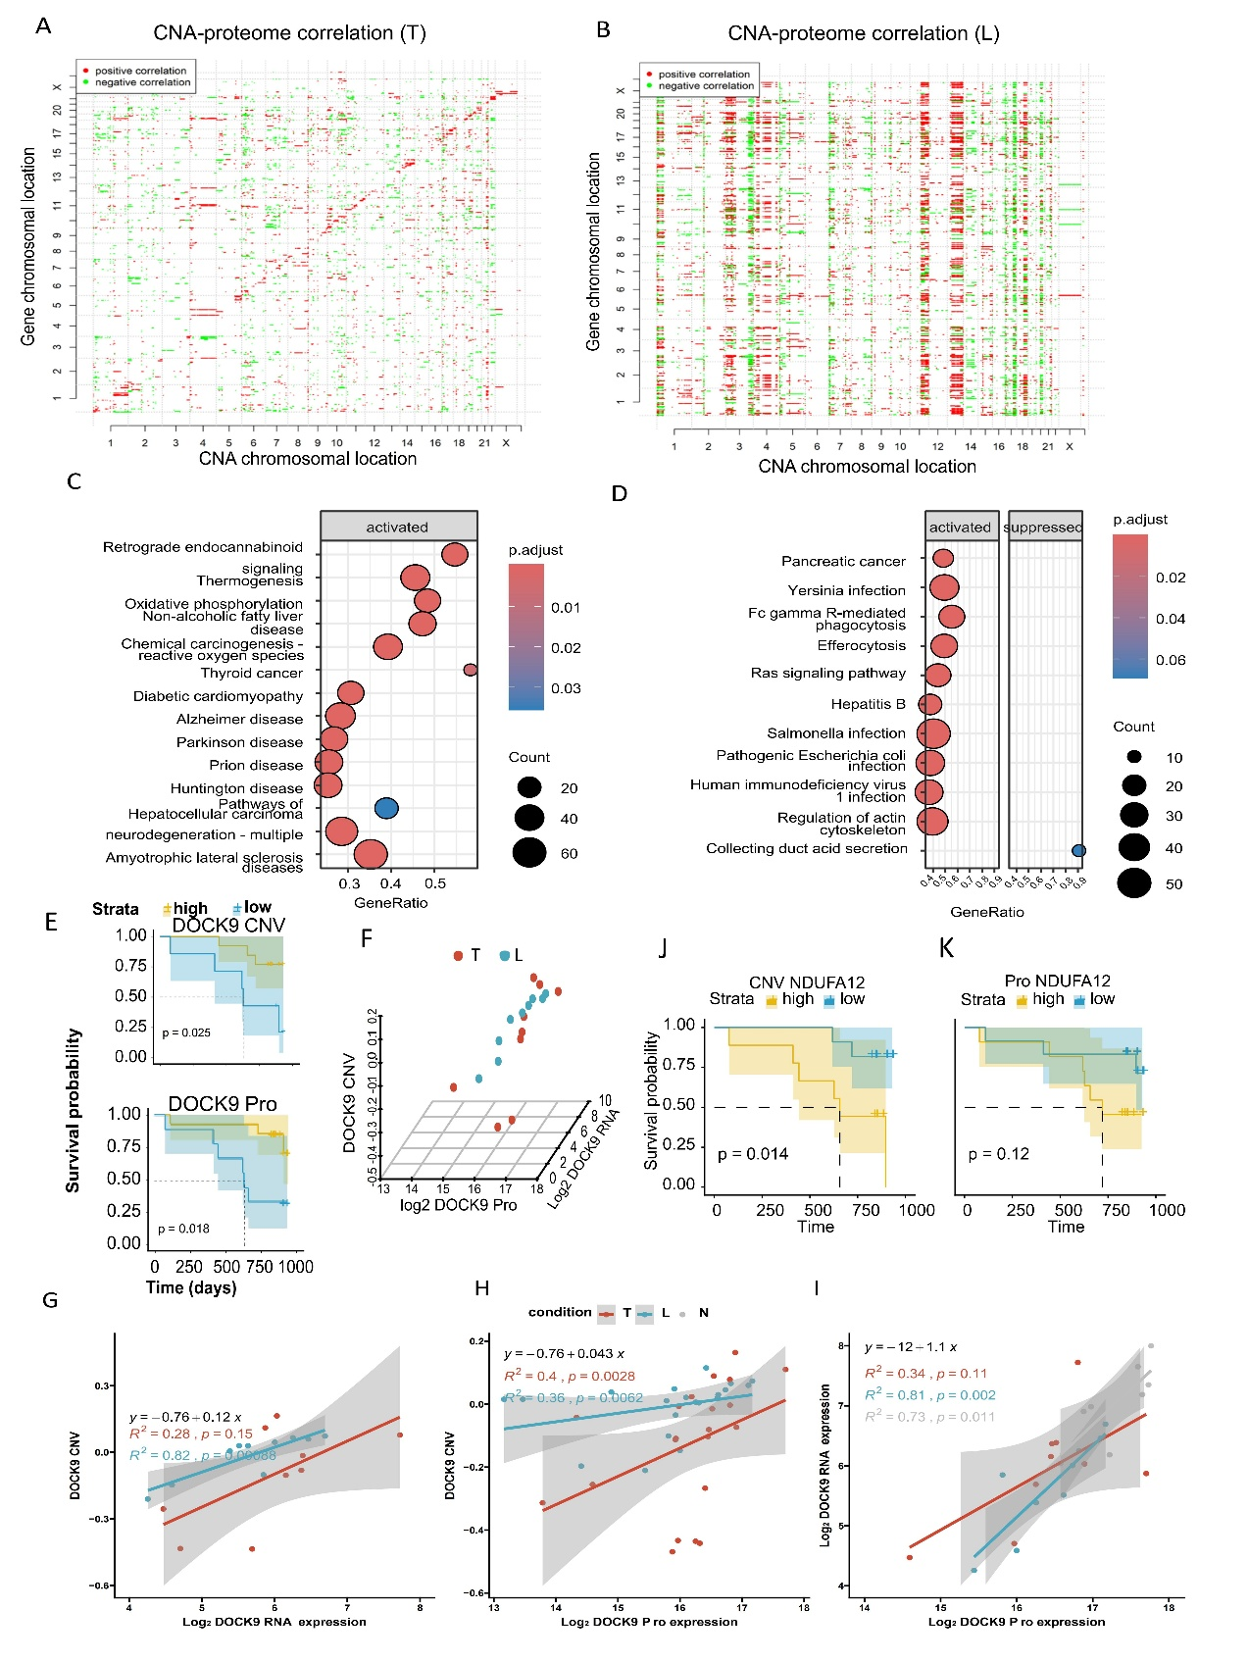
Figure S5. Analysis of the CNV-protein correlations in group T and L, related to Figure 4.
(A-B) Scatter plots visualizing significant correlations between CNVs (x axes) and protein expression (y axes) in groups T (A) and L (B), illustrating potential cis- and trans-regulatory effects. (C-D) Functional enrichment of CNV-correlated proteins. Bubble charts display the biological pathways overrepresented among proteins whose expression is closely correlated to CNV changes in groups T (C) and L (D). (E) Kaplan-Meier survival analysis for ESCC patients stratified by high versus low DOCK9 CNVs (upper, p=0.025) and protein expression (lower, p=0.018). (F) The 3D scatter plot depicting the correlations among the DOCK9 CNVs, mRNA expression and protein abundance in T (red) and L (blue) groups. (G) Correlation between the DOCK9 copy number and its mRNA expression in groups T and L. (H) Correlation between the DOCK9 copy number and its protein expression in groups T and L. (I) Correlation between DOCK9 mRNA and protein expression level across groups T, L and N. (J-K) Kaplan-Meier curves for patient survival stratified by NDUFA12 CNVs (J, p=0.014) and protein expression (K, p=0.12).

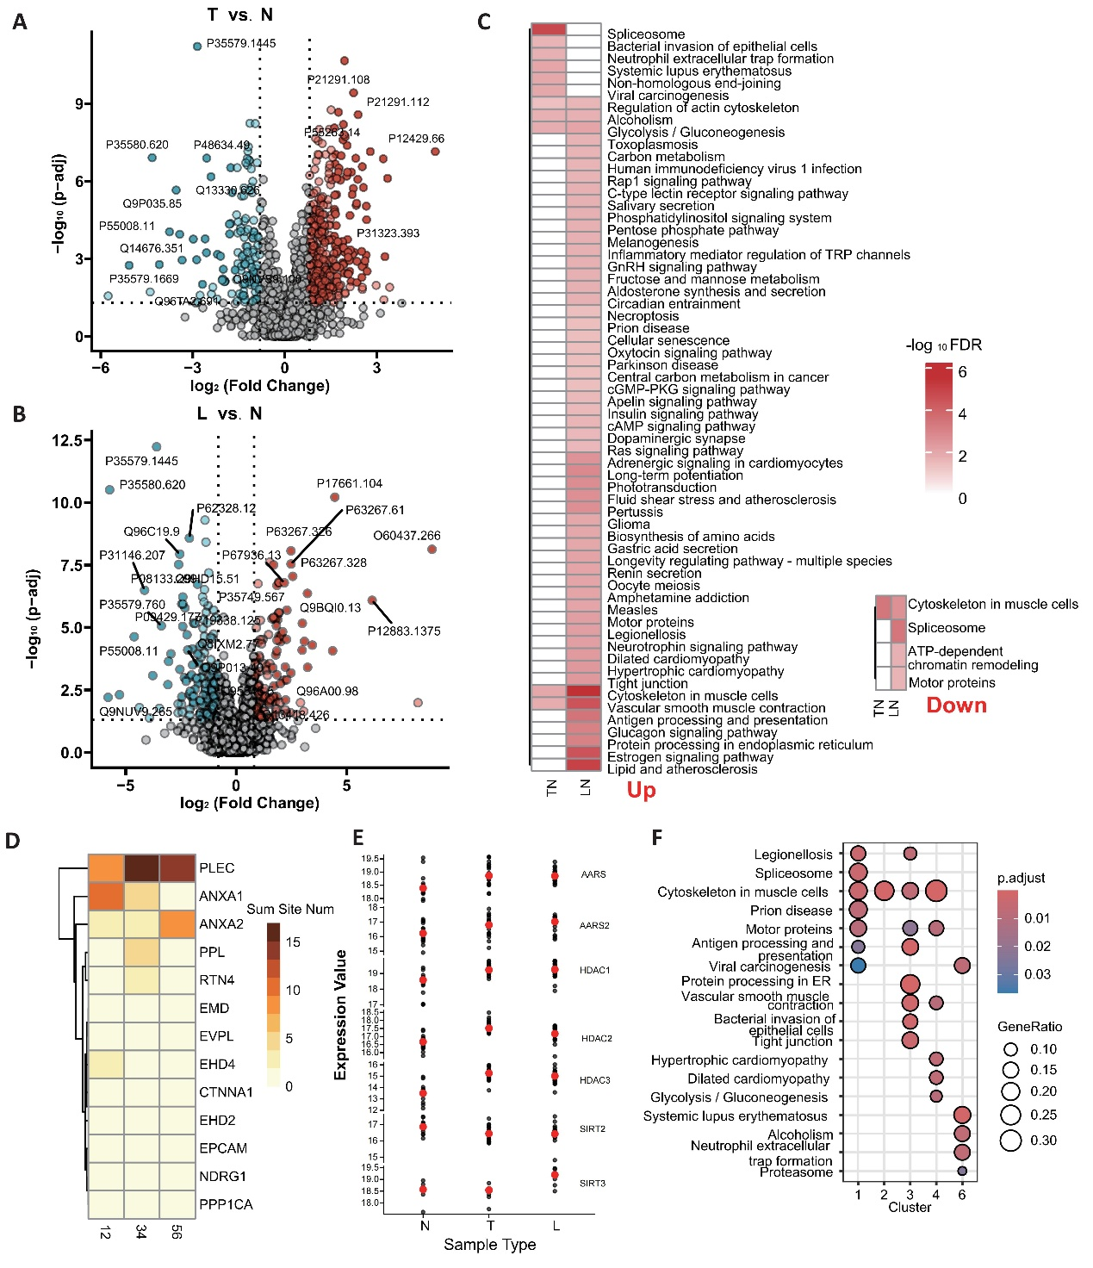
Figure S6. Analysis of the different Kla-modified proteins and in our cohort, related to Figure 5.
(A-B) Volcano plots depicting differentially expressed Kla sites in group T (A) and L (B) compared with group N. The vertical dashed lines denote |log₂FC| = 1, and the horizontal dashed line indicates -log₁₀ (adjusted p value) = 1. (C) Pathway enrichment analysis of proteins harboring up-regulated (left) or down-regulated (right) Kla sites in groups T and L compared to group N. (D) Heatmap showing the quantity of Kla sites on proteins involved in the cadherin pathway, represented by a gradient from light brown to dark brown. (E) Expression analysis of known Kla-related writers and erasers across groups N, T and L. (F) Enriched biological pathways for Kla-modified proteins identified within the 6 expression clusters.
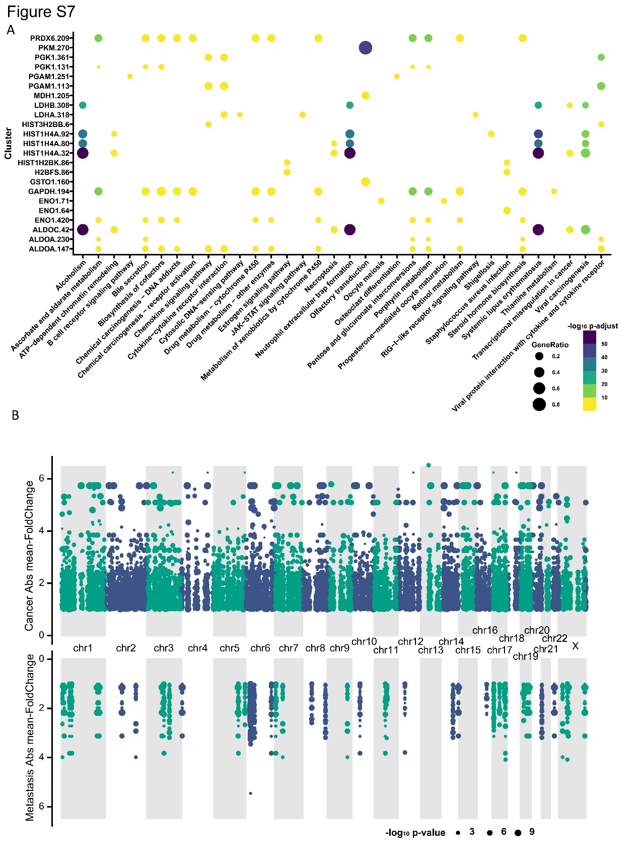
Figure S7. Kla-modified proteins correlated CNV genes and mutated genes with another algorithm in group T and L, related to Figure 6.
(A) Enriched biological pathways for CNV genes whose copy number alterations show significant correlation with Kla-modified protein abundance in groups T and L. (B) Comparative analysis of gene mutation profiles in groups T and L, identified by an independent variant detection method.
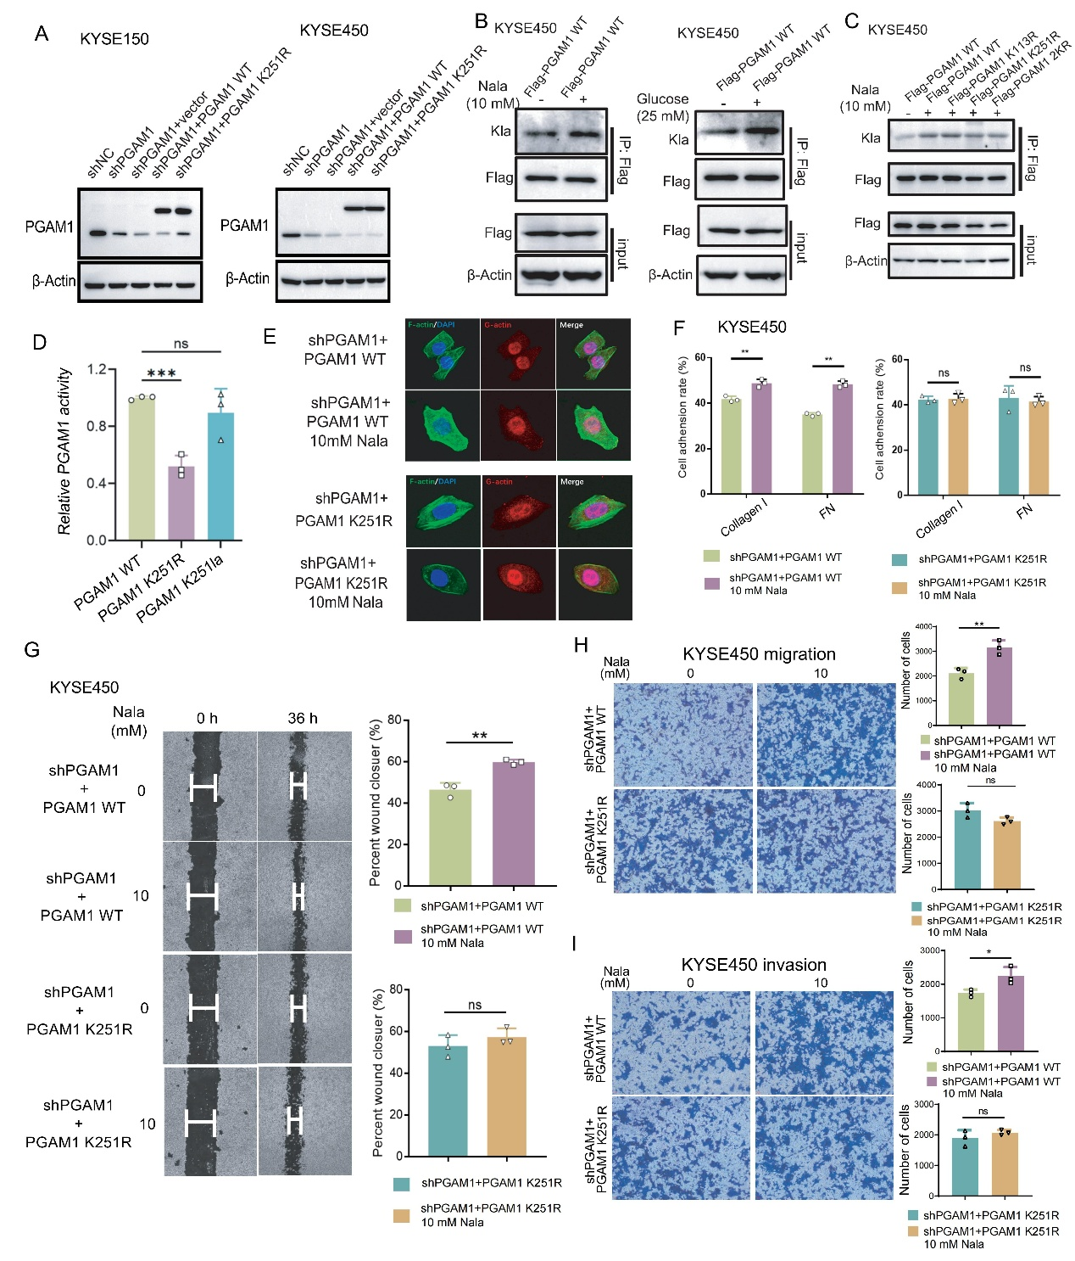
Figure S8. Indicated KYSE150 and 450 cell lines were established, and the in vitro assays were performed, related to Figure 7.
(A) Western blot analysis of PGAM1 protein expression in KYSE150 and 450 cells expressing the indicated shRNAs or overexpression vectors. (B) KYSE450 cells stably expressing Flag-tagged PGAM1 were treated with 10mM Nala or 25mM glucose for 24h. (C) KYSE450 cells expressing Flag-tagged PGAM1 mutants (WT, K113R, K251R and 2KR) were stimulated with 10mM Nala for 24h. IP: Flag-M2 beads or Kla antibody conjugated agarose in B-C. (D) PGAM1 enzymatic activity of WT, K251R mutant and K251 lactylation proteins. ***p<0.001; ns: no significance. (E) Confocal Imaging of F-actin and G-actin in KYSE150 cells. (F) Cell adhesion assays on KYSE450 cell lines to collagen I and FN. Cells were treated with 10mM Nala or not with indicated constructs. (G) Wound healing assays assessing the migration of PGAM1 knockdown KYSE450 cells, treated with or without 10 mM Nala across the indicated genetic backgrounds. (H-I) Transwell assays to examine changes in cell migration (H) and invasion (I) of PGAM1 knockdown KYSE450 cell lines treated with 10 mM Nala or not with indicated constructs. Western blot validation and functional assays were repeated three times (n=3 biological replicates).

