Supplementary Figures
Supplementary Figure 1
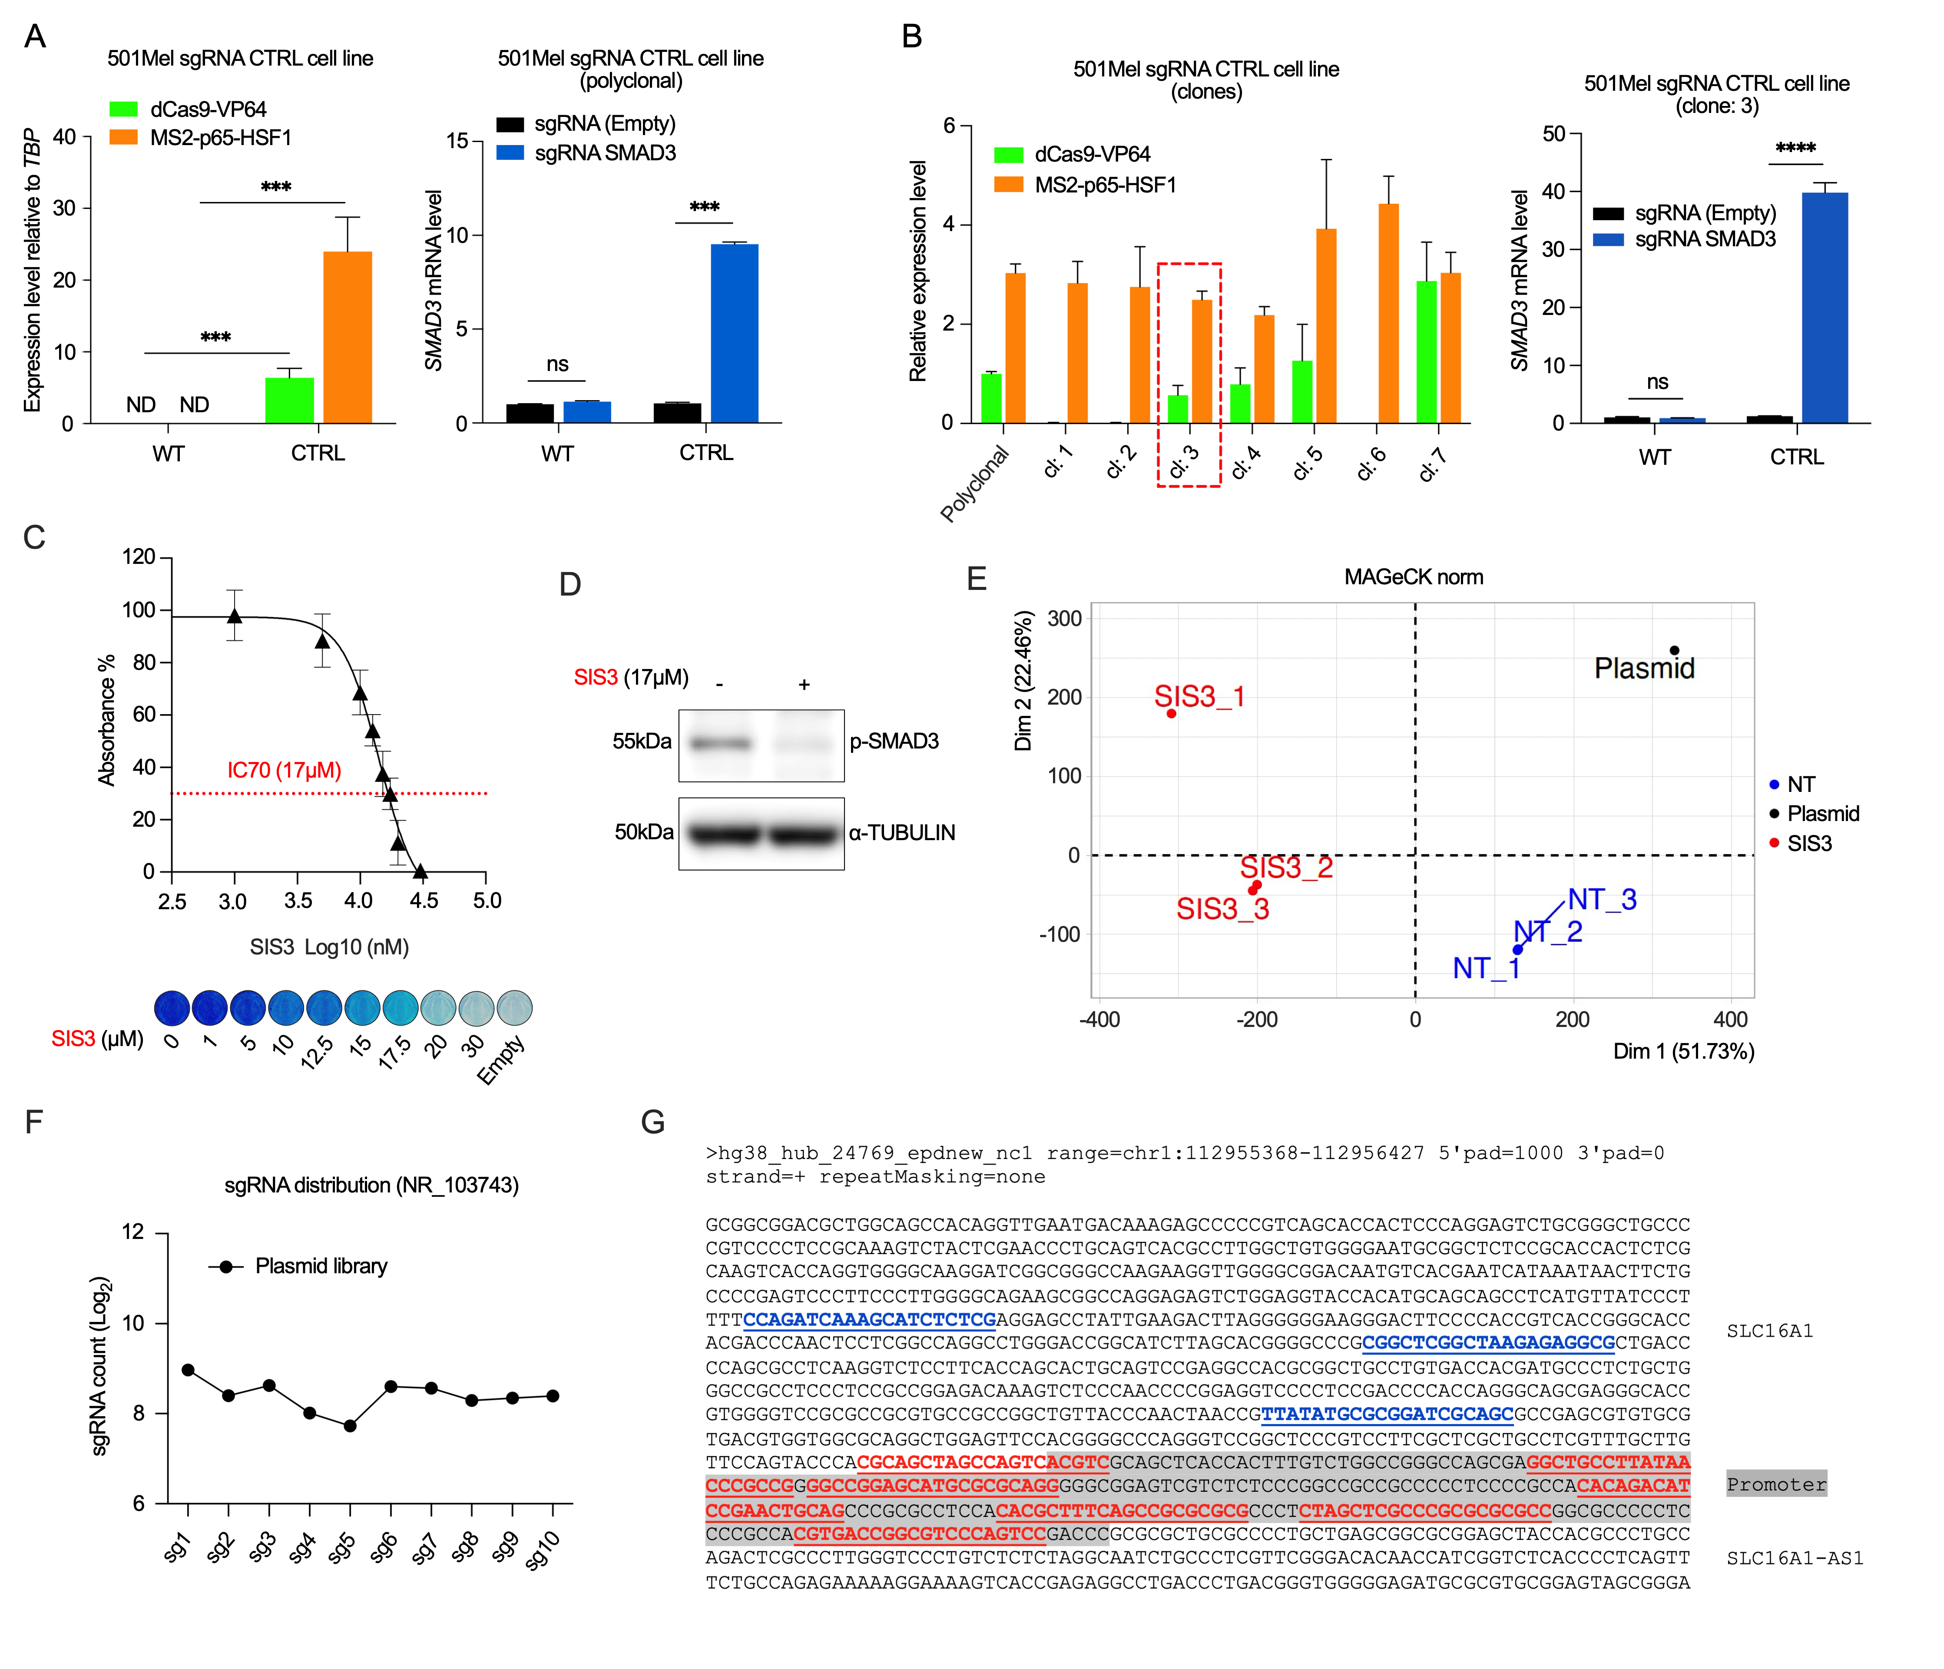
Supplementary Figure 1. CRISPR activation screen identifies SLC16A1/SLC16A1-AS1 promoter activation as driver of resistance to SMAD3 inhibition. A Validation of genetically engineered 501Mel cell line expressing components of CRISPR-SAM. dCas9-VP64 and MS2-p65-HSF1 constructs were introduced into 501Mel cells using lentiviral vectors. qPCR analysis was performed to validate the expression of dCas9-VP64 and MS2-p65-HSF1 in a polyclonal cell population after antibiotics selection. Target gene expression induction was validated by the measured increase in SMAD3 mRNA levels 48h after transient transfection using a sgRNA targeting SMAD3 promoter. B Clonal analysis of dCas9-VP64 and MS2-p65-HSF1 expression levels and selection of clone number 3 from for further experiments. Target gene expression induction was validated by the measured increase in SMAD3 mRNA levels 48h after transient transfection of a clonal cell line using a sgRNA targeting SMAD3 promoter. C Determination of the IC70 SIS3 concentration used for the CRISPR-screen. 501Mel cells were seeded to 96w plates at low confluency (5000 cells per well) and treated for 4 days to measure the dose-dependent effect of SMAD3 inhibition by SIS3 on cell viability. Cell viability was determined by methylene blue assay and is presented as measured absorbance of solubilized methylene blue ratios. D WB analysis of phospho-SMAD3 protein level upon treatment with 17μM SIS3 for 48h. E PCA plot of sgRNAs in SIS3-treated CRISPR-SAM cell library compared to non-treated control cell library. F Sequencing count number and genomic distribution of sgRNA target sites within SLC16A1/SLC16A1-AS1 promoter in CRISPR-SAM plasmid library before amplification. G Genomic location of sgRNA target sequences within SLC16A1/SLC16A1-AS1 promoter.
Supplementary Figure 2
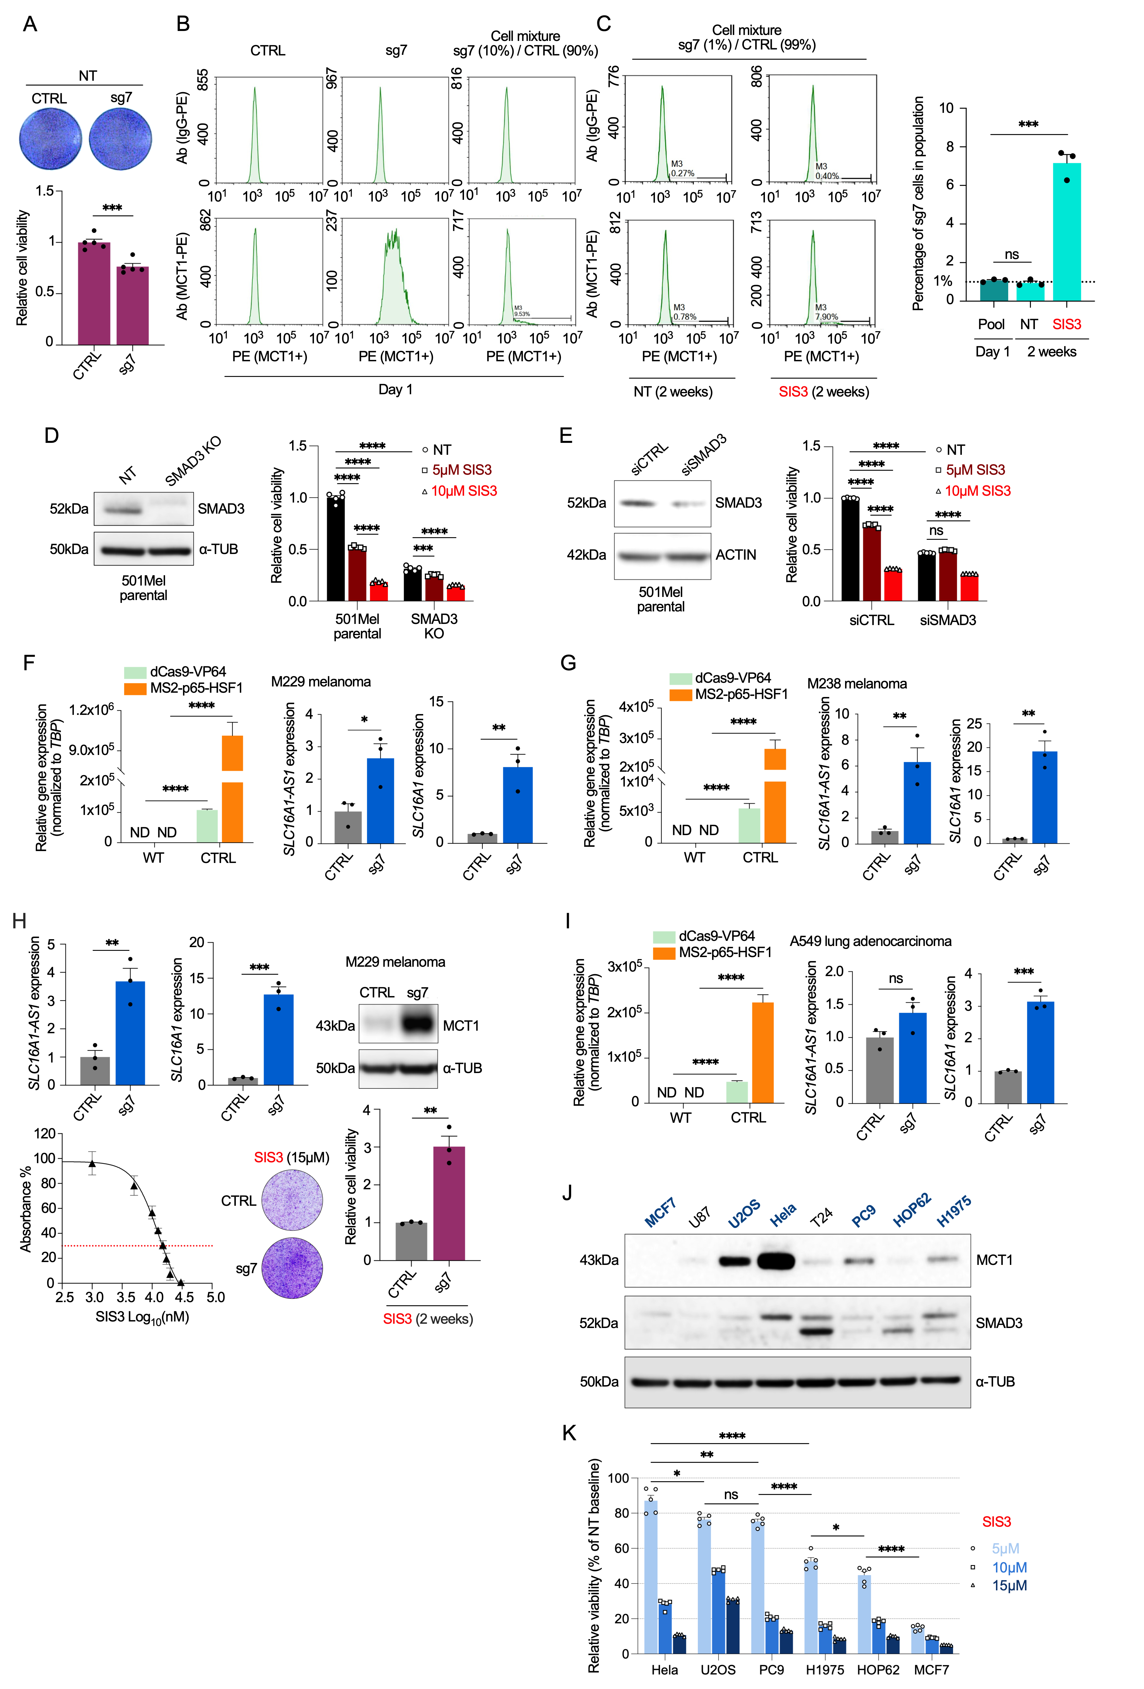
Supplementary Figure 2. SLC16A1/SLC16A1-AS1 promoter activation drives resistance to SMAD3 inhibitor in melanoma and lung adenocarcinoma. A The effect of SLC16A1/SLC16A1-AS1 promoter activation by CRISPR-SAM (sg7) on cell growth in 501Mel melanoma cells. Cells were seeded on 96w plates at low confluency (1000 cells per well) and grown for 5 days (NT). Cell density is visualized by methylene blue staining and measured by the absorbance of solubilized methylene blue. B Flow cytometry analysis of MCT1-positive cells in sgRNA CTRL and sg7 cell lines or in mixed population of sgRNA CTRL (90%) and sg7 (10%) cells after 1 day of cell seeding. C The effect of SLC16A1/SLC16A1-AS1 promoter activation by CRISPR-SAM (sg7) on the cell viability during SIS3 treatment. Mixed population of sgRNA CTRL (99%) and sg7 (1%) cell lines were grown without (NT) or with 17μM SIS3 for 2 weeks. Flow cytometry analysis was used to determine the proportion of MCT1-positive cells within the cell population. D The dose-dependent effect of SIS3 on the cell viability of 501Mel Naïve parental and SMAD3 KO cells measured by methylene blue assay (right). WB confirmation of SMAD3 KO (left). E The dose-dependent effect of SIS3 on the cell viability of 501Mel siCTRL and siSMAD3 cells measured by methylene blue assay (right). WB confirmation of SMAD3 KD by SMAD3-targeting siRNA (left). F-G Validation of M229 and M238 sgRNA CTRL cell line. dCas9-VP64 and MS2-p65-HSF1 constructs were introduced into M229 and M238 cells using lentiviral vector. qPCR measurements were performed to validate the expression in a polyclonal cell population after antibiotics selection. Target gene expression induction was validated by the measured increase in SLC16A1/SLC16A1-AS1 expression levels 48h after transient transfection. H The effect of SLC16A1/SLC16A1-AS1 promoter activation by CRISPR-SAM (sg7) on cell growth in presence of SIS3 in human M229 melanoma cells. Cells were seeded on 6w plates at low confluency (50000 cells per well) and treated with 15μM SIS3 for 2 weeks. I Validation of A549 sgRNA CTRL cell line. dCas9-VP64 and MS2-p65-HSF1 constructs were introduced into A549 cells using lentiviral vector. qPCR measurements were performed to validate the expression in a polyclonal cell population after antibiotics selection. Target gene expression induction was validated by the measured increase in SLC16A1/SLC16A1-AS1 expression levels 48h after transient transfection. J WB measurement of MCT1 and SMAD3 protein levels in a panel of cancer cell lines. K The dose-dependent effect of SIS3 on cell viability in a panel of cancer cell lines measured by methylene blue assay. Cells were seeded on 96w plates at low confluency (1000 cells per well) and grown with or without SIS3 for 4-5 days. Cell density is visualized by methylene blue staining and measured by the absorbance of solubilized methylene blue.
Supplementary Figure 3
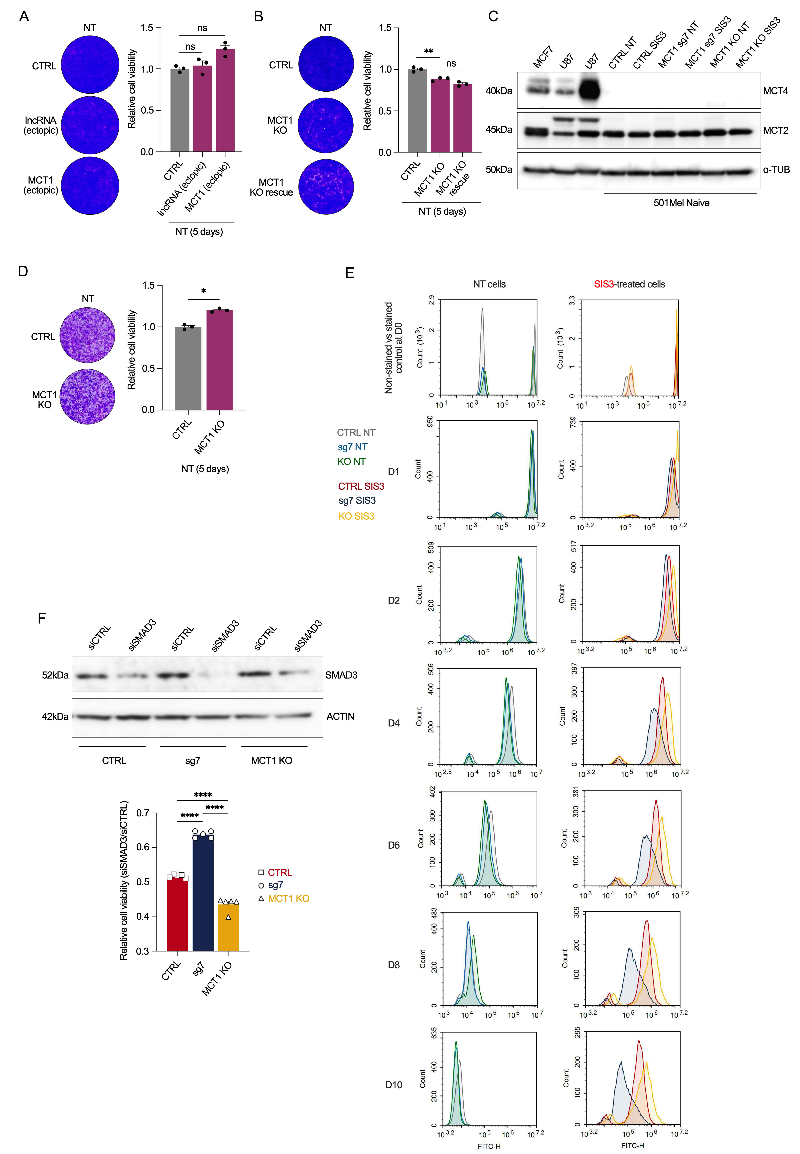
Supplementary Figure 3. Resistance to SMAD3 inhibitor is caused by MCT1 protein. A The effect of ectopic lncRNA or MCT1 overexpression on cell viability of 501Mel cells without drug treatment. Cells were seeded on 6w plates at low confluency (10000 cells per well) and grown for 5 days. Cell density is visualized by crystal violet staining and measured by the absorbance of solubilized crystal violet. B The effect of MCT1 KO and rescued MCT1 expression on cell viability of 501Mel cells during 5 days without drug treatment. C WB analysis of MCT2 and MCT4 protein level in MCF7, U87 and 501Mel cells without (NT) or with 2 weeks of SIS3 treatment. D The effect of MCT1 KO on cell viability of SKMel28 cells during 5 days without drug treatment. E Proliferation over 10 days of 501Mel CTRL, MCT1^{(sg7)} and MCT1 KO cells in non-treated and SIS3 treated cells measured by dynamic proliferation assay. F The effect of siRNA-mediated SMAD3 KD on cell viability in an MCT1-dependent manner, measured by crystal violet assay. CTRL, MCT1^{(sg7)} and MCT1 KO 501Mel cells were transfected with siCTRL or siSMAD3, with knockdown confirmed by western blot (top). Relative viability of siSMAD3 cells normalized to siCTRL for each genotype (bottom).
Supplementary Figure 4
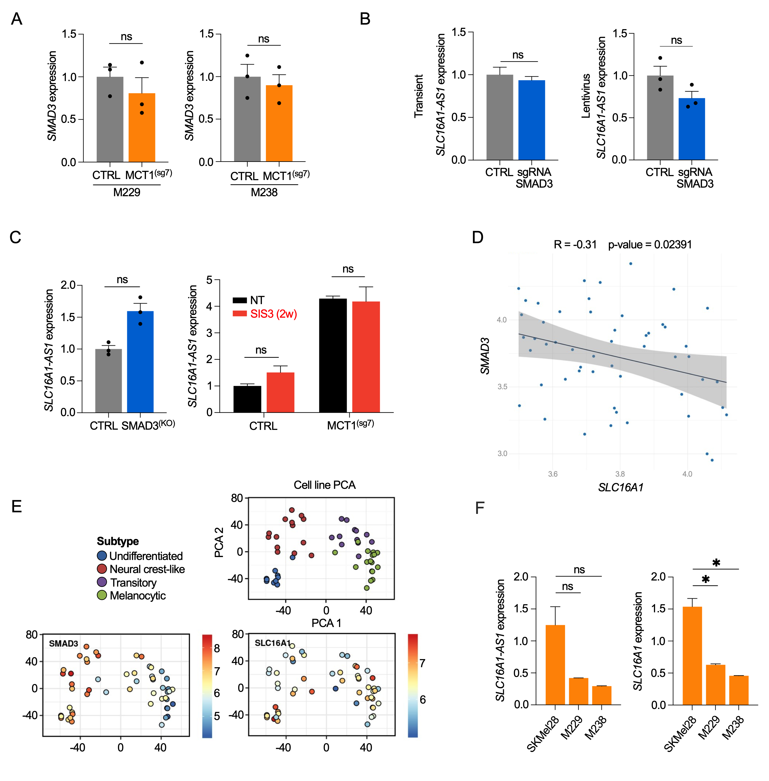
Supplementary Figure 4. MCT1 and SMAD3 are markers of opposing gene regulatory programs. A qPCR measurement of SMAD3 expression level in M229 and M238 cell lines with stable MCT1 overexpression by CRISPR-SAM using sg7. B qPCR measurement of SLC16A1-AS1 expression level in 501Mel cells upon transient or stable SMAD3 overexpression by CRISPR-SAM using sg1. C qPCR measurement of SLC16A1-AS1 expression levels in 501Mel SMAD3 KO cells and in 501Mel NT or sg7 cells after 2 weeks of SIS3 treatment. D MCT1 and SMAD3 gene expression correlation analysis in melanoma cell lines (CCLE gene expression data). E PCA of SMAD3 and SLC16A1 expression in different melanoma subtypes (Tsoi et al., 2018). F qPCR measurement of SLC16A1 and SLC16A1-AS1 expression levels in melanocytic/transitory SKMel28, transitory M229 and neural crest-like M238 melanoma cell lines.
Supplementary Figure 5
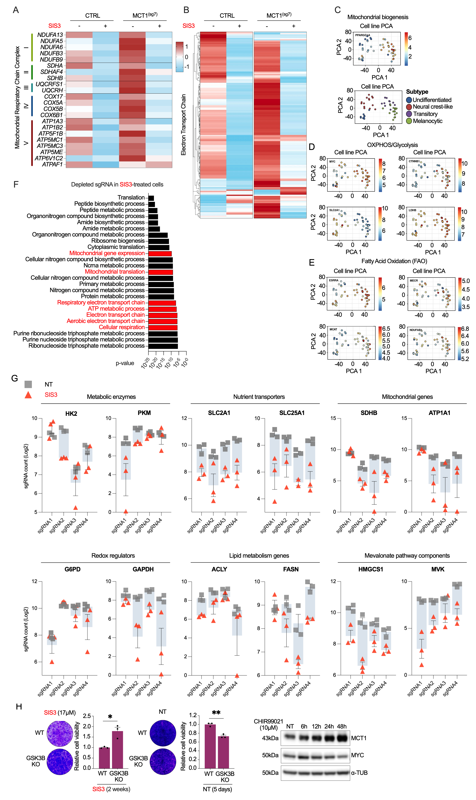
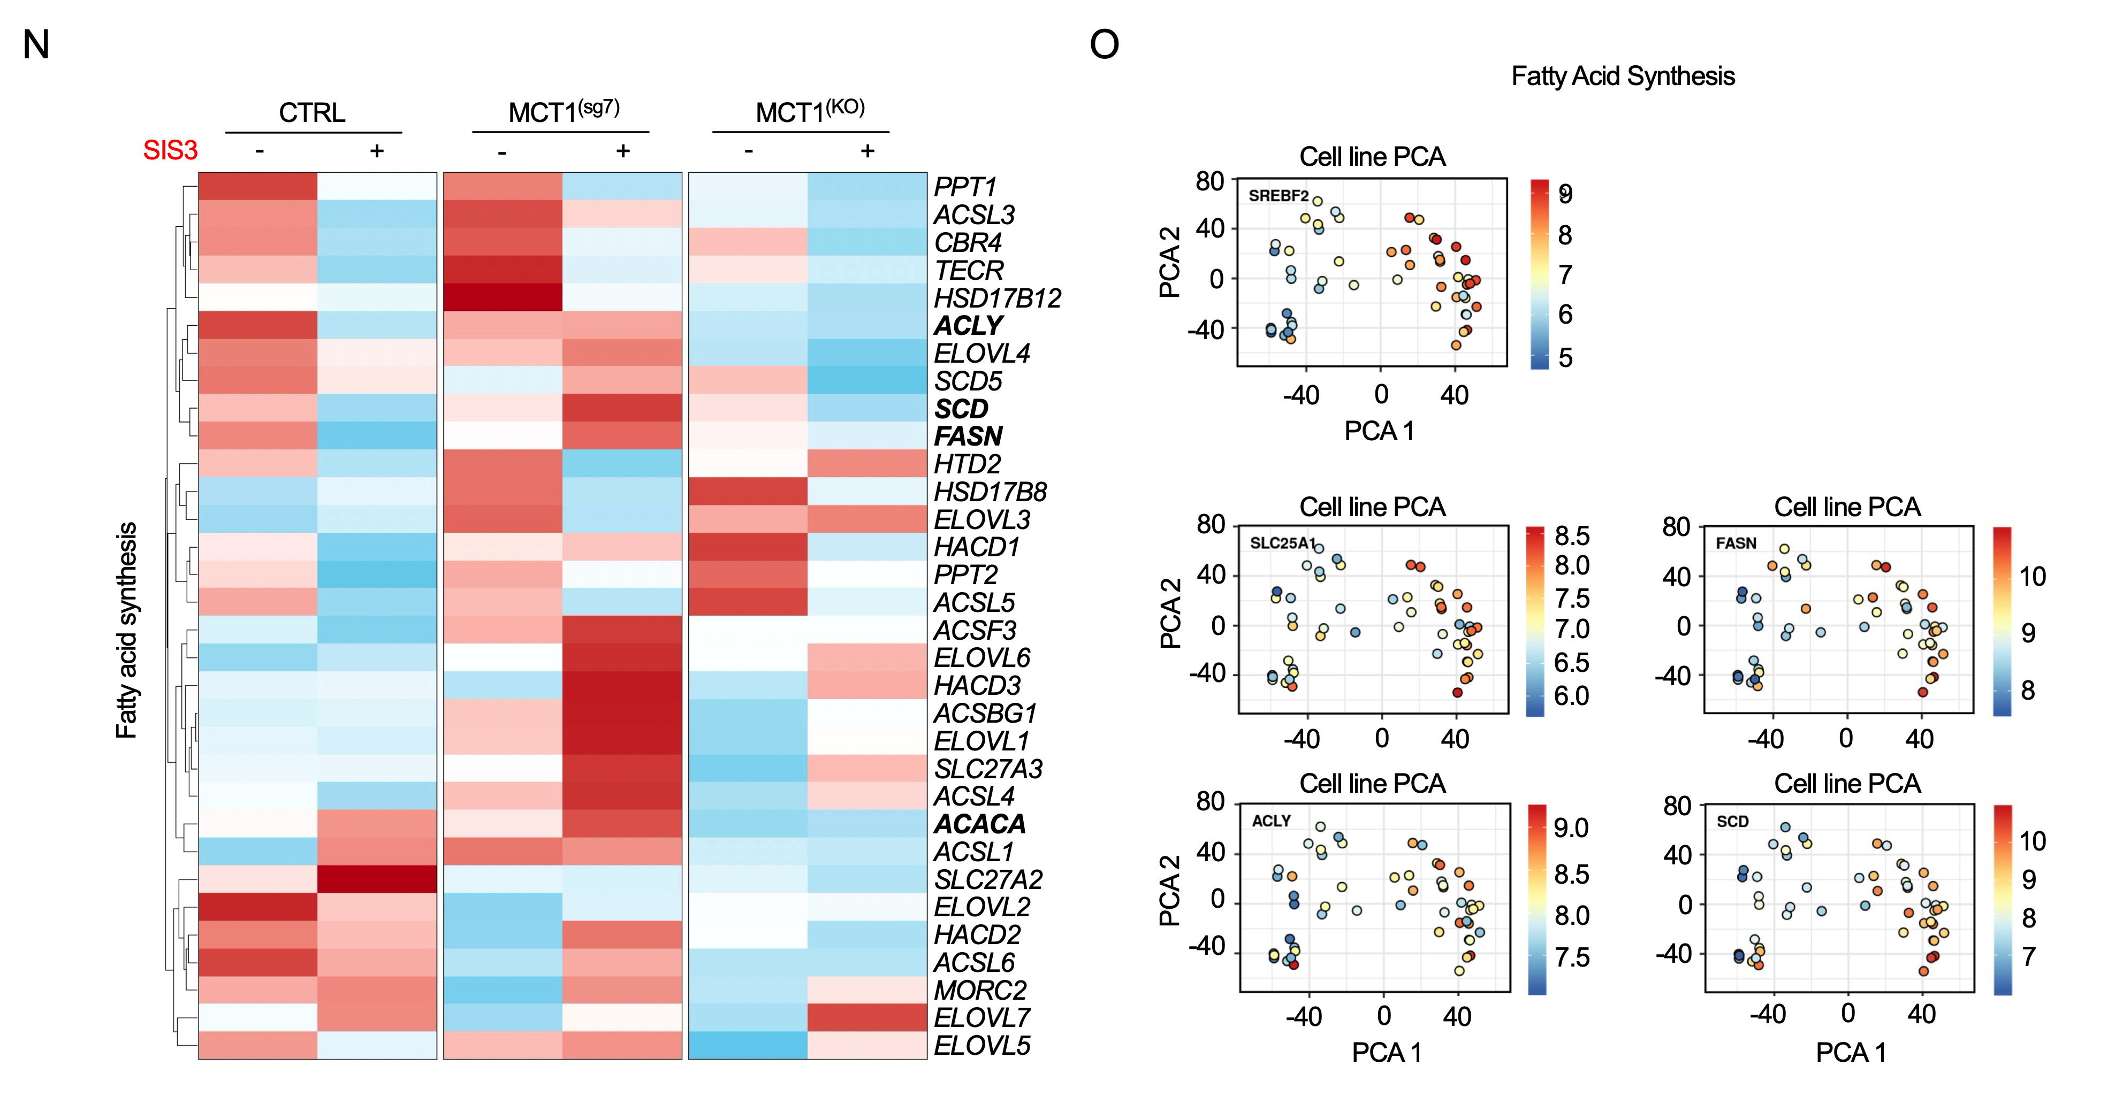
Supplementary Figure 5. Integrated transcriptomic and functional genomic analysis identifies the MCT1-regulated metabolic axis essential for SIS3 resistance. A Heatmap of expression of genes in respiratory electron transport chain complexes in CTRL or MCT1^{(sg7)} cells with or without 2 weeks of SIS3 treatment. Data is presented as log₂ Z-score for each row. B Heatmap and hierarchical clustering of expression of genes related to Electron Transport Chain (ETC) in CTRL or MCT1^{(sg7)} cells with or without 2 weeks of SIS3 treatment. Data is presented as log₂ Z-score for each row. C PCA of PPARGC1A expression in different melanoma subtypes. D-E PCA of OXPHOS, Glycolysis and FAO related gene expression in different melanoma subtypes. F Pathway enrichment analysis of sgRNA-targeted genes with negative fold change after SIS3 treatment compared to non-treated CRISPR-KO cell library. G Log₂ sgRNA count numbers after 2 weeks of SIS3 treatment compared to non-treated CRISPR KO cell library. Data highlights genes related to metabolic pathways. H The effect of GSK3B KO using sg4 from Brunello KO library on cell growth in presence of SIS3 for 2 weeks or during 5 days without drug treatment in 501Mel melanoma cells. WB measurement of MCT1 and MYC protein level in response to 10μM GSK3B inhibitor CHIR99021 during 48h of treatment. Cell density evaluation of 501Mel cells (seeded at 10000 cells per 6w) after 10 days of 10μM SIS3 treatment alone or together with 1μM GSK3B inhibitor CHIR99021. I SLC16A1 and MYC gene expression correlation analysis in melanoma cell lines (CCLE gene expression data). J Heatmap and hierarchical clustering of expression of genes related to WNT/β-catenin pathway in CTRL or MCT1^{(sg7)} cells with or without 2 weeks of SIS3 treatment. Data is presented as log₂ Z-score for each row. K Heatmap of sgRNA count numbers after 2 weeks of SIS3 treatment compared to non-treated CRISPR KO cell library. Data is presented as log₂ Z-score for each row and highlights genes related to WNT/β-catenin pathway. Heatmap of expression of genes related to WNT/β-catenin pathway in CTRL, MCT1^{(sg7)} and MCT1^{(KO)} cells with or without 2 weeks of SIS3 treatment. Data is presented as log₂ Z-score for each row. L Heatmap of sgRNA count numbers after 2 weeks of SIS3 treatment compared to non-treated CRISPR KO cell library. Data is presented as log₂ Z-score for each row and highlights genes related to OXPHOS and FAO. Heatmap of expression of genes related to OXPHOS and FAO in CTRL, MCT1^{(sg7)} and MCT1^{(KO)} cells with or without 2 weeks of SIS3 treatment. Data is presented as log₂ Z-score for each row. M Heatmap of sgRNA count numbers after 2 weeks of SIS3 treatment compared to non-treated CRISPR KO cell library. Data is presented as log₂ Z-score for each row and highlights genes related to pentose phosphate pathway and fatty acid synthesis. Heatmap of expression of genes related to pentose phosphate pathway in CTRL, MCT1^{(sg7)} and MCT1^{(KO)} cells with or without 2 weeks of SIS3 treatment. Data is presented as log₂ Z-score for each row. N Heatmap and hierarchical clustering of expression of genes related to fatty acid synthesis in CTRL, MCT1^{(sg7)} and MCT1^{(KO)} cells with or without 2 weeks of SIS3 treatment. Data is presented as log₂ Z-score for each row. O PCA of expression of genes involved in the initial stages of fatty acid synthesis in different melanoma subtypes.
Supplementary Figure 6
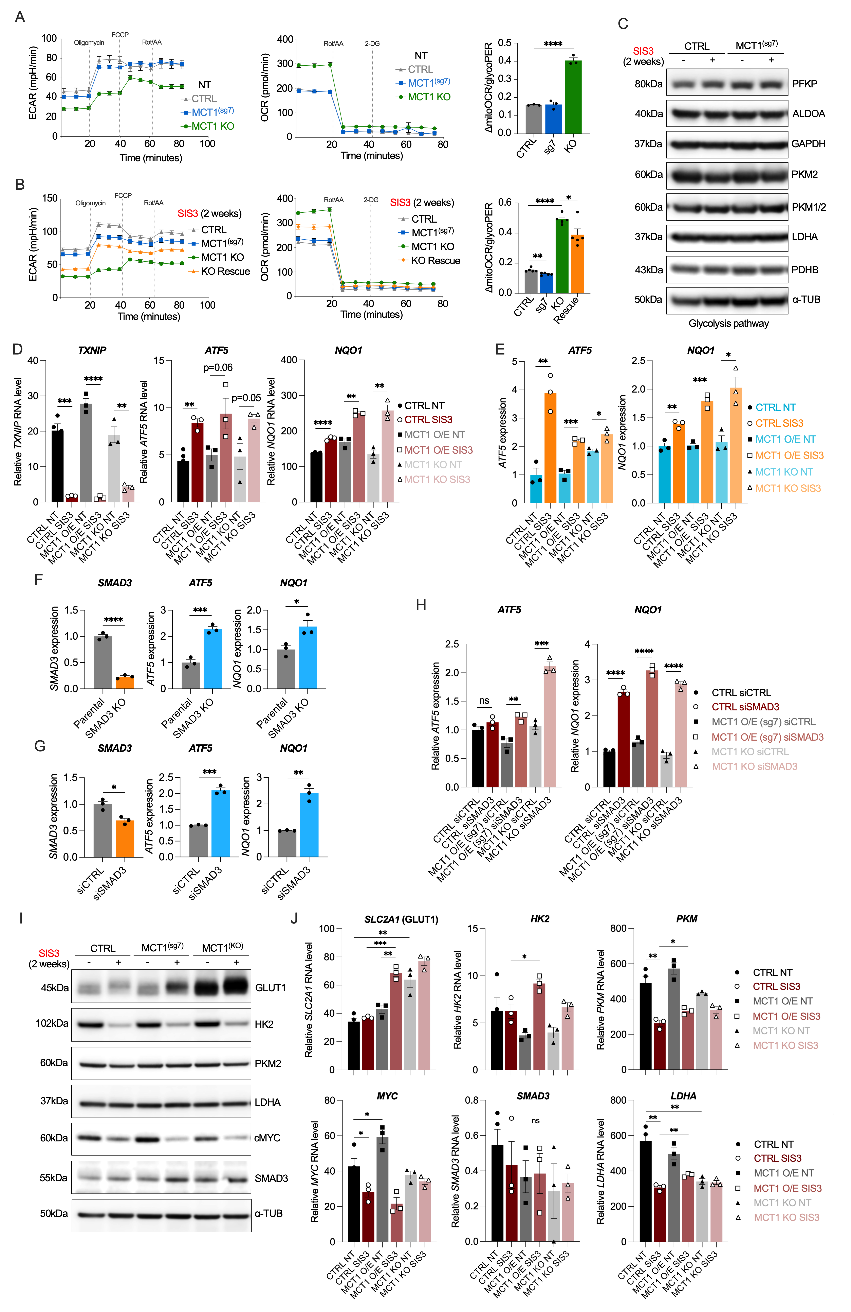
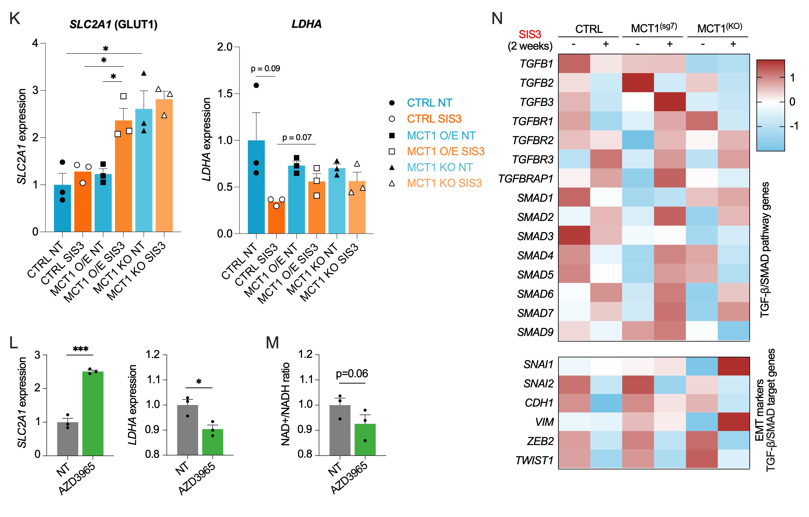
Supplementary Figure 6. MCT1 confers metabolic flexibility enabling glycolytic switch and anabolic reprogramming under drug pressure. A OCR and ECAR measurements in non-treated 501Mel CTRL, MCT1^{(sg7)} and MCT1 KO cells using Seahorse Mito Stress Test and Glycolysis Rate Assay. ΔmitoOCR/glycoPER ratio was calculated. B OCR and ECAR measurements in SIS3-treated (2 weeks) 501Mel CTRL, MCT1^{(sg7)} and MCT1 KO cells using Seahorse Mito Stress Test and Glycolysis Rate Assay. ΔmitoOCR/glycoPER ratio was calculated. C WB analysis of glycolytic enzyme levels in 501Mel CTRL and MCT1^{(sg7)} cells treated or not with SIS3 for 2 weeks. D Relative RNA levels (LR-RNAseq data) of transcriptional markers of energetic and oxidative stress TXNIP, ATF5 and NQO1 in CTRL, MCT1^{(sg7)} and MCT1 KO 501Mel cells with or without SIS3. E qPCR validation of ATF5 and NQO1 induction by SIS3 across CTRL, MCT1^{(sg7)} and MCT1 KO 501Mel cells. F Genetic SMAD3 loss induces ATF5 and NQO1 expression. Relative SMAD3, ATF5 and NQO1 mRNA levels in parental and SMAD3 KO 501Mel cells by qPCR. G siRNA-mediated SMAD3 knockdown induces ATF5 and NQO1 expression. Relative SMAD3, ATF5 and NQO1 mRNA levels in siCTRL and siSMAD3-transfected 501Mel cells by qPCR. H ATF5 and NQO1 induction by siRNA-mediated SMAD3 knockdown across CTRL, MCT1^{(sg7)} and MCT1 KO 501Mel cells by qPCR. I WB analysis of GLUT1, HK2, PKM2, LDHA, cMYC and SMAD3 protein levels in 501Mel CTRL, MCT1^{(sg7)} and MCT1^{(KO)} cells treated with SIS3 or not. J Expression of genes (LR-RNAseq data) in CTRL, MCT1^{(sg7)} and MCT1^{(KO)} cells with or without 2 weeks of SIS3 treatment. K qPCR validation of SLC2A1 and LDHA gene expression in CTRL, MCT1^{(sg7)} and MCT1^{(KO)} cells with or without 2 weeks of SIS3 treatment. L The effect of 24h AZD3965 (50nM) treatment on the expression of SLC2A1 and LDHA. M The effect of 12h AZD3965 (50nM) treatment on the NAD+/NADH ratio. N Heatmap and hierarchical clustering of expression of genes related to TGF-β/SMAD3 pathway in CTRL, MCT1^{(sg7)} and MCT1^{(KO)} cells with or without 2 weeks of SIS3 treatment. Data is presented as log₂ Z-score for each row.
Supplementary Figure 7
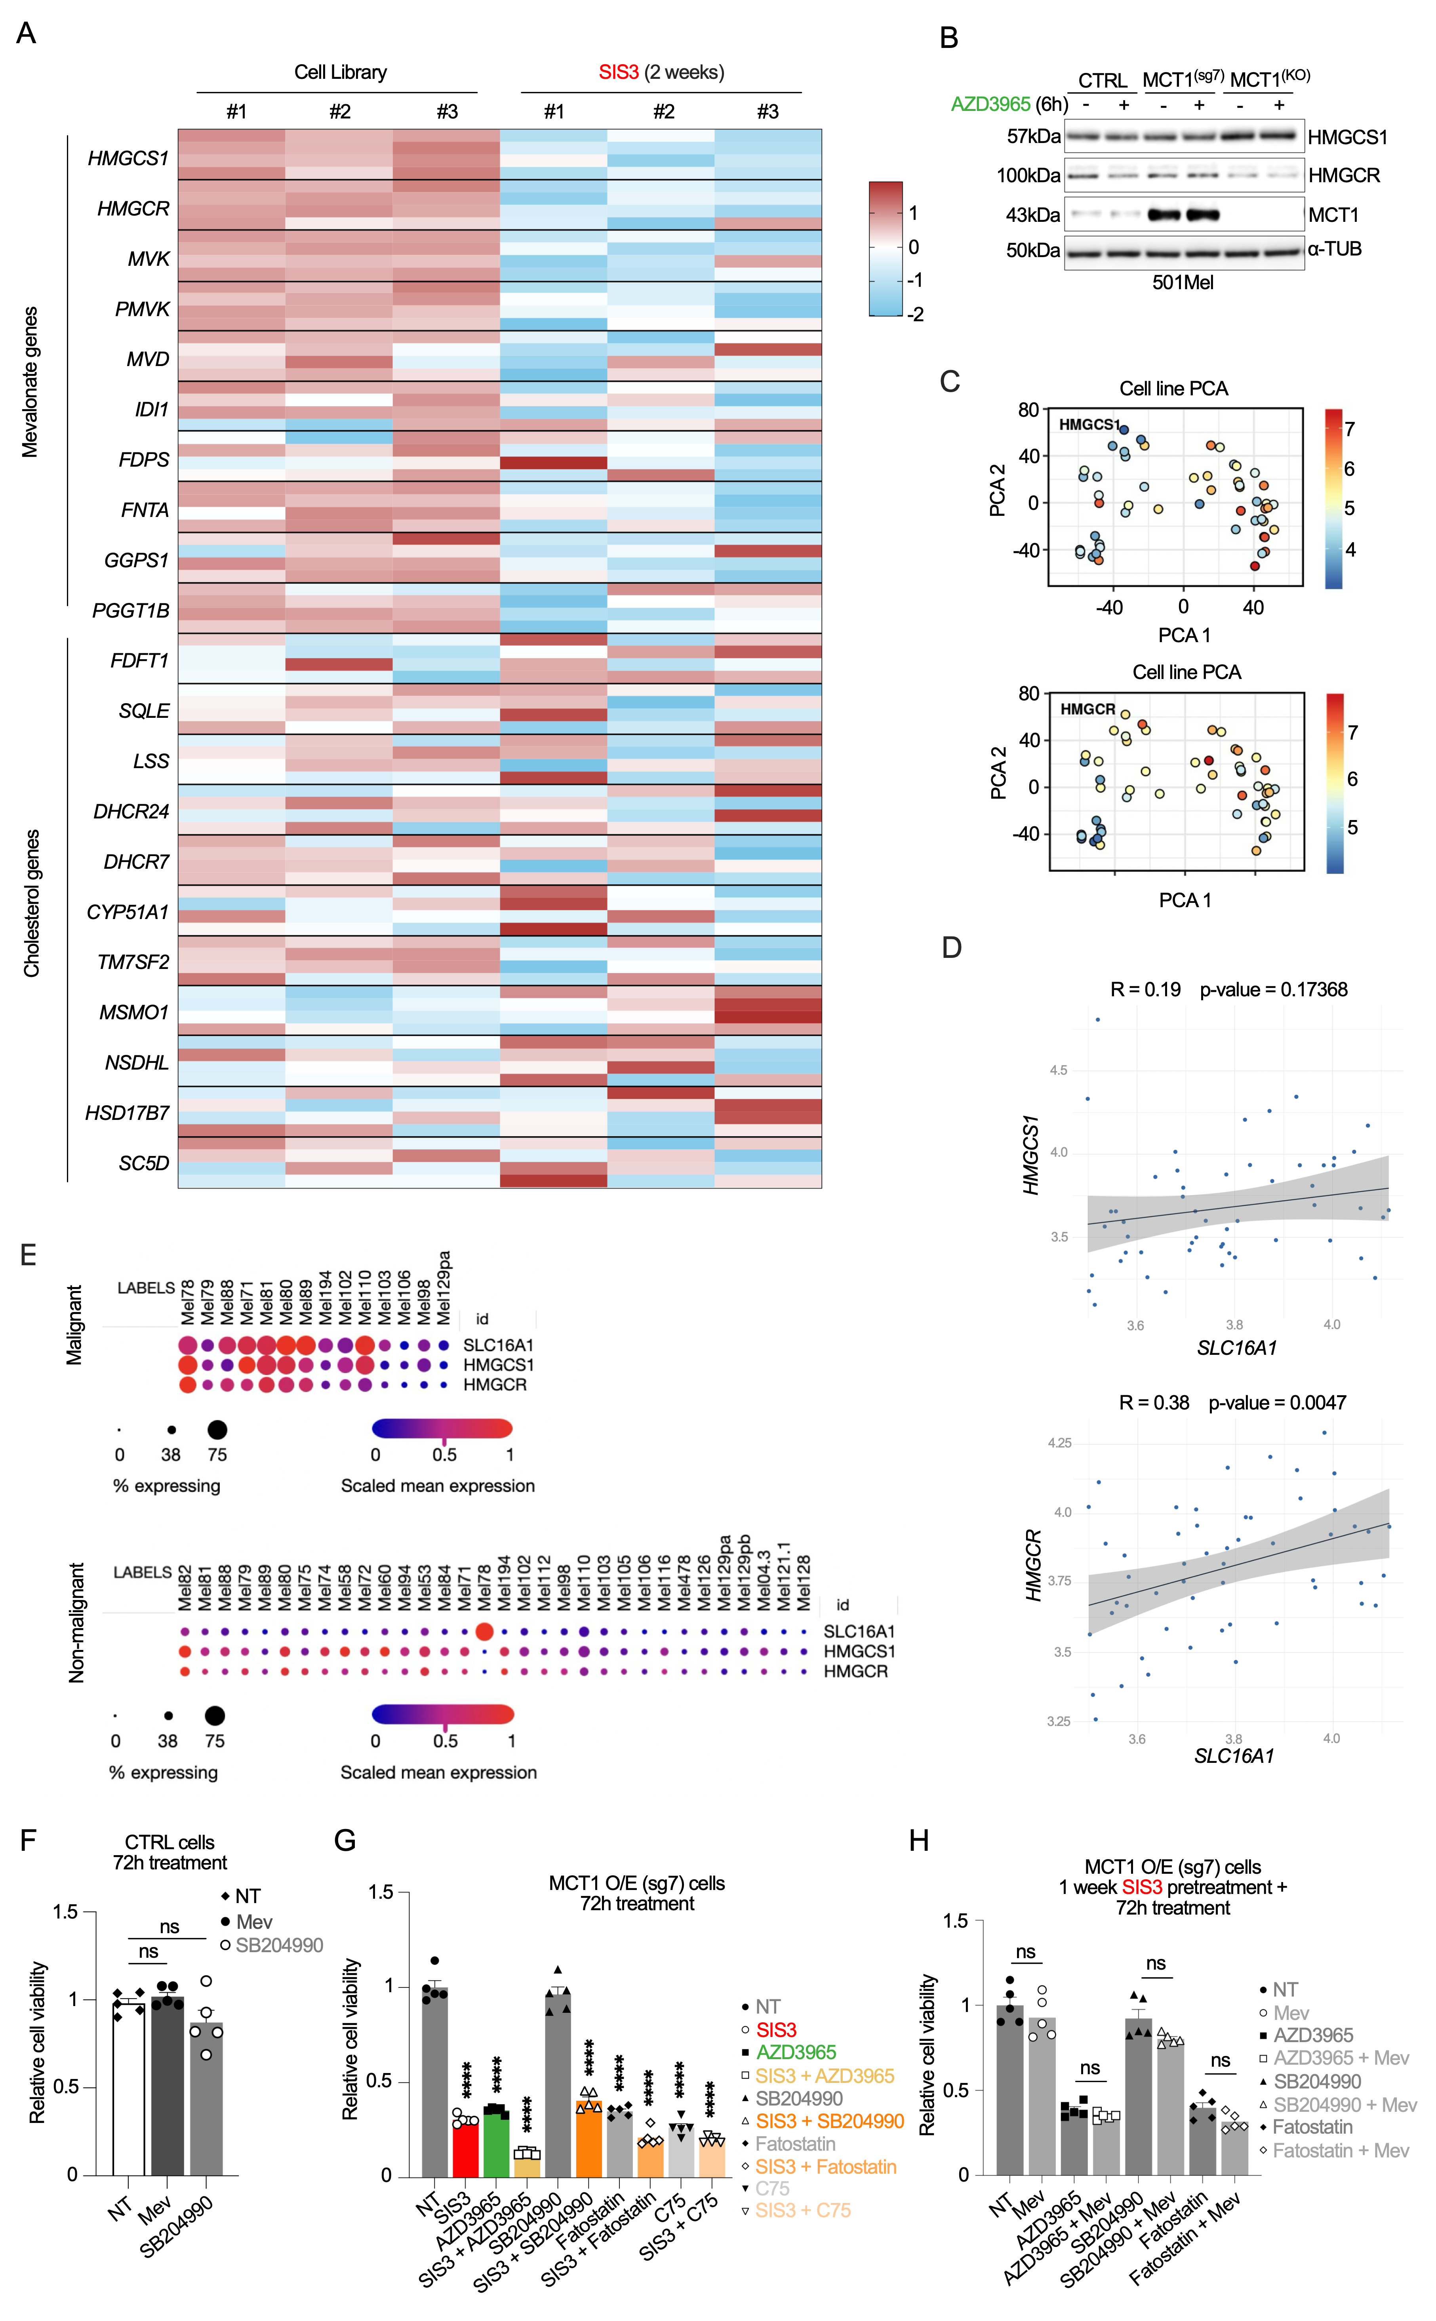
Supplementary Figure 7. MCT1-dependent resistance to SIS3 requires mevalonate biosynthesis pathway. A Heatmap of sgRNA count numbers after 2 weeks of SIS3 treatment compared to non-treated CRISPR KO cell library. Data is presented as log₂ Z-score for each row and highlights genes related mevalonate and cholesterol biosynthesis pathway. B WB analysis of HMGCS1 and HMGCR protein levels in 501Mel CTRL, MCT1^{(sg7)} and MCT1^{(KO)} cells after 6h of 50nM AZD3965 treatment. C PCA of HMGCS1 and HMGCR expression in different melanoma subtypes. D SLC16A1 and HMGCS1 or HMGCR gene expression correlation analysis in melanoma cell lines (CCLE gene expression data). E Analysis of single-cell expression data of MCT1, HMGCS1 and HMGCR in a published dataset of melanoma patient tumor samples (Jerby-Arnon et al., 2018). F The effect of SB204990 (ACLY inhibitor) and mevalonate on cell viability of 501Mel CTRL cells. Cells were seeded on 96w plates at 1000 cells/well and treated with 30μM SB204990 or 50μM of mevalonate during 72 hours. Relative cell viability was determined by methylene blue assay. G The effect of 20nM AZD3965, 10μM SIS3, and SIS3 combination with 30μM SB204990, 25μM Fatostatin (SREBP2 inhibitor) and 10μM C75 (FASN inhibitor) on cell viability of MCT1^{(sg7)} cells. Cells were seeded on 96w plates at 1000 cells/well and further treated with inhibitors during 72 hours. Relative cell viability was determined by methylene blue assay. H The effect of 20nM AZD3965, 25μM Fatostatin, 10μM C75 and/or 50μM mevalonate on cell viability of MCT1^{(sg7)} cells pre-treated with 15μM SIS3 for 1 week. Cells were seeded on 96w plates at 1000 cells/well and further treated with 10μM SIS3 together with inhibitors during 72 hours. Relative cell viability was determined by methylene blue assay.
Supplementary Figure 8
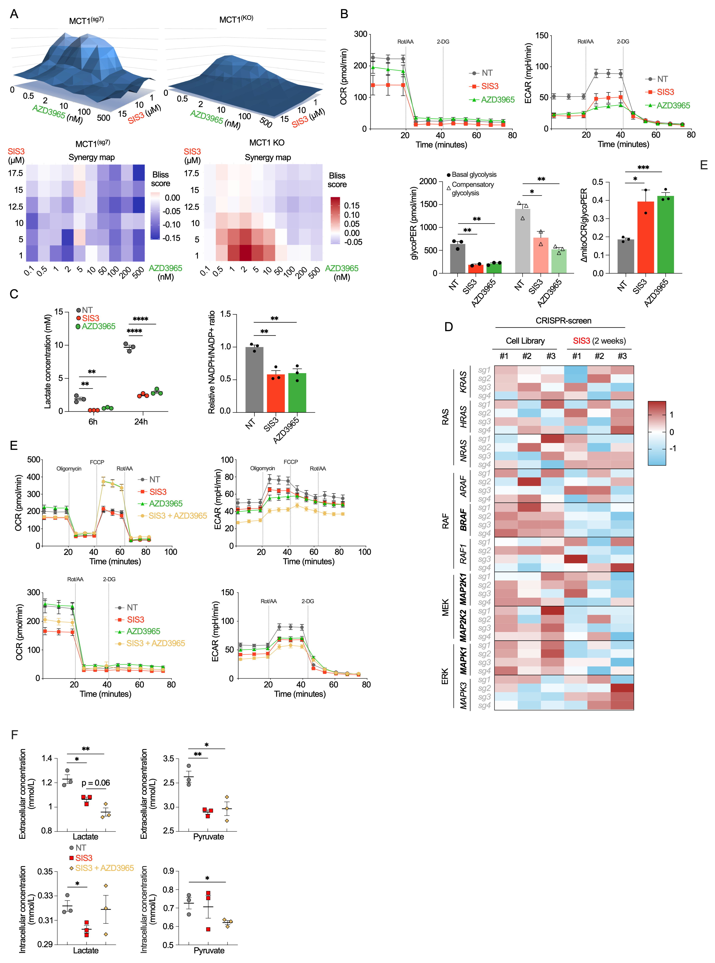
Supplementary Figure 8. Combined SMAD3 and MCT1 inhibition produces synergistic anti-tumor effects and durable suppression of BRAFi-resistant melanoma. A The combined effect of SIS3 and AZD3965 treatment on cell viability in 501Mel MCT1^{(sg7)} and MCT1^{(KO)} cells. Cells were seeded to 96w plates at 5000 cells/well and treated for 4 days with various drug concentration combinations. Cell viability was determined by methylene blue assay. Synergy scores for combined SIS3 and AZD3965 treatment were calculated using Bliss independence assay and are presented as heatmap. B OCR and ECAR measurements in SIS3-treated (2 weeks) 501Mel CTRL, MCT1^{(sg7)} and MCT1 KO cells using Seahorse Glycolysis Rate Assay. Basal glycolysis, compensatory glycolysis and ΔmitoOCR/glycoPER ratio was calculated. C Measurement of extracellular lactate concentration in cell culture media in response to MCT1 or SMAD3 inhibition. 501Mel CTRL cells were treated with 50nM AZD3965 or 17μM SIS3 for 6h or 24h. Relative NADPH/NADP+ ratio measured in 501Mel CTRL cells treated with 17μM SIS3 (48h) or 10nM AZD3965 (12h). D Heatmap of sgRNA count numbers after 2 weeks of SIS3 treatment compared to non-treated CRISPR KO cell library. Data is presented as log₂ Z-score for each row and highlights genes related to RAS-RAF-MEK-ERK signaling pathway. E OCR and ECAR measurements in BRAF inhibitor-resistant M229R cells non-treated or treated with 10μM SIS3, 10nM AZD3965 or in combination using Seahorse Mito Stress Test and Glycolysis Rate Assay. F Quantitative analysis of extracellular and intracellular lactate and pyruvate concentration in BRAF inhibitor resistant M229R cells after 6 days of recovery from SIS3 or SIS3+AZD3965 treatment.
Supplementary Figure 9
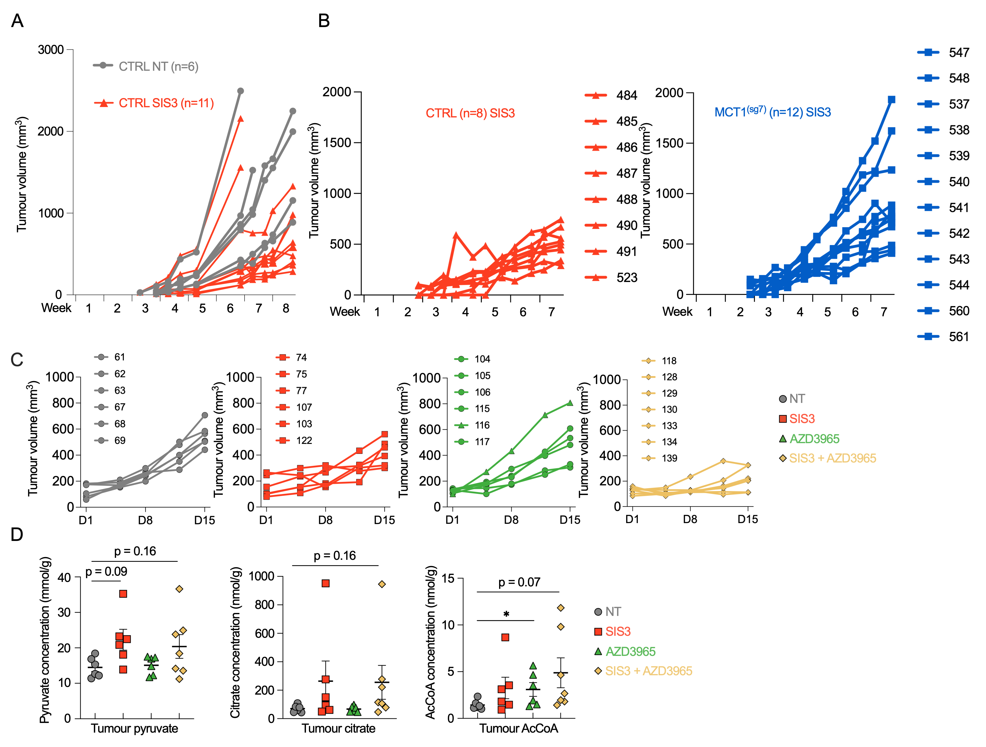
Supplementary Figure 9. Co-inhibition of SMAD3 and MCT1 potently reduces tumor growth in vivo. A The effect of SIS3 treatment on 501Mel CTRL cell xenograft growth compared to non-treated control. Mice were treated daily and intraperitoneally with 3.75μg/g of SIS3. B The effect of MCT1 overexpression on xenograft growth compared to CTRL cell xenografts in SIS3-treated mice. Mice were treated daily and intraperitoneally with 3.75μg/g of SIS3. C The effect of non-treated (NT), SIS3 (5μg/g), AZD3965 (50mg/kg) or SIS3 and AZD3965 combined treatment on 501Mel CTRL cell xenograft growth. Mice were treated daily and intraperitoneally with 5μg/g of SIS3 and/or fed with 50mg/kg AZD3965 twice daily. D Quantitative analysis of intratumoral pyruvate, citrate and AcCoA concentration in 501Mel xenografts non-treated or treated with SIS3, AZD3965 or SIS3 and AZD3965 combined.

Supplementary Table 1. Oligos used in the study
qPCR primers
SLC16A1-AS1_For | GATAGAATTGTGGCAGGCGG
SLC16A1-AS1_Rev | AGGCTCTGGAGTGTGACTTC
SLC16A1_For_1 | TCAGGCTGTGGCTTGATTGC
SLC16A1_Rev_1 | GCCAATGGTCGCCTCTTGTAGAA
SLC16A1_For_2 | GGAGGTCCTATCAGCAGTATCC
SLC16A1_Rev_2 | AAGCCCAAGACCTCCAATGA
SMAD3_For | CCATCTCCTACTACGAGCTGAA
SMAD3_Rev | CACTGCTGCATTCCTGTTGAC
HMGCS1_For | CCAGTGGCAGAAAGAGGGAA
HMGCS1_Rev | GCTTCCAGGCCACTATAGATACT
HMGCR_For | TCGAATGCATGGCCTCTTTG
HMGCR_Rev | GTCACTGCTCAAAACATCCTCT
SNAI2_For | CTGTGACAAGGAATATGTGAGCC
SNAI2_Rev | CAAATGCTCTGTTGCAGTGAG
SNAI1_For | GGAAGCCTAACTACAGCGAGCT
SNAI1_Rev | CTGGAAGGTAAACTCTGGATTAG
CDH2_For | CCCTGCTTCAGGCGTCTGTA
CDH2_Rev | TGCTTGCATAATGCGATTTCACC
CDH1_For | TTGCACCGGTCGACAAAGGAC
CDH1_Rev | TGGAGTCCCAGGCGTAGACCAA
VIM_For | CCACCAGGTCCGTGTCCTCGT
VIM_Rev | CGCTGCCCAGGCTGTAGGTG
ZEB1_For | GGTCATGATGAAAATGGAACACC
ZEB1_Rev | AGGTGTAACTGCACAGGGAGCA
ZEB2_For | GACAGATCAGCACCAAATGC
ZEB2_Rev | GCTGATGTGCGAACTGTAGG
TWIST1_For | GGAGTCCGCAGTCTTACGAG
TWIST1_Rev | TCTGGAGGACCTGGTAGAGG
ATF5_For | GCTCGTAGACTATGGGAAACTCC
ATF5_Rev | CATCCAGTCAGAGAAGCCATCAC
NQO1_For | CCTGCCATTCTGAAAGGCTGGT
NQO1_Rev | GTGGTGATGGAAAGCACTGCCT
TBP_For | GAGCTGTGATGTGAAGTTTCC
TBP_Rev | TCTGGGTTTGATCATTCTGTAG
dCas9-VP64_For | AAGAGCAGACGGCTGGAAAAT
dCas9-VP64_Rev | CTCTTGAAGTTGGGGGTCAGG
MS2-p65-HSF1_For | TTACTCAGTTCGTGCTCGTGG
MS2-p65-HSF1_Rev | TGCCACCCCATTAGCGAAAT
mMct1_1_F | GACCATTGTGGAATGCTGCCCT
mMct1_1_R | CGATGATGAGGATCACGCCACA
mMct1_2_F | AATGCTGCCCTGTCCTCCTA
mMct1_2_R | CCCAGTACGTGTATTTGTAGTCTCCAT
m_lncRNA_Mct1_1_F | GTCGGGATTATGGCTAGTGG
m_lncRNA_Mct1_1_R1 | AGGCTCTGTGGCTTTGACTTT
m_lncRNA_Mct1_1_R2 | TGGAATCTGGGCTTGGTGAA
gDNA primers
gSMAD3_KO1_For | CCATTTCCCCTACTTTAGGCTT
gSMAD3_KO1_Rev | GGTTACAGTTGGGAGACTGGAC
Seq primers
U6_seq_For: | GACTATCATATGCTTACCGT
i5_seq | AATGATACGGCGACCACCGAGATCTACAC
i7_seq | CAAGCAGAAGACGGCATACGAGAT
NGS_Lib_sanger_For | GCTTTATATATCTTGTGGAAAGGACGAAACACC
NGS_Lib_sanger_Rev | GCCAAGTTGATAACGGACTAGCCTT
sgRNA oligos
SLC16A1_sg2_1 | CACCGCGCCTCTCTTAGCCGAGCCG
SLC16A1_sg2_2 | AAACCGGCTCGGCTAAGAGAGGCGC
SLC16A1-AS1_sg5_1 | CACCGGGCTGCCTTATAACCCGCCG
SLC16A1-AS1_sg5_2 | AAACCGGCGGGTTATAAGGCAGCCC
SLC16A1-AS1_sg7_1 | CACCGCTGCAGTTCGGATGTCTGTG
SLC16A1-AS1_sg7_2 | AAACCACAGACATCCGAACTGCAGC
SLC16A1-AS1_sg8_1 | CACCGCGCGCGCGGCTGAAAGCGTG
SLC16A1-AS1_sg8_2 | AAACCACGCTTTCAGCCGCGCGCGC
SLC16A1-AS1_sg9_1 | CACCGGGCGCGCGCGGGCGAGCTAG
SLC16A1-AS1_sg9_2 | AAACCTAGCTCGCCCGCGCGCGCCC
SMAD3_sg1_1 | CACCGGGTGAGGCCGCAGAGGCGGA
SMAD3_sg1_2 | AAACTCCGCCTCTGCGGCCTCACCC
mMct1_sg1_1 | CACCGGCGCAGCCCGCAGCGTGTGG
mMct1_sg1_2 | AAACCCACACGCTGCGGGCTGCGCC
mMct1_sg2_1 | CACCGAGCTGGGAGTATGTATGGCA
mMct1_sg2_2 | AAACTGCCATACATACTCCCAGCTC
SMAD3_KO1_sg1_1 | CACCGGTGCGGCTCTACTACATCGG
SMAD3_KO1_sg1_2 | AAACCCGATGTAGTAGAGCCGCACC
SLC16A1_KO_sg3_1 | CACCGGGGTGAATAGGGTTAAGTCC
SLC16A1_KO_sg3_2 | AAACGGACTTAACCCTATTCACCCC
SLC16A1_KO_sg4_1 | CACCGTATCCATGACACTTCGCTGG
SLC16A1_KO_sg4_2 | AAACCCAGCGAAGTGTCATGGATAC
GSK3B_KO_sg4_1 | CACCGGTGGCTCCAAAGATCAACTC
GSK3B_KO_sg4_2 | AAACGAGTTGATCTTTGGAGCCACC

Supplementary Table 2. MRM parameters used for LC-MS/MS analyses.
Compound | Ionisation mode | MRM transition | Cone (V) | Collision (eV)
Citrate | ESI+ | 676.4 → 134.0 | 40 | 35
¹³C₂-citrate | ESI+ | 678.4 → 134.0 | 40 | 35
Lactate | ESI+ | 252.0 → 134.0 | 30 | 30
¹³C₃-lactate | ESI+ | 255.0 → 134.0 | 30 | 30
Pyruvate | ESI+ | 250.0 → 134.0 | 30 | 30
¹³C-pyruvate | ESI+ | 251.0 → 134.0 | 30 | 30
Acetyl-CoA | ESI+ | 810.1 → 303.1 | 62 | 30
¹³C₂-Acetyl-CoA | ESI+ | 812.2 → 305.2 | 70 | 30
Malonyl-CoA | ESI+ | 854.1 → 347.2 | 60 | 26
¹³C₃-Malonyl-CoA | ESI+ | 857.1 → 350.2 | 60 | 26
Mevalonate | ESI- | 147.0 → 59.0 | 20 | 14
¹³C₂-mevalonate | ESI- | 149.0 → 59.0 | 20 | 14

Supplementary Data.

Supplementary Data 1. CRISPR-activation screen sgRNA counts and MAGeCK analysis

Supplementary Data 2. CRISPR-KO screen sgRNA counts and MAGeCK analysis

Supplementary Data 3. RNAseq and CRISPR-screen gDNAseq analysis of MCT family genes

Supplementary Data 4. List of genes included in gene expression heatmaps from RNAseq data

