Additional file 2
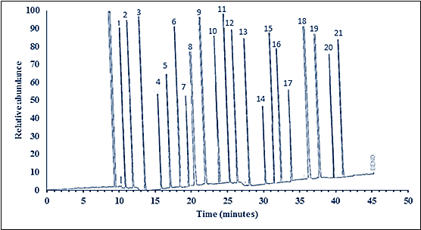

1, C- 8:0; 2,C – 10:0; 3, C – 12:0; 4, C – 14:0; 5, C – 14: 1; 6, C – 15: 0; 7, C – 16:0; 8, C – 16:1; 9, C – 18:0; 10, C – 18: 1; 11, C– 18:2; 12, C – 20:0; 13, C – 18:3; 14, C – 20:3; 15, C – 22:1; 16, C – 20:4; 17, C – 20:5; 18, C – 22:5; 19, C – 22:6; 20, C – 24:0; 21, C – 24:1.
Figure 1. GC-FID Chromatogram of fatty acids standards

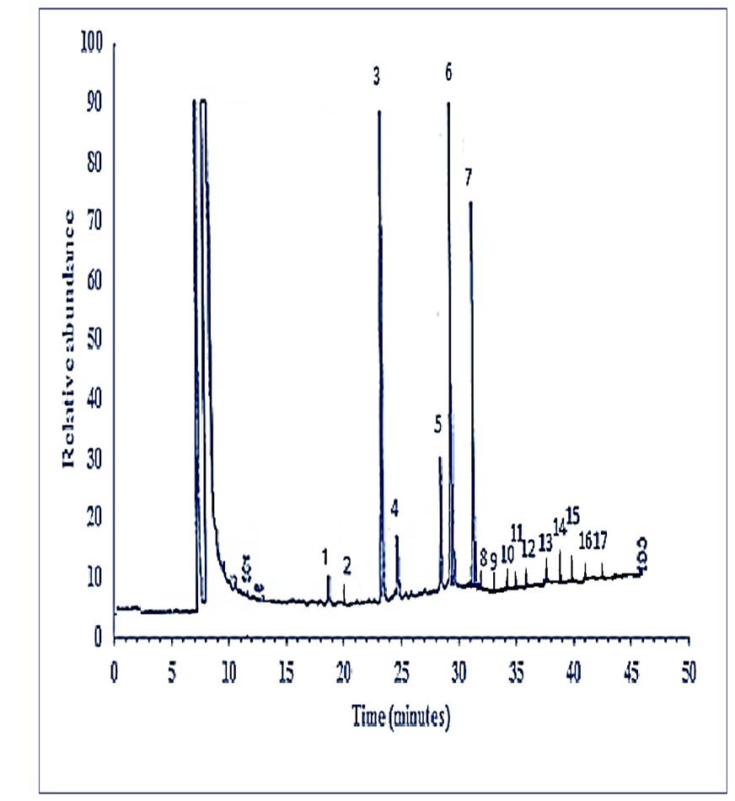
1, C – 14:0; 2, C – 14: 1; 3, C – 16:0; 4, C – 16:1; 5, C – 18:0; 6, C – 18: 1; 7, C– 18:2, 8, C – 20:0; 9, C – 18:3; 10, C – 20:3; 11, C – 22:1; 12, C – 20:4; 13, C – 20:5; 14, C – 22:5; 15, C – 22:6; 16, C – 24:0; 17, C – 24:1.
Figure 2. (a) GC-FID Chromatogram of serum total fatty acids in HBV- cirrhosis Patient

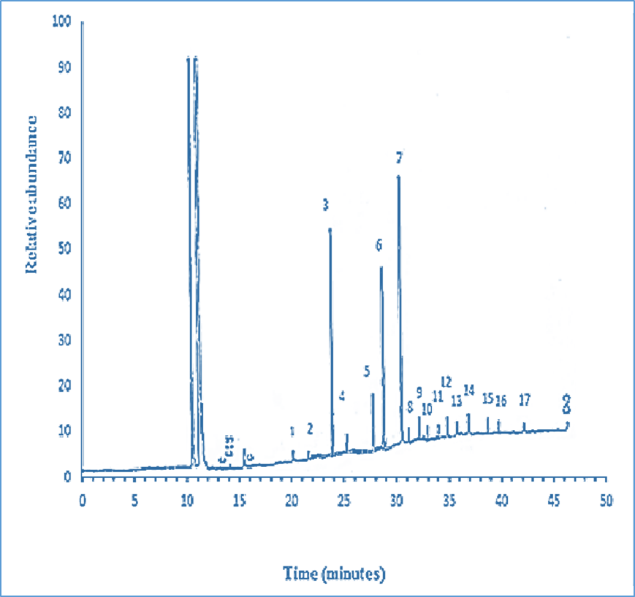

1, C – 14:0; 2, C – 14: 1; 3, C – 16:0; 4, C – 16:1; 5, C – 18:0; 6, C – 18: 1; 7, C– 18:2, 8, C – 20:0; 9, C – 18:3; 10, C – 20:3; 11, C – 22:1; 12, C – 20:4; 13, C – 20:5; 14, C – 22:5; 15, C – 22:6; 16, C – 24:0; 17, C – 24:1.

Figure 2. (b) GC-FID Chromatogram of serum total fatty acids in control subject

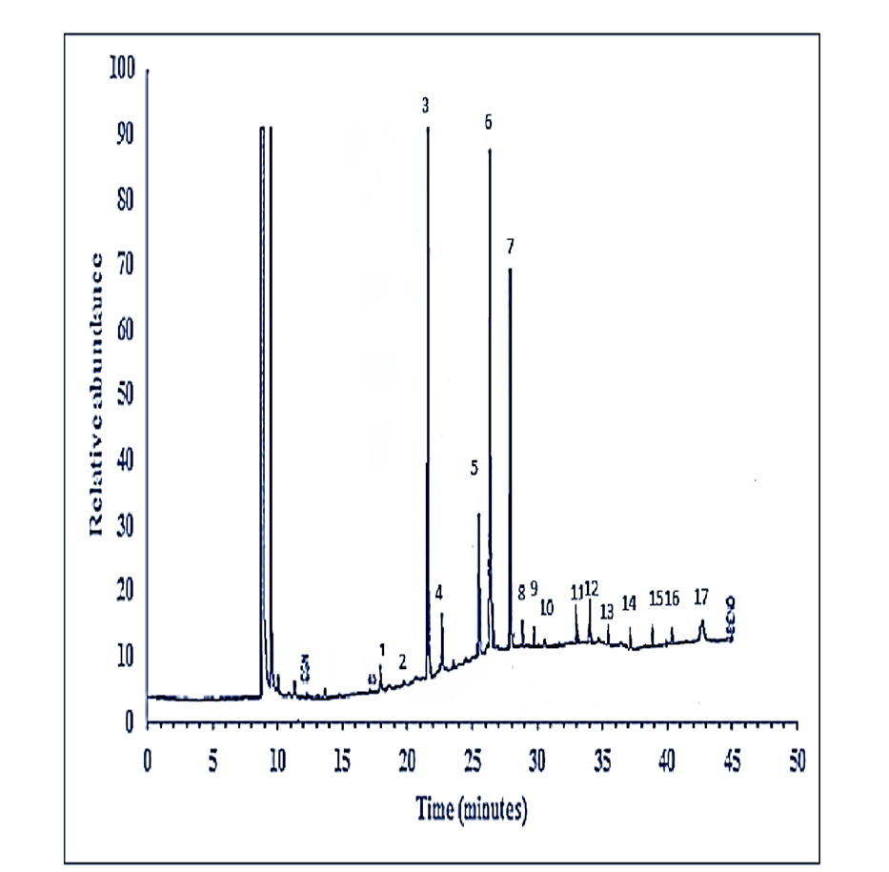
1, C – 14:0; 2, C – 14: 1; 3, C – 16:0; 4, C – 16:1; 5,C – 18:0; 6, C – 18: 1; 7, C– 18:2, 8, C – 20:0; 9, C – 18:3; 10, C – 20:3; 11, C – 22:1; 12, C – 20:4; 13, C – 20:5; 14, C – 22:5; 15, C – 22:6; 16, C – 24:0; 17, C – 24:1.
Figure 3. (a) GC-FID Chromatogram of serum free fatty acids in HBV- cirrhosis patient

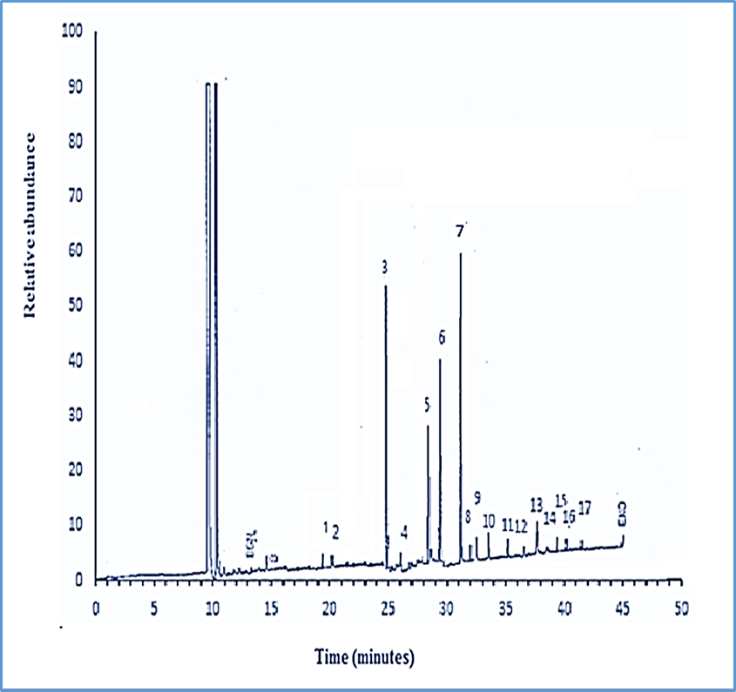

1, C – 14:0; 2, C – 14: 1; 3, C – 16:0; 4, C – 16:1; 5, C – 18:0; 6, C – 18: 1; 7, C– 18:2, 8, C – 20:0; 9, C – 18:3; 10, C – 20:3; 11, C – 22:1; 12, C – 20:4; 13, C – 20:5; 14, C – 22:5; 15, C – 22:6; 16, C – 24:0; 17, C – 24:1.
Figure 3. (b) GC-FID Chromatogram of serum free fatty acids in control subject

