Table S1. List of PCR primers
Gene | Forward (5′–3′) | Reverse (5′–3′)
IRS-1 | CCAGCAGCAGTAGCAGCATCAG | GCTTACCGCCACCACTCTCAAC
C/EBP-a | TATAGACATCAGCGCCTACATC | TTCTTGTCCACCGACTTATGAC
C/EBP-β | CAAGCTGAGCGACGAGTACA | CAGCTGCTCCACCTTCTTCT
LPL | CCTGATGACGCTGATTTTGTAG | CAATGAAGAGATGAATGGAGCG
PPAR-γ | GTGCCAGTTTCGATCCGTAGA | GGCCAGCATCGTGTAGATGA
FABP4 | CATCCGGTCAGAGAGTACTTTT | TAGGGTTATGATGCTCTTCACC
AdipoQ | CCAATGTACCCATTCGCTTTAC | GAAGTAGTAGAGTCCCGGAATG
ATGL | CAGAGATGGACTTCGATTCCTT | CAGGTGCTCTAGAATTCGATCT
HSL | CTCACAGTTACCATCTCACCTC | GATTTTGCCAGGCTGTTGAGTA
CPT1-a | CTACATCACCCCAACCCATATT | GATCCCAGAAGACGAATAGGTT
GAPDH | ACTCCACTCACGGCAAATTC | TCTCCATGGTGGTGAAGACA

Table S2. List of miR-410-3P mimics or inhbitors sequences
miR-410-3P | Sequence(5'-3')
mimics | AAUAUAACACAGAUGGCCUGU
 | AGGCCAUCUGUGUUAUAUUUU
inhibitors | ACAGGCCAUCUGUGUUAUAUU

Table S3. List of si-RNA sequences
siRNA | Sequence(5'-3')
si-NC | UUCUCCGAACGUGUCACGUTT
si-IRS-1#1 | GGCUUCUAUUGAGGAAUAUTT
si-IRS-1#2 | GAGGAGCUGAGCAAUUAUATT

Table S4. Clinical variables of non-cachexia and cachexia patients in miRNA sequencing
Features | Cachexia(n=3) | Non-cachexia(n=3) | t | p
Gender | Only male
Age(years) | 64.33±4.92 | 57.67±12.28 | 0.783 | 0.516
Weight(kg） | 63±3.26 | 69±3.74 | 2.166 | 0.163
Body weight loss(%) | 14.63±5.95 | 0±0 | 6.155 | 0.025
BMI(kg/m2) | 21.12±0.9 | 24.82±0.72 | 9.7 | 0.01
TNM stage | Only III stage | Only II stage
IL-6（pg/ml） | 5.47±2.32 | 2.3±0.14 | 2.544 | 0.126
TNF-a（pg/ml） | 8.63±3.48 | 7.7±2.71 | 0.319 | 0.78
Total protein (g/L) | 59.33±2.05 | 62.67±2.05 | 2.026 | 0.18
Albumin(g/L) | 34.33±2.87 | 40±0.82 | 4.095 | 0.055

Table S5. List of miRNAs selected by miRNA sequencing
miRNA ID | Sequence (5’→ 3’)
hsa-miR-122-5p | TGGAGTGTGACAATGGTGTTTG
hsa-miR-1-3p | TGGAATGTAAAGAAGTATGTAT
hsa-miR-337-3p | CTCCTATATGATGCCTTTCTTC
hsa-miR-323a-3p | CACATTACACGGTCGACCTCT
hsa-miR-329-3p | AACACACCTGGTTAACCTCTTT
hsa-miR-485-3p | GTCATACACGGCTCTCCTCTCT
hsa-miR-431-5p | TGTCTTGCAGGCCGTCATGCA
hsa-miR-411-3p | TATGTAACACGGTCCACTAACC
hsa-miR-495-3p | AAACAAACATGGTGCACTTCTT
hsa-miR-548ay-5p | AAAAGTAATTGTGGTTTTTGC
hsa-miR-410-3p | AATATAACACAGATGGCCTGT

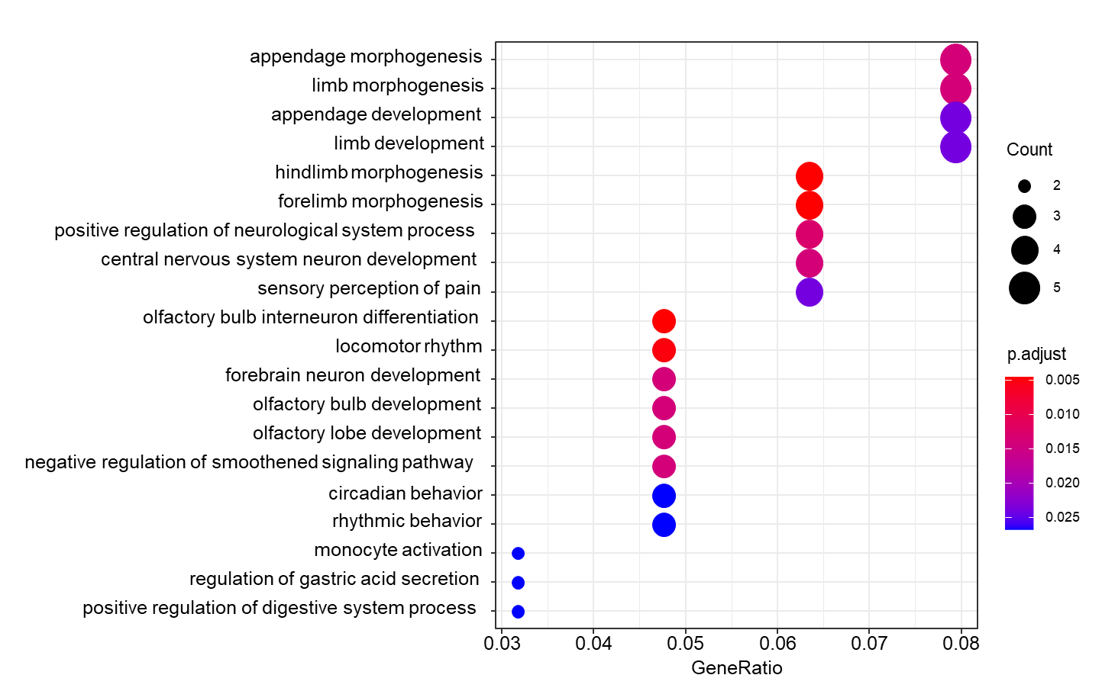
Figure S1. Enrichment analysis of target genes in GO database (screening the top 20 genes in biological process)

