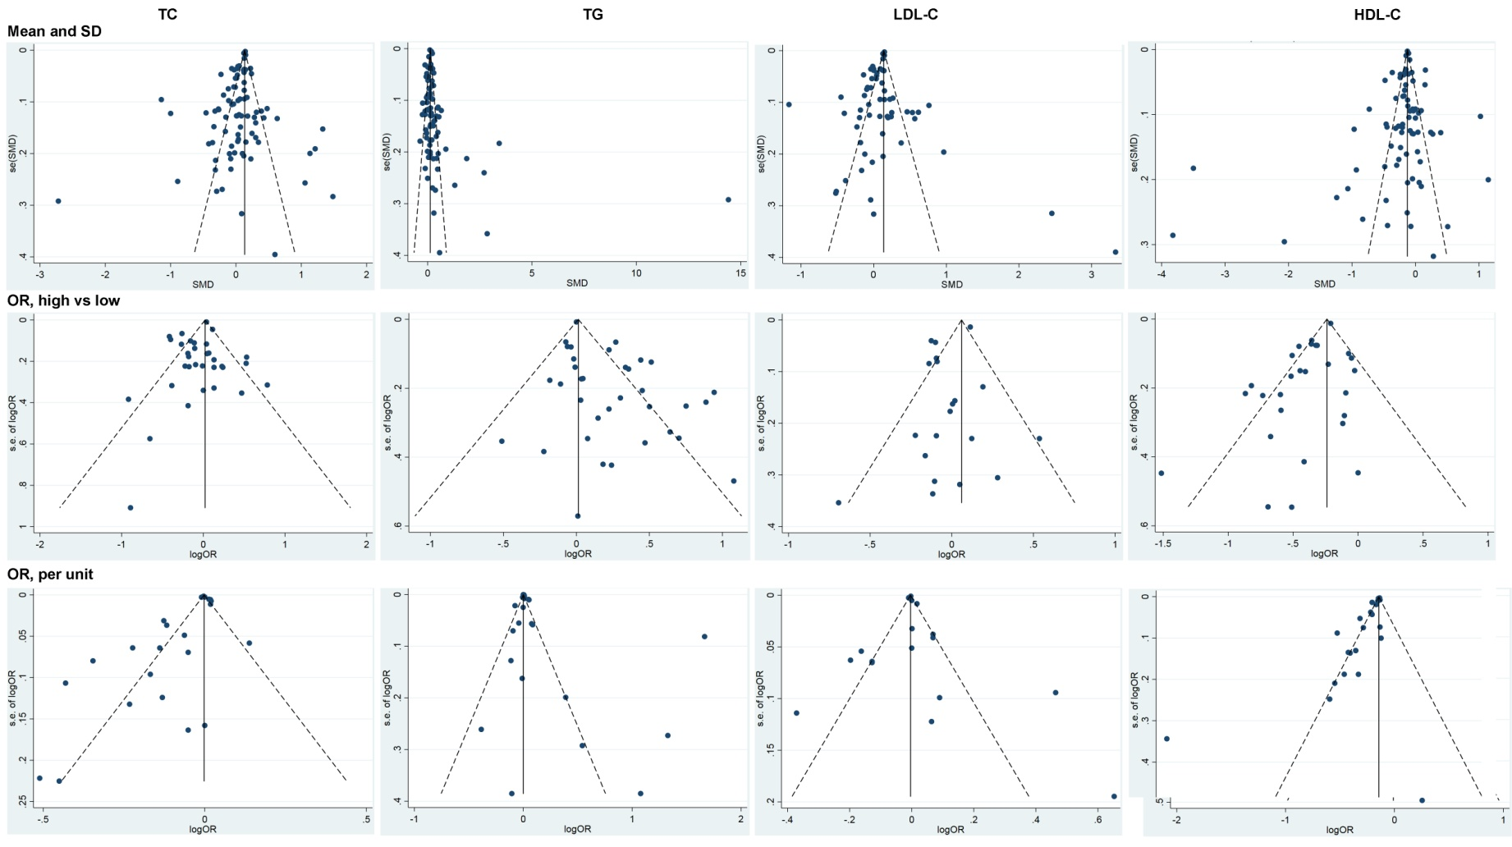
Additional file 9. Funnel plots for the final meta-analyses. TC: total cholesterol, LDL-C: low-density lipoprotein cholesterol, HDL-C: high-density lipoprotein cholesterol, SD: standard deviation, OR: odd ratios.

