Additional file 5. publication bias test. (a) DM; (b) Dyslipidemia; (c) Gender; (d) Hypertension; (e) Surgical procedure.

(a)
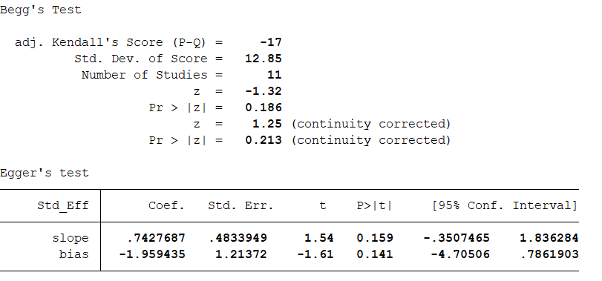

(b)
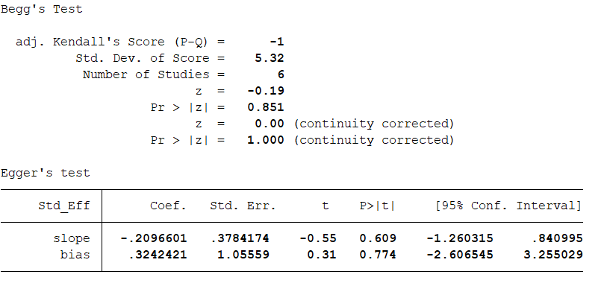

(c)
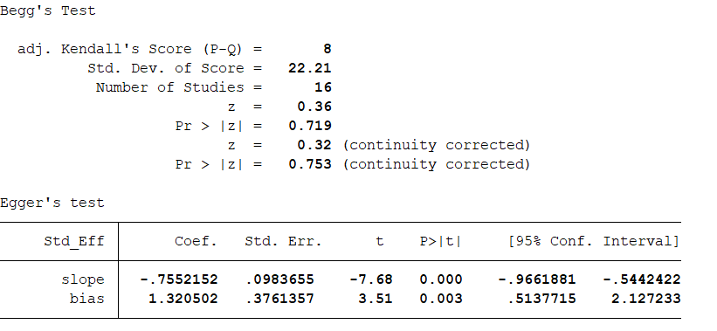

(d)
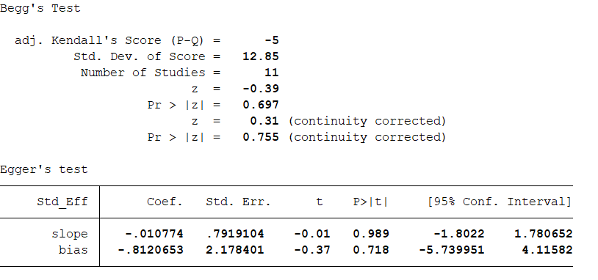

(e)
