Association between Apolipoproteins and lipoprotein(a) values with metabolic syndrome: A systematic review and meta-analysis

Supplementary Material
Table S1. Search strategies
Source | PubMed
Search | Formula
#1 | Metabolic Syndrome [MH] OR Cardiometabolic Syndrome [MH] OR Metabolic Syndrome X [MH] OR Reaven Syndrome X [MH] OR Insulin Resistance Syndrome X [MH]
#2 | Apolipoproteins [MH] OR Lipoprotein(a) [MH]
#3 | #1 AND #2
Source | Scopus
Search | Formula
#1 | TITLE-ABS-KEY(“Metabolic Syndrome*” OR “Cardiometabolic Syndrome*” OR “Metabolic Syndrome X*” OR “Insulin Resistance Syndrome X*” OR “Reaven Syndrome X*”)
#2 | TITLE-ABS-KEY (“Apolipoproteins*”)
#3 | TITLE-ABS-KEY (“Lipoprotein(a)*”)
#4 | #2 OR #3
#5 | #1 AND #4
Source | Web of Science
Search | Formula
#1 | TI=(“Metabolic Syndrome*” OR “Cardiometabolic Syndrome*” OR “Metabolic Syndrome X*” OR “Insulin Resistance Syndrome X*” OR “Reaven Syndrome X*”)
#2 | TI=(“Apolipoproteins*”)
#3 | TI=(“Lipoprotein(a)*”)
#4 | #2 OR #3
#5 | #1 AND #4
Source | Embase
Search | Formula
#1 | 'Metabolic Syndrome'/exp
#2 | 'Apolipoproteins'/exp
#3 | 'Lipoprotein(a)'/exp
#4 | #2 OR #3
#5 | #1 AND #4
Source | OVID
Search | Formula
#1 | ('Metabolic Syndrome* OR Cardiometabolic Syndrome* OR Metabolic Syndrome X* OR Insulin Resistance Syndrome X* OR Reaven Syndrome X *).kw.
#2 | (Apolipoproteins*).kw.
#3 | ('Lipoprotein(a)*).kw.
#4 | #2 OR #3
#5 | #1 AND #4

Table S2. Criteria for clinical diagnosis of metabolic syndrome used in the included studies
Diagnostic criteria | Definition
American Heart Association/National Heart Lung and Blood Institute (AHA/NHLBI) | Three of more of following five criteria needed to be present: (1) waist circumference > 90 cm for men and >80 cm for women, (2) fasting serum triglycerides >= 150 mg/dl or on drug treatment for elevated triglycerides, (3) HDL cholesterol <40 mg/dl for men and <50 mg/dl for women or on drug treatment to increase HDL cholesterol, (4) fasting blood glucose >100 mg/dl or on drug treatment for diabetes and (5) systolic blood pressure >130 mmHg or diatolic > 85 mmHg or on drug treatment for hypertension.
National Cholesterol Education Program-Adult Treatment Panel III(NCEP-ATP III) | Three of the following factors: waist circumference >102cm (men) or >88cm(women), triglyceride level ≥1.69mmol/l, HDL cholesterol<1.03mmol/l (men) or < 1.29mmol/l (women), blood pressure ≥130/85mmHg, or fasting glucose ≥6.1mmol/l.
International Diabetes Federation(IDF) | Central obesity plus any two of the following four factors: raised fasting plasma glucose (≥100 mg/dL) or treatment of previously diagnosed type 2 diabetes, raised blood pressure (systolic blood pressure ≥130 or diastolic blood pressure ≥85 mmHg) or treatment of previously diagnosed hypertension, raised triglycerides (≥150 mg/dl), and reduced HDL cholesterol (<40 mg/dL in males, <50 mg/dL in females).
Chinese Diabetes Society(CDS) | Three of the following 5 criteria: abdominal obesity (waistline ≥90 cm in adult male and 85 cm in adult female subjects), elevated blood pressure (SBP ≥130 mmHg and/or DBP ≥85 mmHg, or on treatment for diagnosed hypertension formerly), hyperglycemia (FBG ≥6.1 mmol/L, or on appropriate hypoglycemic medication), elevated TG (≥1.7 mmol/L, or on appropriate lipid-lowering medication) and reduced HDL-C (<1.03 mmol/L in adult male and <1.30 mmol/L in adult female subjects, or on appropriate lipid-lowering medication).
World Health Organization(WHO) | Impaired glucose intolerance, Impaired fasting glycemiaI, T2DM, or lowered insulin sensitivity plus any 2 of the following: (1)Men: waist-to-hip ratio >0.90,women: waist-to-hip ratio >0.85 and/or BMI >30; (2) TG ≥150 mg/dL and/or HDL-C <35 mg/dL in men or <39 mg/dL in women; systolic blood pressure ≥140 mmHg or diatolic ≥ 90 mmHg and (3) microalbuminuria
Harmonized Definition of MetS (HDM) | Three or more of the following: 1) waist circumference ≥ 90 cm in menand ≥85 cm in women; 2) triglycerides ≥150 mg/dL; 3) HDL cholesterol <40 mg/dL inmen and <50 mg/dL in women; 4) blood pressure ≥ 130/85 mm Hg or on antihypertensivemedication; and 5) fasting glucose ≥ 100 mg/dL or on antidiabetic medication.

Table S3. Quality assessment of included studies
 | NEWCASTLE - OTTAWA QUALITY ASSESSMENT SCALE FOR COHORT STUDIES
STUDY |  | SELECTION |  |  |  | COMPARABILITY | OUTCOME
 |  | Representativeness of the exposed cohort | Selection of the non-exposed cohort | Ascertainment of exposure | Demonstration that outcome of interest was not present at start of study | Comparability of Cohorts on the Basis of the Design or Analysis Maximum : ☆☆ | Assessment of outcome | Was follow-up long enough for outcomes to occur | Adequacy of follow up of cohorts | SCORE | Evidence quality
Chou YL et al. (A) |  | ☆ | ☆ | ☆ | ☆ | ☆☆ | ☆ | ☆ | ☆ | 9 | Low risk of bias
Chou YL et al. (B) |  | ☆ | ☆ | ☆ | ☆ | ☆ | ☆ | ☆ | ☆ | 8 | Low risk of bias
Sung K et al. |  | ☆ | ☆ | ☆ | ☆ | ☆☆ | ☆ | ☆ | ☆ | 9 | Low risk of bias
Borja M et al. |  | ☆ | ☆ | ☆ | ☆ | ☆ | ☆ | ☆ | ☆ | 8 | Low risk of bias
 |  |  |  | NEWCASTLE - OTTAWA QUALITY ASSESSMENT SCALE FOR CASE-CONTROL STUDIES
 | STUDY |  | SELECTION |  |  |  | COMPARABILITY |  | EXPOSURE
 |  | Is the case definition adequate? |  | Representativeness of the cases | Selection of Controls | Definition of Controls | Comparability of cases and controls on the basis of the design or analysis (Maximum : ☆☆ ) |  | Same method of ascertainment for cases and controls | Non-Response rate | Ascertainment of exposure | SCORE | Evidence quality
Savinova O et al. |  | ☆ |  | ☆ | ☆ | ☆ | ☆ |  | ☆ | ☆ | ☆ | 8 | Low risk of bias
De Souza J et al. |  | ☆ |  | ☆ | ☆ | ☆ | ☆☆ |  | ☆ | ☆ | ☆ | 9 | Low risk of bias
Belfki H et al. |  | ☆ |  | ☆ | ☆ | ☆ | ☆ |  | ☆ | ☆ | ☆ | 8 | Low risk of bias
Barkas F et al. |  | ☆ |  | ☆ | ☆ | ☆ | ☆ |  | ☆ | ☆ | ☆ | 8 | Low risk of bias
Reynoso-Villalpando G et al. |  | ☆ |  | ☆ |  |  | ☆ |  | ☆ | ☆ | ☆ | 6 | High risk of bias
Boumaiza I et al. |  | ☆ |  | ☆ | ☆ | ☆ | ☆☆ |  | ☆ | ☆ | ☆ | 9 | Low risk of bias
Sierra-Johnson J et al. |  | ☆ |  | ☆ | ☆ | ☆ | ☆☆ |  | ☆ | ☆ | ☆ | 9 | Low risk of bias
 | NEWCASTLE - OTTAWA QUALITY ASSESSMENT SCALE FOR CROSS-SECTIONAL STUDIES
STUDY |  | SELECTION |  |  |  | COMPARABILITY | OUTCOME
 |  | Representativeness of the sample | Sample size | Non-respondents | Ascertainment of the exposure (risk factor) | The subjects in different outcome groups are comparable, based on the study design or analysis. Confounding factors are controlled.  Maximum : ☆☆ | Assessment of outcome | Statistical test | SCORE | Evidence quality
Lind L et al. |  | ☆ | ☆ | ☆ | ☆ | ☆☆ | ☆ | ☆ | 8 | Low Risk of Bias
Won S et al. (A) |  | ☆ | ☆ | ☆ | ☆ | ☆ | ☆ |  | 6 | High Risk of Bias
Won S et al. (B) |  | ☆ | ☆ | ☆ | ☆ | ☆ | ☆ |  | 6 | High Risk of Bias
Pitsavos C et al. |  | ☆ | ☆ | ☆ | ☆ | ☆ | ☆ |  | 6 | High Risk of Bias
Hee C et al. (A) |  | ☆ | ☆ | ☆ | ☆ | ☆☆ | ☆ | ☆ | 8 | Low Risk of Bias
Hee C et al. (B) |  | ☆ | ☆ | ☆ | ☆ | ☆☆ | ☆ | ☆ | 8 | Low Risk of Bias
Lim Y et al. |  | ☆ | ☆ | ☆ | ☆ | ☆☆ | ☆ | ☆ | 8 | Low Risk of Bias
Dullaart R et al. |  | ☆ | ☆ | ☆ | ☆ | ☆☆ | ☆ | ☆ | 8 | Low Risk of Bias
Sreckovic B et al. |  | ☆ | ☆ | ☆ | ☆ | ☆☆ | ☆ | ☆ | 8 | Low Risk of Bias
Mattsson N et al. |  | ☆ | ☆ | ☆ | ☆ | ☆☆ | ☆ | ☆ | 8 | Low Risk of Bias
Nurtazina A et al. |  | ☆ | ☆ | ☆ | ☆ | ☆☆ | ☆ | ☆ | 8 | Low Risk of Bias
Won D et al. |  | ☆ | ☆ | ☆ | ☆ | ☆☆ | ☆ | ☆ | 8 | Low Risk of Bias
Du R et al. |  | ☆ | ☆ | ☆ | ☆ | ☆☆ | ☆ | ☆ | 8 | Low Risk of Bias
Hye J et al. (A) |  | ☆ | ☆ | ☆ | ☆ | ☆☆ | ☆ | ☆ | 8 | Low Risk of Bias
Hye J et al. (B) |  | ☆ | ☆ | ☆ | ☆ | ☆☆ | ☆ | ☆ | 8 | Low Risk of Bias
Pei W et al. |  | ☆ | ☆ | ☆ | ☆ | ☆☆ | ☆ | ☆ | 8 | Low Risk of Bias
Bonora E et al. |  | ☆ | ☆ | ☆ | ☆ | ☆☆ | ☆ | ☆ | 8 | Low Risk of Bias
Cankurtaran M et al. |  | ☆ | ☆ | ☆ | ☆ | ☆ | ☆ |  | 6 | High Risk of Bias
Muntner P et al. |  | ☆ | ☆ | ☆ | ☆ | ☆☆ | ☆ | ☆ | 8 | Low Risk of Bias
Panagiotakos D et al. |  | ☆ | ☆ | ☆ | ☆ | ☆☆ | ☆ | ☆ | 8 | Low Risk of Bias
Rohit A et al. |  | ☆ | ☆ | ☆ | ☆ | ☆☆ | ☆ | ☆ | 8 | Low Risk of Bias
Li Y et al. |  | ☆ | ☆ | ☆ | ☆ | ☆☆ | ☆ | ☆ | 8 | Low Risk of Bias
Andrea G et al. |  | ☆ | ☆ | ☆ | ☆ | ☆☆ | ☆ | ☆ | 8 | Low Risk of Bias
Sharan H et al. |  | ☆ | ☆ | ☆ | ☆ | ☆☆ | ☆ | ☆ | 8 | Low Risk of Bias
Blatter M et al. |  | ☆ | ☆ | ☆ | ☆ | ☆☆ | ☆ | ☆ | 8 | Low Risk of Bias
Jing F et al. |  | ☆ | ☆ | ☆ | ☆ | ☆☆ | ☆ | ☆ | 8 | Low Risk of Bias
He H et al. |  | ☆ | ☆ | ☆ | ☆ | ☆☆ | ☆ | ☆ | 8 | Low Risk of Bias
Park J et al. |  | ☆ | ☆ | ☆ | ☆ | ☆☆ | ☆ | ☆ | 8 | Low Risk of Bias
Makaridze Z et al. (A) |  | ☆ | ☆ | ☆ | ☆ | ☆☆ | ☆ | ☆ | 8 | Low Risk of Bias
Makaridze Z et al. (B) |  | ☆ | ☆ | ☆ | ☆ | ☆☆ | ☆ | ☆ | 8 | Low Risk of Bias
Boiko A et al. |  | ☆ | ☆ | ☆ | ☆ | ☆☆ | ☆ | ☆ | 8 | Low Risk of Bias
Al-Daghri N et al. |  | ☆ | ☆ | ☆ | ☆ | ☆ | ☆ |  | 6 | High Risk of Bias
Wang W et al. |  | ☆ | ☆ | ☆ | ☆ | ☆☆ | ☆ | ☆ | 8 | Low Risk of Bias
Guven A et al. |  | ☆ | ☆ | ☆ | ☆ | ☆☆ | ☆ | ☆ | 8 | Low Risk of Bias
Wu X et al. |  | ☆ | ☆ | ☆ | ☆ | ☆☆ | ☆ | ☆ | 8 | Low Risk of Bias
Cardoso-Saldaña G et al. |  | ☆ | ☆ | ☆ | ☆ | ☆ | ☆ |  | 6 | High Risk of Bias
Jun J et al. |  | ☆ | ☆ | ☆ | ☆ | ☆☆ | ☆ | ☆ | 8 | Low Risk of Bias
Onat A et al. |  | ☆ | ☆ | ☆ | ☆ | ☆ | ☆ |  | 6 | High Risk of Bias
Gentile M et al. |  | ☆ | ☆ | ☆ | ☆ | ☆☆ | ☆ | ☆ | 8 | Low Risk of Bias
Vaverková H et al. |  | ☆ | ☆ | ☆ | ☆ | ☆ | ☆ |  | 6 | High Risk of Bias
Prasad M et al. |  | ☆ | ☆ | ☆ | ☆ | ☆ | ☆ |  | 6 | High Risk of Bias
Kotani K et al. |  | ☆ | ☆ | ☆ | ☆ | ☆☆ | ☆ | ☆ | 8 | Low Risk of Bias
Mokhsin A et al. (A) |  | ☆ | ☆ | ☆ | ☆ | ☆☆ | ☆ | ☆ | 8 | Low Risk of Bias
Mokhsin A et al. (B) |  | ☆ | ☆ | ☆ | ☆ | ☆☆ | ☆ | ☆ | 8 | Low Risk of Bias
Riediger N et al. |  | ☆ | ☆ | ☆ | ☆ | ☆☆ | ☆ | ☆ | 8 | Low Risk of Bias

Figure S1. Subgroup analysis according to assay method of the association between ApoB levels and MetS
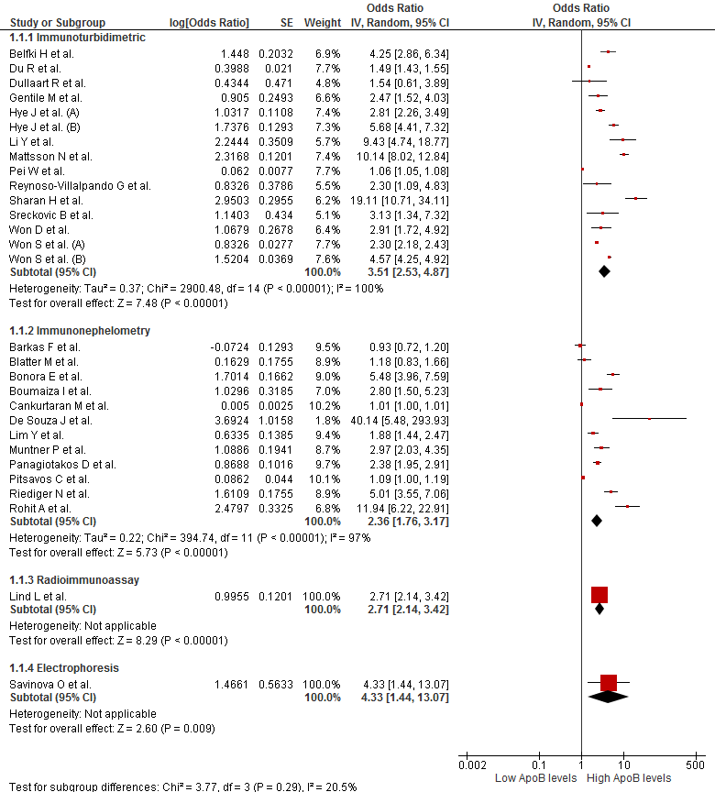
Figure S2. Subgroup analysis according to diagnostic criteria of the association between ApoB levels and MetS
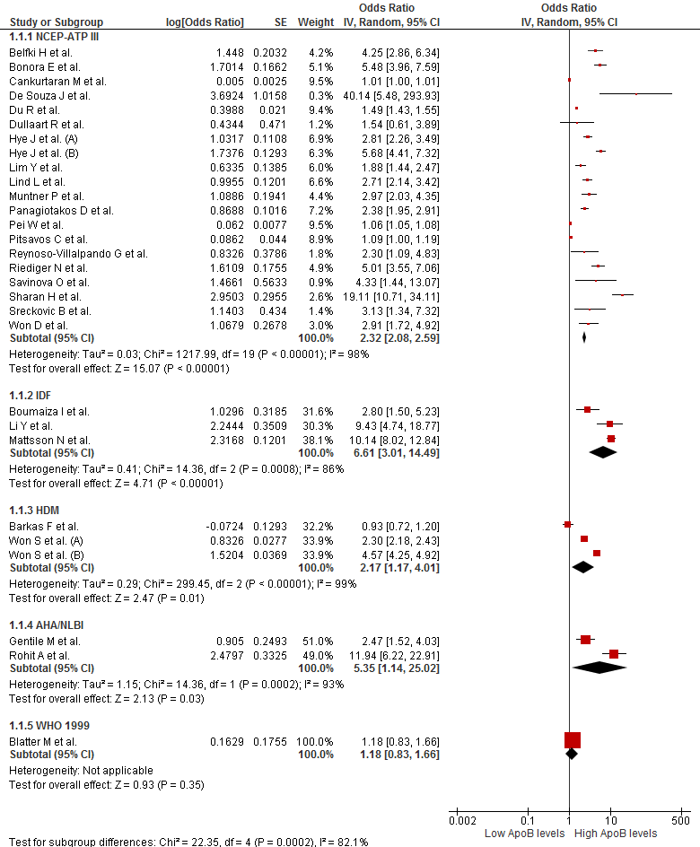
Figure S3. Subgroup analysis according to sex of the association between ApoB levels and MetS
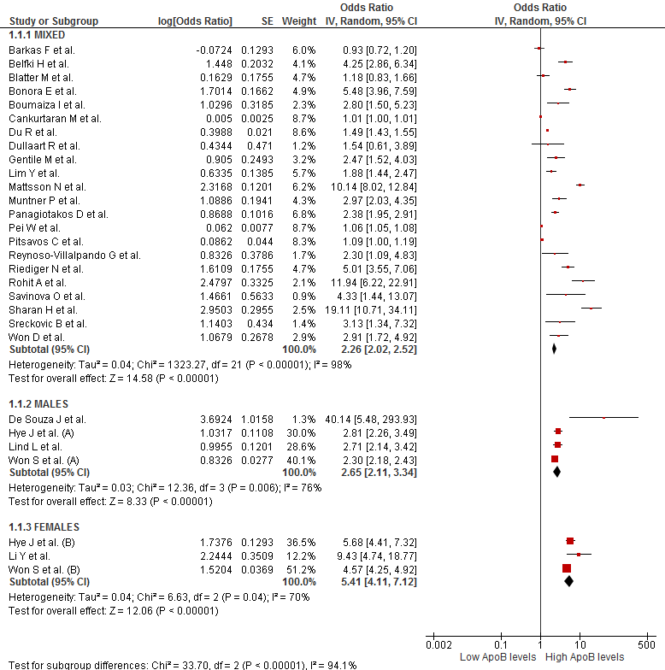
Figure S4. Subgroup analysis according to continents of the association between ApoB levels and MetS
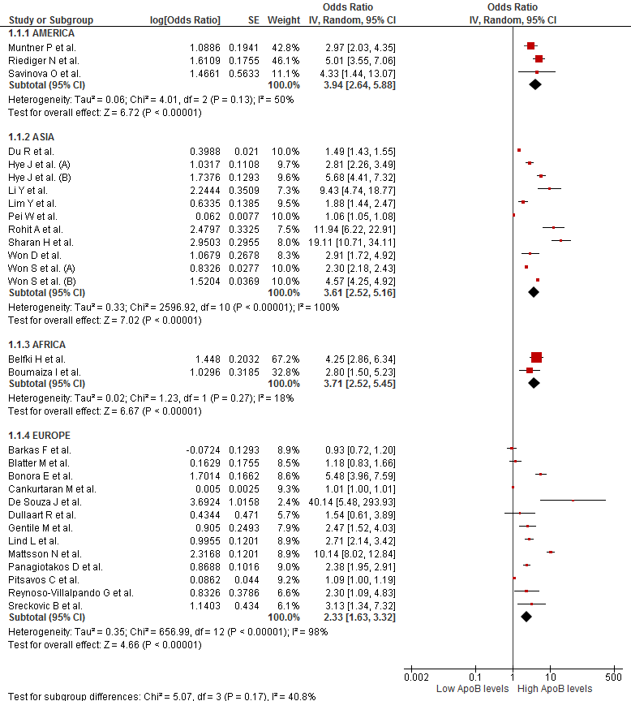
Figure S5. Subgroup analysis according to study design of the association between ApoB levels and MetS
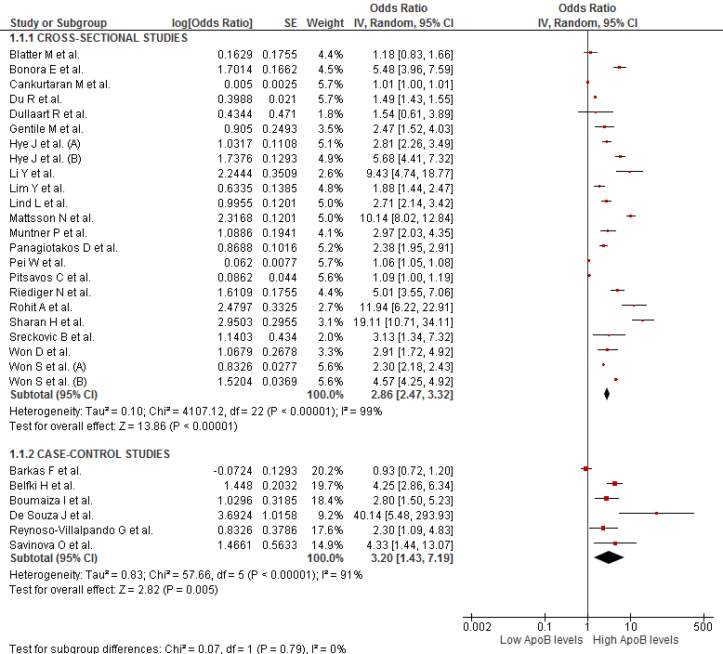
Figure S6. Sensitivity analysis according to risk of bias of the association between ApoB levels and MetS
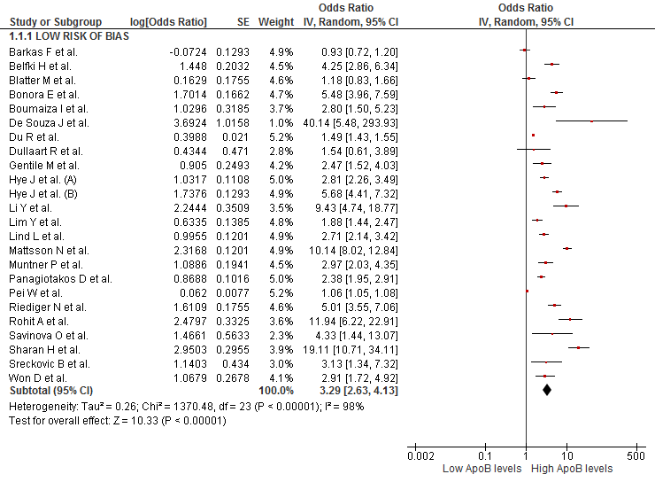
Figure S7. Subgroup analysis according to assay method of the association between ApoA1 levels and MetS
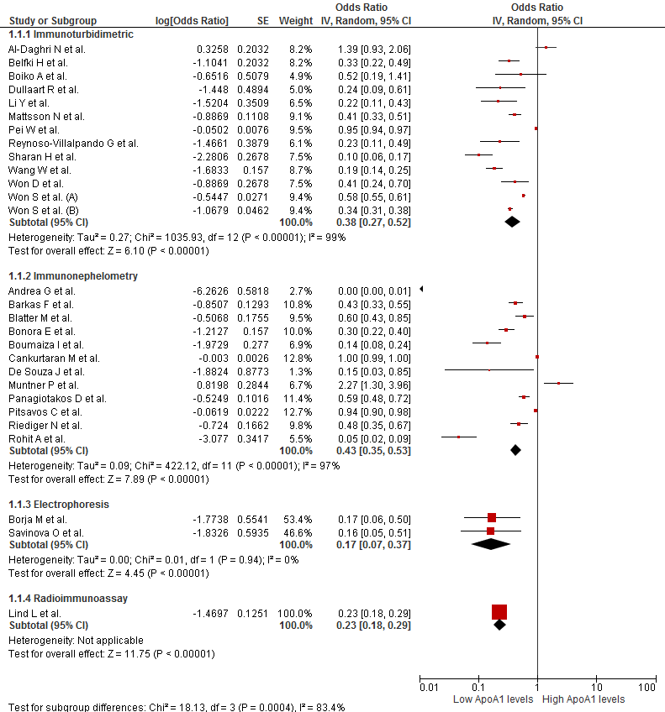
Figure S8. Subgroup analysis according to diagnostic criteria of the association between ApoA1 levels and MetS
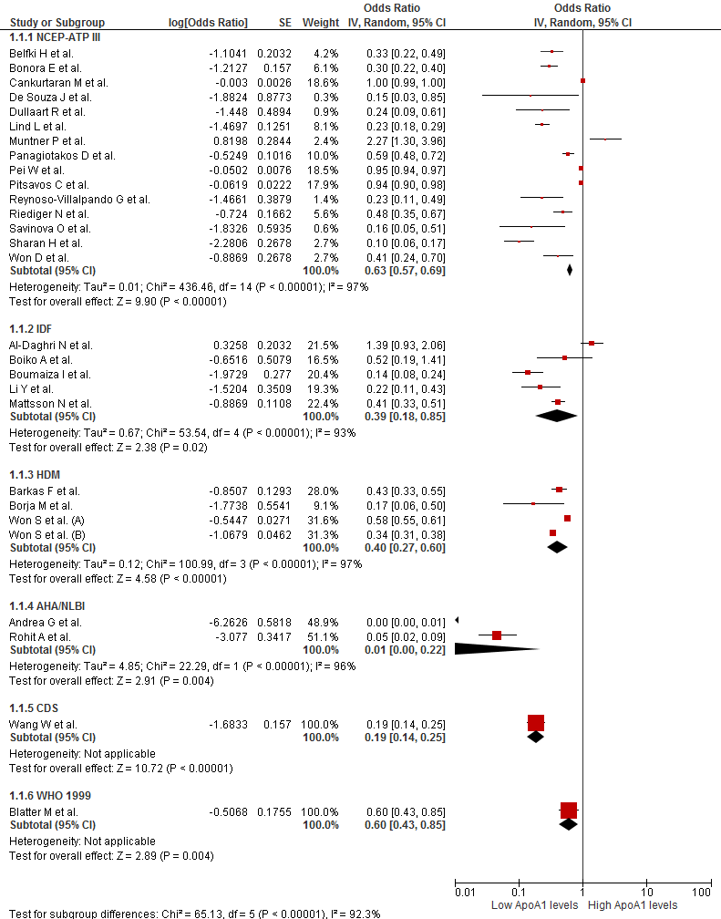
Figure S9. Subgroup analysis according to sex of the association between ApoA1 levels and MetS
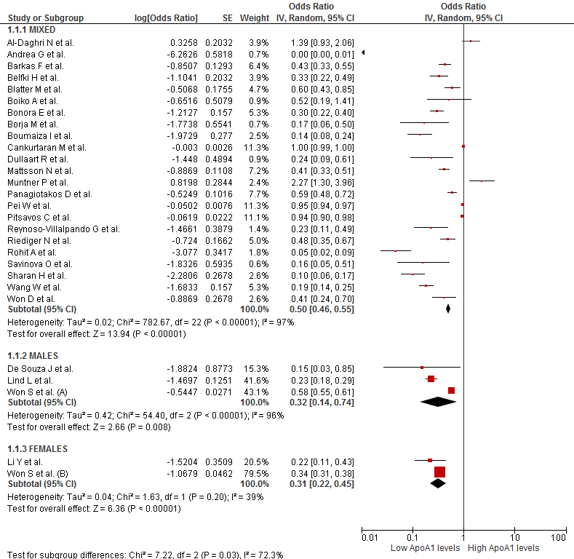
Figure S10. Subgroup analysis according to continents of the association between ApoA1 levels and MetS
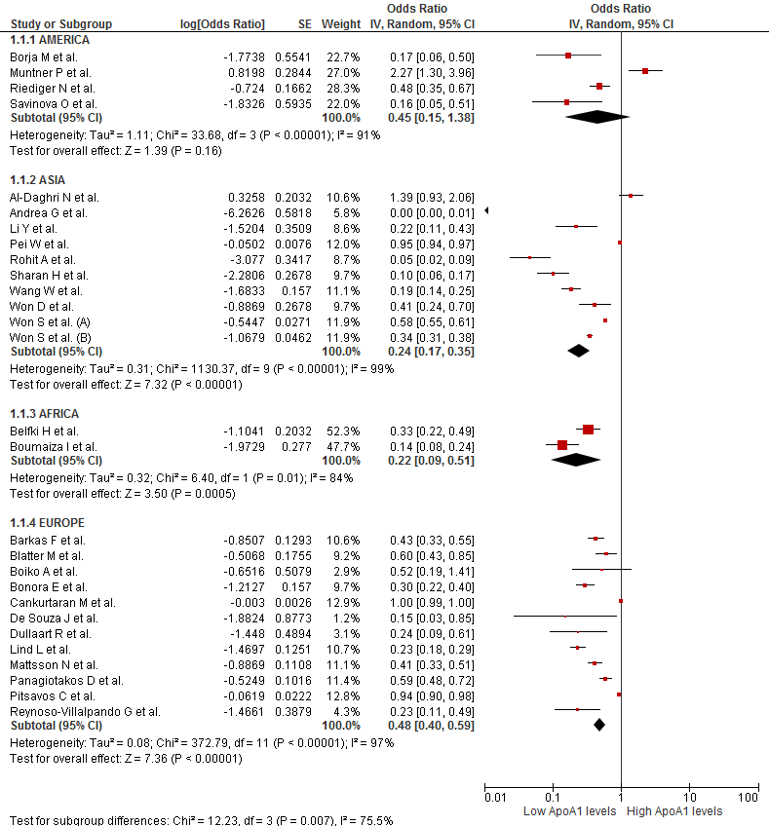

Figure S11. Subgroup analysis according to study design of the association between ApoA1 levels and MetS
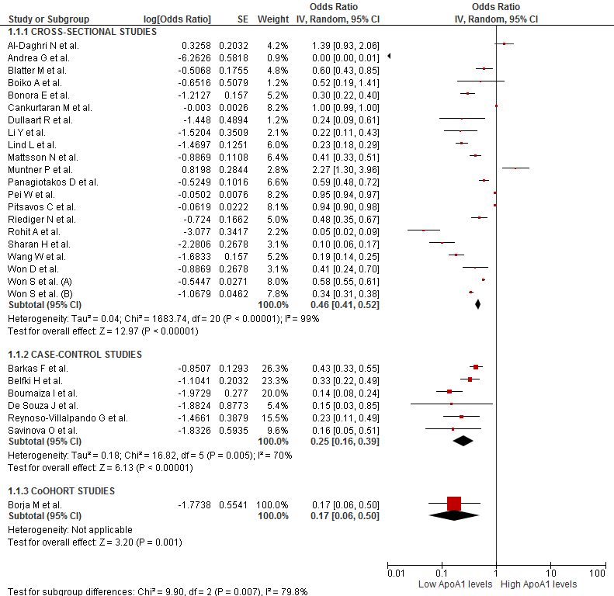
Figure S12. Sensitivity analysis according to risk of bias of the association between ApoA1 levels and MetS
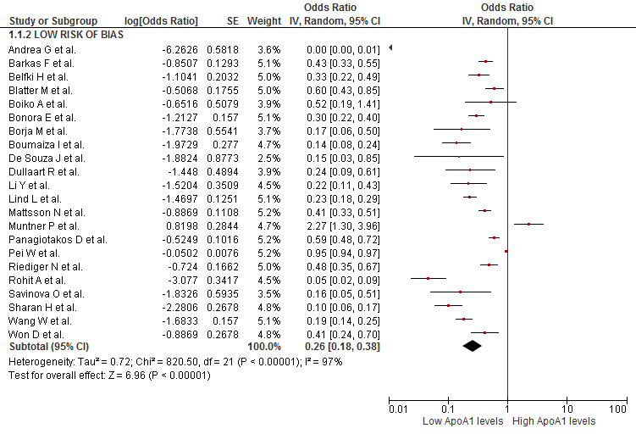
Figure S13. Subgroup analysis according to diagnostic criteria of the association between ApoB/ApoA1 ratio levels and MetS
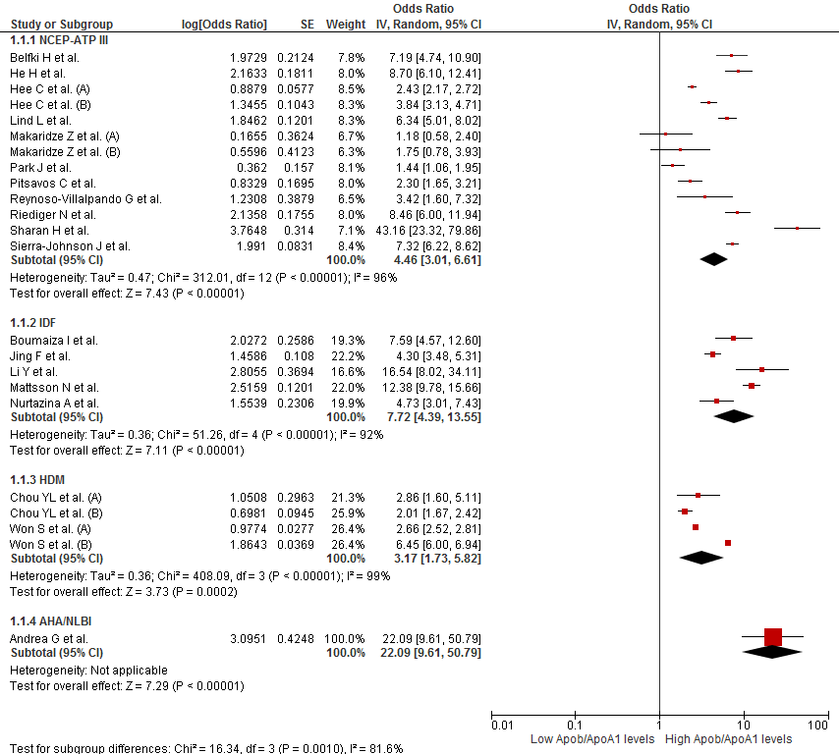
Figure S14. Subgroup analysis according to gender of the association between ApoB/ApoA1 ratio levels and MetS
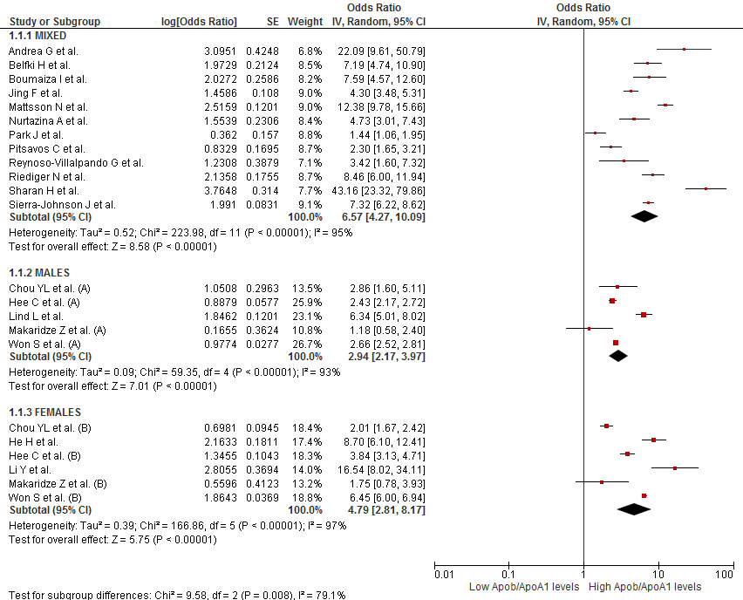
Figure S15. Subgroup analysis according to continents of the association between ApoB/ApoA1 ratio levels and MetS
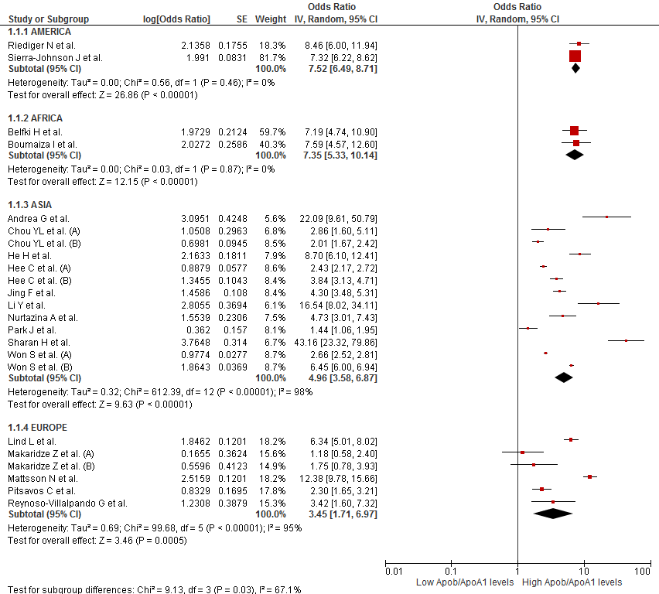
Figure S16. Subgroup analysis according to study design of the association between ApoB/ApoA1 ratio levels and MetS
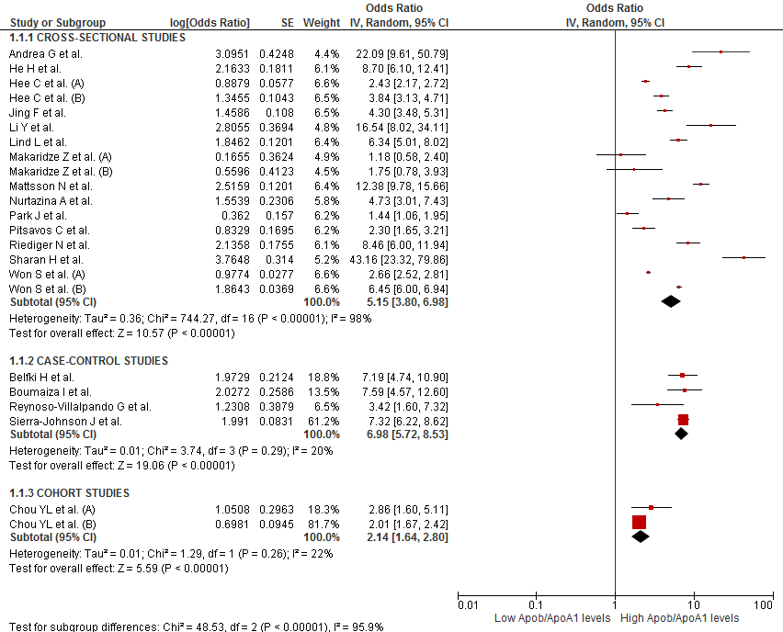
Figure S17. Sensitivity analysis according to risk of bias of the association between ApoB/ApoA1 ratio levels and MetS
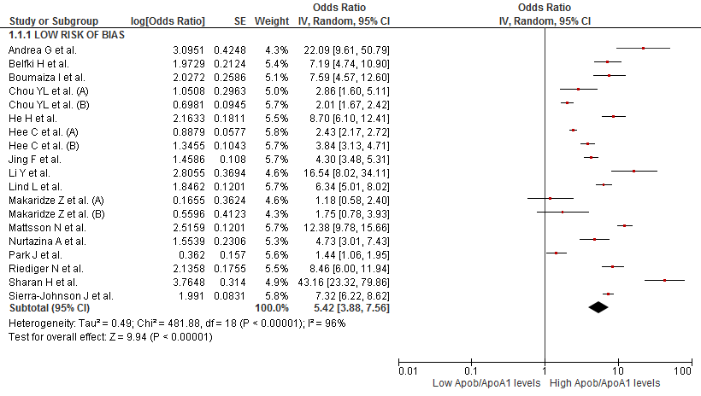
Figure S18. Subgroup analysis according to assay method of the association between lipoprotein(a) levels and MetS
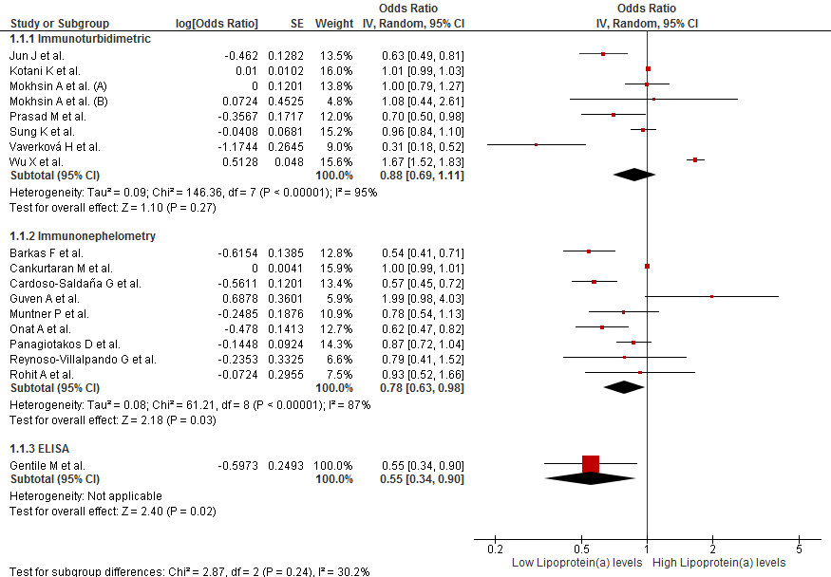
Figure S19. Subgroup analysis according to diagnostic criteria of the association between lipoprotein(a) levels and MetS
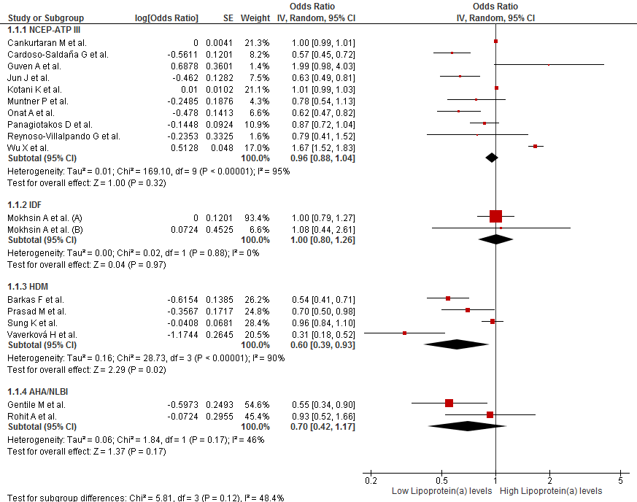
Figure S20. Subgroup analysis according to continents of the association between lipoprotein(a) levels and MetS
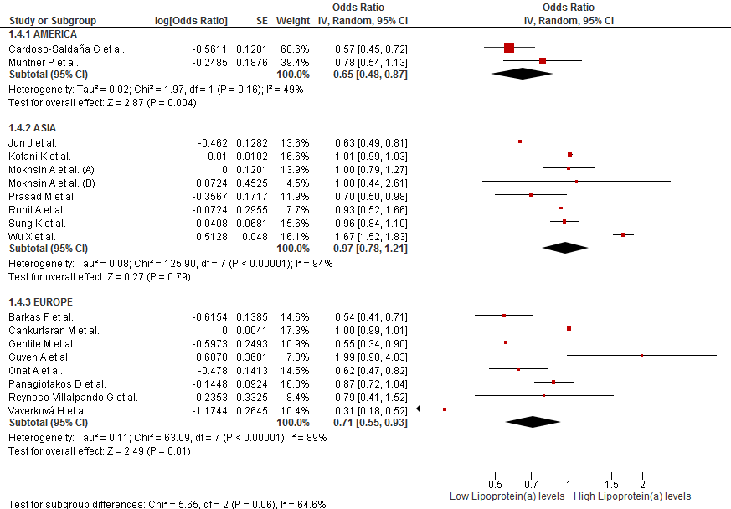
Figure S21. Subgroup analysis according to study design of the association between lipoprotein(a) levels and MetS
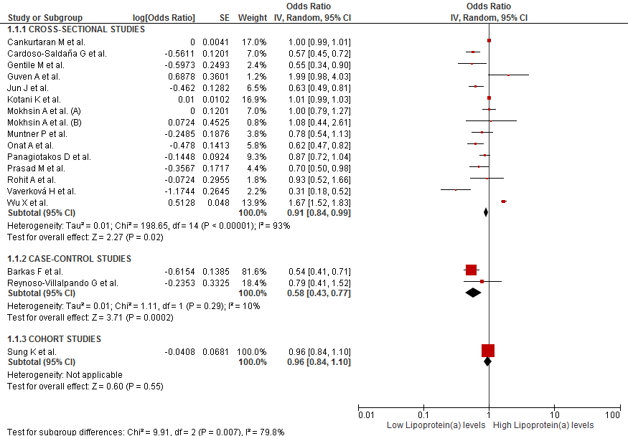

Figure S22. Sensitivity analysis according to risk of bias of the association between lipoprotein(a) levels and MetS
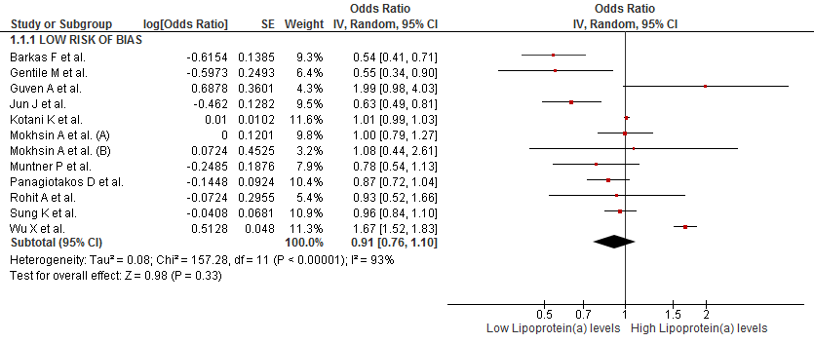
Figure S23. Funnel Plot of the studies that evaluated the association between ApoB and MetS
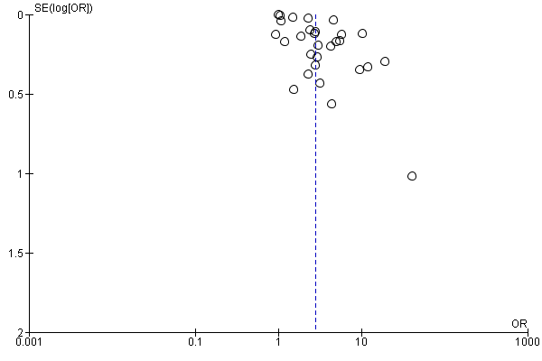
Figure S24. Funnel Plot of the studies that evaluated the association between ApoA1 and MetS
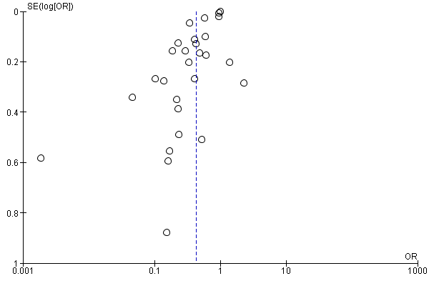
Figure S25. Funnel Plot of the studies that evaluated the association between ApoB/ApoA1 ratio and MetS

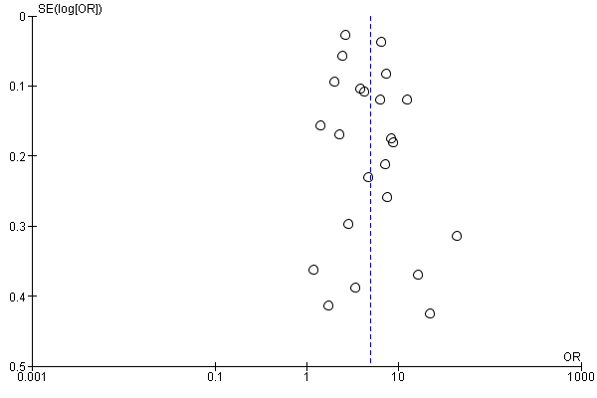
Figure S26. Funnel Plot of the studies that evaluated the association between Lipoprotein (a) and MetS
