Supplementary materials
Balancing adipocyte production and lipid metabolism to treat obesity-induced diabetes with a novel proteoglycan from Ganoderma lucidum

YingXin Wang ¹, Fanzhen Yu ¹, Xinru Zheng ¹, Jiaqi Li ¹, Zeng Zhang ², Qianqian Zhang ¹, Jieying Chen ¹, Yanming He ^{2,*}, Hongjie Yang ^{2,*} and Ping Zhou ^{1,*}.
¹ State Key Laboratory of Molecular Engineering of Polymers, Department of Macromolecular Science, Fudan University, Shanghai 200433, China
² Yueyang Hospital of Integrated Traditional Chinese and Western Medicine, Shanghai University of Traditional Chinese Medicine, Shanghai 200437, China
* Correspondence to: pingzhou@fudan.edu.cn (P.Z.), Tel/Fax: +86-21-31244038; yanghongjie1964@aliyun.com (H.Y.); heyanming176@163.com (Y.H.)

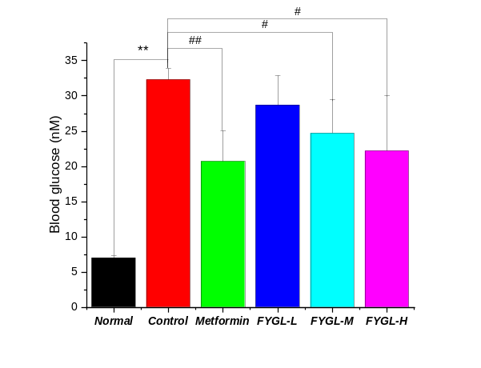  A | 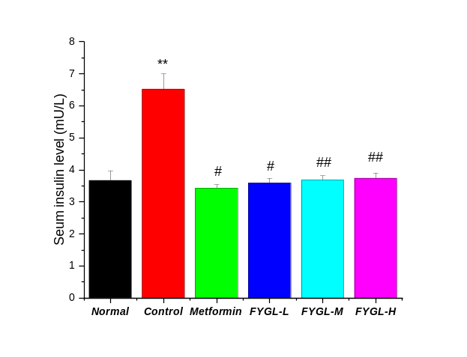  B
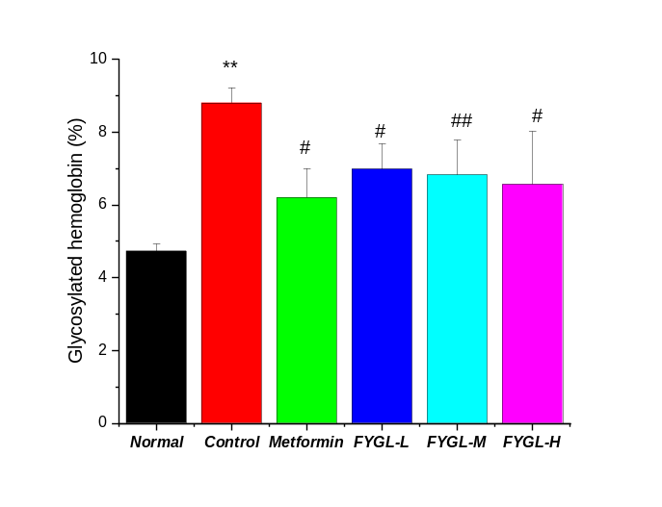
C
Figure S1. Basic metabolic indexes of db/db mice treated with FYGL for 8 weeks. (A) blood glucose; (B) serum insulin level; (C) glycosylated hemoglobin. #p < 0.05, ##p < 0.01, **p < 0.01 vs. control group [1].

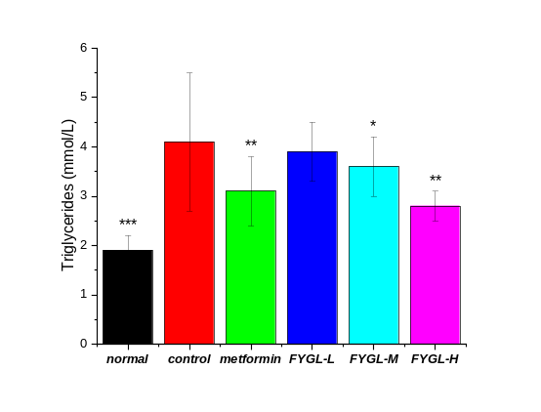  A | 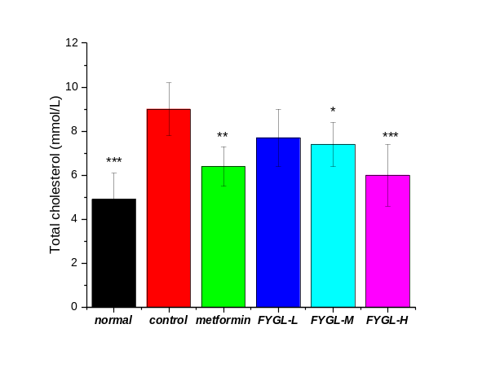  B
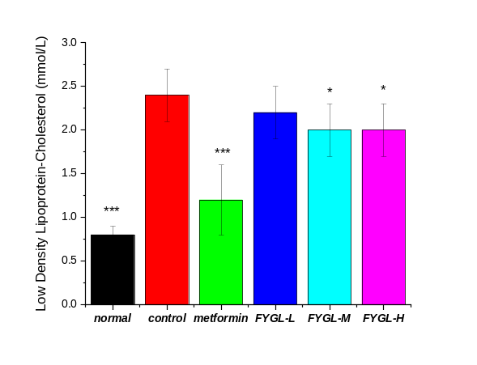  C | 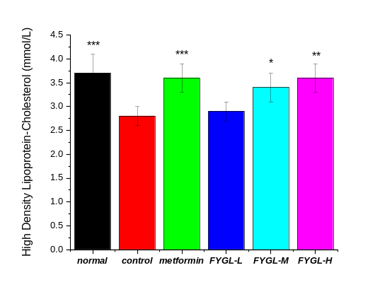  D
Figure S2. Serum lipids profiles of db/db mice treated with FYGL for 8 weeks. (A) TG content; (B) TC content; (C) LDL-c content; (D) HDL-c content. *p < 0.05, **p < 0.01, ***p < 0.001 vs. control group [1].

References
1. Pan D, Zhang D, Wu J, Chen C, Xu Z, Yang H, Zhou P: A novel proteoglycan from Ganoderma lucidum fruiting bodies protects kidney function and ameliorates diabetic nephropathy via its antioxidant activity in C57BL/6 db/db mice. Food and Chemical Toxicology 2014, 63:111-118.

