Table A. 1 VOC metabolites targeted in this study.
VOC metabolites | Parent Compound | Aberration | Detection rate | LLOD  (ng/ml)
2-Methylhippuric acid | Xylene | 2MHA | 92.59% | 5.00
3- and 4-Methylhippuric acid | Xylene | 3MHA+ 4MHA | 99.60% | 8.00
N-Acetyl-S-(2-carbamoylethyl)-L-cysteine | Acrylamide | AAMA | 99.90% | 2.20
N-Acetyl-S-(N-methylcarbamoyl)-L-cysteine | N,N-Dimethylformamide | AMCC | 99.65% | 6.26
2-Aminothiazoline-4-carboxylic acid | Cyanide | ATCA | 96.56% | 15.0
N-Acetyl-S-(benzyl)-L-cysteine | Toluene | BMA | 99.35% | 0.500
N-Acetyl-S-(n-propyl)-L-cysteine | 1-Bromopropane | BPMA | 75.20% | 1.20
N-Acetyl-S-(2-carboxyethyl)-L-cysteine | Acrolein | CEMA | 99.25% | 6.96
N-Acetyl-S-(2-cyanoethyl)-L-cysteine | Acrylonitrile | CYMA | 86.85% | 0.500
N-Acetyl-S-(3,4-dihydroxybutyl)-L-cysteine | 1,3-Butadiene | DHBMA | 99.98% | 5.25
N-Acetyl-S-(2-hydroxypropyl)-L-cysteine | Propylene oxide | 2HPMA | 94.87% | 5.30
N-Acetyl-S-(3-hydroxypropyl)-L-cysteine | Acrolein | 3HPMA | 99.84% | 13.0
Mandelic acid | Styrene | MA | 98.59% | 12.0
N-Acetyl-S-(4-hydroxy-2-butenyl)-L-cysteine | 1,3-Butadiene | MHBMA3 | 96.75% | 0.600
Phenylglyoxylic acid | Ethylbenzene, styrene | PGA | 99.23% | 12.0
N-Acetyl-S-(3-hydroxypropyl-1-methyl)-L-cysteine | Crotonaldehyde | HPMMA | 99.99% | 1.70

Table A.2. Characteristics of study population (N=1410)
Variables | Mean (SD)/N (%)ª
Age (yr) | 48.19 (17.09)
Sex
Men | 729 (51.8)
Women | 681 (48.2)
Race
Non-Hispanic Black | 301 (10.1)
Non-Hispanic White | 602 (70.8)
Other race | 507 (19.2)
Marital status
Married or with partners | 867 (64.8)
Window or divorce | 253 (16.3)
Unmarried | 290 (18.9)
Education level
Less than high School | 275 (13.5)
High School Grad/GED or Equivalent | 299 (19.4)
Some College or AA degree | 428 (34.1)
College Graduate or above | 408 (32.9)
PIR
Low | 322 (14.3)
Middle | 572 (36.4)
High | 516 (49.4)
Smoking
Smoker | 352 (24.7)
Non-smoker | 1058 (75.3)
Drinking
No | 1065 (80.7)
Yes | 345 (19.3)
BMI (kg/m²) | 29.25 (6.88)
Creatinine (mg/dL) | 118.08 (73.05)
Physical activity (min) | 157.50 (265.60)
Energy intake (kcal) | 2242.94 (1007.11)
TC (mg/dL) | 193.08 (40.93)
TG (mg/dL) | 115.52 (66.29)
HDL (mg/dL) | 54.94 (16.53)
LDL (mg/dL) | 115.04 (35.21)

ª, Data are presented as N (weighted %) / weighted mean (SD).

Aberration | TR | TC | LDL-C | HDL-C
2MHA | 0 | 0.05024 | 0.13388 | 0
3MHA+ 4MHA | 0.00252 | 0.00288 | 0.11788 | 0
AAMA | 0.02428 | 0.0028 | 0.12452 | 0
AMCC | 0.09212 | 0.0148 | 0.101 | 0.99836
ATCA | 0.00248 | 0.029 | 0.197 | 0
BMA | 0 | 0.00164 | 0.12068 | 0
BPMA | 0 | 0 | 0.13236 | 0
CEMA | 0.02004 | 0.00984 | 0.13088 | 0
CYMA | 0.13152 | 0.02548 | 0.12712 | 0.0048
DHBMA | 0.0006 | 0.00448 | 0.20596 | 0
2HPMA | 0 | 0 | 0.12172 | 0
3HPMA | 0.00128 | 0 | 0.12 | 0
MA | 0.00592 | 0.09424 | 0.13656 | 1
MHBMA3 | 0.04628 | 0.00276 | 0.11444 | 0.01448
PGA | 0.00136 | 0.00248 | 0.11796 | 0
HPMMA | 0.3962 | 0.00032 | 0.12504 | 0.0002
Table A3 PIP values in BKMR

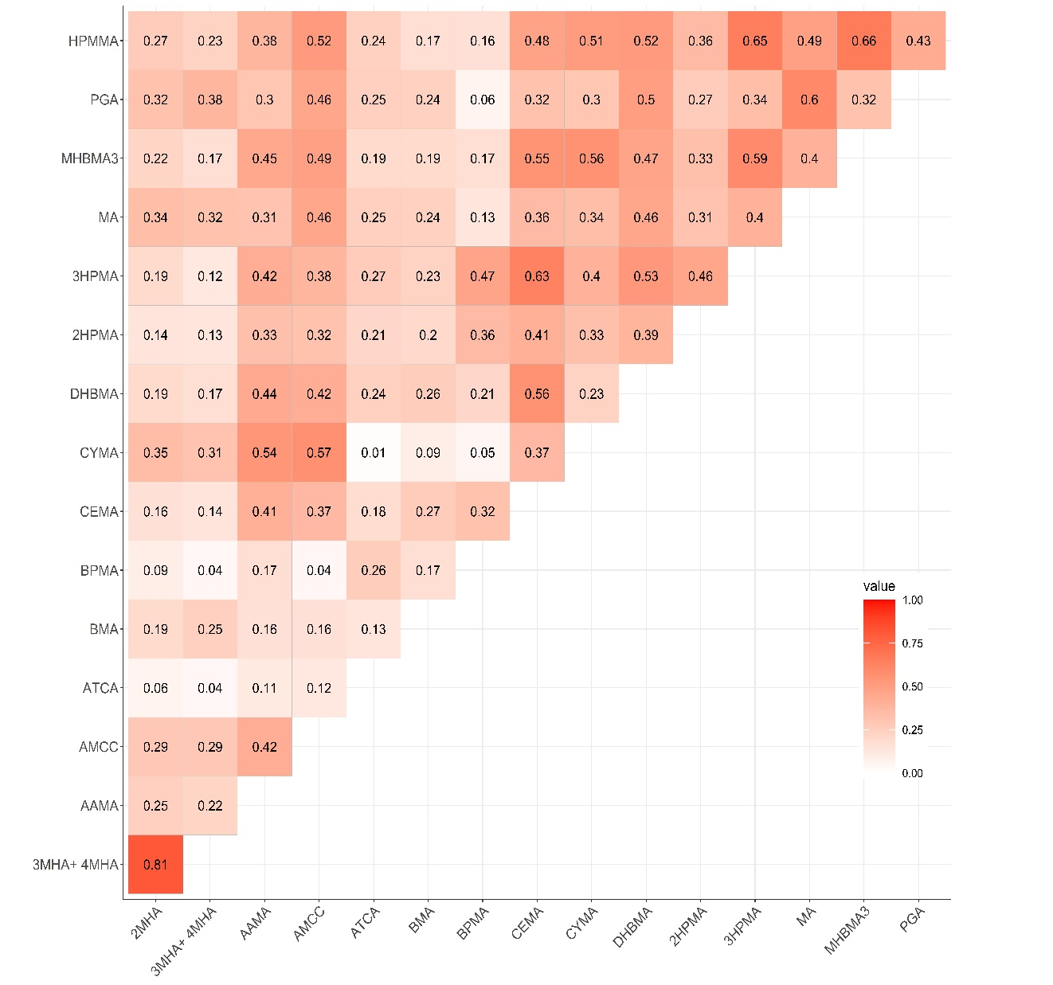

Fig. A.1 Pearson correlation coefficients matrix for the VOCs visualized as heatmap. (Red shows a positive correlation, the intensity of the shaded squares reflects the magnitude of the correlation coefficient.).

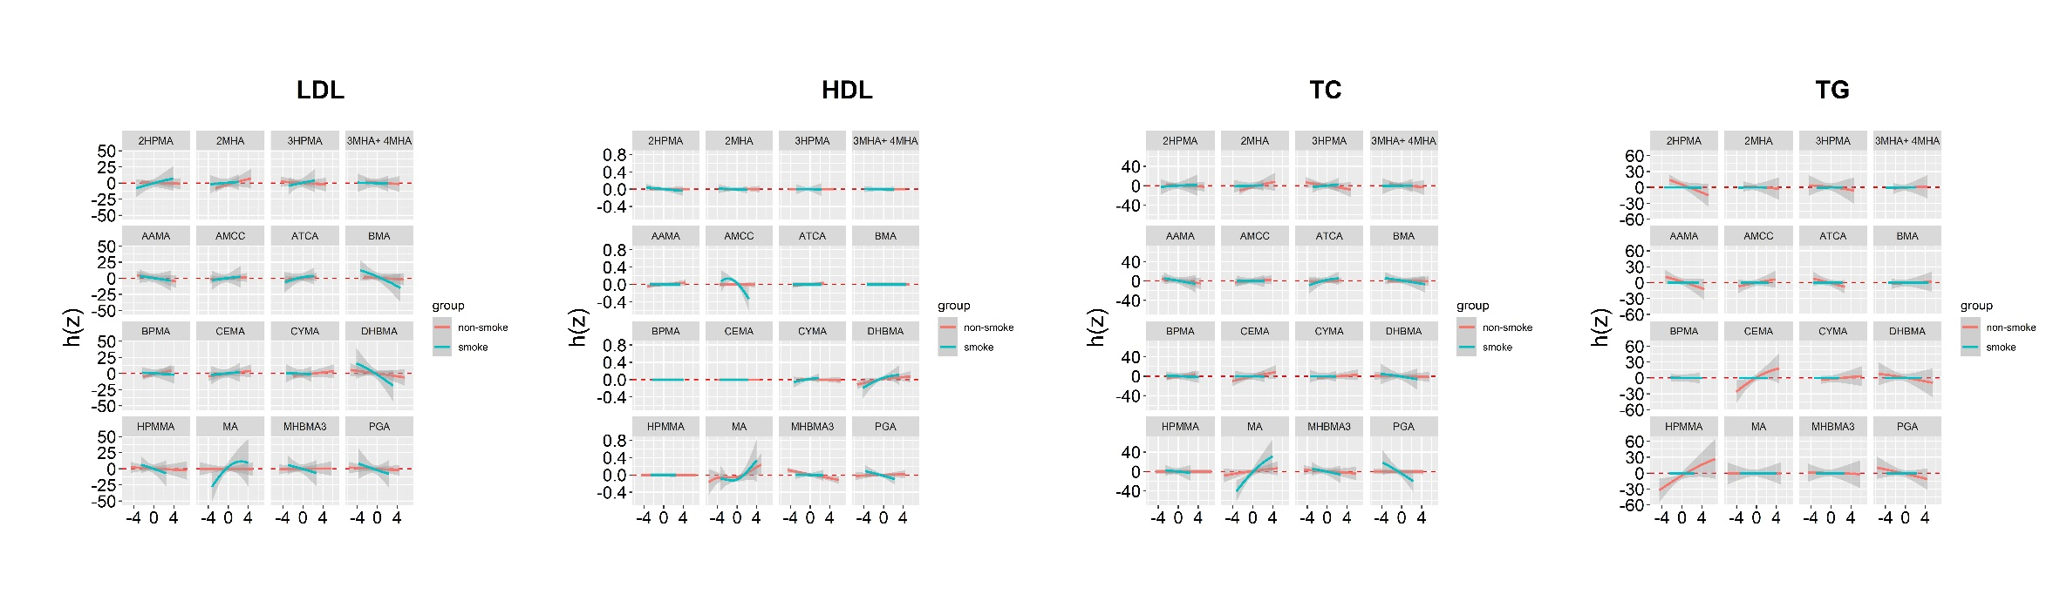
Fig. A.2 Univariate exposure–response functions and 95% credible intervals (shaded areas) for each VOC in smoker and non-smoker with the other VOCs holding at the median.

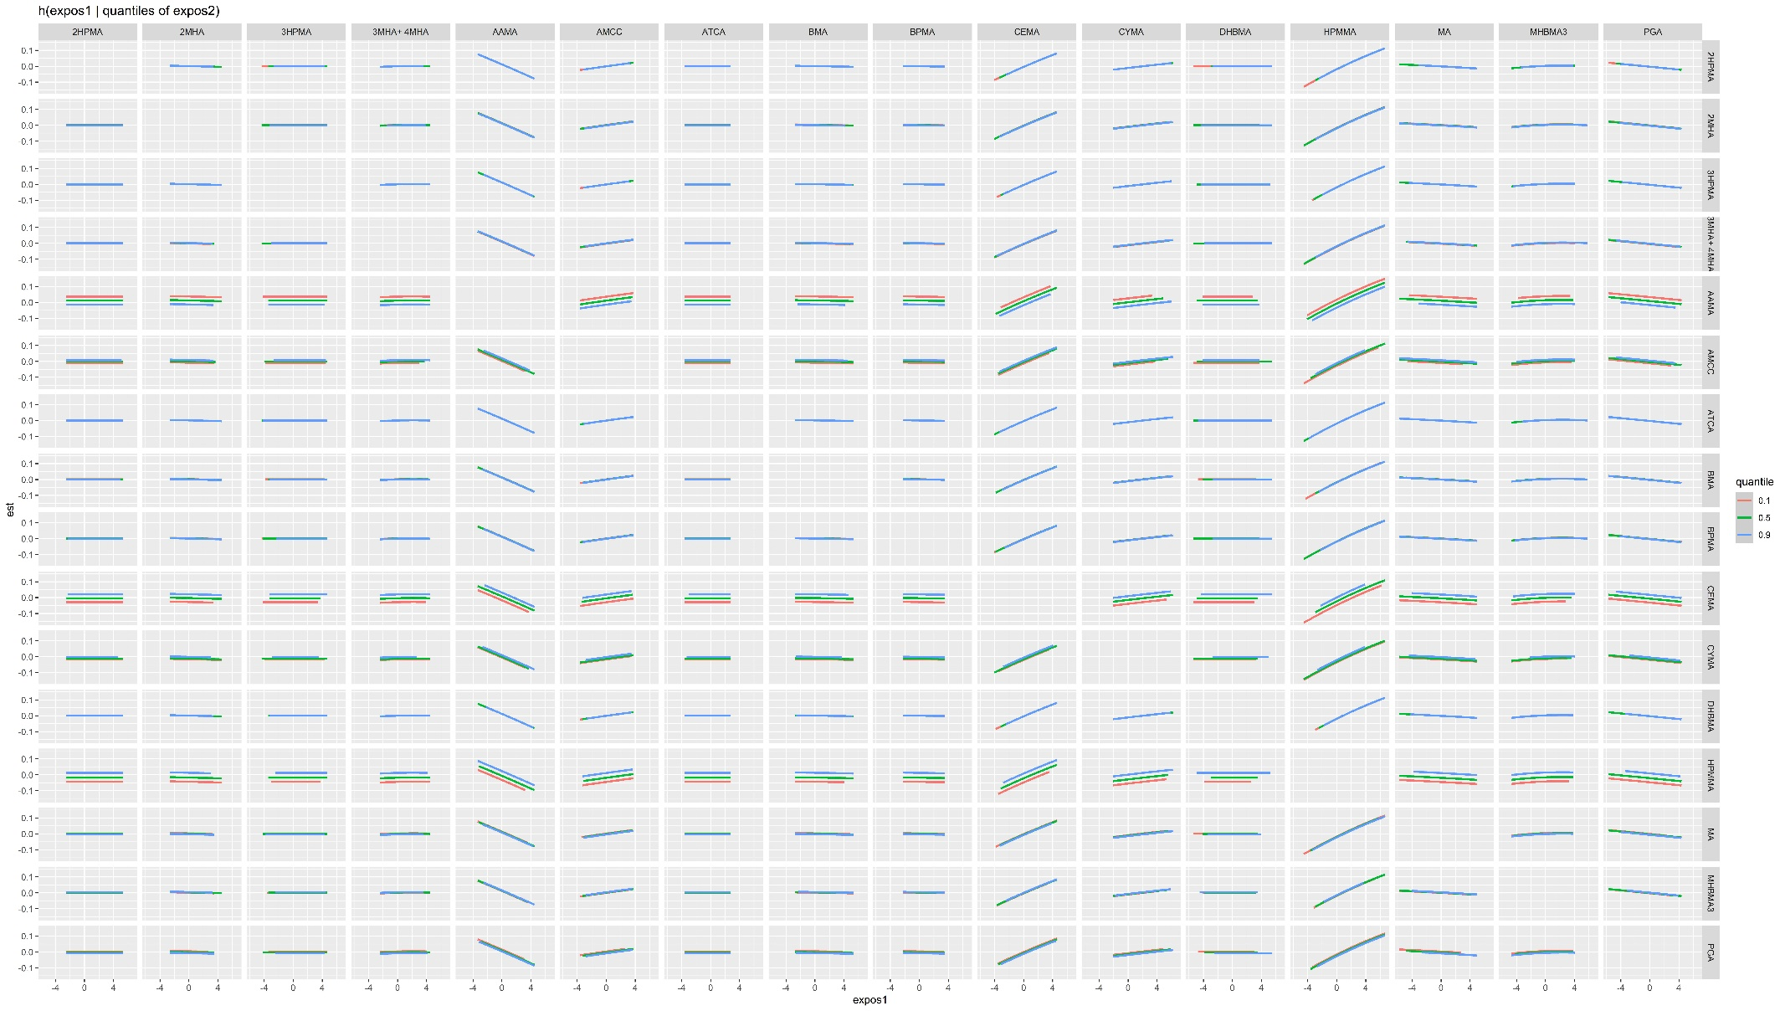
Figure A3 Interaction effect among VOCs on TC in BKMR model.

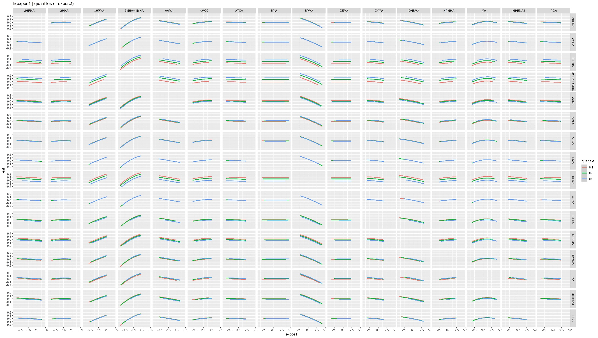
Figure A4 Interaction effect among VOCs on TG in BKMR model.

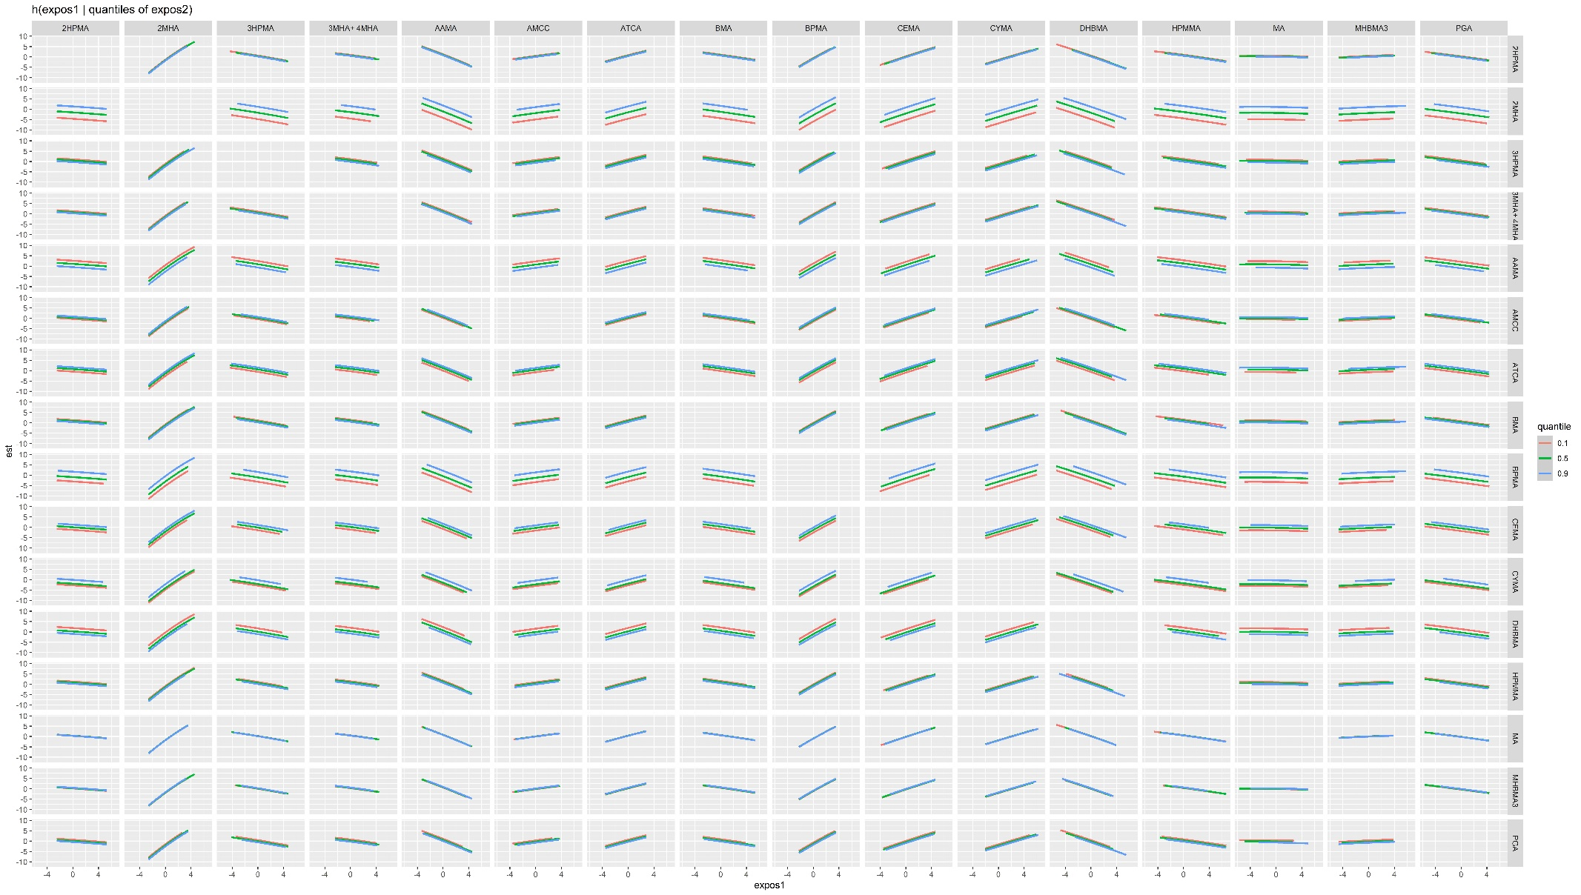
Figure A5 Interaction effect among VOCs on LDL-C in BKMR model.

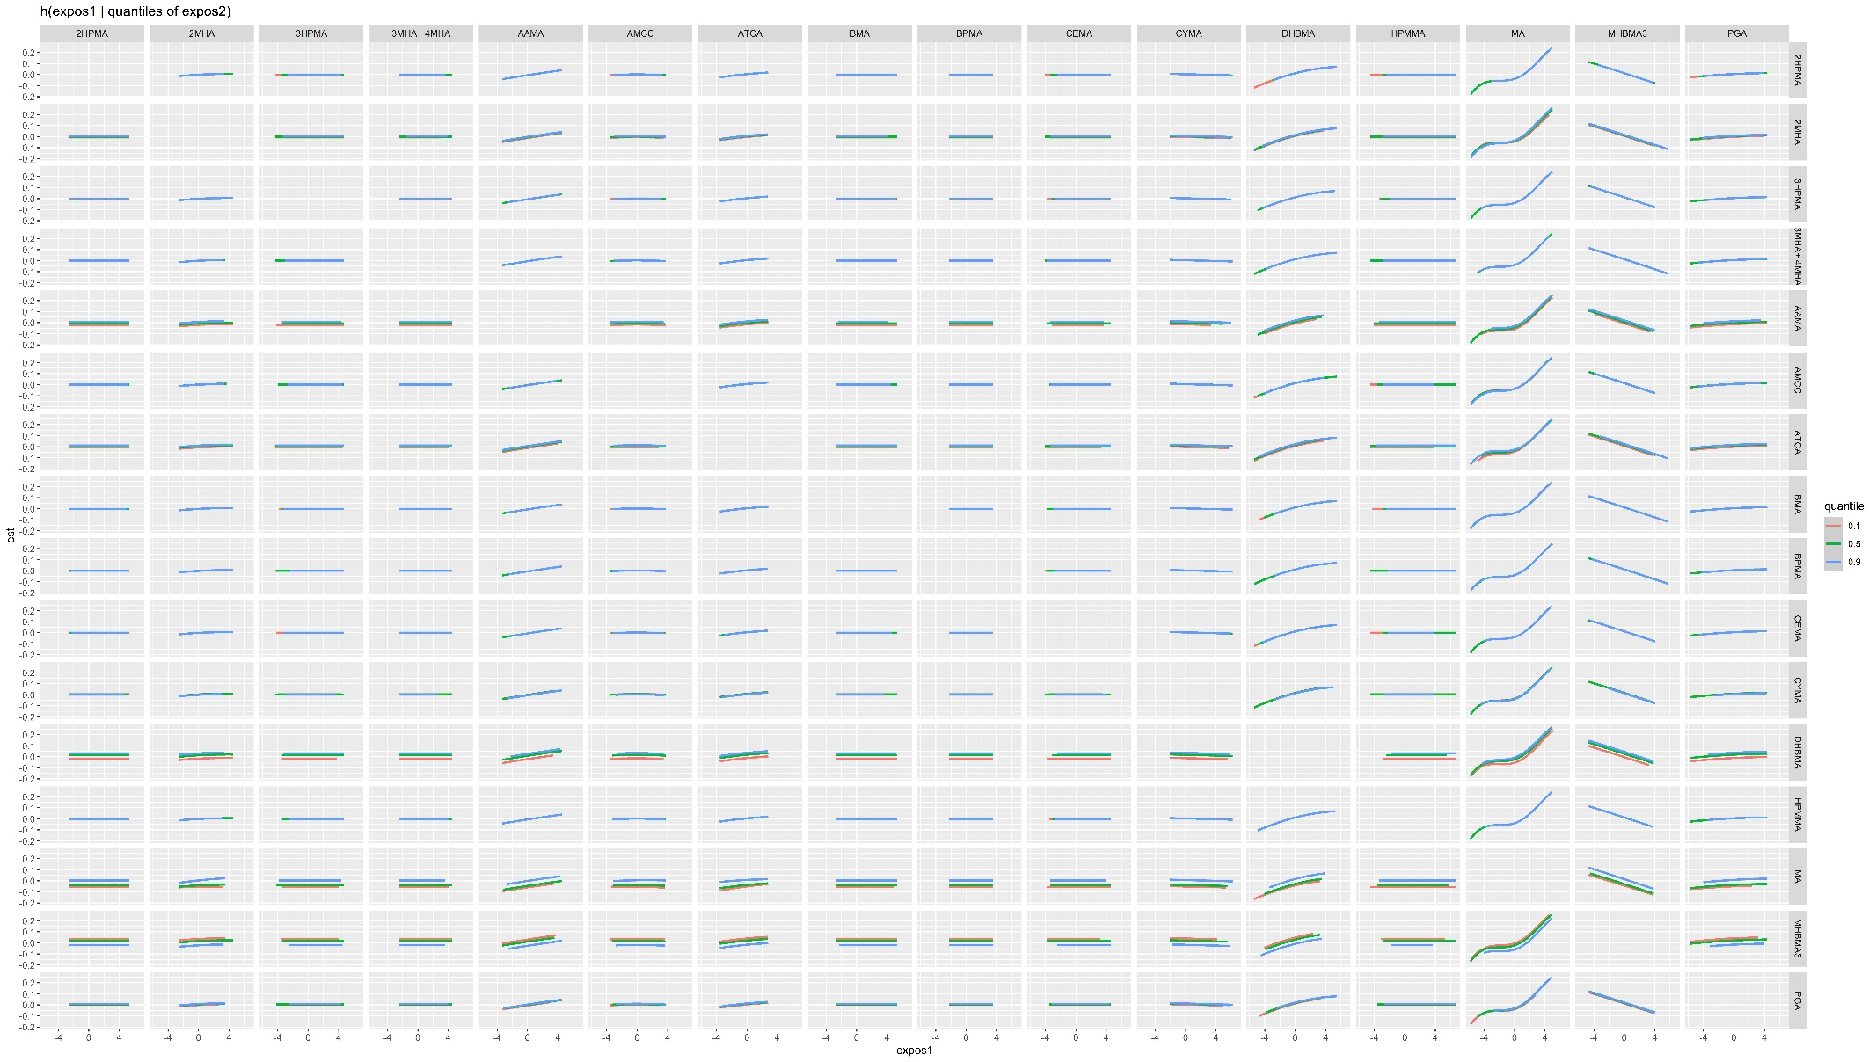
Figure A6 Interaction effect among VOCs on HDL-C in BKMR model.

