Supplementary Figure 1. Study design
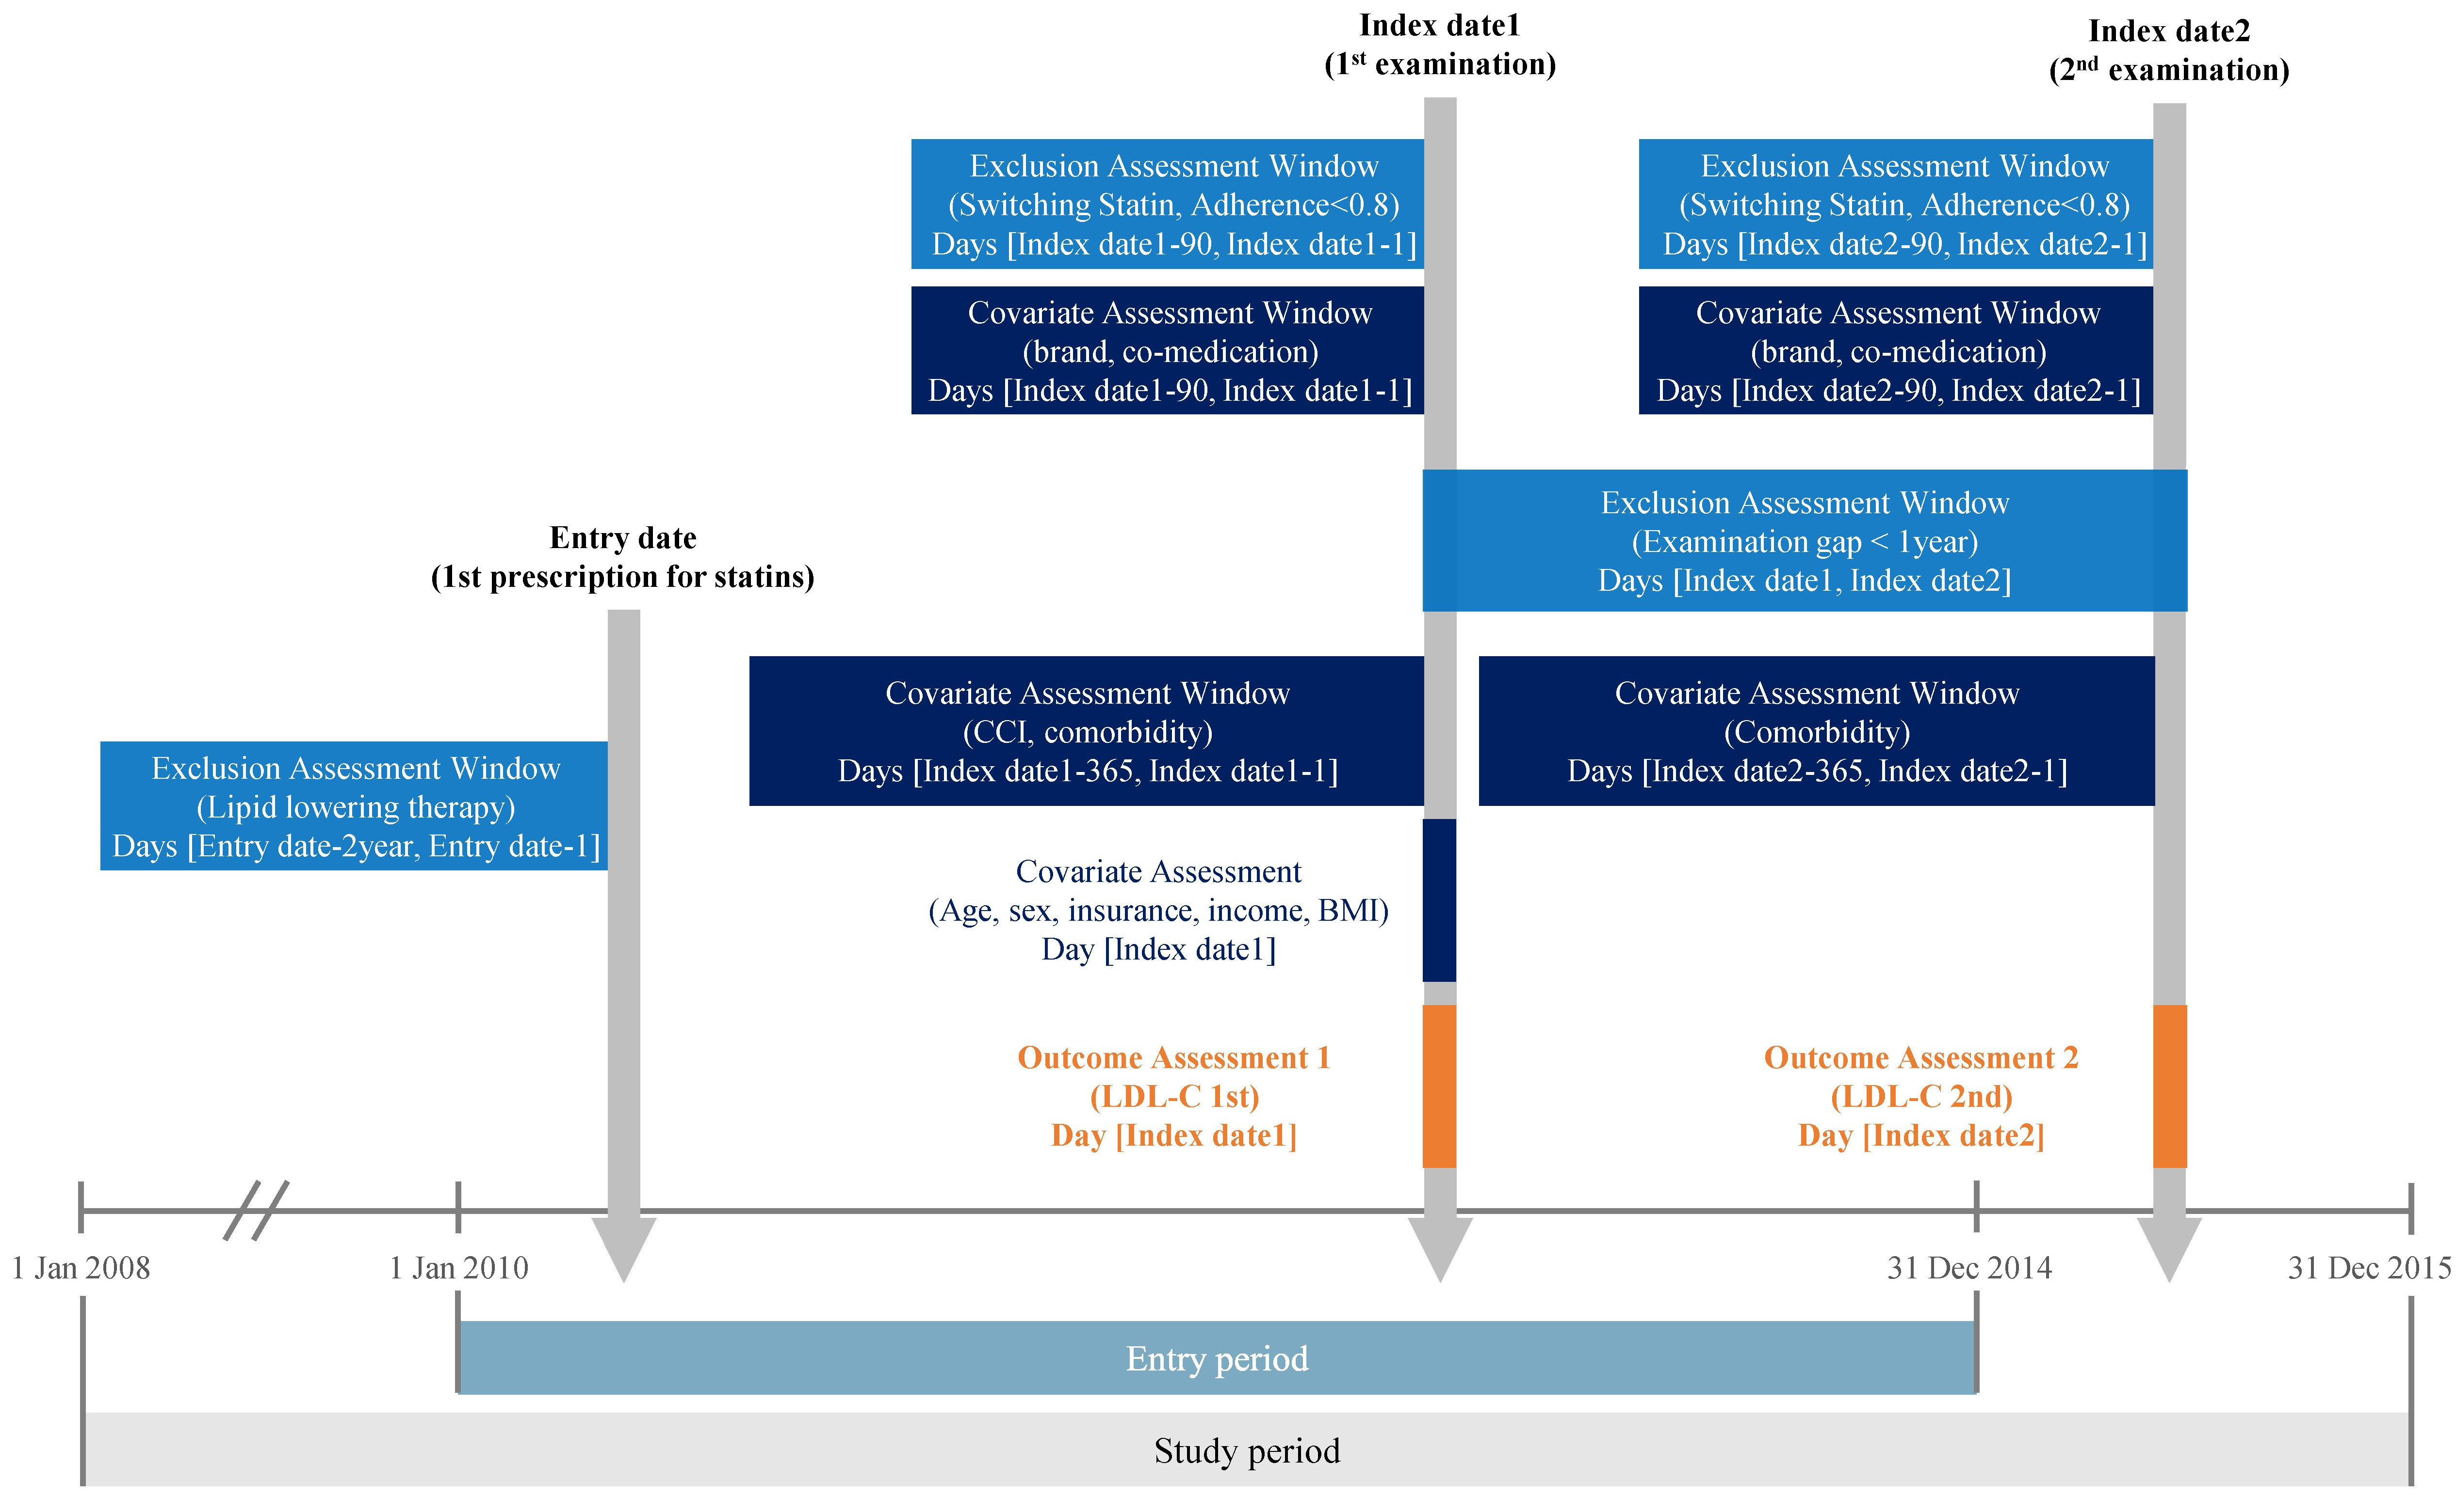
CCI, Charlson comorbidity index; LDL-C, low-density lipoprotein-cholesterol

