

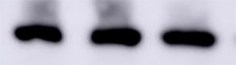
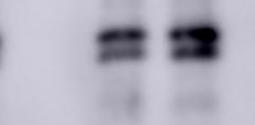
Fig 1
HEK293
HEK293
NC WT WT
NC WT WT
GAPDH
Mature LDLR
Precursor LDLR

GAPDH
Mature LDLR
Precursor LDLR

