Figure S1. Study flow chart.
Figure S2. The transcriptional expression and genetic alterations of ARGs in CRC. A. Heatmap of the expression of top 50 DEGs in the cancer samples and normal samples. B. Volcano plots of DEGs between the above two groups. C. Univariate Cox regression analysis for screening the survival-related ARGs. D. The interaction and correlation of the prognosis related differentially expressed ARGs in CRC. E. The CNV frequency of ARGs F. Locations of CNV alterations on 23 chromosomes.

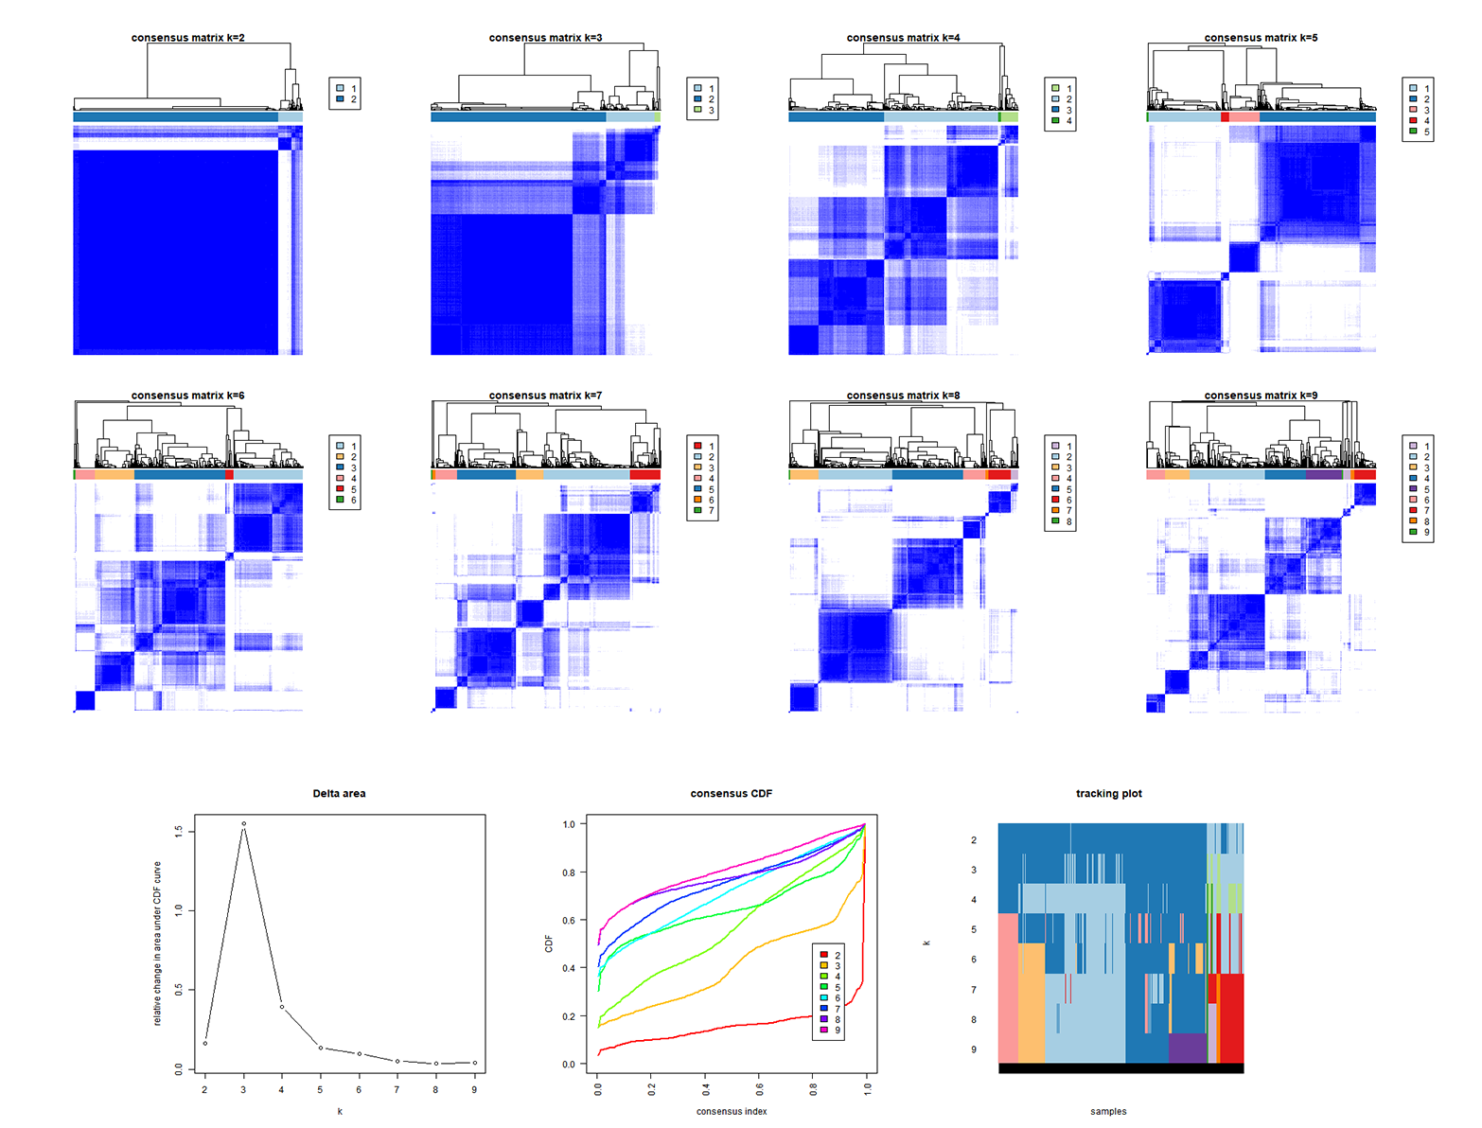
Figure S3. A. Identification of molecular subtypes based on the expression of ARGs through consensus clustering analysis
Figure S4. Somatic mutations alterations of related to the ARGs-based signature in CRC. The maftool exhibited the incidence of somatic mutations of ARGs in low- (A) and high-risk patients (B) of CRC. C, D. Identification of tumour driver genes in both cohorts. Comparison of co-occurrence and mutually exclusive mutations of the mutated genes between the high-risk (E) and low-risk groups (F).
Figure S5. Forest plots showing the results of differentially mutated genes between the high and low-risk cohorts.
Figure S6. Screening of small-molecule drugs between high and low-risk patient subgroups
Figure S7. mRNA expression levels of ARGs in CRC cell line and normal cell line. RT-PCR results of FABP4 (A), CD36 (B), CPT2 (C), ACADL (D) and ANGPT1 (E).

The list of gene primers
ACADL Forward, 5'-TTGGCAAAACAGTTGCTCAC-3'. Reverse, 5'-ACATGTATCCCCAACCTCCA-3'. GAPDH Forward, 5'-GGACCTGACCTGCCGTCTAG-3’. Reverse, 5'-GTAGCCCAGGATGCCCTTGA-3'. Cd36 Forward: 5'-CTTTGGCTTAATGAGACTGGGAC-3' Reverse: 5'-GCAACAAACATCACCACACCA-3'. FABP4 Forward: 5'-TGGGCCAGGAATTTGACGA-3' Reverse: 5'-CATTTCTGCACATGTACCAGGACAC-3'. ANGPT1 Forward: 5'- TGCAGCAACCAGCGCCGAAA-3' Reverse: 5'-CAGGGCAGTTCCCGTCGTGT-3'. CPT2 Forward: 5'-AAAGAAGCAGCAATGGGCCAG-3' Reverse: 5'-CCAGGTAGAGCTCAGGCAAG-3'.

