Table S1. Compositions of experimental diets
 | High-fat diet | Normal chow diet
Energy (kcal/kg diet) | 5240 | 3850
Protein (kcal %) | 20 | 20
Carbohydrate (kcal %) | 20 | 70
Fat (kcal %) | 60 | 10
Ingredient gm % (kcal %)
Casein | 200 (800) | 200 (800)
L-Cystine | 3 (12) | 3 (12)
Corn Starch | 0 (0) | 506.2 (2024.8)
Maltodextrin | 125 (500) | 125 (500)
Sucrose | 68.8 (275) | 68.8 (275)
Cellulose, BW200 | 50 (0) | 50 (0)
Soybean Oil | 25 (225) | 25 (225)
Lard | 245 (2205) | 20 (180)
Mineral Mix S10026 | 10 (0) | 10 (0)
DiCalcium Phosphate | 13 (0) | 13 (0)
Calcium Carbonate | 5.5 (0) | 5.5 (0)
Potassium Citrate, 1 H20 | 16.5 (0) | 16.5 (0)
Vitamin Mix V10001 | 10 (40) | 10 (40)
Choline Bitartrate | 2 (0) | 2 (0)
FD&C Yellow Dye # 5 | 0 (0) | 0.4 (0)
FD&C Red Dye # 40 | 0 (0) | 0 (0)
FD&C Blue Dye # 1 | 0.05 (0) | 0.01 (0)
Total | 773.85 (4057) | 1055.05 (4057)
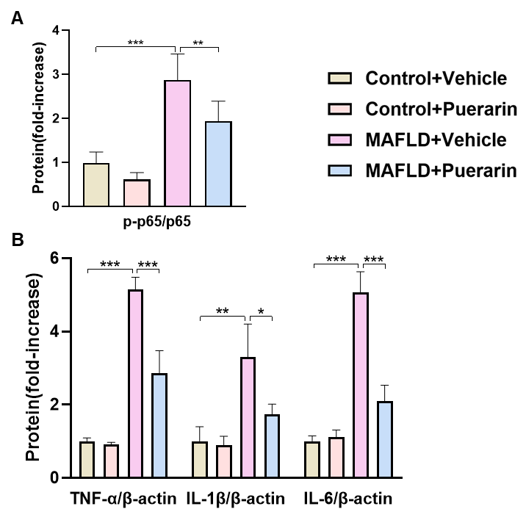
Supplementary Figure 1. A-B. Relative proteins between Control+Vehicle, Control+Puerarin, T2DM+Vehicle, T2DM+Puerarin groups. Densitometric analyses of p-p65/p65, TNF-α, IL-1β, IL-6. Data are expressed as mean ± SD (n = 4). *P < 0.05, **P < 0.01, ***P < 0.001.
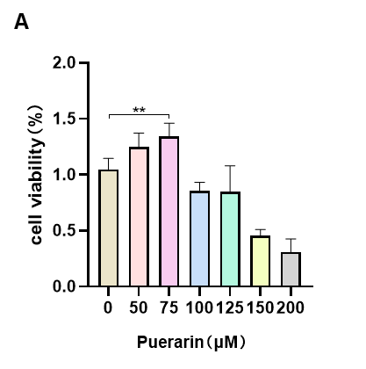
Supplementary Figure 2. A. The cell counting kit 8 (CCK8) assay. The concentration of puerarin (50, 75, 100, 125, 150, 200 μmmol/L) when it was co-incubated with AML12 cells. Data are expressed as mean ± SD (n = 3).*P< 0.05, **P < 0.01, ***P < 0.001.

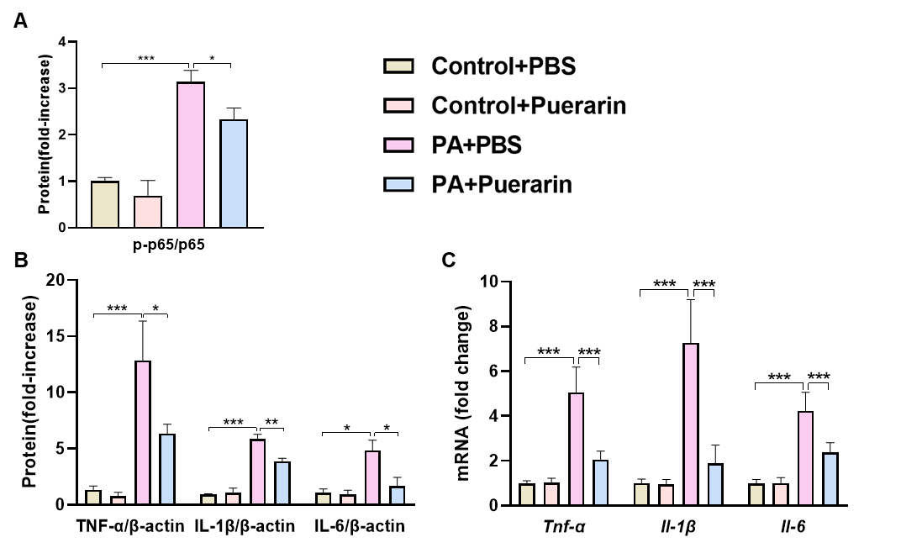
Supplementary Figure 3. A-B. Relative proteins between Control+PBS, Control+Puerarin, PA+PBS, PA+Puerarin groups. Densitometric analyses of p-p65/p65, TNF-α, IL-1β, IL-6. C. AML12 cells mRNA levels of Tnf-α, Il-1β, and Il-6 were detected by RT-qPCR. Data are expressed as mean ± SD (n = 4). *P < 0.05, **P < 0.01, ***P < 0.001.

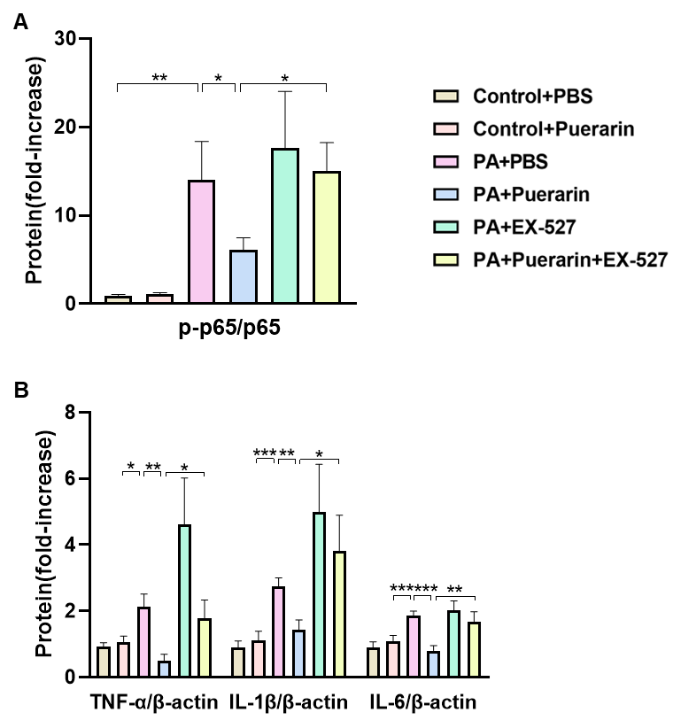Supplementary Figure 4. A-B. Relative proteins between Control+PBS, Control+Puerarin, PA+PBS, PA+Puerarin, PA+EX-527, PA+Puerarin+EX-527 groups. Densitometric analyses of p-p65/p65, TNF-α, IL-1β, IL-6. Data are expressed as mean ± SD (n = 4). *P < 0.05, **P < 0.01, ***P < 0.001.
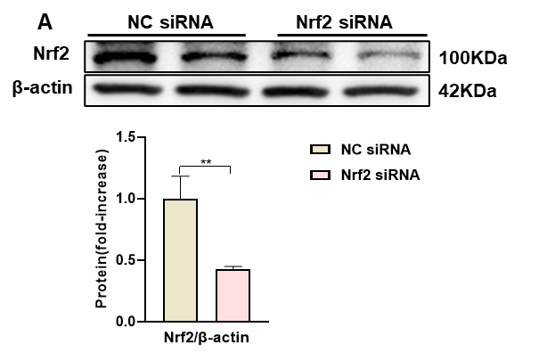
Supplementary Figure 5. A. Nrf2 knockdown verification detected by western blotting. Data are expressed as mean ± SD (n = 3).*P< 0.05, **P < 0.01, ***P < 0.001.

