Supplementary material

 | Random sequence generation | Allocation concealment | Blinding | Incomplete outcome | Selective reporting | Others | Overall
Biessels, 2019 | Low risk | Low risk | Low risk | Unclear | Low risk | Unclear | Unclear
Xue，2020 | Low risk | Unclear | Unclear | Unclear | Unclear | High risk | High risk
Biessels, 2021 | Low risk | Low risk | Low risk | Unclear | Low risk | Unclear | Unclear
Supplementary Table 1. Results of quality assessment of RCT studies using the Cochrane Collaboration’s risk-of-bias tool.

 | Selection | Comparability | Outcome | Quality Scores
Borzì，2019 | **** | * | ** | 7
Isik, 2017 | **** | ** | ** | 8
Bulut, 2020 | **** | ** | ** | 8

Supplementary Table 2. Results of quality assessment of non-RCT studies using the Newcastle-Ottawa Scale.

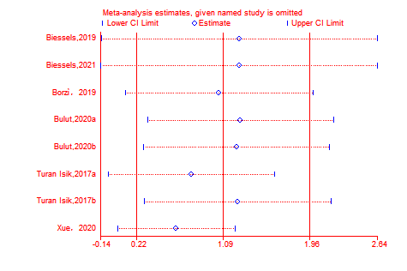
Supplementary Fig.1. Leave-one-out sensitivity analysis.
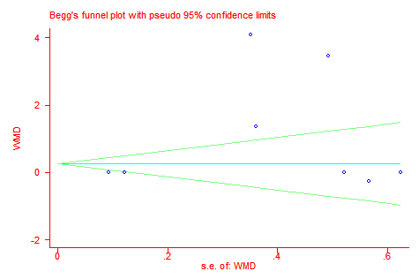
Supplementary Fig.2. Begg’s funnel plot for publication bias evaluation.

