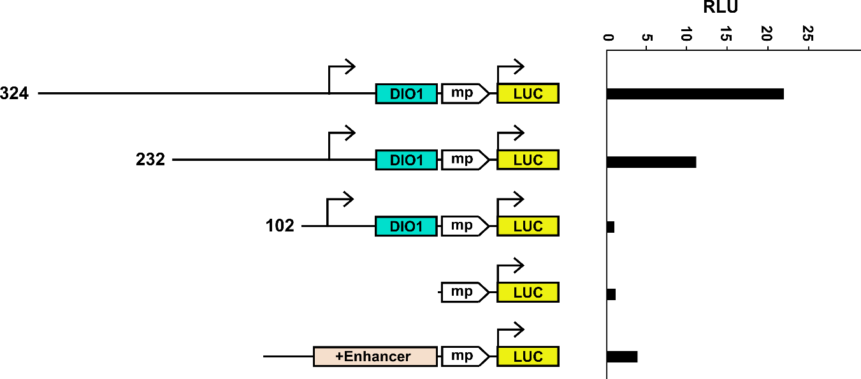

Supplemental Figure S1. Evaluation of enhancer activity by Luciferase reporter assay.

- gRNA-1- Bulk culture
Total efficiency: 97.8%. R² = 0.98
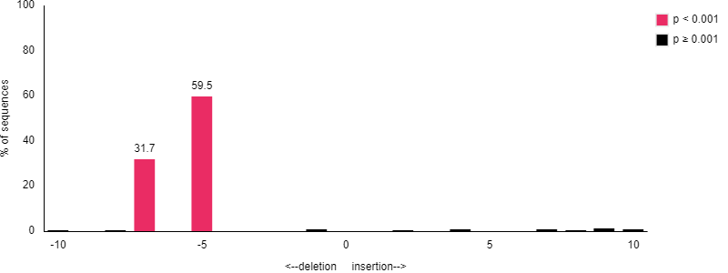

- gRNA-2 Bulk culture
Total efficiency: 88.5%. R² = 0.99
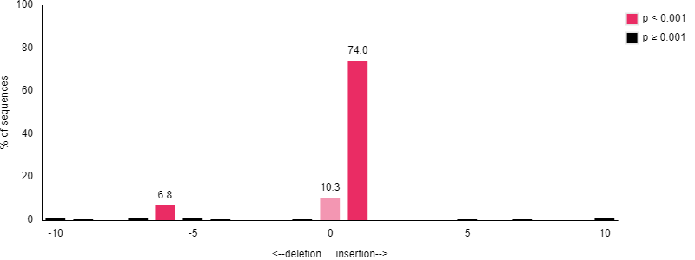

Supplemental Figure S2. Estimation of genome editing efficiency by TIDE. Indel spectrum of UpsDIO1 mutants assessed by Tracking of Indels by Decomposition (TIDE). A) Indel spectrum of gRNA-1 bulk mutant B) Indel spectrum of gRNA-2 bulk mutant.

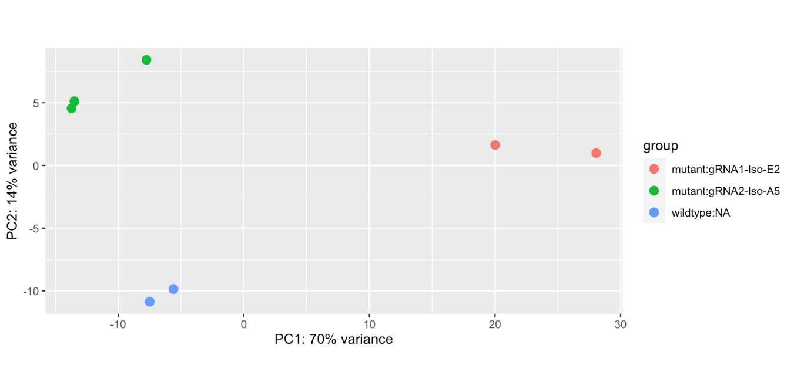

Supplemental Figure S3. PCA of gRNA-1, gRNA-2 mutant clones and WT HepG2 cells

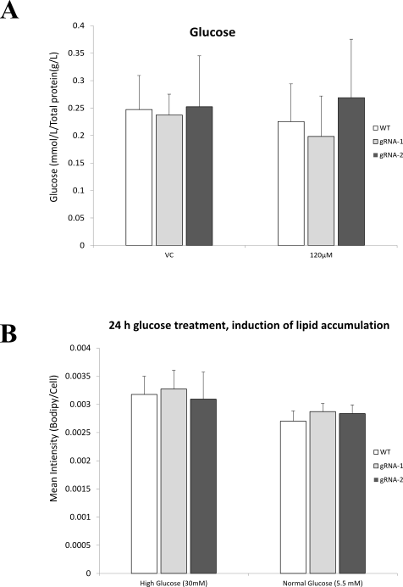

Supplemental Figure S4. A) Biochemical quantification of culture cell extracts after treatment with 120 µM OA for glucose. B) Lipid accumulation by glucose overloading.

