Supplementary material
Figure legends
Figure S1. Correlations of the environmental phenols (BP-3, TCS, MP, PP). Evaluating the correlation between four environmental phenols using Pearson test. ***: P-value < 0.001.
Figure S2. Mediation analysis of cholesterol on the interaction between phenol mixtures and obesity. Cholesterol mediated association between mixed environmental phenols and abdominal obesity. The models were adjusted for urinary creatinine, age, gender, and race/ethnicity, family income-to-poverty ratio (PIR), education levels, physical activity, smoking status, alcohol drinking status, total energy intake, hypertension, and diabetes. *: P-value < 0.05.

Figure S1
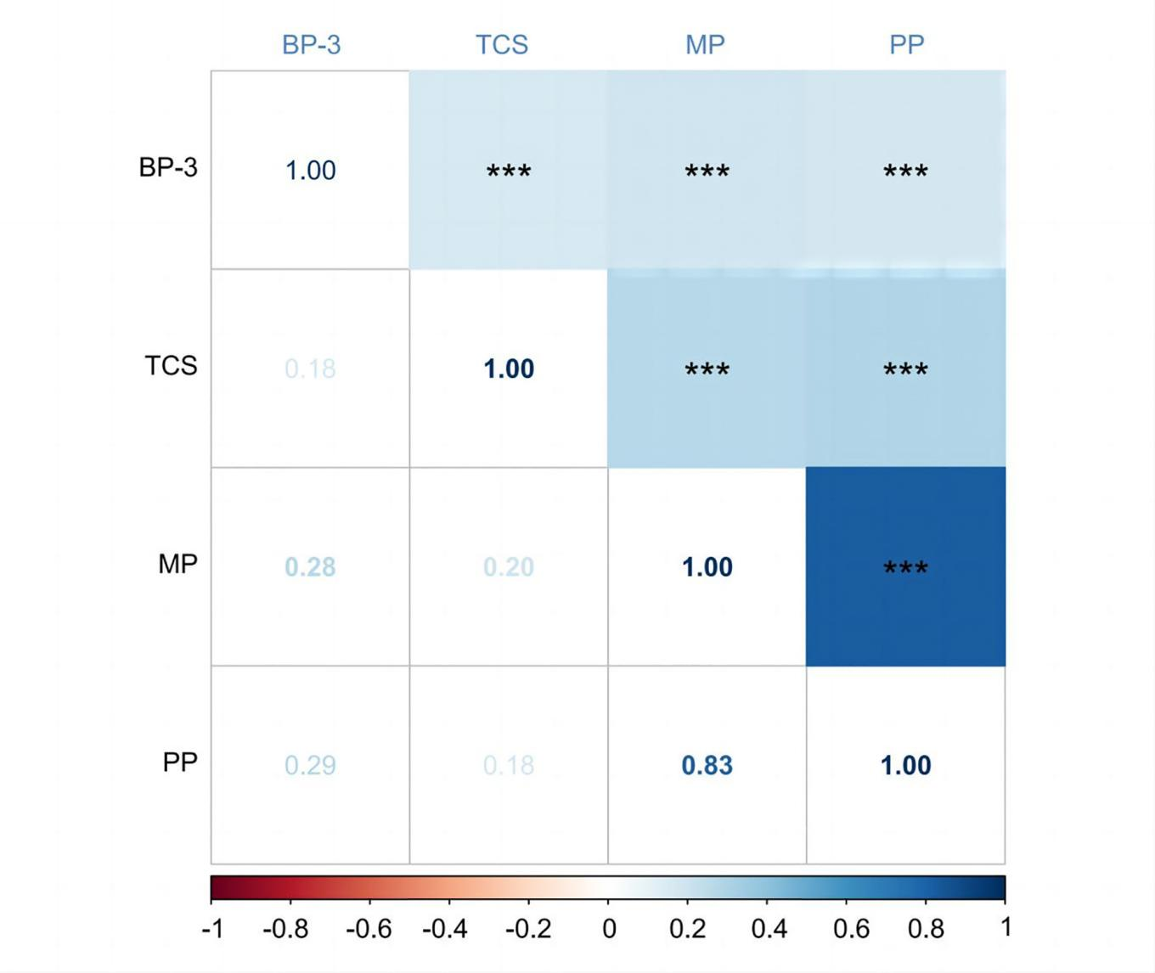

Figure S2

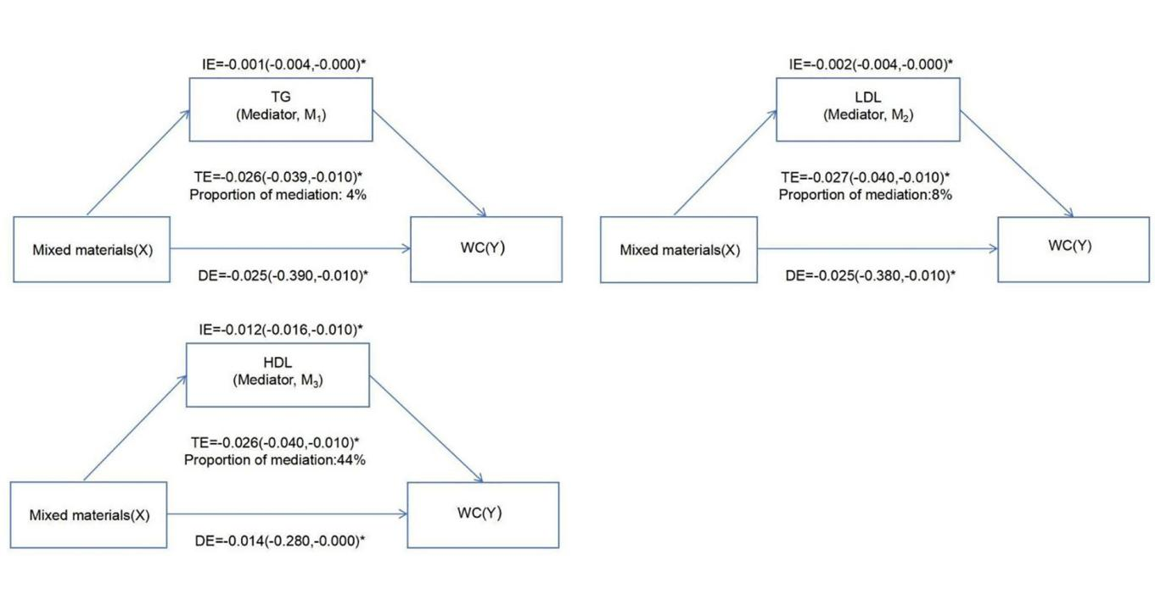

Table S1 WQS model was used to evaluate the relationship between WCS index and obesity.
 | BMI |  | WC
Outcomes | OR (95% CI) | P-value | OR (95% CI) | P-value
b1_negative
 | 0.770(0.644,0.919) | 0.004 | 0.781 (0.658,0.928) | 0.004
Note: Adjusted covariates: urine creatinine, age, gender, race, family PIR, education levels, smoking status, alcohol drinking status, total energy intake, hypertension, and diabetes. CI: confidence interval. OR: Odd ratio. BMI: higher body mass index. WC: waist circumference.

Table S2 In BKMR, the PIP value of various BP-3, TCS, parabens.
 | BMI | WC
Variable | PIP | PIP
BP-3 | 0.593 | 0.090
TCS | 0.466 | 0.125
MP | 0.718 | 0.121
PP | 0.283 | 0.197
Note: Adjusted covariates: urinary creatinine, age, gender, race, family PIR, education levels, smoking status, alcohol drinking status, total energy intake, hypertension, and diabetes. BMI: higher body mass index. WC: waist circumference. PIP: posterior inclusion probability. BP-3: benzophenol-3 (BP-3). TCS: triclosan. MP: methyl paraben. PP: propyl paraben.

Table S3 Cholesterol mediated the relationship between BP-3, TCS, Parabens and obesity in NHANES.
 |  | TE |  | DE |  | IE | proportion of mediation
 | BP-3 | -0.0207(-0.0316,-0.0084) | -0.0194(-0.0296,-0.0073) |  | -0.0014(-0.0034,0.0006)
M₁(TG) | TCS | 0.0003(-0.0105,0.0109) | -0.0004(-0.0115,0.0099) |  | 0.0007(-0.0013,0.0026)
 | MP | -0.0267(-0.0404,-0.0143) | -0.0254(-0.0391,-0.0125) |  | -0.0013(-0.0037,0.0011)
 | PP | -0.0224(-0.0329,-0.0120) | -0.0207(-0.0310,-0.0102) |  | -0.0017(-0.0037,0.0001)
M₂(LDL) | BP-3 | -0.0208(-0.0313,-0.0098) | -0.0197(-0.0304,-0.0089) |  | -0.0011(-0.0024,-0.0002) |  | 5%
M₂(LDL) | TCS | -0.0001(-0.0102,0.0103) | -0.0003(-0.0102,0.0102) |  | 0.0002(-0.0006,0.0012)
M₂(LDL) | MP | -0.0266(-0.0395,-0.0125) | -0.0258(-0.0387,-0.0117) |  | -0.0008(-0.0022,0.0002)
M₂(LDL) | PP | -0.0227(-0.0329,-0.0123) | -0.0219(-0.0320,-0.0115) |  | -0.0007(-0.0019,0.0000)
M₃(HDL) | BP-3 | -0.0207(-0.0318,-0.0102) | -0.0138(-0.0245,-0.0035) |  | -0.0069(-0.0104,-0.0034) |  | 34%
M₃(HDL) | TCS | -0.0003(-0.0117,0.0099) | 0.0048(-0.0057,0.0151) |  | -0.0052(-0.0087,-0.0020) |  | 44%
M₃(HDL) | MP | -0.0259(-0.0393,-0.0126) | -0.0185(-0.0308,-0.0060) |  | -0.0074(-0.0116,-0.0033) |  | 29%
M₃(HDL) | PP | -0.0217(-0.0315,-0.0118) | -0.0159(-0.0257,-0.0065) |  | -0.0059(-0.0091,-0.0028) |  | 27%
Note: Adjusted covariates: urinary creatinine, age, gender, race, family PIR, education levels, smoking status, alcohol drinking status, total energy intake, hypertension, and diabetes. TG: triglyceride. LDL: low density lipoprotein cholesterol. HDL: high-density lipoprotein cholesterol. TE: total effect. IE: indirect effect. DE: direct effect. BMI: higher body mass index. WC: waist circumference.

Table S4 Cholesterol mediated the relationship between BP-3, TCS, Parabens and WC in NHANES.
 |  | TE | DE | IE | proportion of mediation
 | BP-3 | -0.0126(-0.0220,-0.0017) | -0.0112(-0.0202,-0.0004) | -0.0015(-0.0036,0.0006)
M₁(TG) | TCS | -0.0037(-0.0138,0.0069) | -0.0045(-0.0148,0.0058) | 0.0008(-0.0015,0.0030)
 | MP | -0.0260(-0.0353,-0.0168) | -0.0248(-0.0343,-0.0149) | -0.0013(-0.0036,0.0011)
 | PP | -0.0219(-0.0309,-0.0124) | -0.0200(-0.0288,-0.0107) | -0.0019(-0.0039,0.0001)
M₂(LDL) | BP-3 | -0.0131(-0.0223,-0.0031) | -0.0114(-0.0206,-0.0017) | -0.0017(-0.0033,-0.0004) | 13%
M₂(LDL) | TCS | -0.0044(-0.0138,0.0060) | -0.0047(-0.0139,0.0058) | 0.0003(-0.0010,0.0019)
M₂(LDL) | MP | -0.0263(-0.0351,-0.0154) | -0.0251(-0.0337,-0.0142) | -0.0012(-0.0028,0.0003)
M₂(LDL) | PP | -0.0220(-0.0307,-0.0126) | -0.0209(-0.0295,-0.0114) | -0.0012(-0.0027,0.0001)
M₃(HDL) | BP-3 | -0.0124(-0.0224,-0.0029) | -0.0064(-0.0160,0.0031) | -0.0060(-0.0089,-0.0030) | 48%
M₃(HDL) | TCS | -0.0040(-0.0148,0.0064) | 0.0006(-0.0095,0.0113) | -0.0047(-0.0078,-0.0018) | 66%
M₃(HDL) | MP | -0.0255(-0.0346,-0.0151) | -0.0197(-0.0289,-0.0093) | -0.0058(-0.0090,-0.0026) | 23%
M₃(HDL) | PP | -0.0214(-0.0302,-0.0124) | -0.0163(-0.0249,-0.0076) | -0.0051(-0.0077,-0.0025) | 24%
Note: Adjusted covariates: urinary creatinine, age, gender, race, family PIR, education levels, smoking status, alcohol drinking status, total energy intake, hypertension, and diabetes. TG: triglyceride. LDL: low density lipoprotein cholesterol. HDL: high-density lipoprotein cholesterol. TE: total effect. IE: indirect effect. DE: direct effect. BMI: higher body mass index. WC: waist circumference.

