Additional File 1
Table S1. List of qPCR primers
Organism | Gene | Forward Primer (5'- 3') | Reverse Primer (5'- 3')
Mus musculus | Cebpa | CTAGGAGATTCCGGTGTGGC | CCCGAGAGGAAGCAGGAATC
Mus musculus | Cebpb | CGCCTTATAAACCTCCCGCT | TGGCCACTTCCATGGGTCTA
Mus musculus | Pparg | CCAAGAATACCAAAGTGCGATC | TCACAAGCATGAACTCCATAGT
Mus musculus | Fasn | GTGAGACTCCTTGGAGGGTG | TCTAGAGGGCTTGCACCAAC
Mus musculus | Scd1 | CGCCCCTACGACAAGAACAT | AAGCCCAAAGCTCAGCTACT
Mus musculus | Mtor | ACTGTGTCTTGGCATCCCTG | AGCCTTCAGGATAGGCTCCA
Mus musculus | Pnpla2 | CAGAGATGGACTTCGATTCCTT | CAGGTGCTCTAGAATTCGATCT
Mus musculus | Lipe | GGAGCTCCAGTCGGAAGAGG | GTCTTCTGCGAGTGTCACCA
Mus musculus | Elovl6 | TGCAGCATGACAACGACCAGTG | AATGGCAGAAGAGCACAAGGTAGC
Mus musculus | Srebf1 | GCTACCGGTCTTCTATCAATGA | CGCAAGACAGCAGATTTATTCA
Mus musculus | Ppara | CGTTTGTGGCTGGTCAAGTT | TCCTCACCGATGGACTGAGA
Mus musculus | Ucp1 | ATTCAGAGGCAAATCAGCTTTG | GTGTTTCTCTCCCTGAAGAGAA

Organism | Gene | Forward Primer (5'- 3') | Reverse Primer (5'- 3')
Homo sapiens | CEBPA | TATAGGCTGGGCTTCCCCTT | AGCTTTCTGGTGTGACTCGG
Homo sapiens | CEBPB | GGCCGGTTTCGAAGTTGATG | TGCCCCCAAAAGGCTTTGTA
Homo sapiens | PPARG | TGACCAGAAGCCTGCATTTCT | ACGGAGCTGATCCCAAAGTT
Homo sapiens | FASN | CGCGGTTTAAATAGCGTCGG | AGACAGGTCCTTCAGCTTGC
Homo sapiens | SCD | CTTGCGATATGCTGTGGTGC | CCGGGGGCTAATGTTCTTGT
Homo sapiens | MTOR | GCCGCGCGAATATTAAAGGA | CTGGTTTCCTCATTCCGGCT
Homo sapiens | PNPLA2 | GGGACTCACAGTTGCCAAGA | CAAGTAAGCAGGCGGTCACA
Homo sapiens | LIPE | ATTACTTAGTGGGGGCCAGC | GGATCCCTGCAGAGTCTTCG
Homo sapiens | ELOVL6 | GAGAATGAAGCCATCCAAT | CAGAGACCAGAGCACTAA
Homo sapiens | SREBF1 | TTCCGAGGAACTTTTCGCCG | GCCGACTTCACCTTCGATGT
Homo sapiens | PPARA | TCACCACAGTAGCTTGGAGC | GTGAAAGCGTGTCCGTGATG
Table S1 (Continued). List of qPCR primers

Table S2. Fatty acid profile of CAC and control patients
Fatty acids | WS (n=12) | CAC (n=12) | p-value
C6:0 | <0.01 | <0.01 | /
C8:0 | <0.01 | <0.01 | /
C10:0 | <0.01 | <0.01 | /
C11:0 | <0.01 | <0.01 | /
C12:0 | 0.072 ± 0.015 | 0.098 ± 0.031 | 0.0833
C13:0 | <0.01 | <0.01 | /
C14:0 | 0.87 ± 0.11 | 1.06 ± 0.31 | 0.1783
C14:1n-9 | 0.061 ± 0.019 | 0.098 ± 0.079 | 0.296
C15:0 | 0.095 ± 0.014 | 0.088 ± 0.0096 | 0.3752
C15:1n-10 | <0.01 | <0.01 | /
C16:0 | 16.63 ± 0.85 | 20.57 ± 1.22 | 0.0001
C16:1n-9 | 2.56 ± 0.67 | 2.99 ± 1.24 | 0.4668
C17:0 | 0.19 ± 0.024 | 0.17 ± 0.039 | 0.3925
C17:1n-9 | <0.01 | <0.01 | /
C18:0 | 4.26 ± 0.65 | 3.92 ± 0.97 | 0.489
C18:1n-11 | <0.01 | <0.01 | /
C18:1n-9 | 44.77 ± 1.24 | 43.88 ± 1.42 | 0.2728
C18:1n-9, trans | <0.01 | <0.01 | /
C18:2n-6 (LA) | 26.34 ± 0.66 | 22.84 ± 1.36 | 0.0002
C18:2n-6, trans | <0.01 | <0.01 | /
C18:3n-3 (LNA) | 0.91 ± 0.14 | 0.96 ± 0.26 | 0.6368
C18:3n-6 | 0.060 ± 0.025 | 0.047 ± 0.024 | 0.3654
C19:0 | <0.01 | <0.01 | /

Table S2 (Continued). Fatty acid profile of CAC and control patients

Fatty acids | WS (n=12) | CAC (n=12) | p-value
C20:0 | 0.29 ± 0.11 | 0.31 ± 0.15 | 0.8637
C20:1n11 | 0.96 ± 0.15 | 1.11 ± 0.32 | 0.3244
C20:2n-6 | 0.50 ± 0.084 | 0.54 ± 0.11 | 0.5243
C20:3n-3 | 0.053 ± 0.0082 | 0.062 ± 0.015 | 0.2531
C20:3n-6 | 0.28 ± 0.086 | 0.29 ± 0.11 | 0.8408
C20:3n-9 | <0.01 | <0.01 | /
C20:4n-6 | 0.26 ± 0.31 | 0.34 ± 0.21 | 0.6394
C20:5n-3 (EPA) | 0.035 ± 0.011 | 0.028 ± 0.0075 | 0.2346
C21:0 | <0.01 | <0.01 | /
C22:0 | 0.073 ± 0.040 | 0.075 ± 0.052 | 0.9518
C22:5n-3 (DPA) | 0.45 ± 0.13 | 0.46 ± 0.097 | 0.8837
C22:6n-3 (DHA) | 0.21 ± 0.075 | 0.16 ± 0.054 | 0.2608
C23:0 | <0.01 | <0.01 | /
C24:0 | 0.043 ± 0.015 | 0.050 ± 0.027 | 0.6072
C24:1n-15 | 0.037 ± 0.016 | 0.040 ± 0.014 | 0.7134

Table S3. Fatty acid profile of Elovl6-KD and NC mature 3T3-L1 adipocytes
Fatty acids | NC (n=3) | Elovl6-KD (n=3) | p-value
C6:0 | <0.01 | <0.01 | /
C8:0 | <0.01 | <0.01 | /
C10:0 | 0.215 ± 0.024 | 0.220 ± 0.040 | 0.8610
C11:0 | 0.162 ± 0.020 | 0.155 ± 0.019 | 0.6651
C12:0 | 0.311 ± 0.012 | 0.287 ± 0.035 | 0.3228
C13:0 | 0.791 ± 0.033 | 0.739 ± 0.057 | 0.2374
C14:0 | 6.85 ± 0.55 | 5.396 ± 1.146 | 0.1198
C14:1n-9 | 1.69 ± 0.36 | 1.62 ± 0.25 | 0.8016
C15:0 | 14.23 ± 0.44 | 14.61 ± 0.26 | 0.2728
C15:1n-10 | <0.01 | <0.01 | /
C16:0 | 20.85 ± 0.43 | 24.07 ± 0.80 | 0.0036
C16:1n-9 | 27.62 ± 0.63 | 30.20 ± 1.15 | 0.0272
C17:0 | 2.69 ± 0.31 | 2.37 ± 0.16 | 0.1828
C17:1n-9 | 7.73 ± 0.18 | 7.73 ± 0.21 | 0.9911
C18:0 | 1.526 ± 0.039 | 1.42 ± 0.12 | 0.2227
C18:1n-9 | 8.63 ± 0.76 | 4.53 ± 0.47 | 0.0013
C18:1n-11 | 2.37 ± 0.20 | 2.23 ± 0.21 | 0.4277
C18:1n-9, trans | <0.01 | <0.01 | /
C18:2n-6, trans | <0.01 | <0.01 | /
C18:2n-6 (LA) | 1.242 ± 0.054 | 1.115 ± 0.050 | 0.0402
C18:3n-3 (LNA) | <0.01 | <0.01 | /
C18:3n-6 | <0.01 | <0.01 | /
Table S3 (Continued). Fatty acid profile of Elovl6-KD and NC mature 3T3-L1 adipocytes

Fatty acids | NC (n=3) |  | Elovl6-KD (n=3) |  | p-value
C19:0 |  | 0.116 ± 0.015 |  | 0.135 ± 0.006 |  | 0.1083
C20:0 |  | <0.01 |  | <0.01 |  | /
C20:1n-11 | <0.01 |  | <0.01 |  | /
C20:2n-6 | 0.044 ± 0.001 |  | 0.045 ± 0.002 |  | 0.4220
C20:3n-3 | <0.01 |  | <0.01 |  | /
C20:3n-6 | 0.035 ± 0.002 |  | 0.032 ± 0.002 |  | 0.1686
C20:3n-9 | 0.372 ± 0.031 |  | 0.351 ± 0.009 |  | 0.3418
C20:4n-6 | 0.893 ± 0.030 |  | 0.97 ± 0.10 |  | 0.2755
C20:5n-3 (EPA) | 0.123 ± 0.017 |  | 0.110 ± 0.006 |  | 0.2817
C21:0 | 0.081 ± 0.007 |  | 0.079 ± 0.003 |  | 0.6913
C22:0 | <0.01 |  | <0.01 |  | /
C22:1n-13 | <0.01 |  | <0.01 |  | /
C22:2n-6 | 0.133 ± 0.004 |  | 0.134 ± 0.004 |  | 0.7017
C22:4n-6 | 0.093 ± 0.007 |  | 0.101 ± 0.003 |  | 0.1764
C22:5n-3 (DPA) | 0.328 ± 0.010 |  | 0.307 ± 0.007 |  | 0.0459
C22:6n-3 (DHA) | 0.567 ± 0.067 |  | 0.546 ± 0.037 |  | /
C23:0 | <0.01 |  | <0.01 |  | /
C24:0 | <0.01 |  | <0.01 |  | /
C24:1n-15 | 0.110 ± 0.007 |  | 0.100 ± 0.017 |  | 0.3909

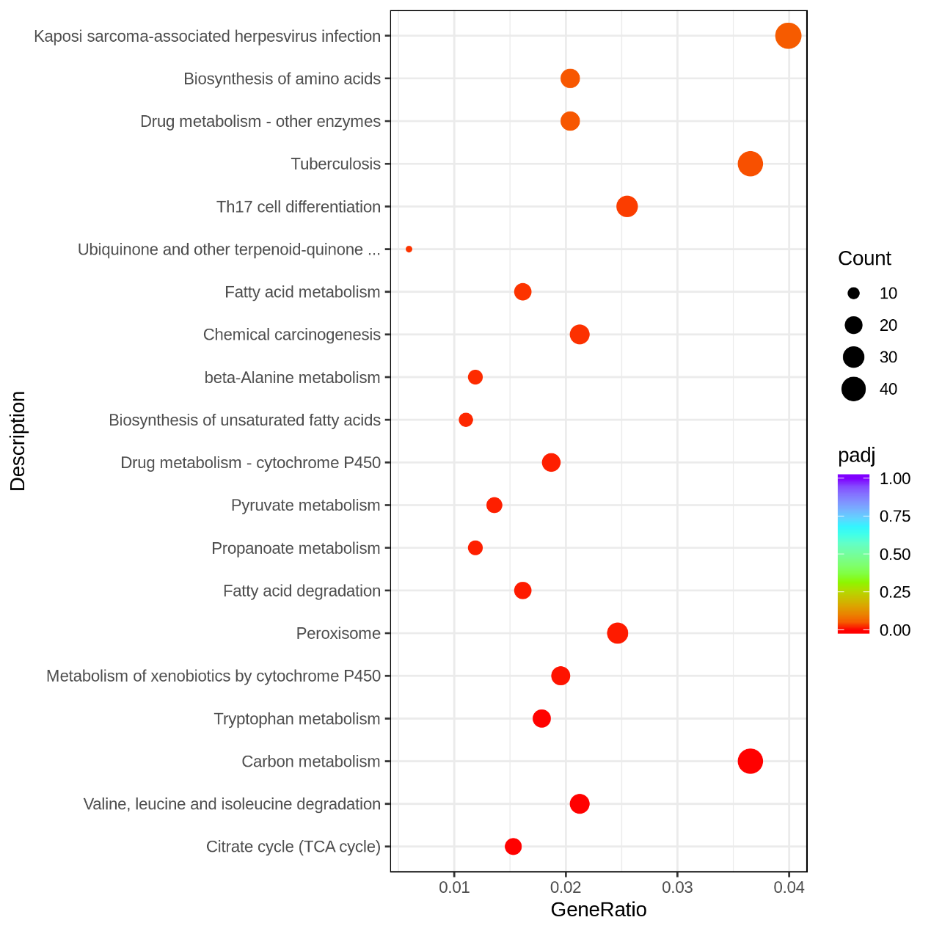
Fig. S1 Top 20 significant KEGG pathways in WAT of CAC and CONT mice.

