Supplementary Table S1 Detailed information on categorical covariables
Covariable | Range | Grouping for adjustment
Race | Mexican American | Mexican American
 | Non-Hispanic White | Non-Hispanic White
 | Non-Hispanic Black | Non-Hispanic Black
 | Other Hispanic | Other Hispanic
 | Other Race - Including Multi-Racial | Other Race
Marital status | Never married | Living alone
 | Widowed | Living alone
 | Separated | Living alone
 | Divorced | Living alone
 | Living with partner | Married or living with a partner
 | Married | Married or living with a partner
Education level | Less than 9th grade | <High school
 | 9-11th grade (Includes 12th grade with no diploma) | <High school
 | High school graduate/GED or equivalent | ≥High school
 | Some college or AA degree | ≥High school
 | College graduate or above | ≥High school
Physical activity | Engaging in any moderate recreational activities for at least 10 continuous minutes | Yes
 |  | No
Alcohol intake | had <12 drinks in a lifetime | Never
 | had ≥12 drinks in 1 year and did not drink last year, or did not drink last year but drank ≥12 drinks in a lifetime | Former
 | 1 drink per day for female and 2 drink per day for male | Mild
 | 2-3 drinks per day for females and 3-4 drinks per day for males. | Moderate
 | ≥3 drinks per day for females or ≥ 4drinks per day for males | Heavy
Diabetes | NA | (1) self-reported diagnosis by a physician or healthcare professional
 |  | (2) HbA1c (glycated hemoglobin) level over 6.5%,
 |  | (3) fasting blood glucose (FPG) level over 126 mg/dL (7.0 mmol/L)
Hypertension | NA | (1) Self-reported diagnosis of hypertension
 |  | (2) BP≥130 mmHg and/or DBP≥80 mmHg
 |  | (3) the use of antihypertensive medication
Body mass index (kg/m²) | <18.5 | Underweight
 | 18.5-25 | Normal
 | 25-30 | Overweight
 | ≥30 | Obese

Supplementary Table S2 Variance inflation factors for variables
Outcome variables | Covariables | GVIF | Df | GVIF^(1/(2*Df))
FEV1
 | CMI | 1.190880511 | 1 | 1.091274718
 | Age | 1.314790049 | 1 | 1.146642948
 | Gender | 1.142230562 | 1 | 1.068751871
 | Race | 1.33264297 | 4 | 1.036547543
 | Marital status | 1.099257623 | 1 | 1.048454874
 | Education level | 1.268411144 | 1 | 1.126237605
 | BMI | 1.153244693 | 1 | 1.07389231
 | PIR | 1.342704833 | 1 | 1.158751411
 | Physical activity | 1.162262614 | 1 | 1.078082842
 | Smoking status | 1.33053039 | 1 | 1.15348619
 | Alcohol intake | 1.447203747 | 4 | 1.047288199
 | Total cholesterol | 1.106997452 | 1 | 1.052139464
 | Serum cotinine | 1.361481543 | 1 | 1.166825412
 | FeNO | 1.069485404 | 1 | 1.034159274
FVC
 | CMI | 1.190880511 | 1 | 1.091274718
 | Age | 1.314790049 | 1 | 1.146642948
 | Gender | 1.142230562 | 1 | 1.068751871
 | Race | 1.33264297 | 4 | 1.036547543
 | Marital status | 1.099257623 | 1 | 1.048454874
 | Education level | 1.268411144 | 1 | 1.126237605
 | BMI | 1.153244693 | 1 | 1.07389231
 | PIR | 1.342704833 | 1 | 1.158751411
 | Physical activity | 1.162262614 | 1 | 1.078082842
 | Smoking status | 1.33053039 | 1 | 1.15348619
 | Alcohol intake | 1.447203747 | 4 | 1.047288199
 | Total cholesterol | 1.106997452 | 1 | 1.052139464
 | Serum cotinine | 1.361481543 | 1 | 1.166825412
 | FeNO | 1.069485404 | 1 | 1.034159274
FEV1/FVC
 | CMI | 1.190880511 | 1 | 1.091274718
 | Age | 1.314790049 | 1 | 1.146642948
 | Gender | 1.142230562 | 1 | 1.068751871
 | Race | 1.33264297 | 4 | 1.036547543
 | Marital status | 1.099257623 | 1 | 1.048454874
 | Education level | 1.268411144 | 1 | 1.126237605
 | BMI | 1.153244693 | 1 | 1.07389231
 | PIR | 1.342704833 | 1 | 1.158751411
 | Physical activity | 1.162262614 | 1 | 1.078082842
 | Smoking status | 1.33053039 | 1 | 1.15348619
 | Alcohol intake | 1.447203747 | 4 | 1.047288199
 | Total cholesterol | 1.106997452 | 1 | 1.052139464
 | Serum cotinine | 1.361481543 | 1 | 1.166825412
 | FeNO | 1.069485404 | 1 | 1.034159274
Abbreviation: CMI, cardiometabolic index; GVIF, Generalized Variance Inflation Factor; Df, Degrees of Freedom; FEV1, forced expiratory volume in one second; FVC, forced vital capacity; BMI, body mass Index; PIR, the ratio of family income to poverty.

Supplementary TableS3 Weighted multiple linear regression models of components of CMI with pulmonary function
Pulmonary function | Components  of CMI | βª (95% CI), P-value
Pulmonary function | Components  of CMI | Model 1^{b} | Model 2^{c} | Model 3^{d}
FEV1 (mL)
 | TG | -0.17(-0.55,0.21) 0.383 | -0.35( -0.56, -0.15) 0.001 | -0.29( -0.49, -0.08) 0.007
 | HDL-C | -9.95(-12.09,-7.81) <0.001 | 4.67( 3.16, 6.17) <0.001 | 2.79( 1.11, 4.46) 0.002
 | Waist | -2.31(-4.68,0.07) 0.056 | -0.83( -2.30, 0.65) 0.265 | 9.69( 6.51, 12.87) <0.001
 | Height | 60.43(57.40,63.46) <0.001 | 40.86( 37.74, 43.97) <0.001 | 39.86( 36.90, 42.82) <0.001
 | WHtR | -2660.94(-3035.03,-2286.86) <0.001 | -912.45(-1155.96,-668.93) <0.001 | -4571.7(-5188.90,-3954.51) <0.001
FVC (mL)
 | TG | -0.03(-0.48,0.42) 0.896 | -0.54( -0.80, -0.28) <0.001 | -0.46( -0.72, -0.19) 0.002
 | HDL-C | -13.06(-15.62,-10.50) <0.001 | 5.74( 3.94, 7.54) <0.001 | 2.78( 0.93, 4.64) 0.005
 | Waist | -0.51(-3.25,2.24) 0.712 | -2.3( -4.24, -0.36) 0.021 | 17.26( 13.64, 20.89) <0.001
 | Height | 84.31(81.25,87.36) <0.001 | 59.7( 56.45, 62.95) <0.001 | 58.3( 55.15, 61.45) <0.001
 | WHtR | -3247.59(-3671.56,-2823.62) <0.001 | -1513.39(-1827.95,-1198.82) <0.001 | -5997.38(-6747.23,-5247.52) <0.001
Note:βª, effect value; Model 1^{b}: no covariables were adjusted; Model 2^{c}: adjusted for gender, age, and race; Model 3^{d}: adjusted for all variables
Significant values are in [bold]
Abbreviation: CMI, cardiometabolic index; 95% CI, 95% confidence interval; TG, triglyceride; HDL-C, high-density lipoprotein cholesterol; WHtR, waist-to-height ratio; FEV1, forced expiratory volume in one second; FVC, forced vital capacity

Supplementary Table S4 Subgroup analysis for the association between CMI and pulmonary function
Pulmonary Function | Subgroup | βª (95% CI) | Adjusted  P-value | Adjusted  p for interaction
FEV1 (mL)
 | Age (year) |  |  | 0.456
 | <60 | -88.33(-128.69, -47.97) | <0.001
 | ≥60 | -69.75(-161.10, 21.60) | 0.141
 | Gender |  |  | 0.456
 | Female | -63.39(-124.21, -2.57) | 0.056
 | Male | -100.36(-158.12, -42.61) | 0.002
 | BMI (kg/m²) |  |  | 0.798
 | Underweight | -481.86(-1093.87, 130.14) | 0.122
 | Normal | -62.99(-154.75, 28.76) | 0.171
 | Overweight | -74.22(-129.27, -19.16) | 0.020
 | Obese | -115.84(-174.01, -57.67) | <0.001
 | Physical Activity |  |  | 0.456
 | Yes | -105.17(-151.28, -59.07) | <0.001
 | No | -59.24(-112.56, -5.92) | 0.046
 | Smoking status |  |  | 0.456
 | Yes | -93.88(-141.20, -46.55) | <0.001
 | No | -66.76(-124.67, -8.86) | 0.043
FVC (mL)
 | Age (year) |  |  | 0.15
 | <60 | -110.02(-160.51, -59.52) | <0.001
 | ≥60 | -136.02(-243.97, -28.06) | 0.018
 | Gender |  |  | 0.323
 | Female | -90.71(-155.40, -26.02) | 0.012
 | Male | -134.35(-207.81, -60.89) | <0.001
 | BMI (kg/m²) |  |  | 0.445
 | Underweight | 100.34( -484.12, 684.80) | 0.689
 | Normal | -105.79(-225.54, 13.97) | 0.088
 | Overweight | -88.8(-157.65, -19.95) | 0.017
 | Obese | -155.03(-234.62, -75.43) | <0.001
 | Physical Activity |  |  | 0.498
 | Yes | -137.59(-203.51, -71.68) | <0.001
 | No | -85.76(-144.40, -27.13) | 0.012
 | Smoking status |  |  | 0.323
 | Yes | -121.67(-176.68, -66.67) | <0.001
 | No | -100.59(-171.42, -29.76) | 0.012
Note: Adjusted for age, gender, race, BMI, total cholesterol, serum cotinine, FeNO, education, marital status, the ratio of family income to poverty, physical activity, smoking status, alcohol consumption, hypertension, and diabetes except for subgroup variables;βª, effect value
Significant values are in [bold]
Abbreviations: CMI, cardiometabolic index; 95% CI, 95% confidence interval; FEV1, forced expiratory volume in one second; FVC, forced vital capacity; BMI, body mass index

Supplementary Table S5 Sensitivity analysis of weighted multiple linear regression models of CMI with pulmonary function
Pulmonary function | log₂-CMI | βª (95% CI), P-value
Pulmonary function | log₂-CMI | Model 1^{b} | Model 2^{c} | Model 3^{d}
FEV1 (mL)
 | Continuous | -2.49(-65.28,60.29) 0.937 | -102.5(-135.73, -69.27) <0.001 | -87.17(-127.57, -46.78) <0.001
 | Q1 | Reference | Reference | Reference
 | Q2 | 54.96( -63.29,173.20) 0.354 | -39.68(-115.81, 36.46) 0.299 | -22.95( -96.65, 50.75) 0.528
 | Q3 | 15.12( -83.10,113.34) 0.758 | -75.85(-144.32, -7.39) 0.031 | -52.47(-122.05, 17.11) 0.133
 | Q4 | -6.32(-113.75,101.10) 0.906 | -185.7(-253.36,-118.05) <0.001 | -153.5(-233.67, -73.34) <0.001
 | P for trend | 0.744 | <0.001 | <0.001
FVC (mL)
 | Continuous | 32.24(-41.58,106.05) 0.384 | -137.13(-177.15, -97.11) <0.001 | -103.6(-152.42, -54.79) <0.001
 | Q1 | Reference | Reference | Reference
 | Q2 | 103.55(-39.62,246.72) 0.152 | -58.88(-153.06, 35.31) 0.214 | -26.18(-119.30, 66.94) 0.569
 | Q3 | 77.73(-43.10,198.56) 0.202 | -106.14(-195.83, -16.45) 0.022 | -60.8(-151.99, 30.39) 0.183
 | Q4 | 73.15(-55.89,202.19) 0.260 | -240.38(-324.75,-156.01) <0.001 | -166.31(-265.39, -67.22) 0.002
 | P for trend | 0.302 | <0.001 | <0.001
FEV1 / FVC
 | Continuous | -0.01(-0.01,0.00) <0.001 | 0( 0.00, 0.00) 0.325 | 0(-0.01, 0.00) 0.371
 | Q1 | Reference | Reference | Reference
 | Q2 | -0.01(-0.01, 0.00) 0.109 | 0( 0.00, 0.01) 0.599 | 0(-0.01, 0.01) 0.827
 | Q3 | -0.01(-0.02, 0.00) 0.005 | 0( 0.00, 0.01) 0.515 | 0(-0.01, 0.01) 0.762
 | Q4 | -0.01(-0.02,-0.01) <0.001 | 0( 0.00, 0.01) 0.568 | 0(-0.01, 0.00) 0.172
 | P for trend | <0.001 | 0.544 | 0.222
Note: In sensitivity analysis, CMI is converted from a continuous variable to a categorical variable (quartile); βª, effect value; Model 1^{b}: no covariables were adjusted; Model 2^{c}: adjusted for gender, age, and race; Model 3^{d}: adjusted for all variables
Significant values are in [bold]
Abbreviation: CMI, cardiometabolic index; 95% CI: 95% confidence interval; FEV1, forced expiratory volume in one second; FVC, forced vital capacity

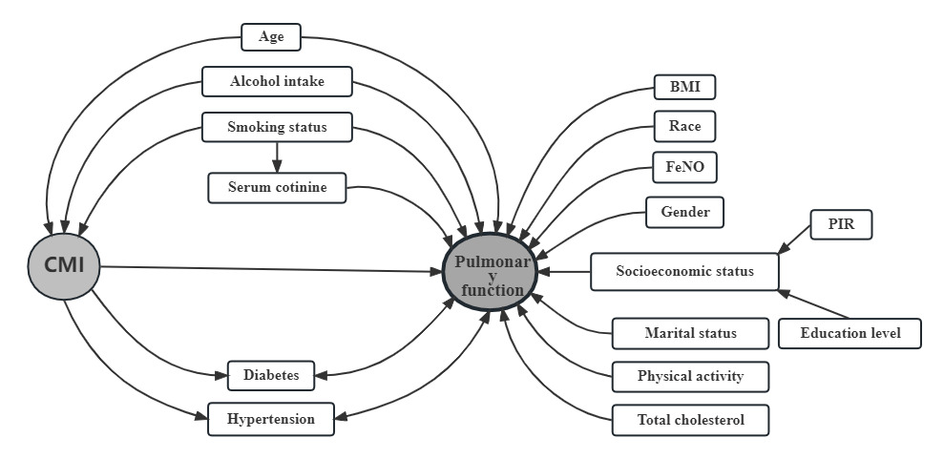
Supplementary Figure S1 Directed acyclic graph for selection of minimal set of confounders

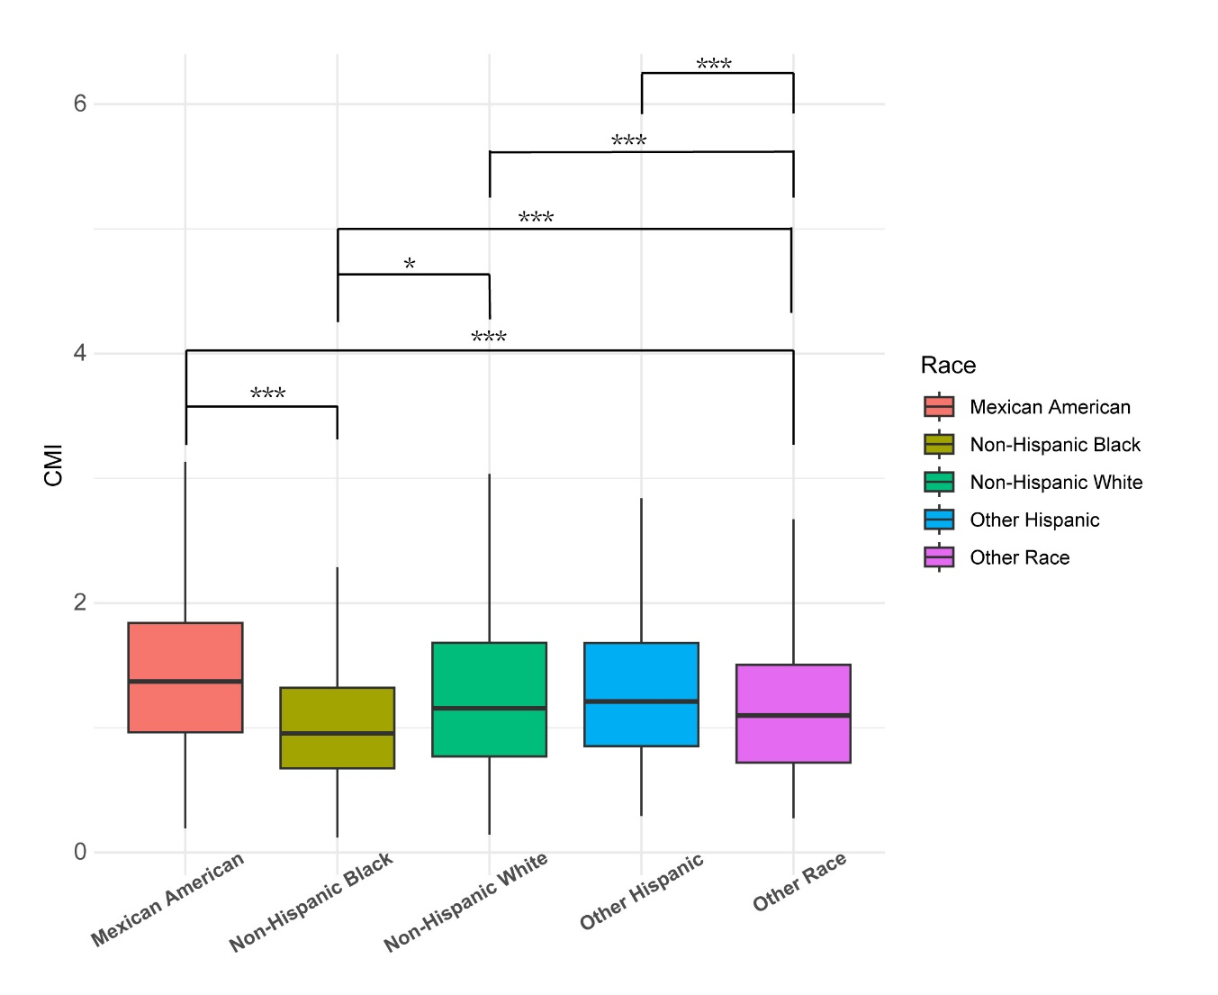
Supplementary Figure S2 Post-hoc analysis among different races

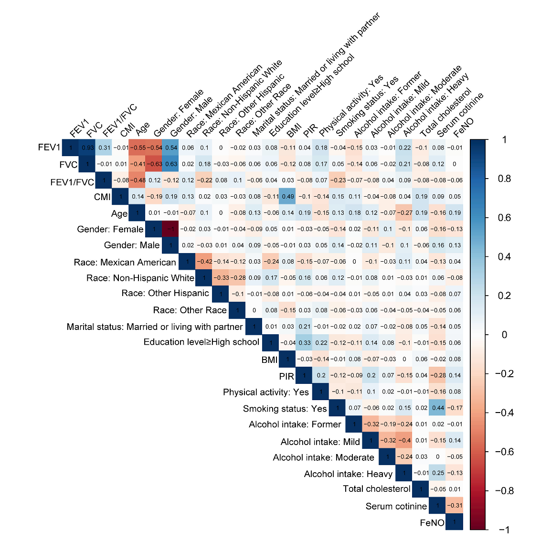
Supplementary Figure S3 Heatmap of Spearman’s rank correlation coefficients

