Supplementary Figures Overview
Figure S1. Manhattan plots of GWAS of five MetS components
Figure S2. UpSet plot of signals related to MetS and its components
Figure S3. MetS associated GCTA-COJO SNPs in relation with each MetS component
Figure S4. Locus zoom plots including APOA5 SNPs within MetS/TG/HDL phenotypes
Figure S5. Comparison of fine-mapping results from KoGES and UK Biobank cohorts of TG values
Figure S6. Regional association plots for APOA5 locus in TG GWAS regarding KoGES and UK Biobank cohorts
Figure S7. LD Blocks of the KoGES and UK Biobank cohorts
Figure S8. Multilayered effects of rs651821/rs2266788 in interaction with HDL and environmental factors

Figure S1. Manhattan plots of GWAS of five MetS components
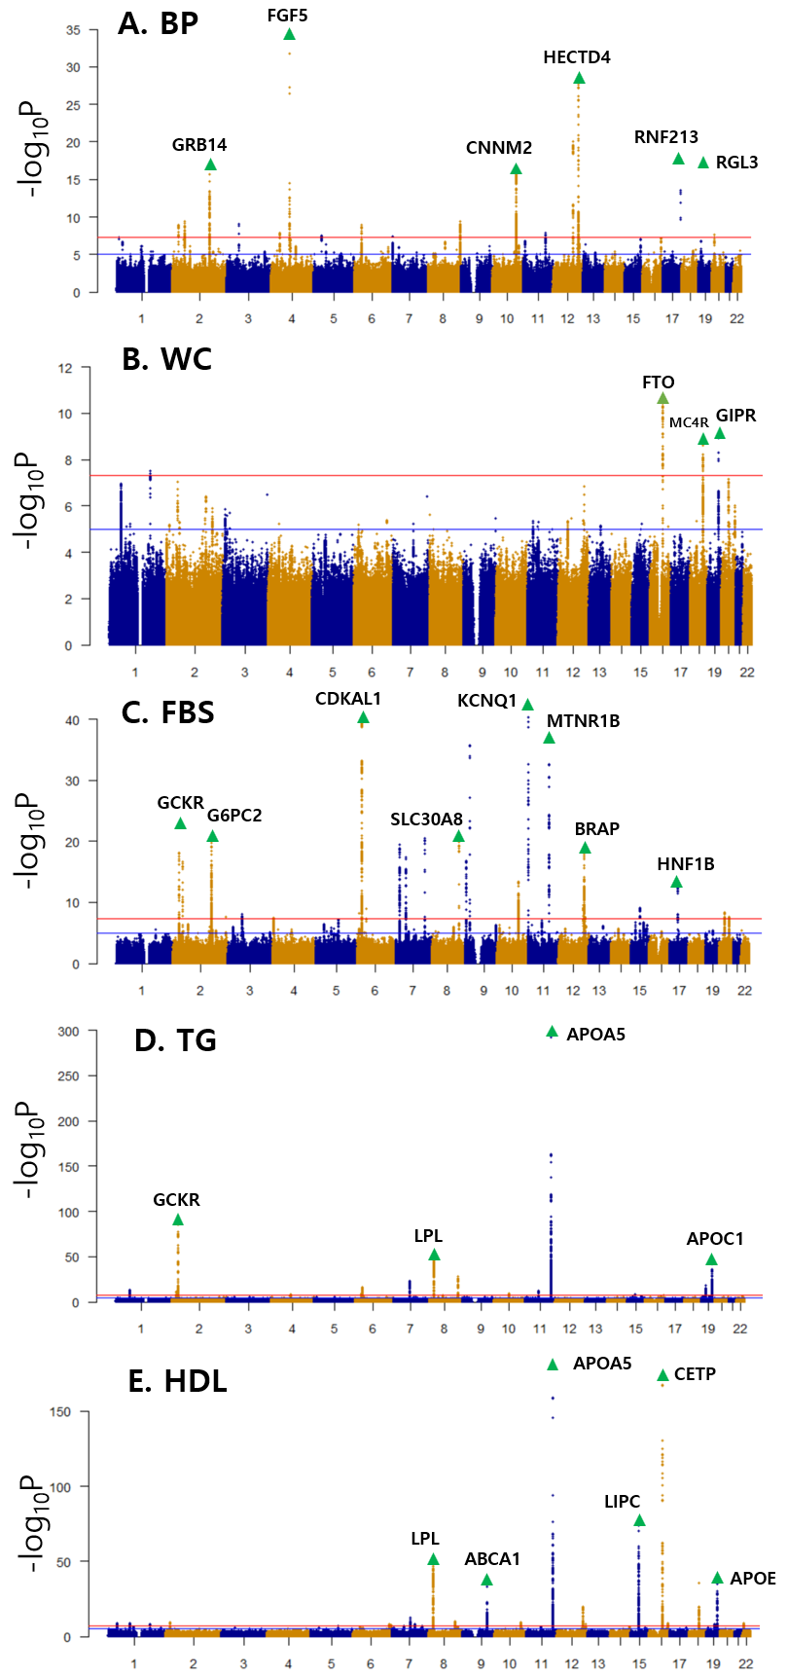

BP: Blood pressure, WC: Waist circumference, FBS: Fasting blood sugar, TG: Triglycerides, HDL: High-density lipoprotein cholesterol

Figure S2. UpSet plot of signals related to MetS and its components
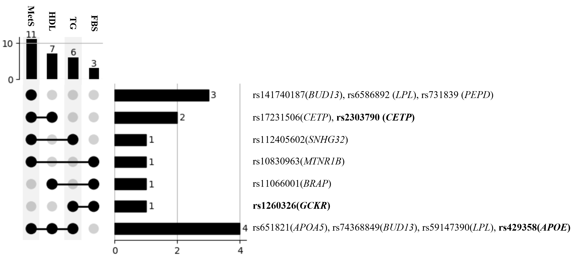
SNPs related to MetS and its components. The left upset plot indicates if each MetS GCTA-COJO(Genome-wide complex trait analysis related conditional and joint multiple-SNP analysis) derived SNP is associated with each MetS component with genome-wide significance (P-value<5E-08). The horizontal bar graph and its number indicate how many SNPs are associated with corresponding traits, and each SNP rsID and its nearest gene are indicated accordingly to the right. Bold indicates non-synonymous exonic SNPs.

Figure S3. MetS associated GCTA-COJO SNPs in relation with each MetS component
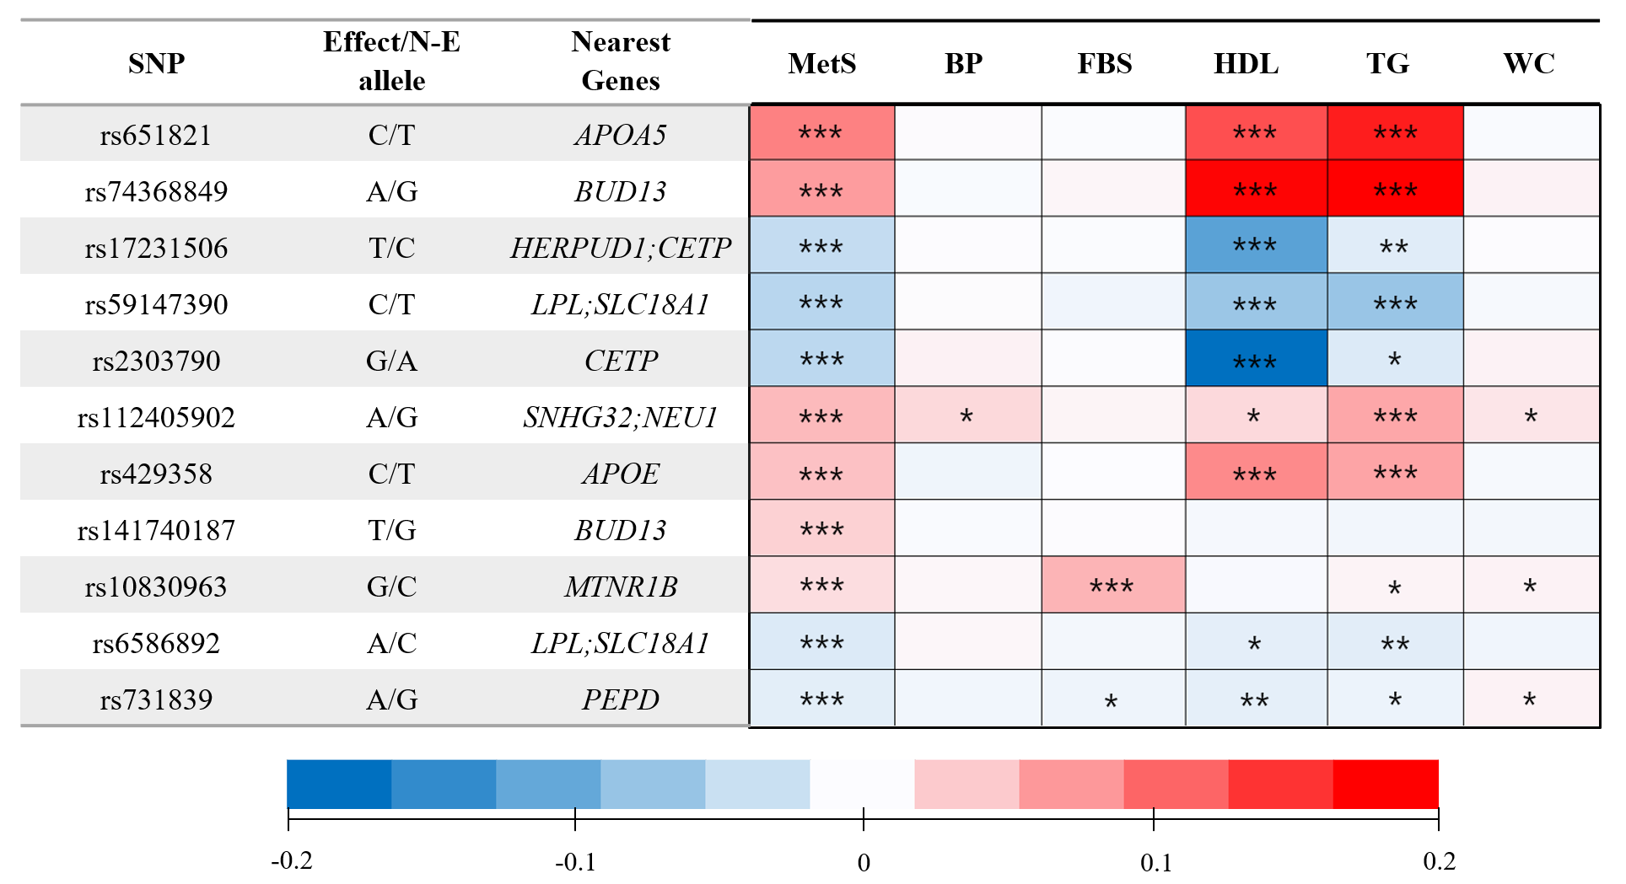
Colors refer to the size and direction of the beta effect.
Asterisks indicate P-value significance (*** < 5E-08 , ** < 1E-05 , * < 0.05)
GCTA-COJO: Genome-wide complex trait analysis - Conditional and Joint multiple SNP analysis, SNP: Single Nucleotide Polymorphism, BP: Blood pressure, FBS: Fasting blood sugar, HDL: High-density lipoprotein, TG: Triglyceride, WC: Waist circumference, MetS: Metabolic syndrome, N-E allele: Non-effect allele

Figure S4. Locus zoom plots including APOA5 SNPs within A. MetS, B. TG and C. HDL
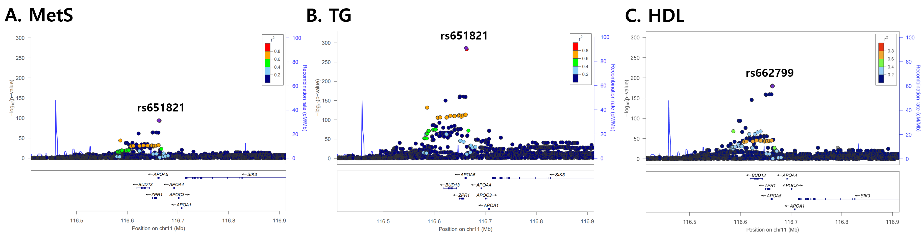

Figure S5. Comparison of fine-mapping results from KoGES and UK Biobank cohorts of TG values
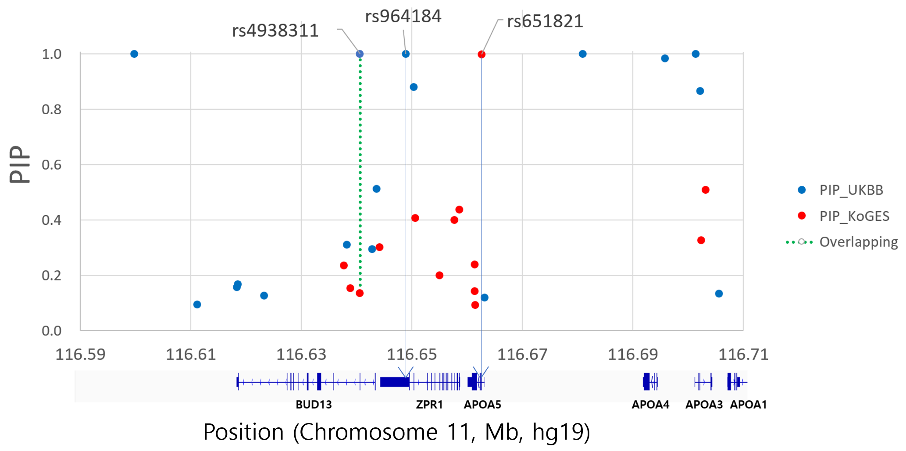

The x-axis shows the genetic position(hg19) on the chromosome 11 APOA5 region and y-axis shows the posterior inclusion probability (PIP). The red and blue circles represent the SNPs of Koreans and UK Biobank. Dotted line indicates overlapping SNPs. SNPs of PIPs over 0.1 are depicted.

Figure S6. Regional association plots for APOA5 locus in TG GWAS regarding KoGES and UK Biobank cohorts
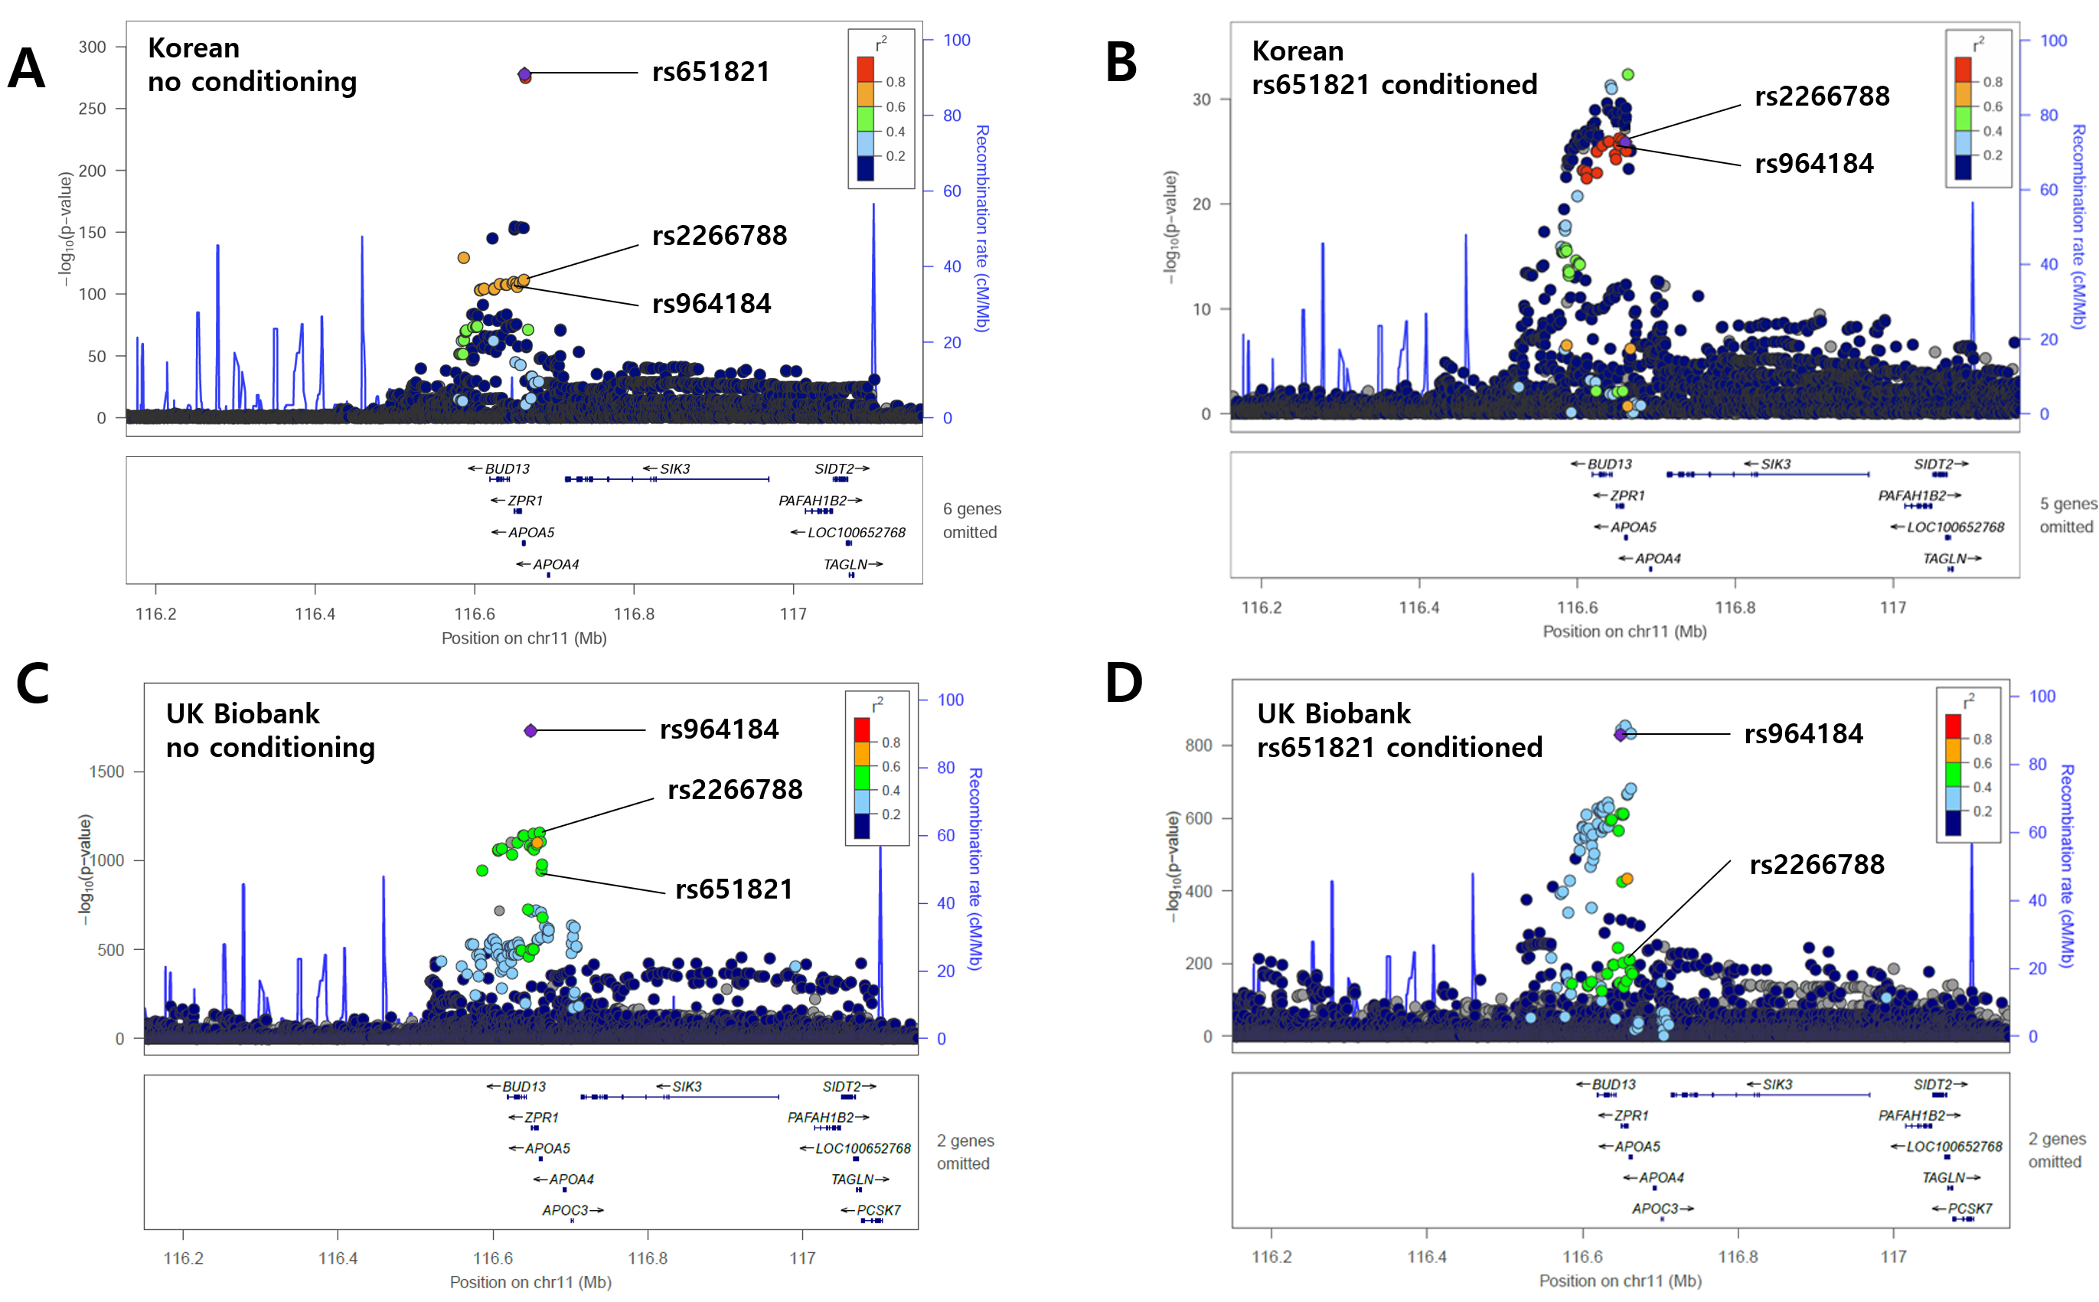
Figure S7. LD Blocks of the (A)KoGES and (B)UK Biobank cohorts derived from separate TG GWAS
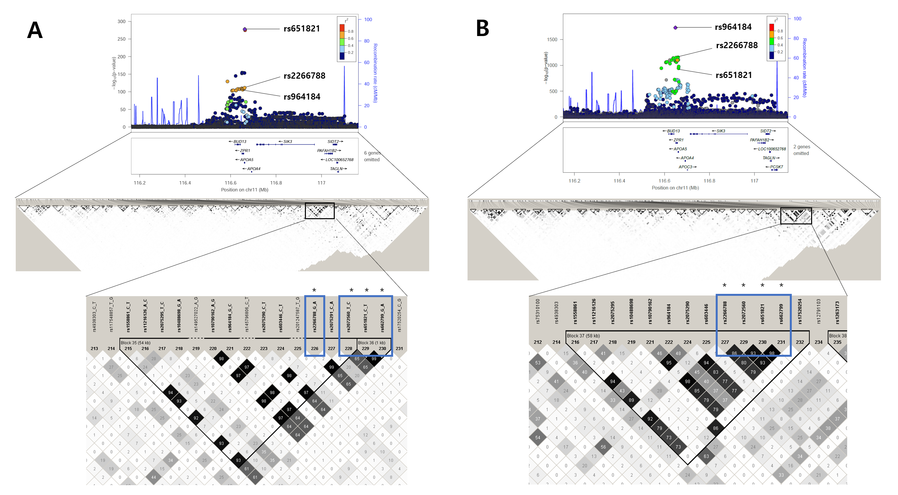

Figure S8. Multilayered effects of rs651821/rs2266788 in interaction with HDL and environmental factors
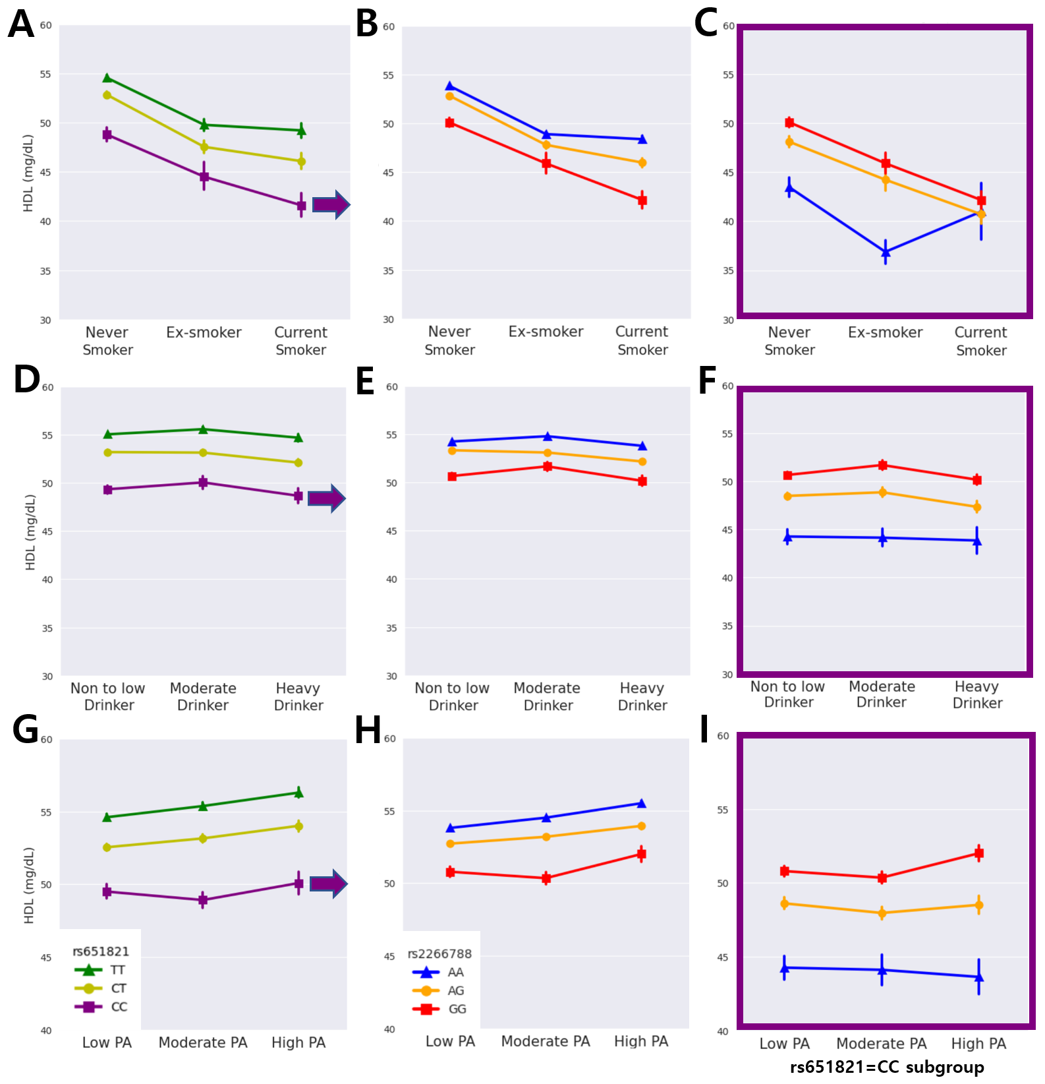
Plasma HDL levels in accordance to rs651821 and rs2266788 genotypes stratified by smoking (A-C), alcohol drinking (D-F), and physical activity (G-I). Subfigures A, D, G correlates to rs651821 genotypes in the total population, B, E, H correlates to rs2266788 genotypes in the total population and C, F, I refers to rs2266788 genotypes within the rs651821 CC subgroup. HDL: High-density lipoprotein cholesterol, PA: Physical activity

