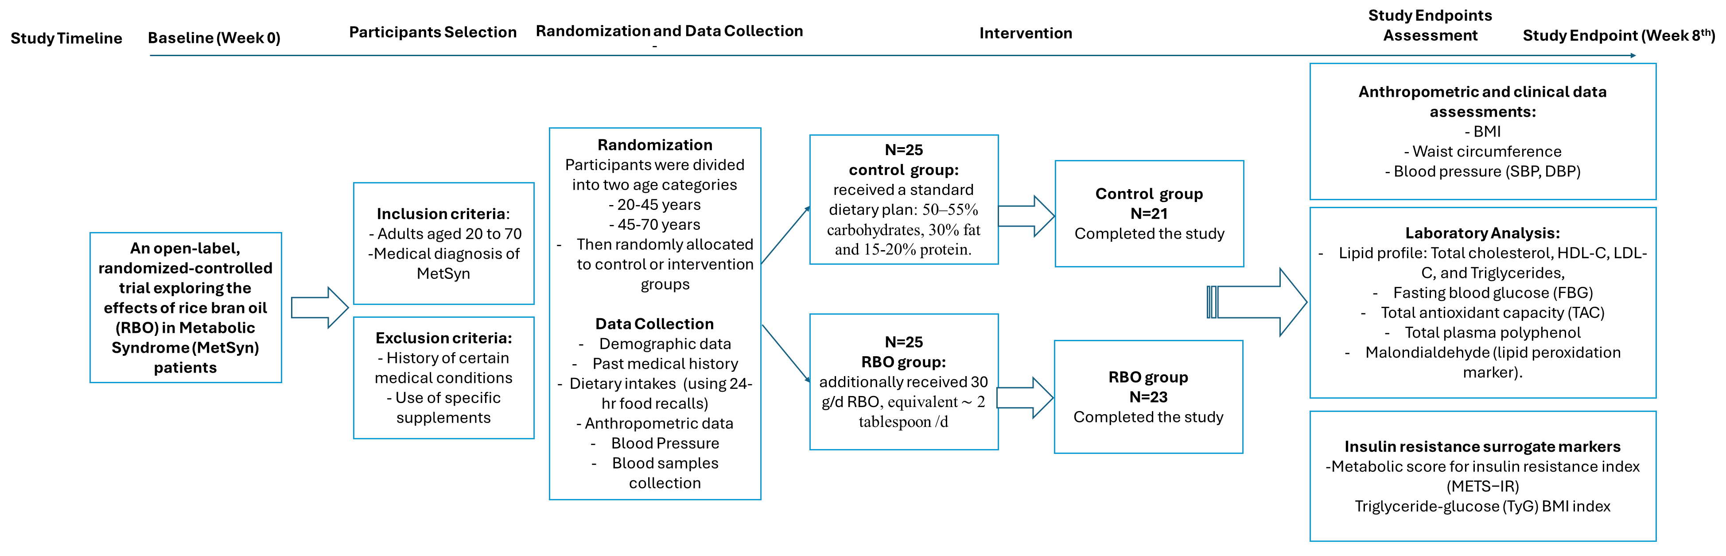
Supplementary Figure 1. An overview of the study procedure.
Supplementary Table 1. Dietary energy and macronutrients intake of study participants based on 24-hr food recalls at baseline and after the intervention.
 | Control group | Intervention group | P-value*
 | N=21 | N=23
Mean dietary intakes (per day)
Total Energy (kcal/d), Baseline | 2637.05 (762.871) | 2671.34 (517.898) | 0.86
Total Energy (kcal/d), After the intervention | 2657.16 (642.443) | 2604.97 (429.682) | 0.75
Total Protein (g/d), Baseline | 80.6052 (22.3119) | 82.5583 (18.5318) | 0.75
Total Protein (g/d), After the intervention | 81.4925 (21.2924) | 81.7643 (14.5697) | 0.96
Total Carbohydrates (g/d), Baseline | 404.39 (123.969) | 397.97 (73.285) | 0.83
Total Carbohydrates (g/d), After the intervention | 405.692 (108.856) | 402.545 (73.028) | 0.91
Total Fat (g/d), Baseline | 79.9626 (29.6608) | 84.3594 (25.0349) | 0.60
Total Fat (g/d), After the intervention | 80.7933 (24.036) | 76.1449 (18.0267) | 0.47
Data are presented as mean (SD) for continuous measures, and n (%) for categorical measures.
* Independent sample t-test.

