Supplement Table 1. Threshold effect between lipid profiles and gout
Exposure: | HDL | TG | LDL | TC | CMI
Model 1
A straight line effect | 1.00 (0.99, 1.00) 0.295 | 1.00 (1.00, 1.01) <0.001 | 1.00 (1.00, 1.00) 0.496 | 1.00 (1.00, 1.00) 0.543 | 1.18 (1.10, 1.27) <0.001
Model 2
Fold points(K) | 53 | 67 | 178 | 136 | 4.01
< K-segment effect1 | 0.98 (0.97, 1.00) 0.058 | 0.99 (0.98, 1.01) 0.524 | 1.00 (0.99, 1.00) 0.229 | 0.99 (0.96, 1.01) 0.321 | 1.24 (1.11, 1.39) <0.001
> K-segment effect2 | 1.00 (0.99, 1.01) 0.667 | 1.00 (1.00, 1.01) <0.001 | 1.01 (0.99, 1.02) 0.290 | 1.00 (1.00, 1.00) 0.351 | 1.10 (0.97, 1.26) 0.125
Effect size difference of 2 vs 1 | 1.02 (1.00, 1.04) 0.112 | 1.01 (0.99, 1.03) 0.273 | 1.01 (1.00, 1.02) 0.205 | 1.02 (0.99, 1.05) 0.293 | 0.89 (0.73, 1.09) 0.257
Equation predicted values at breakpoints | -3.61 (-3.79, -3.43) | -3.69 (-3.85, -3.52) | -3.35 (-3.59, -3.11) | -3.62 (-3.83, -3.41) | -2.47 (-2.70, -2.23)
Log likelihood ratio tests | 0.118 | 0.284 | 0.233 | 0.312 | 0.274
Result variable: Gout
Exposure variables: HDL, TG, LDL, TC, CMI
Results are expressed as OR (95%CI).
Adjusted for gender, age, race, BMI, education level, Income to poverty ratio, alcohol, smoke, diabetes, hypertention, eGFR, HOMA-IR and release cycle

Supplement Table 2. Subgroup analyses for the association between LDL and gout
Subgroups | Q1 | Q2 | Q3 | Q4 | P for interaction
Gender |  |  |  |  | 0.815
Male | ref | 1.06 (0.71, 1.57) 0.730 | 0.90 (0.60, 1.35) 0.616 | 081 (0.54, 1.22) 0.646
Female | ref | 1.06 (0.60, 1.89) 0.833 | 0.92 (0.52 1.64) 0.780 | 1.03 (0.59, 1.77 0.928
Body mass index(kg/m2) |  |  |  |  | 0.768
<25 | ref | 1.40 (0.74, 2.67) 0.300 | 0.73 (0.34, 1.55) 0.410 | 1.02 (0.51, 2.05) 0.960
25-30 | ref | 0.98 (0.53, 1.83) 0.950 | 0.97 (0.53, 1.80) 0.933 | 0.99 (0.55, 1.81) 0.983
≥30 | ref | 1.04 (0.64, 1.69) 0.870 | 0.97 (0.60, 1.55) 0.884 | 0.79 (0.49, 1.27) 0.323
Race |  |  |  |  | 0.752
Mexican American | ref | 1.08 (0.40, 2.95) 0.876 | 0.95 (0.35, 2.55) 0.913 | 0.36 (0.10, 1.29) 0.120
Other Hispanic | ref | 1.30 (0.28, 6.60) 0.783 | 1.38 (0.27, 7.08) 0.697 | 2.37 (0.52, 10.78) 0.266
Non-Hispanic White | ref | 1.18 (0.72, 1.93) 0.509 | 0.89 (0.54, 1.48) 0.654 | 1.11 (0.69, 1.81) 0.662
Non-Hispanic Black | ref | 0.98 (0.51, 1.86) 0.943 | 0.77 (0.39, 1.52) 0.450 | 0.72 (0.37, 1.37) 0.315
Other Race | ref | 0.984 (0.39, 2.50) 0.974 | 1.12 (0.46, 2.74) 0.809 | 0.92 (0.37, 2.26) 0.847
Smoking status |  |  |  |  | 0.715
No | ref | 0.89 (0.54, 1.49) 0.664 | 0.77 (0.47, 1.27) 0.306 | 0.71 (0.43, 1.18) 0.191
Yes | ref | 1.18 (0.77, 1.81) 0.442 | 0.97 (0.63, 1.51) 0.902 | 1.05 (0.69, 1.60) 0.825
Alcohol consumption |  |  |  |  | 0.786
No | ref | 1.01 (0.67, 1.53) 0.956 | 0.93 (0.61, 1.40) 0.727 | 0.82 (0.54, 1.24) 0.350
Yes | ref | 1.16 (0.69, 1.95) 0.582 | 0.852 (0.49, 1.47) 0.568 | 1.01 (0.60, 1.69) 0.978

Supplement Table 3. Subgroup analyses for the association between TC and gout
Subgroups | Q1 | Q2 | Q3 | Q4 | P for interaction
Gender |  |  |  |  | 0.751
Male | ref | 1.07 (0.71, 1.61) 0.761 | 1.35 (0.90 2.01) 0.144 | 1.14 (0.75, 1.71) 0.542
Female | ref | 1.07 (0.57, 1.97) 0.855 | 0.97 (0.52, 1.79) 0.92 | 1.01 (0.56, 1.80) 0.980
Body mass index(kg/m2) |  |  |  |  | 0.943
<25 | ref | 0.93 (0.44, 1.96) 0.850 | 1.16 (0.56, 2.38) 0.695 | 1.10 (0.53, 2.26) 0.805
25-30 | ref | 1.29 (0.67, 2.48) 0.443 | 1.49 (0.79, 2.81) 0.224 | 1.36 (0.73, 2.55) 0.330
≥30 | ref | 1.04 (0.65, 1.69) 0.863 | 1.09 (0.68, 1.75) 0.729 | 0.93 (0.58, 1.50) 0.764
Race |  |  |  |  | 0.645
Mexican American | ref | 0.57 (0.19, 1.66) 0.30 | 0.89(0.34, 2.34) 0.81 | 0.44 (0.14, 1.36) 0.15
Other Hispanic | ref | 1.80 (0.33, 9.97) 0.50 | 2.80(0.50,15.76) 0.241 | 2.91(0.53, 15.91) 0.218
Non-Hispanic White | ref | 1.12 (0.66, 1.90) 0.679 | 1.56 (0.94, 2.58) 0.084 | 1.26 (0.76, 2.09) 0.370
Non-Hispanic Black | ref | 1.26 (0.66, 2.40) 0.480 | 0.73 (0.36, 1.50) 0.396 | 0.98 (0.50, 1.92) 0.955
Other Race | ref | 1.10 (0.41, 2.93) 0.844 | 1.28 (0.50, 3.28) 0.601 | 1.38 (0.57, 3.37) 0.475
Smoking status |  |  |  |  | 0.309
No | ref | 1.06 (0.63, 1.79) 0.827 | 0.87 (0.51, 1.48) 0.603 | 1.02 (0.61, 1.70) 0.946
Yes | ref | 1.02 (0.65, 1.61) 0.921 | 1.45 (0.94, 2.24) 0.092 | 1.14 (0.74, 1.77) 0.554
Alcohol consumption |  |  |  |  | 0.689
No | ref | 0.95 (0.62, 1.46) 0.825 | 1.00 (0.66, 1.53) 0.999 | 1.03 (0.68, 1.55) 0.895
Yes | ref | 1.28 (0.71, 2.28) 0.409 | 1.56 (0.89, 2.72) 0.119 | 1.25 (0.71, 2.21) 0.439
The data: OR (95% CI) P value.
The Supplement Table 2-3 analyses were based on Model Ⅲ.
Model Ⅲ: gender, age, race, BMI, education level, Income to poverty ratio, alcohol, smoke, diabetes, hypertention, eGFR, HOMA-IR and release cycle were adjusted

Supplement Table 4. Threshold effect between HDL and GGT
Exposure | HDL
Model 1
A straight line effect | 0.27 (0.22, 0.31) <0.001
Model 2
Fold points(K) | 56
< K-segment effect1 | -0.15 (-0.25, -0.05) 0.005
> K-segment effect2 | 0.51 (0.44, 0.59) <0.001
Effect size difference of 2 vs 1 | 0.66 (0.52, 0.81) <0.001
Equation predicted values at breakpoints | 22.53 (21.34, 23.71)
Log likelihood ratio tests | <0.001
Result variable: GGT
Exposure variables: HDL
Results are expressed as OR (95%CI).
Adjusted for gender, age, race, BMI, education level, Income to poverty ratio, alcohol, smoke, diabetes, hypertention, eGFR, HOMA-IR and release cycle
GGT: γ-glutamyltransferase

Supplement Table 5. Association between CMI and gout, hyperuricemia
Exposure | Model I | Model II | Model Ⅲ
Gout
Continuous | 1.23 (1.14, 1.31) <0.001 | 1.25 (1.16, 1.33) <0.001 | 1.18 (1.10, 1.27) <0.001
Q1 | Reference (1) | Reference (1) | Reference (1)
Q2 | 1.21 (0.82, 1.79) 0.341 | 1.32 (0.89, 1.96) 0.168 | 1.16 (0.78, 1.74) 0.456
Q3 | 1.28 (0.87, 1.90) 0.212 | 1.54 (1.05, 2.27) 0.029 | 1.23 (0.82, 1.84) 0.311
Q4 | 2.15 (1.46, 3.15) <0.001 | 2.50 (1.72, 3.62) <0.001 | 1.81 (1.22, 2.70) 0.004
Hyperuricemia
Continuous | 1.26 (1.21, 1.31) <0.001 | 1.42 (1.37, 1.48) <0.001 | 1.24 (1.19, 1.30) <0.001
Q1 | Reference (1) | Reference (1) | Reference (1)
Q2 | 1.57 (1.31, 1.89) <0.001 | 2.01 (1.67, 2.41) <0.001 | 1.54 (1.28, 1.86) <0.001
Q3 | 2.23 (1.87, 2.67) <0.001 | 3.46 (2.91, 4.13) <0.001 | 2.22 (1.85, 2.67) <0.001
Q4 | 3.43 (2.86, 4.12) <0.001 | 6.01 (5.04, 7.17) <0.001 | 3.30 (2.73, 3.99) <0.001
The data: β (95%CI) Pvalue / OR (95%CI) Pvalue.
Model Ⅰ: gender, age, race, BMI were adjusted
Model Ⅱ: gender, age, race, education level, Income to poverty ratio, alcohol, smoke, diabetes, hypertension, eGFR and release cycle were adjusted;
Model Ⅲ: gender, age, race, BMI, education level, Income to poverty ratio, alcohol, smoke, diabetes, hypertention, eGFR, HOMA-IR and release cycle were adjusted
OR: Odds ratio, BMI: Body mass index, eGFR: Estimated glomerular filtration, HOMA-IR: Homeostatic model assessment for insulin resistance, CMI: Cardiometabolic Index

Subgroups | Q1 | Q2 | Q3 | Q4 | P for interaction
Gender |  |  |  |  | 0.882
Male | ref | 1.07 (0.64, 1.78) 0.803 | 1.13 (0.70, 1.87) 0.640 | 1.59 (0.96, 2.64) 0.072
Female | ref | 1.37 (0.72, 2.61) 0.343 | 1.35 (0.71, 2.69) 0.380 | 2.29 (1.18, 4.45) 0.014
Body mass index(kg/m2) |  |  |  |  | 0.932
<25 | ref | 1.71 (0.92, 3.20) 0.092 | 1.69 (0.80, 3.58) 0.172 | 2.90 (1.36, 6.18) 0.006
25-30 | ref | 1.07 (0.52, 2.19) 0.731 | 1.09 (0.53, 2.23) 0.591 | 1.86 (0.92, 3.76) 0.087
≥30 | ref | 0.91 (0.40, 2.07) 0.830 | 0.94 (0.43, 2.03) 0.875 | 1.24 (0.58, 2.67) 0.576
Race |  |  |  |  | 0.836
Mexican American | ref | 1.52 (0.16, 14.46) 0.735 | 2.30 (0.27, 19.82) 0.447 | 3.37 (0.41, 28.07) 0.261
Other Hispanic | ref | 1.29 (0.13, 12.94) 0.83 | 1.18 (0.13, 11.02) 0.886 | 2.21 (0.24, 20.16) 0.483
Non-Hispanic White | ref | 1.10 (0.58, 2.07) 0.769 | 1.17 (0.63, 2.18) 0.628 | 1.77 (0.97, 3.25) 0.065
Non-Hispanic Black | ref | 1.07 (0.56, 2.03) 0.846 | 0.99 (0.49, 2.01) 0.987 | 1.00 (0.44, 2.29) 0.998
Other Race | ref | 2.37 (0.67, 8.38) 0.180 | 2.96 (0.88, 9.97) 0.081 | 4.40 (1.32, 14.65) 0.016
Smoking status |  |  |  |  | 0.436
No | ref | 0.82 (0.46, 1.49) 0.521 | 0.96 (0.54, 1.71) 0.877 | 1.32 (0.73, 2.38) 0.356
Yes | ref | 1.59 (0.91, 2.77) 0.106 | 1.58 (0.90, 2.79) 0.112 | 2.37 (1.35, 4.16) 0.003
Alcohol consumption |  |  |  |  | 0.472
No | ref | 1.15 (0.72, 1.85) 0.560 | 1.00 (0.61, 1.63) 0.999 | 1.55 (0.95, 2.53) 0.077
Yes | ref | 1.23 (0.58, 2.59) 0.590 | 1.75 (0.85, 3.61) 0.127 | 2.38 (1.16, 4.92) 0.019

Supplement Table 6. Subgroup analyses for the association between CMI and gout

The data: OR (95% CI) P value.
The Supplement Table 6 analyses were based on Model Ⅲ.
Model Ⅲ: gender, age, race, BMI, education level, Income to poverty ratio, alcohol, smoke, diabetes, hypertention, eGFR, HOMA-IR and release cycle were adjusted

Supplement Table 7. Baseline characteristics of propensity score–matched cohorts by gout from NHANES 2007-2018
 | Control Group  (n=708) | Gout  (n=354) | P value
Age(years) | 46.68 ± 21.46 | 60.56 ± 13.81 | < 0.001*
Gender |  |  | < 0.001*
male | 286 (40.4%) | 234 (66.1%)
female | 422 (59.6%) | 120 (33.9%)
Race/ethnicity |  |  | < 0.001*
Mexican American | 167 (23.6%) | 36 (10.2%)
Other Hispanic | 79 (11.2%) | 24 (6.8%)
Non-Hispanic White | 252 (35.6%) | 163 (46.0%)
Non-Hispanic Black | 149 (21%) | 79 (22.3%)
Other Race | 61 (8.6%) | 52 (14.7%)
Body mass index(kg/m2) | 28.01 ± 7.64 | 30.85 ± 6.85 | < 0.001*
WHtR | 0.58 ± 0.11 | 0.63 ± 0.09 | < 0.001*
Income to poverty ratio |  |  | 0.457
<1 | 165 (23.3%) | 91 (25.7%)
1-3 | 330 (46.6%) | 151 (42.7%)
≥3 | 213 (30.1%) | 112 (31.6%)
Education level |  |  | 0.267
Less than high school | 177 (25.0%) | 89 (25.1%)
High school | 162 (22.9%) | 96 (27.1%)
More than high school | 369 (52.1%) | 169 (47.7%)
Smoking status |  |  | < 0.001*
No | 450 (63.6%) | 146 (41.2%)
Yes | 258 (36.4%) | 208 (58.8%)
Alcohol consumption |  |  | 0.550
No | 421 (59.5%) | 218 (61.6%)
Yes | 287 (40.5%) | 136 (38.4%)
Hypertension |  |  | < 0.001*
No | 434 (61.3%) | 143 (40.4%)
Yes | 274 (38.7%) | 211 (59.6%)
Diabetes |  |  | < 0.001*
No | 550 (77.7%) | 239 (67.5%)
Yes | 158 (22.3%) | 115 (32.5%)
eGFR | 98.92 ± 31.56 | 79.36 ± 24.97 | < 0.001*
HDL | 56.64 ± 17.05 | 51.27 ± 15.66 | < 0.001*
LDL | 111.78 ± 35.65 | 119.83 ± 37.09 | < 0.001*
TG | 107.77 ± 66.92 | 142.55 ± 76.57 | < 0.001*
TC | 189.96 ± 40.48 | 199.60 ± 42.37 | 0.0003*
CMI | 1.40 ± 1.37 | 2.16 ± 2.13 | < 0.001*
GGT | 34.79 ± 73.72 | 44.30 ± 66.96 | 0.041*
HOMA-IR | 4.11 ± 9.12 | 5.42 ± 9.75 | 0.032*
Leukocytes | 6.68 ± 2.16 | 7.25 ± 3.06 | < 0.001*
Lymphocytes | 2.02 ± 0.68 | 2.11 ± 1.82 | 0.256
NLR | 2.11 ± 1.39 | 2.42 ± 1.59 | 0.002*
SII | 502.24 ± 373.77 | 553.48 ± 413.78 | 0.043*
Release cycle |  |  | 0.011*
2007-2008 | 134 (18.9%) | 63 (17.8%)
2009-2010 | 155 (21.9%) | 57 (16.1%)
2011-2012 | 108 (15.3%) | 53 (15.0%)
2013-2014 | 98 (13.8%) | 36 (10.2%)
2015-2016 | 82 (11.6%) | 55 (15.5%)
2017-2018 | 131 (18.5%) | 90 (25.4%)
Mean±SD for continuous variables: P value was calculated by the t-test; % for categorical variables, P value was calculated by the chi-square test.
* Signifcant at the P<0.05 level
BMI: Body mass index, WHtR: waist-to-height ratio, HOMA-IR: Homeostatic model assessment for insulin resistance, GGT: γ-glutamyltransferase, NLR: neutrophil lymphocyte ratio, SII: The systemic immune inflammation index, eGFR: Estimated glomerular filtration, CMI: Cardiometabolic Index

Supplement Table 8. Baseline characteristics of propensity score–matched cohorts by hyperuricemia from NHANES 2007-2018
 | Control Group  (n=3318) | Hyperuricemia  (n=1659) | P value
Age(years) | 46.27 ± 16.54 | 48.52 ± 17.35 | < 0.001*
Gender |  |  | < 0.001*
male | 1680 (50.6%) | 928 (55.9%)
female | 1638 (49.4%) | 731 (44.1%)
Race/ethnicity |  |  | 0.026 *
Mexican American | 506 (15.3%) | 233 (14.0%)
Other Hispanic | 384 (11.6%) | 157 (9.5%)
Non-Hispanic White | 1345 (40.5%) | 673 (40.6%)
Non-Hispanic Black | 683 (20.6%) | 356 (21.5%)
Other Race | 400 (12.1%) | 240 (14.5%)
Body mass index(kg/m2) | 28.92 ± 6.54 | 30.52 ± 6.24 | < 0.001*
WHtR | 0.59 ± 0.10 | 0.61 ± 0.09 | < 0.001*
Income to poverty ratio |  |  | 0.240
<1 | 742 (22.4%) | 337 (20.3%)
1-3 | 1420 (42.8%) | 721 (43.5%)
≥3 | 1156 (34.8%) | 601 (36.2%)
Education level |  |  | 0.594
Less than high school | 805 (24.3%) | 381 (23.0%)
High school | 734 (22.1%) | 376 (22.7%)
More than high school | 1779 (53.6%) | 902 (54.4%)
Smoking status |  |  | 0.084
No | 1887 (56.9%) | 900 (54.2%)
Yes | 1431 (43.1%) | 759 (45.8%)
Alcohol consumption |  |  | 0.436
No | 1994 (60.1%) | 988 (59.6%)
Yes | 1324 (39.9%) | 671 (40.4%)
Hypertension |  |  | < 0.001*
No | 2445 (73.7%) | 1124 (67.8%)
Yes | 873 (26.3%) | 535 (32.2%)
Diabetes |  |  | 0.006*
No | 2845 (85.7%) | 1372 (82.7%)
Yes | 473 (14.3%) | 287 (17.3%)
eGFR | 98.37 ± 20.92 | 93.84 ± 21.63 | < 0.001*
HDL | 53.83 ± 15.36 | 50.90 ± 15.28 | < 0.001*
LDL | 118.23 ± 35.17 | 124.17 ± 36.46 | < 0.001*
TG | 112.12 ± 62.82 | 137.68 ± 72.85 | < 0.001*
TC | 194.48 ± 40.16 | 202.60 ± 41.09 | 0.0003*
CMI | 1.47 ± 1.25 | 1.93 ± 1.44 | < 0.001*
GGT | 28.50 ± 33.20 | 33.95 ± 34.39 | < 0.001*
HOMA-IR | 3.47 ± 4.52 | 4.27 ± 5.01 | < 0.001*
Leukocytes | 6.76 ± 2.06 | 6.86 ± 1.92 | 0.103
Lymphocytes | 2.06 ± 0.67 | 2.08 ± 0.65 | 0.154
NLR | 2.07 ± 1.08 | 2.08 ± 1.17 | 0.888
SII | 507.03 ± 308.61 | 507.17 ± 295.62 | 0.988
Release cycle |  |  | 0.779
2007-2008 | 604 (18.2%) | 315 (19.0%)
2009-2010 | 611 (18.4%) | 293 (17.7%)
2011-2012 | 555 (16.7%) | 261 (15.7%)
2013-2014 | 543 (16.4%) | 264 (15.9%)
2015-2016 | 453 (13.7%) | 244 (14.7%)
2017-2018 | 552 (16.6%) | 282 (17.0%)
Mean±SD for continuous variables: P value was calculated by the t-test; % for categorical variables, P value was calculated by the chi-square test.
* Signifcant at the P<0.05 level
BMI: Body mass index, WHtR: waist-to-height ratio, HOMA-IR: Homeostatic model assessment for insulin resistance, GGT: γ-glutamyltransferase, NLR: neutrophil lymphocyte ratio, SII: The systemic immune inflammation index, eGFR: Estimated glomerular filtration, CMI: Cardiometabolic Index

Supplement Figure 1. Smooth spline plots
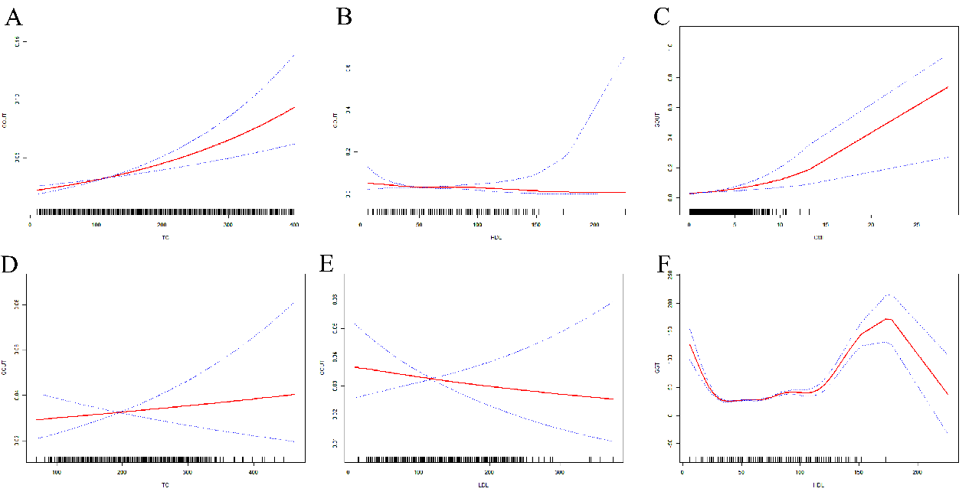The potential associations between lipid biomarkers, CMI and gout. The solid red line represents the smooth curve fit between variables. Blue bands represent the 95 % of confidence interval from the fit. A.TG and gout, B.HDL and gout, C.CMI and gout, D.LDL and gout, E.TC and gout, F.HDL and GGT
GGT: γ-glutamyltransferase, CMI: the Cardiometabolic Index

Supplement Figure 2-4. Mediating effects and proportions on the associations between TG, HDL and gout

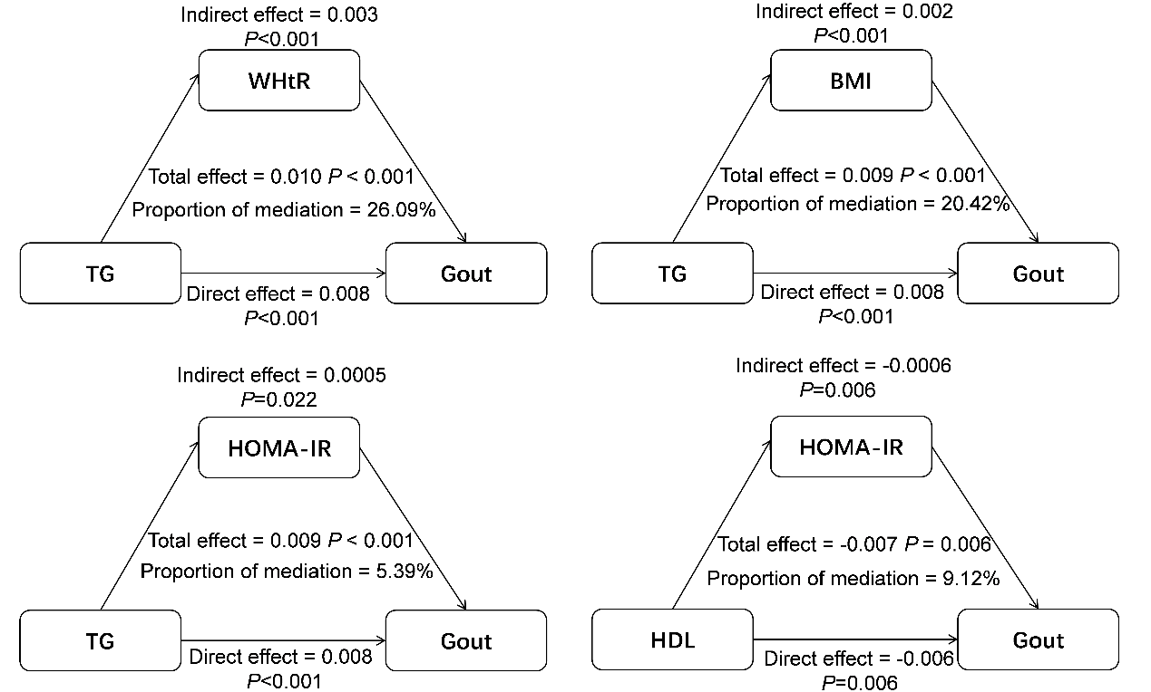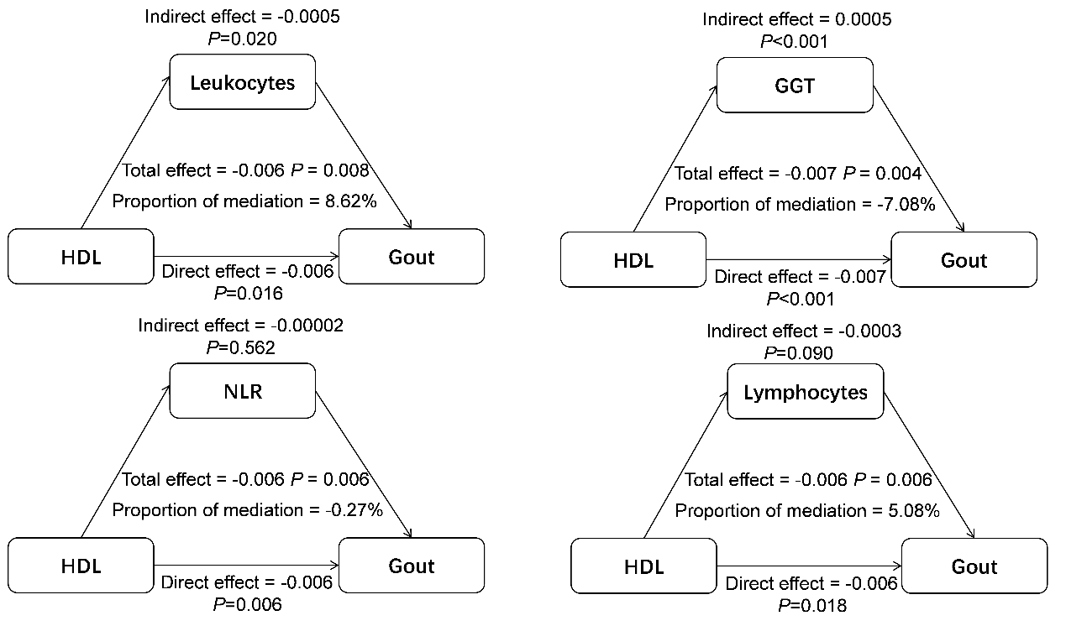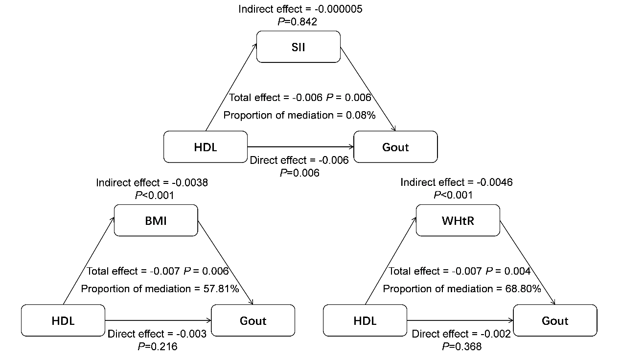
The covariates were adjusted based on the Model Ⅱ. BMI: Body mass index, WHtR: waist-to-height ratio, HOMA-IR: Homeostatic model assessment for insulin resistance, GGT: γ-glutamyltransferase, NLR: neutrophil lymphocyte ratio, SII: The systemic immune-inflammation index

Supplementary Instruction: Definitions of meditations covariates
Leukocyte and lymphocyte counts were assessed using Beckman Coulter MAXM instruments in MECs, employing the Beckman Coulter method for both counting and sizing, which were subsequently reported as ×1000 cells/µL. Neutrophil lymphocyte ratio was calculated in the equation that: NLR = neutrophil (/L)/lymphocyte (/L). The systemic immune inflammation index was calculated in the equation that: SII = platelet (/L) *neutrophil (/L)/lymphocyte (/L) Gamma-glutamyl Transaminase (GGT) was analyzed using a Hitachi Model 704 multichannel analyzer in NHANES 1999–2002, a Beckman Synchron LX20 in NHANES 2003–2008, a Beckman UniCel DxC800 Synchron analyzer in NHANES 2009–2016, and a Roche Cobas 6000 analyzer in NHANES 2017–2018. The income to poverty ratio was defined as the index of the annual earnings relative to poverty based on the size of the family. Alcohol consumption is defined basing on the following question: “In your entire life, have you/ had at least 12 drinks of any type of alcoholic beverage?” Drinking <12 drinks in a lifetime was defined as never drinking, drinking at least 12 drinks in a lifetime was defined as drinking. The cigarette smoking status was defined based on the criterion of smoking at least 100 cigarettes during a person’s lifetime. Hypertension was defined as systolic blood pressure≥140 mmHg, diastolic blood pressure≥90 mmHg, self-reported hypertension, or taking antihypertensive medications, where systolic and diastolic blood pressure were obtained by calculating the mean blood pressure. Diabetes is defined as a self-reported diagnosis, the use of insulin or oral hypoglycemic agents, fasting blood glucose (FBG)≥126 mg/dL, oral glucose tolerance test (OGTT)≥200 mg/dL, or HbA1c≥6.5%. Estimated glomerular filtration rate (eGFR, mL/minute/1.73 m²) was calculated using the following equation: eGFR = 141 × min ( $\frac{Scr}{κ}$, 1 ) ^{α} × max ( $\frac{Scr}{κ}$, 1 )^{-1.209} × 0.993^{Age} × 1.018 [ if female ] × 1.159 [ if non Hispanic black ] where Scr is serum creatinine (mg/dL), κ is 0.7 for females and 0.9 for males, a is 0.329 for females and 0.411 for males, min indicates the minimum of Scr/κ or 1, and max indicates the maximum of Scr or 1. HOMA-IR was calculated by using the formulas: HOMA-IR = fasting serum insulin *FPG (mmol/l)/22.5.

