List of contents:
Fig.1 The flow chart of inclusion and exclusion of research objects (Association of Plasma Homocysteine with Cardiometabolic Multimorbidity: A Cross-Sectional Study in Northwest China, 2018-2020).
Fig. S2 The flow chart of inclusion and exclusion of research objects (Association of Plasma Homocysteine with Cardiometabolic Multimorbidity: A Cross-Sectional Study in Northwest China, 2018-2020).
Table S1 Association between homocysteine and cardiometabolic multimorbidity in subset analysis (Association of Plasma Homocysteine with Cardiometabolic Multimorbidity: A Cross-Sectional Study in Northwest China, 2018-2020).
Table S2 The variables in the model were collinearity diagnosed
Table S3 Sensitivity analysis of the association between homocysteine and cardiometabolic multimorbidity (Association of Plasma Homocysteine with Cardiometabolic Multimorbidity: A Cross-Sectional Study in Northwest China, 2018-2020).

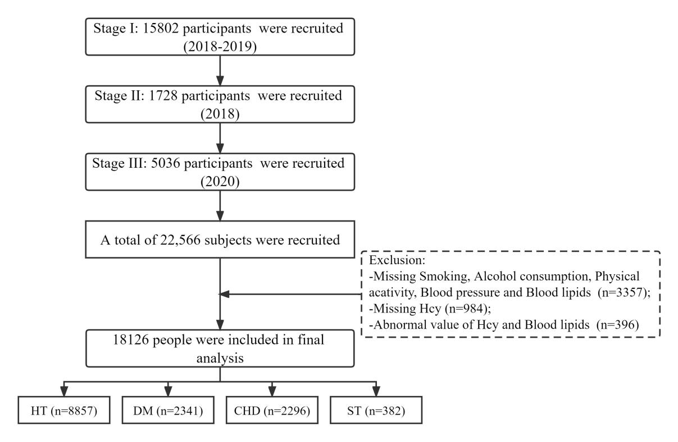
Fig. S1 The flow chart of inclusion and exclusion of research objects (Association of Plasma Homocysteine with Cardiometabolic Multimorbidity: A Cross-Sectional Study in Northwest China, 2018-2020). Hcy, homocysteine; HT, Hypertension; DM, Diabetes; CHD, Coronary heart disease; ST, Stroke.
Fig. S2 The Spearman correlation between homocysteine and lipid indices (Association of Plasma Homocysteine with Cardiometabolic Multimorbidity: A Cross-Sectional Study in Northwest China, 2018-2020). The deeper the color, the greater the correlation, and the blank grid indicates no statistical significance. Hcy, homocysteine (μmol/L); HDL, High density lipoprotein cholesterol (mmol/L); LDL, Low density lipoprotein cholesterol (mmol/L); TC, Total cholesterol (mmol/L); TG, Triglyceride (mmol/L); FPG, Fasting blood glucose(mmol/L); SBP, Systolic pressure (mmHg); DBP, Diastolic pressure (mmHg).
Table S1 Association between homocysteine and cardiometabolic multimorbidity in subset analysis (Association of Plasma Homocysteine with Cardiometabolic Multimorbidity: A Cross-Sectional Study in Northwest China, 2018-2020).
Presence of CMM | Events (%) | Crude Model |  | Model 1 |  | Model 2
Presence of CMM | Events (%) | OR (95% CI) | P value | OR (95% CI) | P value | OR (95% CI) | P value
having at least 2 diseases
Age (years)
<=64 | 741 (7.6) | 1.005 (0.999, 1.011) | 0.079 | 1.005 (0.999, 1.011) | 0.083 | 1.005 (0.999, 1.011) | 0.058
>64 | 1755 (20.9) | 1.006 (1.002, 1.011) | 0.002 | 1.008 (1.003, 1.012) | <0.001 | 1.006 (1.002, 1.011) | 0.003
Sex
Male | 983 (13.0) | 1.012 (1.007, 1.017) | <0.001 | 1.008 (1.003, 1.013) | 0.003 | 1.007 (1.002, 1.012) | 0.006
Female | 1513 (14.3) | 1.005 (1.001, 1.010) | 0.015 | 1.005 (1.000, 1.010) | 0.038 | 1.005 (0.999, 1.009) | 0.052
BMI (kg/m²)
<24 | 698 (9.6) | 1.009 (1.003, 1.015) | 0.002 | 1.007 (1.001, 1.013) | 0.027 | 1.006 (0.999, 1.013) | 0.050
>=24 | 1798 (16.5) | 1.007 (1.004, 1.011) | <0.001 | 1.005 (1.001, 1.009) | 0.018 | 1.005 (1.000, 1.009) | 0.029
TC (mmol/L)
<6.2 | 2171 (13.2) | 1.008 (1.005, 1.012) | <0.001 | 1.006 (1.002, 1.009) | 0.003 | 1.005 (1.001, 1.009) | 0.007
>=6.2 | 325 (19.9) | 1.007 (0.998, 1.016) | 0.136 | 1.007 (0.997, 1.017) | 0.160 | 1.007 (0.997, 1.017) | 0.180
TG (mmol/L)
<2.3 | 14 (14.9) | 1.005 (1.002, 1.009) | 0.006 | 1.003 (0.999, 1.008) | 0.106 | 1.004 (0.999, 1.008) | 0.069
>=2.3 | 2482 (13.8) | 1.013 (1.007, 1.019) | <0.001 | 1.010 (1.003, 1.016) | 0.003 | 1.010 (1.003, 1.016) | 0.002
HDL-C (mmol/L)
<1 | 394 (17.0) | 1.010 (1.002, 1.018) | 0.014 | 1.004 (0.996, 1.013) | 0.295 | 1.005 (0.996, 1.013) | 0.286
>=1 | 2102 (13.3) | 1.008 (1.004, 1.011) | <0.001 | 1.006 (1.002, 1.010) | 0.002 | 1.005 (1.002, 1.009) | 0.006
LDL-C (mmol/L)
<4.1 | 2209 (13.1) | 1.008 (1.005, 1.011) | <0.001 | 1.005 (1.002, 1.009) | 0.003 | 1.005 (1.001, 1.009) | 0.008
>=4.1 | 287 (22.6) | 1.009 (0.999, 1.019) | 0.086 | 1.008 (0.998, 1.019) | 0.124 | 1.006 (0.995, 1.018) | 0.268
having at least 3 diseases
Age (years)
0~64 | 78 (0.8) | 1.010 (0.995, 1.026) | 0.207 | 1.010 (0.995, 1.026) | 0.662 | 1.011 (0.995, 1.027) | 0.173
>64 | 308 (3.7) | 1.002 (0.993, 1.011) | 0.610 | 1.003 (0.994, 1.012) | 0.506 | 1.001(0.992, 1.011) | 0.832
Sex
Male | 148 (1.9) | 1.007 (0.996, 1.019) | 0.233 | 0.999 (0.986, 1.012) | 0.859 | 0.996 (0.983, 1.010) | 0.599
Female | 238 (2.2) | 1.007 (0.998, 1.017) | 0.135 | 1.007 (0.996, 1.018) | 0.197 | 1.007 (0.996, 1.017) | 0.210
BMI (kg/m²)
<24 | 92 (1.3) | 1.005 (0.989, 1.021) | 0.535 | 1.002 (0.985, 1.019) | 0.843 | 1.000 (0.983, 1.018) | 0.994
>=24 | 294 (2.7) | 1.007 (0.999, 1.016) | 0.099 | 1.003 (0.994, 1.013) | 0.459 | 1.003 (0.994, 1.012) | 0.522
TC (mmol/L)
<6.2 | 334 (2.0) | 1.007 (0.999, 1.015) | 0.067 | 1.004 (0.995, 1.012) | 0.423 | 1.002 (0.994, 1.011) | 0.583
>=6.2 | 52 (3.2) | 1.004 (0.983, 1.025) | 0.700 | 1.002 (0.979, 1.026) | 0.845 | 1.001 (0.977, 1.025) | 0.955
TG (mmol/L)
<2.3 | 1 (1.1) | 1.006 (0.996, 1.015) | 0.250 | 1.003 (0.993, 1.014) | 0.517 | 1.005 (0.995, 1.015) | 0.340
>=2.3 | 385 (2.1) | 1.007 (0.996, 1.019) | 0.224 | 1.000 (0.987, 1.014) | 0.991 | 1.000 (0.987, 1.014) | 0.953
HDL-C (mmol/L)
<1 | 59 (2.5) | 0.992 (0.970, 1.014) | 0.473 | 0.980 (0.956, 1.005) | 0.115 | 0.980 (0.956, 1.005) | 0.114
>=1 | 327 (2.1) | 1.009 (1.001, 1.017) | 0.023 | 1.007 (0.999, 1.016) | 0.100 | 1.006 (0.997, 1.015) | 0.190
LDL-C (mmol/L)
<4.1 | 336 (2.0) | 1.009 (1.001, 1.017) | 0.027 | 1.005 (0.997, 1.014) | 0.215 | 1.004 (0.996, 1.013) | 0.353
>=4.1 | 50 (3.9) | 0.991 (0.966, 1.017) | 0.506 | 0.985 (0.956, 1.014) | 0.303 | 0.981 (0.951, 1.012) | 0.219
Bold P value represent <0.05. Crude Model was not adjusted for any variables; Model 1 was adjusted for age, sex, BMI, education, physical activity, smoking and alcohol drinking; Model 2 was adjusted for TC, TG, HDL-C and LDL-C based on Model 1. Hcy, homocysteine; OR, Odds ratio; CI, Confidence interval; BMI, Body mass index; TC, Total cholesterol; TG, Triglyceride; HDL-C, High density lipoprotein cholesterol; LDL-C, Low density lipoprotein cholesterol.
Table S2 The variables in the model were collinearity diagnosed
Variable | VIF | Df
Hcy | 1.015 | 1
age | 1.262 | 1
sex | 1.289 | 1
BMI | 1.047 | 1
alcohol drinking | 1.092 | 1
smoking | 1.225 | 1
education | 1.159 | 1
physical activity | 1.101 | 1
TC | 2.813 | 1
TG | 1.132 | 1
HDL-C | 1.297 | 1
LDL-C | 2.361 | 1
VIF, Variance inflation factor; Df, Degree of freedom.

Table S3 Sensitivity analysis of the association between homocysteine and cardiometabolic multimorbidity (Association of Plasma Homocysteine with Cardiometabolic Multimorbidity: A Cross-Sectional Study in Northwest China, 2018-2020).
Presence of CMM | Events (%) | Crude Model |  | Model 1 |  | Model 2
 |  | OR (95% CI) | P value | OR (95% CI) | P value | OR (95% CI) | P value
having at least 2 diseases
Hcy |  | 1.065 (1.022, 1.110) | 0.002 | 1.062 (1.017, 1.109) | 0.003 | 1.055 (1.010, 1.102) | 0.016
Quartiles
Q1 | 494 (10.9) | Reference |  | Reference |  | Reference
Q2 | 625 (13.8) | 1.187 (1.044, 1.349) | 0.009 | 1.172 (1.028, 1.337) | 0.018 | 1.161 (1.017, 1.326) | 0.027
Q3 | 665 (14.7) | 1.166 (1.026, 1.325) | 0.018 | 1.146 (1.005, 1.308) | 0.042 | 1.124 (0.984, 1.283) | 0.086
Q4 | 712 (15.7) | 1.231 (1.084, 1.397) | 0.001 | 1.197 (1.049, 1.365) | 0.007 | 1.170 (1.025, 1.336) | 0.020
having at least 3 diseases
Hcy |  | 1.039 (0.942 1.146) | 0.447 | 1.038 (0.938, 1.147) | 0.472 | 1.022 (0.923, 1.133) | 0.673
Quartiles
Q1 | 75 (1.7) | Reference |  | Reference |  | Reference
Q2 | 101 (2.2) | 1.151(0.852, 1.555) | 0.359 | 1.114 (0.822, 1.509) | 0.487 | 1.093 (0.806, 1.483) | 0.567
Q3 | 99 (2.2) | 0.986 (0.727, 1.339) | 0.929 | 0.962 (0.706 1.311) | 0.806 | 0.911 (0.667, 1.246) | 0.562
Q4 | 111 (2.4) | 1.080 (0.800, 1.458) | 0.614 | 1.049 (0.772, 1.424) | 0.759 | 0.994 (0.730, 1.354) | 0.969
Bold P value represent <0.05. Crude Model was not adjusted for any variables; Model 1 was adjusted for age, sex, BMI, education, physical activity, smoking and alcohol drinking; Model 2 was adjusted for TC, TG, HDL-C and LDL-C based on Model 1. Hcy, homocysteine (μmol/L); OR, Odds ratio; CI Confidence interval; CMM, cardiometabolic multimorbidity

