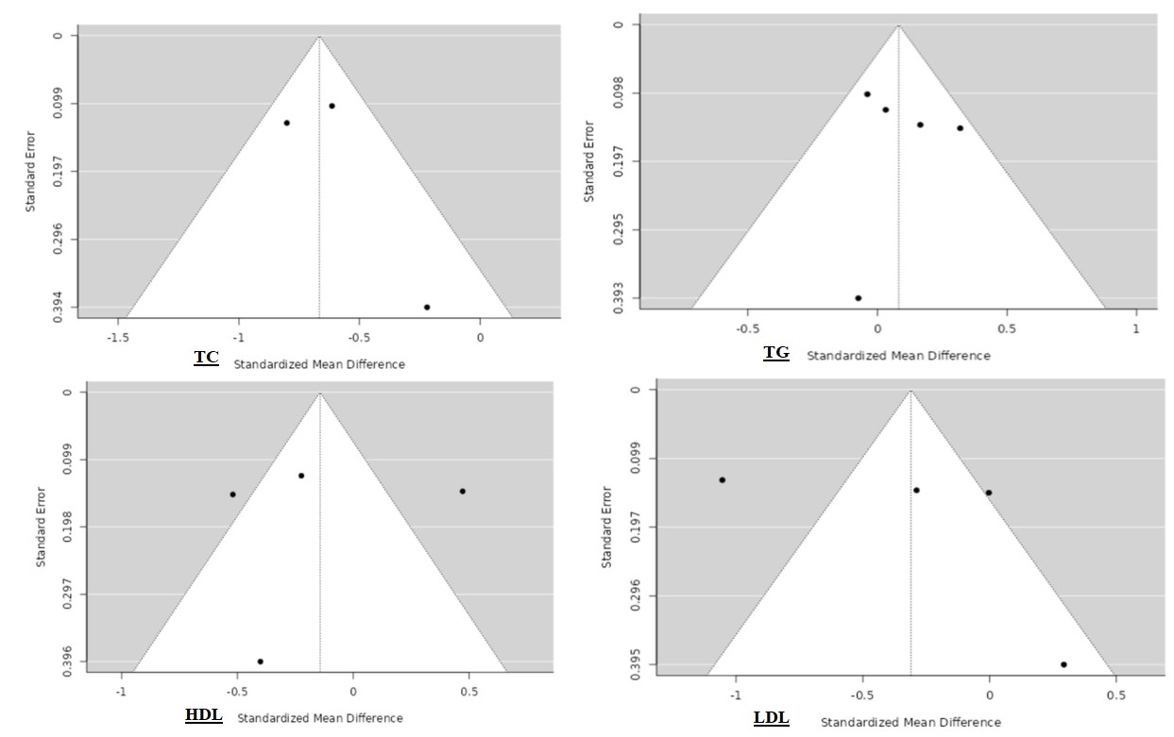

Supplementary file 3: Figure S3. Funnel plots to detect publication bias for the meta-analyses of the studies on patients with beta-thalassemia minor and their controls.

