Supplementary Figure 1.
Differences in plasma resolvins levels between triple-negative vs non-triple-negative breast cancer patients.
No difference was observed in resolvins D2, D3 and E1 levels among the two groups in triple-negative with respect to non-triple-negative breast cancer patients.
Data are expressed as pg/ml and are presented as median (95% CI).

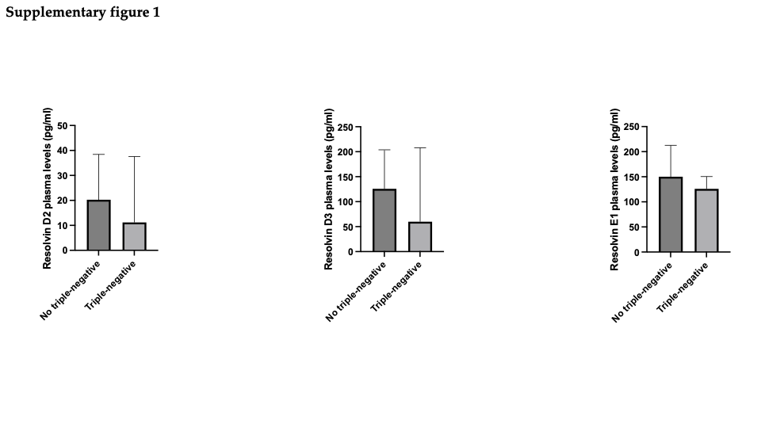

Supplementary Figure 2.
Differences in plasma resolvins levels according to Ki-67% expression.
No difference was observed in resolvins D1, D2 and E1 levels among the two groups in breast cancer patients with high Ki-67% expression (≥ 20%) with respect to those with low Ki-67% expression.
Data are expressed as pg/ml and are presented as median (95% CI).

