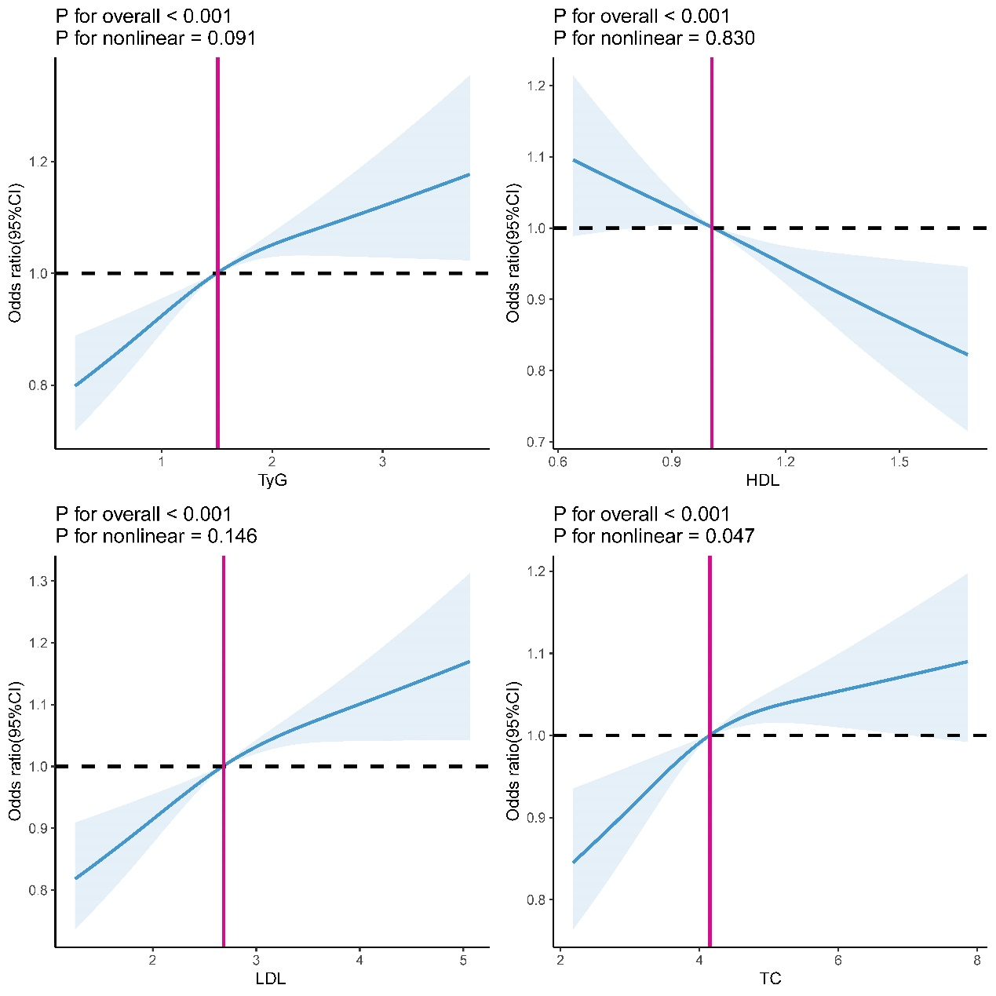
SFig. 1 Relationships between TyG, HDL, LDL and TC with the risk of CHD by the restricted cubic spline (RCS) method. TC, total cholesterol; LDL, low-density lipoprotein; HDL, high-density lipoprotein; TyG, the triglyceride-glucose; CHD, coronary heart disease.

Table S1 Associations between covariates and ASCVD
 | β | OR(95%CI) | P
Lipids profiles with CAS
Age (years) | 0.091 | 1.096(1.052,1.143) | <0.001
Sex(Male vs. Female) | 0.340 | 1.404(0.775,2.553) | 0.262
Lp(a) (≥30mg/dL vs. <30mg/dL) | 0.152 | 1.164(0.682,2.004) | 0.579
History of Smoking(Yes vs. No) | 0.083 | 1.086(0.715,1.652) | 0.698
History of hypertension (Yes vs. No) | 0.244 | 1.276(0.786,2.092) | 0.325
History of diabetes (Yes vs. No) | -0.386 | 0.679(0.234,2.104) | 0.490
Family history of CHD (Yes vs. No) | 0.180 | 1.198(0.051,185.06) | 0.915
Lipids profiles with severe CAS
Age (years) | 0.000 | 1.000(0.956,1.046) | 0.989
Sex(Male vs. Female) | 0.175 | 1.192(0.428,3.306) | 0.735
Lp(a) (≥30mg/dL vs. <30mg/dL) | 0.507 | 1.661(0.920,3.097) | 0.093
History of Smoking (Yes vs. No) | 0.106 | 1.112(0.711,1.735) | 0.642
History of hypertension (Yes vs. No) | 0.279 | 1.321(0.834,2.111) | 0.236
History of diabetes (Yes vs. No) | 0.030 | 1.030(0.483,2.296) | 0.940
Family history of CHD (Yes vs. No) | 1.828 | 6.224(0.36,940.118) | 0.223
Lipids profiles with CHD
Age (years) | 0.026 | 1.027(0.971,1.087) | 0.354
Sex(Male vs. Female) | -0.09 | 0.914(0.391,2.251) | 0.840
Lp(a) (≥30mg/dL vs. <30mg/dL) | 0.615 | 1.850(0.929,3.640) | 0.079
History of Smoking (Yes vs. No) | 0.123 | 1.131(0.662,1.922) | 0.650
History of hypertension (Yes vs. No) | 0.183 | 1.201(0.682,2.100) | 0.524
History of diabetes (Yes vs. No) | 0.850 | 2.339(0.771,6.944) | 0.132
Family history of CHD (Yes vs. No) | 0.580 | 1.785(0.074,275.481) | 0.725

