Sensitivity analysis
Table S1 Threshold effect analysis of the TyG and diabetes in simplified adjusted models
New-onset diabetes | HR, 95%CI | P-value
One-line linear regression | 1.37 (0.97, 1.94) | 0.072
Two-piece-wise regression
Inflection points of TyG | 7.83
≤ 7.83 | 0.07 (0.02, 0.31) | 0.001
> 7.83 | 1.64 (1.15, 2.35) | 0.007
P for log-likelihood ratio test |  | 0.001
95% CI for inflection points | 7.71, 7.99
Adjust for: HDL-c, WC, AST, age, GGT, ALT, TC, regular exerciser, BMI, HbA1c, and smoking status.

Table S2 The comparison between the TyG index and HbA1c in terms of sensitivity, specificity, positive and negative likelihood ratios, and AUROCs
Variables | AUC (95% CI) | Specificity | Sensitivity | Positive-LR |  | Negative-LR
TyG | 0.6224 (0.5813, 0.6635 ) | 0.6535 | 0.5665 | 1.6349 | 0.6634
HbA1c | 0.7261 (0.6884,0.7637) | 0.6730 | 0.6700 | 2.0490 | 0.4904

Table S3 Baseline characteristics of participants stratified by TyG levels
TyG | ≤7.82 | >7.82 | P value
Participants | 185 | 2321
Age, years | 44.15 ± 7.95 | 44.83 ± 8.35 | 0.282
BMI, kg/m² | 24.60 ± 3.36 | 25.58 ± 3.09 | <0.001
WC, cm | 83.00 ± 8.46 | 86.24 ± 7.66 | <0.001
ALT, U/L | 26.64 ± 14.91 | 32.79 ± 19.60 | <0.001
AST, U/L | 20.69 ± 10.32 | 22.47 ± 9.74 | 0.018
GGT, U/L | 20.03 ± 12.04 | 29.14 ± 22.56 | <0.001
TC, mg/dL | 189.61 ± 32.49 | 212.17 ± 32.98 | <0.001
TG, mg/dL | 41.99 ± 7.99 | 133.10 ± 68.38 | <0.001
HbA1c, ％ | 5.28 ± 0.31 | 5.30 ± 0.34 | 0.330
FPG, mg/dL | 94.20 ± 7.12 | 97.42 ± 6.43 | <0.001
SBP, mmHg | 120.37 ± 15.26 | 123.68 ± 14.78 | 0.004
DBP, mmHg | 75.03 ± 11.06 | 78.06 ± 10.08 | <0.001
HDL-c, mg/dL | 55.92 ± 13.71 | 45.05 ± 10.40 | <0.001
Sex |  |  | <0.001
Male | 119 (64.32%) | 1913 (82.42%)
Female | 66 (35.68%) | 408 (17.58%)
Regular exerciser |  |  | 0.815
No | 156 (84.32%) | 1972 (84.96%)
Yes | 29 (15.68%) | 349 (15.04%)
Smoking status |  |  | <0.001
Never | 109 (58.92%) | 1071 (46.14%)
Past | 45 (24.32%) | 596 (25.68%)
Current | 31 (16.76%) | 654 (28.18%)
New-onset diabetes |  |  | 0.403
No | 173 (93.51%) | 2130 (91.77%)
Yes | 12 (6.49%) | 191 (8.23%)
Categorical variables were displayed as N (%), and continuous variables were digested as median (interquartile range) or mean ± standard deviation.

Table S4 Baseline characteristics between NAFLD and non NAFLD participants
Variable | NAFALD | non NAFLD | P value
Participants | 2506 | 11765
Age, years | 44.78 ± 8.32 | 43.27 ± 8.99 | <0.001
BMI, kg/m² | 25.50 ± 3.12 | 21.33 ± 2.61 | <0.001
WC, cm | 86.00 ± 7.77 | 74.10 ± 7.92 | <0.001
ALT, U/L | 27.00 (20.00-39.00) | 15.00(12.00-20.00) | <0.001
AST, U/L | 22.34 ± 9.79 | 17.35 ± 8.14 | <0.001
GGT, U/L | 23.00 (16.00-33.00) | 14.00 (11.00-18.00) | <0.001
HDL-c, mg/dL | 45.86 ± 11.04 | 58.71 ± 15.34 | <0.001
TC, mg/dL | 210.51 ± 33.46 | 195.50 ± 32.98 | <0.001
TG, mg/dL | 110.00 (77.00-158.75) | 58.00(40.00-84.00) | <0.001
HbA1c, ％ | 5.30 ± 0.33 | 5.15 ± 0.31 | <0.001
FPG, mg/dL | 97.18 ± 6.54 | 91.79 ± 7.24 | <0.001
SBP, mmHg | 123.43 ± 14.84 | 111.93 ± 14.03 | <0.001
DBP, mmHg | 77.83 ± 10.19 | 69.71 ± 9.86 | <0.001
TyG | 8.58 ± 0.54 | 7.89 ± 0.59 | <0.001
Sex |  |  | <0.001
Male | 2032 (81.09%) | 5403 (45.92%)
Female | 474 (18.91%) | 6362 (54.08%)
Regular exerciser |  |  | <0.001
No | 2128 (84.92%) | 9667 (82.17%)
Yes | 378 (15.08%) | 2098 (17.83%)
Smoking status |  |  | <0.001
Never | 1180（47.90%） | 7565 (64.30%)
Past | 641（25.58%） | 1930 (16.40%)
Current | 685（27.33%） | 2270 (19.29%)
New-onset diabetes |  |  | <0.001
No | 2303（91.90%） | 11645 (98.98%)
Yes | 203（8.10%） | 120 (1.02%)
Categorical variables were displayed as N (%), and continuous variables were digested as median (interquartile range) or mean ± standard deviation.

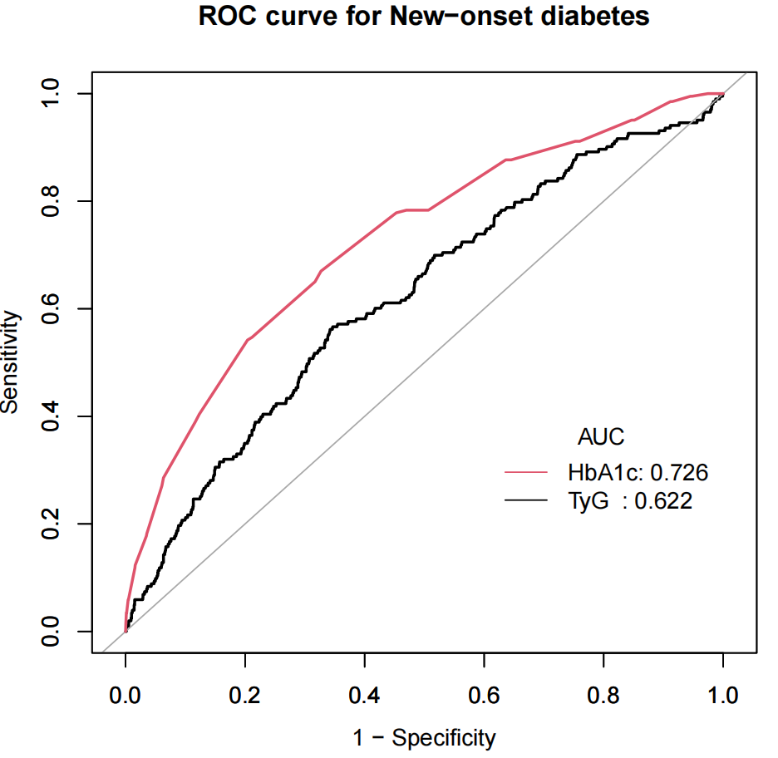
Fig. S1. AUROC Comparison

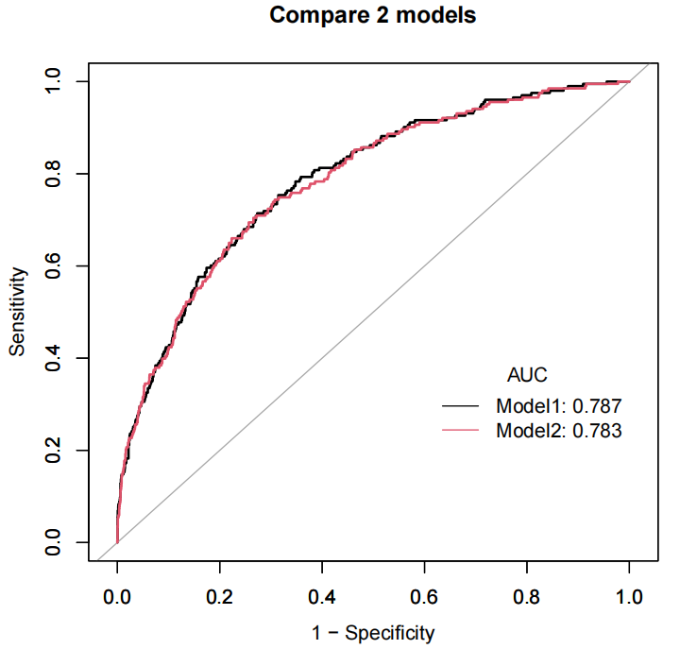
Fig. S2 ROC curves for Models II, and the simplified model. Model 1 = Table3 Models II. Model 2= Simplified Model including only variables significant in univariate analysis (without SBP, DBP, and sex).

