Supplementary Table S1. Proportion of missing values for the variable.
Variables | n (%)
Systolic blood pressure | 4 (0.4%)
Diastolic blood pressure | 6 (0.6%)
Body mass index | 13 (1.2%)
Low-density lipoprotein cholesterol | 1 (0.1%)
Platelet | 2 (0.2%)

Supplementary Table S2. Evaluation metrics for the fit-goodness in different group-based trajectory modellings.
Models | AvePP, % | Proportions per class, % | BIC | OCC
First-order equation
2-group | 90.0-82.1 | 71.6-28.4 | -792.58 | 3.1-11.6
3-group | 77.4-34.5-70.2 | 60.6-16.6-22.9 | -802.71 | 1.2-568.6-6.8
4-group | N/A-45.8-30.1-67.4 | 26.6-34.0-16.6-22.9 | -813.19 | N/A-0.4-6.5-5.4
5-group | N/A-67.4-31.4-N/A-28.1 | 19.3-22.9-22.2-19.0-16.6 | -823.7 | N/A-5.4-0.4-N/A-2.0
Second-order equation
2-group | 89.1-83.8 | 64.9-35.1 | -734.6 | 4.0-10.5
3-group | 80.5-89.8-81.6 | 29.8-53.1-17.0 | -670.4 | 9.7-7.5-23.1
4-group | 88.7-81.3-81.1-83.3 | 45.6-11.9-28.2-14.4 | -611.3 | 9.0-35.5-10.8-30.8
5-group | 80.8-78.8-66.8-81.4-84.9 | 5.9-29.0-22.6-27.4-15.2 | -611.6 | 78.3-9.1-6.9-11.1-31.7
Third-order equation
2-group | 89.1-83.8 | 64.9-35.1 | -741.5 | 4.0-10.5
3-group | 89.8-81.6-80.5 | 53.1-17.0-29.8 | -680.9 | 7.5-23.1-9.7
4-group | 88.7-81.3-81.1-83.3 | 45.6-11.9-28.2-14.4 | -625.2 | 9.0-35.5-10.8-30.8
5-group | 78.8-66.8-81.4-84.9-80.8 | 29.0-22.6-27.4-15.2-5.9 | -629.0 | 9.1-6.9-11.1-31.7-78.3
Number of participants: N = 200.
Abbreviations: AvePP, average posterior probability; BIC, Bayesian Information Criterion; OCC, odds of correct classification.

Supplementary Table S3. Outcomes of participants by trajectories.
Outcomes | Trajectory 1 | Trajectory 2 | Trajectory 3 | Trajectory 4 | P
Composite | 219 (43.5) | 32 (27.1) | 133 (43.3) | 63 (41.7) | 0.010
All-cause death | 202 (40.1) | 29 (24.6) | 122 (39.7) | 60 (39.7) | 0.015
Cardiovascular death | 47 (9.3) | 8 (6.8) | 18 (5.9) | 9 (6.0) | 0.246
Non-cardiovascular death | 155 (30.8) | 21 (17.8) | 104 (33.9) | 51 (33.8) | 0.010
MACE | 64 (12.7) | 11 (9.3) | 29 (9.4) | 12 (7.9) | 0.258
CAD/CVA | 17 (3.4) | 3 (2.5) | 11 (3.6) | 3 (2.0) | 0.781
Number of participants: N = 200.
P values were calculated using the Chi-square or Fisher’s exact test for categorical variables to compare differences across trajectories
Abbreviations: CAD: coronary artery disease; CVA, cerebrovascular accident; MACE, major adverse cardiovascular events.
Supplementary Table S4. Associations of apolipoprotein A1 quartiles and different outcomes.
Outcomes | HR | 95% CI | P
Composite outcomes
Per SD increase | 0.90 | 0.82-1.00 | 0.046
Quartile 1 | 1.28 | 0.98-1.67 | 0.072
Quartile 2 | 0.94 | 0.70-1.25 | 0.649
Quartile 3 | 0.94 | 0.71-1.24 | 0.649
Quartile 4 | Reference
All-cause Death
Per SD increase | 0.92 | 0.83-1.02 | 0.113
Quartile 1 | 1.24 | 0.94-1.64 | 0.130
Quartile 2 | 0.91 | 0.68-1.23 | 0.554
Quartile 3 | 0.96 | 0.72-1.28 | 0.766
Quartile 4 | Reference
Cardiovascular Death
Per SD increase | 0.81 | 0.63-1.04 | 0.094
Quartile 1 | 1.65 | 0.89-3.09 | 0.115
Quartile 2 | 0.97 | 0.49-1.92 | 0.936
Quartile 3 | 0.83 | 0.42-1.68 | 0.609
Quartile 4 | Reference
Non-cardiovascular Death
Per SD increase | 0.95 | 0.84-1.06 | 0.339
Quartile 1 | 1.15 | 0.84-1.57 | 0.374
Quartile 2 | 0.90 | 0.64-1.25 | 0.522
Quartile 3 | 0.98 | 0.71-1.36 | 0.921
Quartile 4 | Reference
MACE
Per SD increase | 0.78 | 0.63-0.96 | 0.021
Quartile 1 | 1.69 | 1.00-2.85 | 0.050
Quartile 2 | 1.05 | 0.60-1.85 | 0.871
Quartile 3 | 0.80 | 0.44-1.45 | 0.464
Quartile 4 | Reference
Number of participants: N = 200.
Cox proportional hazards models were applied to estimate HR, 95% CI, P values across trajectories.
Quartile 1: apolipoprotein A1 < 1.28 g/L; Quartile 2: 1.28 ≤ apolipoprotein A1 < 1.46 g/L; Quartile 3: 1.46 ≤ apolipoprotein A1 < 1.68 g/L; Quartile 4: apolipoprotein A1 ≥ 1.68 g/L.
Cox proportional hazards models were adjusted by age, sex, body mass index, hypertension, diabetes mellitus, triglyceride, low-density lipoprotein cholesterol, glucose, uric acid, white blood cell, red blood cell.
Supplementary Table S5. Subgroup analysis for MACE and cardiovascular death among the Apolipoprotein A1 trajectories.
Characteristics |  | MACE |  |  |  | Cardiovascular death
 |  | HR | 95% CI | P | P for interaction | HR | 95% CI | P | P for interaction
Sex
Male | Trajectory 1 | 1.92 | 0.70-5.30 | 0.208 | 0.379 | 1.77 | 0.55-5.67 | 0.339 | 0.699
 | Trajectory 2 | 2.89 | 0.73-11.50 | 0.132 | 0.379 | 1.72 | 0.28-10.43 | 0.554 | 0.699
 | Trajectory 3 | 2.29 | 0.76-6.89 | 0.139 | 0.379 | 1.63 | 0.44-6.10 | 0.466 | 0.699
 | Trajectory 4 | Reference |  |  | 0.379 | Reference |  |  | 0.699
Female | Trajectory 1 | 2.30 | 1.01-5.26 | 0.048 | 0.379 | 2.47 | 0.93-6.58 | 0.071 | 0.699
 | Trajectory 2 | 2.13 | 0.74-6.15 | 0.164 | 0.379 | 2.73 | 0.81-9.13 | 0.104 | 0.699
 | Trajectory 3 | 1.14 | 0.46-2.84 | 0.775 | 0.379 | 1.10 | 0.37-3.30 | 0.859 | 0.699
 | Trajectory 4 | Reference |  |  | 0.379 | Reference |  |  | 0.699
Age
Age ≥ 65 years | Trajectory 1 | 2.35 | 1.18-4.66 | 0.015 | 0.332 | 2.23 | 1.02-4.85 | 0.044 | 0.905
 | Trajectory 2 | 2.51 | 0.94-6.70 | 0.066 | 0.332 | 2.55 | 0.81-8.00 | 0.108 | 0.905
 | Trajectory 3 | 1.22 | 0.57-2.61 | 0.617 | 0.332 | 1.10 | 0.46-2.67 | 0.828 | 0.905
 | Trajectory 4 | Reference |  |  | 0.332 | Reference |  |  | 0.905
Age < 65 years | Trajectory 1 | 1.06 | 0.20-5.54 | 0.949 | 0.332 | 3.88 | 0.32-47.82 | 0.290 | 0.905
 | Trajectory 2 | 2.54 | 0.43-14.93 | 0.302 | 0.332 | 7.30 | 0.53-100.80 | 0.138 | 0.905
 | Trajectory 3 | 1.97 | 0.38-10.28 | 0.421 | 0.332 | 3.70 | 0.27-50.13 | 0.326 | 0.905
 | Trajectory 4 | Reference |  |  | 0.332 | Reference |  |  | 0.905
BMI
BMI ≥ 23 kg/m² | Trajectory 1 | 2.60 | 1.16-5.82 | 0.020 | 0.077 | 2.76 | 1.06-7.18 | 0.037 | 0.571
 | Trajectory 2 | 1.71 | 0.53-5.53 | 0.371 | 0.077 | 2.54 | 0.71-9.14 | 0.153 | 0.571
 | Trajectory 3 | 1.74 | 0.73-4.15 | 0.213 | 0.077 | 1.52 | 0.53-4.39 | 0.438 | 0.571
 | Trajectory 4 | Reference |  |  | 0.077 | Reference |  |  | 0.571
BMI < 23 kg/m² | Trajectory 1 | 1.10 | 0.36-3.30 | 0.869 | 0.077 | 1.13 | 0.32-4.02 | 0.846 | 0.571
 | Trajectory 2 | 3.33 | 0.88-12.64 | 0.077 | 0.077 | 2.43 | 0.45-13.22 | 0.306 | 0.571
 | Trajectory 3 | 0.90 | 0.27-2.96 | 0.858 | 0.077 | 0.86 | 0.21-3.42 | 0.824 | 0.571
 | Trajectory 4 | Reference |  |  | 0.077 | Reference |  |  | 0.571
 |  |  |  |  | 0.234 |  |  |  | 0.426
DM |  |  |  |  | 0.234 |  |  |  | 0.426
No DM | Trajectory 1 | 2.98 | 1.16-7.62 | 0.023 | 0.234 | 2.53 | 0.97-6.61 | 0.059 | 0.426
 | Trajectory 2 | 4.46 | 1.46-13.68 | 0.009 | 0.234 | 4.02 | 1.22-13.24 | 0.022 | 0.426
 | Trajectory 3 | 2.23 | 0.82-6.06 | 0.118 | 0.234 | 1.55 | 0.53-4.53 | 0.419 | 0.426
 | Trajectory 4 | Reference |  |  | 0.234 | Reference |  |  | 0.426
DM | Trajectory 1 | 1.32 | 0.53-3.27 | 0.554 | 0.234 | 1.81 | 0.53-6.17 | 0.346 | 0.426
 | Trajectory 2 | 0.81 | 0.16-4.07 | 0.801 | 0.234 | 0.82 | 0.09-7.81 | 0.862 | 0.426
 | Trajectory 3 | 0.78 | 0.29-2.15 | 0.635 | 0.234 | 0.88 | 0.23-3.34 | 0.852 | 0.426
 | Trajectory 4 | Reference |  |  | 0.234 | Reference |  |  | 0.426
Number of participants: N = 1080.
Cox proportional hazards models were applied to estimate HR, 95% CI, P values across trajectories.
Cox proportional hazards models were adjusted by age, sex, bmi, hypertension, diabetes mellitus, triglyceride, low-density lipoprotein cholesterol, glucose, uric acid, white blood cell, red blood cell.
Abbreviations: BMI, body mass index; CI, confidence interval; HR, hazard ratio; MACE, major adverse cardiovascular events.
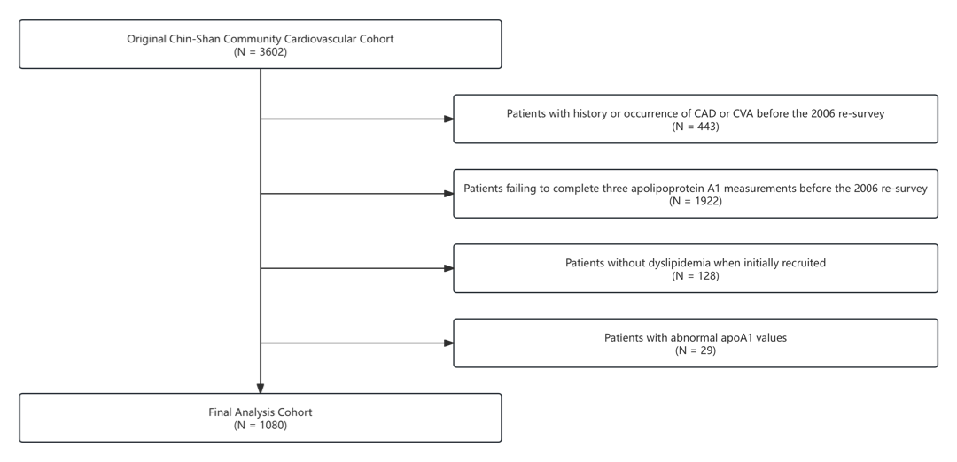
Supplementary Figure S1. Flowchat of this study. ApoA1, apolipoprotein A1; CAD, CAD: coronary artery disease; CVA, cerebrovascular accident.

