Association of Oxidative Balance Scores with Osteoarthritis through Oxidative Stress: A Cross-Sectional Study Utilizing the NHANES Database
- Supplementary Methods.
This section includes diagnostic criteria for comorbidities
Diabetes
Diabetes was defined using questionnaires and laboratory measures. Participants who were asked "Has a doctor or health professional told you have diabetes?" and answered yes were identified as having diabetes. In addition, participants who answered "no" with fasting blood glucose ≥126 mg/dL or glycosylated hemoglobin (HbA1c)≥6.5% were also considered diabetes，according to the American Diabetes Association standard [1].
Depression
Depression was defined using the Patient Health Questionnaire (PHQ-9), a nine-item screening tool on a scale of 0 to 27, and individuals with a score of 10 or greater were defined with depression [2].
Hypertension
Hypertension was defined using questionnaires and laboratory measures. Participants who were asked “Has a doctor or health professional told you have hypertension, also called high blood pressure?”, and answered yes were identified as having hypertension. Moreover, according to laboratory measurements, whose averages systolic blood pressure (SBP) was ≥140 mmHg or diastolic blood pressure (DBP) was ≥ 90 mmHg would also be defined as hypertension patients [3].
Hyperlipidaemia
According to United States National Cholesterol Education Program, hyperlipidaemia was defined as triglycerides ≥200 mg/dL or HDL-cholesterol < 40 mg/dL or LDL-cholesterol ≥130 mg/dL or total cholesterol ≥ 150 mg/dL or total cholesterol/ HDL-cholesterol ≥ 5 [4].
Physical activity
A physical activity questionnaire was collected for each participant, based on the activity types, duration, intensity, and frequency within 30 days. The metabolic equivalent of task (MET) score for specific activities was calculated according to the activity types and intensity, and the total MET minutes per week were then computed. According to the national physical activity guidelines (low physical activity < 500 METs/week; high physical activity ≥ 500 METs/week [5].
- Supplementary Tables.
Table S1 ROC test results
Bootstrap test for comparing correlated ROC curves
ROC(C-index) vs ROC（RFM）
D = 2.0492, boot.n = 2000, boot.stratified = 1, p-value = 0.04045
ROC(C-index) vs ROC（BMI）
D = 14.449, boot.n = 2000, boot.stratified = 1, p-value < 2.2e-16
ROC(RFM) vs ROC（BMI）
D = 14.463, boot.n = 2000, boot.stratified = 1, p-value < 2.2e-16
- Supplementary Figures.

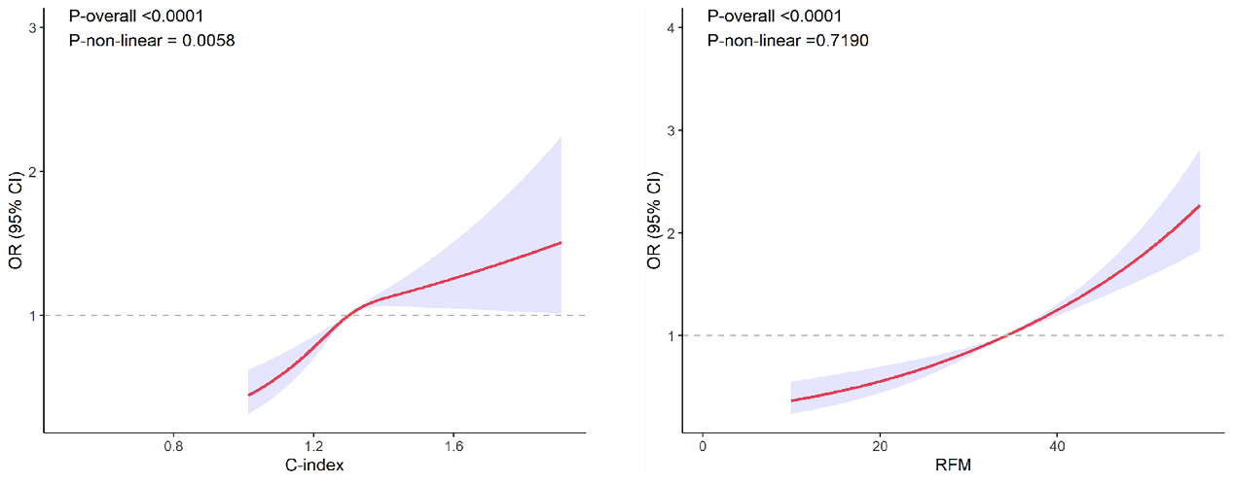
Fig.S1 RCS results of C-index and RFM (knot = 3)

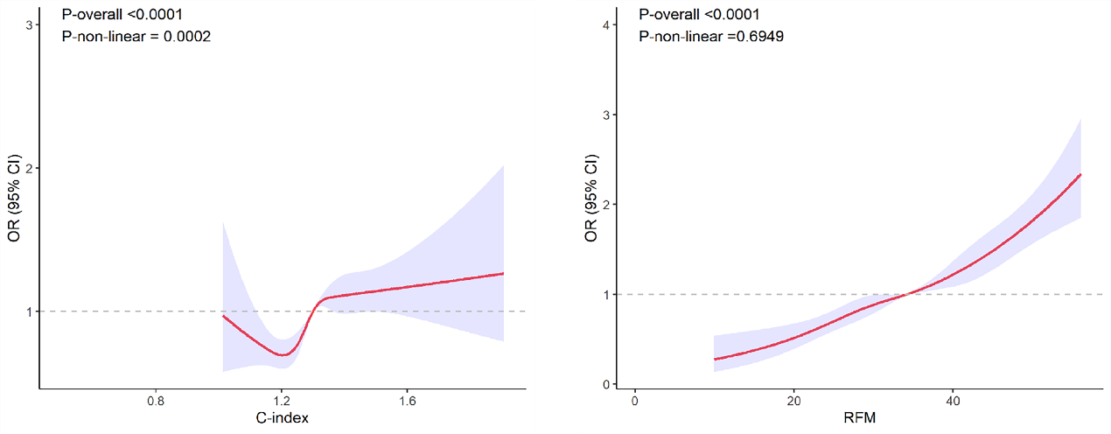
Fig.S2 RCS results of C-index and RFM (knot = 5)
- Supplementary Reference.
1. Rayburn WF: Diagnosis and classification of diabetes mellitus: highlights from the American Diabetes Association. J Reprod Med 1997, 42:585-586.
2. Kroenke K, Spitzer RL, Williams JB: The PHQ-9: validity of a brief depression severity measure. J Gen Intern Med 2001, 16:606-613.
3. Jones NR, McCormack T, Constanti M, McManus RJ: Diagnosis and management of hypertension in adults: NICE guideline update 2019. Br J Gen Pract 2020, 70:90-91.
4. Kreisberg RA, Oberman A: Medical management of hyperlipidemia/dyslipidemia. J Clin Endocrinol Metab 2003, 88:2445-2461.
5. MacGregor KA, Gallagher IJ, Moran CN: Relationship Between Insulin Sensitivity and Menstrual Cycle Is Modified by BMI, Fitness, and Physical Activity in NHANES. J Clin Endocrinol Metab 2021, 106:2979-2990.

