Supplementary Fig. 1. Lp(a) concentrations in the entire cohort.
A.
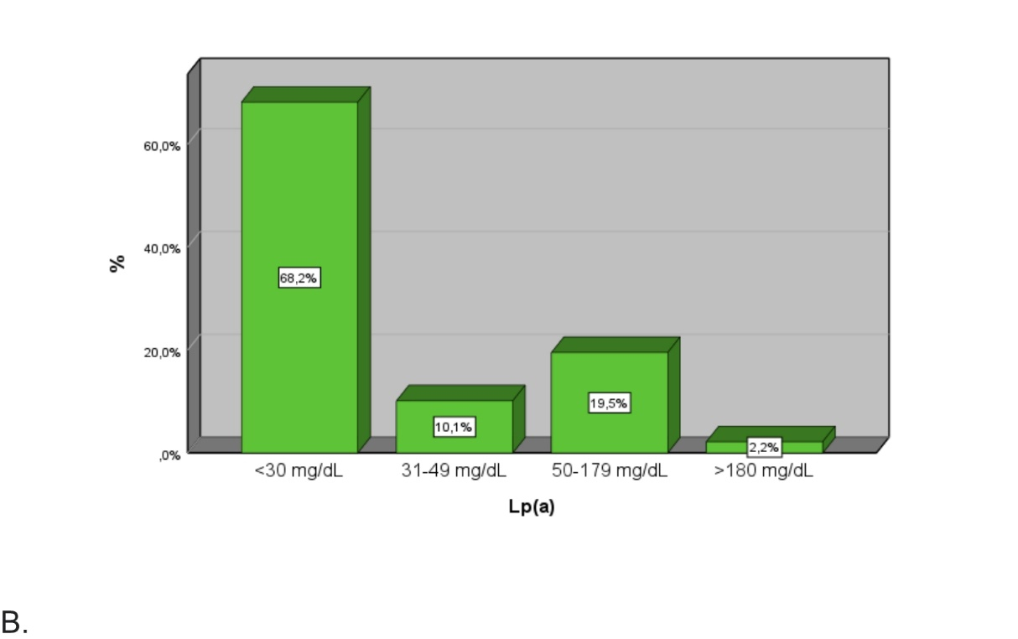
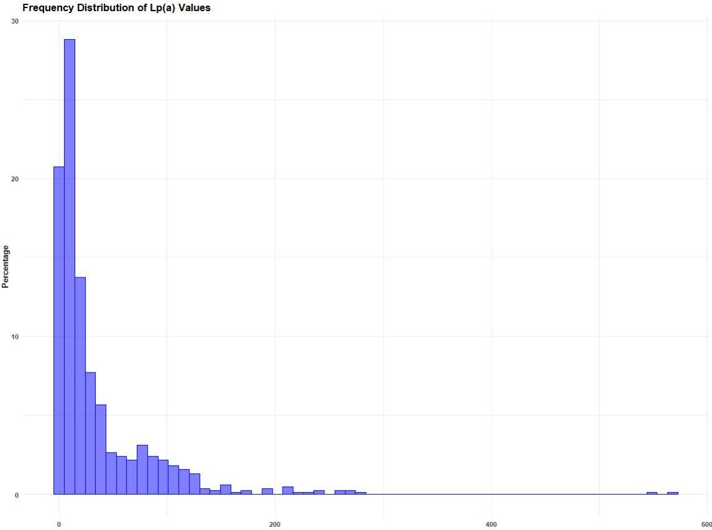
Panel A shows the percentage of individuals according to the Lp(a) risk classification by (6). Panel B shows the distribution of Lp(a) in the entire cohort. Lp: lipoprotein.

Supplementary Fig. 2. Correlation matrix of Lp(a) concentrations with other parameters according to lipid-lowering therapy.
A.
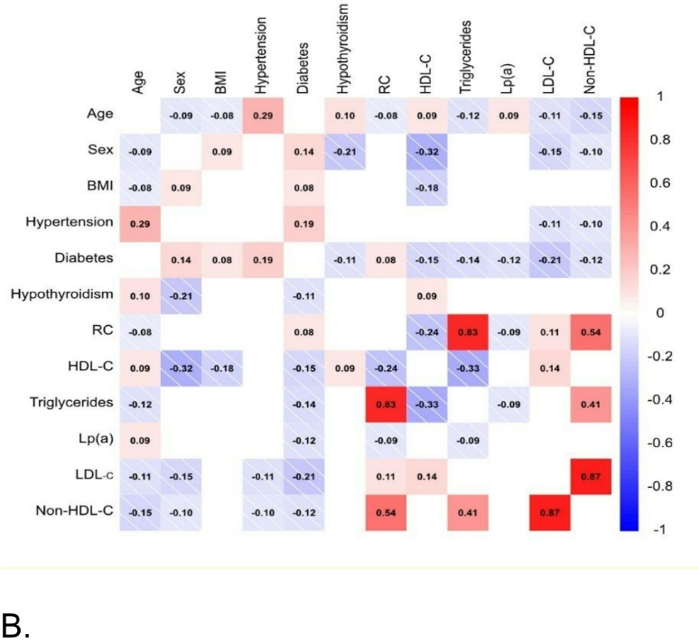
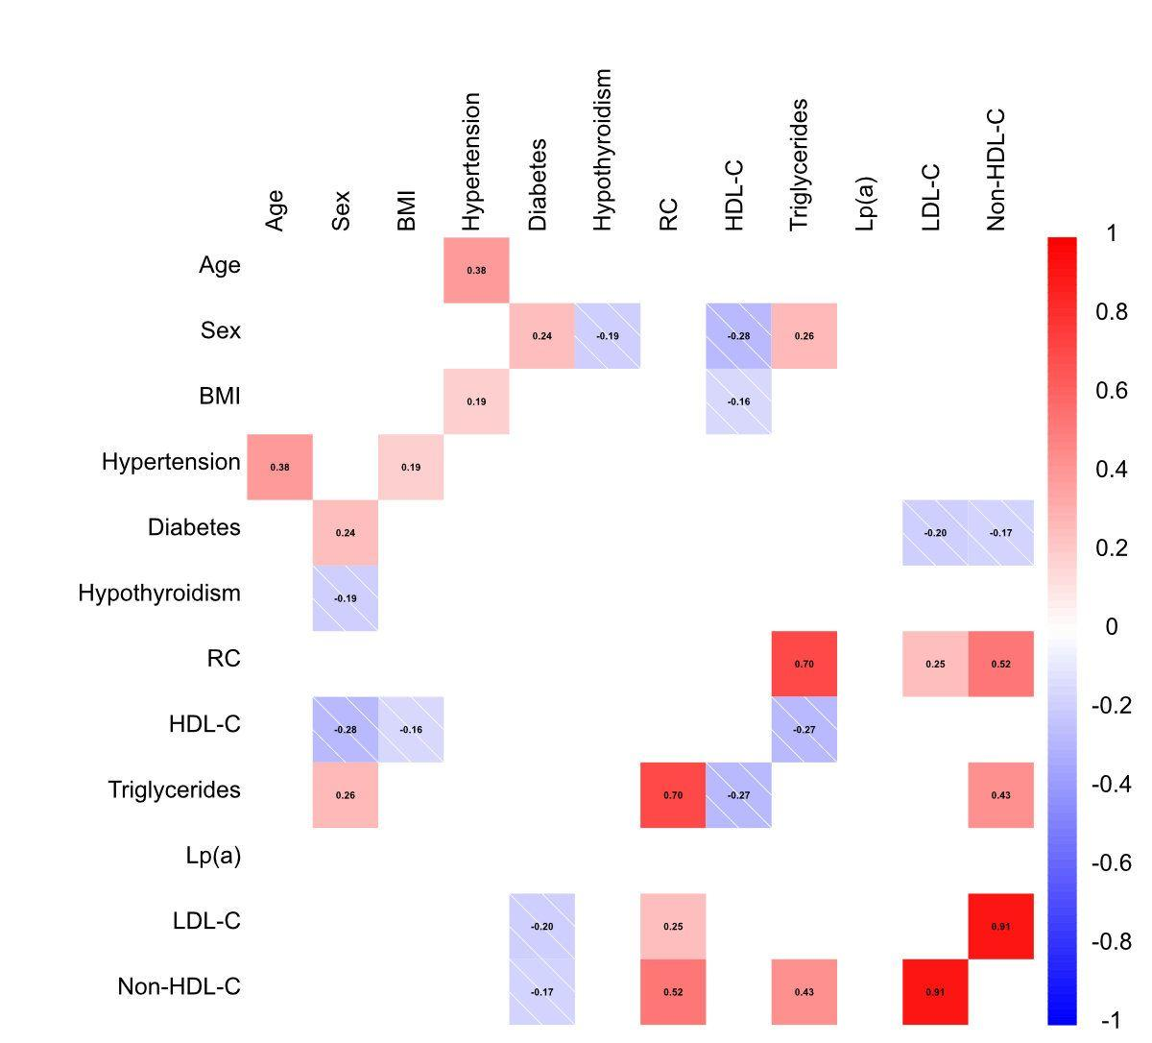
Panel A. Individuals with lipid-lowering therapy. Panel B. Individuals without lipid-lowering therapy.
BMI: body mass index; C: cholesterol; HDL: high-density lipoprotein; LDL: low-density lipoprotein; Lp: lipoprotein; RC: remnant cholesterol.
Supplementary Fig. 3. Prevalence of diabetes is higher in individuals with lower Lp(a) concentration
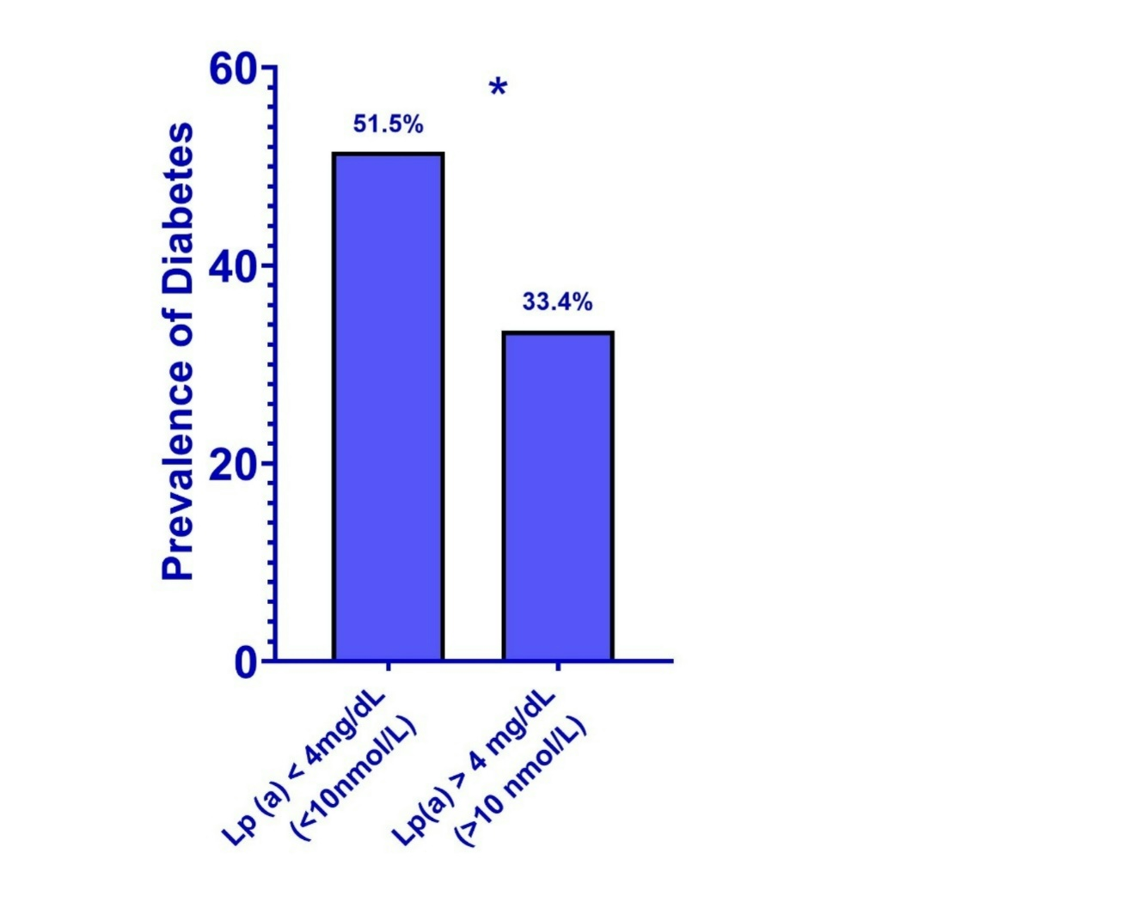
Lp : lipoprotein, * p < 0.001

Supplementary Fig. 4. Proportion of individuals with Lp(a) > 50 mg/dL (> 125 nmol/L) on intensification therapy
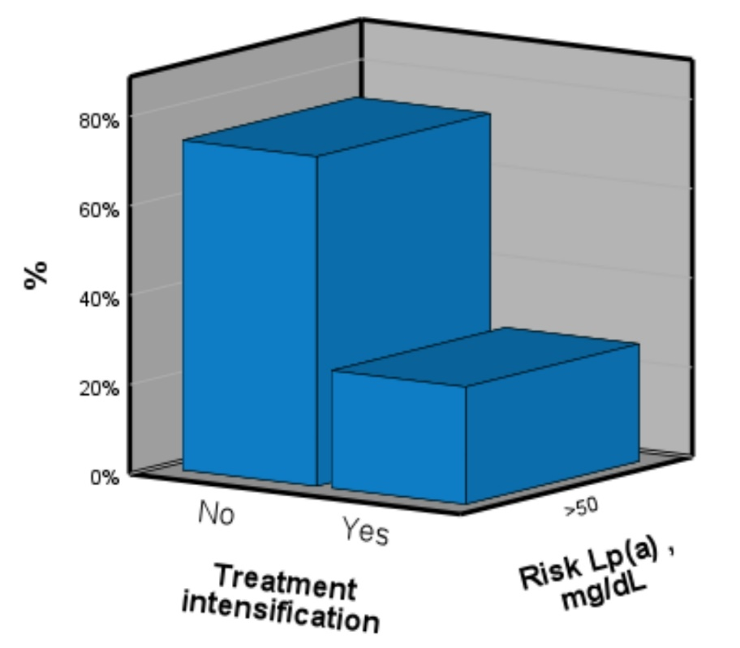
Lp: lipoprotein. Treatment intensification included comprehensive management of all cardiovascular risk factors, with targets individualized according to each patient's risk profile.

Supplementary Fig. 5. Lipid-lowering therapy before and after Lp(a) measurement.
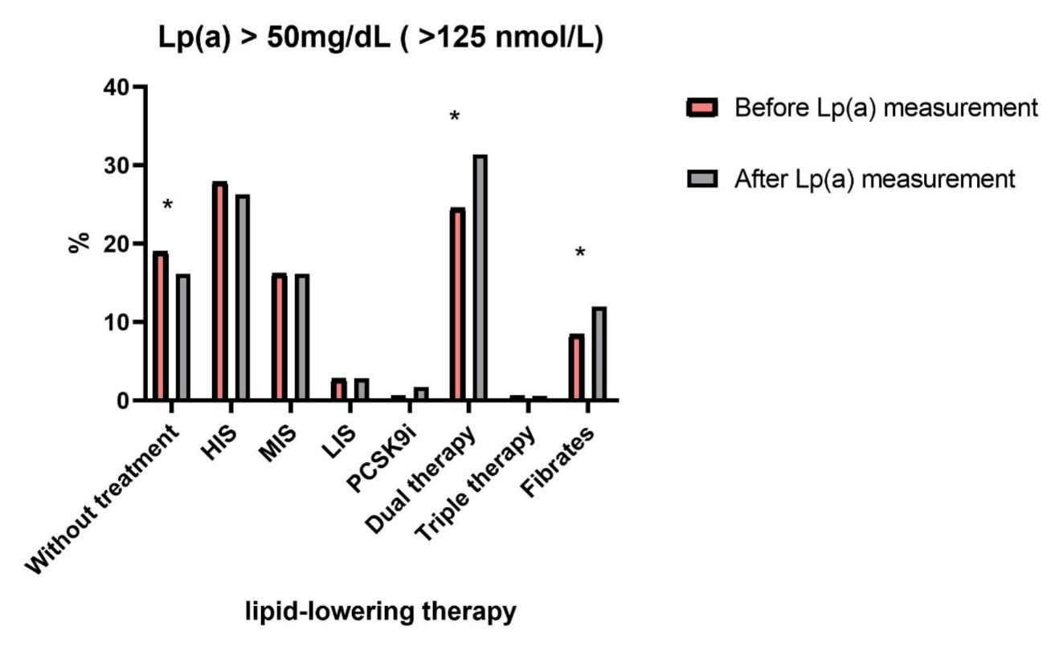
HIS: high-intensity statin; IPCSK9: proprotein convertase subtilisin/kexin type 9; LIS: Low-intensity statin; lipoprotein; Lp: lipoprotein; MIS: moderate-intensity statin
Dual Therapy: statin plus ezetimibe or statin plus PCSK9 inhibitors; Triple therapy: Statin plus ezetimibe plus PCSK9 inhibitors

Supplementary Fig. 6. Prevalence of ASCVD across Lp (a) concentrations
ASCVD: atherosclerotic cardiovascular disease; Lp: lipoprotein
Lp(a): >30 mg/dL (> 75 nmol/L); 30–50 mg/dL (75–125 nmol/L) ;> 50 mg/dL (> 125 nmol/L); >180 mg/dL (> 430 nmol/L)

