Modulation of Interleukins 38 and 1β Gene Expression by N-(4-benzoylphenyl)-5-nitrofuran-2-carboxamide in Triton WR-1339 Induced Hyperlipidemic Rats

Supplementry figure and tables:

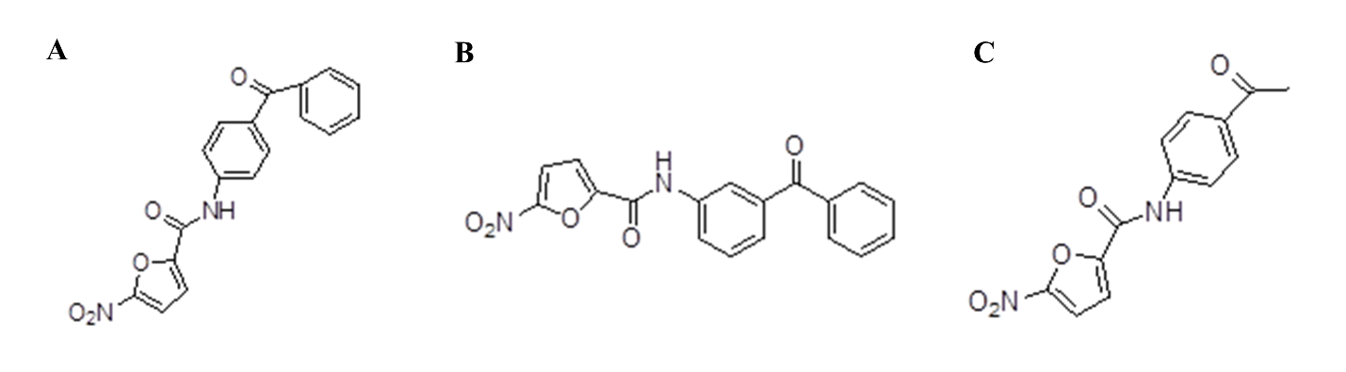
Fig. S1: Chemical structure of novel anti-hyperlipidemic compounds. (A) N-(4-benzoylphenyl)-5-nitrofuran-2-carboxamide (NF4BP), (B) N-(3-benzoylphenyl)-5-nitrofuran-2-carboxamide (NF3BP), and (C) N-(4-acetylphenyl)-5-nitrofuran-2-carboxamide (NF4AP).

Table S1: The effect of novel compounds on the blood lipid profile of rats with induced hyperlipidemia (Triton WR-1339) after 20 hours. Results are represented as mean ± SEM.

Groups | TG (mg/dl) | TC (mg/dl) | LDL-C (mg/dl) | HDL-C (mg/dl)
NCG | 47.80 ± 3.007 | 70.00 ± 3.592 | 6.200 ± 0.3742 | 23.34 ± 2.499
HCG | 9075 ± 1575 | 277.0 ± 49.00 | 70 ± 61.00 | 44.8 ± 14.60
Fenofibrate | 1736 ± 315.5 | 231.8 ± 11.76 | 9.250 ± 1.315 | 13.25 ± 0.6292
NF4BP | 1783 ± 231.5 | 227.0 ± 12.12 | 10.67 ± 1.453 | 14.00 ± 1.000
NF3BP | 1508 ± 242.0 | 204.3 ± 13.38 | 13.33 ± 0.8819 | 15.00 ± 0.5774
NF4AP | 2850 ± 366.9 | 240.3 ± 8.159 | 11.75 ± 0.4787 | 14.75 ± 0.4787

Table S2: Heat map for genes expression in Triton WR-1339 treated group adjusted to genes expression in the normal control group. The intensity of the red color indicates an overexpression in gene expression, while the intensity of the green color indicates a downregulation in the expression of genes.

Gene Name | NCG | HCG
CRP | 1 | -3.305
TNF-a | 1.001 | 1.5
CXCL-16 | 1.012 | -1.272
IL-38 | 1.091 | 2.452
IL-1 β | 0.9996 | 5.745
IL-6 | 1.026 | 1.168
VCAM-1 | 1.002 | -3.401
ICAM-1 | 1.004 | 1.271

Table S3: Heat map for genes expression in groups treated with novel compounds adjusted to genes expression in Triton WR-339 group. The intensity of the red color indicates an overexpression in gene expression, while the intensity of the green color indicates a downregulation in the expression of genes.

Gene | Fenofibrate | NF4BP | NF3BP | NF4AP
CRP | -1.3662 | 1.3059 | -1.203 | -3.2174
TNF-a | -2.4343 | -2.274 | -4.4299 | -3.5975
CXCL-16 | -1.6224 | -1.6983 | -2.2201 | -1.7838
IL-38 | 53.8199 | 42.1876 | 2.26318 | 13.2641
IL-1β | -2.6782 | -5.8748 | -5.9983 | -7.3434
IL-6 | -4.2334 | -2.936 | -4.3673 | -4.8919
VCAM-1 | 12.4305 | 5.84312 | 2.60425 | 1.70096
ICAM-1 | 2.39823 | 1.74555 | -1.1539 | -1.3394

