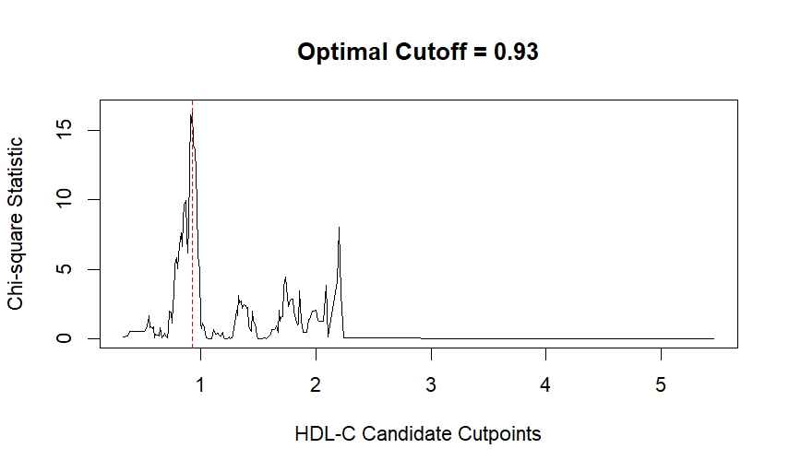
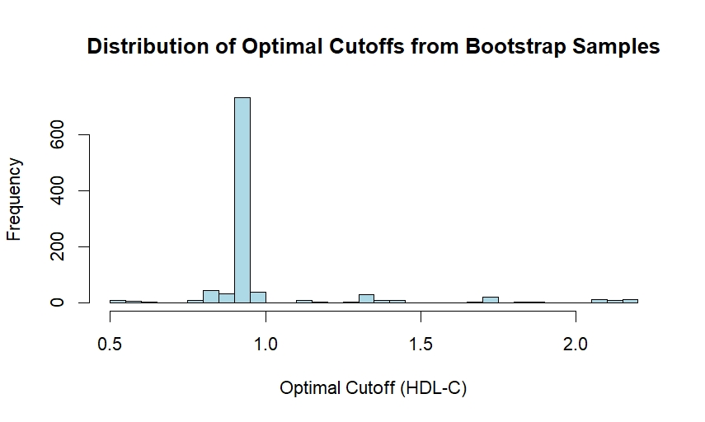
Figure S1. Determination of the optimal HDL-C threshold using the MSS method (A) and bootstrap validation (B) in the male subgroup. HDL-C: high-density lipoprotein cholesterol; MSS: maximum selected statistics.
A
B

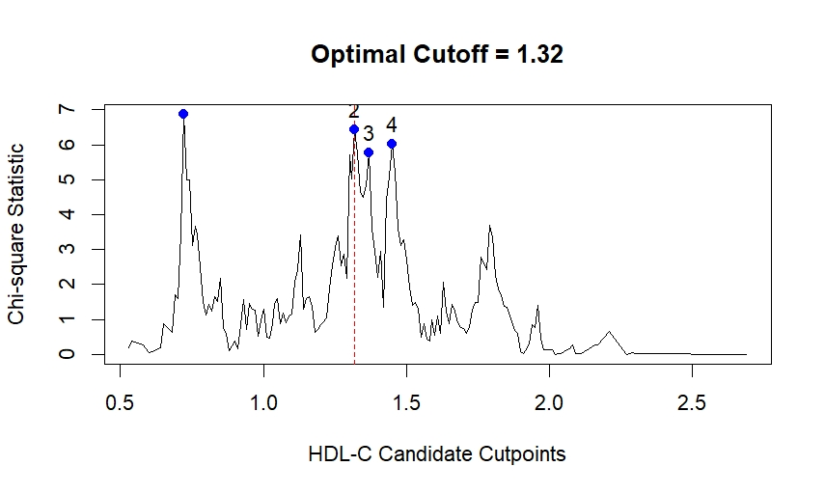
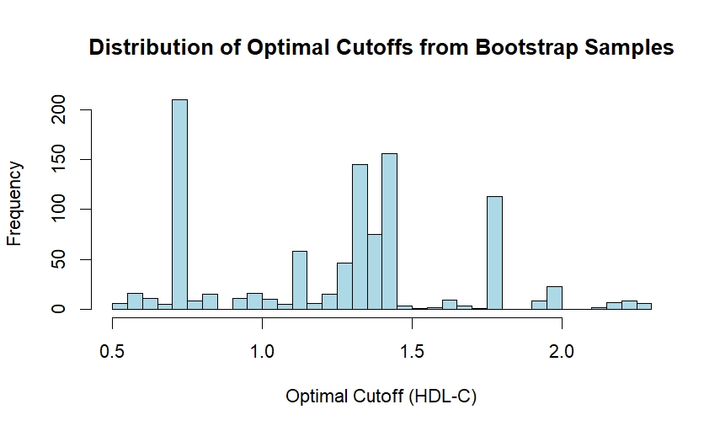
A
B

Figure S2. Determination of the optimal HDL-C threshold using the MSS method (A) and bootstrap validation (B) in the female subgroup. HDL-C: high-density lipoprotein cholesterol; MSS: maximum selected statistics.

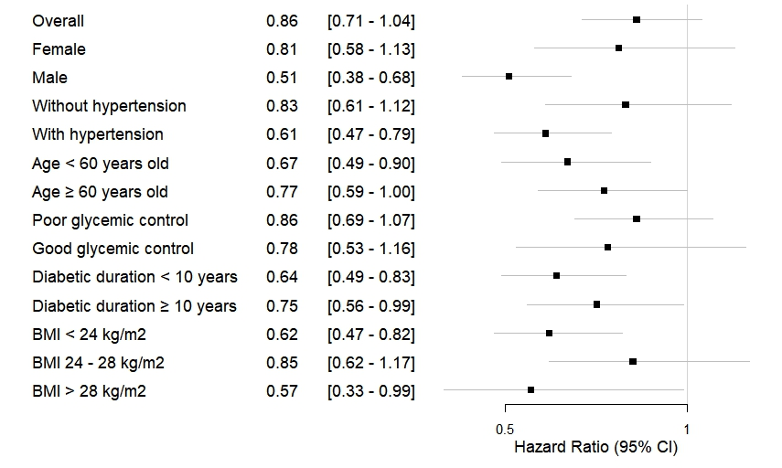
Figure S3. Sensitivity analysis with the traditional 1.0 mmol/L HDL-C cutoff confirmed subgroup heterogeneity in threshold effects and demonstrated superior validity of the 0.93 mmol/L threshold over the conventional cutoff for DKD risk stratification. DKD: diabetic kidney disease; HDL-C: high-density lipoprotein cholesterol; BMI: body mass index.

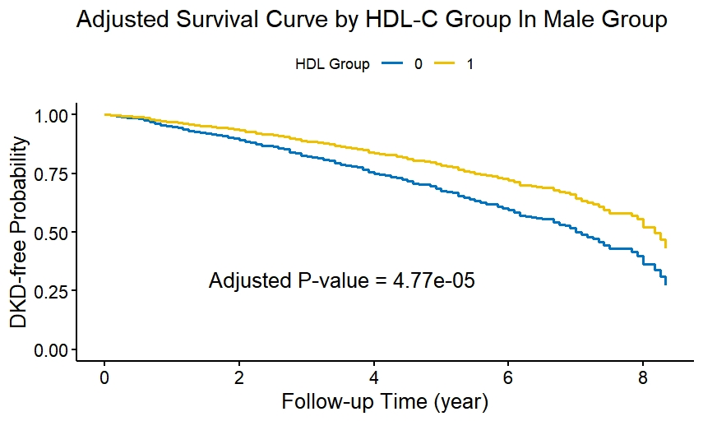
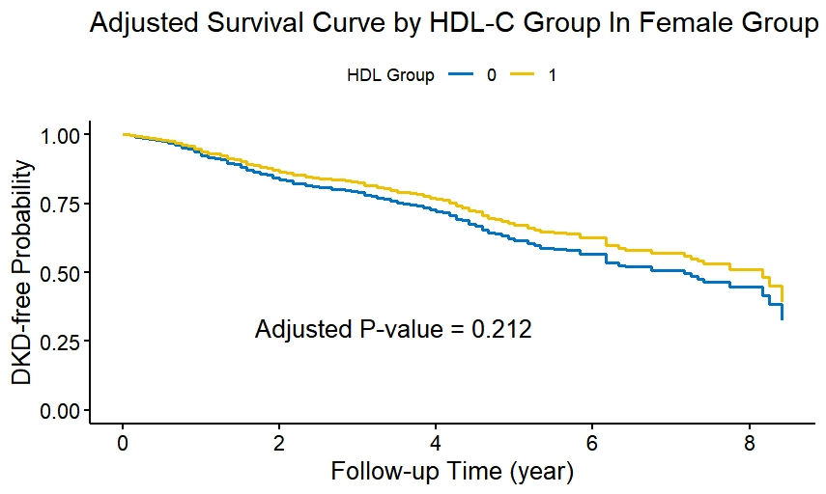
Figure S4. Gender-stratified Kaplan-Meier analysis demonstrated significantly lower cumulative DKD incidence in males with HDL-C ≥ 0.93 mmol/L compared to lower HDL-C groups (A), while no significant difference was observed in females (B). HDL group 0：subjects with HDL-C < 0.93 mmol/L; HDL group 1：subjects with HDL-C ≥ 0.93 mmol/L; DKD: diabetic kidney disease; HDL-C: high-density lipoprotein cholesterol.
B
A

