2. Methods
2.3 Covariates
With data from previous studies, we identified confounding variables that were added, involving age, sex, race / ethnicity, marital status, education level, poverty income ratio (PIR) / total income, drinking status, smoking status, hypertension, diabetes, stroke, coronary heart disease / heart disease. Age was classified as <45,45–60, and≥60 years. Marital status and education level were collected from demographic information. Smoking status, drinking status, hypertension, diabetes, stroke, and coronary heart disease diagnosis were collected from self-reports.
To examine multicollinearity among covariates, the variance inflation factor (VIF) was calculated for each variable in this study. All VIF values were below 5 (see Supplementary File Table 1-8), indicating an absence of serious multicollinearity and supporting the robustness of the model. In addition, a DAG (Supplementary Figure S1) was constructed in this study using the DAGitty software (version 3.1, http://www.dagitty.net/dags.html) to determine the minimum set of covariate adjustments (MSA) based on clinical soundness and previously published literature. The MSA consisted of sex, age, race, education level, drinking status, smoking status. Ultimately, sex, age, race, education level, marital status, poverty income ratio (PIR) / total income, smoking was included in the cross-sectional analyses. However, in the context of machine learning models aimed at predicting migraine risk, we retained these variables.
2.4 Statistical analysis
We used appropriate sample weights for calculations to ensure that accurate estimates of American and Chinese. Categorical data were represented as number counts and percentage frequencies (%), while continuous variables were denoted by mean and standard error (SE). Weighted Student’s T-tests were performed for continuous data to assess differences within groups, while weighted chi-square tests were utilized for categorical variables. The missingness and distribution of the variables are shown in Supplementary Figure S2-3. Because the missing value of drinking reached 70%, it was excluded, and multiple interpolation was leveraged to recover the remaining missing values.

Weighted logistic regression was applied to examine associations between TyG-related indicators (TyG–BMI, TyG–WC, TyG–WHtR) and migraine. Model 1 was unadjusted, while Model 2 was adjusted for age, sex, race, marital status, education, smoking. We explored linear trends in TyG and its composite indices by treating quartiles as continuous factors. Subgroup analysis based on fully adjusted models in sensitivity analysis. Furthermore, possible nonlinear effects were explored using smooth curve fitting and inflection points were sought by threshold analysis and saturation effect models.

In this study, Boruta's algorithm was used to screen the covariates. We used SMOTE under sampling to balance the sample. A variety of machine learning algorithms—including Decision Tree, GBDT, AdaBoost, LightGBM, Logistic Regression, Random Forest, Naive Bayes, CatBoost, and XGBoost—were applied to construct predictive models for migraine occurrence. The dataset was randomly divided into a training set (70%) and a test set (30%) to guarantee model generalizability. Ten-fold cross-validation was performed on the training set to optimize hyperparameters and mitigate overfitting. Model performance was validated on the test set using standard classification metrics. To interpret the contribution of each feature, SHAP (Shapley Additive Explanations) was used, highlighting the most influential variables in the top-performing model.
All analyses were conducted utilizing EmpowerStats (http://www.empowerstats.com), R (http://www.R-project.org), Python (version 3.9.12) and DecisionLinnc1.0 software. Statistical significance was established with a two-sided P value of less than 0.05.

Supplementary Table 1. Multicollinearity screening of independent variables in NHANES
Variables | Variance inflation factors.
Sex | 1.1
Age | 1.4
Race | 1.3
Education level | 1.4
Marital status | 1.1
PIR | 1.3
Smoking status | 1.1
Diabetes | 1.1
Hypertension | 1.2
Coronary heart disease | 1.1
Stroke | 1.1
TyG | 1.2

Supplementary Table 2. Multicollinearity screening of independent variables in NHANES
Variables | Variance inflation factors.
Sex | 1.1
Age | 1.3
Race | 1.3
Education level | 1.4
Marital status | 1.1
PIR | 1.3
Smoking status | 1.1
Diabetes | 1.1
Hypertension | 1.2
Coronary heart disease | 1.1
Stroke | 1.1
TyG-BMI | 1.1

Supplementary Table 3. Multicollinearity screening of independent variables in NHANES
Variables | Variance inflation factors.
Sex | 1.1
Age | 1.3
Race | 1.3
Education level | 1.4
Marital status | 1.1
PIR | 1.3
Smoking status | 1.2
Diabetes | 1.1
Hypertension | 1.3
Coronary heart disease | 1.1
Stroke | 1.1
TyG-WC | 1.3

Supplementary Table 4. Multicollinearity screening of independent variables in NHANES
Variables | Variance inflation factors.
Sex | 1.1
Age | 1.4
Race | 1.3
Education level | 1.4
Marital status | 1.1
PIR | 1.3
Smoking status | 1.1
Diabetes | 1.1
Hypertension | 1.3
Coronary heart disease | 1.1
Stroke | 1.1
TyG-WHtR | 1.2

Supplementary Table 5. Multicollinearity screening of independent variables in CHARLS
Variables | Variance inflation factors.
Sex | 2
Age | 1.3
Nation | 1
Marital status | 1.2
Education level | 1.2
Total income | 1
Smoking status | 1.9
Diabetes | 1.1
Hypertension | 1.1
Heart disease | 1.1
Stroke | 1
TyG | 1.1

Supplementary Table 6. Multicollinearity screening of independent variables in CHARLS
Variables | Variance inflation factors.
Sex | 2
Age | 1.3
Nation | 1
Marital status | 1.2
Education level | 1.2
Total income | 1.1
Smoking status | 1.9
Diabetes | 1.1
Hypertension | 1.2
Heart disease | 1.1
Stroke | 1
TyG-BMI | 1.2

Supplementary Table 7. Multicollinearity screening of independent variables in CHARLS
Variables | Variance inflation factors.
Sex | 2
Age | 1.3
Nation | 1
Marital status | 1.2
Education level | 1.2
Total income | 1
Smoking status | 1.9
Diabetes | 1.1
Hypertension | 1.2
Heart disease | 1.1
Stroke | 1
TyG-WC | 1.1

Supplementary Table 8. Multicollinearity screening of independent variables in CHARLS
Variables | Variance inflation factors.
Sex | 2
Age | 1.3
Nation | 1
Marital status | 1.2
Education level | 1.2
Total income | 1
Smoking status | 1.9
Diabetes | 1.1
Hypertension | 1.2
Heart disease | 1.1
Stroke | 1
TyG-WHtR | 1.2

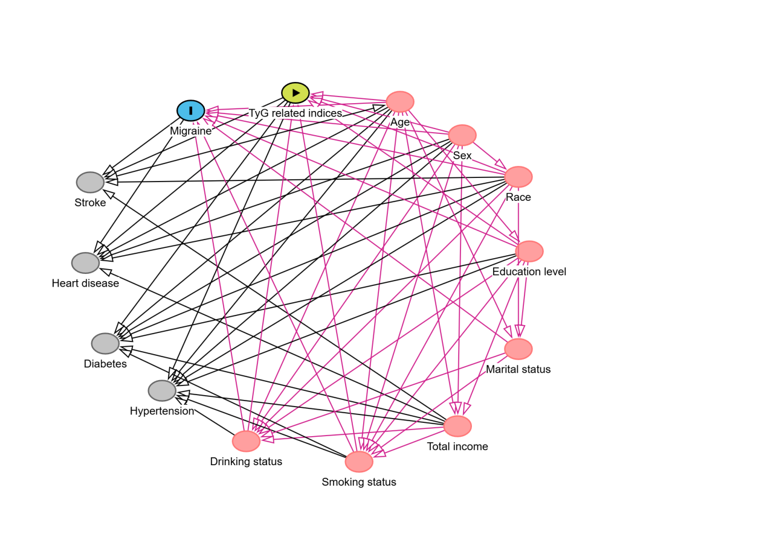
Supplementary Figure S1. Directed acyclic graph (DAG) for TyG related indices and migraine

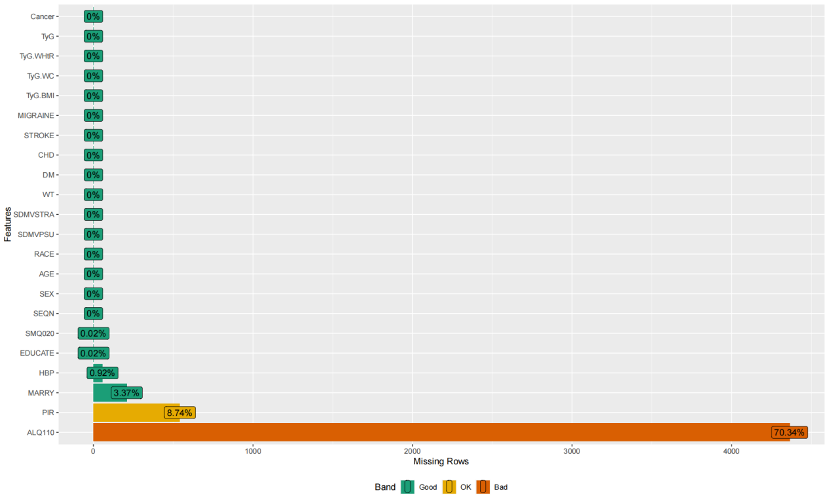
Supplementary Figure S2. Missing values before multiple interpolation in NHANES

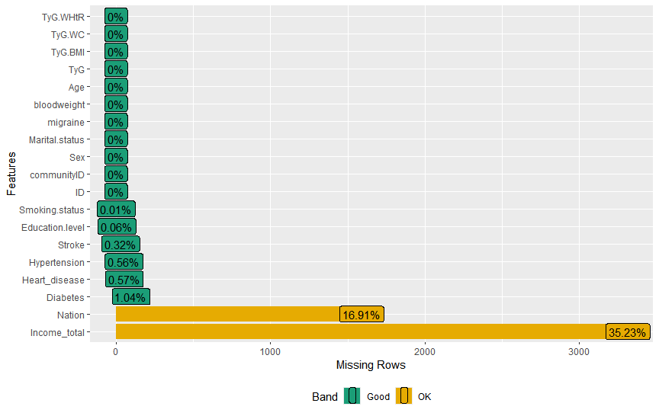
Supplementary Figure S3. Missing values before multiple interpolation in CHARLS

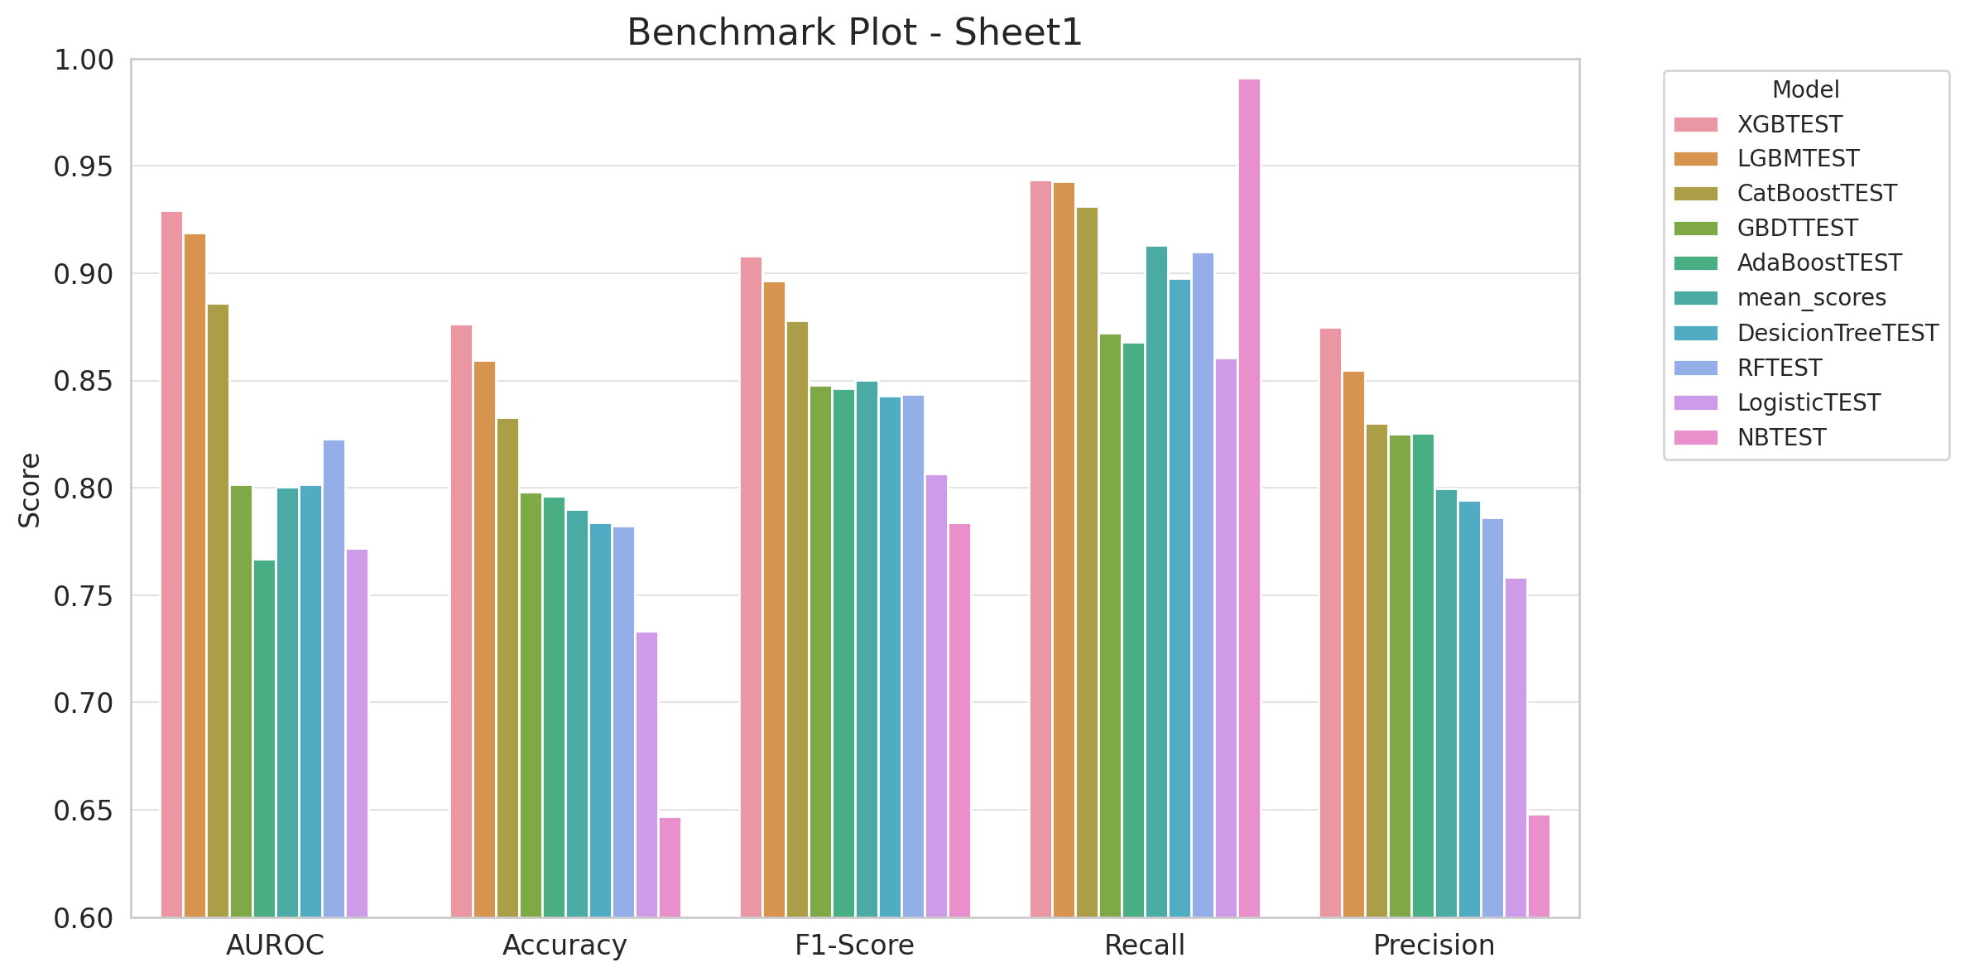
Supplementary Figure S4. Benchmark plots comparing the predictive performance of multi-model evaluation of test sets results on TyG-BMI across five key metrics (AUROC, Accuracy, F1-score, Recall, Precision)

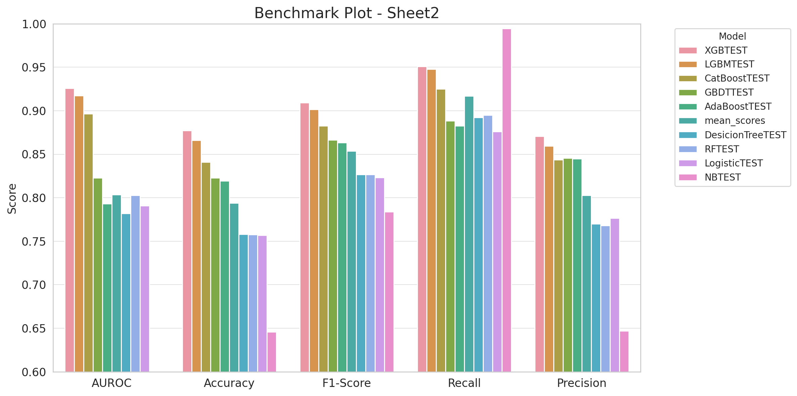
Supplementary Figure S5. Benchmark plots comparing the predictive performance of multi-model evaluation of test sets results on TyG-WHtR across five key metrics (AUROC, Accuracy, F1-score, Recall, Precision)

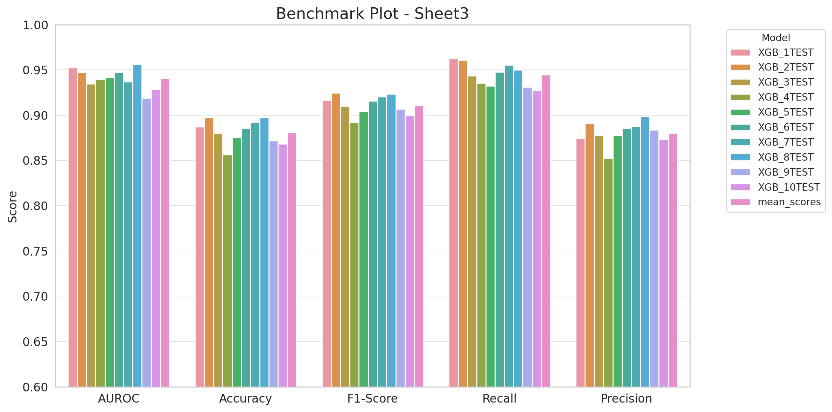
Supplementary Figure S6. Benchmark plots comparing the predictive performance of cross-validated multi-model assessment results on TyG-BMI across five key metrics (AUROC, Accuracy, F1-score, Recall, Precision)

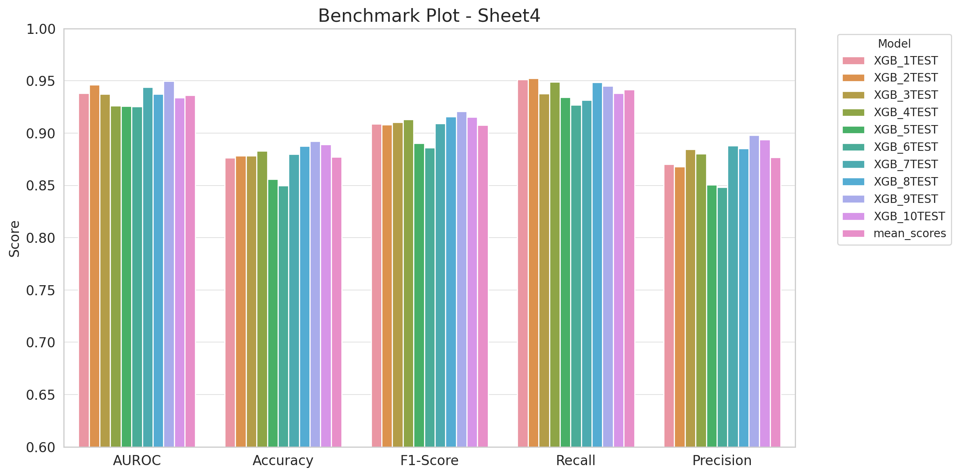
Supplementary Figure S7. Benchmark plots comparing the predictive performance of cross-validated multi-model assessment results on TyG-WHtR across five key metrics (AUROC, Accuracy, F1-score, Recall, Precision)

