Assessing the Impact of Aggressive versus Intermediate LDL-C Goal Achievement in Asian Adults: A Retrospective Cohort Study Using National Health Insurance Service-senior cohort

Yu-Cheol Lim, PhD; Suk-Chan Jang, PhD; Eui-Kyung Lee, PhD; Mi-Hai Park, PhD

Table of contents
Table S1. Definition of very high- and high-risk groups 2
Table S2. Baseline characteristics (continuous variables) 3
Table S3. Factors associated with all-cause death 4
Table S4. Baseline characteristics (very high-risk group and high-risk group) 6
Table S5. Risk of atherosclerotic cardiovascular disease and all-cause death in very high-risk group (unmatched) 8
Table S6. Risk of atherosclerotic cardiovascular disease and all-cause death in high-risk group (unmatched) 9

Figure of contents
Figure S1. Kaplan-Meier survival curves for ASCVD 9
Figure S2. Kaplan-Meier survival curves for CAD 10
Figure S3. Kaplan-Meier survival curves for stroke 11
Figure S4. Kaplan-Meier survival curves for PAD 12
Figure S5. Kaplan-Meier survival curves for revascularization 13
Figure S6. Kaplan-Meier survival curves for all-cause death 14

Table S1. Definition of very high- and high-risk groups
Risk group | Definition (ICD-10 code)
Very high-risk | Coronary artery diseases | (I20, I21, I22, I23, I24, I25)
High-risk | Atherosclerotic stroke | (I63, I64, I693) and hospitalization
High-risk | Transient ischemic attack | (G450, G451, G452, G453, G458, G459, G460, G461, G462)
High-risk | Artery diseases | (I65, I66, I70, I739, I74)
High-risk | Coronary or peripheral revascularization | Related procedure codes
High-risk | Abdominal aortic aneurysm | (I713, I714)
High-risk | Diabetes mellitus with major cardiovascular disease risk factors* ≥ 3 | (E10, E11, E13, E14)
* Age (man ≥ 45, woman ≥ 55), family history of cardiovascular disease, hypertension, smoking, High-density lipoprotein-cholesterol < 40mg/dL

Table S2. Baseline characteristics (continuous variables)
Variables | Crude |  |  |  |  | PS matching
Variables | Intermediate achiever (n=1553) |  | Aggressive achiever (n=1129) |  |  | Intermediate achiever (n=951) |  | Aggressive achiever  (n=951)
Variables | Mean | SD | Mean | SD |  | Mean | SD | Mean | SD
Age | 65.104 | 7.736 | 65.505 | 7.571 |  | 64.995 | 7.591 | 65.148 | 7.529
LDL-C on the index date (mg/dL) | 79.039 | 11.790 | 52.523 | 11.702 |  | 78.288 | 11.602 | 52.648 | 11.644
PS, propensity score; SD, standard deviation; LDL-C, low-density lipoprotein cholesterol

Table S3. Factors associated with all-cause death
Variables | Crude |  | Adjusted
Variables | Odds ratio | (95% CI) | Odds ratio | (95% CI)
Aggressive goal  (ref. intermediate goal) | 1.230 | (0.734 - 2.063) | 1.178 | (0.676 - 2.055)
Entry year (ref. 2011)
2012 | 0.887 | (0.357 - 2.208) | 0.876 | (0.334 - 2.297)
2013 | 1.265 | (0.552 - 2.895) | 1.242 | (0.504 - 3.062)
2014 | 1.652 | (0.762 - 3.581) | 1.646 | (0.701 - 3.861)
Age groups (ref. < 60)
60-64 | 0.516 | (0.295 - 0.903) | 0.418 | (0.226 - 0.774)
65-69 | 3.733 | (0.72 - 19.343) | 3.631 | (0.686 - 19.23)
70-74 | 4.143 | (0.832 - 20.632) | 3.944 | (0.781 - 19.923)
75- | 10.901 | (2.4 - 49.52) | 9.876 | (2.125 - 45.889)
Sex (ref. male)
Female | 40.481 | (9.67 - 169.466) | 46.010 | (10.693 - 197.965)
Insurance type (ref. NHI)
Medicaid | <0.001 | (<0.001 - >999.999) | <0.001 | (<0.001 - >999.999)
Income level (ref. Low)
Middle | 1.522 | (0.726 - 3.19) | 1.541 | (0.7 - 3.393)
High | 1.858 | (0.943 - 3.662) | 1.288 | (0.624 - 2.66)
Entry statin (ref. atorvastatin)
Combi-therapy | <0.001 | (<0.001 - >999.999) | <0.001 | (<0.001 - >999.999)
Others | 2.045 | (0.961 - 4.355) | 1.403 | (0.617 - 3.188)
Rosuvastatin | 1.328 | (0.646 - 2.728) | 1.085 | (0.491 - 2.398)
Simvastatin | 1.223 | (0.558 - 2.681) | 1.295 | (0.552 - 3.039)
ASCVD risk (ref. very-high)
High | 0.772 | (0.44 - 1.355) | 1.338 | (0.511 - 3.504)
PDC range (ref. low)
Moderate (50-80%) | 0.088 | (0.01 - 0.772) | 0.148 | (0.016 - 1.401)
High (80%<) | 0.431 | (0.167 - 1.113) | 0.546 | (0.188 - 1.589)
Comorbidity
Angina | 1.406 | (0.738 - 2.682) | 1.718 | (0.577 - 5.114)
Myocardial infarction | 6.872 | (1.921 - 24.581) | 9.612 | (2.032 - 45.457)
Stroke | 2.538 | (1.348 - 4.78) | 1.957 | (0.951 - 4.025)
abetes mellitus | 1.389 | (0.828 - 2.329) | 1.559 | (0.88 - 2.761)
Hypertension | 1.350 | (0.725 - 2.517) | 1.240 | (0.614 - 2.505)
Congestive heart failure | 1.075 | (0.33 - 3.501) | 0.266 | (0.034 - 2.087)
Heart failure | 1.682 | (0.396 - 7.148) | 4.534 | (0.356 - 57.768)
Cancer | 1.394 | (0.426 - 4.567) | 1.073 | (0.294 - 3.917)
ASCVD, atherosclerotic cardiovascular disease; NHI, national health insurance; PDC, proportion of days covered

Table S4. Baseline characteristics (very high-risk group and high-risk group)
Variables | Very high-risk group |  |  |  |  |  | High-risk group
Variables | Intermediate achiever (n=354) |  | Aggressive achiever (n=294) |  |  |  | Intermediate achiever (n=1199) |  | Aggressive achiever  (n=835)
Variables | No. of patients | % | No. of patients | % | P-value |  | No. of patients | % | No. of patients | % | P-value
Entry year |  |  |  |  | 0.3941 |  |  |  |  |  | 0.0004
2011 | 71 | 20.06 | 45 | 15.31 |  |  | 248 | 20.68 | 154 | 18.44
2012 | 86 | 24.29 | 69 | 23.47 |  |  | 305 | 25.44 | 184 | 22.04
2013 | 83 | 23.45 | 78 | 26.53 |  |  | 326 | 27.19 | 200 | 23.95
2014 | 114 | 32.2 | 102 | 34.69 |  |  | 320 | 26.69 | 297 | 35.57
Age groups |  |  |  |  | 0.138 |  |  |  |  |  | 0.074
<60 | 73 | 20.6 | 80 | 27.2 |  |  | 398 | 33.2 | 229 | 27.4
60-64 | 73 | 20.6 | 54 | 18.4 |  |  | 225 | 18.8 | 169 | 20.2
65-69 | 80 | 22.6 | 58 | 19.7 |  |  | 244 | 20.4 | 189 | 22.6
70-74 | 66 | 18.6 | 64 | 21.8 |  |  | 170 | 14.2 | 118 | 14.1
75- | 62 | 17.5 | 38 | 12.9 |  |  | 162 | 13.5 | 130 | 15.6
Sex |  |  |  |  | 0.005 |  |  |  |  |  | <.0001
Female | 168 | 47.5 | 107 | 36.4 |  |  | 661 | 55.1 | 351 | 42.0
Insurance type |  |  |  |  | 0.197 |  |  |  |  |  | 0.653
NHI | 352 | 99.4 | 294 | 100.0 |  |  | 1,185 | 98.8 | 827 | 99.0
Medicaid | 2 | 0.6 | - | - |  |  | 14 | 1.2 | 8 | 1.0
Income |  |  |  |  | 0.247 |  |  |  |  |  | 0.033
Low | 90 | 25.4 | 86 | 29.3 |  |  | 384 | 32.0 | 223 | 26.7
Middle | 113 | 31.9 | 77 | 26.2 |  |  | 340 | 28.4 | 262 | 31.4
High | 151 | 42.7 | 131 | 44.6 |  |  | 475 | 39.6 | 350 | 41.9
Index statin |  |  |  |  | 0.271 |  |  |  |  |  | <.0001
Atorvastatin | 202 | 57.1 | 147 | 50.0 |  |  | 779 | 65.0 | 488 | 58.4
Combi-therapy | 3 | 0.9 | 2 | 0.7 |  |  | 13 | 1.1 | 15 | 1.8
Others | 37 | 10.5 | 28 | 9.5 |  |  | 120 | 10.0 | 65 | 7.8
Rosuvastatin | 66 | 18.6 | 74 | 25.2 |  |  | 123 | 10.3 | 165 | 19.8
Simvastatin | 46 | 13.0 | 43 | 14.6 |  |  | 164 | 13.7 | 102 | 12.2
Risk group
Very-high risk | 354 | 100.0 | 294 | 100.0 |  |  | - | - | - | -
High risk | - | - | - | - |  |  | 1199 | 100.0 | 835 | 100.0
PDC groups |  |  |  |  | 0.284 |  |  |  |  |  | <.0001
Low (<50%) | 17 | 4.8 | 9 | 3.1 |  |  | 157 | 13.1 | 43 | 5.2
Moderate (50%-80%) | 21 | 5.93 | 12 | 4.1 |  |  | 136 | 11.34 | 67 | 8.0
High (80%<) | 316 | 89.3 | 273 | 92.9 |  |  | 906 | 75.6 | 725 | 86.8
Comorbidity
Angina | 209 | 59.0 | 179 | 60.9 | 0.633 |  | - | - | - | - | -
Myocardial infarction | 14 | 4.0 | 14 | 4.8 | 0.615 |  | - | - | - | - | -
Stroke | 25 | 7.1 | 16 | 5.4 | 0.399 |  | 108 | 9.0 | 113 | 13.5 | 0.001
Diabetes mellitus | 116 | 32.8 | 111 | 37.8 | 0.185 |  | 395 | 32.9 | 331 | 39.6 | 0.002
Hypertension | 255 | 72.0 | 228 | 77.6 | 0.109 |  | 831 | 69.3 | 593 | 71.0 | 0.408
Congestive heart failure | 30 | 8.5 | 32 | 10.9 | 0.299 |  | 38 | 3.2 | 22 | 2.6 | 0.483
Heart failure | 14 | 4.0 | 17 | 5.8 | 0.278 |  | 18 | 1.5 | 5 | 0.6 | 0.058
Cancer | 17 | 4.8 | 10 | 3.4 | 0.374 |  | 46 | 3.8 | 29 | 3.5 | 0.669

Table S5. Risk of atherosclerotic cardiovascular disease and all-cause death in very high-risk group (unmatched)
Outcomes | Model 1  Crude | Model 2  Fully adjusted | Model 3  Time-dependent cox | Model 4  Marginal Structural Model
Outcomes | Hazard ratio (95% CI) | Hazard ratio (95% CI) | Hazard ratio (95% CI) | Hazard ratio (95% CI)
ASCVD (composite outcome) | 1.141 (0.816 - 1.595) | 1.149 (0.810 - 1.632) | 1.195 (0.626 - 2.282) | 1.586 (0.828 - 3.036)
Coronary artery disease and cardiac arrest | 0.853 (0.521 - 1.396) | 0.828 (0.496 - 1.382) | 0.837 (0.335 - 2.087) | 1.073 (0.420 - 2.747)
Stroke | 0.904 (0.491 - 1.666) | 1.020 (0.534 - 1.949) | 2.007 (0.695 - 5.801) | 2.188 (0.721 - 6.635)
Peripheral artery disease | 2.204 (0.739 - 6.578) | 2.056 (0.596 - 7.086) | 1.751 (0.282 - 10.893) | 7.367 (0.710 - 76.411)
Revascualrization | 1.313 (0.874 - 1.972) | 1.284 (0.840 - 1.962) | 1.181 (0.539 - 2.590) | 1.866 (0.886 - 3.930)
All-cause death | 2.778 (1.143 - 6.752) | 3.580 (1.343 - 9.543) | 2.962 (0.730 - 12.017) | 3.006 (0.715 - 12.646)
ASCVD, atherosclerotic cardiovascular disease

Table S6. Risk of atherosclerotic cardiovascular disease and all-cause death in high-risk group (unmatched)
Outcomes | Model 1  Crude | Model 2  Fully adjusted | Model 3  Time-dependent cox | Model 4  Marginal Structural Model
Outcomes | Hazard ratio (95% CI) | Hazard ratio (95% CI) | Hazard ratio (95% CI) | Hazard ratio (95% CI)
ASCVD (composite outcome) | 1.402 (1.071 - 1.836) | 1.229 (0.926 - 1.632) | 1.361 (0.833 - 2.223) | 1.691 (0.996 - 2.872)
Coronary artery disease and cardiac arrest | 1.344 (0.796 - 2.271) | 1.076 (0.617 - 1.876) | 1.081 (0.444 - 2.629) | 1.063 (0.412 - 2.742)
Stroke | 1.427 (0.999 - 2.038) | 1.311 (0.901 - 1.908) | 1.572 (0.820 - 3.011) | 2.095 (1.038 - 4.227)
Peripheral artery disease | 1.038 (0.509 - 2.118) | 0.850 (0.396 - 1.825) | 1.819 (0.577 - 5.731) | 1.622 (0.458 - 5.738)
Revascualrization | 1.690 (1.124 - 2.541) | 1.520 (0.986 - 2.341) | 1.121 (0.547 - 2.299) | 1.312 (0.600 - 2.869)
All-cause death | 1.304 (0.789 - 2.155) | 1.096 (0.641 - 1.873) | 1.220 (0.500 - 2.977) | 1.370 (0.574 - 3.271)
ASCVD, atherosclerotic cardiovascular disease

Figure S1. Kaplan-Meier survival curves for ASCVD
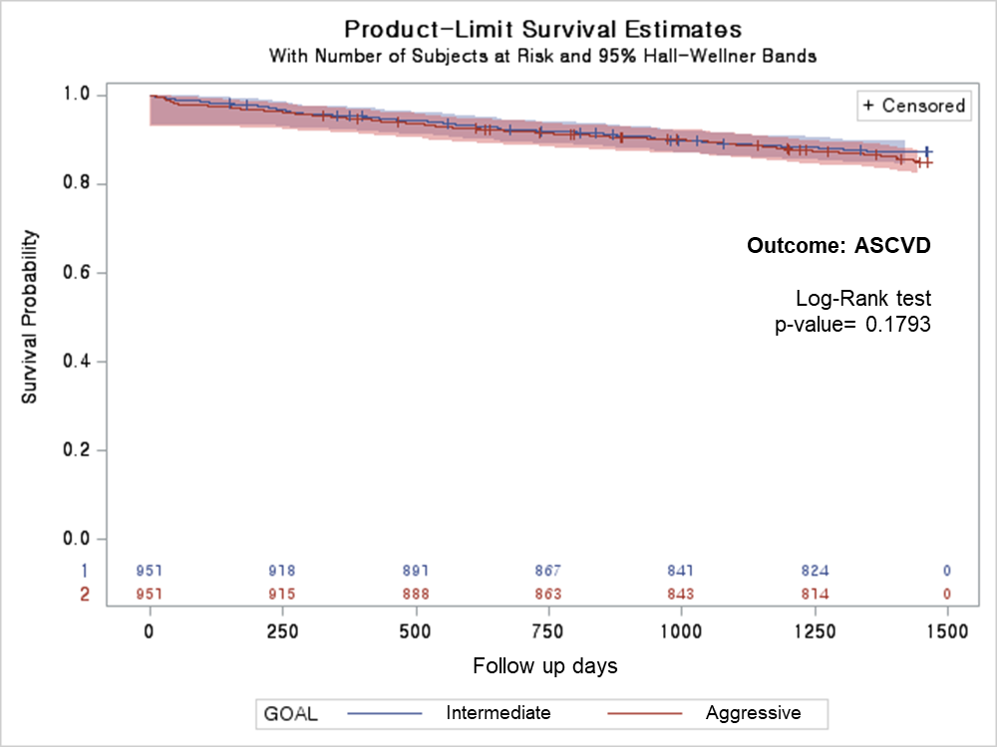
ASCVD, atherosclerotic cardiovascular disease

Figure S2. Kaplan-Meier survival curves for CAD
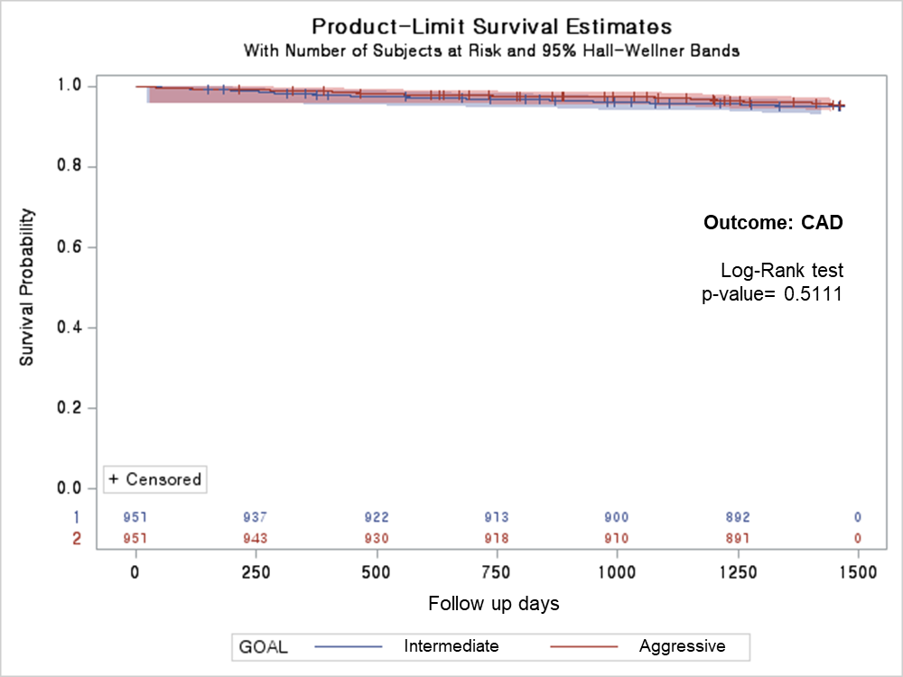
CAD, Coronary artery disease

Figure S3. Kaplan-Meier survival curves for stroke
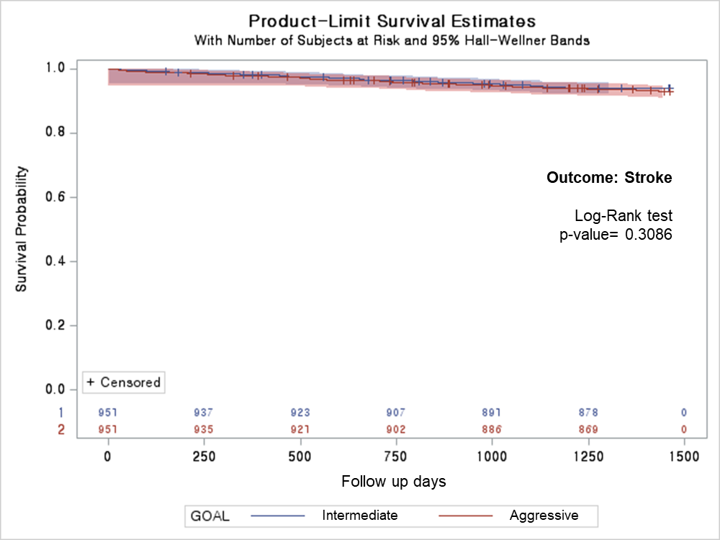

Figure S4. Kaplan-Meier survival curves for PAD
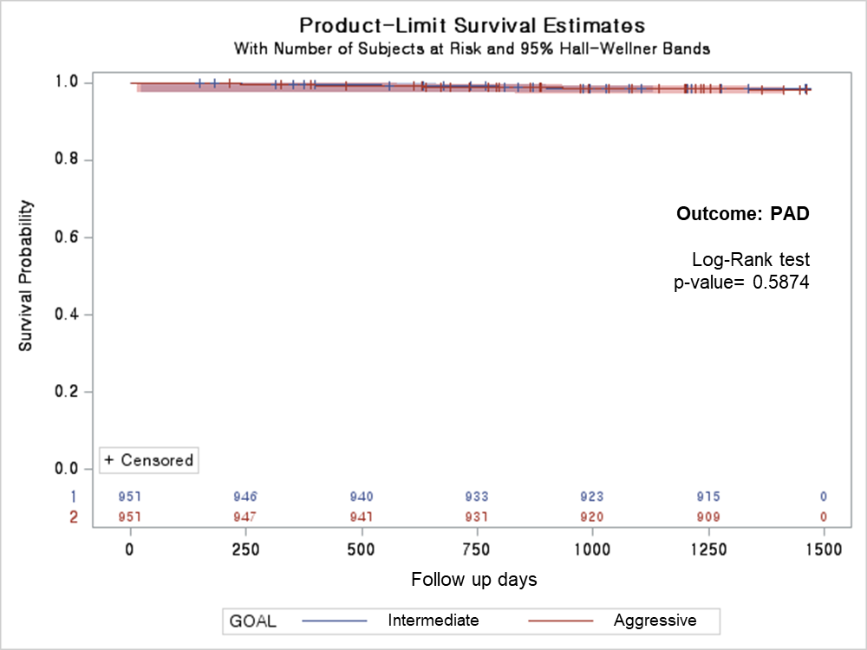
PAD, Peripheral artery disease

Figure S5. Kaplan-Meier survival curves for revascularization
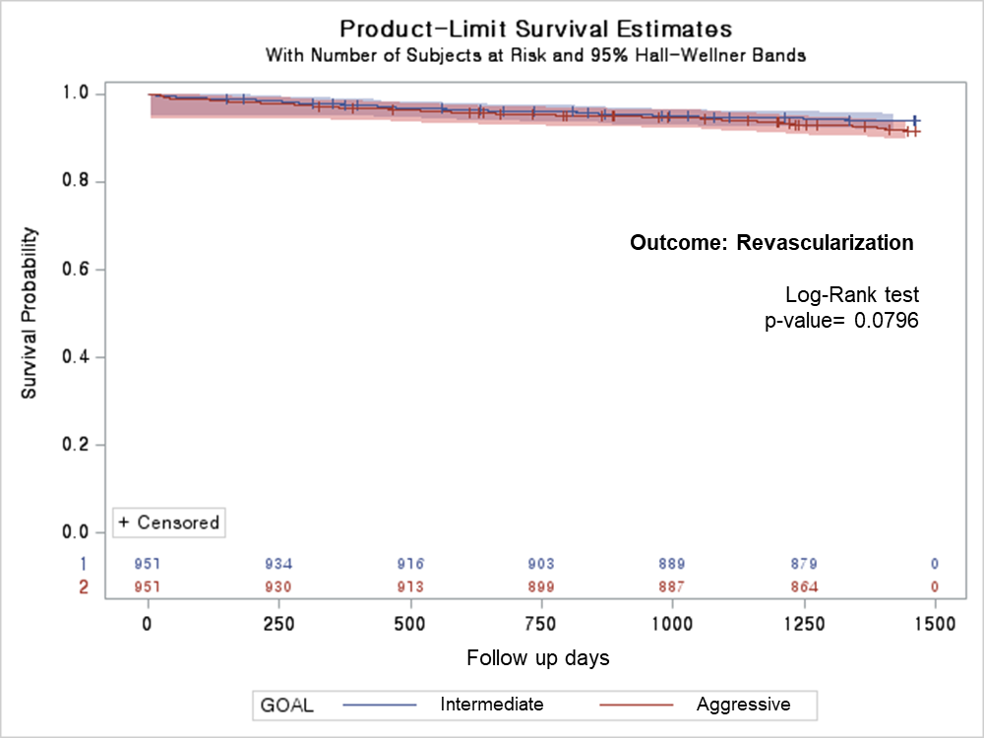
Figure S6. Kaplan-Meier survival curves for all-cause death
