Supplementary Material
Figures
During 2017-2019:
Participants were enrolled
N = 35,078
35,078
Exclude participants with:
1) Metabolic syndrome before 2020 (n = 5,453)
2) No 3-year consecutive health checks (n = 24,967)
3) Missing IR info (n = 243)
3-year checks and no metabolic syndrome
N = 4,415

Exclude participants with:
1) No 2020-2022 checks or partial info loss (n = 479)
2) Participants with pancreatic diseases, hepatitis,
bile duct diseases, malignant tumors, severe liver and kidney insufficiency, severe infections (n = 186)

Participants eligible for analysis
N = 3,750

Figure S1 Flowchart of participant selection from 2017-2019
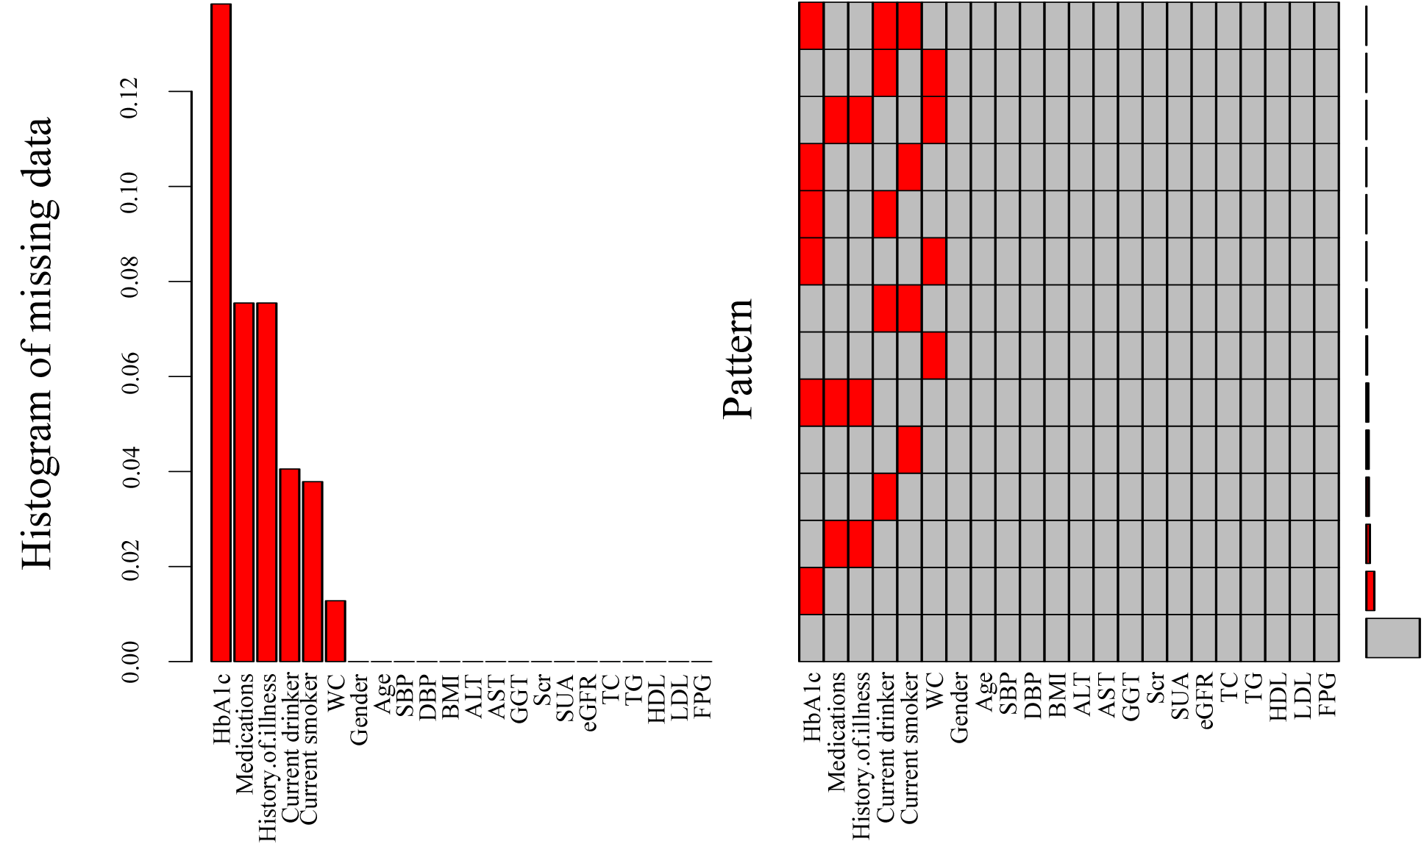
Figure S2 Summary of missing variables
The missing proportion of HbA1c, medications, history of illness, drinking, smoking, and WC was 13.84%, 7.55%, 7.55%, 4.05%, 3.79% and 1.28%, respectively.
Abbreviations: HbA1c: Glycated hemoglobin; Medications: Antihypertensive medication, antidiabetic drug and lipid-lowering agents; History of illness: Hypertension, diabetes and hyperlipidemia; WC: Waist circumference; SBP: Systolic blood pressure; DBP: Diastolic blood pressure; BMI: Body mass index; ALT: Alanine aminotransferase; AST: Aspartate aminotransferase; GGT: Gamma-glutamyl transferase; Scr: Serum creatinine; SUA: Serum uric acid; eGFR: Estimated glomerular filtration rate; TC: Total cholesterol; TG: Triglyceride; HDL-C: High-density lipoprotein cholesterol; LDL-C: Low-density lipoprotein cholesterol; FPG: Fasting plasma glucose.
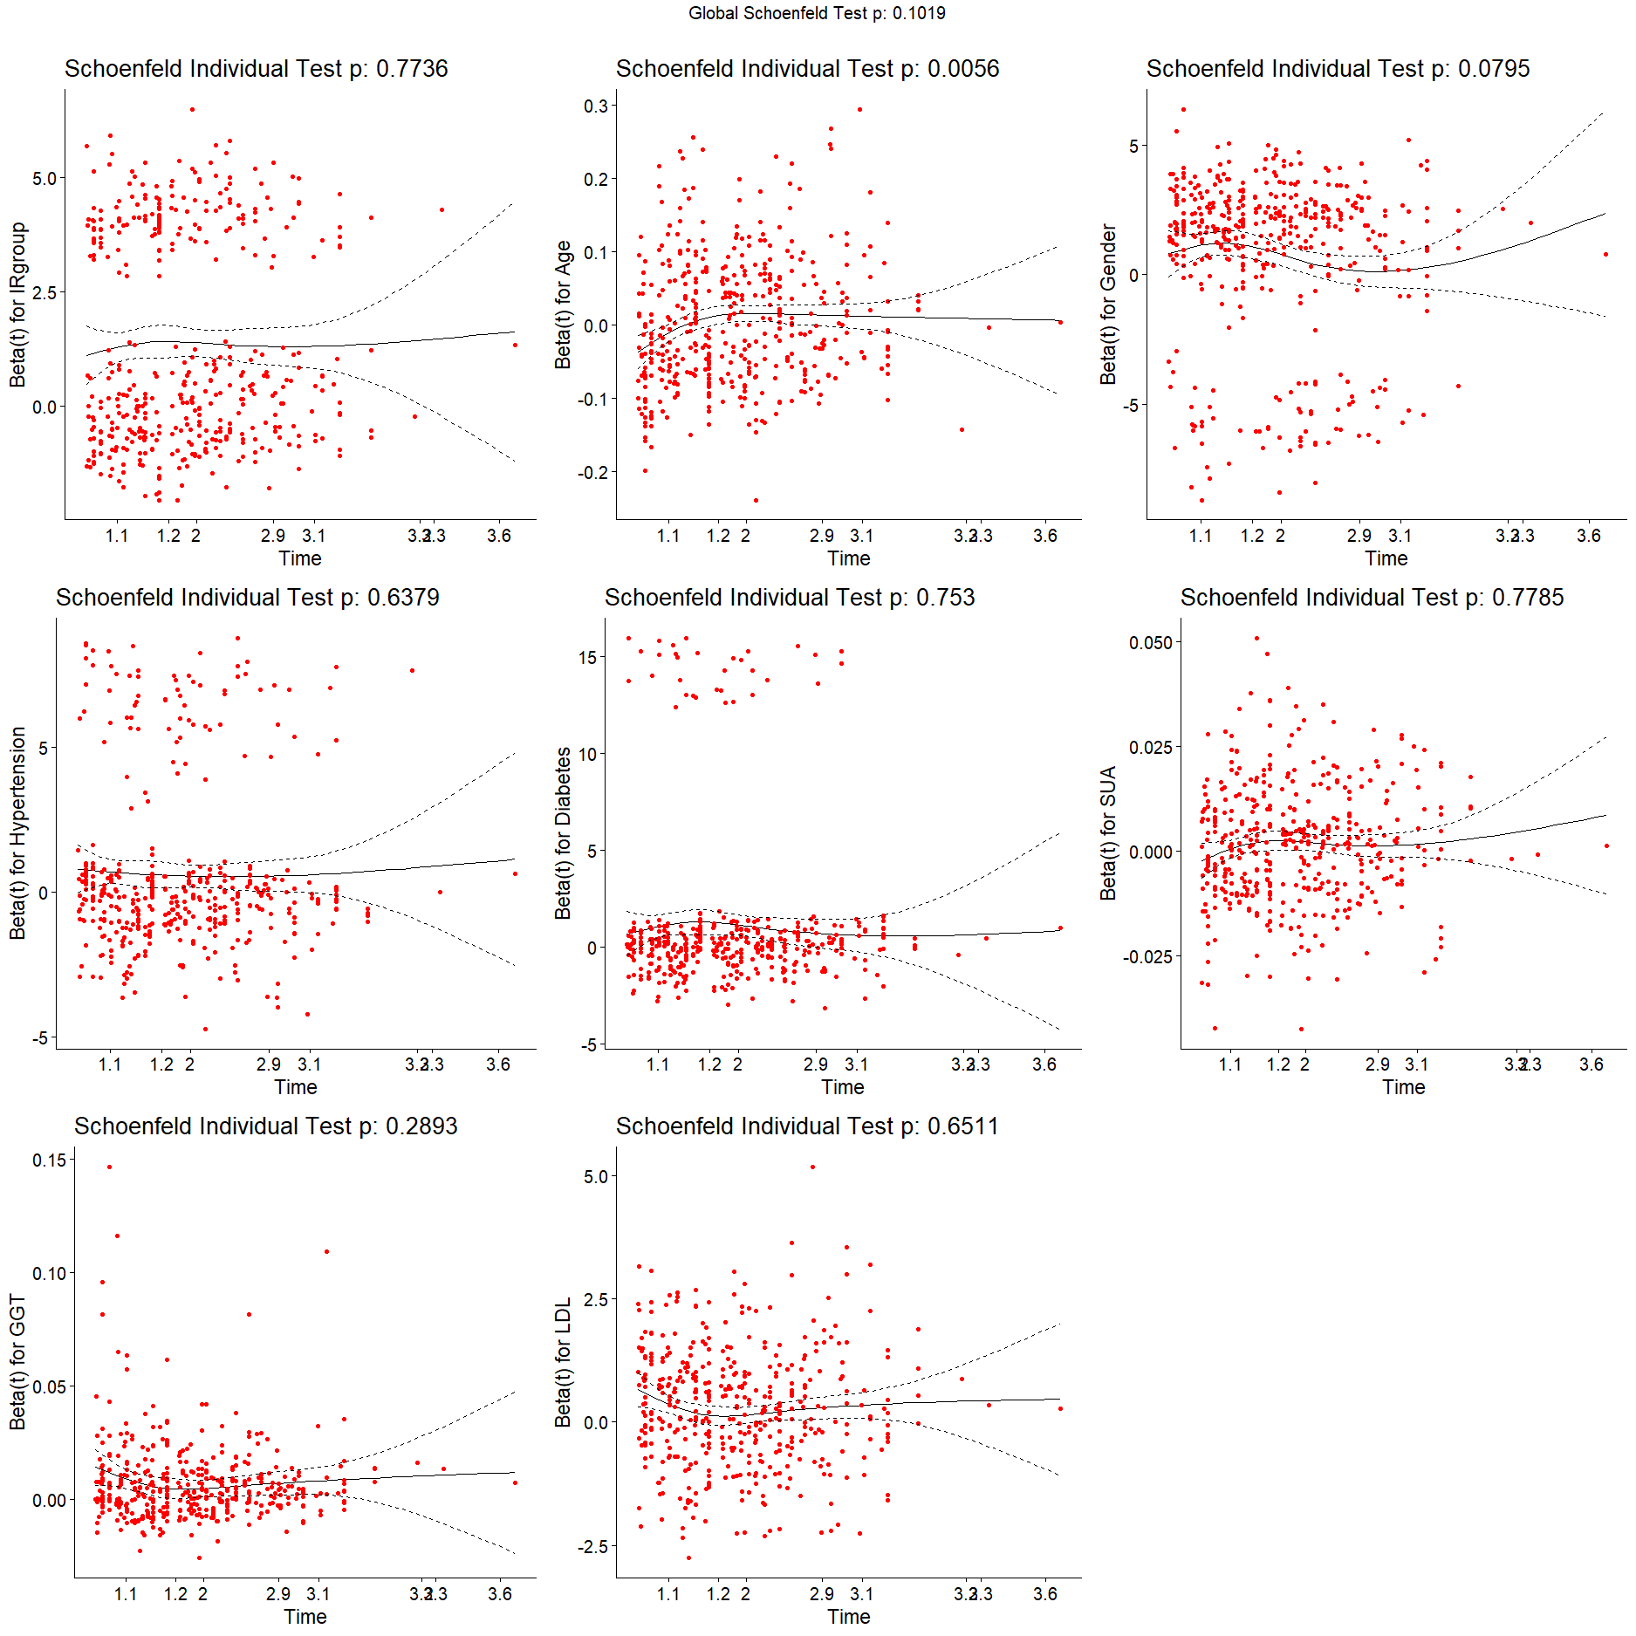
Figure S3 Schoenfeld residuals plots for variables in the PH assumption test. Abbreviations: IR group: METS-IR trajectory groups; GGT: Gamma-glutamyl transferase; SUA: Serum uric acid; LDL-C: Low-density lipoprotein cholesterol.

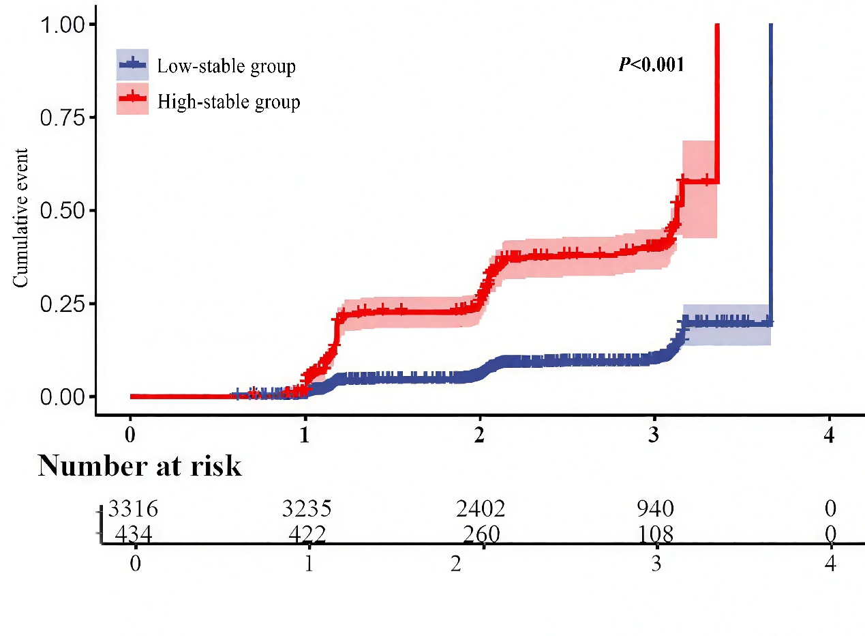
High-stability group
Low-stability group
Figure S4 Cumulative event probability curve of the total population in METS-IR trajectory groups

Tables
Table S1 The statistics for trajectory models for METS-IR from 2017-2019
No.  Latent class | Polynomial degree¹ | Log-Lik | AIC | BIC | % Participants per class | Mean posterior  Probabilities² | Entropy³
1 | Linear | -29569 | 59151 | 59188 | 100 | NA | NA
 | Quadratic | -8136 | 162755 | 162817 | 100 | NA | NA
 | Cubic | >-1×10⁹ | >2×10⁹ | >2×10⁹ | 100 | NA | NA
2 | Linear | -29507 | 59034 | 59096 | 88.43/11.57 | 0.8411/0.6625 | 788.119
 | Quadratic | -81360 | 162773 | 162836 | 58.32/41.68 | 0.5065/0.5062 | 2598.792
 | Cubic | >-1×10⁹ | >2×10⁹ | >2×10⁹ | NA/NA | NA/NA | 0
3 | Linear | -29500 | 59024 | 59099 | 44.61/53.28/2.11 | 0.8163/0.8076/0.7658 | 1036.795
 | Quadratic | -81365 | 162766 | 162878 | 58.32/0/41.68 | 0.3421/NA/0.3416 | 4118.314
 | Cubic | >-1×10⁹ | >2×10⁹ | >2×10⁹ | NA/NA/NA | NA/NA/NA | 0
4 | Linear | -29497 | 59025 | 59118 | 0/44.43/53.44/2.13 | NA/0.8151/0.8072/0.7736 | 1009.409
 | Quadratic | -81379 | 162803 | 162940 | 58.32/0/0/41.68 | 0.2598/NA/NA/0.2593 | 5195.968
 | Cubic | >-1×10⁹ | >2×10⁹ | >2×10⁹ | NA/NA/NA/NA | NA/NA/NA/NA | 0
5 | Linear | -29562 | 59161 | 59273 | 0/0/92.21/7.79/0 | NA/NA/0.8499/0.6552/NA | 1199.021
 | Quadratic | -81372 | 162796 | 162958 | 58.32/0/0/0.03/41.65 | 0.2105/NA/NA/0.2003/0.2099 | 6031.196
 | Cubic | >-1×10⁹ | >2×10⁹ | >2×10⁹ | NA/NA/NA/NA/NA | NA/NA/NA/NA/NA | 0
Abbreviations: Log-Lik: Log-likelihood; AIC: Akaike information criterion; BIC: Bayesian information criterion; % Participants per class: Percentage of participants in each latent class.
¹Polynomial degree: Defines the complexity of the polynomial used in the model for trajectory analysis: linear, quadratic, cubic.
²Mean posterior probabilities: Average posterior probability, reflecting the average probability of an individual belonging to a certain class.
³Entropy: Used to assess the clarity of latent class divisions. The closer values are to 0, the clearer the class divisions they imply.

Table S2 Univariate cox PH regression model for the risk of MetS
Variable | β | Sx̄ | Wald χ² | P | HR (95%CI)
METS-IR Trajectory Group (Q1) | 1.801 | 0.118 | 231.500 | <0.001 | 6.058 (4.803, 7.640)
Gender (Male) | 1.345 | 0.135 | 100.021 | <0.001 | 3.840 (2.950, 4.998)
Age (years old) | 0.011 | 0.004 | 9.979 | 0.002 | 1.011 (1.004, 1.018)
WC (cm) | 0.108 | 0.007 | 246.286 | <0.001 | 1.114 (1.099, 1.129)
SBP (mmHg) | 0.028 | 0.003 | 89.885 | <0.001 | 1.028 (1.022, 1.034)
DBP (mmHg) | 0.046 | 0.005 | 92.485 | <0.001 | 1.047 (1.037, 1.056)
BMI | 0.319 | 0.020 | 250.565 | <0.001 | 1.375 (1.322, 1.431)
ALT (U/L) | 0.016 | 0.003 | 27.694 | <0.001 | 1.017 (1.010, 1.023)
AST (U/L) | 0.010 | 0.005 | 4.628 | 0.031 | 1.010 (1.001, 1.019)
GGT (U/L) | 0.018 | 0.002 | 65.786 | <0.001 | 1.018 (1.014, 1.022)
Scr (μmol/L) | 0.022 | 0.003 | 41.463 | <0001 | 1.022 (1.015, 1.029)
SUA (μmol/L) | 0.006 | 0.001 | 103.581 | <0.001 | 1.006 (1.005, 1.008)
eGFR (ml/ (min*1.73m²) | -0.010 | 0.003 | 8.393 | 0.004 | 0.991 (0.984, 0.997)
TC (mmol/L) | 0.206 | 0.057 | 12.925 | <0.001 | 1.228 (1.098, 1.374)
TG (mmol/L) | 0.666 | 0.060 | 124.387 | <0.001 | 1.946 (1.731, 2.188)
HDL-C (mmol/L) | -2.515 | 0.204 | 152.361 | <0.001 | 0.081 (0.054, 0.121)
LDL-C (mmol/L) | 0.341 | 0.063 | 29.702 | <0.001 | 1.407 (1.244, 1.590)
FPG (mmol/L) | 0.519 | 0.063 | 68.540 | <0.001 | 1.681 (1.486, 1.901)
HbA1c (%) | 0.779 | 0.099 | 61.832 | <0.001 | 2.180 (1.795, 2.647)
Smoking (Non-smoker) | 0.737 | 0.103 | 51.033 | <0.001 | 2.091 (1.708, 2.560)
Drinking (Non-drinker) | 0.422 | 0.103 | 16.862 | <0.001 | 1.525 (1.247, 1.865)
Hypertension (non-hypertension) | 0.845 | 0.143 | 34.755 | <0.001 | 2.329 (1.758, 3.084)
Diabetes (non-diabetes) | 1.308 | 0.216 | 36.512 | <0.001 | 3.697 (2.419, 5.650)
Hyperlipidemia (non-hyperlipidemia) | -0.079 | 0.278 | 0.081 | 0.776 | 0.924 (0.536, 1.594)
Antihypertensive medication | 0.747 | 0.215 | 12.028 | 0.001 | 2.110 (1.384, 3.2190
Antidiabetic drug | 1.348 | 0.309 | 19.021 | <0.001 | 3.850 (2.101, 7.055)
Lipid-lowering agents | -0.036 | 0.379 | 0.009 | 0.924 | 0.964 (0.459, 2.025)
Abbreviations: WC: Waist circumference; SBP: Systolic blood pressure; DBP: Diastolic blood pressure; BMI: Body mass index; ALT: Alanine aminotransferase; AST: Aspartate aminotransferase; GGT: Gamma-glutamyl transferase; Scr: Serum creatinine; SUA: Serum uric acid; eGFR: Estimated glomerular filtration rate; TC: Total cholesterol; TG: Triglyceride; HDL-C: High-density lipoprotein cholesterol; LDL-C: Low-density lipoprotein cholesterol; FPG: Fasting plasma glucose; HbA1c: Glycated hemoglobin.

Table S3 Collinearity analysis results for multivariate regression variables
Model | B | SE | Beta | t | Significance | Tolerance | VIF
(Constant) | -0.370 | 0.033 |  | -11.067 | 0.000
IR group | 0.236 | 0.016 | 0.237 | 14.892 | 0.000 | 0.927 | 1.079
Age | 0.001 | 0.000 | 0.023 | 1.411 | 0.158 | 0.895 | 1.117
Gender | 0.045 | 0.012 | 0.069 | 3.611 | 0.000 | 0.642 | 1.557
Hypertension | 0.073 | 0.018 | 0.066 | 4.070 | 0.000 | 0.897 | 1.115
Diabetes | 0.182 | 0.030 | 0.095 | 6.052 | 0.000 | 0.956 | 1.046
GGT | 0.001 | 0.000 | 0.081 | 4.927 | 0.000 | 0.881 | 1.135
SUA | 0.000 | 0.000 | 0.042 | 2.162 | 0.031 | 0.626 | 1.597
LDL-C | 0.027 | 0.006 | 0.066 | 4.159 | 0.000 | 0.944 | 1.060
Abbreviations: IR group: METS-IR trajectory groups; GGT: Gamma-glutamyl transferase; SUA: Serum uric acid; LDL-C: Low-density lipoprotein cholesterol.

Table S4 Sensitivity analysis excluding participants with missing data
Model | β | Sx̄ | Wald χ² | P | HR (95%CI)
Model 1
Low-stability Group |  |  |  |  | 1.000
High-stability Group | 1.810 | 0.139 | 169.538 | <0.001 | 6.107 (4.651, 8.020)
Model 2
Low-stability Group |  |  |  |  | 1.000
High-stability Group | 1.522 | 0.143 | 113.912 | <0.001 | 4.583 (3.465, 6.061)
Model 3
Low-stability Group |  |  |  |  | 1.000
High-stability Group | 1.613 | 0.146 | 122.633 | <0.001 | 5.020 (3.773, 6.679)
Model 4
Low-stability Group |  |  |  |  | 1.000
High-stability Group | 1.600 | 0.147 | 117.979 | <0.001 | 4.952 (3.710, 6.609)
Model 1: No adjustment; Model 2: Adjusted for gender; Model 3: Adjusted for gender, hypertension, diabetes; Model 4: Based on Model 3, adjusted for GGT, LDL-C.

Table S5 Sensitivity analysis excluding participants who developed MetS within one year of follow-up
Model | β | Sx̄ | Wald χ² | P | HR (95%CI)
Model 1
Low-stability Group |  |  |  |  | 1.000
High-stability Group | 1.821 | 0.120 | 229.449 | <0.001 | 6.179 (4.881, 7.820)
Model 2
Low-stability Group |  |  |  |  | 1.000
High-stability Group | 1.638 | 0.125 | 171.653 | <0.001 | 5.147 (4.028, 6.576)
Model 3
Low-stability Group |  |  |  |  | 1.000
High-stability Group | 1.685 | 0.127 | 176.989 | <0.001 | 5.390 (4.206, 6.909)
Model 4
Low-stability Group |  |  |  |  | 1.000
High-stability Group | 1.588 | 0.130 | 149.716 | <0.001 | 4.894 (3.795, 6.312)
Model 1: No adjustment; Model 2: Adjusted for gender and age; Model 3: Adjusted for gender, age, hypertension, diabetes; Model 4: Based on Model 3, adjusted for GGT, LDL-C, SUA.
Table S6 Sensitivity analysis classifying METS-IR trajectories into three groups
Model | β |  | Sx̄ | Wald χ² |  |  | P | HR (95%CI)
Model 1
Low-stability Group |  |  |  |  | 225.156 | <0.001 |  | 1.000
Moderate-stability Group | 2.602 | 0.203 |  |  | 165.046 | <0.001 |  | 13.489 (9.070, 20.062)
High-stability Group | 4.186 |  | 0.297 | 198.354 |  |  | <0.001 | 65.776 (36.733, 117.781)
Model 2
Low-stability Group |  |  |  |  | 192.979 | <0.001 |  | 1.000
Moderate-stability Group | 2.368 | 0.206 |  |  | 131.949 | <0.001 |  | 10.673 (7.126, 15.987)
High-stability Group | 1.440 |  | 0.111 | 167.897 |  |  | <0.001 | 55.813 (30.825, 101.060)
Model 3
Low-stability Group |  |  |  |  | 189.643 | <0.001 |  | 1.000
Moderate-stability Group | 2.353 | 0.207 |  |  | 129.672 | <0.001 |  | 10.519 (7.016, 15.771)
High-stability Group | 1.024 |  | 0.129 | 63.187 |  |  | <0.001 | 54.856 (30.199, 99.645)
Model 4
Low-stability Group |  |  |  |  | 168.395 | <0.001 |  | 1.000
Moderate-stability Group | 2.245 | 0.208 |  |  | 116.008 | <0.001 |  | 9.439 (6.273, 14.201)
High-stability Group | 0.926 |  | 0.131 | 50.090 |  |  | <0.001 | 46.959 (25.520, 86.407)
Model 1: No adjustment; Model 2: Adjusted for gender and age; Model 3: Adjusted for gender, age, hypertension, diabetes; Model 4: Based on Model 3, adjusted for GGT, LDL-C, SUA.

Health Examination Questionnaire: Survey on Common Chronic Diseases and Health-Related Factors in the Henan Physical Examination Population

1. Demographic Information
(1) Age: _____ | (2) Gender: □ Female □Male
(3) Ethnicity: □ Han ethnicity □ Ethnic minorities _____
(4) Residence: Province: _____ City: _____ District/County: _____
(5) Education:
□ Junior high school and below  □ Senior high school (Vocational high school) | □ University or above
(6) Marital status:
□ Unmarried  □ Married (With spouse) | □ Divorced  □ Widowed
(7) Occupation:
□ National civil servant  □ Staff  □ Laborer  □ Individual operator  □ Retired person  □ Unemployed | □ Professional technical personnel  □ Corporate manager  □ Commercial service personnel  □ Freelancer  □ Farmer  □ Others: ____
(8) Previous work and life exposure (≥1 year):
□ None
□ Asbestos, Radon, Beryllium, Chromium, Cadmium, Silicon, Coal smoke and Coal soot
□ Kitchen grease fumes (kitchen ventilator: □ frequently used, □ occasionally used,
□ Rarely Used)
(9) Income/month:
□ <3000  □ 5000-10000 | □ 3000-4999  □ >10000
(10) Mode of transportation:
□ Bicycle □ Private car | □ Electric bike/Motorcycle
□ Public/Shared transportation (e.g. Bus, Subway)
2. Smoking and Drinking
(1) Smoking:
□ The number of years currently smoking: _____.
The average number of cigarettes smoked per day: _____
□ Never smoke.
□ The number of years since quitting smoking: _____.
□ The number of years of passive smoking: _____.
The duration of passive smoking in a day: _____.
(2) Drinking:
□ The number of years of regular alcohol consumption: ____.
The frequency of alcohol consumption per week: _____.
The average alcohol consumption per drinking occasion: _____.
□ Never drink alcohol or only drink occasionally (<1 time/month)
(3) Types of alcohol consumed (Multiple choices allowed):
□ Liquor  □ Red wine | □ Beer  □ Rice wine
3. Diet (Last 3 months)
(1) Eating regularly:
□ Regular meals | □ Irregular meals
(2) Eating patterns:
□ Mostly eating at home | □ Eat in the canteen
□ Restaurants or takeout food (□1-2 times/week, □3-5 times/week, □>5 times/week)
(3) Dietary preferences:
□ Vegetarian-based diet □ Meat-based diet □ Meat-vegetarian balance
(4) Taste habits:
□ Heavy salty, heavy spicy, heavy oil □ General taste | □ Sweet  □ Light taste
(5) Chili pepper:
□ None
□ Yes (The number of days eating chili peppers: ___ days/week.
The frequency of eating chili peppers: _____/day).
(6) Staple food structure:
□ Mainly fine grains □ Mainly coarse grains □ Coarse-fine grains balance
(7) Eating vegetables/fruits:
Eating vegetables: _____days/week  Eating fruits: _____days/week  Eating meat: ____days/week  Drinking milk/yogurt: _____days/week | Eating eggs/duck eggs: _____days/week  Eating beans/legumes: _____days/week  Eating dried fruits/nuts: _____days/week
(8) Tea:
□ None
□ Yes [The number of years of drinking tea: _____years.
The number of days for drinking tea: _____days/week
(□Green tea □flower tea □black tea □white tea □others _____)]
(9) Coffee:
□ None
□ Yes (The number of years of drinking coffee: _____years.
The number of days for drinking coffee: _____days/week)
4. Sleep (Sleeping past 11 pm is defined as staying up late)
(1) Bedtime routine:
□ Early sleep  □ Frequent late bedtime | □ Occasional late bedtime  □ Consistent late bedtime
(2) Sleep quality:
□ Very good □ Better □ Normal □ Poor □ Very poor
(3) Sleep duration:
□ <7h □ 7-8h □ >8h
(4) Sleep disturbances:
□ None □ Difficulty falling asleep □ Wake up at night □ Nightmare □ Snoring
□ Experience fatigue, lethargy and poor energy in next day
5. Sport (Last 3 months)
(1) Mode of exercise:
□ None □ Walking □ Jogging □ Cycling □ Ball games
□ Yoga □ Strength exercises □ Tai chi □ Brisk walking □ Swimming
□ Stair climbing □ Ballroom dancing □ Aerobics □ Mountaineering □Others____
(2) Years of exercise: _____years
(3) Number of exercises per week:
□ 1-2/day □ 3-5/day □ >5/day
(4) The duration of each exercise:
□ <30 minutes □ 30-60 minutes □ >60 minutes
(5) Average hours of sunshine per day:
□ None □ <15 minutes □ >30minutes □ 15-30minutes
6. Stool condition (Last 3 months)
(1) Frequency of bowel movements
□ 1-2/day or 1/2days □ >2/day □ <3/week
(2) Stool shape:
□ Well-formed stools that are soft and moist. □ Unformed stools
□ Stool is dry and hard, with a small amount and a feeling of incomplete evacuation
7. Emotions and Stress (Last 3 months)
(1) Psychological stress:
□ None □ A little □ Comparatively large □ Normal □ Large
(2) States of mind:
□ Joyful □ Peaceful □ Anxious □ Depressed □ Frustrated
8. Somatic symptoms (Last 3 months)
(1) Stomach symptoms:
□ None □ Stomach pain, acid reflux, heartburn □ Nausea, hiccups, or indigestion
(2) Intestinal symptoms:
□ None | □ Mucus and bloody stools
□ Chronic diarrhea (duration _____years, ____months/per year)
□ Chronic constipation (duration _____ years, ____months/per year)
(3) Chest symptoms:
□ None  □ Chest tightness | □ Flustered  □ Chest pain
(4) Other symptoms:
□ None  □ Headaches  □ Frequent falls or fear of falling  □ Mental trauma or distress □ Issues related to sexual life | □ Sleep problems or troubles  □ Feeling tired or listless  □ Loss of height >3cm after age  □ Decreased sexual function  □ Menstrual-related issues (Female)
□ Joint (Neck, Shoulders, Waist, Hips, Knees) pain
□ Dizziness or fainting for short periods of time
9. Medical history and Medication history
(1) Medical history:
□ None  □ Diabetes  □ Coronary heart disease  □ Gallstones  □ Hyperuricemia or gout  □ Intestinal polyps  □ Atrial fibrillation  □ Rheumatoid arthritis | □ Hypertension  □ Hyperlipidemia  □ Stroke  □ Fatty liver  □ Osteoporosis (or fracture)  □ Valvular heart disease  □ History of cholecystectomy  □ Crohn's disease
□ Chronic appendicitis or history of appendectomy
□ Chronic obstructive pulmonary disease
□ Tumors (lung cancer, stomach cancer, colorectal cancer, liver cancer, breast cancer, ovarian cancer, cervical cancer, prostate cancer, other cancers)
□ Breast diseases (including history of breast biopsy, history of surgery for benign breast diseases, etc.)
□ Others: _____
(2) Medication history:
□ None  □ Hypoglycemic drugs  □ Antiarrhythmic drugs  □ Antidepressant drugs  □ Calcium tablets  □ Endocrine therapy  □ Others: _____ | □ Antihypertensive drugs  □ Lipid-lowering drugs  □ Uric acid-lowering drugs  □ Thyroid drugs  □ Vitamins  □ Steroids (Cortisone, Prednisone)
(3) Menstrual and reproductive history (Female):
First menstrual period at the age of _____ The menstrual cycle is _____ days
(4) Fertility status:
□ Nulliparous
□ Parous (Number of pregnancies _____ Number of births _____
Age at first childbirth _____)
Delivery method (□ Natural childbirth □ Artificial delivery)
(5) Lactation history:
□ No history of breastfeeding
□ Has a history of breastfeeding (Breastfeeding > 4 months: □ No □ Yes)
(6) Menopausal occurring:
□ No
□ Yes (The age of menopause _____.)
(7) Allergy history:
□ None
□ Yes [allergen type (pollen, seafood, pet hair, fruit, milk, penicillin, etc.)]
(8) History of Pet Keeping:
□ None
□ Yes (Number of years of pet ownership _____.)
10. Family History
(1) Father:
□ None  □ Diabetes mellitus  □ Coronary heart disease  □ Osteoporosis (or fracture) | □ Hypertension  □ Hyperlipidemia  □ Stroke
□ Tumor (□ lung cancer, □ gastric cancer, □ colorectal cancer, □ colorectal cancer, □ liver cancer, □ prostate cancer, □ other cancers )
□ Others (□hunchback, □others: _____)
(2) Mother:
□ None  □ Diabetes mellitus  □ Coronary heart disease  □ Osteoporosis (or fracture) | □ Hypertension  □ Hyperlipidemia  □ Stroke
□ Tumor [□lung cancer, □gastric cancer, □colorectal cancer, □colorectal cancer,
□ liver cancer, □Breast cancer (□mother, □aunt, □grandmother,
□maternal grandmother), □ovarian cancer (□mother, □grandmother,
□maternal grandmother), □cervical cancer, □other cancers ]
□ Others (□hunchback, □others: _____)
(3) Children:
□ None  □ Diabetes mellitus  □ Coronary heart disease | □ Hypertension  □ Hyperlipidemia  □ Stroke
□ Tumors (□lung cancer, □gastric cancer, □colorectal cancer, □liver cancer,
□ breast cancer, □ovarian cancer, □cervical cancer, □other cancers )
□ Others: _____
(4) Brothers and sisters:
□ None  □ Diabetes mellitus  □ Coronary heart disease | □ Hypertension  □ Hyperlipidemia  □ Stroke
□ Tumors (□lung cancer, □gastric cancer, □colorectal cancer, □liver cancer,
□ breast cancer, □ovarian cancer, □cervical cancer, □other cancers )
□ Others: _____

