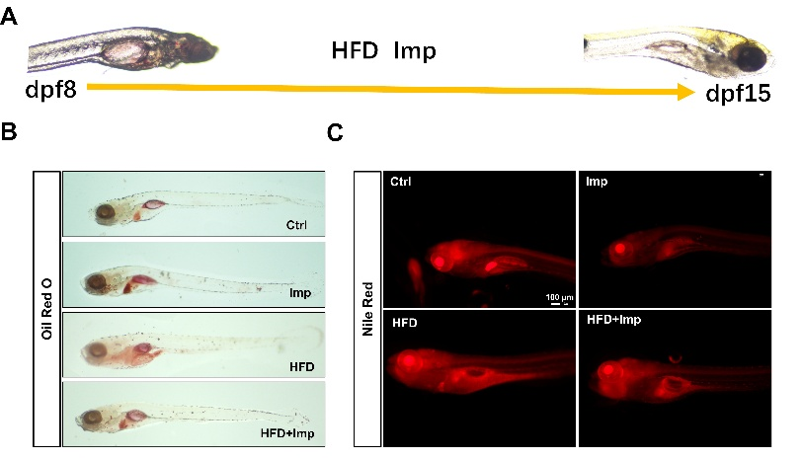
Supplementary Figure 1 ImP ameliorated lipid accumulation in zebrafish larvae at 15 dpf. (A) Schematic diagram of zebrafish larvae treated with HFD and/or ImP from 8 to 15 dpf. (B) Oil Red O staining of 15 dpf larvae shows decreased lipid deposition with ImP treatment. (C) Nile Red fluorescence images confirm reduced lipid accumulation. Scale bar = 100 μm.
Supplementary Figure 2 ImP treatment does not affect AMPK or mTORC1 signaling in adipocytes. (A) Immunoblot of p-AMPK, AMPK, and p-4-EBP1 in treated mature human adipocytes. (B) The quantitative analysis was shown as a bar graph in the right panel (n = 3). All results are represented as the mean ±SD. Unpaired t-test, ns, not significant.

