Table S1. Univariate analysis of risk factor associated with HUA.
Variable | OR (95% CI) | P value
Gender
Male | Reference
Female | 1.25 (1.03~1.53) | 0.026
Age | 1.01 (0.99~1.03) | 0.231
Smoking
No | Reference
Yes | 0.72 (0.44~1.19) | 0.202
Drinking
No | Reference
Yes | 0.83 (0.54~1.27) | 0.385
Hypertension
No | Reference
Yes | 1.4 (1.09~1.8) | 0.009
Diabetes
No | Reference
Yes | 0.86 (0.69~1.08) | 0.203
MACEs
No | Reference
Yes | 0.93 (0.74~1.18) | 0.546
BMI | 1.1 (1.07~1.13) | <0.001
Pulse | 1 (1~1.01) | 0.206
Serum albumin | 1.01 (0.97~1.05) | 0.592
BUN | 1.34 (1.25~1.43) | <0.001
eGFR | 0.96 (0.96~0.97) | <0.001
Hb | 1 (0.99~1) | 0.18
PLT | 1 (1~1) | 0.02

Table S2. Predictive Value of blood lipid index Profiles for HUA for male
Variable | AUC | Specificity | Sensitivity | Accuracy | Cut off
RC | 60.51% | 0.391 | 0.804 | 0.450 | 0.755
CRI-I | 62.67% | 0.550 | 0.667 | 0.567 | 3.554
CRI-Ⅱ | 61.97% | 0.583 | 0.614 | 0.587 | 1.979
AI | 62.67% | 0.550 | 0.667 | 0.567 | 2.554
LCI | 64.73% | 0.601 | 0.651 | 0.608 | 11.537
AIP | 63.65% | 0.541 | 0.688 | 0.562 | -0.080

Table S3. Predictive Value of blood lipid index Profiles for HUA for female
Variable | AUC | Specificity | Sensitivity | Accuracy | Cut off
RC | 56.20% | 0.678 | 0.431 | 0.635 | 0.900
CRI-I | 61.59% | 0.762 | 0.420 | 0.703 | 3.235
CRI-Ⅱ | 60.59% | 0.571 | 0.590 | 0.574 | 1.969
AI | 61.59% | 0.762 | 0.420 | 0.703 | 2.235
LCI | 63.33% | 0.640 | 0.570 | 0.628 | 14.452
AIP | 67.61% | 0.683 | 0.573 | 0.664 | -0.043

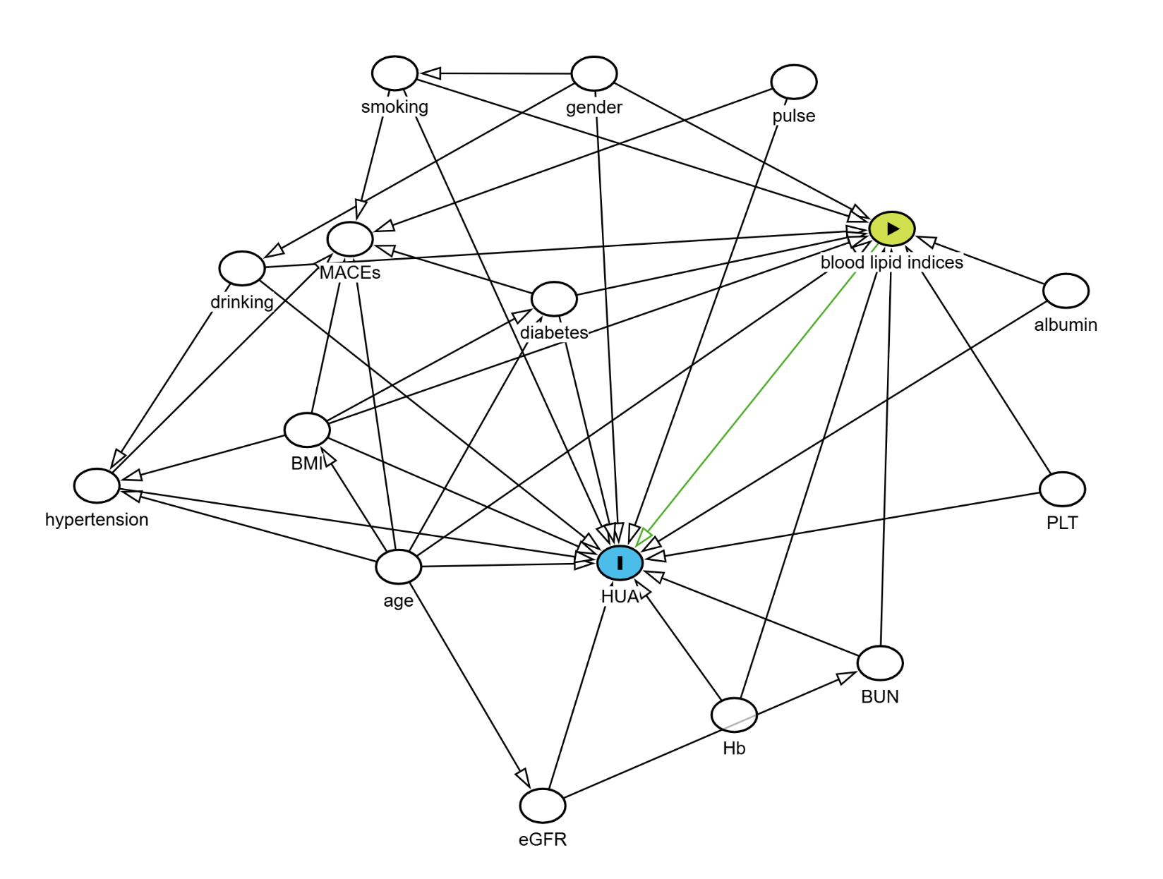
Figure S1. The DAG graph

