High Circulating PCSK9 Concentration is Associated with Increased and Sex-Specific Risks of Metabolic Disease, Diabetes Mellitus, MASLD, and Long-Term Mortality in a Taiwanese Population
Supplementary Methods

Definitions of MetS, diabetes mellitus, and metabolic liver diseases
Supplementary Method S1 presents the definitions of various parameters, including MetS, diabetes mellitus, and metabolic liver diseases used in the present study [22-24]. By the recently updated National Cholesterol Education Program Adult Treatment Panel III (NCEP ATPIII) criteria report [1], MetS is typically diagnosed in individuals who present with at least three of the following five risk factors: (1) Central obesity: WC >90 cm for men, WC >80 cm for women; (2) High BP: systolic BP ≥130 mmHg and/or diastolic BP ≥85 mmHg or a history of hypertension; (3) Low HDL-C: HDL-C <40 mg/dL for men, HDL-C <50 mg/dL for women; (4) High TG: TG ≥150 mg/dL; (5) High FPG: FPG ≥100 mg/dL or a history of DM. DM was defined as a FPG level ≥126 mg/dL, a HbA1c concentration ≥6.5% or a self-reported history of DM. Prediabetes was defined as a FPG level ≥89 mg/dL and <126 mg/dL or an HbA1c concentration ≥5.6% and <6.5%, without self-reported history of diabetes.

Definition of Metabolic liver disease
Metabolic liver disease was defined according to two different evolutional terms, including NAFLD and MASLD. The definitions of NAFLD and MASLD were shown in Supplementary Figure 1 [2-4]

Definition of all-cause, cardiovascular and cancer mortality
Following the definition of cause of death by the International Classification of Diseases, 10th Revision (ICD-10), all-cause mortality was categorized under ICD-10 codes A00–Y98; cancer mortality was categorized under ICD-10 codes C00–C97; and cardiovascular mortality was categorized under ICD-10 codes I10-I15 for hypertensive disease; ICD-10 codes I01, I02, I05–I09, I20–I25, I27, and I30–I52 for heart disease; ICD-10 codes I60–I69 for cerebrovascular disease; ICD-10 code I70 for atherosclerosis, and ICD-10 code I71 for aortic aneurysm and dissection.

References
- Grundy SM, Cleeman JI, Daniels SR, Donato KA, Eckel RH, Franklin BA, et al: Diagnosis and management of the metabolic syndrome: an American Heart Association/National Heart, Lung, and Blood Institute Scientific Statement. Circulation. 2005, 112:2735-2752.
- Bilson J, Mantovani A, Byrne CD, Targher G: Steatotic liver disease, MASLD and risk of chronic kidney disease. Diabetes Metab. 2024, 50:101506.
- Rinella ME, Lazarus JV, Ratziu V, Francque SM, Sanyal AJ, Kanwal F, et al: A multisociety Delphi consensus statement on new fatty liver disease nomenclature. Hepatology. 2023, 78:1966-1986.
- Ko YS, Hsu LA, Wu S, Liao MS, Teng MS, Chou HH, et al: Causal Associations Between Remnant Cholesterol Levels and Atherosclerosis-Related Cardiometabolic Risk Factors: A Bidirectional Mendelian Randomization Analysis. Genes (Basel). 2025, 16.

Supplementary Figure 1. Definitions of NAFLD, MAFLD, and MASLD.
Abbreviation: HBV: hepatic B virus; HCV: hepatic C virus; BMI: body mass index; WC: waist circumference; TG: triglycerides; HDL-C: high-density lipoprotein-cholesterol; HbA1c: glycosylated hemoglobin; NAFLD: non-alcoholic fatty liver disease; MASLD: metabolic dysfunction-associated steatotic liver disease (Ko e al., 2025).
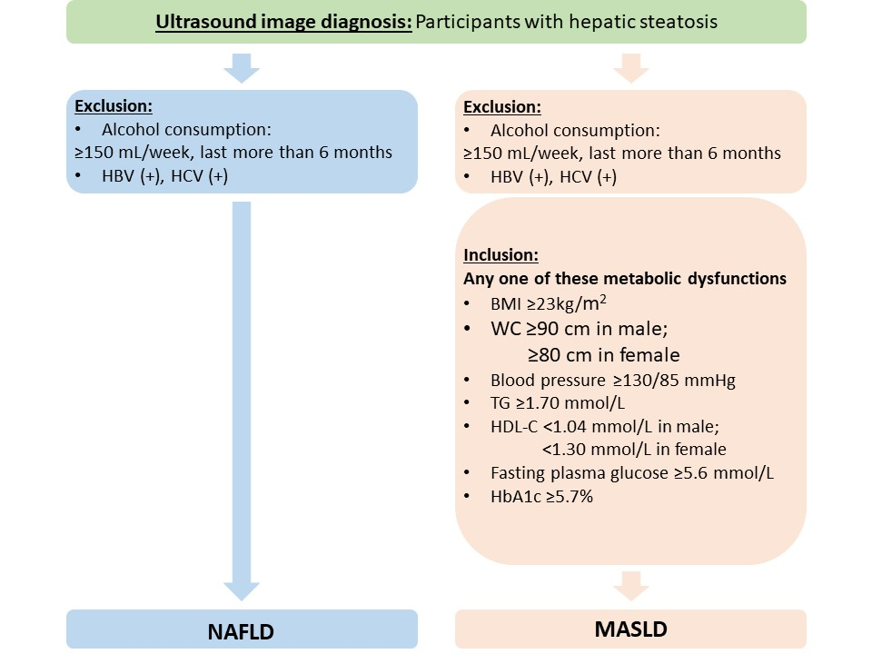

Reference

Ko YS, Hsu LA, Wu S, Liao MS, Teng MS, Chou HH, et al: Causal Associations Between Remnant Cholesterol Levels and Atherosclerosis-Related Cardiometabolic Risk Factors: A Bidirectional Mendelian Randomization Analysis. Genes (Basel). 2025, 16.

Supplementary Table 1. Baseline characteristics of 7950 TWB participants according to sex
Clinical and biochemical parameters |  | All | Male | Female | P
 |  | N = 7950 | N = 3698 | N = 4252 | P
Anthropology | Age (years) | 49.36 ± 11.10 | 49.46 ± 11.33 | 49.27 ± 10.90 | 0.0651
Anthropology | Waist circumference (cm) | 83.60 ± 9.98 | 87.38 ± 9.01 | 80.31 ± 9.61 | 2.58 × 10⁻¹³⁰
Anthropology | Waist hip ratio | 0.87 ± 0.07 | 0.89 ± 0.05 | 0.84 ± 0.07 | 3.10 × 10⁻¹⁴²
Anthropology | BMI (kg/m²) | 24.20 ± 3.62 | 25.15 ± 3.40 | 23.39 ± 3.60 | 3.40 × 10⁻⁹⁵
Blood Pressure* | Systolic BP (mmHg) | 114.87 ± 15.97 | 119.28 ± 14.81 | 111.29 ± 15.99 | 4.80 × 10⁻⁶⁶
Blood Pressure* | Diastolic BP (mmHg) | 71.78 ± 10.56 | 75.84 ± 10.13 | 68.48 ± 9.73 | 7.97 × 10⁻¹²⁷
Blood Pressure* | Mean BP (mmHg) | 86.15 ± 11.61 | 90.32 ± 10.89 | 82.75 ± 11.06 | 1.72 × 10⁻¹¹³
Lipid profiles** | Total cholesterol (mg/dL) | 193.08 ± 34.95 | 191.02 ± 34.96 | 194.82 ± 34.84 | 1.65 × 10⁻¹²
Lipid profiles** | HDL-Cholesterol (mg/dL) | 54.02 ± 13.28 | 48.65 ± 11.16 | 58.54 ± 13.24 | 2.67 × 10⁻¹⁴⁶
Lipid profiles** | LDL-Cholesterol (mg/dL) | 117.07 ± 30.53 | 117.27 ± 30.32 | 116.90 ± 30.71 | 0.1036
Lipid profiles** | Triglyceride (mg/dL) | 91.50 (65.00 - 133.00) | 105.00 (73.00 - 151.00) | 82.00 (60.00 - 117.00) | 1.12 × 10⁻²³
Glucose  Metabolism# | Fasting plasma glucose (mg/dL) | 93.84 ± 14.73 | 96.36 ± 15.89 | 91.71 ± 13.30 | 3.60 × 10⁻¹⁹
Glucose  Metabolism# | HbA1C (%) | 5.64 ± 0.60 | 5.67 ± 0.67 | 5.60 ± 0.54 | 0.9501
Insulin resistance surrogate markers**# | TyG index | 8360 (5824 - 12398) | 9900 (6806 - 14560) | 7315 (5220 - 10680) | 3.31 × 10⁻³⁷
Insulin resistance surrogate markers**# | TyG-BMI (× 10³) | 198.91 (129.74 - 315.4681) | 247.78 (161.73 - 379.26) | 167.62 (113.70 - 257.07) | 1.38 × 10⁻³²
Insulin resistance surrogate markers**# | TyG-WC (× 10³) | 691.42 (455.68 - 1079.63) | 859.88 (570.32 - 1309.04) | 579.22 (389.24 - 874.00) | 7.59 × 10⁻¹²³
Uric acid*** | Uric acid (mg/dL) | 5.52 ± 1.38 | 6.34 ± 1.26 | 4.87 ± 1.10 | <10⁻³⁰⁷
Renal function | Creatinine (mg/dL) | 0.74 ± 0.26 | 0.89 ± 0.22 | 0.61 ± 0.22 | <10⁻³⁰⁷
Renal function | eGFR (mL/min/1.73 m²) | 102.61 ± 23.63 | 94.50 ± 19.32 | 109.66 ± 24.76 | 1.24 × 10⁻¹⁷⁵
Liver function | AST(GOT) (mkat/L) | 23.00 (19.00 - 27.00) | 24.00 (20.00 - 28.00) | 21.00 (18.00 - 25.00) | 1.14 × 10⁻¹²
Liver function | ALT(GPT) (mkat/L) | 19.00 (14.00 - 27.00) | 23.00 (17.00 - 32.00) | 16.00 (13.00 - 22.00) | 1.08 × 10⁻³⁶
Liver function | γGT (mkat/L) | 18.00 (12.00 - 27.00) | 22.00 (16.00 - 34.00) | 14.00 (11.00 - 21.00) | 7.26 × 10⁻²²
Liver function | Serum albumin (mg/dL) | 4.57 ± 0.24 | 4.63 ± 0.24 | 4.52 ± 0.23 | 2.50 × 10⁻¹⁰⁴
Liver function | Total bilirubin (mg/dL) | 0.68 ± 0.28 | 0.75 ± 0.30 | 0.62 ± 0.23 | 3.05 × 10⁻¹³⁴
Hematological parameters | Leukocyte count (× 10⁹/L) | 6.03 ± 1.56 | 6.23 ± 1.57 | 5.86 ± 1.53 | 0.2963
Hematological parameters | Red blood cell count (10⁶/μL) | 4.78 ± 0.51 | 5.06 ± 0.46 | 4.54 ± 0.41 | <10⁻³⁰⁷
Hematological parameters | Platelet count (10³/μL) | 238.09 ± 56.20 | 224.93 ± 50.19 | 249.54 ± 58.61 | 1.71 × 10⁻¹⁰⁸
Hematological parameters | Hemoglobin (g/dL) | 13.93 ± 1.56 | 15.02 ± 1.14 | 12.98 ± 1.22 | <10⁻³⁰⁷
 | Hematocrit (%) | 43.55 ± 4.54 | 46.47 ± 3.62 | 41.02 ± 3.65 | <10⁻³⁰⁷
PCSK9 level |  | 155.25 ± 42.73 | 151.43 ± 41.82 | 158.57 ± 43.24 | 1.35 × 10⁻²⁴
Participants were analyzed after the exclusion of those with a history of *hypertension, **hyperlipidemia, #DM, and ***gout.
Note: Data are presented as mean ± SD or median (interquartile range). Data with skew distribution are logarithmically transformed before statistical testing to meet the assumption of normal distribution.
P: adjusted for age, BMI, current smoking status.
Abbreviations: BMI, body mass index; BP, blood pressure; HDL-C, high-density lipoprotein cholesterol; LDL-C, low-density lipoprotein cholesterol; HbA1C, hemoglobin A1C; TyG, Triglyceride glucose; eGFR, estimated glomerular filtration rate; ALT, alanine aminotransferase; AST, aspartate aminotransferase; γGT, gamma-glutamyl transferase; DM, diabetes mellitus.

Supplementary Figure 2. Frequency distribution of PCSK9 level in the study (N = 7950) (A), in male and female only (B).
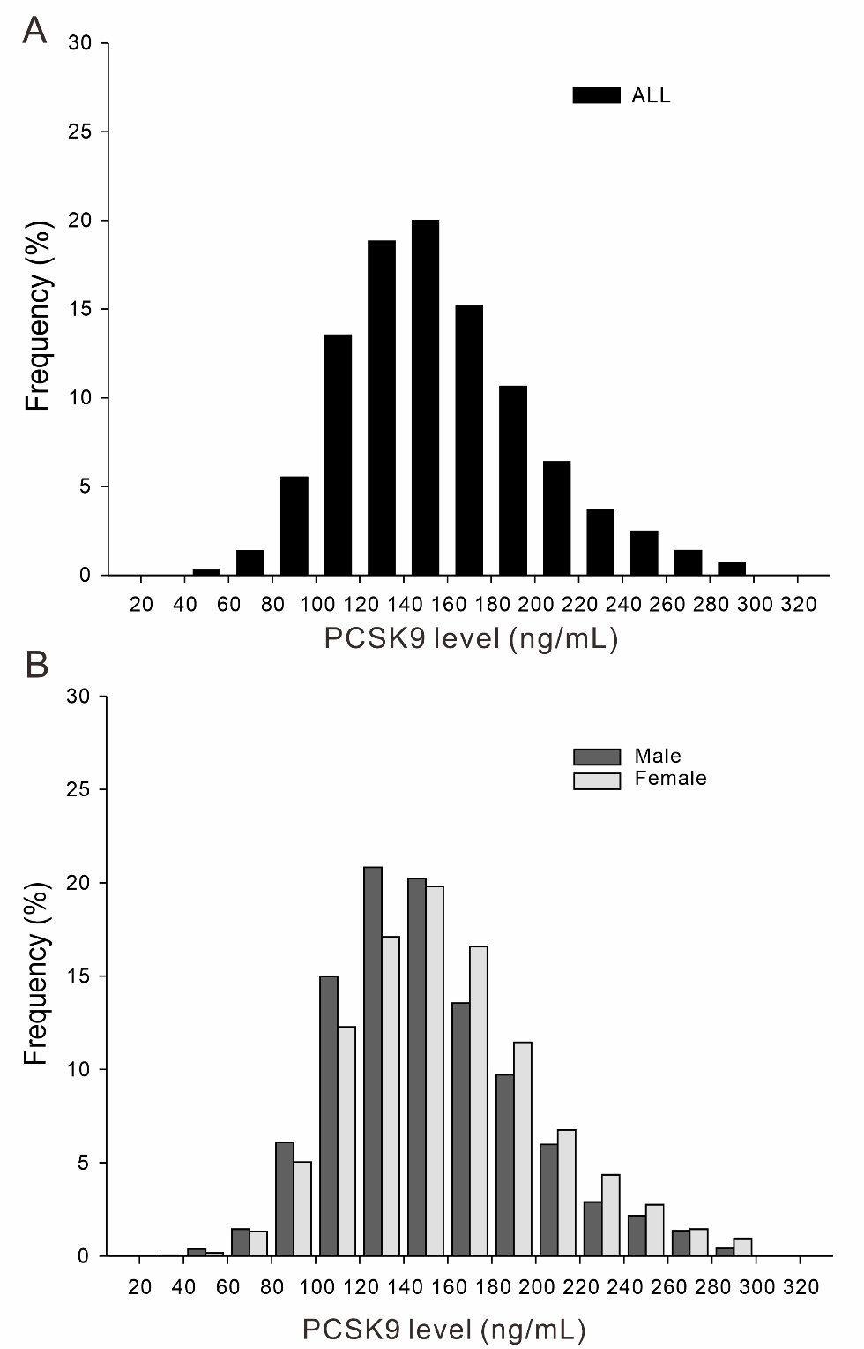

Supplementary Table 2. Baseline characteristics of study subjects according to sex in 6478 TWB participants

Clinical and biochemical parameters |  | All | Male | Female | P
 |  | N = 6478 | N = 2831 | N = 3647 | P
Anthropology | Age (years) | 47.58 ± 10.85 | 47.22 ± 11.11 | 47.85 ± 10.64 | 0.3811
Anthropology | Waist circumference (cm) | 82.48 ± 9.63 | 86.47 ± 8.72 | 79.39 ± 9.16 | 5.71 × 10⁻¹⁰⁹
Anthropology | Waist hip ratio | 0.86 ± 0.07 | 0.89 ± 0.05 | 0.84 ± 0.07 | 2.20 × 10⁻¹²²
Anthropology | BMI (kg/m²) | 24.87 ± 3.49 | 24.89 ± 3.32 | 23.08 ± 3.42 | 1.22 × 10⁻⁸⁷
Blood Pressure | Systolic BP (mmHg) | 114.38 ± 15.97 | 118.89 ± 14.83 | 110.89 ± 15.94 | 1.48 × 10⁻⁶³
Blood Pressure | Diastolic BP (mmHg) | 71.65 ± 10.59 | 75.84 ± 10.17 | 68.40 ± 9.74 | 2.61 × 10⁻¹²⁰
Blood Pressure | Mean BP (mmHg) | 85.90 ± 11.66 | 90.19 ± 10.97 | 82.56 ± 11.08 | 1.09 × 10⁻¹⁰⁷
Lipid profiles | Total cholesterol (mg/dL) | 193.71 ± 34.93 | 192.55 ± 35.14 | 194.60 ± 34.74 | 4.77 × 10⁻⁷
Lipid profiles | HDL-Cholesterol (mg/dL) | 54.74 ± 13.26 | 49.12 ± 11.12 | 59.10 ± 13.15 | 1.78 × 10⁻¹²⁹
Lipid profiles | LDL-Cholesterol (mg/dL) | 117.60 ± 30.53 | 118.58 ± 30.40 | 116.84 ± 30.62 | 0.7875
Lipid profiles | Triglyceride (mg/dL) | 88.00 (63.00 - 128.00) | 102.00 (72.00 - 150.00) | 79.00 (58.00 - 112.00) | 1.16 × 10⁻²⁷
Glucose metabolism | Fasting plasma glucose (mg/dL) | 93.12 ± 14.47 | 95.80 ± 16.04 | 91.05 ± 12.74 | 1.33 × 10⁻²⁰
Glucose metabolism | HbA1C (%) | 5.61 ± 0.60 | 5.65 ± 0.68 | 5.57 ± 0.52 | 0.2526
Insulin resistance surrogate markers | TyG index | 8160 (5696 - 12065) | 9737 (6699 - 14388) | 7110 (5100 - 10320) | 7.29 × 10⁻³⁹
Insulin resistance surrogate markers | TyG-BMI (× 10³) | 191.1 (126.09 - 3306.08) | 240.24 (157.91 - 371.84) | 162.17 (110.77 - 246.52) | 1.97 × 10⁻³⁴
Insulin resistance surrogate markers | TyG-WC (× 10³) | 664.02 (442.82 - 1044.86) | 838.60 (556.45 - 1292.53) | 558.83 (389.98 - 844.36) | 9.93 × 10⁻¹¹⁷
Uric acid* | Uric acid (mg/dL) | 5.43 ± 1.36 | 6.34 ± 1.22 | 4.78 ± 1.04 | <10⁻³⁰⁷
Renal function | Creatinine (mg/dL) | 0.72 ± 0.18 | 0.88 ± 0.13 | 0.60 ± 0.10 | <10⁻³⁰⁷
Renal function | eGFR (mL/min/1.73 m²) | 104.64 ± 22.70 | 96.44 ± 17.95 | 111.00 ± 23.93 | 4.02 × 10⁻¹⁴⁹
Liver function | AST (mkat/L) | 22.00 (19.00 - 26.00) | 24.00 (20.00 - 28.00) | 21.00 (18.00 - 25.00) | 5.57 × 10⁻¹⁵
Liver function | ALT (mkat/L) | 18.00 (14.00 - 26.00) | 22.00 (17.00 - 32.00) | 16.00 (12.00 - 21.00) | 5.71 × 10⁻⁴¹
Liver function | γGT (mkat/L) | 17.00 (12.00 - 26.00) | 22.00 (16.00 - 33.00) | 14.00 (10.00 - 20.00) | 9.87 × 10⁻¹⁹
Liver function | Serum albumin (mg/dL) | 4.57 ± 0.24 | 4.64 ± 0.23 | 4.51 ± 0.23 | 3.00 × 10⁻¹⁰⁶
Liver function | Total bilirubin (mg/dL) | 0.67 ± 0.28 | 0.75 ± 0.31 | 0.61 ± 0.23 | 1.15 × 10⁻¹²²
Hematological parameters | Leukocyte count (× 10⁹/L) | 5.98 ± 1.55 | 6.18 ± 1.56 | 5.83 ± 1.53 | 0.9781
Hematological parameters | Red blood cell count (10⁶/μL) | 4.77 ± 0.51 | 5.09 ± 0.46 | 4.53 ± 0.41 | <10⁻³⁰⁷
Hematological parameters | Platelet count (10³/μL) | 240.11 ± 56.21 | 226.26 ± 49.88 | 250.86 ± 58.46 | 6.89 × 10⁻⁹⁶
Hematological parameters | Hemoglobin (g/dL) | 13.86 ± 1.58 | 15.05 ± 1.10 | 12.94 ± 1.24 | <10⁻³⁰⁷
Hematological parameters | Hematocrit (%) | 43.41 ± 4.58 | 46.62 ± 3.50 | 40.91 ± 3.68 | <10⁻³⁰⁷
 | PCSK9 level | 152.35 ± 41.47 | 148.17 ± 40.11 | 155.60 ± 42.22 | 1.89 × 10⁻¹⁹
Participants were analyzed after the exclusion of those with a history of *gout.
Note: Data are presented as mean ± SD or median (interquartile range). Data with skew distribution are logarithmically transformed before statistical testing to meet the assumption of normal distribution.
P: adjusted for age, BMI, current smoking status.
Abbreviations: BMI, body mass index; BP, blood pressure; HDL-C, high-density lipoprotein cholesterol; LDL-C, low-density lipoprotein cholesterol; HbA1C, hemoglobin A1C; TyG, Triglyceride glucose; eGFR, estimated glomerular filtration rate; ALT, alanine aminotransferase; AST, aspartate aminotransferase; γGT, gamma-glutamyl transferase.

Supplementary Figure 3. Box plots of PCSK9 levels in 4064 participants with NAFLD (A-C) and percentage of NAFLD (D-F) across the quartiles of PCSK9. P₁: unadjusted, P₂: adjusted for age, BMI, sex and current smoking status.
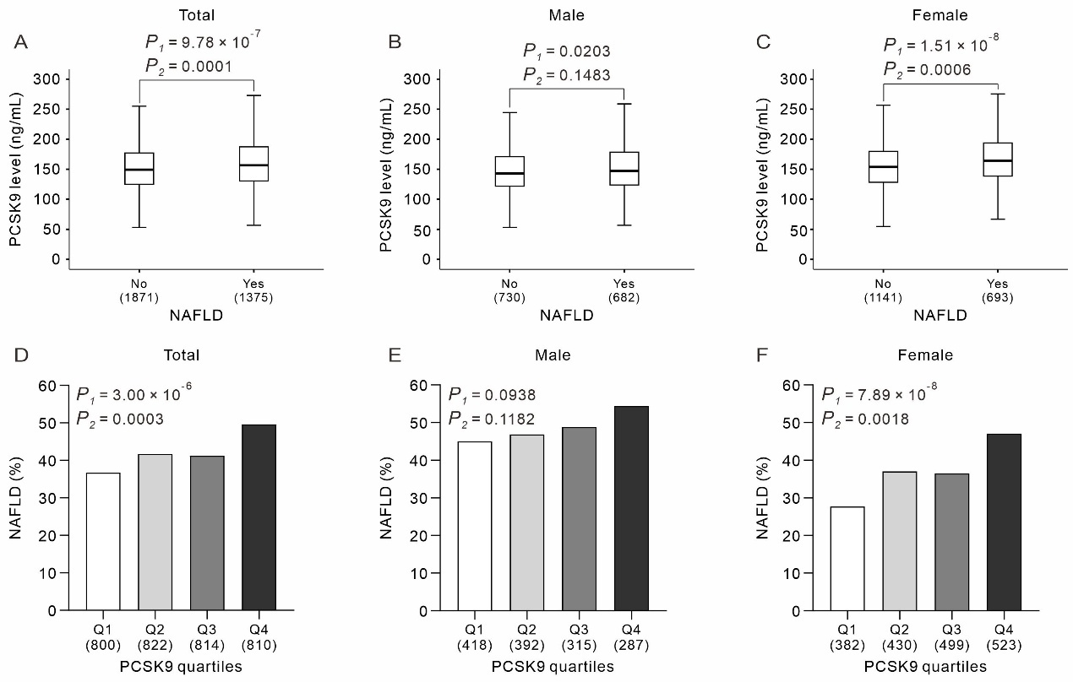

Supplementary Table 3. Association between PCSK9 levels and atherosclerotic risk factors in 7950 TWB participants
 |  | N | PCSK9 levels | P₁ | P₂ | P₃ | Adjusted P₃ | P₄ | Adjusted P₄
Sex (male vs. female) | Male | 3698 | 151.43 ± 41.82 | 1.16 × 10⁻¹³ | 1.92 × 10⁻¹⁴ | 1.35 × 10⁻²⁴ | 2.16 × 10⁻²³ | 8.08 × 10⁻²⁴ | 1.29 × 10⁻²²
Sex (male vs. female) | Female | 4252 | 158.57 ± 43.24
Sex differences in age <50 | Male | 1811 | 148.03 ± 40.89 | 0.4599 | -- | 0.0408 | 0.6528 | 0.0237 | 0.3792
Sex differences in age <50 | Female | 2134 | 147.00 ± 40.68
Sex differences in age ≥50 | Male | 1887 | 154.70 ± 42.45 | 2.22 × 10⁻³² | -- | 1.15 × 10⁻³⁵ | 1.84 × 10⁻³⁴ | 1.38 × 10⁻³³ | 2.21 × 10⁻³²
Sex differences in age ≥50 | Female | 2118 | 170.23 ± 42.60
Age in male participants | Age <50 | 1811 | 148.03 ± 40.89 | 8.57 × 10⁻⁷ | -- | 7.12 × 10⁻⁸ | 1.14 × 10⁻⁶ | 2.05 × 10⁻⁹ | 3.28 × 10⁻⁸
Age in male participants | Age ≥50 | 1887 | 154.70 ± 42.45
Age in female participants | Age <50 | 2134 | 147.00 ± 40.68 | 1.84 × 10⁻⁷⁴ | -- | 4.90 × 10⁻⁶³ | 7.84 × 10⁻⁶² | 1.94 × 10⁻⁶⁴ | 3.10 × 10⁻⁶³
Age in female participants | Age ≥50 | 2118 | 170.23 ± 42.60
Current smoking status | No | 7133 | 155.22 ± 42.84 | 0.6378 | 9.40 × 10⁻⁵ | 0.0002 | 0.0032 | 0.0079 | 0.1264
Current smoking status | Yes | 817 | 155.55 ± 41.78
Obesity (%) | Non-Obese | 4979 | 152.97 ± 41.97 | 1.78 × 10⁻⁹ | 3.37 × 10⁻¹⁴ | 7.62 × 10⁻¹⁴ | 1.22 × 10⁻¹² | 3.92 × 10⁻¹³ | 6.27 × 10⁻¹²
Obesity (%) | Obese | 2970 | 159.04 ± 43.65
Central obesity (%) | Non-central obese | 3351 | 148.67 ± 40.60 | 6.87 × 10⁻³³ | 2.58 × 10⁻¹⁷ | 5.00 × 10⁻⁶ | 8.00 × 10⁻⁵ | 3.20 × 10⁻⁵ | 0.0005
Central obesity (%) | Central obese | 4063 | 160.62 ± 43.55
Hypertension (%) | No | 6348 | 153.10 ± 41.82 | 4.67 × 10⁻¹⁷ | 9.68 × 10⁻⁷ | 0.0013 | 0.0208 | 8.00 × 10⁻⁶ | 0.0001
Hypertension (%) | Yes | 1602 | 163.76 ± 45.17
DM (%) | Normal | 4194 | 148.13 ± 40.28 | 3.79 × 10⁻⁶³ | 8.14 × 10⁻³⁸ | 2.24 × 10⁻³⁰ | 3.58 × 10⁻²⁹ | 1.62 × 10⁻¹³ | 2.59 × 10⁻¹²
DM (%) | Prediabetes | 3048 | 160.78 ± 43.23
DM (%) | DM | 708 | 173.64 ± 45.59
Insulin resistance by
TyG (%) | No | 5936 | 150.57 ± 40.78 | 2.34 × 10⁻⁵⁸ | 8.08 × 10⁻⁶¹ | 2.63 × 10⁻⁴⁷ | 4.21 × 10⁻⁴⁶ | 7.51 × 10⁻⁴⁷ | 1.20 × 10⁻⁴⁵
TyG (%) | Yes | 2014 | 169.06 ± 45.29
TyG-BMI (%) | No | 5935 | 150.98 ± 41.07 | 8.18 × 10⁻⁵⁰ | 3.33 × 10⁻⁵⁴ | 2.27 × 10⁻³⁸ | 3.63 × 10⁻³⁷ | 1.97 × 10⁻³⁹ | 3.15 × 10⁻³⁸
TyG-BMI (%) | Yes | 2014 | 167.78 ± 44.92
TyG-WC (%) | No | 5933 | 150.79 ± 41.01 | 8.68 × 10⁻⁵⁴ | 1.15 × 10⁻⁵⁸ | 3.28 × 10⁻⁴³ | 5.25 × 10⁻⁴² | 6.42 × 10⁻⁴⁴ | 1.03 × 10⁻⁴²
TyG-WC (%) | Yes | 2016 | 168.30 ± 44.87
Metabolic syndrome (%) | No | 6166 | 151.45 ± 41.12 | 2.31 × 10⁻⁴³ | 2.44 × 10⁻³² | 1.60 × 10⁻¹⁹ | 2.56 × 10⁻¹⁸ | 2.94 × 10⁻²⁰ | 4.70 × 10⁻¹⁹
Metabolic syndrome (%) | Yes | 1782 | 168.28 ± 45.42
Metabolic liver disease
MASLD | No | 1974 | 153.10 ± 39.45 | 9.54 × 10⁻⁹ | 1.42 × 10⁻⁸ | 4.60 × 10⁻⁵ | 0.0007 | 0.0001 | 0.0016
MASLD | Yes | 1272 | 162.52 ± 44.10
NAFLD | No | 1871 | 153.36 ± 39.39 | 9.78 × 10⁻⁷ | 4.45 × 10⁻⁹ | 0.0001 | 0.0016 | 0.0003 | 0.0048
NAFLD | Yes | 1375 | 161.45 ± 43.99
P₁: unadjusted
P₂: adjusted for age and sex
P₃: adjusted for age, sex, BMI and current smoking status; adjusted for age, BMI and current smoking status across sex categories; adjusted for BMI and current smoking status across different age-sex groups.
Adjusted P₃: with Bonferroni correction, n = 16
P₄: P₃ with further adjusted for physical activity and alcohol consumption status
Adjusted P₄: with Bonferroni correction, n = 16
Abbreviations: DM, diabetes mellitus; TyG, Triglyceride glucose; MASLD: metabolic dysfunction-associated steatotic liver disease; NAFLD: non-alcoholic fatty liver disease.
Supplementary Table 4. Baseline characteristics of 6478 study participants according to the quartiles of circulating PCSK9 level
Clinical and biochemical parameters |  | Q1 (N = 1735) | Q2 (N = 1666) | Q3 (N = 1614) | Q4 (N = 1463) | P | Adjusted P
Anthropology | Age (years) | 44.96 ± 10.71 | 46.90 ± 10.72 | 48.82 ± 10.73 | 50.09 ± 10.54 | 9.28 × 10⁻⁴⁸ | 2.69 × 10⁻⁴⁶
Anthropology | Waist circumference (cm) | 81.49 ± 9.67 | 82.31 ± 9.82 | 82.72 ± 9.37 | 83.60 ± 9.52 | 3.00 × 10⁻⁶ | 8.70 × 10⁻⁵
Anthropology | Waist hip ratio | 0.85 ± 0.06 | 0.86 ± 0.06 | 0.86 ± 0.07 | 0.87 ± 0.07 | 1.08 × 10⁻⁸ | 3.13 × 10⁻⁷
Anthropology | BMI (kg/m²) | 23.66 ± 3.53 | 23.78 ± 3.52 | 23.89 ± 3.40 | 24.20 ± 3.49 | 2.87 × 10⁻¹² | 8.32 × 10⁻¹¹
Blood Pressure | Systolic BP (mmHg) | 112.41 ± 15.34 | 114.27 ± 16.22 | 114.43 ± 15.36 | 116.80 ± 16.74 | 2.64 × 10⁻³ | 0.0766
Blood Pressure | Diastolic BP (mmHg) | 70.67 ± 10.40 | 71.66 ± 10.62 | 71.66 ± 10.53 | 72.81 ± 10.75 | 5.00 × 10⁻⁶ | 1.45 × 10⁻⁴
Blood Pressure | Mean BP (mmHg) | 84.59 ± 11.34 | 85.86 ± 11.79 | 85.91 ± 11.45 | 87.47 ± 11.94 | 2.70 × 10⁻⁵ | 7.83 × 10⁻⁴
Lipid profiles | Total cholesterol (mg/dL) | 183.46 ± 32.04 | 191.39 ± 32.42 | 197.55 ± 33.55 | 204.26 ± 38.59 | 2.40 × 10⁻⁴⁹ | 6.96 × 10⁻⁴⁸
Lipid profiles | HDL-Cholesterol (mg/dL) | 54.46 ± 12.99 | 54.15 ± 12.83 | 54.92 ± 13.13 | 55.54 ± 14.15 | 0.2213 | >1
Lipid profiles | LDL-Cholesterol (mg/dL) | 110.70 ± 29.09 | 117.05 ± 29.25 | 120.68 ± 30.15 | 123.01 ± 32.47 | 2.01 × 10⁻¹⁹ | 58.3 × 10⁻¹⁸
Lipid profiles | Triglyceride (mg/dL) | 76.00 (56.00 - 107.00) | 86.00 (62.00 - 122.25) | 92.00 (66.00 - 130.00) | 105.00 (73.00 - 151.00) | 7.93 × 10⁻⁷¹ | 2.30 × 10⁻⁶9
Glucose metabolism | Fasting plasma glucose (mg/dL) | 90.65 ± 9.30 | 92.56 ± 12.57 | 93.54 ± 14.18 | 96.25 ± 20.13 | 7.47 × 10⁻²² | 2.17 × 10⁻²0
Glucose metabolism | HbA1C (%) | 5.49 ± 0.42 | 5.58 ± 0.55 | 5.63 ± 0.59 | 5.74 ± 0.78 | 1.27 × 10⁻¹⁸ | 3.68 × 10⁻¹7
Insulin resistance surrogate markers | TyG index | 6723 (4900 - 9898) | 7854 (5545 - 11521) | 8552 (6051 - 12462) | 9851 (6807 - 14646) | 1.79 × 10⁻⁸² | 5.19 × 10⁻⁸1
Insulin resistance surrogate markers | TyG-BMI (× 10³) | 155.32 (106.75 - 245.28) | 185.14 (124.26 - 292.86) | 202.02 (133.39 - 312.21) | 235.16 (155.26 - 371.87) | 4.63 × 10⁻⁷⁶ | 1.34 × 10⁻⁷⁴
Insulin resistance surrogate markers | TyG-WC (× 10³) | 535.82 (380.62 - 842.93) | 640.49 (435.89 - 996.48) | 695.17 (474.96 - 1062.52) | 821.99 (549.54 - 1283.83) | 3.08 × 10⁻⁵⁵ | 8.93 × 10⁻⁵⁴
Uric acid* | Uric acid (mg/dL) | 5.49 ± 1.38 | 5.42 ± 1.32 | 5.41 ± 1.36 | 5.40 ± 1.36 | 0.4135 | >1
Renal function | Creatinine (mg/dL) | 0.74 ± 0.18 | 0.73 ± 0.18 | 0.71 ± 0.17 | 0.70 ± 0.18 | 0.0125 | 0.3625
Renal function | eGFR (mL/min/1.73 m²) | 104.22 ± 22.25 | 104.90 ± 22.68 | 104.65 ± 22.57 | 104.82 ± 23.40 | 0.0157 | 0.4553
Liver function | AST(GOT) (mkat/L) | 22.00 (18.00 - 25.00) | 22.00 (19.00 - 26.00) | 22.00 (19.00 - 26.25) | 23.00 (19.00 - 27.00) | 5.00 × 10⁻⁶ | 1.47 × 10⁻⁴
Liver function | ALT(GPT) (mkat/L) | 18.00 (13.00 - 24.00) | 18.00 (14.00 - 25.00) | 19.00 (14.00 - 27.00) | 19.00 (15.00 - 28.00) | 9.74 × 10⁻¹¹ | 2.82 × 10⁻⁹
Liver function | γGT (mkat/L) | 15.00 (11.00 - 23.00) | 16.00 (12.00 - 25.00) | 18.00 (12.00 - 26.25) | 19.00 (13.00 - 30.00) | 3.87 × 10⁻¹⁵ | 1.12 × 10⁻¹³
Liver function | Serum albumin (mg/dL) | 4.58 ± 0.24 | 4.57 ± 0.23 | 4.57 ± 0.23 | 4.55 ± 0.27 | 0.0133 | 0.3857
Liver function | Total bilirubin (mg/dL) | 0.74 ± 0.30 | 0.69 ± 0.28 | 0.66 ± 0.26 | 0.61 ± 0.25 | 1.12 × 10⁻⁴0 | 3.25 × 10⁻³⁹
Hematological parameters | Leukocyte count (× 10⁹/L) | 5.98 ± 1.50 | 6.02 ± 1.59 | 5.95 ± 1.50 | 5.97 ± 1.62 | 0.4102 | >1
Hematological parameters | Red blood cell (10⁶/μL) | 4.79 ± 0.54 | 4.78 ± 0.50 | 4.77 ± 0.49 | 4.76 ± 0.50 | 0.0087 | 0.2523
Hematological parameters | Platelet count (10³/μL) | 236.10 ± 55.42 | 240.44 ± 57.34 | 239.45 ± 54.92 | 245.21 ± 56.89 | 1.42 × 10⁻⁷ | 4.12 × 10⁻⁶
Hematological parameters | Hemoglobin (g/dL) | 13.75 ± 1.66 | 13.88 ± 1.59 | 13.89 ± 1.55 | 13.94 ± 1.49 | 3.01 × 10⁻²² | 8.73 × 10⁻²1
Hematological parameters | Hematocrit (%) | 42.97 ± 4.75 | 43.41 ± 4.64 | 43.65 ± 4.52 | 43.66 ± 4.33 | 8.55 × 10⁻³¹ | 2.48 × 10⁻²⁹
Participants were analyzed after the exclusion of those with a history of *gout.
Note: Data are presented as mean ± SD or median (interquartile range). Data with skew distribution are logarithmically transformed before statistical testing to meet the assumption of normal distribution.
P: adjusted age, sex, BMI and current smoking status
Adjusted P: with Bonferroni correction, n = 29
Abbreviations: BMI, body mass index; BP, blood pressure; HDL-C, high-density lipoprotein cholesterol; LDL-C, low-density lipoprotein cholesterol; HbA1C, hemoglobin A1C; TyG, Triglyceride glucose; eGFR, estimated glomerular filtration rate; ALT, alanine aminotransferase; AST, aspartate aminotransferase; γGT, gamma-glutamyl transferase.

Supplementary Figure 4. ORs of the quartiles of PCSK9 in participants with IR by TyG (A), IR by TyG-BMI (B) or NAFLD (C), stratified by sex. Comparison of Q2, Q3 or Q4 with Q1 as the reference group. ORs of the quartiles of PCSK9 were estimated after adjusting for age, sex, BMI and current smoking status for all participants, adjusting for age, BMI and current smoking status for male or female participants. ªEffect of sex on the association between quartiles of PCSK9 and IR by TyG, IR by TyG-BMI or NAFLD.

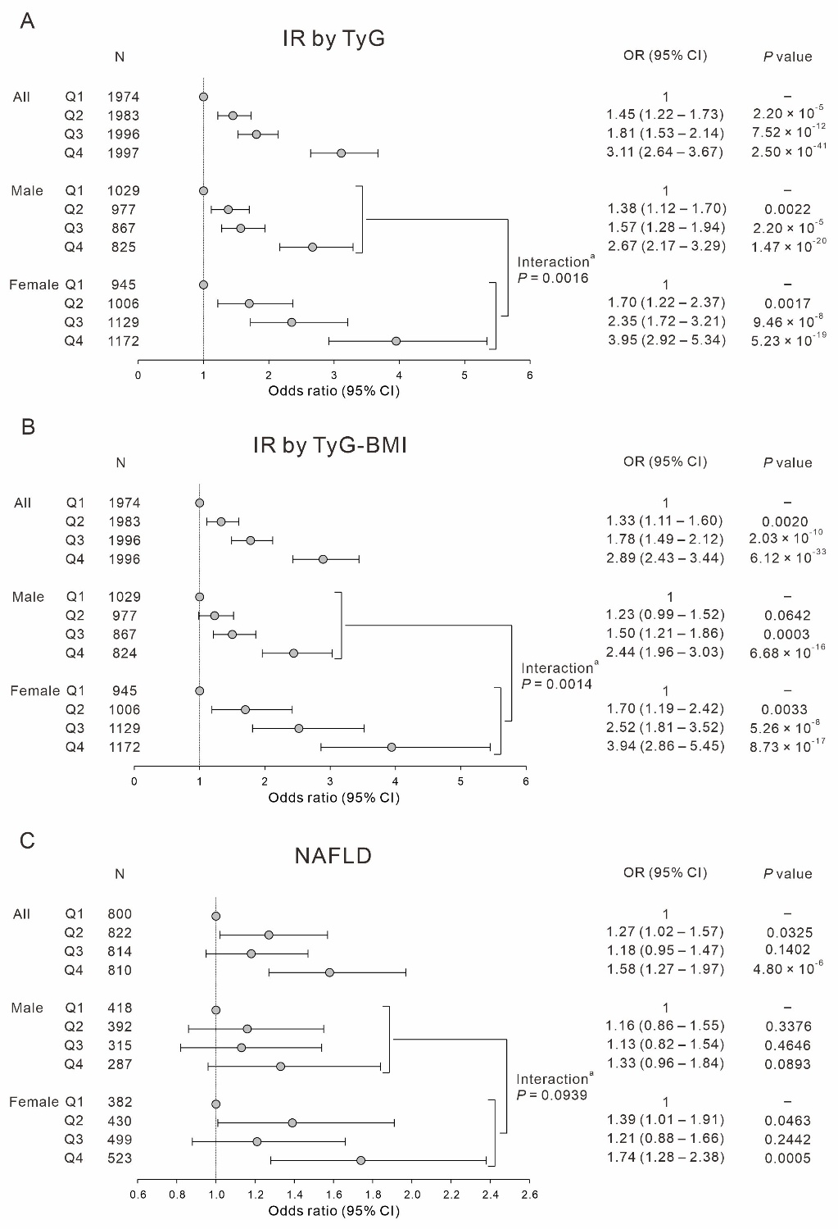
Supplementary Figure 5. The Receiver Operating Characteristic (ROC) Curve of circulating PCSK9 levels for long-term mortality risk prediction

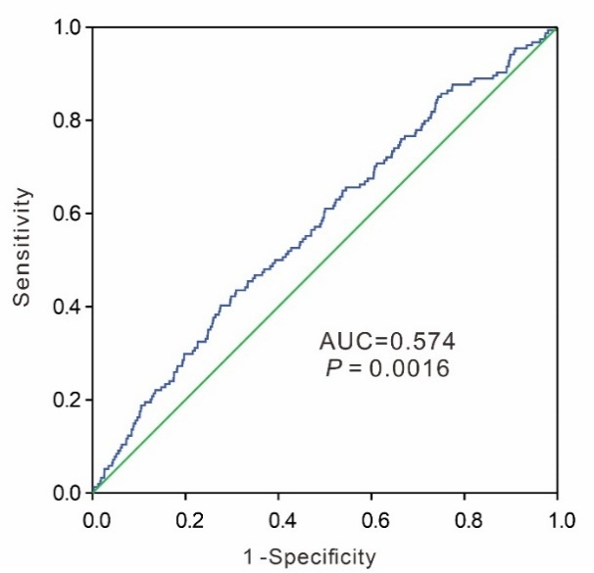

Supplementary Table 5: Sensitivity Analysis of PCSK9 Measurement Error on Mortality Outcomes
Outcome | Original HR (95% CI) | P value | Simulated HR Range | Mean Simulated HR | Note
Total mortality | 1.57 (1.14–2.18) | 0.0063 | 1.003 – 1.006 | 1.0047 | HR direction stable across simulations
CV mortality | 1.52 (0.79–2.92) | 0.2148 | 0.9996 – 1.0069 | 1.0033 | HR direction stable across simulations
Non-CV mortality | 1.59 (1.10 - 2.32) | 0.0148 | 1.0035 – 1.0071 | 1.0051 | HR direction stable across simulations
Cancer mortality | 1.40 (0.85 - 2.29) | 0.1835 | 1.0005 – 1.0050 | 1.0029 | HR direction stable across simulations

