Combination Therapy of Statin and Acipimox Versus Statin Monotherapy in Acute Myocardial Infarction with Hypertriglyceridemia: A Multicenter Propensity Score–Matched Analysis
Supplementary material
Tianshu Gu, Junyu Liu, Zuo Qi, Yukun Zhang, Sutao Hu, Ze Zhang, Zhengkai Xue, Tong Liu, Kangyin Chen

eFigure1. Covariate balance before and after propensity-score matching.
This Love plot displays the absolute standardized mean differences (SMDs) of baseline variables before and after weighting, including demographics (age, sex), clinical characteristics (STEMI, Killip class, HFRS group, PCI), comorbidities (hypertension, diabetes mellitus, cerebrovascular disease, peripheral vascular disease), and medications or laboratory markers (aspirin, P2Y12 inhibitors, β-blockers, ACEI/ARB, oral anticoagulants, diuretics, nitrates, fibrates, ARNI, PPI, triglyceride, HDL, LDL). An absolute SMD < 0.1 indicates good covariate balance between groups.
eFigure2. Comparison of safety-related laboratory markers between the statin monotherapy and statin + acipimox groups in the matched cohort.
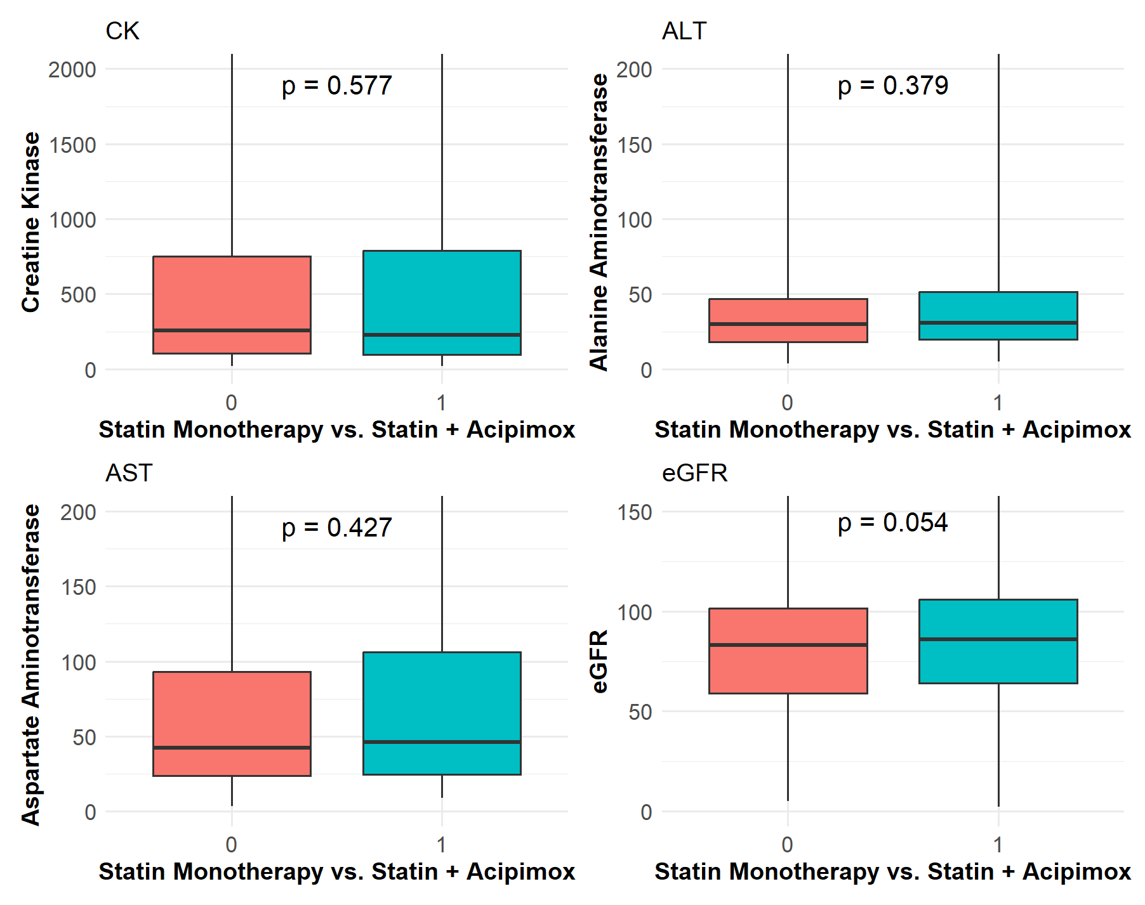
Box plots depict distributions of creatine kinase (CK), alanine aminotransferase (ALT), aspartate aminotransferase (AST), and estimated glomerular filtration rate (eGFR). No significant between-group differences were observed for CK (P = 0.577), ALT (P = 0.379), AST (P = 0.427), or eGFR (P = 0.054), indicating no detectable muscle, hepatic, or renal safety concerns associated with acipimox use.

eFigure2. Subgroup analyses for the association between treatment and 1-year outcomes.
This forest plot illustrates the hazard ratios (aHRs) and 95% confidence intervals for the association between treatment and 1-year major adverse cardiovascular and cerebrovascular events (MACCE) and net adverse clinical events (NACE) across clinically relevant subgroups. Subgroups were defined by sex (male vs. female), age (≥65 vs. <65 years), Killip class (>Ⅰ vs. Ⅰ), STEMI vs. NSTEMI presentation, presence of hypertension, and presence of diabetes mellitus. No significant interaction was observed across subgroups, indicating that the beneficial association of treatment with outcomes was consistent among different patient strata.

eTable1. Sensitivity analyses of the association between treatment and 1-year cardiovascular outcomes after propensity-score matching
Outcomes | PSM-HR (95% CI) | P value
MACCE
Model 1 | 0.675 (0.509–0.896) |  | 0.007
Model 2 | 0.677 (0.510–0.900) |  | 0.007
Model 3 | 0.680 (0.511–0.904) |  | 0.008
NACE
Model 1 | 0.635 (0.484–0.834) |  | <0.001
Model 2 | 0.629 (0.479–0.827) |  | <0.001
Model 3 | 0.633 (0.481–0.832) |  | <0.001

eTable2. Sensitivity analyses of the association between treatment and 1-year cardiovascular outcomes using inverse probability of treatment weighting
Outcomes | IPTW-HR (95% CI) | P value
MACCE
Univariate analysis | 0.546 (0.416–0.717) |  | <0.001
Model 1 | 0.545 (0.415–0.716) |  | <0.001
Model 2 | 0.531 (0.403–0.700) |  | <0.001
Model 3 | 0.536 (0.408–0.704) |  | <0.001
NACE |  |  | <0.001
Univariate analysis | 0.583 (0.443–0.767) |  | <0.001
Model 1 | 0.588 (0.446–0.775) |  | <0.001
Model 2 | 0.569 (0.434–0.745) |  | <0.001
Model 3 | 0.575 (0.439–0.752) |  | <0.001

eTable3. Sensitivity analyses adjusting for calendar year and inter-hospital clustering
Outcomes | aHR (95% CI) | P value
MACCE
Adjusted for calendar year | 0.639 (0.470–0.868) | 0.006
Adjusted for hospital-level clustering | 0.608 (0.458–0.807) | <0.001
NACE
Adjusted for calendar year | 0.570 (0.427–0.760) | <0.001
Adjusted for hospital-level clustering | 0.570 (0.435–0.746) | 0.003

eTable4. Associations between acipimox use patterns and one-year clinical outcomes, comparing in-hospital–only use and post-discharge continued use with the no-acipimox reference group based on Cox proportional hazards models
Outcomes  (no-acipimox group as the reference) | HR (95% CI) | P value
MACCE
in-hospital use only | 1.003 (0.677–1.487) | 0.988
post-discharge continued use | 0.499 (0.358–0.694) | <0.001
NACE
in-hospital use only | 0.899 (0.613–1.320) | 0.589
post-discharge continued use | 0.499 (0.366–0.680) | <0.001
All-cause death
in-hospital use only | 1.388 (0.676–2.848) | 0.377
post-discharge continued use | 0.458 (0.223–0.939) | 0.035
Cardiac death
in-hospital use only | 1.886 (0.853–4.168) | 0.118
post-discharge continued use | 0.420 (0.168–1.052) | 0.066
MI
in-hospital use only | 0.642 (0.271–1.518) | 0.319
post-discharge continued use | 0.556 (0.310–0.997) | 0.049
Stroke
in-hospital use only | 1.072 (0.400–2.872) | 0.885
post-discharge continued use | 0.415 (0.166–1.038) | 0.062
Revascularization
in-hospital use only | 0.933 (0.542–1.608) | 0.803
post-discharge continued use | 0.536 (0.347–0.826) | 0.004
Bleeding events
in-hospital use only | 0.728 (0.281–1.886) | 0.517
post-discharge continued use | 0.515 (0.256–1.034) | 0.065

eTable5. Fine–Gray competing risk analyses for one-year outcomes (non-cardiac death as the competing event for MACCE and cardiac death; all-cause death as the competing event for non-fatal outcomes)
Outcome | Subdistribution HR (95% CI) | P-value
MACCE | 0.621 (0.469–0.822) | <0.001
Cardiac death | 0.789 (0.401–1.551) | 0.492
Myocardial infarction | 0.583 (0.345–0.986) | 0.044
Revascularization | 0.637 (0.438–0.926) | 0.018
Bleeding event | 0.571 (0.309–1.055) | 0.074
Stroke | 0.578 (0.275–1.214) | 0.148

