Supplemental Digital Content.
Figure S1. Flowchart illustrating the participant selection process for this study.
Figure S2. Forest plot of association between fatty acids and IA risk. Odds ratios (ORs) and 95% confidence intervals (CIs) were adjusted for age, sex, body mass index, education, smoking status, alcohol consumption, history of diabetes, hypertension, coronary artery disease, and ischemic stroke.
Figure S3. Association between fatty acids and IA risk across different age groups. Odds ratios (ORs) and 95% confidence intervals (CIs) were adjusted for age, sex, body mass index, education, smoking status, alcohol consumption, history of diabetes, hypertension, coronary artery disease, and ischemic stroke.
Figure S4. Association between fatty acids and IA risk across different sex. Odds ratios (ORs) and 95% confidence intervals (CIs) were adjusted for age, sex, body mass index, education, smoking status, alcohol consumption, history of diabetes, hypertension, coronary artery disease, and ischemic stroke.
Figure S5. Potential non-linear relationship between total MUFA and IA risk assessed by a restricted cubic spline model. The solid red line indicates adjusted ORs for IA risk, and the dashed line indicates 95% CIs. Adjustments were made for age, sex, BMI, education, smoking status, alcohol consumption, diabetes, hypertension, coronary artery disease, and stroke.
Figure S6. Forest plot of association between fatty acids and IA rupture. Odds ratios (ORs) and 95% confidence intervals (CIs) were adjusted for age, sex, body mass index, education, smoking status, alcohol consumption, history of diabetes, hypertension, coronary artery disease, and ischemic stroke.
Figure S7. Association between fatty acids and IA rupture across different age group. Odds ratios (ORs) and 95% confidence intervals (CIs) were adjusted for age, sex, body mass index, education, smoking status, alcohol consumption, history of diabetes, hypertension, coronary artery disease, and ischemic stroke.
Figure S8. Association between fatty acids and IA rupture across different sex. Odds ratios (ORs) and 95% confidence intervals (CIs) were adjusted for age, sex, body mass index, education, smoking status, alcohol consumption, history of diabetes, hypertension, coronary artery disease, and ischemic stroke.
Figure S9. Calibration plots of rupture risk models incorporating fatty acids. A: Calibration performance of the PHASES+FA, ELAPSS+FA, and UCAS+FA models in the training set. B: Calibration performance of the same models in the independent test set. The diagonal grey line represents perfect calibration, whereas the colored line indicates model-predicted probabilities.
Figure S10. Decision Curve Analysis for predicting intracranial aneurysm risk. The DCA compares the net benefit of different models in predicting the risk of intracranial aneurysm rupture. The x-axis represents the threshold probability, or the probability at which a decision to treat is made, and the y-axis represents the net benefit, which accounts for both true positives and false positives. The curve indicates the model's performance across different threshold values, with higher net benefits suggesting better predictive accuracy. The horizontal line represents the "treat-all" strategy, while the diagonal line represents the "treat-none" strategy.
Table S1. Baseline characteristics of the training and test sets.
Table S2. Association of high vs. low tertile fatty acid levels with intracranial aneurysm presence.
Table S3. Association between fatty acid levels and the presence of intracranial aneurysms in participants without metabolic or cardiovascular comorbidities (diabetes, coronary artery disease, and ischemic stroke).
Table S4. Association of high vs. low tertile fatty acid levels with intracranial aneurysm rupture.
Table S5. Association between fatty acid levels and the rupture of intracranial aneurysms in participants without metabolic or cardiovascular comorbidities (diabetes, coronary artery disease, and ischemic stroke).
Table S6. Comparative analysis of discrimination improvement for aneurysm rupture between traditional risk models and FA-integrated models in the training and test sets.
Table S7. Calibration of models in training and test sets.
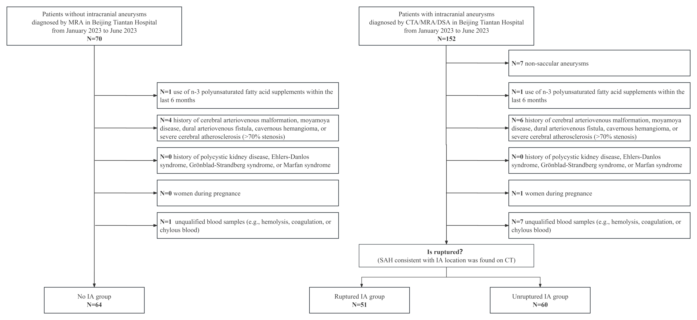
Figure S1. Flowchart illustrating the participant selection process for this study.

Figure S2. Forest plot of association between fatty acids and IA risk. Odds ratios (ORs) and 95% confidence intervals (CIs) were adjusted for age, sex, body mass index, education, smoking status, alcohol consumption, history of diabetes, hypertension, coronary artery disease, and ischemic stroke.
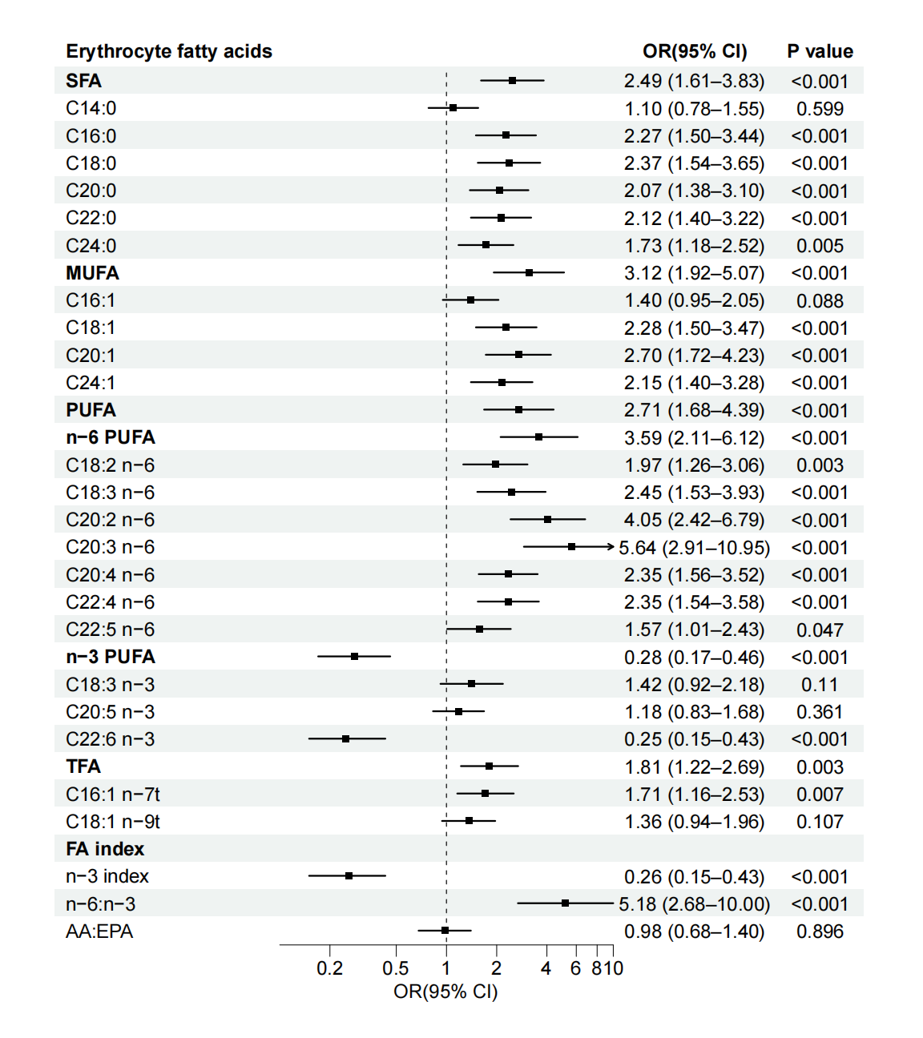
ORs and 95% CIs represent the OR per one standard deviation increase in the respective fatty acid level. Abbreviation: SFA, saturated fatty acid; MUFA, monounsaturated fatty acid; PUFA, polyunsaturated fatty acid; TFA, trans fatty acid; FA, fatty acid; AA, arachidonic acid, C20:4n-6; EPA, eicosapentaenoic acid, C20:5n-3; DHA, docosahexaenoic acid, C22:6n3; ALA, α-linolenic acid, C18:3n-3; OA, oleic acid, C18:1.

Figure S3. Association between fatty acids and IA risk across different age groups. Odds ratios (ORs) and 95% confidence intervals (CIs) were adjusted for age, sex, body mass index, education, smoking status, alcohol consumption, history of diabetes, hypertension, coronary artery disease, and ischemic stroke.
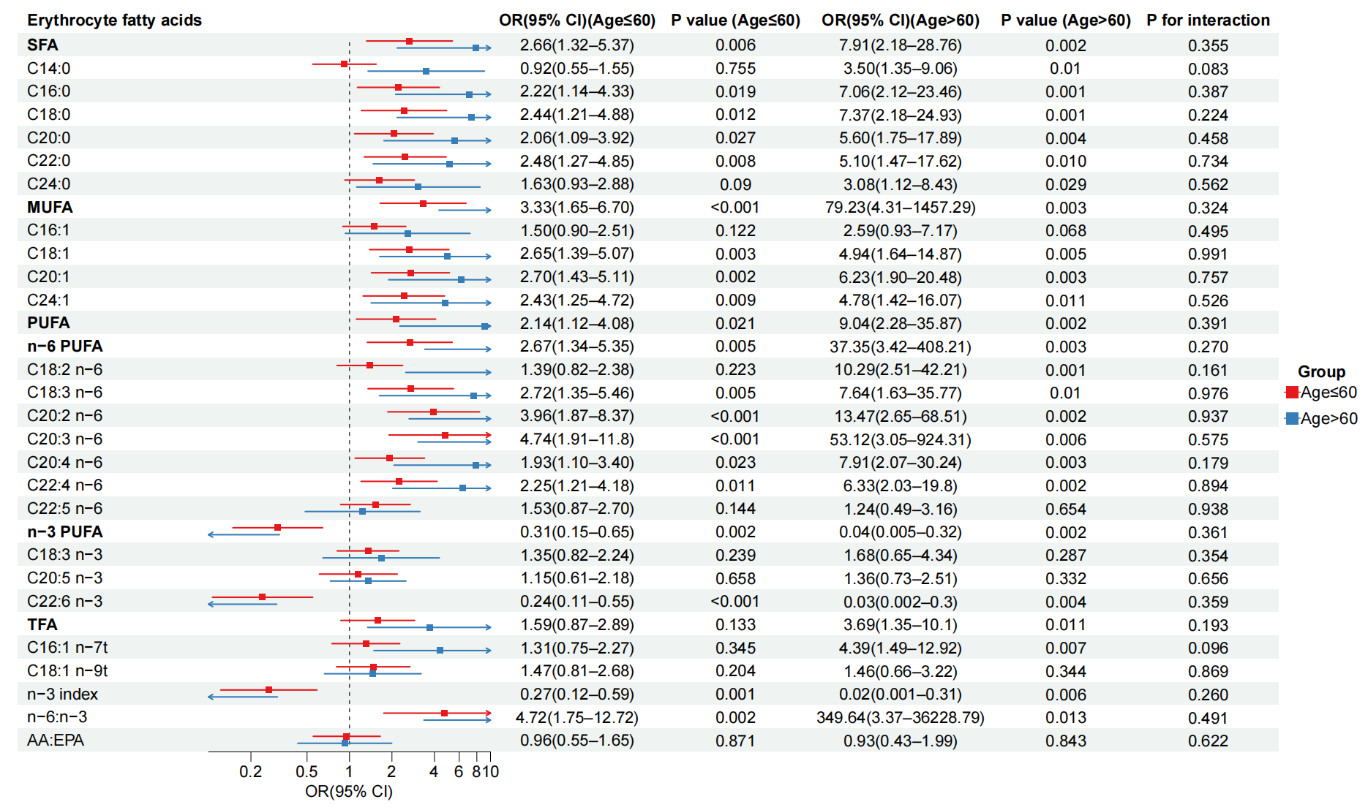

ORs and 95% CIs represent the OR per one standard deviation increase in the respective fatty acid level. Abbreviation: SFA, saturated fatty acid; MUFA, monounsaturated fatty acid; PUFA, polyunsaturated fatty acid; TFA, trans fatty acid; FA, fatty acid; AA, arachidonic acid, C20:4n-6; EPA, eicosapentaenoic acid, C20:5n-3; DHA, docosahexaenoic acid, C22:6n3; ALA, α-linolenic acid, C18:3n-3; OA, oleic acid, C18:1.

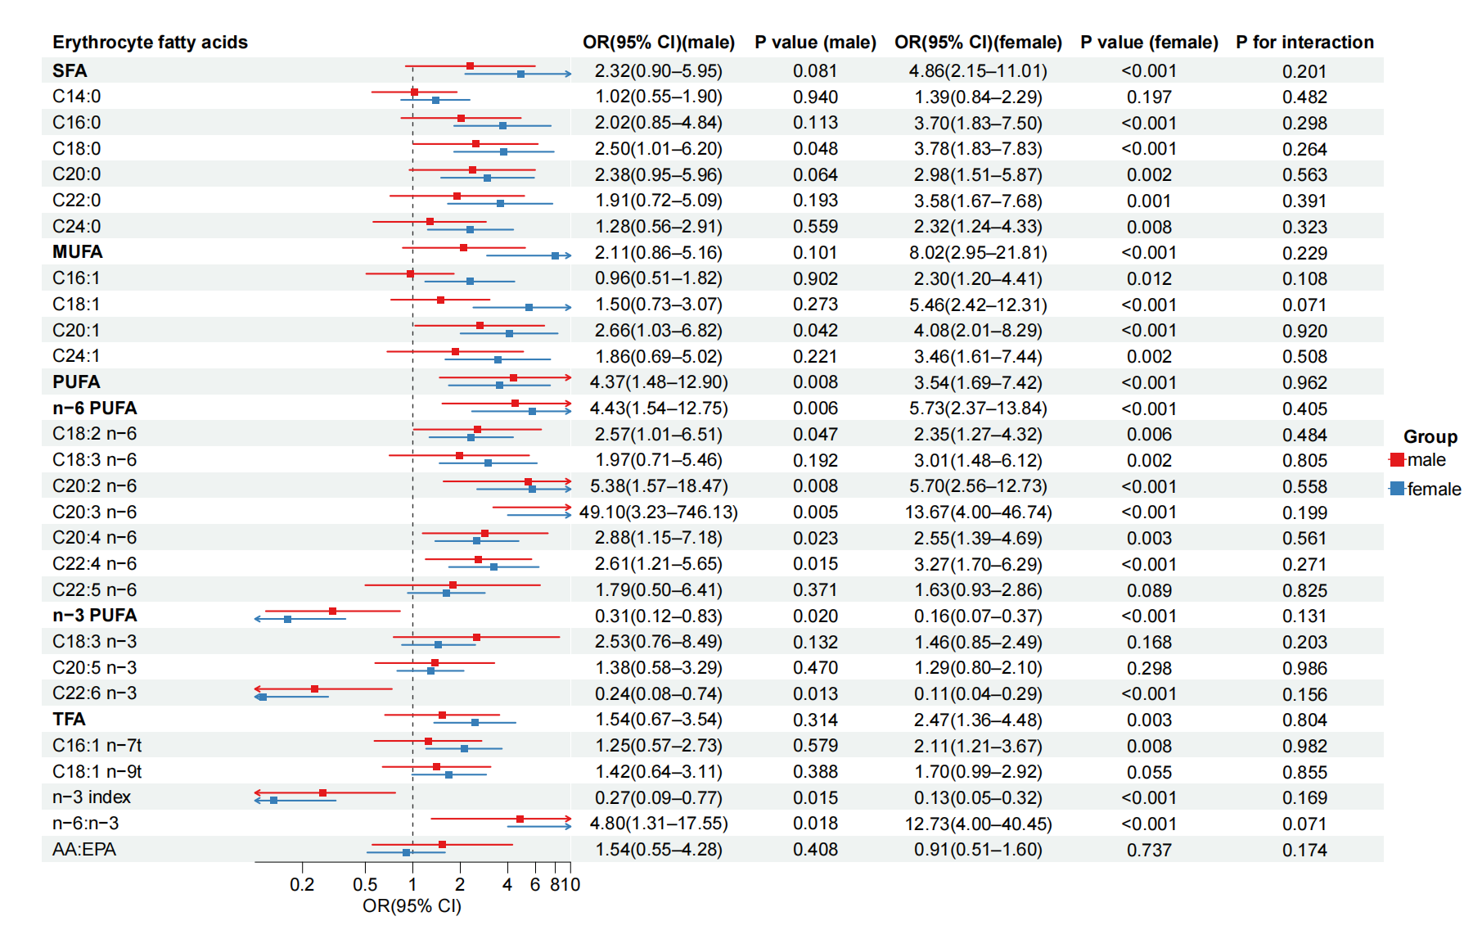
Figure S4. Association between fatty acids and IA risk across different sex. Odds ratios (ORs) and 95% confidence intervals (CIs) were adjusted for age, sex, body mass index, education, smoking status, alcohol consumption, history of diabetes, hypertension, coronary artery disease, and ischemic stroke.

ORs and 95% CIs represent the OR per one standard deviation increase in the respective fatty acid level. Abbreviation: SFA, saturated fatty acid; MUFA, monounsaturated fatty acid; PUFA, polyunsaturated fatty acid; TFA, trans fatty acid; FA, fatty acid; AA, arachidonic acid, C20:4n-6; EPA, eicosapentaenoic acid, C20:5n-3; DHA, docosahexaenoic acid, C22:6n3; ALA, α-linolenic acid, C18:3n-3; OA, oleic acid, C18:1.
Figure S5. Potential non-linear relationship between total MUFA and IA risk assessed by a restricted cubic spline model. The solid red line indicates adjusted ORs for IA risk, and the dashed line indicates 95% CIs. Adjustments were made for age, sex, BMI, education, smoking status, alcohol consumption, diabetes, hypertension, coronary artery disease, and stroke.
Abbreviations: MUFA, monounsaturated fatty acid; OR, odd ratio; CI, confidence interval.

Figure S6. Forest plot of association between fatty acids and IA rupture. Odds ratios (ORs) and 95% confidence intervals (CIs) were adjusted for age, sex, body mass index, education, smoking status, alcohol consumption, history of diabetes, hypertension, coronary artery disease, and ischemic stroke.
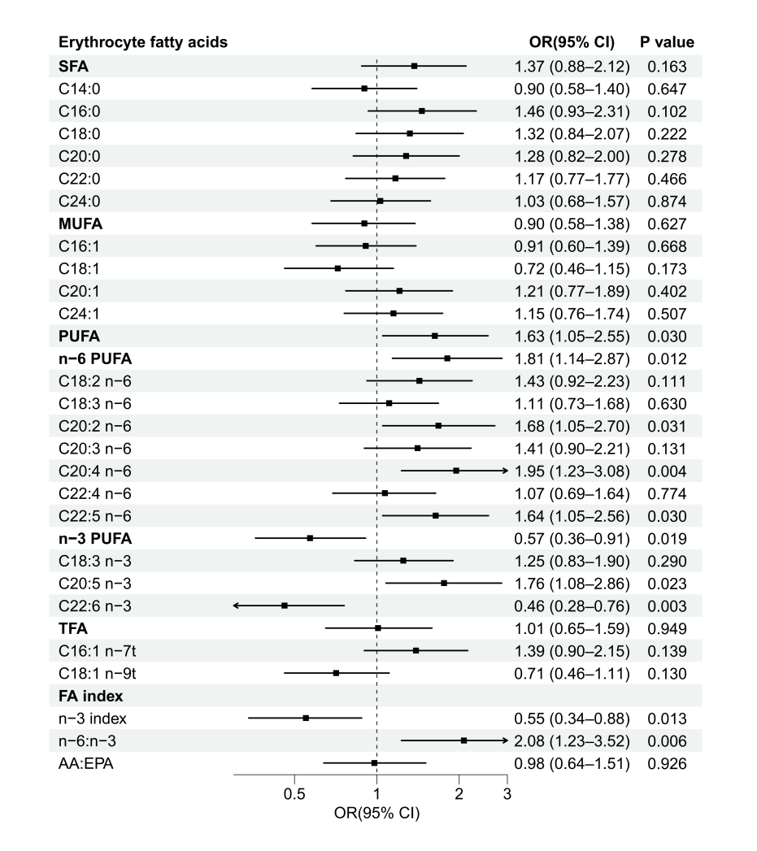
ORs and 95% CIs represent the OR per one standard deviation increase in the respective fatty acid level. Abbreviation: SFA, saturated fatty acid; MUFA, monounsaturated fatty acid; PUFA, polyunsaturated fatty acid; TFA, trans fatty acid; FA, fatty acid; AA, arachidonic acid, C20:4n-6; EPA, eicosapentaenoic acid, C20:5n-3; DHA, docosahexaenoic acid, C22:6n3; ALA, α-linolenic acid, C18:3n-3; OA, oleic acid, C18:1.

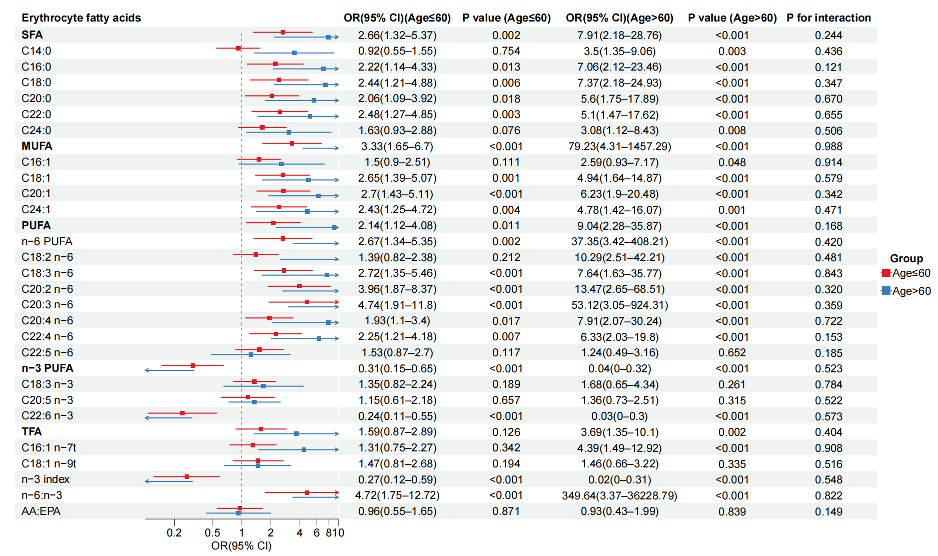
Figure S7. Association between fatty acids and IA rupture across different age group. Odds ratios (ORs) and 95% confidence intervals (CIs) were adjusted for age, sex, body mass index, education, smoking status, alcohol consumption, history of diabetes, hypertension, coronary artery disease, and ischemic stroke.

ORs and 95% CIs represent the OR per one standard deviation increase in the respective fatty acid level. Abbreviation: SFA, saturated fatty acid; MUFA, monounsaturated fatty acid; PUFA, polyunsaturated fatty acid; TFA, trans fatty acid; FA, fatty acid; AA, arachidonic acid, C20:4n-6; EPA, eicosapentaenoic acid, C20:5n-3; DHA, docosahexaenoic acid, C22:6n3; ALA, α-linolenic acid, C18:3n-3; OA, oleic acid, C18:1.
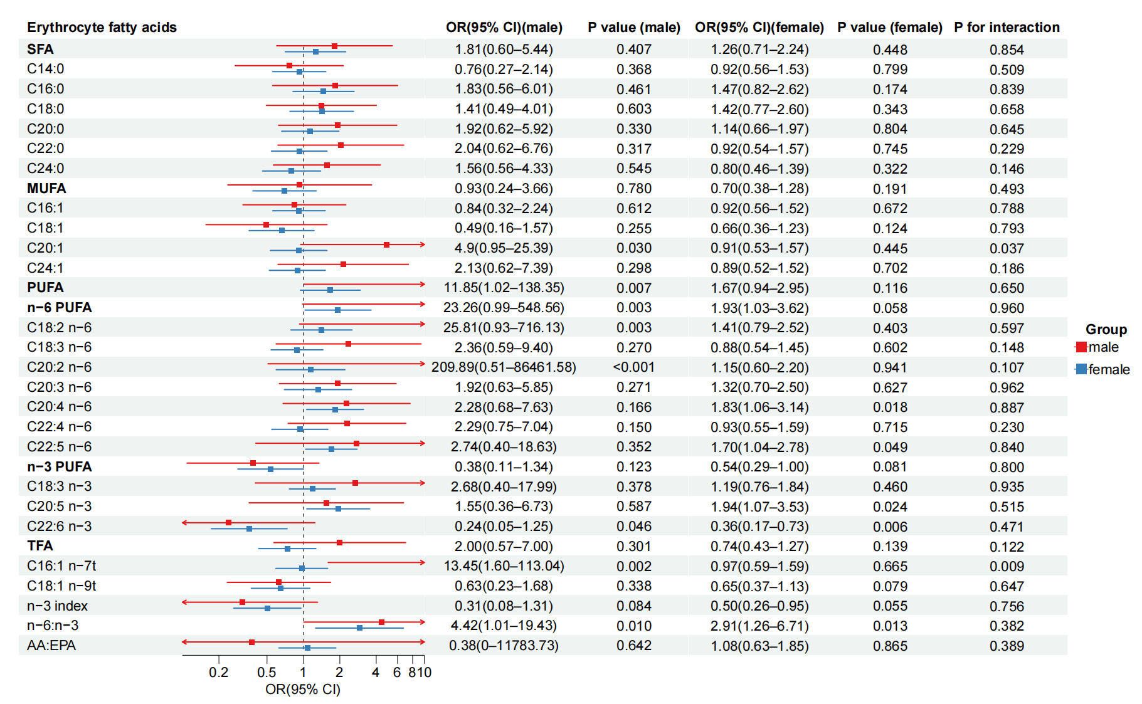
Figure S8. Association between fatty acids and IA rupture across different sex. Odds ratios (ORs) and 95% confidence intervals (CIs) were adjusted for age, sex, body mass index, education, smoking status, alcohol consumption, history of diabetes, hypertension, coronary artery disease, and ischemic stroke.

ORs and 95% CIs represent the OR per one standard deviation increase in the respective fatty acid level. Abbreviation: SFA, saturated fatty acid; MUFA, monounsaturated fatty acid; PUFA, polyunsaturated fatty acid; TFA, trans fatty acid; FA, fatty acid; AA, arachidonic acid, C20:4n-6; EPA, eicosapentaenoic acid, C20:5n-3; DHA, docosahexaenoic acid, C22:6n3; ALA, α-linolenic acid, C18:3n-3; OA, oleic acid, C18:1.

Figure S9. Calibration plots of rupture risk models incorporating fatty acids. A: Calibration performance of the PHASES+FA, ELAPSS+FA, and UCAS+FA models in the training set. B: Calibration performance of the same models in the independent test set. The diagonal grey line represents perfect calibration, whereas the colored line indicates model-predicted probabilities.
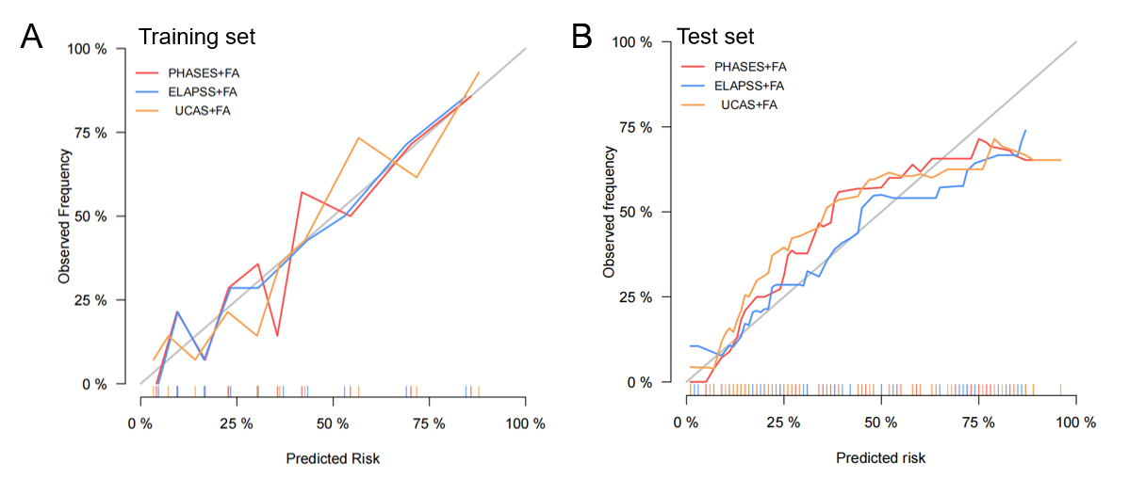

Figure S10. Decision Curve Analysis for predicting intracranial aneurysm risk. The DCA compares the net benefit of different models in predicting the risk of intracranial aneurysm rupture. The x-axis represents the threshold probability, or the probability at which a decision to treat is made, and the y-axis represents the net benefit, which accounts for both true positives and false positives. The curve indicates the model's performance across different threshold values, with higher net benefits suggesting better predictive accuracy. The horizontal line represents the "treat-all" strategy, while the diagonal line represents the "treat-none" strategy.
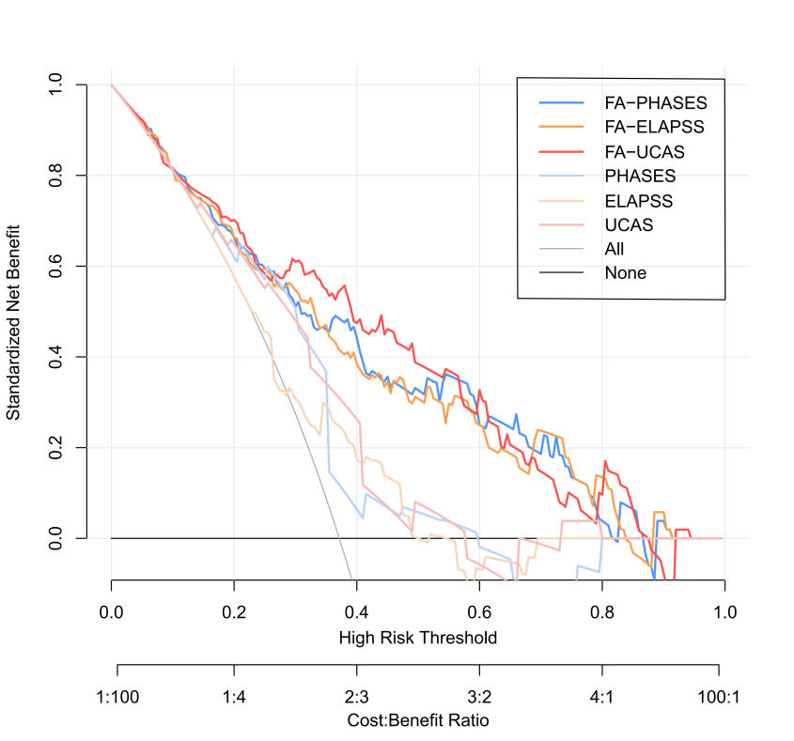
Table S1. Baseline characteristics of the training and test sets.
Variables | Overall (n=164) | Training set (n=111) | Test set (n=53) | P
Age, years, mean(SD) | 59.2 (9.9) | 59.4 (9.4) | 58.6 (11.1) | 0.627
Female, n(%) | 112 (68.3) | 80 (72.1) | 32 (60.4) | 0.185
BMI, kg/m², median(IQR) | 25.4 (22.6–27.5) | 25.4 (22.5–27.3) | 25.4 (23.1–27.7) | 0.623
Education, n(%) |  |  |  | 0.917
Middle school or lower | 51 (31.1) | 35 (31.5) | 16 (30.2)
High school or professional college | 76 (46.3) | 52 (46.8) | 24 (45.3)
University | 37 (22.6) | 24 (21.6) | 13 (24.5)
Diabetes, n(%) | 18 (11.0) | 13 (11.7) | 5 (9.4) | 0.866
Hypertension, n(%) | 93 (56.7) | 69 (62.2) | 24 (45.3) | 0.061
Coronary artery disease, n(%) | 11 (6.7) | 9 (8.1) | 2 (3.8) | 0.481
Prior ischemic stroke, n(%) | 14 (8.5) | 8 (7.2) | 6 (11.3) | 0.560
Prior aSAH, n(%) | 2 (1.2) | 0 (0.0) | 2 (3.8) | 0.194
Smoking, n(%) | 19 (11.6) | 11 (9.9) | 8 (15.1) | 0.478
Alcohol consumption, n(%) | 13 (7.9) | 9 (8.1) | 4 (7.5) | >0.999

Abbreviation: IA, intracranial aneurysm; BMI, body mass index; aSAH, aneurysmal subarachnoid hemorrhage.

Table S2. Association of high vs. low tertile fatty acid levels with intracranial aneurysm presence.
Erythrocyte fatty acids | Unadjusted | Fully adjustedª | P
SFA | 5.83 (2.42–14.03) | 5.63 (2.19–14.44) | < 0.001
C14:0 | 1.16 (0.55–2.45) | 1.07 (0.47–2.47) | 0.870
C16:0 | 3.37 (1.53–7.43) | 3.35 (1.40–8.00) | 0.006
C18:0 | 3.99 (1.73–9.19) | 4.24 (1.73–10.40) | 0.002
C20:0 | 2.50 (1.14–5.46) | 2.29 (0.98–5.37) | 0.056
C22:0 | 3.11 (1.37–7.07) | 3.25 (1.34–7.86) | 0.009
C24:0 | 2.07 (0.93–4.59) | 2.06 (0.86–4.93) | 0.103
MUFA | 6.70 (2.78–16.14) | 10.07 (3.72–27.26) | < 0.001
C16:1 | 1.47 (0.68–3.20) | 1.55 (0.67–3.56) | 0.305
C18:1 | 3.23 (1.45–7.22) | 4.52 (1.83–11.13) | 0.001
C20:1 | 3.46 (1.55–7.73) | 4.84 (1.97–11.89) | < 0.001
C24:1 | 3.11 (1.37–7.07) | 3.05 (1.27–7.33) | 0.013
PUFA | 4.57 (2.04–10.24) | 5.02 (1.97–12.75) | < 0.001
n-6 PUFA | 8.25 (3.32–20.48) | 9.59 (3.37–27.3) | < 0.001
C18:2 n-6 | 1.96 (0.91–4.22) | 2.33 (0.97–5.60) | 0.058
C18:3 n-6 | 3.23 (1.45–7.22) | 3.48 (1.43–8.47) | 0.006
C20:2 n-6 | 8.91 (3.67–21.63) | 10.29 (3.86–27.44) | < 0.001
C20:3 n-6 | 10.32 (4.00–26.61) | 12.78 (4.43–36.84) | < 0.001
C20:4 n-6 | 4.91 (2.13–11.31) | 4.54 (1.84–11.22) | 0.001
C22:4 n-6 | 4.57 (2.04–10.24) | 3.84 (1.56–9.46) | 0.003
C22:5 n-6 | 1.70 (0.79–3.68) | 1.64 (0.71–3.80) | 0.248
n-3 PUFA | 0.11 (0.05–0.28) | 0.11 (0.04–0.28) | < 0.001
C18:3 n-3 | 1.56 (0.73–3.31) | 1.84 (0.79–4.29) | 0.160
C20:5 n-3 | 2.07 (0.97–4.43) | 1.67 (0.72–3.88) | 0.232
C22:6 n-3 | 0.11 (0.04–0.26) | 0.09 (0.03–0.25) | < 0.001
TFA | 3.11 (1.37–7.07) | 3.42 (1.36–8.58) | 0.009
C16:1 n-7t | 2.68 (1.22–5.85) | 3.04 (1.27–7.30) | 0.013
C18:1 n-9t | 1.34 (0.63–2.85) | 1.35 (0.58–3.16) | 0.482
FA index
n-3 index | 0.09 (0.03–0.24) | 0.07 (0.02–0.21) | < 0.001
n-6:n-3 | 11.92 (4.60–30.87) | 13.67 (4.80–38.94) | < 0.001
AA:EPA | 1.07 (0.52–2.23) | 1.20 (0.52–2.78) | 0.670
ªAdjusted for age, sex, BMI, education, smoking status, alcohol consumption, diabetes, hypertension, coronary artery disease, and ischemic stroke.
Abbreviations: SFA, saturated fatty acid; MUFA, monounsaturated fatty acid; PUFA, polyunsaturated fatty acid; TFA, trans fatty acid; FA, fatty acid; AA, arachidonic acid, C20:4n-6; EPA, eicosapentaenoic acid, C20:5n-3; DHA, docosahexaenoic acid, C22:6n3; ALA, α-linolenic acid, C18:3n-3; OA, oleic acid, C18:1.
Table S3. Association between fatty acid levels and the presence of intracranial aneurysms in participants without metabolic or cardiovascular comorbidities (diabetes, coronary artery disease, and ischemic stroke).
Erythrocyte fatty acids | Unadjusted | Fully adjustedª | P
SFA | 2.32 (1.54–3.51) | 2.84 (1.73–4.67) | <0.001
C14:0 | 1.07 (0.76–1.49) | 1.17 (0.80–1.72) | 0.412
C16:0 | 2.06 (1.40–3.03) | 2.53 (1.59–4.02) | <0.001
C18:0 | 2.33 (1.54–3.52) | 2.74 (1.68–4.47) | <0.001
C20:0 | 1.90 (1.28–2.81) | 2.29 (1.46–3.59) | <0.001
C22:0 | 2.05 (1.36–3.09) | 2.38 (1.47–3.85) | <0.001
C24:0 | 1.86 (1.25–2.75) | 2.02 (1.30–3.15) | 0.002
MUFA | 2.61 (1.67–4.07) | 3.63 (2.07–6.34) | <0.001
C16:1 | 1.36 (0.93–1.97) | 1.44 (0.95–2.17) | 0.083
C18:1 | 1.92 (1.31–2.83) | 2.43 (1.55–3.83) | <0.001
C20:1 | 2.36 (1.54–3.63) | 3.03 (1.84–5.00) | <0.001
C24:1 | 2.06 (1.36–3.12) | 2.47 (1.50–4.07) | <0.001
PUFA | 2.41 (1.56–3.74) | 2.42 (1.50–3.91) | <0.001
n-6 PUFA | 3.28 (2.00–5.37) | 3.45 (1.98–5.99) | <0.001
C18:2 n-6 | 1.48 (1.02–2.13) | 1.79 (1.17–2.76) | 0.008
C18:3 n-6 | 2.23 (1.41–3.52) | 2.63 (1.54–4.48) | <0.001
C20:2 n-6 | 3.45 (2.08–5.72) | 4.43 (2.52–7.81) | <0.001
C20:3 n-6 | 3.92 (2.24–6.85) | 5.57 (2.77–11.22) | <0.001
C20:4 n-6 | 2.61 (1.73–3.94) | 2.25 (1.47–3.43) | <0.001
C22:4 n-6 | 2.19 (1.46–3.27) | 2.38 (1.52–3.72) | <0.001
C22:5 n-6 | 1.61 (1.06–2.46) | 1.53 (0.97–2.41) | 0.067
n-3 PUFA | 0.30 (0.19–0.48) | 0.24 (0.13–0.43) | <0.001
C18:3 n-3 | 1.25 (0.84–1.86) | 1.28 (0.84–1.94) | 0.249
C20:5 n-3 | 1.23 (0.87–1.73) | 1.28 (0.87–1.88) | 0.214
C22:6 n-3 | 0.28 (0.17–0.45) | 0.22 (0.12–0.39) | <0.001
TFA | 1.53 (1.07–2.19) | 1.97 (1.29–3.03) | 0.002
C16:1 n-7t | 1.48 (1.03–2.13) | 1.74 (1.15–2.64) | 0.009
C18:1 n-9t | 1.26 (0.90–1.78) | 1.52 (1.02–2.26) | 0.039
FA index
n-3 index | 0.29 (0.18–0.47) | 0.22 (0.12–0.40) | <0.001
n-6:n-3 | 4.61 (2.45–8.69) | 5.66 (2.74–11.73) | <0.001
AA:EPA | 0.84 (0.58–1.22) | 1.01 (0.67–1.52) | 0.976
ªAdjusted for age, sex, BMI, education, smoking status, alcohol consumption, and hypertension.
Abbreviations: SFA, saturated fatty acid; MUFA, monounsaturated fatty acid; PUFA, polyunsaturated fatty acid; TFA, trans fatty acid; FA, fatty acid; AA, arachidonic acid, C20:4n-6; EPA, eicosapentaenoic acid, C20:5n-3; DHA, docosahexaenoic acid, C22:6n3; ALA, α-linolenic acid, C18:3n-3; OA, oleic acid, C18:1.

Table S4. Association of high vs. low tertile fatty acid levels with intracranial aneurysm rupture.
Erythrocyte fatty acids | Unadjusted | Fully adjustedª | P
SFA | 1.68 (0.66–4.28) | 2.17 (0.79–5.95) | 0.134
C14:0 | 0.76 (0.30–1.92) | 0.70 (0.26–1.90) | 0.484
C16:0 | 1.66 (0.65–4.20) | 2.21 (0.81–6.04) | 0.122
C18:0 | 1.49 (0.59–3.77) | 1.64 (0.62–4.32) | 0.321
C20:0 | 1.33 (0.53–3.34) | 1.68 (0.62–4.55) | 0.310
C22:0 | 1.33 (0.53–3.34) | 1.47 (0.56–3.88) | 0.436
C24:0 | 1.07 (0.42–2.70) | 1.12 (0.43–2.93) | 0.822
MUFA | 0.95 (0.38–2.38) | 1.02 (0.38–2.75) | 0.969
C16:1 | 0.61 (0.24–1.54) | 0.58 (0.22–1.53) | 0.268
C18:1 | 0.33 (0.11–0.98) | 0.43 (0.17–1.11) | 0.077
C20:1 | 1.66 (0.65–4.20) | 1.84 (0.66–5.10) | 0.241
C24:1 | 1.19 (0.47–3.00) | 1.40 (0.52–3.74) | 0.507
PUFA | 2.30 (0.90–5.88) | 2.42 (0.91–6.43) | 0.077
n-6 PUFA | 2.59 (1.01–6.68) | 2.76 (1.03–7.39) | 0.044
C18:2 n-6 | 2.32 (0.91–5.95) | 2.55 (0.93–6.99) | 0.069
C18:3 n-6 | 1.06 (0.42–2.67) | 1.14 (0.43–2.99) | 0.792
C20:2 n-6 | 2.05 (0.81–5.23) | 2.53 (0.92–6.91) | 0.071
C20:3 n-6 | 2.06 (0.81–5.25) | 2.25 (0.82–6.19) | 0.116
C20:4 n-6 | 4.20 (1.58–11.17) | 4.54 (1.60–12.86) | 0.004
C22:4 n-6 | 1.19 (0.47–3.00) | 1.36 (0.50–3.64) | 0.546
C22:5 n-6 | 2.59 (1.01–6.68) | 2.68 (0.98–7.29) | 0.054
n-3 PUFA | 0.38 (0.15–0.99) | 0.30 (0.11–0.83) | 0.020
C18:3 n-3 | 0.49 (0.19–1.24) | 0.44 (0.16–1.21) | 0.111
C20:5 n-3 | 2.91 (1.12–7.52) | 3.13 (1.16–8.42) | 0.024
C22:6 n-3 | 0.30 (0.11–0.80) | 0.24 (0.09–0.68) | 0.007
TFA | 1.06 (0.42–2.64) | 1.16 (0.41–3.28) | 0.779
C16:1 n-7t | 1.33 (0.53–3.34) | 1.46 (0.54–3.94) | 0.459
C18:1 n-9t | 0.61 (0.24–1.55) | 0.65 (0.24–1.78) | 0.405
FA index
n-3 index | 0.43 (0.17–1.11) | 0.33 (0.12–0.90) | 0.031
n-6:n-3 | 4.80 (1.78–12.97) | 6.38 (2.19–18.63) | < 0.001
AA:EPA | 0.76 (0.30–1.92) | 0.72 (0.28–1.85) | 0.488
ªAdjusted for age, sex, BMI, education, smoking status, alcohol consumption, diabetes, hypertension, coronary artery disease, and ischemic stroke.
Abbreviations: SFA, saturated fatty acid; MUFA, monounsaturated fatty acid; PUFA, polyunsaturated fatty acid; TFA, trans fatty acid; FA, fatty acid; AA, arachidonic acid, C20:4n-6; EPA, eicosapentaenoic acid, C20:5n-3; DHA, docosahexaenoic acid, C22:6n3; ALA, α-linolenic acid, C18:3n-3; OA, oleic acid, C18:1.

Table S5. Association between fatty acid levels and the rupture of intracranial aneurysms in participants without metabolic or cardiovascular comorbidities (diabetes, coronary artery disease, and ischemic stroke).
Erythrocyte fatty acids | Unadjusted | Fully adjustedª | P
SFA | 1.04 (0.67–1.60) | 1.36 (0.85–2.20) | 0.203
C14:0 | 0.67 (0.42–1.06) | 0.82 (0.5–1.33) | 0.419
C16:0 | 1.03 (0.67–1.59) | 1.56 (0.94–2.59) | 0.087
C18:0 | 1.01(0.65–1.56) | 1.42 (0.87–2.33) | 0.161
C20:0 | 1.07 (0.69–1.65) | 1.21 (0.75–1.93) | 0.432
C22:0 | 1.00 (0.65–1.54) | 1.07 (0.68–1.67) | 0.781
C24:0 | 0.97 (0.63–1.50) | 0.90 (0.57–1.43) | 0.660
MUFA | 0.72 (0.46–1.13) | 0.88 (0.54–1.43) | 0.602
C16:1 | 0.69 (0.42–1.12) | 0.87 (0.55–1.40) | 0.579
C18:1 | 0.60 (0.37–0.96) | 0.76 (0.45–1.29) | 0.316
C20:1 | 1.15 (0.74–1.78) | 1.10 (0.69–1.76) | 0.693
C24:1 | 0.99 (0.64–1.53) | 1.04 (0.66–1.63) | 0.864
PUFA | 1.35 (0.86–2.13) | 1.93 (1.17–3.17) | 0.010
n-6 PUFA | 1.39 (0.88–2.20) | 2.12 (1.27–3.54) | 0.004
C18:2 n-6 | 1.15 (0.74–1.78) | 1.55 (0.96–2.49) | 0.071
C18:3 n-6 | 0.96 (0.62–1.48) | 0.98 (0.62–1.56) | 0.946
C20:2 n-6 | 1.27 (0.82–1.98) | 1.51 (0.92–2.45) | 0.100
C20:3 n-6 | 1.11 (0.72–1.72) | 1.45 (0.87–2.40) | 0.153
C20:4 n-6 | 1.85 (1.14–2.99) | 2.36 (1.39–4.02) | 0.002
C22:4 n-6 | 0.96 (0.62–1.49) | 1.16 (0.73–1.86) | 0.531
C22:5 n-6 | 1.17 (0.75–1.82) | 1.56 (0.96–2.54) | 0.074
n-3 PUFA | 0.85 (0.55–1.32) | 0.53 (0.32–0.90) | 0.018
C18:3 n-3 | 0.94 (0.60–1.46) | 1.23 (0.78–1.94) | 0.377
C20:5 n-3 | 2.31 (1.30–4.12) | 1.91 (1.10–3.32) | 0.022
C22:6 n-3 | 0.69 (0.44–1.09) | 0.40 (0.22–0.70) | 0.001
TFA | 0.88 (0.57–1.36) | 0.93 (0.57–1.50) | 0.755
C16:1 n-7t | 1.26 (0.81–1.95) | 1.22 (0.76–1.97) | 0.412
C18:1 n-9t | 0.60 (0.37–0.96) | 0.71 (0.44–1.15) | 0.163
FA index
n-3 index | 0.87 (0.56–1.35) | 0.51 (0.30–0.87) | 0.013
n-6:n-3 | 1.48 (0.91–2.41) | 2.43 (1.33–4.45) | 0.004
AA:EPA | 0.99 (0.64–1.53) | 0.92 (0.57–1.49) | 0.728
ªAdjusted for age, sex, BMI, education, smoking status, alcohol consumption, and hypertension.
Abbreviations: SFA, saturated fatty acid; MUFA, monounsaturated fatty acid; PUFA, polyunsaturated fatty acid; TFA, trans fatty acid; FA, fatty acid; AA, arachidonic acid, C20:4n-6; EPA, eicosapentaenoic acid, C20:5n-3; DHA, docosahexaenoic acid, C22:6n3; ALA, α-linolenic acid, C18:3n-3; OA, oleic acid, C18:1.

Table S6. Comparative analysis of discrimination improvement for aneurysm rupture between traditional risk models and FA-integrated models in the training and test sets.
Dataset | Comparisons | ΔAUC | 95% CI |  | P | NRI
Dataset | Comparisons | ΔAUC | Lower | Upper | P | NRI
Training Set | PHASES+FA vs. PHASES | 0.145 | 0.058 | 0.231 | <0.001 | 0.316
Training Set | ELAPSS+FA vs. ELAPSS | 0.163 | 0.055 | 0.272 | 0.003 | 0.331
Training Set | UCAS+FA vs. UCAS | 0.134 | 0.054 | 0.214 | 0.001 | 0.308
Test Set | PHASES+FA vs. PHASES | 0.202 | 0.078 | 0.327 | 0.001 | 0.262
Test Set | ELAPSS+FA vs. ELAPSS | 0.209 | 0.061 | 0.357 | 0.006 | 0.292
Test Set | UCAS+FA vs. UCAS | 0.218 | 0.084 | 0.352 | 0.001 | 0.308
Abbreviation: NRI, net reclassification improvement; AUC, area under the curve; CI, confidence interval; FA, fatty acids.

Table S7. Calibration of models in training and test sets.
Dataset | Models | Hosmer–Lemeshow test P
Training Set | PHASES+FA | 0.382
Training Set | ELAPSS+FA | 0.843
Training Set | UCAS+FA | 0.574
Test Set | PHASES+FA | 0.445
Test Set | ELAPSS+FA | 0.937
Test Set | UCAS+FA | 0.098

