Supplementary Figure S1. A multi-step flowchart for variable screening and clinical prediction model development.

Figure S1. A multi-step flowchart for variable screening and clinical prediction model development.
The flowchart illustrates the integrated analytical strategy employed to identify core predictors for early arterial stiffness (baPWV ≥ 1400 cm/s), culminating in the construction of a clinical prediction model. The process began with an initial pool of candidate variables (n=55), categorized into traditional clinical/laboratory variables (n=31) and blood biomarker-derived indices (n=24).
Step 1: Confounder Selection: The 31 traditional variables underwent feature selection using Least Absolute Shrinkage and Selection Operator (LASSO) regression with 10-fold cross-validation (optimal λ selected by the “1-standard-error” rule). This yielded a core set of 10 non-zero coefficient variables (e.g., Age, SBP, DBP) retained as key adjustment covariates.
Step 2: Independent Association Analysis: Each of the 24 derived indices was individually entered into a multivariate logistic regression model, adjusted for the 10 core confounders from Step 1, to identify indices with independent associations. Concurrently, the receiver operating characteristic (ROC) curve analysis evaluated the standalone discriminative ability of each significant index.
Step 3: Machine Learning Validation & Interpretation: All variables selected in Steps 1 and 2 were incorporated into a Random Forest model. Hyperparameters were optimized via grid search with 5-fold cross-validation. SHapley Additive exPlanations (SHAP) analysis was then applied to this optimized model to generate a global ranking of feature importance based on their contribution to predictions.
Step 4: Synthesis and Final Predictor Selection: Findings from the multivariate logistic regression (statistical significance), SHAP analysis (predictive contribution), and ROC analysis (discriminatory capacity) were synthesized. The final set of 7 core predictors was determined by integrating these computational results with considerations of clinical relevance and parsimony.
Step 5: Model Building and Validation: The final 7 predictors were used to construct a multivariable logistic regression model, presented as a nomogram for clinical use. The model’s performance was validated, demonstrating an area under the curve (AUC) of 0.877.

Supplementary Table S1. Sensitivity Analysis: Association between Blood Biomarker-Derived Indicators and Arterial Stiffness
Variable | OR (95% CI) | P value
RC | 1.182(0.943~ 1.481) | 0.148
CRI-I | 1.146(1.036~1.268) | 0.008
CRI-II | 1.190 (1.046~1.353) | 0.008
AI | 1.145(1.035~1.268) | 0.009
AIP | 1.524(1.057~ 2.196） | 0.024
LCI | 1.004 (0.998~1.009) | 0.177
TyG | 1.206(0.982 1.480） | 0.073
TyG-BMI | 1.007(0.998 ~1.015） | 0.125
TyG-WC | 1.002 (1.001 ~1.003) | 0.004
TyG-WHtR | 1.464 (1.233~ 1.739) | <0.001
LAP index | 1.000(0 .997 ~1.004) | 0.793
eGDR index | 1.025 (0.926~ 1.135) | 0.632
VAI | 1.021(0.971~ 1.074) | 0.418
SII | 1.000(1.000~1.001） | 0.122
SIRI | 1.326(1.039~1.692） | 0.024
NLR | 1.075(0.935~1.235） | 0.308
PLR | 0.999(0.997~1.002） | 0.618
PNR | 0.096(0.093~1.000） | 0.047
NHR | 1.194(1.090~1.308) | <0.001
MHR | 4.7701(2.135~10.325) | <0.001
PHR | 1.002(1.001~1,004) | 0.004
LHR | 1.284(1.083~1.522) | 0.004
NMR | 0.999(0.962~1.039) | 0.973
UHR | 1.003(1.001~1.004） | <0.001
Abbreviations: RC, remnant cholesterol; CRI-I, Castelli's risk index-I; CRI-II, Castelli's risk index-II; AI, atherogenic index; AIP, atherogenic index of plasma; LCI, lipoprotein combination index; TyG, triglyceride-glucose index; WC, waist circumference; WHtR, waist-to-height ratio; LAP, lipid accumulation product; eGDR, estimated glucose disposal rate; VAI, visceral adiposity index; SII, systemic immune-inflammation index; SIRI, systemic inflammatory response index; NLR, neutrophil-to-lymphocyte ratio; PLR, platelet-to-lymphocyte ratio; PNR, platelet-to-neutrophil ratio; NHR, neutrophil-to-high-density-lipoprotein cholesterol ratio; MHR, monocyte-to-high-density-lipoprotein cholesterol ratio; PHR, platelet-to-high-density-lipoprotein cholesterol ratio; LHR, lymphocyte-to-high-density-lipoprotein cholesterol ratio; NMR, neutrophil-to-monocyte ratio; UHR, uric acid-to-high-density-lipoprotein cholesterol ratio; BMI, body mass index; eGFR, estimated glomerular filtration rate.
Note: This table presents results from the sensitivity analysis. Each blood biomarker-derived indicator was entered separately into a multivariable logistic regression model with arterial stiffness (baPWV ≥1400 cm/s) as the outcome. All models were adjusted for the following prespecified clinical covariates based on prior knowledge: age, sex, systolic blood pressure, diastolic blood pressure, BMI, waist circumference, education level, monthly income, drinking status, smoking status, tea consumption, exercise status, fasting blood glucose, eGFR, and heart rate. Odds ratios (ORs) with 95% confidence intervals (CIs) and P-values are reported for each indicator. Indicators with P-values < 0.05 are considered statistically significant in this analysis. This analysis was performed to assess the robustness of the primary findings (adjusted for LASSO-selected covariates) to a different covariate adjustment strategy.

Supplementary Table S2 Multicollinearity diagnostics of all variables included in the regression analyses.
Variable / Biomarker-derived indicator | Tolerance | Variance Inflation Factor (VIF) | Inclusion in final model
Covariates
(Adjusted in all models)
Age (years) | 0.798 | 1.253 | Yes
Sex | 0.75 | 1.334
Body mass index (BMI, kg/m²) | 0.491 | 2.036
Systolic blood pressure (mmHg) | 0.253 | 3.958 | Yes
Diastolic blood pressure (mmHg) | 0.246 | 4.072 | Yes
Hip circumference (cm) | 0.593 | 1.688
Fasting blood glucose (mmol/L) | 0.368 | 2.719 | Yes
Heart rate (beats/min) | 0.84 | 1.191 | Yes
Glycated hemoglobin (HbA1c, %) | 0.38 | 2.629 | Yes
Neutrophil count (NEUT, ×10⁹/L) | 0.882 | 1.134
Blood Biomarker-derived Indicators
RC | 0.926 | 1.08
CRI-I | 0.837 | 1.195
CRI-Ⅱ | 0.857 | 1.167
AI | 0.838 | 1.194
LCI | 0.93 | 1.075
AIP | 0.781 | 1.281
TyG | 0.678 | 1.475
TyG-BMI | 0.105 | 9.538
TyG-WC | 0.312 | 3.203
TyG-WHtR | 0.539 | 1.855 | Yes
LAP index | 0.758 | 1.319
eGDR index | 0.24 | 4.160
VAI | 0.897 | 1.115
SII | 0.519 | 1.926
SIRI | 0.367 | 2.724
NLR | 0.521 | 1.92
PLR | 0.946 | 1.057
PNR | 0.531 | 1.883
NHR | 0.299 | 3.342
MHR | 0.621 | 1.610
PHR | 0.773 | 1.294
LHR | 0.995 | 1.005
NMR | 0.660 | 1.516
UHR | 0.702 | 1.425
Abbreviations:
RC Remnant cholesterol , CRI-I Castelli’s risk index-I, CRI-II Castelli’s risk index-II, AI Atherogenic index, LCI Lipoprotein combination index, AIP Atherogenic index of plasma, TyG triglyceride-glucose index,WC waist circumference; WHtR waist-to-height ratio; LAP lipid accumulation product; eGDR estimated glucose disposal rate; VAI visceral adiposity index；SII index Systemic Immune-Inflammation Index；SIRI index: Systemic Inflammatory Response Index; NLR Neutrophil-to-Lymphocyte Ratio; PLR Platelet-to-Lymphocyte Ratio; PNR Platelet-to-Neutrophil Ratio; NHR: Neutrophil-to-high density lipoprotein ratio; MHR Monocyte-to-high density lipoprotein ratio; PHR Platelet-to-high density lipoprotein ratio; LHR: Lymphocyte-to-high density lipoprotein ratio; NMR Neutrophil-to-Monocyte Ratio ; UHR uric acid-to-HDL-cholesterol ratio
Note: Tolerance (1/VIF) and Variance Inflation Factor (VIF) for covariates are from a single combined model. VIF/Tolerance for each biomarker are from separate models containing that biomarker plus all covariates.

Supplementary Table S3. Diagnostic analysis of multicollinearity for all variables in the final model
Variable | Tolerance | Variance Inflation Factor (VIF)
Age (years) | 0.841 | 1.189
Systolic blood pressure (mmHg) | 0.265 | 3.776
Diastolic blood pressure (mmHg) | 0.261 | 3.829
Fasting blood glucose (mmol/L) | 0.369 | 2.712
Heart rate (beats/min) | 0.877 | 1.141
Glycated hemoglobin (HbA1c, %) | 0.384 | 2.601
TyG-WHtR | 0.689 | 1.452
Abbreviations:
TyG triglyceride-glucose index, WHtR waist-to-height ratio.

Supplementary Figure S2. Restricted cubic spline curves for the nine significant blood-derived indices in relation to early arterial stiffness.

Figure S2. Adjusted odds ratios (ORs) with 95% confidence intervals (CIs) for early arterial stiffness risk are plotted against each indicator . The red solid line represents the adjusted OR curve, and the pink shaded area represents the 95% CI. N=2948 for all analyses. P values for non-linearity were all >0.05, indicating approximately linear relationships between each indicator and early arterial stiffness risk. Abbreviations: UHR, uric acid-to-high-density lipoprotein cholesterol ratio; TyG-WhtR, triglyceride-glucose-waist-to-height ratio; TyG-WC, triglyceride-glucose-waist circumference; CR-II, Castelli’s Risk Index-II; CR-I, Castelli’s Risk Index-I; PHR, platelet-to-high-density lipoprotein cholesterol ratio; NHR, neutrophil-to-high-density lipoprotein cholesterol ratio; MHR, monocyte-to-high-density lipoprotein cholesterol ratio.

Supplementary Figure S3. Random Forest hyperparameter tuning results.
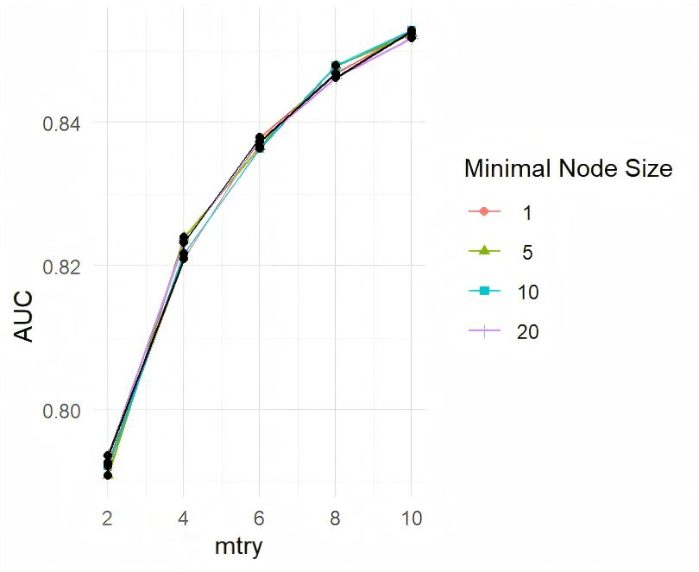
The cross-validation AUC is plotted against mtry (number of features considered per split) for different minimal node sizes. The optimal hyperparameters (mtry=10, min.node.size=10) achieved the highest cross-validation AUC of 0.8529.

