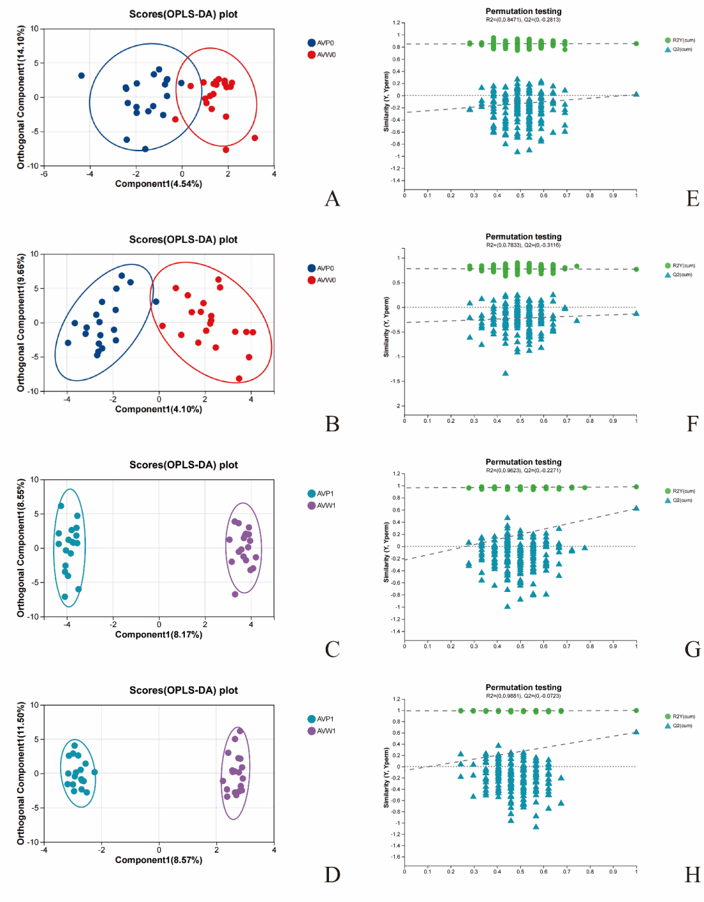
Supplement 2. OPLS-DA of untargeted metabolomics data between the AVP and AVW groups after intervention. (A) Score plot of cationic metabolites comparing the AVP and AVW groups before intervention. (B) Score plot of anionic metabolites comparing the AVP and AVW groups before intervention. (C) Score plot of cationic metabolites comparing the AVP and AVW groups after intervention. (D) Score plot of anionic metabolites comparing the AVP and AVW groups after intervention. (E) Permutation test plot for the cationic OPLS-DA model of AVP and AVW groups before intervention. (F) Permutation test plot for the anionic OPLS-DA model of AVP and AVW groups before intervention. R2Y (cum) and Q2 (cum) are model validation parameters, representing model interpretability and predictability, respectively.(G) Permutation test plot for the cationic OPLS-DA model of AVP and AVW groups after intervention. (H) Permutation test plot for the anionic OPLS-DA model of AVP and AVW groups after intervention. R2Y and Q2 declined with the decrease of replacement retention, and the regression line showed an upward trend, indicating that there was no overfitting phenomenon in the model. 1, post-treatment group.

