Supplementary Figure 1. Directed Acyclic Graphs.

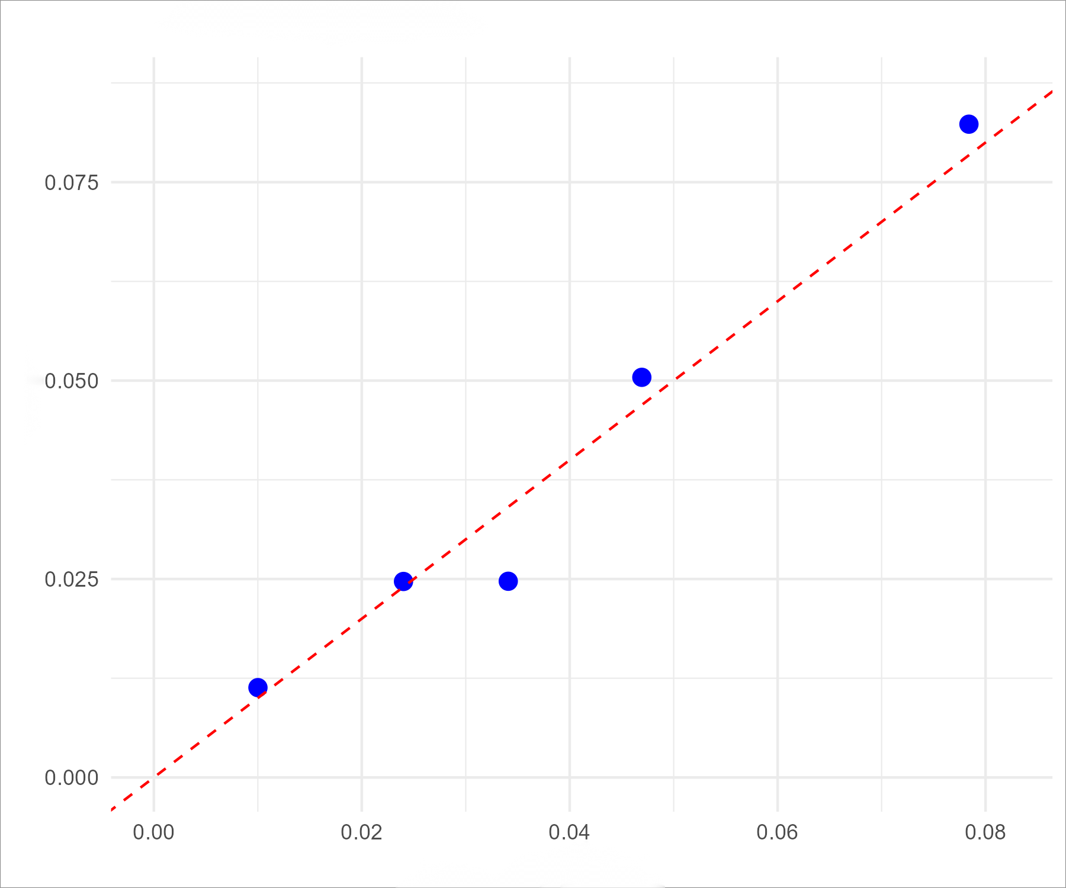
Supplementary Figure 2. Calibration curve at the first TCBI cutoff (953.6)
Note: The vertical axis represents the observed incidence of in‑hospital complications, and the horizontal axis represents the predicted incidence of in‑hospital complications.

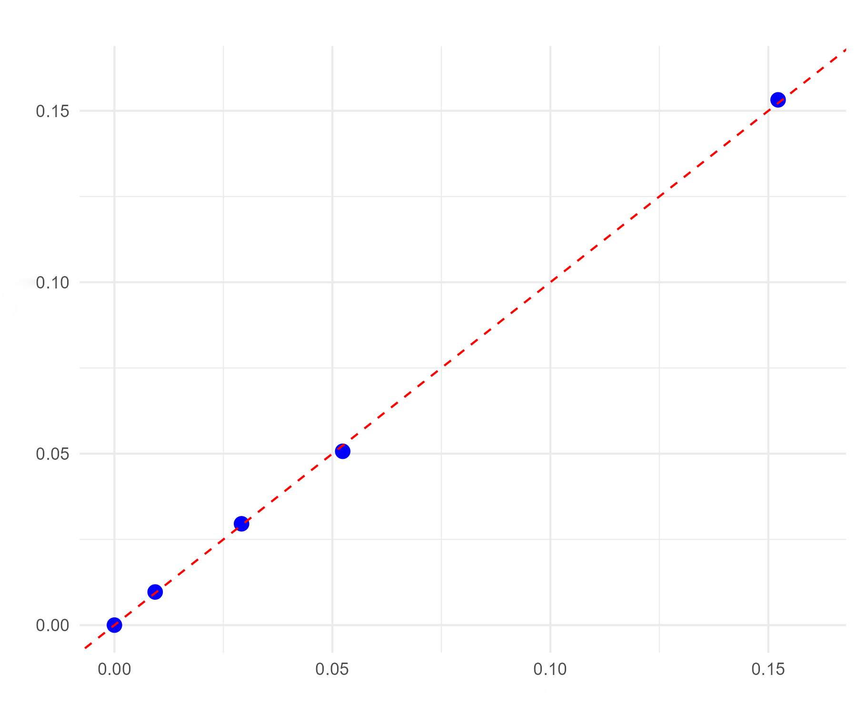
Supplementary Figure 3. Calibration curve at the second TCBI cutoff (1525.0)
Note: The vertical axis represents the observed incidence of in‑hospital complications, and the horizontal axis represents the predicted incidence of in‑hospital complications.

Supplementary Table 1. Area under the curve (AUC) and internal validation results at the first TCBI cutoff (953.6)
Original AUC (95% CI) | Bootstrap Mean | Bootstrap 95% CI | Optimism | Corrected AUC
0.670 (0.650-0.700) | 0.68 | 0.650-0.700 | 0.006 | 0.670

Supplementary Table 2. Area under the curve (AUC) and internal validation results at the second TCBI cutoff (1525.0)
Original AUC (95% CI) | Bootstrap Mean | Bootstrap 95% CI | Optimism | Corrected AUC
0.691 (0.654-0.729) | 0.7 | 0.661-0.735 | 0.009 | 0.683

Supplementary Table 3. Stratified analysis by hospital level (adjusted for variables in Model 3)
Model | Beta | SE | OR(95% CI) | P value
Base Logistic Regression | -0.5248 | 0.1728 | 0.592(0.422-0.830) | ＜0.001
Mixed-effects (random intercept) | -0.5248 | 0.1728 | 0.592(0.422-0.830) | ＜0.001
GEE (exchangeable + robust SE) | -0.5251 | 0.1466 | 0.592(0.444-0.788) | ＜0.001

Supplementary Table 4. Stratified analysis by categories of length of stay (LOS) (adjusted for variables in Model 3)
LOS Categories | OR(95% CI) | P value
7-14 days (n=5,380) | 0.710(0.569-0.887) | 0.002
15-30 days (n=2,908) | 0.639(0.541-0.755) | ＜0.001

Supplementary Table 5. Sensitivity analysis according to ICU admission status (adjusted for variables in Model 3)
ICU admission status | OR(95% CI) | P value
Excluding ICU patients | 0.636(0.550-0.735) | <0.001
ICU patients only | 0.444(0.313-0.631) | <0.001

