Table S1 Weighted logistic regression analysis of association between GLM7 and sarcopenia further adjusted for medication use
Exposure | Weighted OR (95% CI) | P
GLM7 | 2.668 (1.632, 3.864) | <0.001
Categories
Q1 ( ≤ 6.977) | 1 (Ref)
Q2 (6.977–7.443) | 1.192 (0.631, 6.796) | 0.431
Q3 (7.443–7.868) | 6.059 (2.743, 20.065) | 0.026
Q4 (≥ 7.868) | 7.057 (1.360, 14.098) | 0.039
P for trend | <0.001
GLM7, glycolipid metabolism 7 factors; OR, odds ratio; CI, confidence interval
Adjusted for age, sex, marital status, education level, BMI, WC, smoking status, drinking status, physical activity, HbA1c, hypertension, diabetes, and medication use (diabetes and hypertension)

Table S2 Weighted logistic regression analysis of association between GLM7 and sarcopenia after exclusion of missing data of covariates (n=1552)
Exposure | Model 1 |  | Model 2 |  | Model 3
Exposure | Weighted OR (95% CI) | P | Weighted OR (95% CI) | P | Weighted OR (95% CI) | P
GLM7 | 2.597 (1.790, 3.769) | <0.001 | 2.517 (1.728, 3.666) | <0.001 | 2.119 (1.319, 3.406) | 0.003
Categories
Q1 ( ≤ 6.977) | 1 (Ref) |  | 1 (Ref) |  | 1 (Ref)
Q2 (6.977–7.443) | 2.139 (0.636, 7.201) | 0.214 | 2.141 (0.636, 7.203) | 0.214 | 1.941 (0.552, 6.826) | 0.294
Q3 (7.443–7.872) | 5.713 (1.675, 19.491) | 0.006 | 5.736 (1.708, 19.265) | 0.006 | 5.061 (1.471, 17.419) | 0.011
Q4 (≥ 7.872) | 4.116 (1.368, 12.380) | 0.013 | 4.127 (1.373, 12.405) | 0.013 | 3.012 (0.956, 9.491) | 0.059
P for trend | <0.001 |  | <0.001 |  | <0.001
GLM7, glycolipid metabolism 7 factors; OR, odds ratio; CI, confidence interval
Model 1 was adjusted for age, sex, education level, and marital status;
Model 2 was further adjusted for BMI, WC, smoking status, drinking status and physical activity based on Model 1;
Model 3 was further adjusted for comorbidities (diabetes, and hypertension), and HbA1c based on Model 2.

Table S3 Baseline characteristics of CHARLS participants by sarcopenia status (n=7,387)
Characteristics | Total | Non-sarcopenia | Sarcopenia | P-value
Age (years), mean (SE) | 58.2 (0.11) | 57.4 (0.10) | 63.1 (0.36) | <0.001
Sex, n (%) |  |  |  | <0.001
Male | 3,512 (47.5) | 3,021 (49.2) | 491 (39.8)
Female | 3,875 (52.5) | 3,119 (50.8) | 756 (60.2)
Education, n (%) |  |  |  | <0.001
< High school | 3,845 (52.0) | 3,123 (50.7) | 722 (58.5)
High school | 2,512 (34.0) | 2,157 (35.1) | 355 (28.8)
College or above | 1,030 (14.0) | 860 (14.2) | 170 (12.7)
Marital status, n (%) |  |  |  | 0.032
Unmarried | 1,287 (17.4) | 1,045 (17.0) | 242 (19.6)
Married/cohabiting | 6,100 (82.6) | 5,095 (83.0) | 1,005 (80.4)
Drinking status, n (%) |  |  |  | 0.042
Non-current | 6,760 (91.5) | 5,627 (91.7) | 1,133 (90.2)
Current | 627 (8.5) | 513 (8.3) | 114 (9.8)
Smoking status, n (%) |  |  |  | 0.008
Non-current | 6,501 (88.0) | 5,428 (88.4) | 1,073 (85.8)
Current | 886 (12.0) | 712 (11.6) | 174 (14.2)
Physical activity, n (%) |  |  |  | 0.014
Inactive | 3,241 (43.9) | 2,648 (43.1) | 593 (48.0)
Moderate | 2,987 (40.4) | 2,525 (41.1) | 462 (37.4)
Vigorous | 1,159 (15.7) | 967 (15.8) | 192 (14.6)
BMI (kg/m²), n (%) |  |  |  | <0.001
Underweight/normal | 3,824 (51.8) | 2,998 (48.8) | 826 (66.9)
Overweight | 2,427 (32.9) | 2,138 (34.8) | 289 (23.4)
Obesity | 1,136 (15.3) | 1,004 (16.4) | 132 (9.7)
WC (cm), mean (SE) | 82.5 (0.13) | 83.1 (0.12) | 79.8 (0.42) | <0.001
HbA1c (%), mean (SE) | 5.7 (0.02) | 5.6 (0.01) | 5.9 (0.05) | <0.001
Diabetes, n (%) |  |  |  | 0.002
No | 6,798 (92.0) | 5,718 (92.5) | 1,080 (89.8)
Yes | 589 (8.0) | 462 (7.5) | 127 (10.2)
Hypertension, n (%) |  |  |  | 0.364
No | 4,986 (67.5) | 4,197 (67.7) | 789 (66.4)
Yes | 2,401 (32.5) | 1,983 (32.3) | 418 (33.6)
GLM7, mean (SE) | 7.211 (0.005) | 7.185 (0.004) | 7.427 (0.018) | <0.001

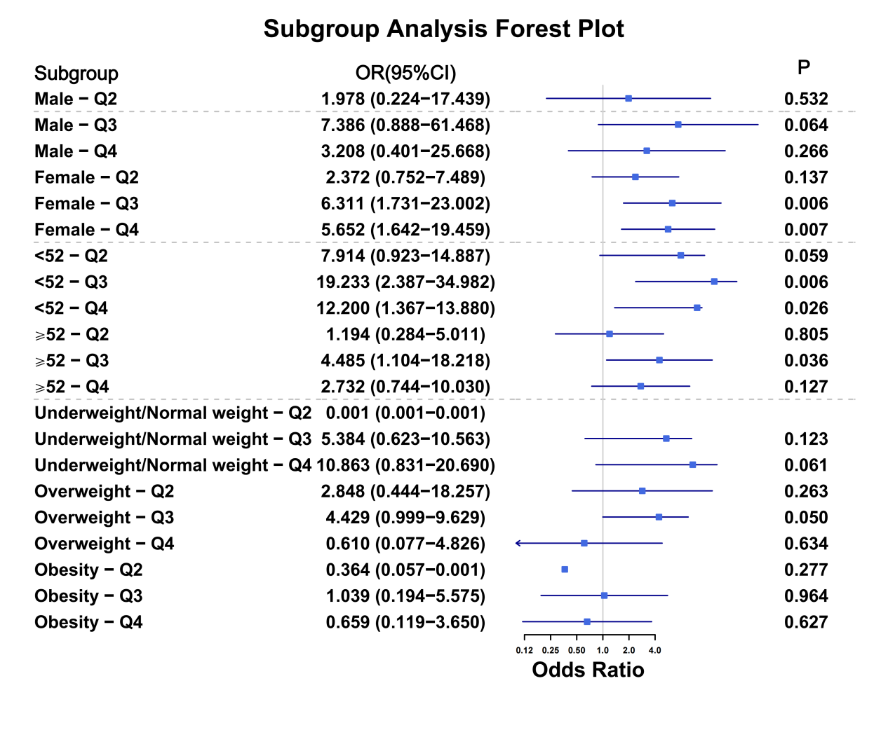
Fig.S1 Associations of the GLM7 with sarcopenia risk stratified by different sex, age, and BMI. Adjusted for sex, marital status, education level, WC, smoking status, drinking status, physical activity, HbA1c, hypertension, and diabetes. OR: Odds ratio; CI: Confidence interval.

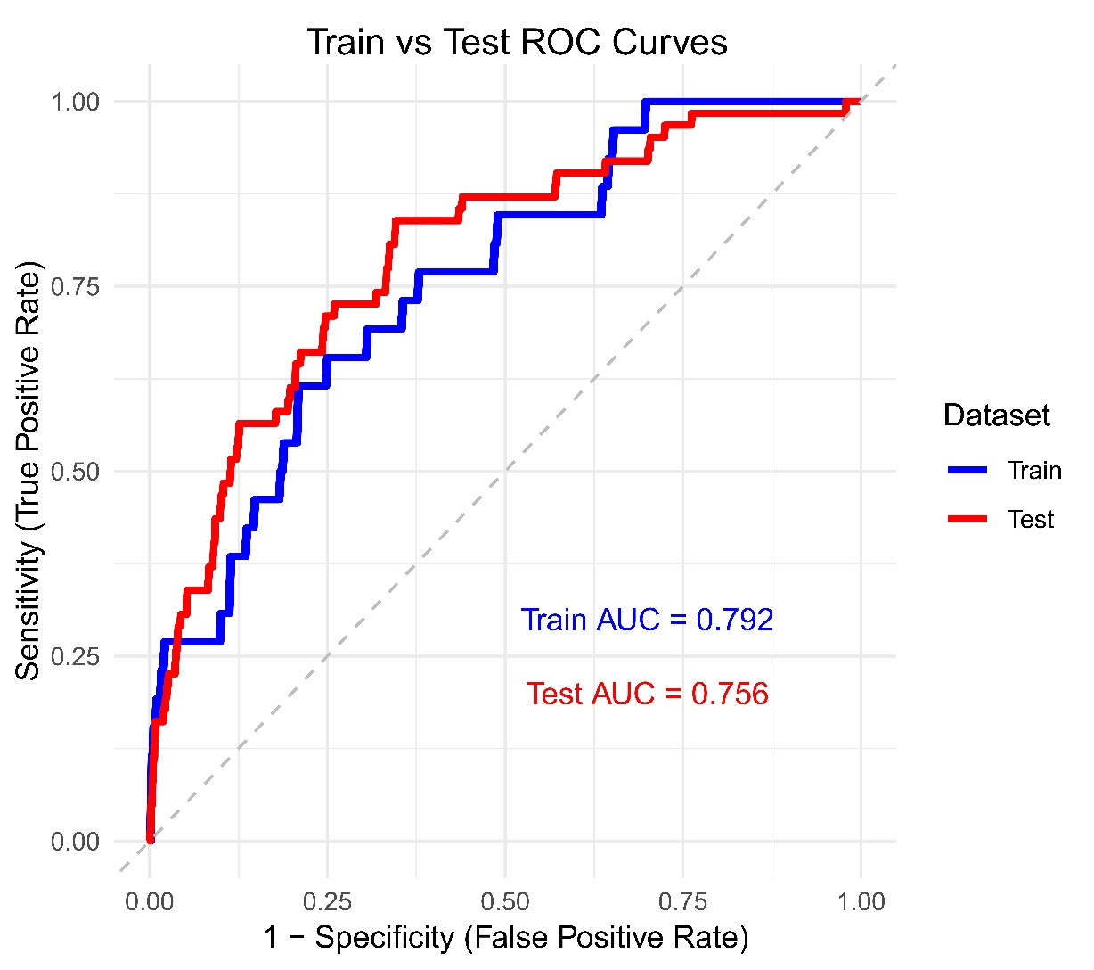
Fig.S2 ROC curve for GLM7 in predicting sarcopenia from patients in NHANES. The dataset was randomly split into training (70%) and test (30%) sets. ROC, receiver operating characteristic curve; AUC, area under the receiver operating characteristic curve.

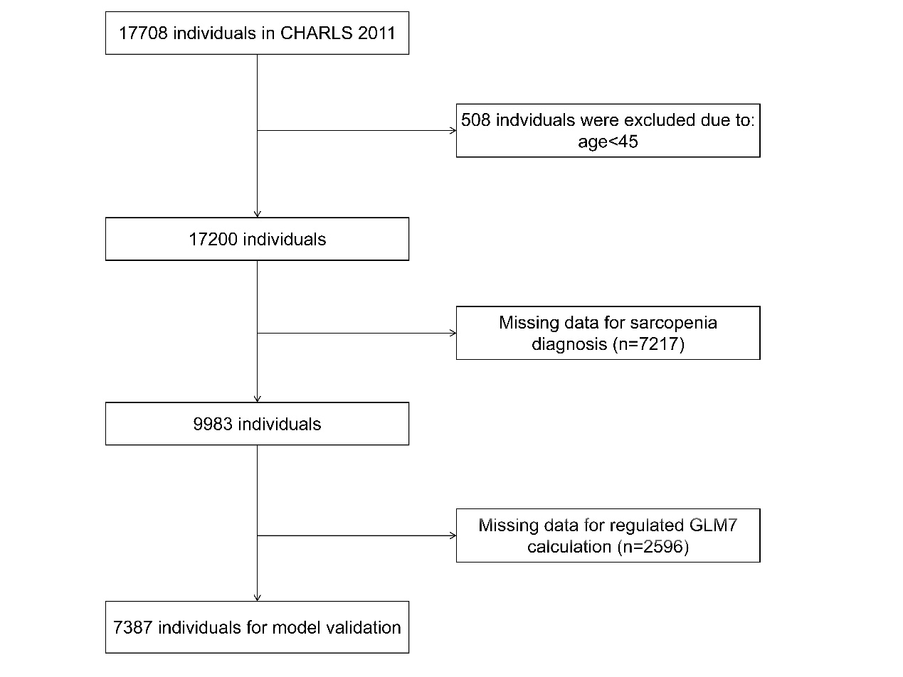
Fig.S3 Flowchart of participants of CHARLS.

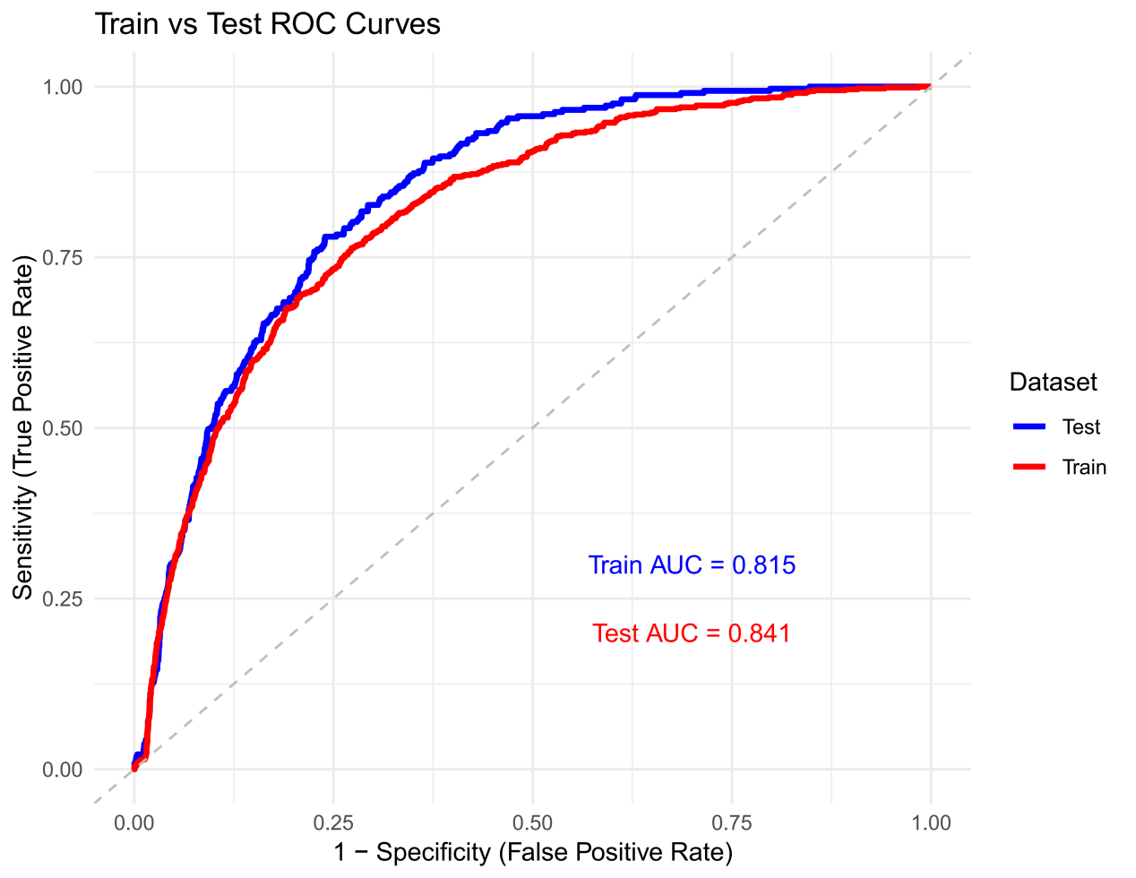
Fig.S4 ROC curve for GLM7 in predicting sarcopenia from participants in CHARLS. The dataset was randomly split into training (70%) and test (30%) sets. ROC, receiver operating characteristic curve; AUC, area under the receiver operating characteristic curve.

