Supplementary Materials

Supplementary Methods
S1. Electroanatomical mapping settings and quality control
Left atrial electroanatomical mapping was performed using the CARTO 3 system (Biosense Webster, Irvine, CA, USA) as part of the routine ablation workflow at the center. Whenever feasible, substrate mapping was performed during sinus rhythm after circumferential pulmonary vein isolation, because bipolar voltage assessment is generally more stable during sinus rhythm and less susceptible to rhythm-related voltage attenuation. When sinus rhythm was not present after pulmonary vein isolation, synchronized electrical cardioversion was performed whenever feasible to restore sinus rhythm. In patients in whom sinus rhythm could not be restored or maintained, substrate mapping was performed during the ongoing atrial arrhythmia.
Voltage maps were generated in a point-by-point manner after reconstruction of the left atrial geometry using a PentaRay multipolar mapping catheter (Biosense Webster, Irvine, CA, USA). Mapping was performed with attention to adequate chamber coverage, catheter stability, endocardial contact, and local electrogram quality. Points acquired within the pulmonary vein ostia, along evident ablation lesion sets, or at sites with obvious noise, far-field signals, unstable catheter position, poor contact, non-anatomical location, or excessive point clustering were excluded from substrate assessment to minimize misclassification of mapping artifact or procedural scar as native low-voltage substrate. During map interpretation, electrogram reproducibility and anatomic consistency were additionally reviewed to avoid classifying isolated or nonreproducible low-amplitude signals as true substrate abnormality.
Particular caution was applied during atrial-arrhythmia mapping. Because bipolar voltage may be attenuated during atrial arrhythmia owing to cycle-length irregularity, changing activation direction, and wavefront collision, electrograms in suspected low-voltage regions were re-evaluated across multiple beats whenever necessary, and regions showing marked beat-to-beat variability were resampled before final classification. In addition, a higher point density was generally sought during atrial-arrhythmia mapping to improve map reliability. These measures were intended to reduce rhythm-related overestimation of left atrial low-voltage areas (LVAs) as much as possible, although some degree of measurement heterogeneity related to mapping rhythm could not be completely eliminated.
S2. Definition and retrospective adjudication of left atrial low-voltage areas
In the present study, left atrial low-voltage area (LVA) was analyzed primarily as a binary substrate phenotype (present vs. absent), in line with the main study design. The electrophysiological definition of LVA followed the prespecified study protocol: a contiguous low-voltage region composed of more than three adjacent mapping points, each spaced approximately 0.5 cm apart, with bipolar voltage amplitudes <0.5 mV.
Retrospective adjudication of LVA was based primarily on the operator’s procedural documentation of left atrial substrate assessment before substrate modification. At this center, ablation strategy is individualized according to left atrial substrate characteristics, particularly when substrate mapping is interpretable before further substrate-directed ablation. Accordingly, the procedural record routinely documents whether low-voltage substrate is present before substrate modification, its approximate anatomical location, and whether abnormal atrial substrate is identified. These procedural records served as the principal source for binary LVA classification in the present study.
To improve reliability, the documented substrate findings were further cross-checked against available archived intra-procedural electroanatomical maps retrieved from the institutional case system. Importantly, LVA adjudication was intended to reflect native substrate abnormalities assessed before substrate modification rather than lesion-related voltage attenuation. Therefore, low-voltage regions attributable to ablation lesions, including those related to pulmonary vein isolation, empirical linear ablation, or vein of Marshall ethanol infusion, were not classified as LVA. Likewise, isolated scattered low-voltage points, regions located predominantly within lesion sets, or low-amplitude signals considered likely to reflect artifact, unstable catheter contact, or rhythm-related beat-to-beat variation were not considered sufficient for LVA classification.
The primary analysis was intentionally based on binary LVA adjudication rather than quantitative burden measurement in the full cohort. This was because the study was retrospective, and archived mapping data were not uniformly stored in a standardized format suitable for robust quantitative re-analysis in all patients. In addition, some archived maps may have been influenced by procedural interventions before or during substrate assessment, particularly in patients mapped during atrial arrhythmia. For example, in some patients who could not be restored to sinus rhythm after pulmonary vein isolation, empirical linear ablation had to be performed before substrate mapping, which could substantially alter the subsequent voltage distribution. For these reasons, binary adjudication of the presence or absence of native LVA was considered more robust and reproducible for the main analysis than retrospective quantification of LVA burden across the entire cohort.
Patients mapped during atrial arrhythmia were not excluded from the primary binary analysis, because in real-world procedural practice they often represent a subgroup with more advanced atrial remodeling and greater difficulty achieving rhythm conversion. Excluding such patients could therefore have reduced cohort representativeness and selectively removed individuals with more abnormal atrial substrate. The potential influence of mapping rhythm on the robustness of the main findings was therefore addressed in prespecified sensitivity analyses.
S3. Quantitative measurement and quality control of left atrial low-voltage burden
In addition to the primary binary analysis, supplementary quantitative analyses were performed in a subset of patients with archived maps suitable for standardized measurement of left atrial low-voltage burden. These analyses were supplementary in nature and were not part of the primary study design.
For the present supplementary analyses, three quantitative variables were exported: the number of accepted mapping points per patient, total LVA burden, and regional LVA burden. The number of accepted mapping points per patient was used as a descriptive indicator of mapping density after exclusion of points considered unsuitable for substrate assessment. Regional LVA burden was defined as the proportion of low-voltage area within a given predefined region relative to the total analyzable left atrial surface area. Total LVA burden was calculated as the sum of the regional LVA burdens across all predefined analyzable regions. Quantitative measurements were performed manually using the measurement tools integrated in the CARTO 3 system.
Regional analyses were restricted to anatomically reproducible regions with relatively stable mapping reliability, including the anterior wall, posterior wall, roof, inferior wall, and right pulmonary vein antrum. In contrast, the mitral isthmus region, septal region, and the area adjacent to the left atrial appendage were not included in the quantitative burden analyses. These regions were excluded because they were more susceptible to mapping error or procedural influence, particularly from vein of Marshall ethanol infusion, complex local anatomy, and limited catheter accessibility. Quantitative LVA burden was assessed using the same voltage definition as in the main analysis (<0.5 mV).
To maintain measurement quality, quantitative analyses were limited to archived maps that allowed reproducible assessment of the predefined analyzable regions. Maps were considered suitable only when left atrial geometry was adequate, anatomical orientation was consistent, and the included regions had no major geometric defects or obvious distortion from lesion-related low-voltage change. Only accepted mapping points were used for quantitative analysis. As described in Supplementary Method S1, points within the pulmonary vein ostia, along evident ablation lesion sets, or at sites with obvious noise, far-field signals, unstable catheter position, poor contact, non-anatomical location, or excessive point clustering were excluded before quantitative assessment.
Because maps acquired during atrial arrhythmia were more frequently incompletely archived and were more susceptible to the effects of intraprocedural ablation, they were not included in the standardized analyses of the association between LDL-C and quantitative LVA burden. However, available quantitative data from maps obtained during both sinus rhythm and atrial arrhythmia were retained for a descriptive sensitivity comparison of mapping characteristics according to mapping rhythm. For example, in some patients who could not be restored to sinus rhythm after pulmonary vein isolation, empirical linear ablation may have been performed before substrate mapping, potentially altering the subsequent voltage distribution. Therefore, all subsequent analyses of regional and total LVA burden in relation to LDL-C were restricted to patients with complete maps obtained during sinus rhythm.
Missing data in the quantitative analyses were mainly due to incomplete archival storage or insufficient map quality for standardized measurement, rather than routine clinical variable missingness. Because the proportion of incomplete quantitative mapping data was low (<10%), no imputation was performed. Instead, a complete-case approach was used, and patients with incomplete quantitative mapping information were excluded from the corresponding analyses.
The primary analyses in the main manuscript remained based on the binary presence or absence of LVA in the full cohort, whereas the quantitative analyses were performed as supplementary sensitivity analyses in the sinus-rhythm subgroup with complete archived maps.
S4. Procedural details
In selected patients with long-standing persistent atrial fibrillation and enlarged left atrial diameter, adjunctive vein of Marshall ethanol infusion (VOMEI) was performed as part of the substrate modification strategy (Supplementary Figure S1). As a participating center in the STABLE-SR-III study [1], the center has accumulated experience with substrate-guided ablation strategies based on circumferential pulmonary vein isolation and additional modification tailored to abnormal left atrial substrate distribution (Supplementary Figure S2). In the present cohort, adjunctive lesion sets were applied at the operator’s discretion according to the substrate pattern and procedural findings.

S4.1. Vein of Marshall ethanol infusion

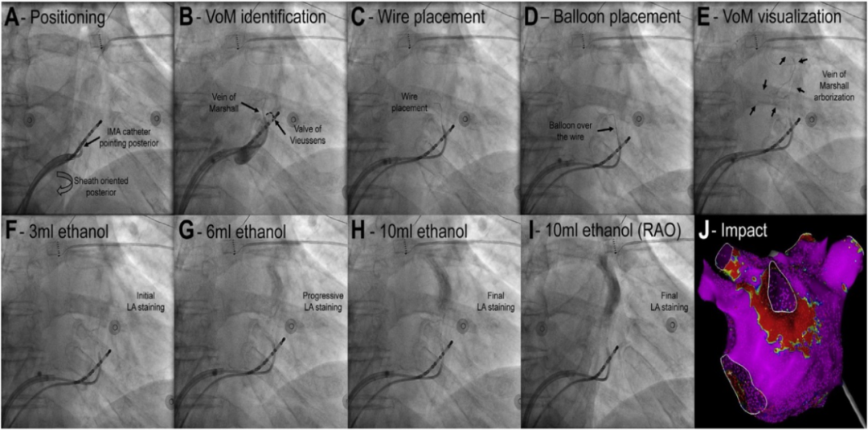
The stepwise procedural workflow of VOMEI is illustrated in Supplementary Figure S1.
A. A 6F JR4.0 guiding catheter (Medtronic, Inc., Minneapolis, MN, USA) was advanced into the coronary sinus via femoral venous access under fluoroscopic guidance. B. Contrast venography was performed to identify the vein of Marshall (VoM) and the valve of Vieussens. C. A 0.014-inch guidewire (Roughthrough; Asahi Intecc, Seto, Aichi, Japan) was advanced through the catheter into the distal segment of the VoM. D. An over-the-wire balloon catheter (diameter 1.5–2.5 mm, length 8–12 mm; Medtronic, Minneapolis, MN, USA) was advanced along the guidewire and inflated to occlude the vessel. E. Contrast injection through the balloon catheter was performed to further visualize the VoM anatomy and arborization. F–I. 95% dehydrated ethanol was infused stepwise from the distal to proximal VoM, approximately 3 mL per injection, with a total volume of 9–10 mL, resulting in progressive staining of the adjacent left atrial myocardium. J. The ablation effect of VOMEI was evaluated using electroanatomical voltage mapping, which typically demonstrated low-voltage regions along the mitral isthmus and adjacent posterolateral left atrial wall, corresponding to the ethanol-induced lesion set.
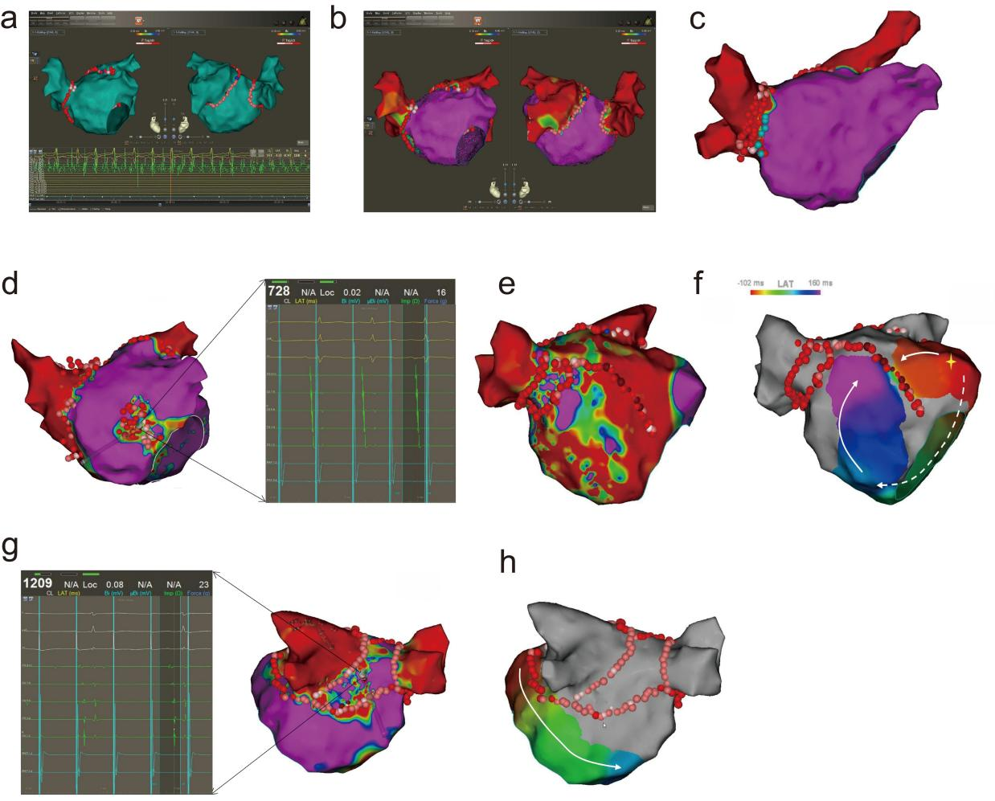
S4.2. Substrate-guided ablation of left atrial low-voltage areas during sinus-rhythm mapping
The substrate-guided workflow for left atrial low-voltage area ablation during sinus-rhythm mapping is illustrated in Supplementary Figure S2.
a) Under the guidance of the CARTO 3 electroanatomical mapping system (Biosense Webster, Irvine, CA, USA), a three-dimensional left atrial geometry was constructed using a PentaRay catheter (Biosense Webster, Irvine, CA, USA). Circumferential pulmonary vein antral isolation was then performed using a SmartTouch SurroundFlow catheter (Biosense Webster, Irvine, CA, USA) until complete electrical isolation was achieved. b) After confirmation of complete pulmonary vein isolation, sinus-rhythm mapping was performed to identify low-voltage areas (LVAs). c–h. Substrate modification during sinus-rhythm mapping. c) If abnormal substrate or fractionated electrograms were detected at the right pulmonary vein antrum, extended pulmonary vein antral ablation was performed. d) Patchy LVAs were treated with homogenization ablation. e-h. For patients with extensive left atrial low-voltage areas, a substrate-based linear ablation strategy was performed. e) In patients with extensive anterior wall LVAs, anterior wall linear ablation was performed. f) Bidirectional conduction block across the anterior line was then confirmed. g) For extensive posterior wall LVAs, posterior wall BOX isolation was performed. h) Successful posterior wall isolation was confirmed by demonstrating both entrance and exit block.
S4.3. Radiofrequency catheter ablation settings
Endocardial radiofrequency catheter ablation was delivered using a contact force–sensing catheter in power-controlled mode (40–50 W), with a temperature limit of 43°C and an irrigation flow rate of 8–20 mL/min. Esophageal temperature monitoring was used during posterior wall ablation to minimize the risk of esophageal injury. Point-by-point ablation was performed with an interlesion distance < 4 mm. Each lesion required catheter stability (< 2 mm movement for ≥ 4 s), contact force ≥ 8 g for ≥ 70% of the application time, and target ablation index (AI) values of 450–600. For mitral isthmus ablation within the coronary sinus, power was limited to 20 W with an irrigation flow rate of 17 mL/min and a duration of 20–25 s per lesion.
S5. Measurement of fibrillatory wave amplitude
Fibrillatory wave (f-wave) amplitude was measured using the institutional digital electrocardiography system. Preprocedural 12-lead electrocardiograms recorded during atrial fibrillation were reviewed, and lead V₁ was selected for analysis because atrial fibrillatory activity is typically most clearly visualized in this lead. A segment with a stable baseline and minimal artifact was identified on each tracing. Using the built-in electronic caliper tool, the amplitude of the most clearly identifiable f-wave within the selected segment was measured. F-wave amplitude was defined as the vertical distance from the nadir of the trough to the peak of the same wave and was recorded in millivolts (mV) [2].

S6. Statistical analysis

S6.1. General statistical principles
All analyses followed an exploratory framework. The aim was to identify clinical factors associated with the presence of LVAs, and then to further examine the relationship of low-density lipoprotein cholesterol (LDL-C) with atrial substrate and post-ablation outcomes. Because this was a retrospective observational study, all findings were interpreted as associations rather than evidence of causality.
The statistical analysis followed a sequential framework. First, baseline comparisons and univariable logistic regression were used to identify candidate factors associated with LVA presence. Candidate covariates were then selected for parsimonious multivariable modeling based on the univariable findings, clinical relevance, and prior evidence. Among the routinely measured metabolic variables, LDL-C was selected as the main exposure for subsequent focused analyses because it showed the most consistent association with LVA presence across the initial univariable and multivariable analyses. Subsequent analyses assessed the robustness and characteristics of the LDL-C–LVA association using incrementally adjusted models and complementary analyses of nonlinearity, potential explanatory pathways, subgroup heterogeneity, categorical LDL-C patterns, and postablation recurrence. Detailed methods for these analyses are provided in the following subsections.
For regression analyses, results are presented as odds ratios or hazard ratios with 95% confidence intervals. Covariates were selected according to the study objective, exploratory results, and clinical relevance. All tests were two-sided. Given the observational design and the exploratory nature of several secondary analyses, findings from spline, quartile, mediation, and subgroup analyses were interpreted cautiously and regarded as hypothesis-generating.
S6.2. Multiple Imputation
Multiple imputation (MI) was used to handle the missing data for hs-CRP, which exhibited a significant proportion of missing values. The imputation procedure was performed using the mice package in R, employing the Predictive Mean Matching (PMM) method for the imputation of 40 datasets.
The imputation model included complete predictor variables, and the imputation was carried out over 20 iterations to ensure convergence. The primary variables used as predictors for the imputation included clinical factors relevant to the presence of LVAs and other baseline characteristics. The imputed datasets were used for subsequent exploratory multivariable model construction, ensuring that the missing values in hs-CRP were appropriately addressed.
All multiple imputation analyses were conducted using R software (version 4.4.1; R Foundation for Statistical Computing, Vienna, Austria) with the mice package.
S6.3. Firth penalized logistic regression for f-wave amplitude
The association between surface electrocardiogram (ECG)-derived f-wave amplitude and LVA presence was further assessed. In the standard logistic model, f-wave amplitude showed an extremely strong inverse association with LVA, resulting in complete separation. Because this can lead to unstable maximum-likelihood estimates, Firth penalized logistic regression was used. Both univariable and multivariable Firth models were fitted. The multivariable model adjusted for age, sex, drinking status, CHA₂DS₂-VASc score, LDL-C, triiodothyronine (T3), and left atrial diameter (LAD), consistent with the main analysis framework (Supplementary Table S1).
To improve clinical interpretability, the effect size was expressed per 0.1 mV decrease in f-wave amplitude. Since the estimated coefficient for f-wave amplitude in the multivariable Firth model was β = −7.393, the corresponding odds ratio for each 0.1 mV decrease was calculated as follows:
$${\text{OR}}_{\text{0.1 }\text{mV} \text{decrease}}\text{=}\text{exp} \text{(−0.1×}\text{β}\text{)} \text{=}\text{exp} \text{[−0.1×(−7.393)]=}\text{exp} \text{(0.7393)=2.09}$$
Accordingly, each 0.1 mV decrease in f-wave amplitude was associated with a 2.09-fold higher odds of LVA presence (95% CI 1.44–3.09, P < 0.001).
These findings indicate a very strong inverse association between f-wave amplitude and LVA presence. Lower f-wave amplitude was associated with a markedly higher likelihood of LVAs, indicating that lower f-wave amplitude may be a marker of more advanced atrial remodeling.
All Firth penalized logistic regression analyses were performed using R software (version 4.4.1; R Foundation for Statistical Computing, Vienna, Austria) with the logistf package.

S6.4. Restricted cubic spline analysis
Restricted cubic spline (RCS) analysis was used as an exploratory method to examine the shape of the association between LDL-C and LVA presence. Because LDL-C showed the most consistent association with LVA presence across the initial analyses, spline analysis was performed to assess whether there was evidence of departure from linearity in its association with LVAs.
RCS analysis was based on logistic regression, with LVA presence as the binary outcome. The model was adjusted for age and sex. LDL-C was modeled using restricted cubic splines with 4 knots placed at the 5th, 35th, 65th, and 95th percentiles of the LDL-C distribution. A linear logistic model and an RCS logistic model were both fitted, and the spline model was used for curve estimation. The overall spline term and its nonlinear component were assessed using analysis of variance from the fitted RCS model. The median LDL-C value was used as the reference point for effect estimation. Odds ratios were then expressed relative to this reference value.
For plotting, predicted odds ratios and 95% confidence intervals were generated across the observed LDL-C range. To avoid unstable estimates at the extremes, predictions were calculated from the 1st to the 99th percentile of LDL-C. Histogram bars were added to the figure to show the distribution of LDL-C values in the study population. As reported in the main text, no statistically significant evidence of nonlinearity was observed after adjustment for age and sex (P for nonlinearity = 0.191), although some visual variation across the LDL-C distribution was apparent. Because formal support for nonlinearity was not present, the spline findings were interpreted cautiously, and the subsequent quartile-based analyses were retained only as descriptive categorizations of LDL-C rather than as evidence of a range-dependent effect. For the exploratory quartile-based Cox analyses, Q3 was used as the model reference category for numerical comparison only. This parameterization was retained solely to express pairwise hazard ratios and should not be interpreted as indicating a biologically or clinically preferred LDL-C range.
All restricted cubic spline analyses were performed using R software (version 4.4.1; R Foundation for Statistical Computing, Vienna, Austria) with the rms, lmtest, and ggplot2 packages.

S6.5. Mediation analysis
To further explore potential pathways linking LDL-C levels to LVA presence, exploratory mediation analyses were performed within a causal mediation framework using the mediation package in R. LDL-C was treated as a continuous exposure, and LVA presence was analyzed as a binary outcome.
Candidate mediators were prespecified according to clinical relevance. These included coronary artery disease, stroke, cardiomyopathy, heart failure, diabetes, fatty liver disease, hypertension, LAD, and left ventricular ejection fraction (LVEF). Each mediator was examined separately in an individual mediation model.
For each candidate mediator, two regression models were fitted. First, a mediator model was constructed with the candidate mediator as the dependent variable and LDL-C as the independent variable, with adjustment for age and sex. For consistency across mediators, linear regression was used for the mediator model. Second, an outcome model was constructed with LVA presence as the dependent variable and both LDL-C and the candidate mediator entered simultaneously, again with adjustment for age and sex. Because LVA presence was a binary variable, the outcome model was fitted using logistic regression.
Mediation effects were estimated using the counterfactual framework implemented in the mediate() function. To improve interpretability for the continuous exposure, mediation effects were evaluated by comparing the 75th percentile of LDL-C (treatment value) with the 25th percentile of LDL-C (control value). For each model, 1,000 simulations were used to estimate the average causal mediation effect (ACME), average direct effect (ADE), total effect, and proportion mediated, together with their 95% confidence intervals and corresponding P values.
Because these analyses were exploratory and based on observational data, mediation findings were interpreted cautiously. In the main analysis, LAD was the only candidate variable showing evidence consistent with a significant indirect pathway in the exploratory mediation analyses and was therefore retained as the principal mediator of interest in the Results section (Supplementary Table S4).
All causal mediation analyses were performed using R software (version 4.4.1; R Foundation for Statistical Computing, Vienna, Austria) with the mediation package.

S6.6. Time-to-event and Cox regression analyses for postablation recurrence
Time-to-event analyses were calculated from the date of the index ablation. For patients with recurrence after the blanking period, event time was defined as the interval from ablation to the first documented recurrence. For arrhythmias occurring during the blanking period that persisted or recurred beyond 90 days, event time was assigned as 90 days. Patients without recurrence were censored at the last follow-up.
Postablation recurrence-free survival was first evaluated using Kaplan–Meier analysis and compared across LDL-C quartiles with the log-rank test. LDL-C quartiles were defined according to the distribution of LDL-C in the study cohort. For the exploratory Cox analyses, Q3 was used as the model reference category for numerical comparison only and should not be interpreted as indicating a biologically or clinically preferred LDL-C range.
Cox proportional hazards regression was used to estimate hazard ratios (HRs) and 95% confidence intervals for recurrence across LDL-C quartiles. Six models with incremental adjustment were fitted, progressing from an unadjusted model to models additionally accounting for demographic characteristics, clinical comorbidities, lipid-related factors, procedural and substrate-related variables, and post-ablation antiarrhythmic drug use. The detailed covariate structure of each model is provided in the corresponding table footnotes (Supplementary Table S7).
For each Cox model, the overall association of LDL-C quartiles with recurrence was assessed by comparing the full model with the corresponding reduced model without the LDL-C quartile term. Proportional hazards assumptions were evaluated using Schoenfeld residual-based tests, and collinearity among predictors was assessed using variance inflation factors derived from the design matrix. These diagnostic results are provided in the Supplementary Tables (S8, S9).
All Kaplan–Meier and Cox regression analyses were performed using R software (version 4.4.1; R Foundation for Statistical Computing, Vienna, Austria) with the survival and survminer packages.

S6.7. Sensitivity analyses according to mapping rhythm
Because bipolar voltage amplitudes may differ according to mapping rhythm, mapping rhythm was treated as a potential source of measurement heterogeneity. To assess robustness, two prespecified sensitivity analyses were performed. First, mapping rhythm was additionally adjusted for in the multivariable logistic regression models in the overall cohort. Second, the main analyses were repeated in patients who underwent sinus-rhythm mapping only. These repeated analyses included logistic regression for LVA presence, mediation analysis, restricted cubic spline analysis, and recurrence analyses using Kaplan–Meier and Cox regression methods. The same LDL-C quartile cutoffs were applied in the sinus-rhythm subgroup. Results were interpreted as supportive analyses for robustness.

S6.8. Supplementary statistical analyses of mapping characteristics and quantitative LVA burden
Supplementary quantitative analyses were performed in patients with complete sinus-rhythm maps suitable for standardized measurement, as described in Supplementary Method S3. These analyses were exploratory and were intended to provide additional information on mapping characteristics, regional distribution, and quantitative LVA burden beyond the primary binary LVA analysis. Patients with incomplete quantitative mapping data were excluded from these analyses, and no imputation was performed. Three quantitative variables were analyzed: the number of accepted mapping points per patient, total LVA burden, and regional LVA burden.
First, mapping characteristics were compared descriptively according to mapping rhythm in the overall cohort, including the number of accepted mapping points per patient and the availability of complete quantitative mapping data. In addition, within the subgroup of patients with complete sinus-rhythm maps, the number of accepted mapping points per patient was compared between patients with and without LVAs.
Second, the regional distribution of LVAs in the sinus-rhythm subgroup with complete quantitative data was described in two ways: by the proportion of patients with involvement in each predefined analyzable region in the overall quantitative subgroup, and by the distribution of regional LVA burden in each region among patients with measurable LVAs. The predefined analyzable regions included the anterior wall, posterior wall, roof, inferior wall, and right pulmonary vein antrum.
Third, associations between LDL-C and quantitative LVA burden were explored in the sinus-rhythm subgroup with complete quantitative data. Because total and regional LVA burden showed skewed distributions, log-transformed variables were used for regression analyses after adding a small constant [log(burden + 0.01)]. Linear regression models were fitted for total LVA burden in an unadjusted model and in progressively adjusted models designated as Models 1f–4f, corresponding to the covariate structures of Models 1a–4a in the primary analysis. For regional LVA burden, exploratory linear regression analyses were performed using the fully adjusted covariate structure of Model 4f. Scatter plots with fitted linear regression lines were used for graphical presentation.
Finally, as an additional exploratory analysis, total LVA burden was categorized into five groups in the sinus-rhythm subgroup with complete quantitative data: 0%, >0–5%, >5–10%, >10–15%, and >15%. LDL-C and selected clinical characteristics were compared across these burden categories. Overall differences in LDL-C across groups were assessed using the Kruskal–Wallis test, followed by pairwise Wilcoxon rank-sum tests with Benjamini–Hochberg adjustment when appropriate. These grouped analyses were considered descriptive and hypothesis-generating.
All supplementary quantitative analyses were performed using R software (version 4.4.1; R Foundation for Statistical Computing, Vienna, Austria).
References
1. Chen H, Li C, Han B, Xiao F, Yi F, Wei Y, et al. Circumferential pulmonary vein isolation with vs without additional low-voltage-area ablation in older patients with paroxysmal atrial fibrillation: A randomized clinical trial. JAMA Cardiol. 2023;8:765–72. https://doi.org/10.1001/jamacardio.2023.1749
2. Peter RH, Morris JJ, McIntosh HD. Relationship of fibrillatory waves and P waves in the electrocardiogram. Circulation. 1966;33:599–606. https://doi.org/10.1161/01.cir.33.4.599
Supplementary Tables
Supplementary Table S1. Firth penalized logistic regression analyses of the association between fibrillatory wave amplitude and the presence of left atrial low-voltage areas.
Model | Beta | SE | OR | 95% CI | P value
Univariable | -8.869 | 1.816 | 1.41 × 10^{–4} | 3.66 × 10–⁶ to 4.62 × 10^{–3} | <0.001
*Multivariable | -7.393 | 1.933 | 6.15 × 10^{–4} | 1.27 × 10^{–5} to 2.61 × 10^{–2} | <0.001
Odds ratios with 95% confidence intervals were estimated using Firth penalized logistic regression because conventional logistic regression showed quasi-complete or complete separation for f-wave amplitude.
*The multivariable model was adjusted for age, sex, drinking history, CHA₂DS₂-VASc score, low-density lipoprotein cholesterol, triiodothyronine, and left atrial diameter.
Abbreviations: SE, standard error; OR, odds ratio; CI, confidence interval.

Supplementary Table S2. Variance inflation factor summary for the incrementally adjusted logistic regression models evaluating the association between continuous LDL-C levels and left atrial low-voltage areas.
Model | Max VIF | Mean VIF | Any VIF > 5 | Number of predictors
Model 1a | 1.056 | 1.044 | No | 3
Model 2a | 1.210 | 1.078 | No | 11
Model 3a | 1.412 | 1.190 | No | 15
Model 4a | 1.415 | 1.214 | No | 16
Model 5a | 1.215 | 1.131 | No | 8
Model 6a | 1.236 | 1.145 | No | 9
VIF analysis was performed to assess multicollinearity among covariates included in the incrementally adjusted logistic regression models for the presence of LVAs. Max VIF indicates the largest VIF value observed within each model, and Mean VIF indicates the average VIF across all predictors included in that model. No model showed evidence of problematic multicollinearity, as all VIF values were below 5.
Model 1a: Adjusted for age and sex;
Model 2a: Adjusted for age, sex, BMI, T3, hypertension, coronary artery disease, heart failure, diabetes, stroke, and COPD;
Model 3a: Adjusted for age, sex, BMI, T3, hypertension, coronary artery disease, heart failure, diabetes, stroke, COPD, hyperlipidemia, triglycerides, HDL-C, and statin use;
Model 4a: Adjusted for age, sex, BMI, T3, hypertension, coronary artery disease, heart failure, diabetes, stroke, COPD, hyperlipidemia, triglycerides, HDL-C, statin use, and LAD.
Model 5a: Adjusted for age, sex, BMI, fatty liver disease, blood glucose, serum albumin, and uric acid.
Model 6a: Adjusted for age, sex, BMI, fatty liver disease, blood glucose, serum albumin, uric acid, and hs-CRP.
Abbreviations: VIF, variance inflation factor; LDL-C, low-density lipoprotein cholesterol; LVAs, left atrial low-voltage areas; BMI, body mass index; T3, triiodothyronine; COPD, chronic obstructive pulmonary disease; HDL-C, high-density lipoprotein cholesterol; LAD, left atrial diameter; hs-CRP, high-sensitivity C-reactive protein.

Supplementary Table S3. Interaction P values before and after false discovery rate correction in subgroup analyses of the association between LDL-C levels and left atrial low-voltage areas.
Subgroup Variable | P for interaction | FDR-adjusted P for interaction
Age | 0.338 | 0.709
Sex | 0.160 | 0.709
LAD | 0.011 | 0.121
BMI | 0.893 | 0.958
eGFR | 0.630 | 0.854
Statins use | 0.958 | 0.958
Heart failure | 0.261 | 0.709
Hypertension | 0.277 | 0.709
Coronary artery disease | 0.386 | 0.709
Stroke | 0.699 | 0.854
Hyperlipidemia | 0.670 | 0.854
P for interaction values were obtained from unadjusted subgroup interaction analyses evaluating the association between continuous LDL-C levels and the presence of LVAs. FDR correction was applied to account for multiple testing across subgroup interaction analyses. Although nominal heterogeneity was observed for LAD before FDR correction, no interaction remained statistically significant after correction.
Abbreviations: LDL-C, low-density lipoprotein cholesterol; LVAs, left atrial low-voltage areas; FDR, false discovery rate; LAD, left atrial diameter; BMI, body mass index; eGFR, estimated glomerular filtration rate.

Supplementary Table S4. Mediation analysis results for left atrial diameter as a mediator of the association between LDL-C levels and the presence of left atrial low-voltage areas.
Effect | Estimate | 95% CI | P value
Indirect effect (ACME) | -0.013 | -0.028 to -0.002 | 0.014
Direct effect (ADE) | -0.072 | -0.136 to -0.012 | 0.020
Total effect | -0.086 | -0.150 to -0.024 | 0.006
Proportion mediated | 15.3% | 2.4% to 55.1% | 0.020
Mediation analysis was performed to explore whether LAD may partly account for the association between LDL-C levels and the presence of LVAs. Estimates are presented as effect coefficients with 95% confidence intervals (CIs). The proportion mediated represents the percentage of the total effect explained by the indirect pathway through LAD. Confidence intervals and P values were obtained using 1,000 bootstrap iterations.
Abbreviations: LAD, left atrial diameter; LDL-C, low-density lipoprotein cholesterol; LVAs, left atrial low-voltage areas; ACME, average causal mediation effect; ADE, average direct effect; CI, confidence interval.
Supplementary Table S5. Baseline characteristics according to quartiles of low-density lipoprotein cholesterol.
Variable | 0.55-1.88 mmol/L (n=102) | 1.88-2.35 mmol/L (n=101) | 2.35-2.90 mmol/L (n=100) | 2.90-4.82 mmol/L (n=101) | P value
Age , years | 69.50 (63.25, 74.00) | 67.00 (61.00, 71.00) | 67.00 (62.00, 72.00) | 66.00 (57.00, 72.00) | 0.019
Male,n (%) | 61 (59.8%) | 66 (65.3%) | 60 (60.0%) | 64 (63.4%) | 0.816
Female,n (%) | 41 (40.2%) | 35 (34.7%) | 40 (40.0%) | 37 (36.6%) | 0.816
Smoking history,n (%) | 15 (14.7%) | 22 (21.8%) | 25 (25.0%) | 23 (22.8%) | 0.305
Drinking history,n (%) | 14 (13.7%) | 15 (14.9%) | 19 (19.0%) | 25 (24.8%) | 0.164
Systolic blood pressure, mm Hg | 131.00 (119.25, 142.00) | 128.00 (116.00, 138.00) | 131.00 (120.75, 143.25) | 129.00 (119.00, 138.00) | 0.418
Diastolic blood pressure, mm Hg | 85.00 (75.00, 93.00) | 81.00 (72.00, 89.00) | 82.00 (75.00, 89.00) | 82.00 (73.00, 88.00) | 0.368
Body-mass index, kg/m² | 24.65 (22.93, 27.19) | 24.67 (23.36, 27.73) | 25.64 (23.43, 28.59) | 25.91 (23.67, 27.85) | 0.033
CHA2DS2-VASc score | 4.00 (3.00, 5.00) | 3.00 (2.00, 4.00) | 3.00 (2.00, 5.00) | 3.00 (1.00, 4.00) | 0.012
Atrial fibrillation duration，years | 1.00 (0.26, 4.00) | 1.00 (0.32, 4.00) | 0.64 (0.24, 3.00) | 1.00 (0.16, 2.00) | 0.422
Laboratory findings
Total Cholesterol, mmol/L | 3.08 (2.67, 3.36) | 3.79 (3.59, 4.00) | 4.41 (4.19, 4.65) | 5.18 (4.91, 5.63) | <0.001
Triglycerides, mmol/L | 0.92 (0.65, 1.29) | 1.17 (0.93, 1.71) | 1.35 (0.94, 1.97) | 1.56 (1.17, 2.28) | <0.001
HDL-C, mmol/L | 1.15 (0.96, 1.33) | 1.14 (1.00, 1.29) | 1.13 (0.99, 1.32) | 1.15 (1.00, 1.36) | 0.955
Fasting Blood Glucose, mmol/L | 5.54 (4.74, 6.63) | 5.41 (4.97, 6.16) | 5.27 (4.83, 6.66) | 5.45 (5.03, 6.40) | 0.709
TSH, μIU/mL | 2.06 (1.41, 3.06) | 2.36 (1.40, 3.09) | 1.91 (1.31, 2.96) | 1.92 (1.34, 2.71) | 0.465
T3, pmol/L | 4.63 (4.07, 4.97) | 4.65 (4.33, 4.99) | 4.65 (4.21, 5.09) | 4.77 (4.30, 5.07) | 0.223
T4, pmol/L | 17.06 (15.81, 18.19) | 17.06 (15.22, 18.66) | 17.06 (15.11, 18.20) | 17.06 (15.09, 18.70) | 0.864
Serum Potassium, mmol/L | 3.94 (3.57, 4.15) | 3.94 (3.67, 4.16) | 3.95 (3.71, 4.14) | 3.98 (3.72, 4.19) | 0.629
Blood Uric Acid, μmol/L | 342.50 (284.93, 408.80) | 358.60 (295.40, 424.70) | 380.45 (310.58, 461.42) | 391.00 (329.00, 457.40) | 0.003
Blood Urea Nitrogen, mmol/L | 5.69 (4.77, 6.61) | 5.78 (4.99, 6.99) | 5.66 (4.76, 6.81) | 5.92 (4.80, 6.94) | 0.741
Blood Creatinine, μmol/L | 72.25 (61.02, 84.00) | 69.00 (63.00, 82.00) | 71.05 (61.22, 81.00) | 73.50 (63.00, 85.00) | 0.646
eGFR, mL/min/1.73m² | 94.69 (79.51, 115.14) | 99.47 (87.29, 116.70) | 98.91 (87.24, 113.27) | 97.19 (83.79, 113.83) | 0.544
Other auxiliary examinations
Left atrial diameter, mm | 46.00 (43.00, 49.00) | 45.00 (43.00, 49.00) | 45.00 (43.00, 48.25) | 45.00 (42.00, 48.00) | 0.497
Left ventricular ejection fraction, % | 58.00 (55.00, 61.00) | 58.00 (55.00, 61.00) | 58.00 (53.00, 61.00) | 58.00 (55.00, 61.00) | 0.938
f-wave amplitude, mV | 0.13 (0.08, 0.18) | 0.13 (0.10, 0.16) | 0.14 (0.11, 0.18) | 0.13 (0.09, 0.17) | 0.122
Basal heart rate, bpm | 91.00 (82.25, 106.75) | 84.00 (72.00, 96.00) | 88.50 (77.00, 103.50) | 92.00 (77.00, 111.00) | 0.007
LVAs, n (%) | 66 (64.7%) | 65 (64.4%) | 52 (52.0%) | 49 (48.5%) | 0.034
Cardiovascular history
Hypertension, n (%) | 74 (72.5%) | 71 (70.3%) | 65 (65%) | 70 (69.3%) | 0.7
Coronary artery disease, n (%) | 27 (26.5%) | 17 (16.8%) | 10 (10%) | 14 (13.9%) | 0.013
Heart failure, n (%) | 30 (29.4%) | 35 (34.7%) | 29 (29%) | 30 (29.7%) | 0.8
Previous stroke, n (%) | 22 (21.6%) | 14 (13.9%) | 19 (19%) | 11 (10.9%) | 0.157
Cardiomyopathy, n (%) | 1 (1%) | 3 (3%) | 2 (2%) | 2 (2%) | 0.776
Other medical history
COPD, n (%) | 5 (4.9%) | 11 (10.9%) | 10 (10.0%) | 8 (7.9%) | 0.424
OSAS, n (%) | 0 (0.0%) | 0 (0.0%) | 1 (1.0%) | 3 (3.0%) | 0.09
Diabetes, n (%) | 22 (21.6%) | 8 (7.9%) | 17 (17%) | 21 (20.8%) | 0.037
Fatty liver, n (%) | 18 (17.6%) | 29 (28.7%) | 30 (30%) | 34 (33.7%) | 0.063
Renal disease, n (%) | 6 (5.9%) | 3 (3%) | 4 (4%) | 6 (5.9%) | 0.713
Hyperthyroidism, n (%) | 0 (0%) | 3 (3%) | 0 (0%) | 1 (1%) | 0.121
Hyperlipidemia, n (%) | 5 (4.9%) | 7 (6.9%) | 7 (7%) | 26 (25.7%) | <0.001
Medications
Statins, n (%) | 56 (54.9%) | 30 (29.7%) | 20 (20%) | 38 (37.6%) | <0.001
Antiplatelet, n (%) | 9 (8.8%) | 3 (3%) | 11 (11%) | 7 (6.9%) | 0.165
Diuretic, n (%) | 48 (47.1%) | 38 (37.6%) | 32 (32%) | 37 (36.6%) | 0.053
Anticoagulant, n (%) | 101 (99%) | 101 (100%) | 100 (100%) | 101 (100%) | 1
β-Blocker, n (%) | 72 (70.6%) | 64 (63.4%) | 63 (63%) | 63 (62.4%) | 0.574
ACEI or ARB, n (%) | 54 (52.9%) | 48 (47.5%) | 42 (42%) | 51 (50.5%) | 0.658
CCBs, n (%) | 41 (40.2%) | 41 (40.6%) | 48 (48%) | 45 (44.6%) | 0.645
Continuous variables are presented as the median (interquartile range), and categorical variables are presented as n (%). Comparisons across LDL-C quartiles were performed using the Kruskal–Wallis test for continuous variables, the chi-square test for categorical variables, and Fisher’s exact test when expected cell counts were small. LDL-C quartiles were defined as follows: Q1, 0.55–1.88 mmol/L; Q2, 1.88–2.35 mmol/L; Q3, 2.35–2.90 mmol/L; and Q4, 2.90–4.82 mmol/L.
Abbreviations: LDL-C, low-density lipoprotein cholesterol; LVAs, left atrial low-voltage areas; HDL-C, high-density lipoprotein cholesterol; TSH, thyroid-stimulating hormone; T3, triiodothyronine; T4, thyroxine; eGFR, estimated glomerular filtration rate; COPD, chronic obstructive pulmonary disease; OSAS, obstructive sleep apnea syndrome; ACEI, angiotensin-converting enzyme inhibitor; ARB, angiotensin receptor blocker; CCBs, calcium channel blockers.

Supplementary Table S6. Multivariable logistic regression analyses of LDL-C quartiles in relation to the presence of left atrial low-voltage areas.
LDL-C Range | Model 1b |  | Model 2b |  | Model 3b
LDL-C Range | OR (95% CI) | P value | OR (95% CI) | P value | OR (95% CI) | P value
Q1(0.55-1.88 mmol/L) | 0.92 (0.50-1.66) | 0.773 | 0.93 (0.50-1.72) | 0.815 | 0.91 (0.48-1.69) | 0.757
Q2(1.88-2.35 mmol/L) | Ref | Ref | Ref | Ref | Ref | Ref
Q3(2.35-2.90 mmol/L) | 0.54 (0.30-0.97) | 0.039 | 0.51 (0.28-0.94) | 0.030 | 0.53 (0.29-0.97) | 0.041
Q4(2.90-4.82 mmol/L) | 0.53 (0.29-0.95) | 0.034 | 0.52 (0.28-0.95) | 0.033 | 0.50 (0.27-0.93) | 0.029
LDL-C was categorized into quartiles according to its distribution in the study population, and the second quartile (Q2) was used as the reference group. The outcome variable was the presence of LVAs identified by three-dimensional electroanatomical mapping during catheter ablation. The reference category was used for model parameterization only and should not be interpreted as indicating a biologically or clinically preferred LDL-C range.
Model 1b: Adjusted for age and sex.
Model 2b: Adjusted for age, sex, BMI, T3, hypertension, coronary artery disease, heart failure, diabetes, stroke, and COPD.
Model 3b: Adjusted for age, sex, BMI, T3, hypertension, coronary artery disease, heart failure, diabetes, stroke, COPD, hyperlipidemia, triglycerides, HDL-C, and statin use.
Abbreviations: LDL-C, low-density lipoprotein cholesterol; LVAs, left atrial low-voltage areas; OR, odds ratio; CI, confidence interval; BMI, body mass index; T3, triiodothyronine; COPD, chronic obstructive pulmonary disease; HDL-C, high-density lipoprotein cholesterol.

Supplementary Table S7. Incrementally adjusted Cox regression analyses of LDL-C quartiles and postablation recurrence.
LDL-C quartile | Model 1 |  | Model 2 |  | Model 3 |  | Model 4 |  | Model 5 |  | Model 6
Comparison | HR (95% CI) | P value | HR (95% CI) | P value | HR (95% CI) | P value | HR (95% CI) | P value | HR (95% CI) | P value | HR (95% CI) | P value
Q1 vs Q3 | 1.45 (0.85–2.47) | 0.168 | 1.46 (0.86–2.48) | 0.161 | 1.47 (0.86–2.52) | 0.160 | 1.39 (0.79–2.44) | 0.253 | 1.21 (0.68–2.14) | 0.512 | 1.08 (0.61–1.92) | 0.791
Q2 vs Q3 | 1.82 (1.10–3.02) | 0.021 | 1.83 (1.10–3.04) | 0.020 | 1.85 (1.11–3.09) | 0.019 | 1.80 (1.07–3.01) | 0.026 | 1.48 (0.88–2.49) | 0.143 | 1.51 (0.90–2.55) | 0.120
Q4 vs Q3 | 2.07 (1.26–3.42) | 0.004 | 2.07 (1.25–3.43) | 0.005 | 2.19 (1.31–3.66) | 0.003 | 1.90 (1.11–3.25) | 0.020 | 1.96 (1.15–3.35) | 0.014 | 1.86 (1.08–3.18) | 0.024
Cox proportional hazards models were used to estimate hazard ratios for postablation recurrence across LDL-C quartiles, with Q3 (2.35–2.90 mmol/L) as the reference group. All models were based on 404 patients and 139 recurrence events. The reference category was used for model parameterization only and should not be interpreted as indicating a biologically or clinically preferred LDL-C range.
Model 1 was univariable.
Model 2 was adjusted for age and sex.
Model 3 was adjusted for age, sex, BMI, atrial fibrillation duration, hypertension, diabetes, coronary artery disease, and prior stroke.
Model 4 was adjusted for age, sex, BMI, atrial fibrillation duration, hypertension, diabetes, coronary artery disease, prior stroke, statin use, TG, and hyperlipidemia.
Model 5 was adjusted for age, sex, BMI, atrial fibrillation duration, hypertension, diabetes, coronary artery disease, prior stroke, statin use, TG, hyperlipidemia, vein of Marshall ethanol infusion, substrate modification, LAD, and LVAs.
Model 6 was adjusted for age, sex, BMI, atrial fibrillation duration, hypertension, diabetes, coronary artery disease, prior stroke, statin use, TG, hyperlipidemia, vein of Marshall ethanol infusion, substrate modification, LAD, LVAs, and AADs use. AADs use was defined as the use of antiarrhythmic drugs after the postablation blanking period.
Abbreviations: AADs, antiarrhythmic drugs; BMI, body mass index; CI, confidence interval; HR, hazard ratio; LAD, left atrial diameter; LDL-C, low-density lipoprotein cholesterol; LVAs, left atrial low-voltage areas; TG, triglycerides.
Supplementary Table S8. Schoenfeld Residual-Based Tests for the Proportional Hazards Assumption in Cox Models of Postablation Recurrence

Model | Test | Chi-square | df | P value
Model 1 | LDL-C quartiles | 4.035 | 3 | 0.258
Model 1 | Global test | 4.035 | 3 | 0.258
Model 2 | LDL-C quartiles | 3.923 | 3 | 0.270
Model 2 | Global test | 7.263 | 5 | 0.202
Model 3 | LDL-C quartiles | 4.287 | 3 | 0.232
Model 3 | Global test | 11.465 | 11 | 0.405
Model 4 | LDL-C quartiles | 4.167 | 3 | 0.244
Model 4 | Global test | 12.123 | 14 | 0.596
Model 5 | LDL-C quartiles | 4.008 | 3 | 0.261
Model 5 | Global test | 18.691 | 18 | 0.411
Model 6 | LDL-C quartiles | 3.920 | 3 | 0.270
Model 6 | Global test | 28.457 | 19 | 0.075

Proportional hazards assumptions were assessed using Schoenfeld residual-based tests for the LDL-C quartile term and for each model globally. P values > 0.05 were considered to indicate no evidence of violation of the proportional hazards assumption. The global test evaluates the proportional hazards assumption for the full set of covariates included in each Cox model. Across all six models, neither the LDL-C quartile term nor the overall model showed a statistically significant departure from the proportional hazards assumption.
Model 1 was univariable.
Model 2 was adjusted for age and sex.
Model 3 was adjusted for age, sex, BMI, atrial fibrillation duration, hypertension, diabetes, coronary artery disease, and prior stroke.
Model 4 was adjusted for age, sex, BMI, atrial fibrillation duration, hypertension, diabetes, coronary artery disease, prior stroke, statin use, TG, and hyperlipidemia. Model 5 was adjusted for age, sex, BMI, atrial fibrillation duration, hypertension, diabetes, coronary artery disease, prior stroke, statin use, TG, hyperlipidemia, vein of Marshall ethanol infusion, substrate modification, LAD, and LVAs.
Model 6 was adjusted for age, sex, BMI, atrial fibrillation duration, hypertension, diabetes, coronary artery disease, prior stroke, statin use, TG, hyperlipidemia, vein of Marshall ethanol infusion, substrate modification, LAD, LVAs, and AADs use. AADs use was defined as the use of antiarrhythmic drugs after the postablation blanking period.
Abbreviations: AADs, antiarrhythmic drugs; BMI, body mass index; df, degrees of freedom; LAD, left atrial diameter; LDL-C, low-density lipoprotein cholesterol; LVAs, left atrial low-voltage areas; TG, triglycerides.

Supplementary Table S9. Multicollinearity diagnostics for Cox regression models of postablation recurrence.
Model | Maximum VIF | Mean VIF | Any VIF > 5 | Number of predictors
Model 1 | N/A | N/A | N/A | 1
Model 2 | 1.53 | 1.34 | No | 3
Model 3 | 1.57 | 1.21 | No | 9
Model 4 | 1.73 | 1.28 | No | 12
Model 5 | 2.70 | 1.45 | No | 16
Model 6 | 2.71 | 1.43 | No | 17
Variance inflation factors were derived from the design matrix of each Cox regression model used to evaluate postablation recurrence. Across all multivariable models, the maximum VIF remained below 3 and no model showed a VIF greater than 5, indicating no evidence of problematic multicollinearity.
Model 1 was univariable.
Model 2 was adjusted for age and sex.
Model 3 was adjusted for age, sex, BMI, atrial fibrillation duration, hypertension, diabetes, coronary artery disease, and prior stroke.
Model 4 was adjusted for age, sex, BMI, atrial fibrillation duration, hypertension, diabetes, coronary artery disease, prior stroke, statin use, TG, and hyperlipidemia. Model 5 was adjusted for age, sex, BMI, atrial fibrillation duration, hypertension, diabetes, coronary artery disease, prior stroke, statin use, TG, hyperlipidemia, vein of Marshall ethanol infusion, substrate modification, LAD, and LVAs.
Model 6 was adjusted for age, sex, BMI, atrial fibrillation duration, hypertension, diabetes, coronary artery disease, prior stroke, statin use, TG, hyperlipidemia, vein of Marshall ethanol infusion, substrate modification, LAD, LVAs, and AADs use. AADs use was defined as the use of antiarrhythmic drugs after the postablation blanking period.
Abbreviations: AADs, antiarrhythmic drugs; BMI, body mass index; LAD, left atrial diameter; LDL-C, low-density lipoprotein cholesterol; LVAs, left atrial low-voltage areas; TG, triglycerides; VIF, variance inflation factor.

Supplementary Table S10. Secondary clinical endpoints according to LDL-C quartiles.
Secondary endpoint | 0.55–1.88 mmol/L  (n=102) | 1.88–2.35 mmol/L  (n=101) | 2.35–2.90 mmol/L  (n=100) | 2.90–4.82 mmol/L  (n=101) | P value
Acute coronary syndrome | 1 (1.0%) | 1 (1.0%) | 0 (0.0%) | 2 (2.0%) | 0.857
Stroke or TIA | 3 (2.9%) | 4 (4.0%) | 5 (5.0%) | 5 (5.0%) | 0.842
Heart failure | 3 (2.9%) | 4 (4.0%) | 2 (2.0%) | 5 (5.0%) | 0.741
All-cause mortality | 1 (1.0%) | 1 (1.0%) | 0 (0.0%) | 0 (0.0%) | 1.000
Values are presented as n (%). P values were derived from Fisher’s exact test for comparisons across LDL-C quartiles. Secondary endpoints included hospitalizations or emergency department visits for acute coronary syndrome, stroke or transient ischemic attack, heart failure, and all-cause mortality.
Abbreviations: LDL-C, low-density lipoprotein cholesterol; TIA, transient ischemic attack.

Supplementary Table S11. Comparison of characteristics and LVA prevalence according to mapping rhythm.
Variable | Atrial arrhythmia mapping  (n=77) | Sinus rhythm mapping  (n=327) | P value
Male sex, n (%) | 44(57.1%) | 207(63.3%) | 0.383
Age, years | 65.00[59.00-71.00] | 67.00[60.50-72.50] | 0.35
BMI, kg/m² | 24.65[22.64-26.56] | 25.39[23.53-28.22] | 0.018
AF duration, years | 1.00[0.32-4.00] | 1.00[0.24-3.00] | 0.432
CHA2DS2-VASc score | 3.00[2.00-5.00] | 3.00[2.00-4.00] | 0.522
Hypertension, n (%) | 46(59.7%) | 234(71.6%) | 0.059
Coronary artery disease, n (%) | 13(16.9%) | 55(16.8%) | 1
Previous stroke/TIA, n (%) | 14(18.2%) | 52(15.9%) | 0.752
Cardiomyopathy, n (%) | 4(5.2%) | 4(1.2%) | 0.046
Heart failure, n (%) | 28(36.4%) | 96(29.4%) | 0.288
Chronic obstructive pulmonary disease, n (%) | 9(11.7%) | 25(7.6%) | 0.357
Blood glucose, mmol/L | 5.29[4.62-6.40] | 5.43[4.94-6.45] | 0.042
Uric acid, umol/L | 365.20[311.00-424.20] | 366.40[307.05-444.40] | 0.476
Creatinine, umol/L | 69.00[61.00-80.50] | 72.40[62.50-84.00] | 0.118
eGFR, mL/min/1.73 m² | 102.31[87.77-117.73] | 96.27[83.67-115.08] | 0.172
Total cholesterol, mmol/L | 4.12[3.57-4.69] | 4.12[3.49-4.82] | 0.8
Triglycerides, mmol/L | 1.17[0.93-1.58] | 1.23[0.89-1.88] | 0.463
HDL-C, mmol/L | 1.12[0.92-1.24] | 1.15[1.00-1.34] | 0.12
LDL-C, mmol/L | 2.26[1.86-2.72] | 2.36[1.88-2.92] | 0.308
TSH, μIU/mL | 2.16[1.40-2.78] | 1.99[1.34-3.02] | 0.719
LAD, mm | 45.00[43.00-48.00] | 45.64[42.00-49.00] | 0.402
LVEF, % | 59.00[55.00-62.00] | 58.00[55.00-61.00] | 0.093
f-wave amplitude, mV | 0.13[0.09-0.17] | 0.13[0.09-0.18] | 0.545
LVA prevalence, n (%) | 64(83.1%) | 168(51.4%) | <0.001
Continuous variables are presented as the mean ± standard deviation or median [interquartile range], as appropriate. Categorical variables are presented as n (%). Comparisons between groups were performed using Student’s t test or the Wilcoxon rank-sum test for continuous variables, and the chi-square test or Fisher’s exact test for categorical variables, as appropriate.
Abbreviations: BMI, body mass index; eGFR, estimated glomerular filtration rate; HDL-C, high-density lipoprotein cholesterol; LAD, left atrial diameter; LDL-C, low-density lipoprotein cholesterol; LVAs, left atrial low-voltage areas; LVEF, left ventricular ejection fraction; TIA, transient ischemic attack; TSH, thyroid-stimulating hormone.
Supplementary Table S12. Sensitivity analysis of the association between LDL-C and LVAs after additional adjustment for mapping rhythm in the overall cohort.
Model | No. of predictors | OR | 95% CI | P value
Model 1c | 4 | 0.704 | 0.525-0.943 | 0.019
Model 2c | 12 | 0.700 | 0.518-0.945 | 0.020
Model 3c | 16 | 0.650 | 0.468-0.902 | 0.010
Model 4c | 17 | 0.723 | 0.515-1.016 | 0.062
Odds ratios with 95% confidence intervals were estimated per 1 mmol/L increase in LDL-C using logistic regression in the overall cohort, with mapping rhythm additionally included as a covariate in all models. Models 1c–3c remained statistically significant after adjustment for mapping rhythm, whereas Model 4c, which further adjusted for LAD, showed attenuation of the association and no longer reached statistical significance. This pattern was consistent with the main analysis and supported the robustness of the inverse direction of association between LDL-C and the presence of LVAs.
Model 1c: Adjusted for age and sex.
Model 2c: Adjusted for age, sex, BMI, T3, hypertension, coronary artery disease, heart failure, diabetes, stroke, and COPD.
Model 3c: Adjusted for age, sex, BMI, T3, hypertension, coronary artery disease, heart failure, diabetes, stroke, COPD, hyperlipidemia, triglycerides, HDL-C, and statin use.
Model 4c: Adjusted for age, sex, BMI, T3, hypertension, coronary artery disease, heart failure, diabetes, stroke, COPD, hyperlipidemia, triglycerides, HDL-C, statin use, and LAD.
Abbreviations: LDL-C, low-density lipoprotein cholesterol; LVAs, left atrial low-voltage areas; OR, odds ratio; CI, confidence interval; BMI, body mass index; T3, triiodothyronine; COPD, chronic obstructive pulmonary disease; HDL-C, high-density lipoprotein cholesterol; LAD, left atrial diameter.
Supplementary Table S13. Baseline characteristics of the sinus-rhythm mapping subgroup according to LVA status.
Variable | LVAs Absent  (n=159) | LVAs Present  (n=168) | P value
Age , years | 65.00[57.00-71.00] | 69.00[65.00-74.00] | <0.001
Male,n (%) | 118(74.2%) | 89(53.0%) | <0.001
Female,n (%) | 41(25.8%) | 79(47.0%) | <0.001
Smoking history,n (%) | 35(22.0%) | 35(20.8%) | 0.901
Drinking history,n (%) | 37(23.3%) | 25(14.9%) | 0.073
Systolic blood pressure, mm Hg | 130.00[120.50-139.50] | 131.00[119.00-140.00] | 0.569
Diastolic blood pressure, mm Hg | 83.00[74.50-91.00] | 83.00[75.00-89.25] | 0.774
Body-mass index, kg/m² | 25.51[23.91-28.44] | 25.33[23.05-27.77] | 0.129
CHA2DS2-VASc score | 3.00[2.00-4.00] | 4.00[3.00-5.00] | <0.001
Atrial fibrillation duration，years | 1.00[0.24-3.00] | 1.00[0.24-4.00] | 0.277
Laboratory findings
Total Cholesterol, mmol/L | 4.28±1.04 | 4.04±0.89 | 0.027
Triglycerides, mmol/L | 1.23[0.92-1.85] | 1.21[0.85-1.90] | 0.432
HDL-C, mmol/L | 1.13[1.00-1.26] | 1.17[1.00-1.40] | 0.081
LDL-C, mmol/L | 2.54±0.81 | 2.30±0.70 | 0.005
Fasting Blood Glucose, mmol/L | 5.42[4.95-6.32] | 5.45[4.91-6.63] | 0.798
TSH, μIU/mL | 1.85[1.23-2.71] | 2.34[1.43-3.21] | 0.024
T3, pmol/L | 4.74[4.30-5.20] | 4.65[4.22-4.91] | 0.012
T4, pmol/L | 17.06[15.35-18.43] | 17.06[15.41-18.17] | 0.99
Serum Potassium, mmol/L | 3.97[3.73-4.20] | 3.96[3.67-4.18] | 0.556
Blood Uric Acid, μmol/L | 370.20[314.35-441.25] | 361.95[297.68-449.15] | 0.562
Blood Urea Nitrogen, mmol/L | 5.78[4.76-6.88] | 5.71[4.80-6.84] | 0.969
Blood Creatinine, μmol/L | 73.00[62.50-85.40] | 71.25[62.75-83.00] | 0.447
eGFR, mL/min/1.73m² | 97.91[83.43-120.24] | 95.00[84.69-110.32] | 0.179
Other auxiliary examinations
Left atrial diameter, mm | 45.00[42.00-48.00] | 47.00[43.75-50.00] | <0.001
Left ventricular ejection fraction, % | 57.00[54.00-61.00] | 58.00[55.00-61.00] | 0.951
f-wave amplitude, mV | 0.15[0.11-0.19] | 0.12[0.08-0.16] | <0.001
Basal heart rate, bpm | 91.00[78.00-104.50] | 87.00[73.00-107.25] | 0.279
Cardiovascular history
Hypertension,n (%) | 114(71.7%) | 120(71.4%) | 1
Coronary artery disease,n (%) | 27(17.0%) | 28(16.7%) | 1
Heart failure,n (%) | 39(24.5%) | 57(33.9%) | 0.081
Previous stroke,n (%) | 26(16.4%) | 26(15.5%) | 0.948
Cardiomyopathy,n (%) | 1(0.6%) | 3(1.8%) | 0.623
Other medical history
COPD,n (%) | 11(6.9%) | 14(8.3%) | 0.785
Diabetes,n (%) | 24(15.1%) | 32(19.0%) | 0.423
Fatty liver,n (%) | 48(30.2%) | 42(25.0%) | 0.354
Renal disease,n (%) | 10(6.3%) | 6(3.6%) | 0.378
Hyperthyroidism,n (%) | 1(0.6%) | 2(1.2%) | 1
Hyperlipidemia,n (%) | 20(12.6%) | 22(13.1%) | 1
Medications
Statins,n (%) | 55(34.6%) | 66(39.3%) | 0.445
Antiplatelet,n (%) | 15(9.4%) | 9(5.4%) | 0.23
Diuretic,n (%) | 53(33.3%) | 67(39.9%) | 0.309
Anticoagulant,n (%) | 159(100.0%) | 167(99.4%) | 1
β-Blocker,n (%) | 102(64.2%) | 107(63.7%) | 1
ACEI or ARB, n (%) | 76(47.9%) | 88(52.4%) | 0.671
CCBs,n (%) | 65(40.9%) | 79(47.0%) | 0.314
This table summarizes patients who underwent substrate mapping exclusively during sinus rhythm. Values are presented as n (%), mean ± standard deviation, or median [interquartile range], as provided in the source worksheet. In this subgroup, 168 of 327 patients had LVAs, and LDL-C levels were lower in patients with LVAs than in those without LVAs (2.30 ± 0.70 vs 2.54 ± 0.81 mmol/L; P = 0.005).
Abbreviations: ACEI, angiotensin-converting enzyme inhibitor; ARB, angiotensin receptor blocker; CCB, calcium channel blocker; CHA2DS2-VASc, congestive heart failure, hypertension, age, diabetes, stroke/transient ischemic attack, vascular disease, and sex category; COPD, chronic obstructive pulmonary disease; eGFR, estimated glomerular filtration rate; HDL-C, high-density lipoprotein cholesterol; LDL-C, low-density lipoprotein cholesterol; LVAs, left atrial low-voltage areas; T3, triiodothyronine; T4, thyroxine; TSH, thyroid-stimulating hormone.
Supplementary Table S14. Incrementally adjusted logistic regression models for the association between continuous LDL-C levels and LVA presence in the sinus-rhythm mapping subgroup.
Model | Sample size | No. of predictors | OR | 95% CI | P value
Model 1d | 327 | 1 | 0.657 | 0.490-0.882 | 0.005
Model 2d | 327 | 3 | 0.697 | 0.509-0.954 | 0.024
Model 3d | 327 | 11 | 0.681 | 0.491-0.944 | 0.021
Model 4d | 327 | 15 | 0.616 | 0.431-0.881 | 0.008
Model 5d | 327 | 16 | 0.688 | 0.476-0.997 | 0.048
Odds ratios with 95% confidence intervals were estimated per 1 mmol/L increase in LDL-C using logistic regression in the sinus-rhythm mapping subgroup. Across all five progressively adjusted models, higher LDL-C levels remained significantly associated with a lower likelihood of LVAs, including the fully adjusted model that additionally incorporated LAD. These findings supported the robustness of the inverse association between LDL-C and LVAs in the subgroup restricted to sinus-rhythm mapping.
Model 1d: unadjusted.
Model 2d: adjusted for age and sex.
Model 3d: adjusted for age, sex, BMI, T3, hypertension, coronary artery disease, heart failure, diabetes, stroke, and COPD.
Model 4d: adjusted for age, sex, BMI, T3, hypertension, coronary artery disease, heart failure, diabetes, stroke, COPD, hyperlipidemia, triglycerides, HDL-C, and statin use.
Model 5d: adjusted for age, sex, BMI, T3, hypertension, coronary artery disease, heart failure, diabetes, stroke, COPD, hyperlipidemia, triglycerides, HDL-C, statin use, and LAD.
Abbreviations: BMI, body mass index; CI, confidence interval; COPD, chronic obstructive pulmonary disease; HDL-C, high-density lipoprotein cholesterol; LAD, left atrial diameter; LDL-C, low-density lipoprotein cholesterol; LVAs, left atrial low-voltage areas; OR, odds ratio; T3, triiodothyronine.
Supplementary Table S15. Mediation analysis of the association between LDL-C and LVAs through LAD in the sinus-rhythm mapping subgroup.
Effect | Estimate | 95% CI | P value
Indirect effect (ACME) | -0.016 | -0.034 to -0.001 | 0.034
Direct effect (ADE) | -0.067 | -0.139 to 0.003 | 0.066
Total effect | -0.083 | -0.153 to -0.009 | 0.030
Proportion mediated | 18.274% | -2.771 to 85.083% | 0.064
Mediation analysis was performed in the sinus-rhythm mapping subgroup to explore whether LAD may partly account for the association between LDL-C and the presence of LVAs. The ACME was statistically significant (P = 0.034), indicating a partial indirect effect through LAD. The proportion mediated was approximately 18%.
Abbreviations: ACME, average causal mediation effect; ADE, average direct effect; CI, confidence interval; LAD, left atrial diameter; LDL-C, low-density lipoprotein cholesterol; LVAs, left atrial low-voltage areas.
Supplementary Table S16. Baseline characteristics according to left atrial low-voltage area status after excluding patients with coronary artery disease.
Variable | LVAs Absent  （n=144） | LVAs Present  （n=192） | P value
Age, years | 65.50[57.00-71.00] | 68.00[62.75-73.00] | <0.001
Male, n（%） | 107(74.3%) | 102(53.1%) | <0.001
Female, n（%） | 37(25.7%) | 90(46.9%) | <0.001
Smoking history, n（%） | 31(21.5%) | 37(19.3%) | 0.71
Drinking history, n（%） | 33(22.9%) | 28(14.6%) | 0.069
Systolic blood pressure, mm Hg | 129.83±14.11 | 130.10±15.69 | 0.865
Diastolic blood pressure, mm Hg | 82.00[73.75-89.25] | 83.00[74.00-90.00] | 0.655
Body mass index, kg/m² | 25.58[23.71-28.47] | 25.00[23.09-27.36] | 0.056
CHA2DS2-VASc score | 3.00[1.75-4.00] | 4.00[2.00-4.00] | <0.001
Atrial fibrillation duration, years | 1.00[0.24-3.00] | 1.00[0.24-4.00] | 0.273
Laboratory findings
Total Cholesterol, mmol/L | 4.34[3.68-4.98] | 4.04[3.51-4.68] | 0.015
Triglycerides, mmol/L | 1.25[0.94-1.87] | 1.24[0.89-1.74] | 0.387
HDL-C, mmol/L | 1.13[1.00-1.31] | 1.15[0.98-1.38] | 0.696
LDL-C, mmol/L | 2.57±0.73 | 2.34±0.67 | 0.003
Fasting Blood Glucose, mmol/L | 5.37[4.92-6.12] | 5.43[4.88-6.47] | 0.681
TSH, μIU/mL | 1.81[1.21-2.71] | 2.24[1.43-3.05] | 0.01
T3, pmol/L | 4.76[4.29-5.20] | 4.65[4.22-4.92] | 0.015
T4, pmol/L | 17.06[15.11-18.47] | 17.06[15.37-18.77] | 0.466
Serum Potassium, mmol/L | 3.98[3.74-4.20] | 3.95[3.70-4.16] | 0.497
Blood Uric Acid, μmol/L | 370.45[313.00-442.30] | 367.50[309.85-436.38] | 0.588
Blood Urea Nitrogen, mmol/L | 5.83[5.00-7.13] | 5.74[4.77-6.92] | 0.364
Blood Creatinine, μmol/L | 73.60[63.00-84.70] | 71.00[63.00-82.00] | 0.233
eGFR, mL/min/1.73 m² | 98.12[86.89-116.12] | 95.56[84.54-113.23] | 0.344
Other auxiliary examinations
Left atrial diameter, mm | 45.00[42.00-48.00] | 46.50[44.00-49.00] | <0.001
Left atrial ejection fraction, % | 58.00[55.00-61.00] | 58.00[55.00-61.00] | 0.598
f-wave amplitude, mV | 0.15[0.12-0.20] | 0.12[0.08-0.16] | <0.001
Basal heart rate, bpm | 89.50[77.00-101.00] | 89.00[75.00-105.00] | 0.923
Cardiovascular history
Hypertension, n（%） | 97(67.4%) | 129(67.2%) | 1
Coronary artery disease, n（%） | 0(0.0%) | 0(0.0%) | NA
Heart failure, n（%） | 35(24.3%) | 60(31.2%) | 0.202
Previous stroke, n（%） | 21(14.6%) | 29(15.1%) | 1
Cardiomyopathy, n（%） | 1(0.7%) | 3(1.6%) | 0.638
Other medical history
COPD, n（%） | 9(6.2%) | 18(9.4%) | 0.401
Diabetes, n（%） | 17(11.8%) | 37(19.3%) | 0.09
Fatty liver, n（%） | 45(31.2%) | 52(27.1%) | 0.476
Renal disease, n（%） | 10(6.9%) | 7(3.6%) | 0.265
Hyperthyroidism, n（%） | 1(0.7%) | 3(1.6%) | 0.638
Hyperlipidemia, n（%） | 17(11.8%) | 22(11.5%) | 1
Medications
Statins, n（%） | 38(26.4%) | 50(26.0%) | 1
Antiplatelet, n（%） | 8(5.6%) | 4(2.1%) | 0.161
Diuretic, n（%） | 44(30.6%) | 76(39.6%) | 0.111
Anticoagulant, n（%） | 144(100.0%) | 192(100.0%) | 1
β-Blocker, n（%） | 88(61.1%) | 126(65.6%) | 0.461
ACEI or ARB, n（%） | 64(44.5%) | 85(44.3%) | 0.912
CCBs, n（%） | 59(41.0%) | 85(44.3%) | 0.622
Continuous variables are presented as the mean ± standard deviation or median [interquartile range], as appropriate. Categorical variables are presented as n (%). Comparisons between groups were performed using Student’s t test or the Wilcoxon rank-sum test for continuous variables, and the chi-square test or Fisher’s exact test for categorical variables, as appropriate.
Abbreviations: LVAs, left atrial low-voltage areas; HDL-C, high-density lipoprotein cholesterol; LDL-C, low-density lipoprotein cholesterol; TSH, thyroid-stimulating hormone; T3, triiodothyronine; T4, thyroxine; eGFR, estimated glomerular filtration rate; COPD, chronic obstructive pulmonary disease; ACEI, angiotensin-converting enzyme inhibitor; ARB, angiotensin receptor blocker; CCB, calcium channel blocker; LAD, left atrial diameter.

Supplementary Table S17. Associations between continuously modeled LDL-C levels and the presence of left atrial low-voltage areas after excluding patients with coronary artery disease.
Model | Number of predictors | OR (95% CI) | P value | Sample Size
Model 1e | 3 | 0.637 (0.455-0.890) | 0.008 | 336
Model 2e | 10 | 0.658 (0.463-0.934) | 0.019 | 336
Model 3e | 14 | 0.639 (0.442-0.925) | 0.018 | 336
*Model 4e | 15 | 0.719 (0.490-1.057) | 0.093 | 336
*Model 4e additionally included LAD as a prespecified exploratory attenuation model. Because LAD may represent a downstream structural correlate of the observed association between LDL-C and the atrial substrate phenotype, Model 4e was considered exploratory rather than part of the primary confounder-adjusted model sequence.
Model 1e: Adjusted for age and sex.
Model 2e: Adjusted for age, sex, BMI, T3, hypertension, heart failure, diabetes, stroke, and COPD.
Model 3e: Adjusted for age, sex, BMI, T3, hypertension, heart failure, diabetes, stroke, COPD, hyperlipidemia, triglycerides, HDL-C, and statin use.
Model 4e: Adjusted for age, sex, BMI, T3, hypertension, heart failure, diabetes, stroke, COPD, hyperlipidemia, triglycerides, HDL-C, statin use, and LAD.
Abbreviations: LDL-C, low-density lipoprotein cholesterol; LVA, left atrial low-voltage area; OR, odds ratio; CI, confidence interval; LAD, left atrial diameter; BMI, body mass index; T3, triiodothyronine; COPD, chronic obstructive pulmonary disease; HDL-C, high-density lipoprotein cholesterol.
Supplementary Table S18. Comparison of mapping characteristics according to mapping rhythm among patients with available quantitative mapping data.
 | Atrial arrhythmia  N = 61 | Sinus rhythm  N = 306 | P value
*Complete mapping proportion, % | 79.22% | 93.58% | <0.001
Mapping point count | 1,694.00 [1,015.00, 2,638.00] | 846.00 [629.00, 1,316.00] | <0.001
Total LVA burden, % | 12.80 [7.20, 19.20] | 1.10 [0.00, 9.10] | <0.001
*Complete mapping proportion was calculated as the number of patients with complete quantitative mapping data divided by the total number of patients in each mapping-rhythm subgroup: 61/77 patients in the atrial-arrhythmia mapping group and 306/327 patients in the sinus-rhythm mapping group.
Continuous variables are presented as median [interquartile range], and categorical variables are presented as n (%) or percentages, as appropriate. Comparisons between groups were performed using the Wilcoxon rank-sum test for continuous variables and the chi-square test or Fisher’s exact test for categorical variables, as appropriate.
Abbreviations: LVA, left atrial low-voltage area.

Supplementary Table S19. Mapping completeness and accepted mapping-point count according to LVA status in the sinus-rhythm mapping subgroup.
 | LVA absent  N = 149 | LVA present  N = 157 | P value
*Complete mapping proportion, % | 93.71% | 93.45% | 0.93
Mapping point count | 880.00 [649.00, 1,304.00] | 828.00 [602.00, 1,316.00] | 0.5
*Complete mapping proportion was calculated within the sinus-rhythm mapping subgroup as the number of patients with complete quantitative mapping data divided by the total number of patients in each LVA-status subgroup: 149/159 patients without LVAs and 157/168 patients with LVAs.
Continuous variables are presented as median [interquartile range], and categorical variables are presented as n (%) or percentages, as appropriate. Comparisons between groups were performed using the Wilcoxon rank-sum test for continuous variables and the chi-square test or Fisher’s exact test for categorical variables, as appropriate.
Abbreviations: LVAs, left atrial low-voltage area.

Supplementary Table S20. Regional distribution of left atrial low-voltage areas in the sinus-rhythm subgroup with complete quantitative data.
Region | Patients with regional LVA involvement, n (%) | Regional LVA burden among patients with LVAs, median [IQR]
Any LVA / Total LVA burden | 157 (51.3%) | 9.00 [4.20, 14.70]
Anterior wall | 96 (31.4%) | 2.00 [0.00, 6.90]
Posterior wall | 104 (34.0%) | 3.10 [0.00, 5.40]
Roof | 75 (24.5%) | 0.00 [0.00, 2.60]
Inferior wall | 45 (14.7%) | 0.00 [0.00, 0.80]
Right pulmonary vein antrum | 33 (10.8%) | 0.00 [0.00, 0.00]
This table summarizes the regional distribution of LVAs in patients with complete sinus-rhythm maps available for supplementary quantitative analyses. The frequency of regional involvement was calculated in the overall sinus-rhythm subgroup with complete quantitative data. Regional LVA burden was summarized only among patients with measurable LVAs. Continuous variables are presented as median [interquartile range].
Abbreviations: LVAs, left atrial low-voltage areas; IQR, interquartile range.

Supplementary Table S21. Associations between LDL-C and quantitative LVA burden in the sinus-rhythm subgroup with complete quantitative data.
Outcome | Model | Beta | 95% CI | P value
Total LVA burden (log) | Unadjusted | -0.856 | -1.345 to -0.368 | <0.001
Total LVA burden (log) | Model 1f | -0.631 | -1.097 to -0.164 | 0.0082
Total LVA burden (log) | Model 2f | -0.668 | -1.15 to -0.187 | 0.0067
Total LVA burden (log) | Model 3f | -0.769 | -1.289 to -0.248 | 0.0039
Total LVA burden (log) | Model 4f | -0.602 | -1.119 to -0.085 | 0.0227
Anterior wall burden (log) | Model 4f | -0.351 | -0.77 to 0.069 | 0.1012
Posterior wall burden (log) | Model 4f | -0.158 | -0.623 to 0.307 | 0.5034
Roof burden (log) | Model 4f | -0.204 | -0.591 to 0.183 | 0.3004
Inferior wall burden (log) | Model 4f | -0.395 | -0.732 to -0.059 | 0.0216
Right pulmonary vein antrum burden (log) | Model 4f | -0.512 | -0.784 to -0.24 | <0.001
Beta coefficients with 95% confidence intervals are shown for LDL-C from linear regression models using log-transformed total or regional LVA burden [log(burden + 0.01)] as the dependent variable.
Unadjusted model: adjusted for none.
Model 1f: adjusted for age and sex.
Model 2f: adjusted for age, sex, BMI, T3, hypertension, coronary artery disease, heart failure, diabetes, stroke, and COPD.
Model 3f: adjusted for age, sex, BMI, T3, hypertension, coronary artery disease, heart failure, diabetes, stroke, COPD, hyperlipidemia, triglycerides, HDL-C, and statin use.
Model 4f: adjusted for age, sex, BMI, T3, hypertension, coronary artery disease, heart failure, diabetes, stroke, COPD, hyperlipidemia, triglycerides, HDL-C, statin use, and LAD.
Regional burden analyses were performed using the covariate structure of Model 4f.
Abbreviations: BMI, body mass index; CI, confidence interval; COPD, chronic obstructive pulmonary disease; HDL-C, high-density lipoprotein cholesterol; LAD, left atrial diameter; LDL-C, low-density lipoprotein cholesterol; LVA, left atrial low-voltage area; T3, triiodothyronine.

Supplementary Table S22. Comparison of LDL-C and selected clinical characteristics across total LVA burden categories in the sinus-rhythm subgroup with complete quantitative data.
Characteristic | 0% | >0-5% | >5-10% | >10-15% | >15% | P value
LDL-C, mmol/L | 2.49 [2.01, 3.11] | 2.45 [1.89, 3.07] | 2.17 [1.90, 2.81] | 2.33 [1.68, 2.67] | 1.92 [1.46, 2.38] | 0.006
Age, years | 65.00 [57.00, 71.00] | 67.00 [65.00, 70.00] | 67.00 [62.00, 73.00] | 72.00 [64.00, 76.00] | 74.00 [69.00, 77.00] | <0.001
Sex |  |  |  |  |  | <0.001
Male | 112 (75%) | 36 (78%) | 23 (53%) | 14 (40%) | 9 (27%)
Female | 37 (25%) | 10 (22%) | 20 (47%) | 21 (60%) | 24 (73%)
LAD, mm | 45.00 [42.00, 48.00] | 45.00 [41.00, 48.00] | 46.00 [41.00, 51.00] | 48.00 [45.00, 52.00] | 47.00 [45.00, 49.00] | 0.002
Accepted mapping points per patient | 879.00 [649.00, 1,270.00] | 751.50 [634.00, 1,129.00] | 914.00 [640.00, 1,612.00] | 854.00 [590.00, 1,386.00] | 800.00 [602.00, 1,444.00] | 0.6
Statin use |  |  |  |  |  | 0.6
No | 98 (66%) | 28 (61%) | 27 (63%) | 23 (66%) | 17 (52%)
Yes | 51 (34%) | 18 (39%) | 16 (37%) | 12 (34%) | 16 (48%)
Continuous variables are presented as median [interquartile range], and categorical variables are presented as n (%). Comparisons across total LVA burden groups were performed using the Kruskal-Wallis rank-sum test for continuous variables and Pearson's chi-square test for categorical variables, as appropriate.
Abbreviations: LAD, left atrial diameter; LDL-C, low-density lipoprotein cholesterol; LVA, left atrial low-voltage area.

Supplementary Table S23. Pairwise comparisons of LDL-C across total LVA burden categories in the sinus-rhythm subgroup with complete quantitative data.
Comparison | n1 | n2 | Wilcoxon statistic | Unadjusted P | BH-adjusted P
0% vs >0-5% | 149 | 46 | 3567 | 0.677 | 0.752
0% vs >5-10% | 149 | 43 | 3807.5 | 0.06 | 0.15
0% vs >10-15% | 149 | 35 | 3161 | 0.051 | 0.15
0% vs >15% | 149 | 33 | 3346 | 0.001 | 0.012
>0-5% vs >5-10% | 46 | 43 | 1126 | 0.262 | 0.328
>0-5% vs >10-15% | 46 | 35 | 949 | 0.171 | 0.285
>0-5% vs >15% | 46 | 33 | 1016 | 0.011 | 0.054
>5-10% vs >10-15% | 43 | 35 | 772 | 0.849 | 0.849
>5-10% vs >15% | 43 | 33 | 871 | 0.092 | 0.183
>10-15% vs >15% | 35 | 33 | 679.5 | 0.213 | 0.304
Pairwise comparisons were performed using Wilcoxon rank-sum tests with Benjamini-Hochberg adjustment for multiple testing. These analyses were conducted as post hoc comparisons following the overall Kruskal-Wallis test across the five total LVA burden groups.
Abbreviations: LDL-C, low-density lipoprotein cholesterol; LVA, left atrial low-voltage area.

Supplementary Figures
For ease of reading, Supplementary Figures S1 and S2 are provided within Supplementary Methods S3 (Procedural details) and are therefore not repeated in the Supplementary Figures section.
Supplementary Figure S3. Mediation analyses of all prespecified candidate pathways linking LDL-C levels to the presence of left atrial low-voltage areas.
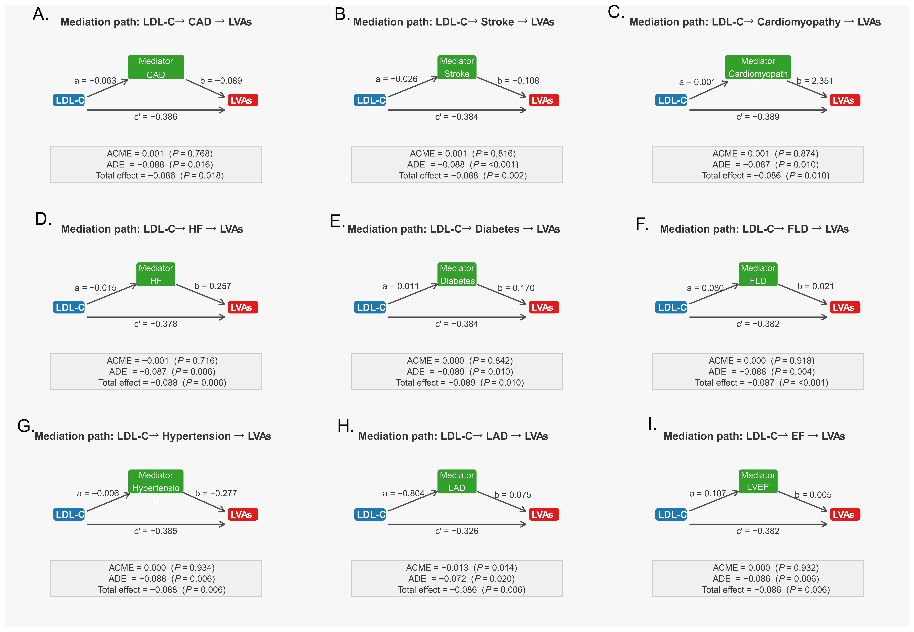
Exploratory mediation analyses were performed using a causal mediation framework to explore potential pathways linking LDL-C levels to the presence of LVAs. The prespecified candidate mediators included coronary artery disease (A), stroke (B), cardiomyopathy (C), heart failure (D), diabetes (E), fatty liver disease (F), hypertension (G), left atrial diameter (H), and left ventricular ejection fraction (I). For each mediator, the path coefficient from LDL-C to the mediator is denoted as a, the path coefficient from the mediator to LVAs as b, and the direct effect of LDL-C on LVAs after accounting for the mediator as c′. Average causal mediation effect (ACME), average direct effect (ADE), and total effect are shown for each model. Among all examined candidate mediators, only left atrial diameter showed a statistically significant indirect effect, suggesting that left atrial structural remodeling, reflected in part by LAD, may partly account for the observed association between LDL-C levels and LVAs. Mediation effects were estimated using 1,000 bootstrap iterations.
Abbreviations: LDL-C, low-density lipoprotein cholesterol; LVAs, left atrial low-voltage areas; CAD, coronary artery disease; HF, heart failure; FLD, fatty liver disease; LAD, left atrial diameter; LVEF, left ventricular ejection fraction; ACME, average causal mediation effect; ADE, average direct effect.

Supplementary Figure S4. Restricted cubic spline analysis of the association between LDL-C levels and postablation recurrence.
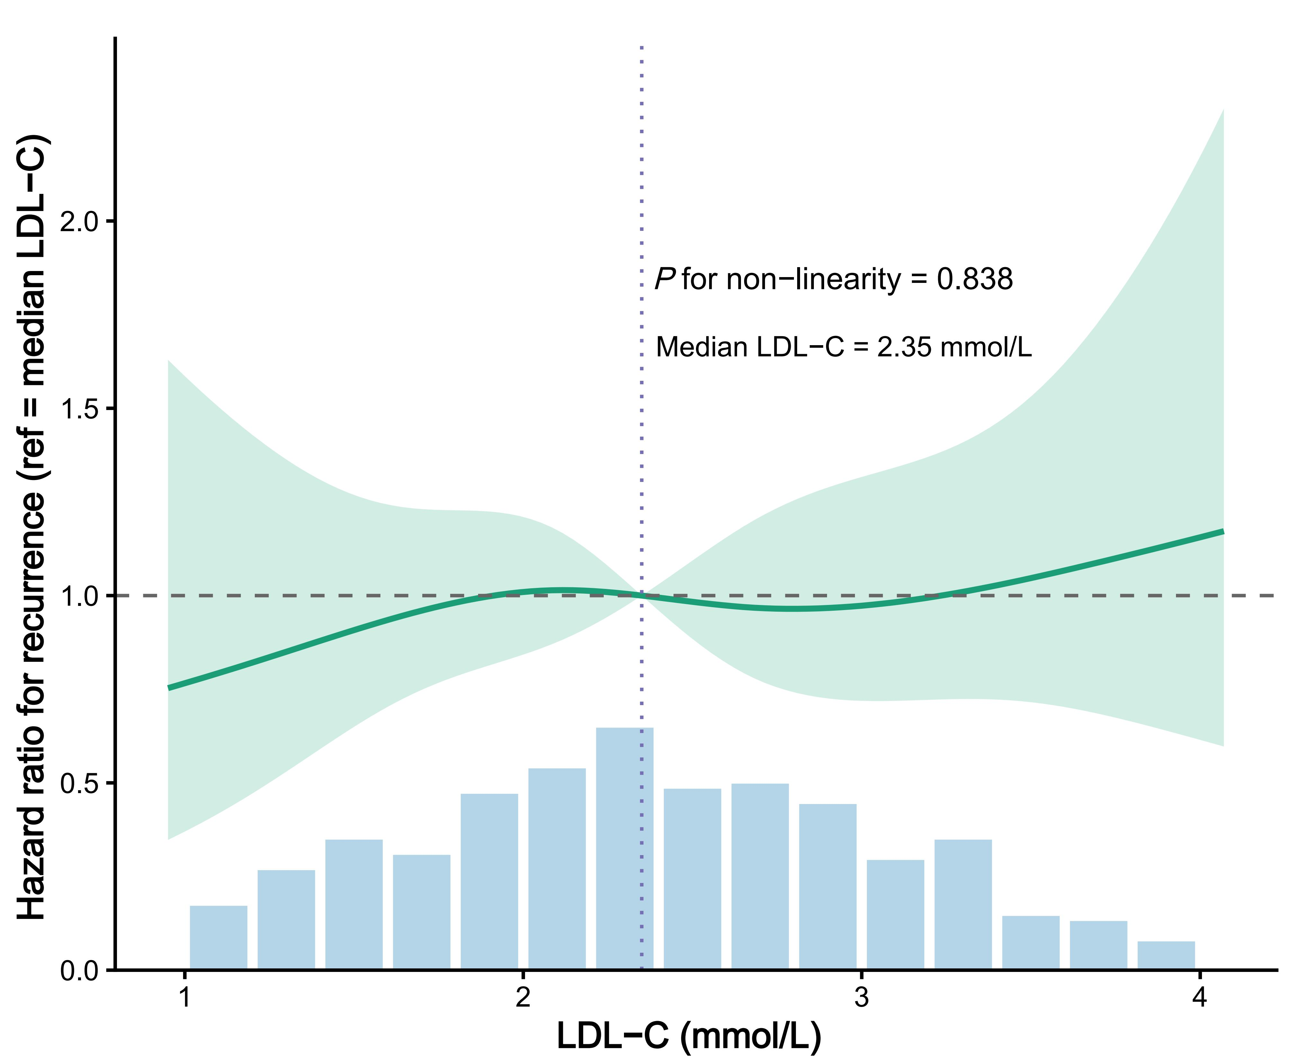

Restricted cubic spline analysis based on a Cox proportional hazards model was used to examine the association between LDL-C levels and postablation recurrence, with the median LDL-C level (2.35 mmol/L) as the reference. The model was adjusted for age and sex. Hazard ratios are presented relative to the median LDL-C value, and histogram bars indicate the distribution of LDL-C values in the study population. No significant evidence of nonlinearity was observed (P for non-linearity = 0.838). Quartile-based recurrence analyses were exploratory and descriptive, and Q3 was used as the model reference category for numerical comparison only rather than to indicate a biologically or clinically preferred LDL-C range.
Abbreviations: LDL-C, low-density lipoprotein cholesterol.
Supplementary Figure S5. Mediation analysis of the association between LDL-C levels and left atrial low-voltage areas through left atrial diameter in the sinus-rhythm mapping subgroup.
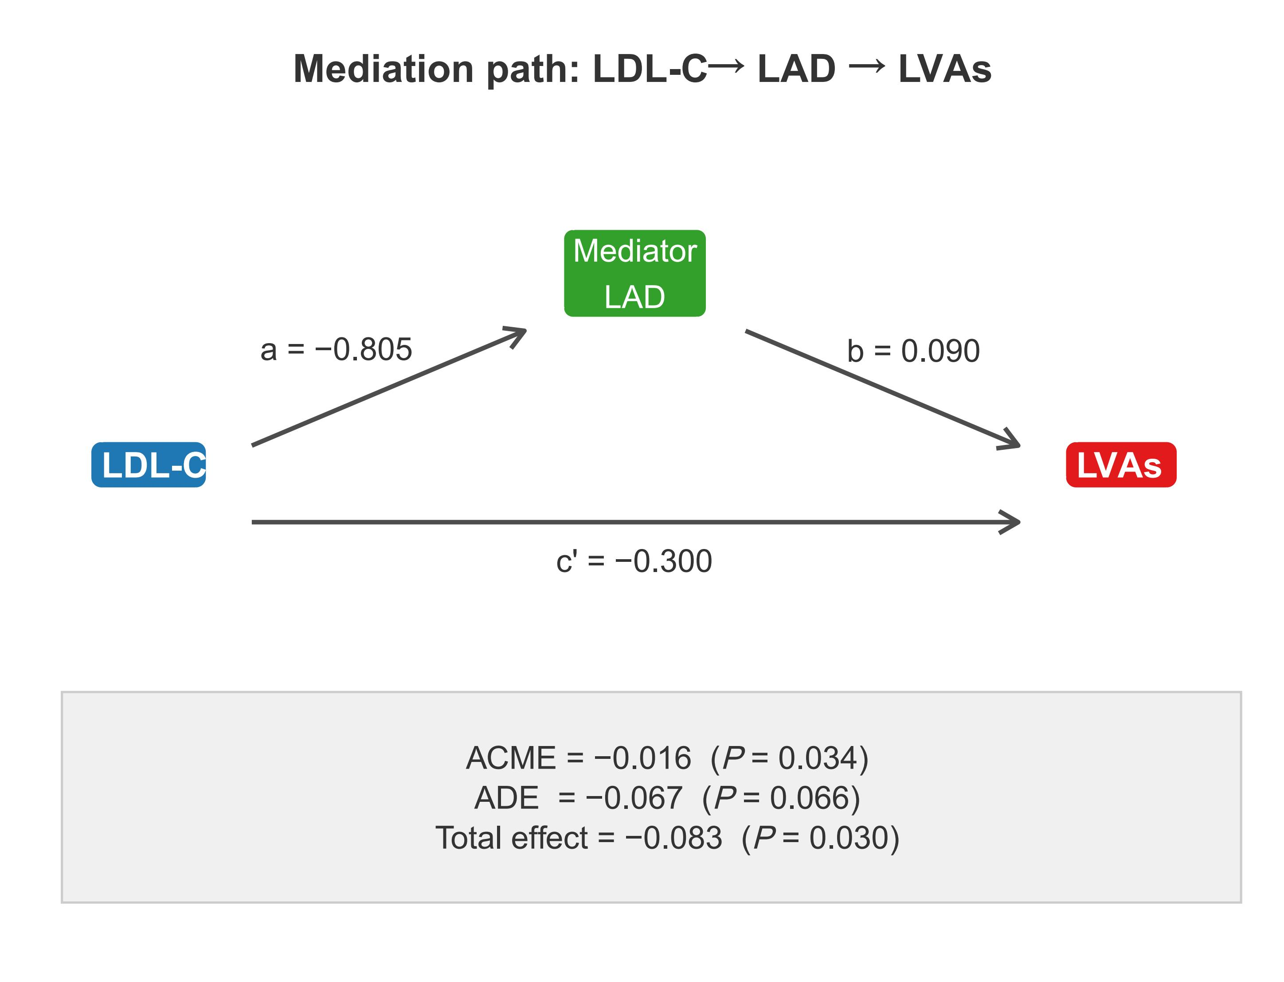

In patients who underwent substrate mapping during sinus rhythm, mediation analysis was performed to explore whether left atrial diameter may partly account for the association between LDL-C levels and the presence of left atrial low-voltage areas. Lower LDL-C levels were associated with a greater LAD (path a = −0.805), and a greater LAD was associated with a greater likelihood of LVAs (path b = 0.090). The indirect effect through LAD remained significant (ACME = −0.016, P = 0.034), accounting for approximately 18% of the total effect, whereas the direct effect was attenuated and no longer statistically significant (ADE = −0.067, P = 0.066). The total effect remained significant (total effect = −0.083, P = 0.030). Significance estimates were obtained using 1,000 bootstrap iterations.
Abbreviations: LDL-C, low-density lipoprotein cholesterol; LAD, left atrial diameter; LVAs, left atrial low-voltage areas; ACME, average causal mediation effect; ADE, average direct effect.
Supplementary Figure S6. Restricted cubic spline analysis of the association between LDL-C levels and the presence of left atrial low-voltage areas in the sinus-rhythm mapping subgroup.
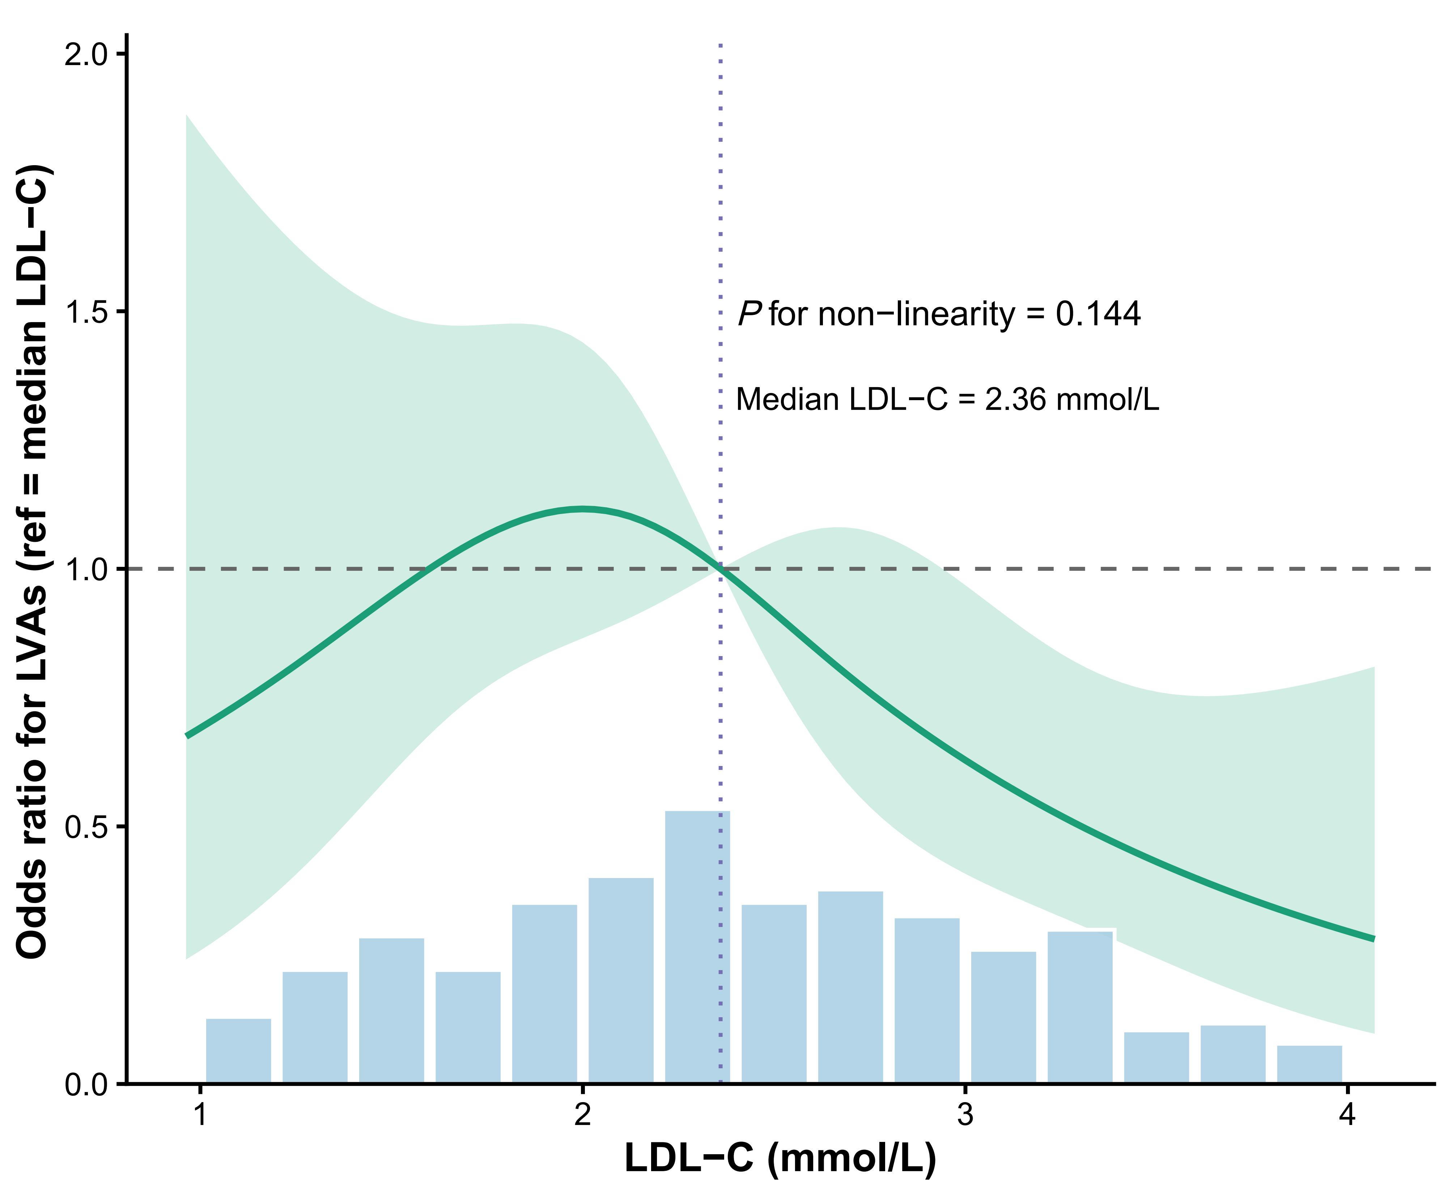
Restricted cubic spline analysis based on logistic regression was used to examine the association between LDL-C levels and the presence of left atrial low-voltage areas in patients who underwent substrate mapping during sinus rhythm, with the median LDL-C level (2.36 mmol/L) as the reference. The model was adjusted for age and sex. Odds ratios are presented relative to the median LDL-C value. No significant evidence of nonlinearity was observed (P for non-linearity = 0.144), and the overall curve pattern was broadly similar to that observed in the overall cohort.
Abbreviations: LDL-C, low-density lipoprotein cholesterol; LVAs, left atrial low-voltage areas.
Supplementary Figure S7. Kaplan–Meier curves for postablation recurrence according to LDL-C quartiles in the sinus-rhythm mapping subgroup.
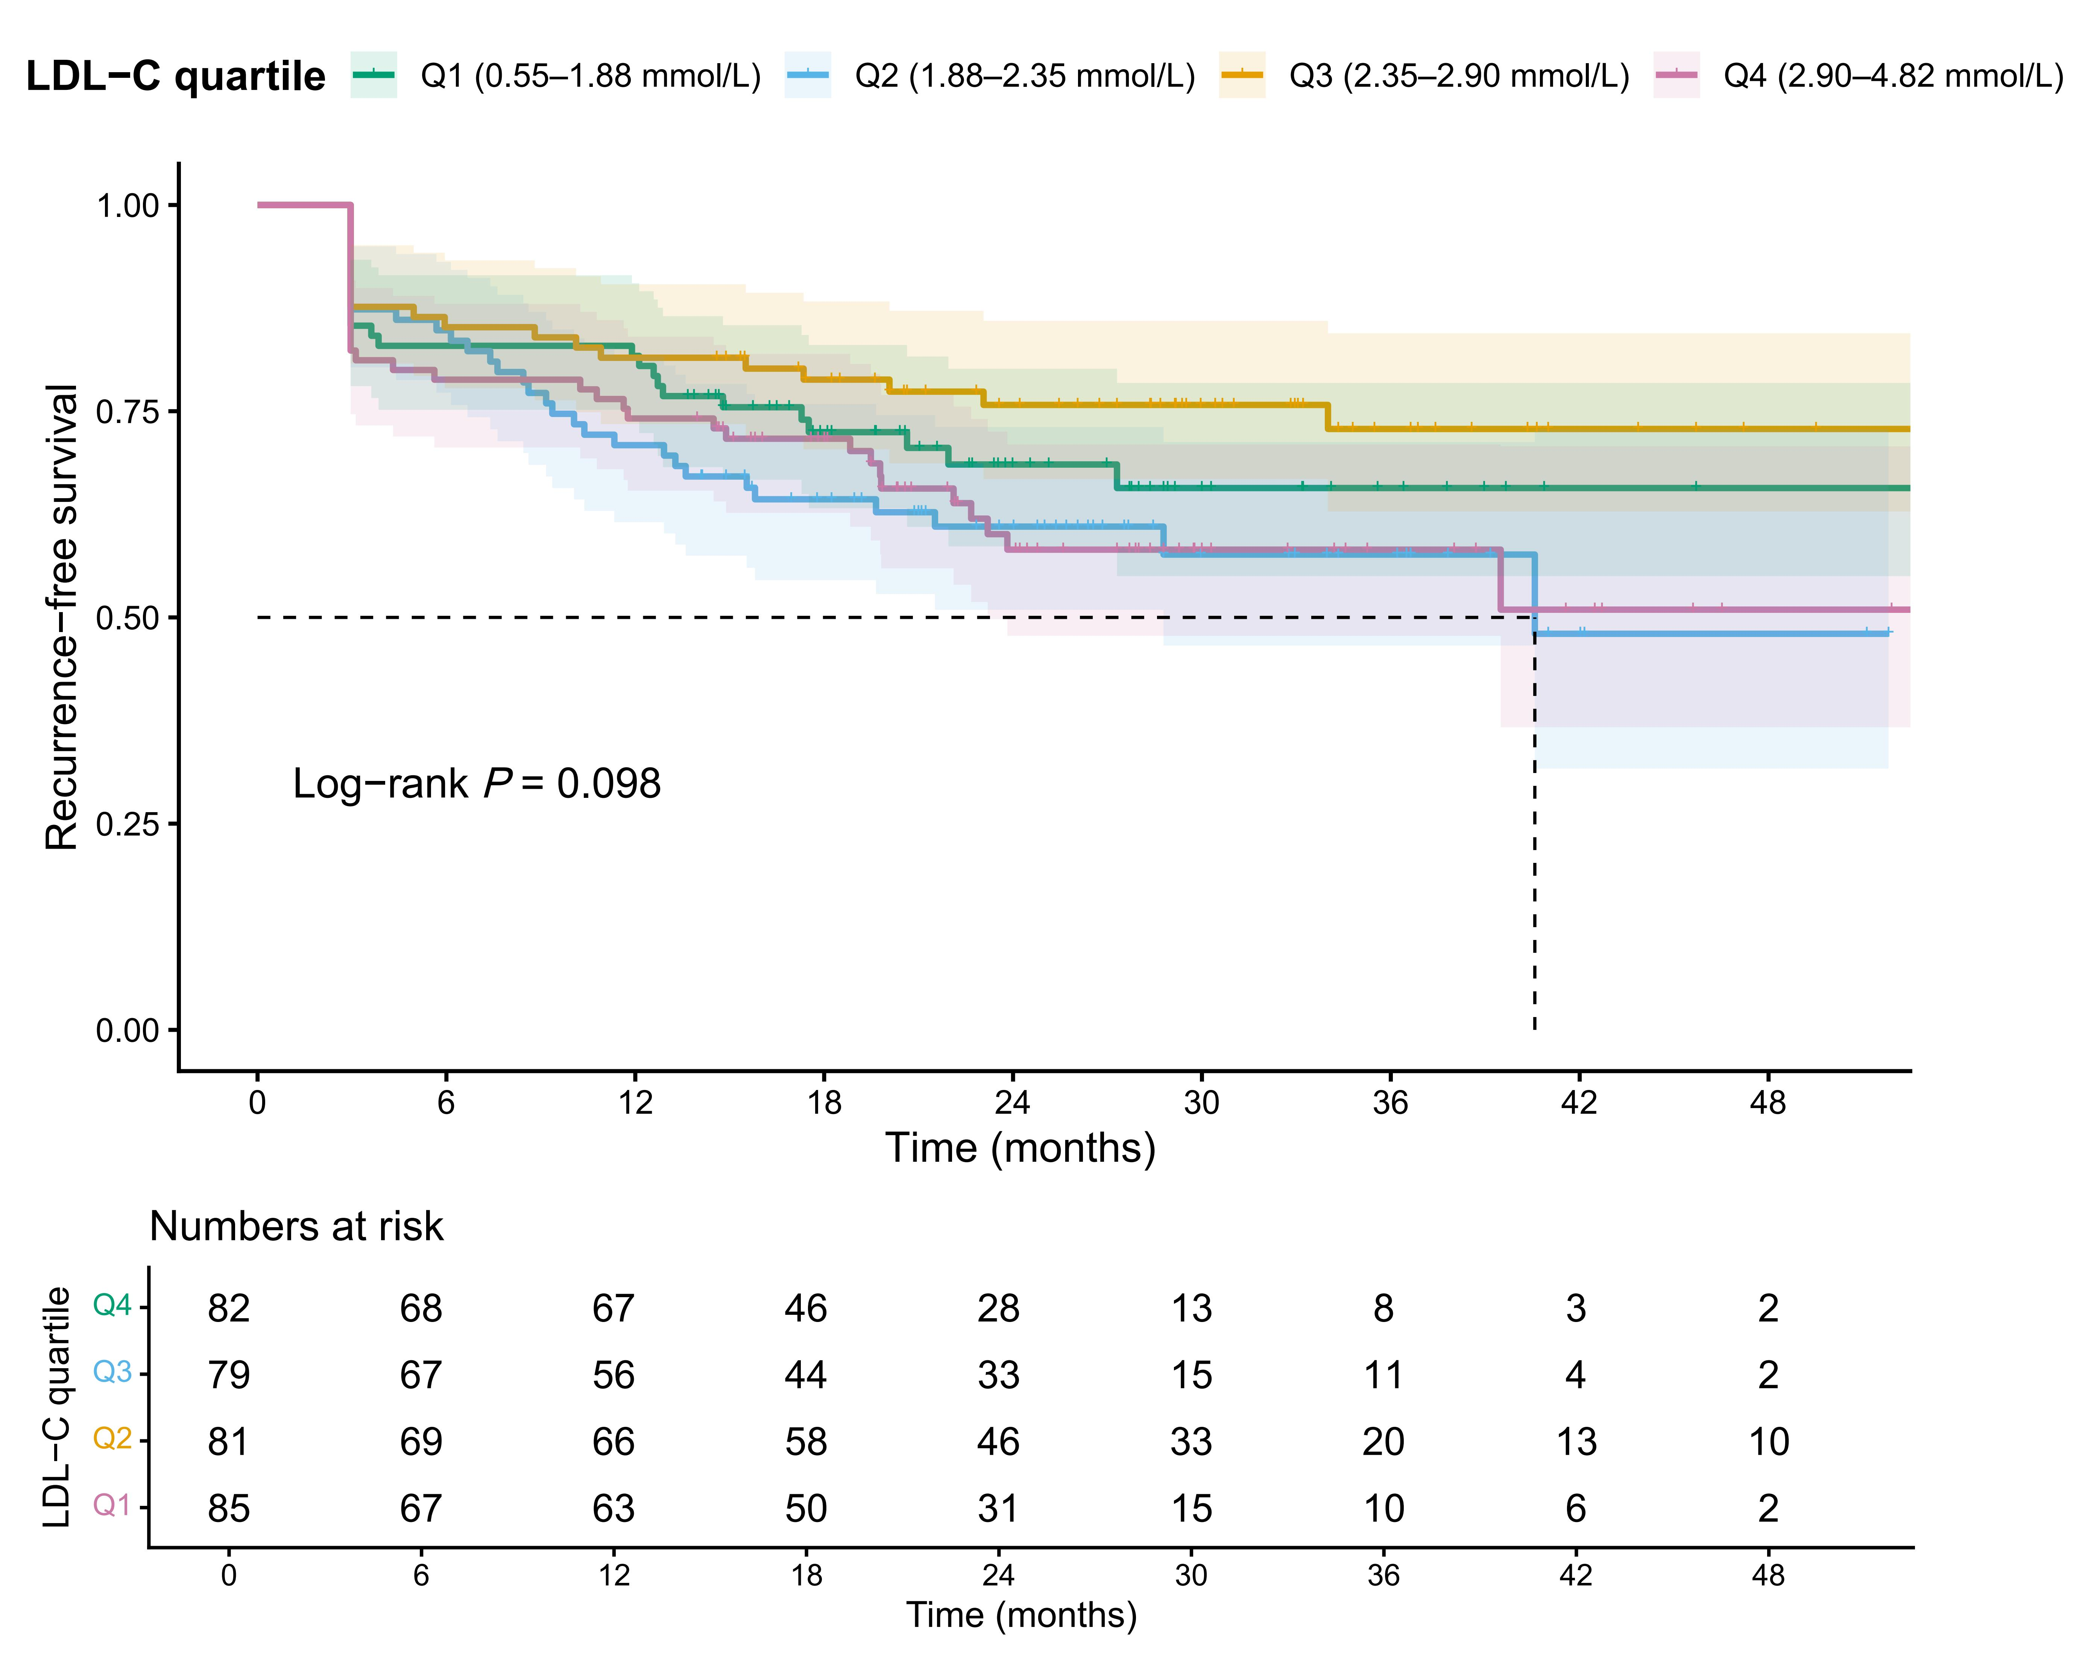
Kaplan–Meier analysis in the sinus-rhythm mapping subgroup showed no statistically significant difference in recurrence-free survival across LDL-C quartiles (log-rank P = 0.098), although a broadly similar qualitative separation of the quartile curves was observed. These quartile-based findings were exploratory and descriptive.
Abbreviations: LDL-C, low-density lipoprotein cholesterol; Q, quartile.
Supplementary Figure S8. Exploratory mediation analysis of the association between LDL-C and left atrial low-voltage areas through LAD after excluding patients with coronary artery disease.
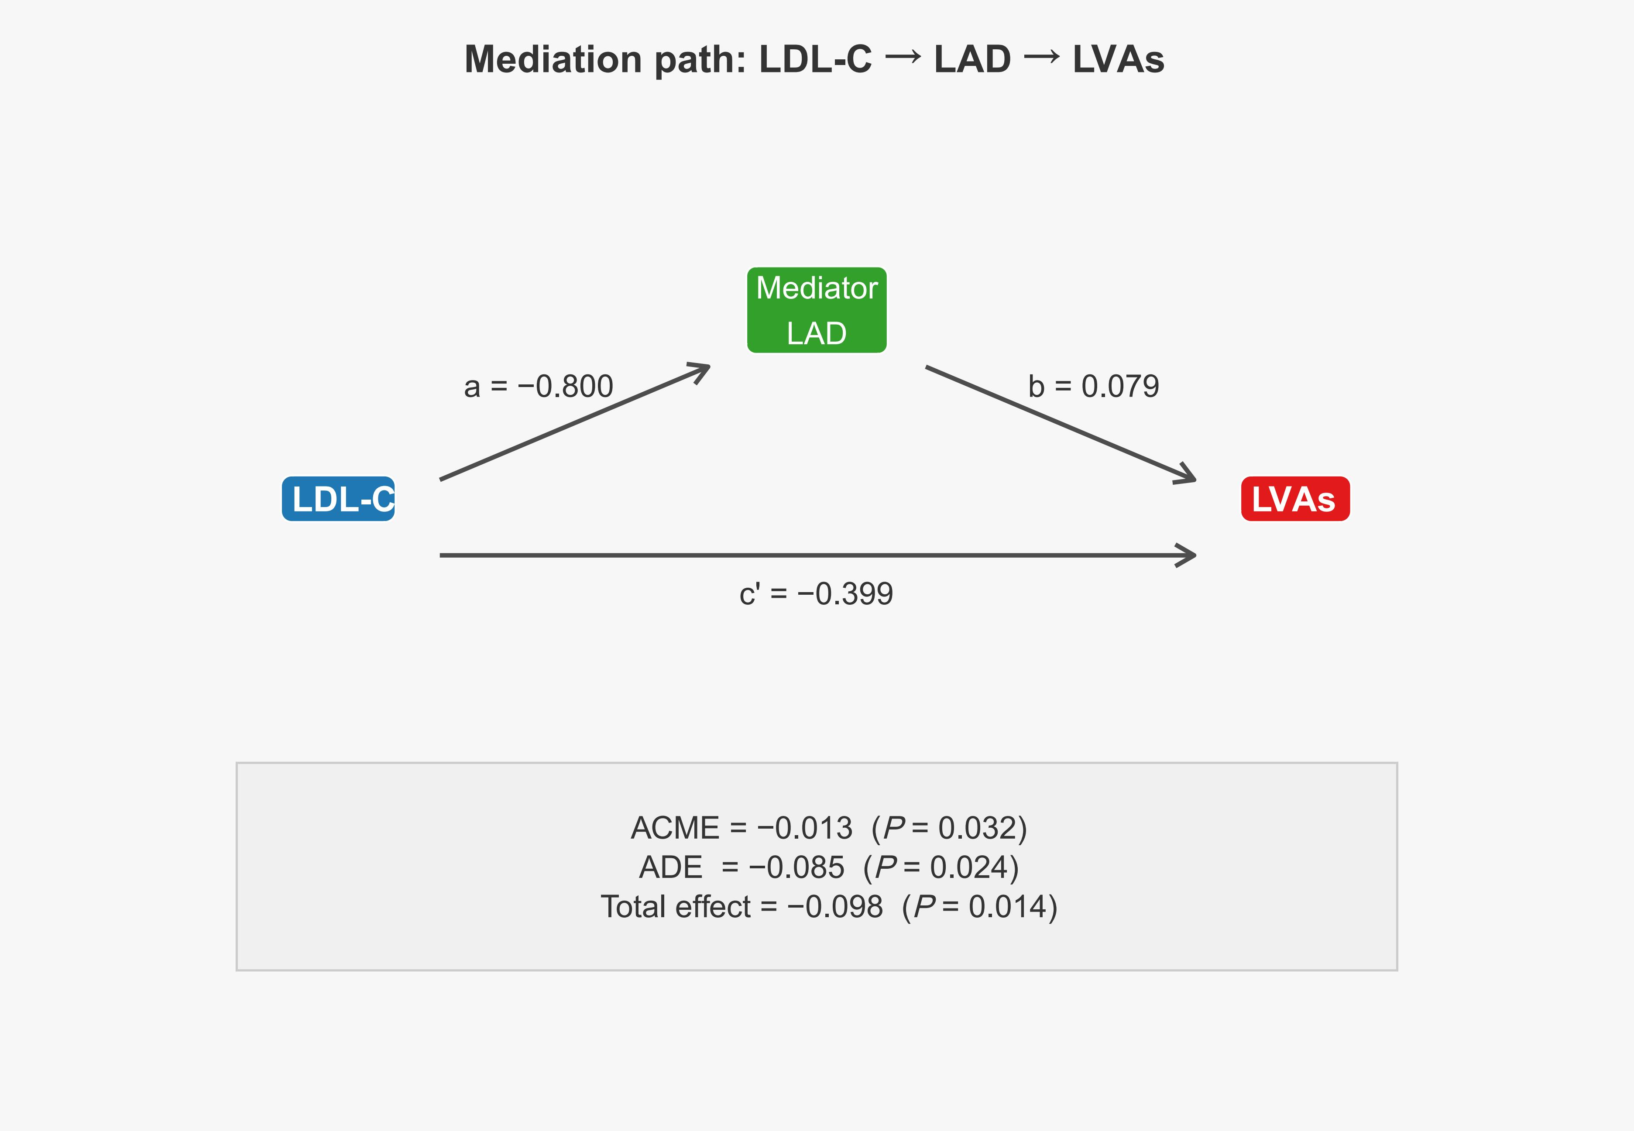
This figure shows the exploratory mediation analysis evaluating whether LAD partially mediated the association between LDL-C and the presence of left atrial low-voltage areas (LVAs) in the cohort excluding patients with coronary artery disease. The path coefficient from LDL-C to LAD was a = −0.800, the path coefficient from LAD to LVAs was b = 0.079, and the direct effect of LDL-C on LVAs was c′ = −0.399. The average causal mediation effect (ACME) was −0.013 (P = 0.032), the average direct effect (ADE) was −0.085 (P = 0.024), and the total effect was −0.098 (P = 0.014).
Abbreviations: LDL-C, low-density lipoprotein cholesterol; LAD, left atrial diameter; LVAs, left atrial low-voltage areas; ACME, average causal mediation effect; ADE, average direct effect.
Supplementary Figure S9. Kaplan–Meier analysis of recurrence-free survival across LDL-C quartiles after excluding patients with coronary artery disease.
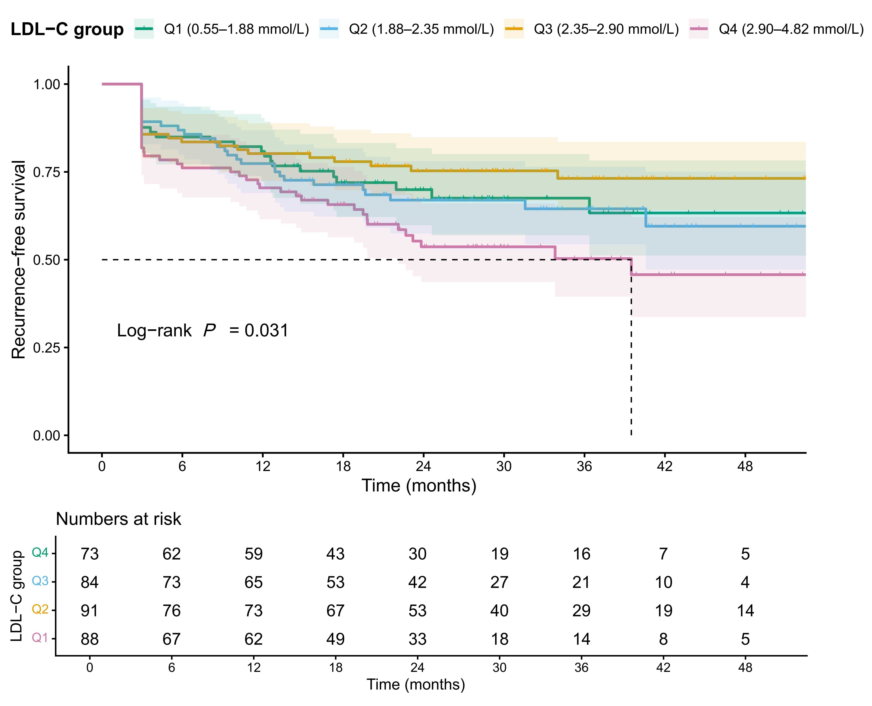
Kaplan–Meier curves show recurrence-free survival after catheter ablation according to baseline LDL-C quartiles in the cohort excluding patients with coronary artery disease. LDL-C quartiles were defined using the same cutoff values as in the main analysis: Q1, 0.55–1.88 mmol/L; Q2, 1.88–2.35 mmol/L; Q3, 2.35–2.90 mmol/L; and Q4, 2.90–4.82 mmol/L. Differences among groups were assessed using the log-rank test (P = 0.031). The numbers at risk are shown below the plot. The pattern of curve separation was broadly similar to that observed in the main cohort.
Abbreviations: LDL-C, low-density lipoprotein cholesterol; Q, quartile.
Supplementary Figure S10. Scatter plots of LDL-C and total LVA burden in the sinus-rhythm subgroup with complete quantitative data.
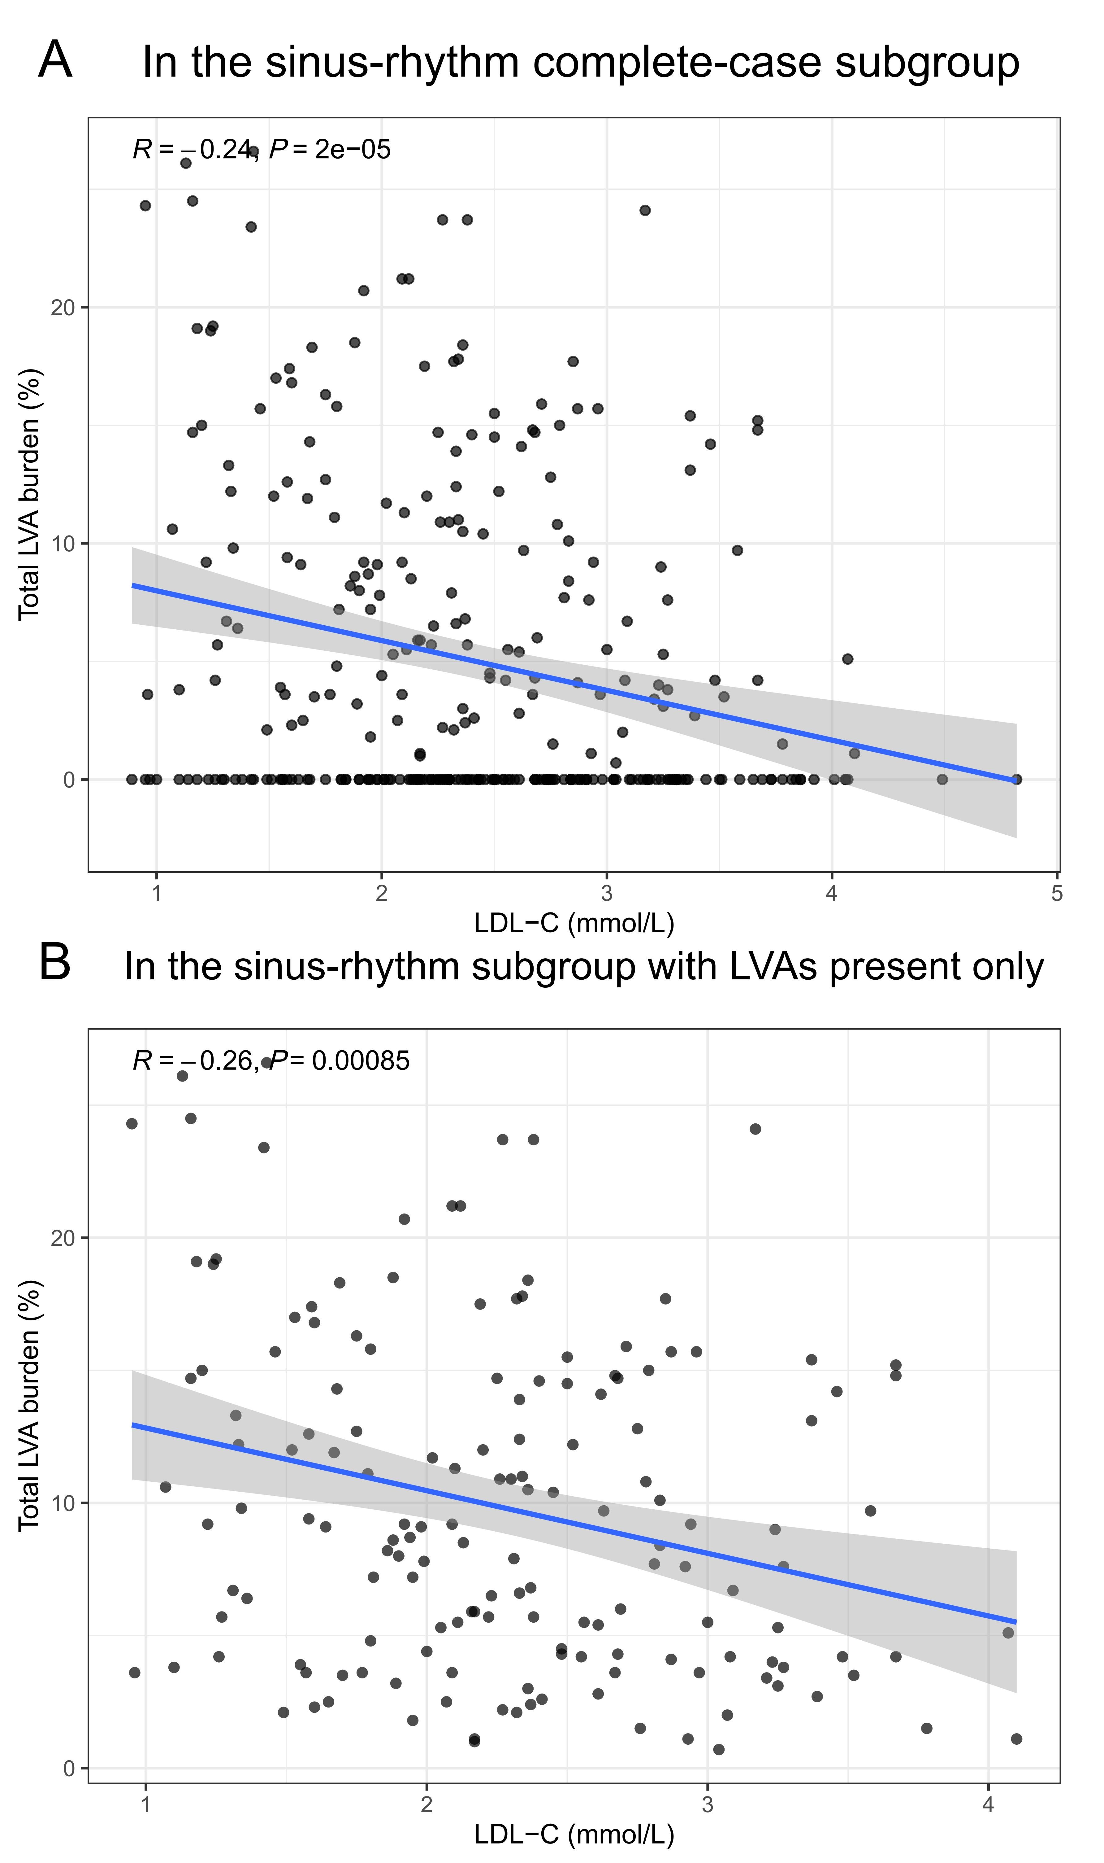
Solid lines indicate fitted linear regression lines, and shaded areas represent 95% confidence intervals. S10A, association between LDL-C and total LVA burden in the sinus-rhythm complete-case subgroup. S10B, association between LDL-C and total LVA burden in the sinus-rhythm subgroup with LVAs present only.
Abbreviations: LDL-C, low-density lipoprotein cholesterol; LVA, left atrial low-voltage area.
Supplementary Figure S11. LDL-C across five total LVA burden groups in the sinus-rhythm subgroup with complete quantitative data.
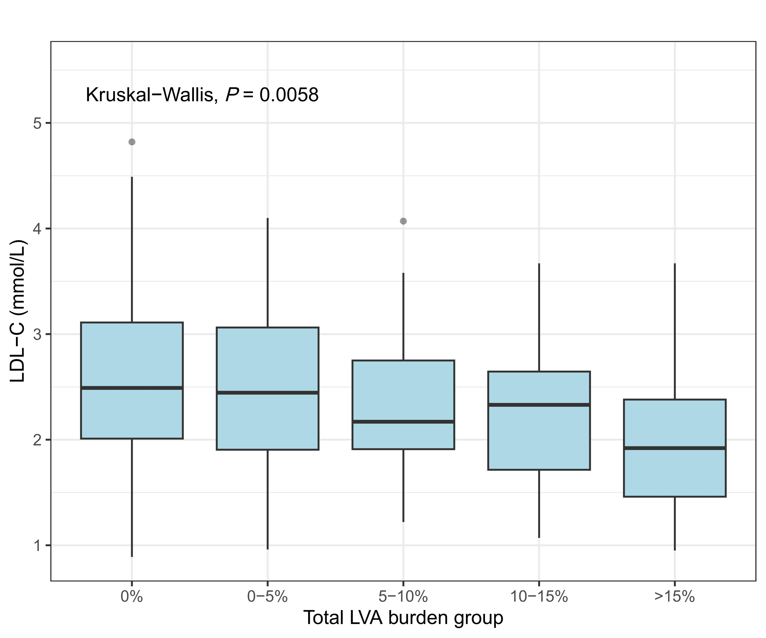
The overall difference across groups was assessed using the Kruskal-Wallis test. The figure shows a significant overall difference in LDL-C across the five burden groups (Kruskal-Wallis P = 0.0058).
Abbreviations: LDL-C, low-density lipoprotein cholesterol; LVA, left atrial low-voltage area.

