Supplementary Materials

Title: Sex-Dimorphic Phenotypic Divergence in Metabolically Driven Thyroid Nodules: The Interplay of Systemic Inflammation and Adiposity
Authors:
Huanqiong Fan^{1#}, Yingyong Yin^{2#}, Shaopeng Huang³, Zhibo Cui⁴, Ling Dao⁵, Guosong Jiang^{6 7*}, Chi-E Qiu^{8*}

Supplementary Figure S1. Directed acyclic graph (DAG). . 1
Supplementary Table S1.Collinearity Diagnostics for Covariates Based on Tolerance and Variance Inflation Factor(VIF) 2
Supplementary Figure S2 Model validation and diagnostic plots for TI-RADS 2 3
Supplementary Figure S3 Model validation and diagnostic plots for TI-RADS 3 4
Supplementary Figure S4 Model validation and diagnostic plots for TI-RADS 4 5
Supplementary Table S2. Association of CHG with thyroid nodule across TI-RADS categories in the overall participant 6
Supplementary Table S3. Association of CHG with thyroid nodule across TI-RADS categories among males. 7
Supplementary Table S4 Association of CHG with thyroid nodule across TI-RADS categories among females. 8
Supplementary Table S5. Sensitivity analysis: Multivariable-adjusted associations between CHG and thyroid nodules across TI-RADS categories among male participants with normal TSH levels. 9
Supplementary Table S6. Sensitivity analysis: Multivariable-adjusted associations between CHG and thyroid nodules across TI-RADS categories among females participants with normal TSH levels. 10
Supplementary Table S7. Sensitivity analysis using a complete-case dataset: Multivariable-adjusted associations between CHG and the presence of thyroid nodules across TI-RADS categories in male participants. 11
Supplementary Table S8. Sensitivity analysis using a complete-case dataset: Multivariable-adjusted associations between CHG and the presence of thyroid nodules across TI-RADS categories in female participants. 12
Supplementary Table S9. Sensitivity analysis: Multivariable-adjusted associations between CHG and the presence of thyroid nodules across TI-RADS categories in women aged <50 years. 13
Supplementary Table S10. Sensitivity analysis: Multivariable-adjusted associations between CHG and the presence of thyroid nodules across TI-RADS categories in women aged ≥50 years. 14
Supplementary Table S11. Sensitivity analysis: Multivariable-adjusted associations between CHG and the presence of thyroid nodules across TI-RADS categories among male participants with BMI <28 (N = 11,943). 15
Supplementary Table S12. Sensitivity analysis: Multivariable-adjusted associations between CHG and the presence of thyroid nodules across TI-RADS categories among non-diabetic male participants. 16
Supplementary Table S13. Sensitivity analysis: Multivariable-adjusted associations between CHG and the presence of thyroid nodules across TI-RADS categories among non-diabetic female participants. 17
Supplementary Table S14. Sensitivity analysis: Mediation analysis of the association between CHG and TI-RADS category 3 thyroid nodules mediated by RDW among non-anemic men. 18
Supplementary Table S15. Sensitivity analysis: Mediation analysis of the association between CHG and TI-RADS category 3 thyroid nodules mediated by red blood cell distribution width (RDW) among male participants after excluding individuals with leukocytosis (white blood cell count >10 × 10⁹/L). 18
Supplementary Table S16. Sensitivity analysis: Mediation analysis of the association between CHG and TI-RADS category 3 thyroid nodules mediated by mean corpuscular volume (MCV) among male participants. 19

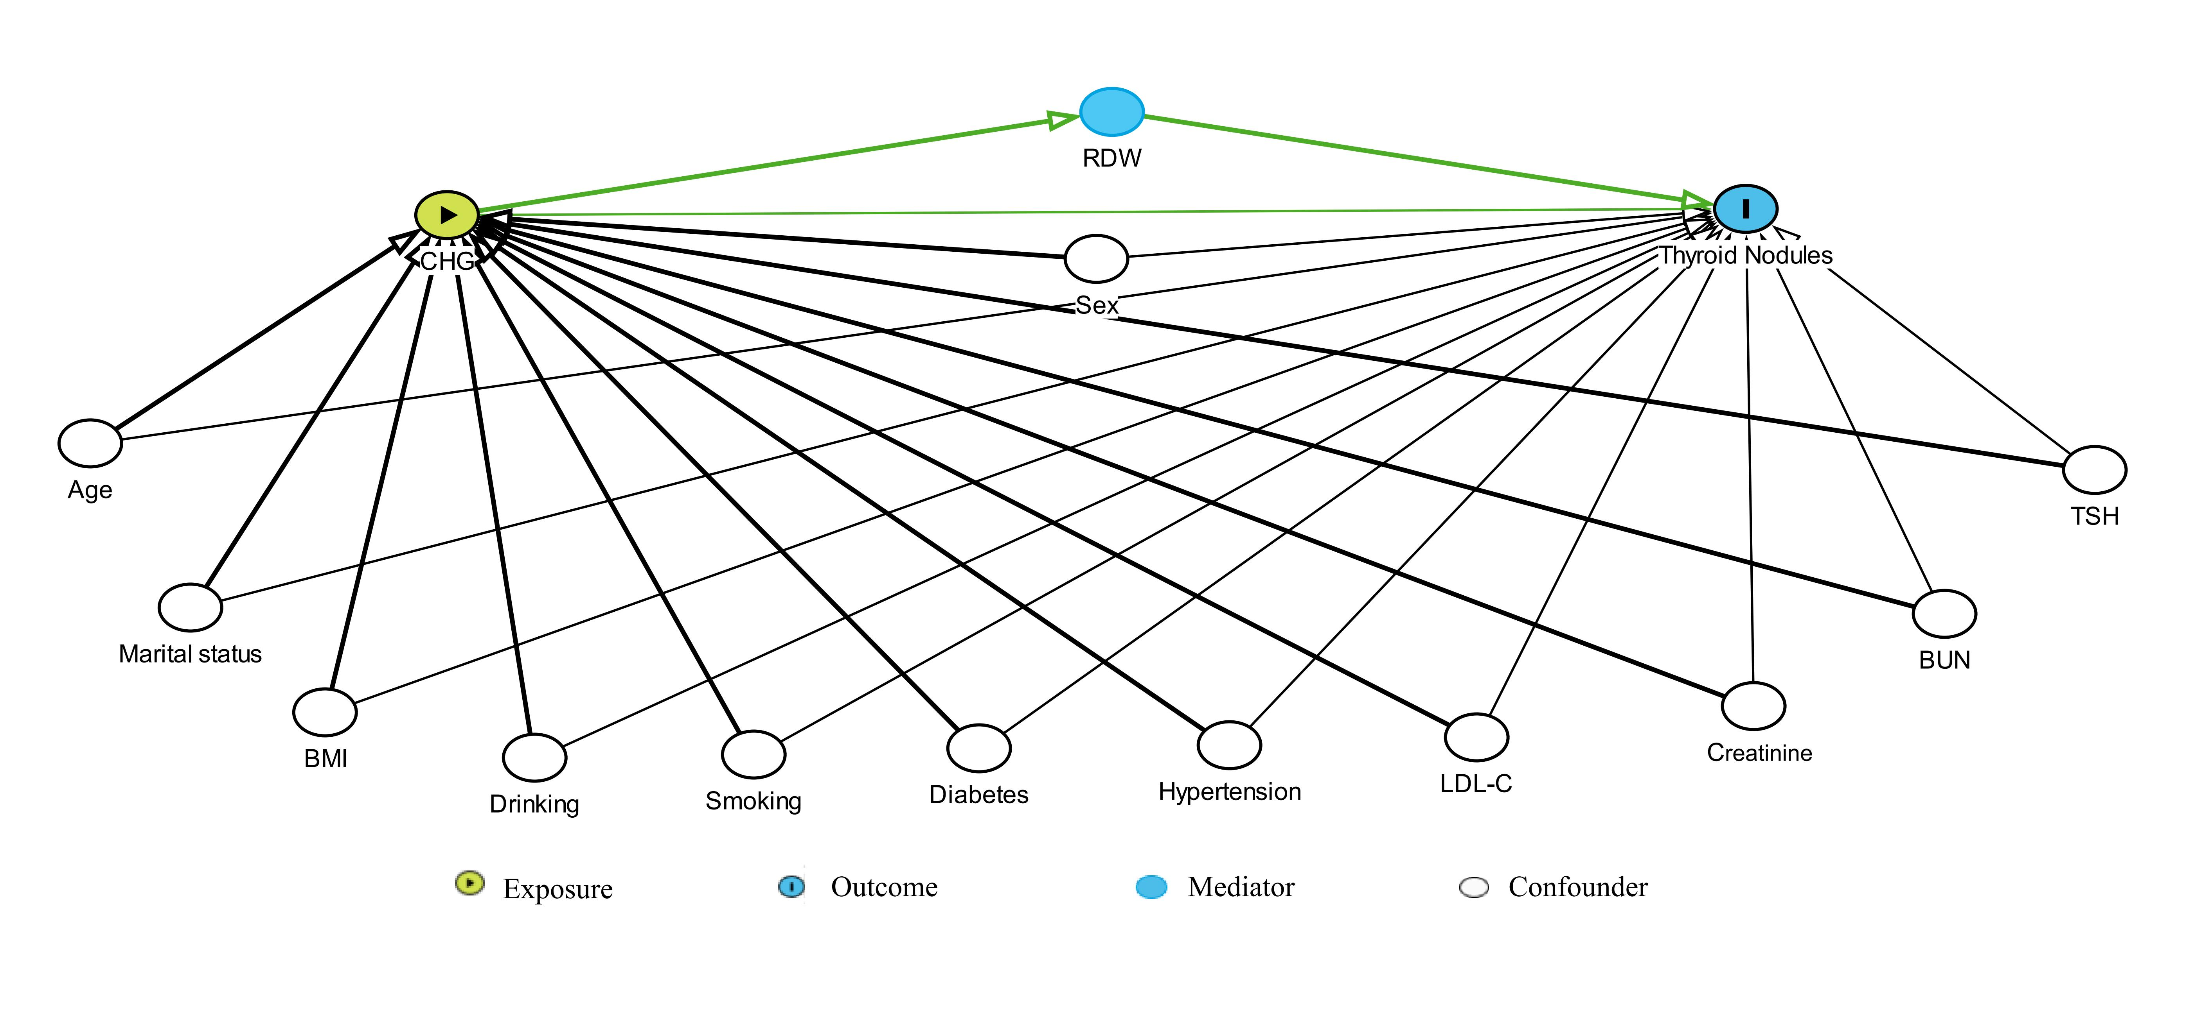

Supplementary Figure S1. Directed acyclic graph (DAG). Abbreviations: BMI, body mass index; BUN, blood urea nitrogen; LDL-C, low-density lipoprotein cholesterol; TSH, thyroid-stimulating hormone; RDW, red blood cell distribution width. RDW as a mediator of the association between CHG and TI-RADS 3 among male participants.

Supplementary Table S1. Collinearity Diagnostics for Covariates Based on Tolerance and Variance Inflation Factor (VIF)
Variables | VIF
Age | 1.385
Sex | 1.931
Marital status | 1.162
Smoking status | 1.38
Drinking status | 1.329
history of hypertension | 1.275
history of diabetes | 1.163
BMI | 1.382
Creatinine | 1.867
BUN | 1.296
LDL-C | 1.252
TSH | 1.047
Abbreviations: BMI, body mass index; BUN, blood urea nitrogen; LDL-C, low-density lipoprotein cholesterol; TSH, thyroid-stimulating hormone. all VIF values were < 5, indicating no meaningful multicollinearity among covariates. Accordingly, all listed variables were considered suitable for inclusion in subsequent multivariable analyses without further collinearity-driven adjustment.

Supplementary Figure S2 Model validation and diagnostic plots for TI-RADS 2

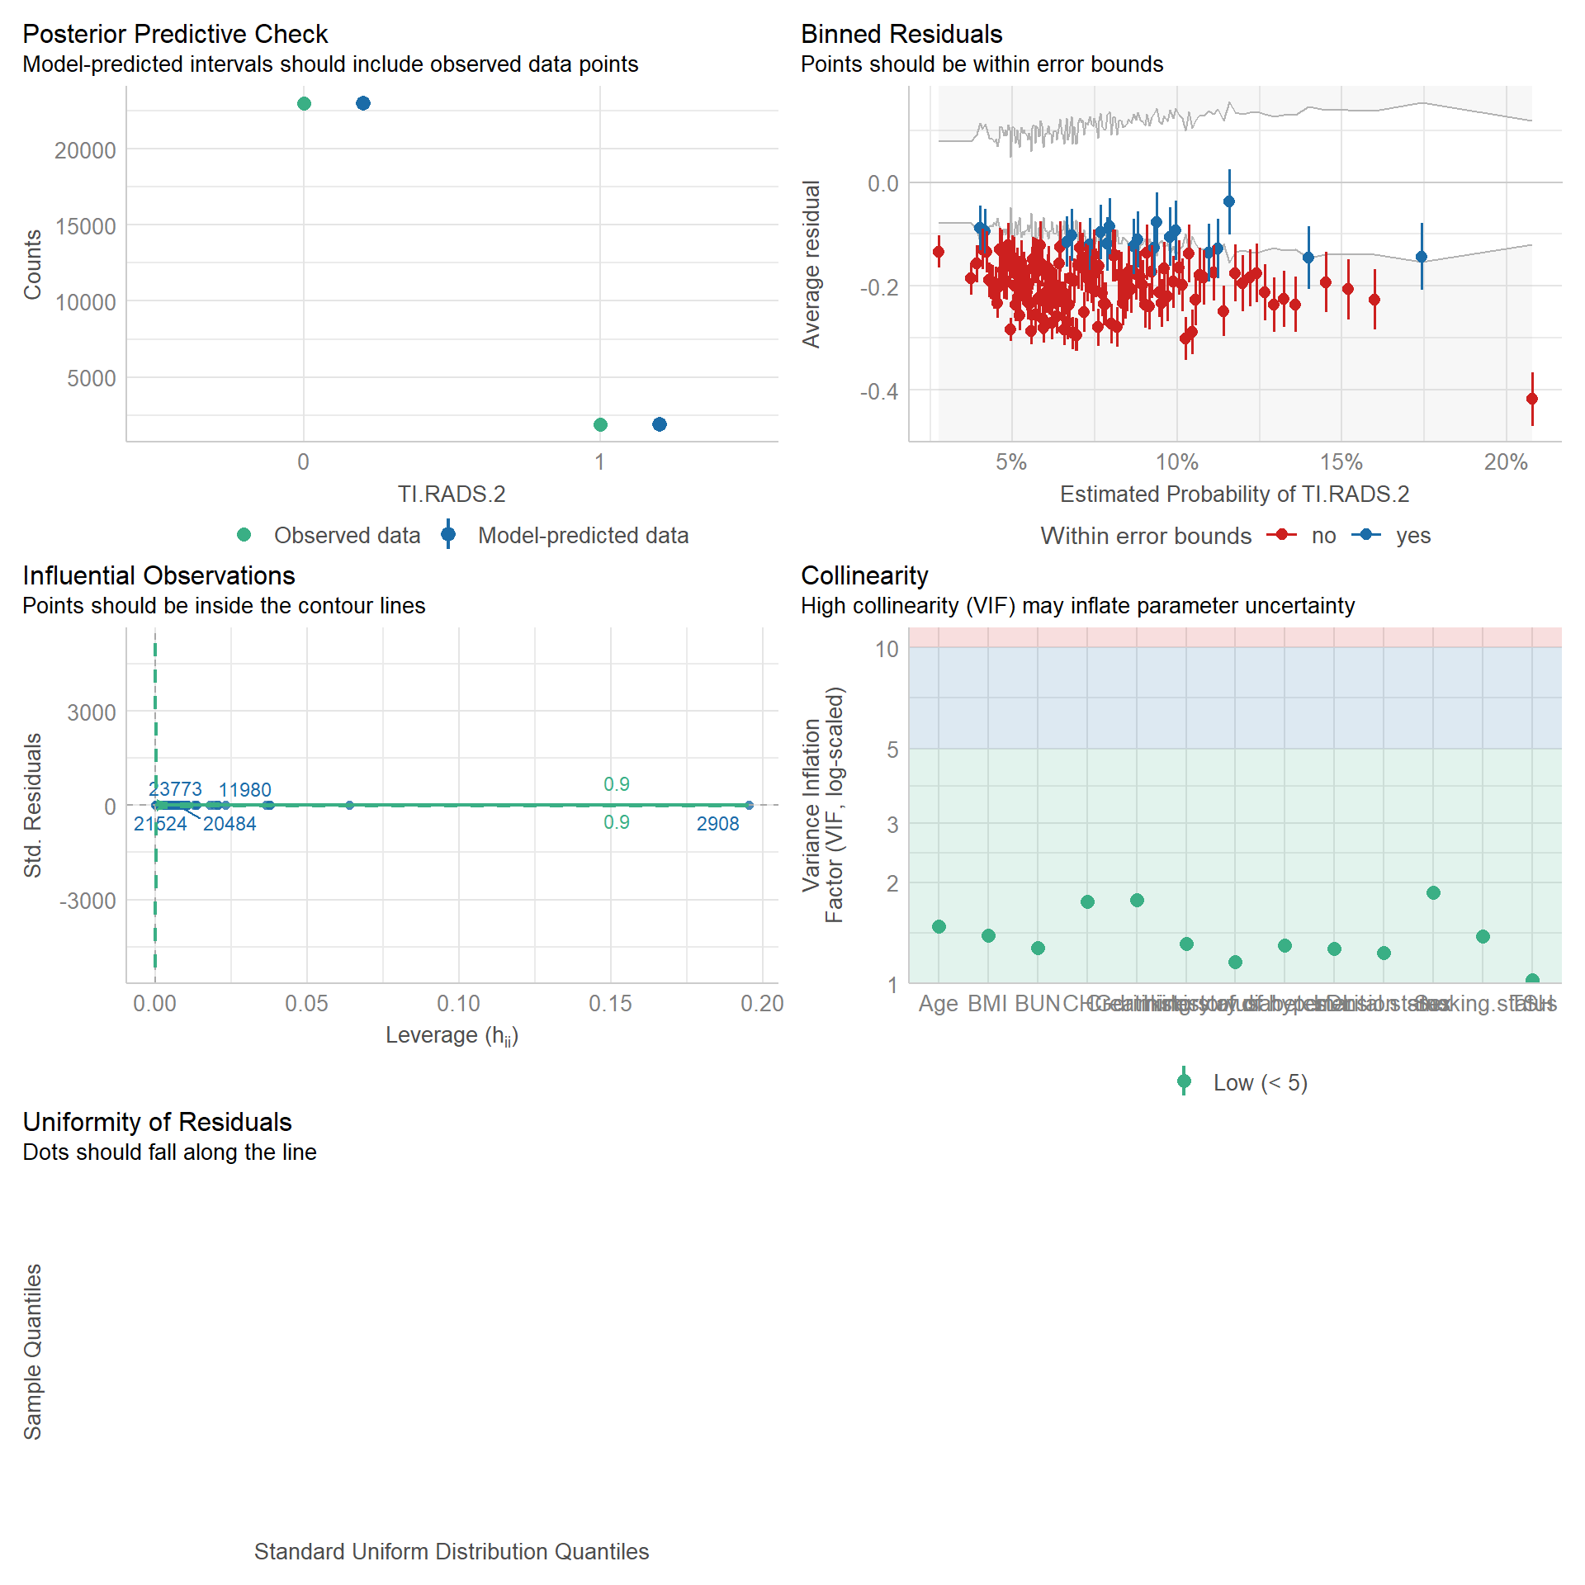

Supplementary Figure S3 Model validation and diagnostic plots for TI-RADS 3

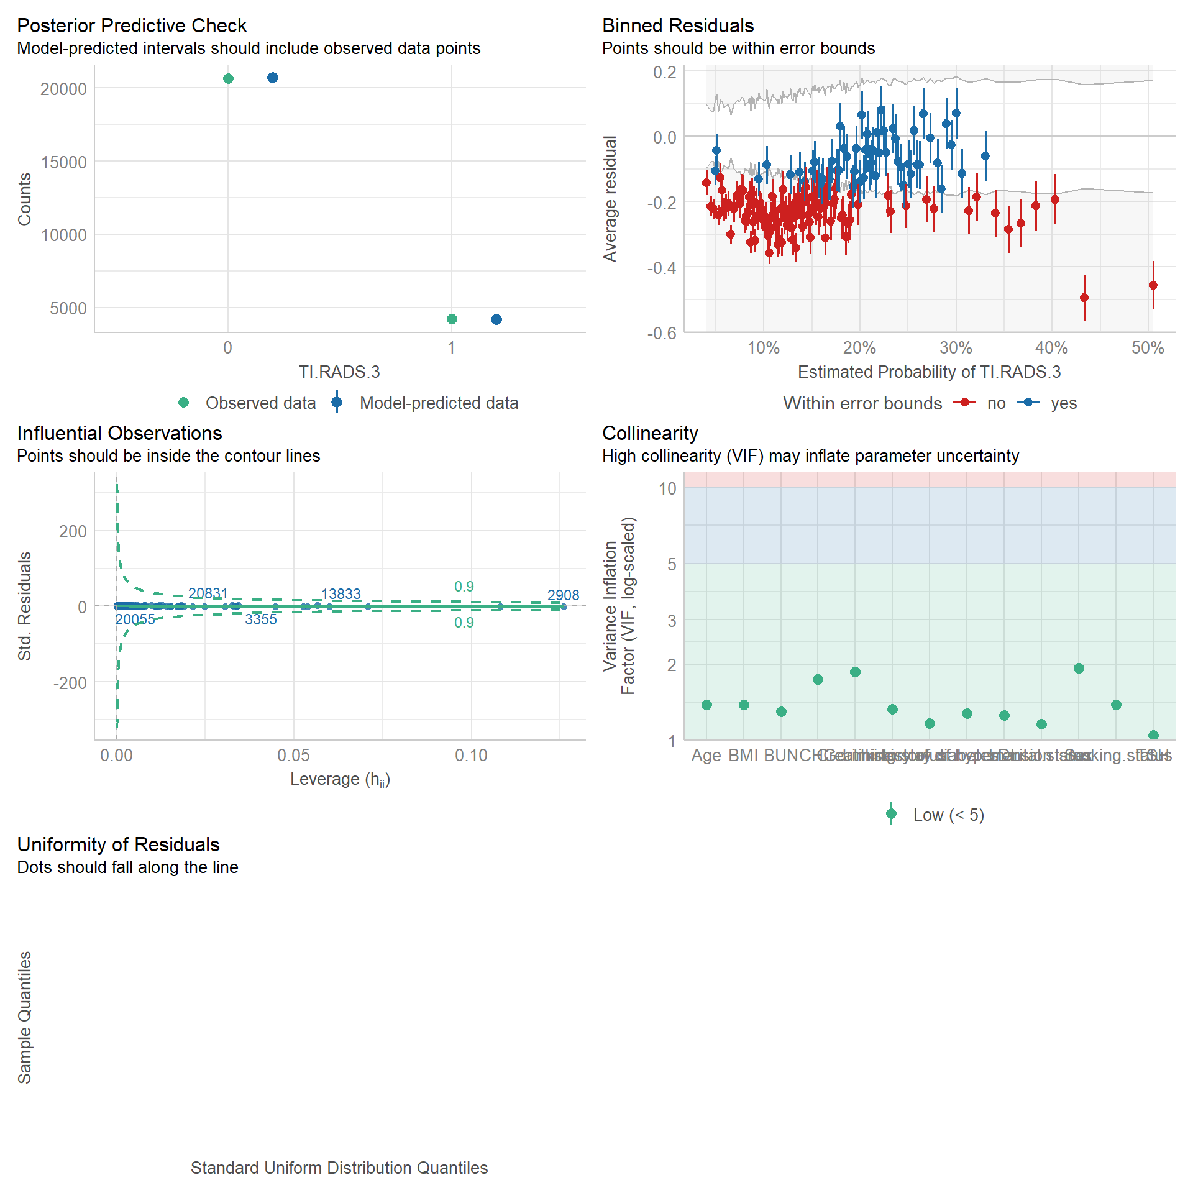

Supplementary Figure S4 Model validation and diagnostic plots for TI-RADS 4
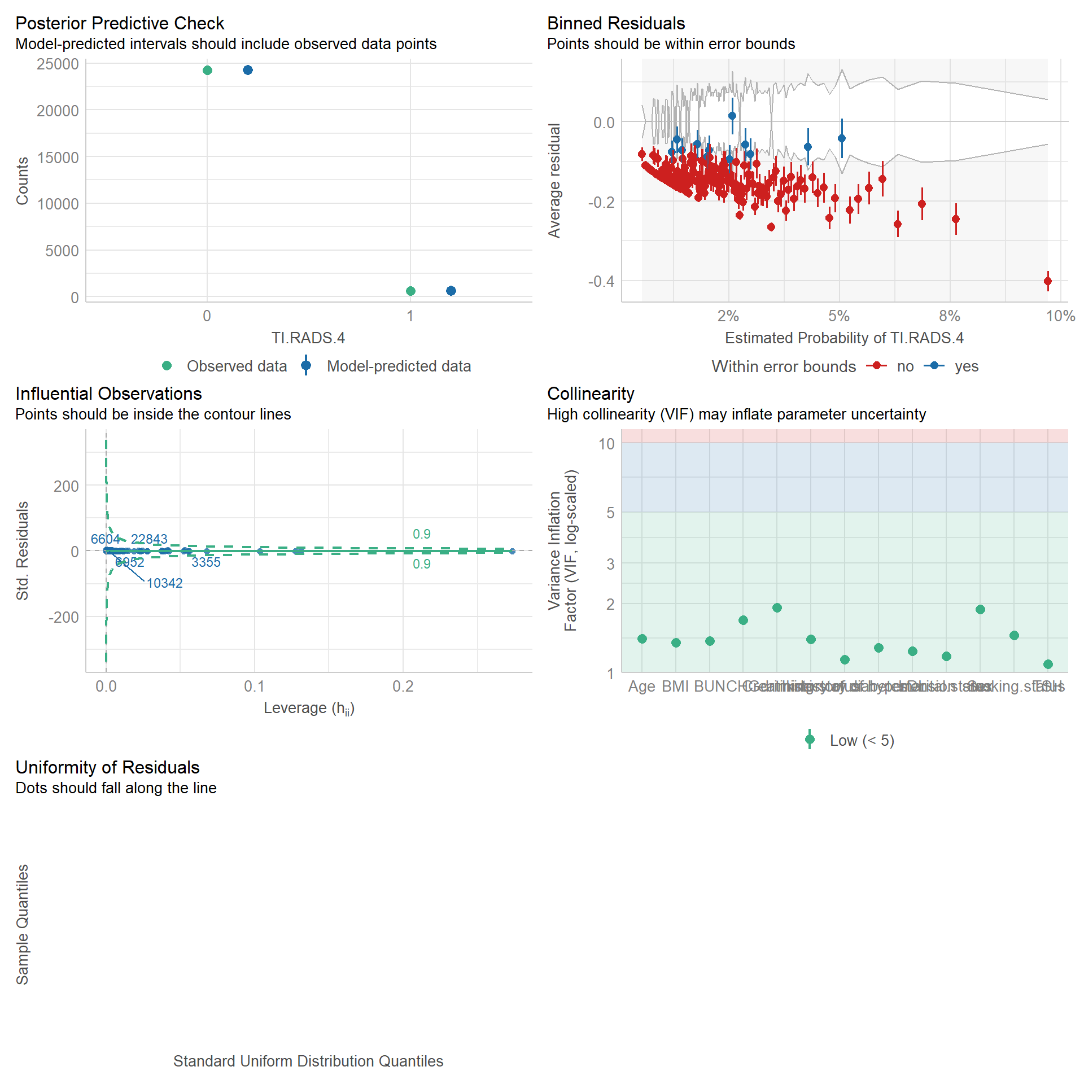

Supplementary Table S2. Association of CHG with thyroid nodule across TI-RADS categories in the overall participant
 |  | Model 1 |  | Model 2 |  | Model 3 |  | Model 4
 |  | OR (95% CI) | P-value | OR (95% CI) | P-value | OR (95% CI) | P-value | OR (95% CI) | P-value
CHG | TI-RADS 2 | 1.13 (0.99~1.28) | 0.067 | 1 (0.87~1.15) | 0.977 | 0.97 (0.84~1.12) | 0.675 | 0.99 (0.83~1.17) | 0.883
CHG tertiles
T1 |  | 1(Ref) |  | 1(Ref) |  | 1(Ref) |  | 1(Ref)
T2 |  | 0.96 (0.86~1.08) | 0.534 | 0.91 (0.81~1.03) | 0.123 | 0.91 (0.81~1.02) | 0.117 | 0.91 (0.80~1.03) | 0.151
T3 |  | 1.08 (0.96~1.2) | 0.212 | 0.98 (0.87~1.11) | 0.752 | 0.96 (0.85~1.09) | 0.562 | 0.97 (0.84~1.12) | 0.681
p for trend |  |  | 0.207 |  | 0.785 |  | 0.578 |  | 0.736
CHG | TI-RADS 3 | 1.40 (1.28~1.54) | <0.001 | 1.32 (1.20~1.47) | <0.001 | 1.25 (1.12~1.38) | <0.001 | 1.19 (1.05~1.34) | 0.006
CHG tertiles
T1 |  | 1(Ref) |  | 1(Ref) |  | 1(Ref) |  | 1(Ref)
T2 |  | 1.16 (1.06~1.26) | 0.001 | 1.12 (1.03~1.23) | 0.009 | 1.12 (1.03~1.22) | 0.011 | 1.09 (1.00~1.20) | 0.061
T3 |  | 1.31 (1.21~1.43) | <0.001 | 1.28 (1.17~1.40) | <0.001 | 1.23 (1.13~1.35) | <0.001 | 1.19 (1.06~1.32) | 0.002
p for trend |  |  | <0.001 |  | <0.001 |  | <0.001 |  | 0.002
CHG | TI-RADS 4 | 1.45 (1.17~1.80) | 0.001 | 1.62 (1.28~2.05) | <0.001 | 1.62 (1.27~2.06) | <0.001 | 1.28 (0.96~1.70) | 0.097
CHG tertiles
T1 |  | 1(Ref) |  | 1(Ref) |  | 1(Ref) |  | 1(Ref)
T2 |  | 1.21 (0.98~1.48) | 0.075 | 1.26 (1.02~1.56) | 0.03 | 1.25 (1.01~1.55) | 0.037 | 1.11 (0.89~1.39) | 0.345
T3 |  | 1.42 (1.16~1.73) | 0.001 | 1.60 (1.29~2.00) | <0.001 | 1.57 (1.26~1.96) | <0.001 | 1.28 (0.99~1.65) | 0.056
p for trend |  |  | 0.001 |  | <0.001 |  | <0.001 |  | 0.053
Results are presented as odds ratios (95% CI) from multivariable logistic regression models with thyroid nodule presence (yes/no) as the outcome and CHG as the
exposure. Abbreviations: CHG:cholesterol,high-density lipoprotein, and glucose index;TI-RADS,Thyroid Imaging Reporting and Data System
Model 1: Unadjusted
Model 2: adjusted for sex, age, marital status
Model 3: adjusted for Model 2, additionally adjusted for smoking status, drinking status, history of hypertension, history of diabetes
Model 4: adjusted for Model 3, additionally adjusted for BMI,serum creatinine, BUN, LDL-C,and TSH

Supplementary Table S3. Association of CHG with thyroid nodule across TI-RADS categories among males.
 |  | Model 1 |  | Model 2 |  | Model 3 |  | Model 4
 |  | OR (95% CI) | P-value | OR (95% CI) | P-value | OR (95% CI) | P-value | OR (95% CI) | P-value
CHG | TI-RADS 2 | 1.46 (1.22~1.74) | <0.001 | 1.24 (1.04~1.49) | 0.018 | 1.26 (1.04~1.52) | 0.016 | 1.27 (1.02~1.57) | 0.029
CHG tertiles
T1 |  | 1(Ref) |  | 1(Ref) |  | 1(Ref) |  | 1(Ref)
T2 |  | 1.21 (1.03~1.42) | 0.018 | 1.16 (0.99~1.36) | 0.073 | 1.16 (0.99~1.37) | 0.067 | 1.17 (0.98~1.39) | 0.076
T3 |  | 1.37 (1.17~1.6) | <0.001 | 1.22 (1.04~1.43) | 0.014 | 1.22 (1.04~1.44) | 0.015 | 1.23 (1.02~1.48) | 0.028
p for trend |  |  | <0.001 |  | 0.015 |  | 0.016 |  | 0.032
CHG | TI-RADS 3 | 1.86 (1.64~2.12) | <0.001 | 1.45 (1.27~1.66) | <0.001 | 1.37 (1.19~1.57) | <0.001 | 1.33 (1.14~1.56) | <0.001
CHG tertiles
T1 |  | 1(Ref) |  | 1(Ref) |  | 1(Ref) |  | 1(Ref)
T2 |  | 1.22 (1.09~1.38) | 0.001 | 1.12 (0.99~1.26) | 0.074 | 1.11 (0.99~1.26) | 0.084 | 1.09 (0.96~1.24) | 0.170
T3 |  | 1.62 (1.45~1.81) | <0.001 | 1.35 (1.20~1.52) | <0.001 | 1.29 (1.15~1.46) | <0.001 | 1.25 (1.10~1.44) | 0.001
p for trend |  |  | <0.001 |  | <0.001 |  | <0.001 |  | 0.001
CHG | TI-RADS 4 | 1.98 (1.43~2.74) | <0.001 | 1.66 (1.19~2.30) | 0.003 | 1.68 (1.19~2.38) | 0.003 | 1.36 (0.92~2.01) | 0.119
CHG tertiles
T1 |  | 1(Ref) |  | 1(Ref) |  | 1(Ref) |  | 1(Ref)
T2 |  | 1.86 (1.35~2.57) | <0.001 | 1.74 (1.26~2.41) | 0.001 | 1.71 (1.24~2.37) | 0.001 | 1.55 (1.11~2.18) | 0.011
T3 |  | 1.97 (1.43~2.71) | <0.001 | 1.73 (1.25~2.38) | 0.001 | 1.68 (1.21~2.33) | 0.002 | 1.42 (0.99~2.04) | 0.054
p for trend |  |  | <0.001 |  | 0.002 |  | 0.003 |  | 0.103
Results are presented as odds ratios (95% CI) from multivariable logistic regression models with thyroid nodule presence (yes/no) as the outcome and CHG as the
exposure.Abbreviations:CHG:cholesterol,high-density lipoprotein, and glucose index;TI-RADS,Thyroid Imaging Reporting and Data System
Model 1: Unadjusted
Model 2: adjusted for age, marital status
Model 3: adjusted for Model 2, additionally adjusted for smoking status, drinking status, history of hypertension, history of diabetes
Model 4: adjusted for Model 3, additionally adjusted for BMI,serum creatinine, BUN, LDL-C,and TSH

Supplementary Table S4 Association of CHG with thyroid nodule across TI-RADS categories among females.
 |  | Model 1 |  | Model 2 |  | Model 3 |  | Model4
 |  | OR (95% CI) | P-value | OR (95% CI) | P-value | OR (95% CI) | P-value | OR (95% CI) | P-value
CHG | TI-RADS 2 | 1.01 (0.81~1.25) | 0.958 | 0.74 (0.58~0.93) | 0.011 | 0.69 (0.54~0.87) | 0.002 | 0.67 (0.50~0.90) | 0.007
CHG tertiles
T1 |  | 1(Ref) |  | 1(Ref) |  | 1(Ref) |  | 1(Ref)
T2 |  | 1.04 (0.88~1.23) | 0.659 | 0.95 (0.80~1.13) | 0.552 | 0.95 (0.80~1.13) | 0.537 | 0.95 (0.79~1.14) | 0.563
T3 |  | 1.01 (0.85~1.20) | 0.930 | 0.81 (0.67~0.97) | 0.022 | 0.78 (0.65~0.94) | 0.008 | 0.78 (0.63~0.97) | 0.026
p for trend |  |  | 0.930 |  | 0.021 |  | 0.008 |  | 0.026
CHG | TI-RADS 3 | 1.81 (1.56~2.10) | <0.001 | 1.21 (1.04~1.42) | 0.017 | 1.15 (0.98~1.35) | 0.097 | 0.98 (0.80~1.19) | 0.835
CHG tertiles
T1 |  | 1(Ref) |  | 1(Ref) |  | 1(Ref) |  | 1(Ref)
T2 |  | 1.34 (1.19~1.52) | <0.001 | 1.19 (1.05~1.35) | 0.007 | 1.19 (1.05~1.35) | 0.006 | 1.13 (0.99~1.30) | 0.062
T3 |  | 1.60 (1.42~1.81) | <0.001 | 1.20 (1.05~1.36) | 0.005 | 1.16 (1.02~1.32) | 0.023 | 1.05 (0.90~1.22) | 0.567
p for trend |  |  | <0.001 |  | 0.007 |  | 0.028 |  | 0.629
CHG | TI-RADS 4 | 2.21 (1.61~3.05) | <0.001 | 1.56 (1.11~2.20) | 0.011 | 1.55 (1.09~2.21) | 0.014 | 1.15 (0.75~1.77) | 0.519
CHG tertiles
T1 |  | 1(Ref) |  | 1(Ref) |  | 1(Ref) |  | 1(Ref)
T2 |  | 1.17 (0.87~1.58) | 0.290 | 1.06 (0.78~1.43) | 0.715 | 1.06 (0.78~1.43) | 0.716 | 0.95 (0.69~1.29) | 0.735
T3 |  | 1.87 (1.42~2.45) | <0.001 | 1.45 (1.09~1.93) | 0.010 | 1.44 (1.08~1.91) | 0.013 | 1.15 (0.82~1.61) | 0.412
p for trend |  |  | <0.001 |  | 0.007 |  | 0.009 |  | 0.351
Results are presented as odds ratios (95% CI) from multivariable logistic regression models with thyroid nodule presence (yes/no) as the outcome and CHG as the
exposure.Abbreviations:CHG:cholesterol,high-density lipoprotein, and glucose index;TI-RADS,Thyroid Imaging Reporting and Data System
Model 1: Unadjusted
Model 2: adjusted for age, marital status
Model 3: adjusted for Model 2, additionally adjusted for smoking status, drinking status, history of hypertension, history of diabetes
Model 4: adjusted for Model 3, additionally adjusted for BMI,serum creatinine, BUN, LDL-C,and TSH

Supplementary Table S5. Sensitivity analysis: Multivariable-adjusted associations between CHG and thyroid nodules across TI-RADS categories among male participants with normal TSH levels.
 |  | Model 1 |  | Model 2 |  | Model 3 |  | Model 4
 |  | OR (95% CI) | P-value | OR (95% CI) | P-value | OR (95% CI) | P-value | OR (95% CI) | P-value
CHG | TI-RADS 2 | 1.52 (1.27~1.83) | <0.001 | 1.30 (1.08~1.56) | 0.006 | 1.30 (1.07~1.57) | 0.009 | 1.29 (1.03~1.61) | 0.024
CHG tertiles
T1 |  | 1(Ref) |  | 1(Ref) |  | 1(Ref) |  | 1(Ref)
T2 |  | 1.23 (1.04~1.46) | 0.014 | 1.18 (1.00~1.40) | 0.052 | 1.18 (1.00~1.40) | 0.052 | 1.18 (0.98~1.41) | 0.075
T3 |  | 1.42 (1.20~1.67) | <0.001 | 1.27 (1.08~1.5) | 0.005 | 1.26 (1.06~1.49) | 0.008 | 1.25 (1.03~1.52) | 0.022
p for trend |  |  | <0.001 |  | 0.005 |  | 0.008 |  | 0.025
CHG | TI-RADS 3 | 1.86 (1.63~2.13) | <0.001 | 1.45 (1.26~1.66) | <0.001 | 1.37 (1.19~1.58) | <0.001 | 1.34 (1.14~1.57) | <0.001
CHG tertiles
T1 |  | 1(Ref) |  | 1(Ref) |  | 1(Ref) |  | 1(Ref)
T2 |  | 1.21 (1.07~1.36) | 0.003 | 1.10 (0.97~1.25) | 0.133 | 1.10 (0.97~1.25) | 0.141 | 1.08 (0.95~1.24) | 0.252
T3 |  | 1.62 (1.44~1.82) | <0.001 | 1.34 (1.19~1.52) | <0.001 | 1.29 (1.14~1.47) | <0.001 | 1.26 (1.09~1.45) | 0.002
p for trend |  |  | <0.001 |  | <0.001 |  | <0.001 |  | 0.001
CHG | TI-RADS 4 | 1.98 (1.41~2.78) | <0.001 | 1.64 (1.16~2.32) | 0.005 | 1.72 (1.19~2.48) | 0.004 | 1.38 (0.92~2.08) | 0.121
CHG tertiles
T1 |  | 1(Ref) |  | 1(Ref) |  | 1(Ref) |  | 1(Ref)
T2 |  | 1.72 (1.23~2.41) | 0.001 | 1.61 (1.15~2.25) | 0.006 | 1.57 (1.12~2.20) | 0.009 | 1.43 (1.00~2.03) | 0.048
T3 |  | 1.93 (1.39~2.68) | <0.001 | 1.68 (1.20~2.34) | 0.002 | 1.65 (1.18~2.32) | 0.003 | 1.40 (0.97~2.03) | 0.076
p for trend |  |  | <0.001 |  | 0.003 |  | 0.005 |  | 0.113

Results are presented as odds ratios (95% CI) from multivariable logistic regression models with thyroid nodule presence (yes/no) as the outcome and CHG as the
exposure.Abbreviations:CHG:cholesterol,high-density lipoprotein, and glucose index;TI-RADS,Thyroid Imaging Reporting and Data System
Model 1: Unadjusted
Model 2: adjusted for age, marital status
Model 3: adjusted for Model 2, additionally adjusted for smoking status, drinking status, history of hypertension, history of diabetes
Model 4: adjusted for Model 3, additionally adjusted for BMI,serum creatinine, BUN, LDL-C,and TSH

Supplementary Table S6. Sensitivity analysis: Multivariable-adjusted associations between CHG and thyroid nodules across TI-RADS categories among females participants with normal TSH levels.
 |  | Model 1 |  | Model 2 |  | Model 3 |  | Model 4
 |  | OR (95% CI) | P-value | OR (95% CI) | P-value | OR (95% CI) | P-value | OR (95% CI) | P-value
CHG | TI-RADS 2 | 1.07 (0.85~1.36) | 0.549 | 0.80 (0.62~1.02) | 0.073 | 0.75 (0.58~0.96) | 0.025 | 0.73 (0.53~0.99) | 0.042
CHG tertiles
T1 |  | 1(Ref) |  | 1(Ref) |  | 1(Ref) |  | 1(Ref)
T2 |  | 1.10 (0.92~1.32) | 0.309 | 1.01 (0.84~1.22) | 0.888 | 1.01 (0.84~1.22) | 0.898 | 1.01 (0.83~1.23) | 0.884
T3 |  | 1.08 (0.90~1.3) | 0.402 | 0.88 (0.73~1.07) | 0.197 | 0.85 (0.70~1.04) | 0.112 | 0.86 (0.68~1.08) | 0.202
p for trend |  |  | 0.406 |  | 0.190 |  | 0.109 |  | 0.199
CHG | TI-RADS 3 | 1.84 (1.57~2.16) | <0.001 | 1.20 (1.01~1.43) | 0.036 | 1.13 (0.95~1.34) | 0.181 | 0.96 (0.78~1.19) | 0.729
CHG tertiles
T1 |  | 1(Ref) |  | 1(Ref) |  | 1(Ref) |  | 1(Ref)
T2 |  | 1.33 (1.16~1.51) | <0.001 | 1.17 (1.03~1.34) | 0.020 | 1.18 (1.03~1.35) | 0.018 | 1.11 (0.96~1.28) | 0.148
T3 |  | 1.56 (1.37~1.78) | <0.001 | 1.15 (1.01~1.32) | 0.042 | 1.11 (0.97~1.28) | 0.130 | 0.99 (0.84~1.17) | 0.899
p for trend |  |  | <0.001 |  | 0.050 |  | 0.153 |  | 0.833
CHG | TI-RADS 4 | 2.27 (1.61~3.21) | <0.001 | 1.58 (1.09~2.29) | 0.016 | 1.54 (1.06~2.25) | 0.025 | 1.12 (0.71~1.77) | 0.635
CHG tertiles
T1 |  | 1(Ref) |  | 1(Ref) |  | 1(Ref) |  | 1(Ref)
T2 |  | 1.08 (0.79~1.49) | 0.627 | 0.98 (0.71~1.35) | 0.894 | 0.98 (0.71~1.35) | 0.888 | 0.87 (0.62~1.21) | 0.402
T3 |  | 1.80 (1.35~2.41) | <0.001 | 1.39 (1.03~1.89) | 0.032 | 1.37 (1.01~1.86) | 0.041 | 1.07 (0.75~1.54) | 0.711
p for trend |  |  |  |  | 0.021 |  | 0.029 |  | 0.613
Results are presented as odds ratios (95% CI) from multivariable logistic regression models with thyroid nodule presence (yes/no) as the outcome and CHG as the
exposure.Abbreviations:CHG:cholesterol,high-density lipoprotein, and glucose index;TI-RADS,Thyroid Imaging Reporting and Data System
Model 1: Unadjusted
Model 2: adjusted for age, marital status
Model 3: adjusted for Model 2, additionally adjusted for smoking status, drinking status, history of hypertension, history of diabetes
Model 4: adjusted for Model 3, additionally adjusted for BMI,serum creatinine, BUN, LDL-C,and TSH

Supplementary Table S7. Sensitivity analysis using a complete-case dataset: Multivariable-adjusted associations between CHG and the

presence of thyroid nodules across TI-RADS categories in male participants.
 |  | Model 1 |  | Model 2 |  | Model 3 |  | Model 4
 |  | OR (95% CI) | P-value | OR (95% CI) | P-value | OR (95% CI) | P-value | OR (95% CI) | P-value
CHG | TI-RADS 2 | 1.46 (1.22~1.74) | <0.001 | 1.23 (1.03~1.48) | 0.022 | 1.25 (1.03~1.52) | 0.023 | 1.26 (1.02~1.55) | 0.031
CHG tertiles
T1 |  | 1(Ref) |  | 1(Ref) |  | 1(Ref) |  | 1(Ref)
T2 |  | 1.20 (1.02~1.41) | 0.027 | 1.14 (0.97~1.35) | 0.109 | 1.15 (0.98~1.36) | 0.090 | 1.16 (0.97~1.37) | 0.096
T3 |  | 1.37 (1.17~1.60) | <0.001 | 1.21 (1.03~1.43) | 0.017 | 1.22 (1.03~1.43) | 0.021 | 1.22 (1.02~1.46) | 0.029
p for trend |  |  | <0.001 |  | 0.018 |  | 0.022 |  | 0.032
CHG | TI-RADS 3 | 1.89 (1.66~2.15) | <0.001 | 1.46 (1.28~1.67) | <0.001 | 1.40 (1.22~1.62) | <0.001 | 1.46 (1.25~1.70) | <0.001
CHG tertiles
T1 |  | 1(Ref) |  | 1(Ref) |  | 1(Ref) |  | 1(Ref)
T2 |  | 1.21 (1.07~1.36) | 0.002 | 1.10 (0.97~1.24) | 0.127 | 1.12 (0.99~1.26) | 0.08 | 1.14 (1.00~1.29) | 0.049
T3 |  | 1.64 (1.47~1.84) | <0.001 | 1.36 (1.21~1.53) | <0.001 | 1.33 (1.17~1.50) | <0.001 | 1.36 (1.19~1.55) | <0.001
p for trend |  |  | <0.001 |  | <0.001 |  | <0.001 |  | <0.001
CHG | TI-RADS 4 | 1.98 (1.43~2.74) | <0.001 | 1.66 (1.20~2.31) | 0.003 | 1.73 (1.21~2.47) | 0.003 | 1.80 (1.24~2.63) | 0.002
CHG tertiles
T1 |  | 1(Ref) |  | 1(Ref) |  | 1(Ref) |  | 1(Ref)
T2 |  | 1.85 (1.34~2.55) | <0.001 | 1.74 (1.26~2.40) | 0.001 | 1.72 (1.25~2.39) | 0.001 | 1.79 (1.28~2.50) | 0.001
T3 |  | 1.95 (1.42~2.69) | <0.001 | 1.72 (1.25~2.38) | 0.001 | 1.70 (1.22~2.36) | 0.002 | 1.78 (1.25~2.53) | 0.001
p for trend |  |  | <0.001 |  | 0.002 |  | 0.003 |  | 0.003
Results are presented as odds ratios (95% CI) from multivariable logistic regression models with thyroid nodule presence (yes/no) as the outcome and CHG as the
exposure.Abbreviations:CHG:cholesterol,high-density lipoprotein, and glucose index;TI-RADS,Thyroid Imaging Reporting and Data System
Data presented are ORs and 95% CIs.
Model 1: Unadjusted
Model 2: adjusted for age, marital status
Model 3: adjusted for Model 2, additionally adjusted for smoking status, drinking status, history of hypertension, history of diabetes
Model 4: adjusted for Model 3, additionally adjusted for serum creatinine, BUN, LDL-C,and TSH

Supplementary Table S8. Sensitivity analysis using a complete-case dataset: Multivariable-adjusted associations between CHG and the presence of thyroid nodules across TI-RADS categories in female participants.
 |  | Model 1 |  | Model 2 |  | Model 3 |  | Model 4
 |  | OR (95% CI) | P-value | OR (95% CI) | P-value | OR (95% CI) | P-value | OR (95% CI) | P-value
CHG | TI-RADS 2 | 1.02 (0.82~1.27) | 0.868 | 0.75 (0.59~0.95) | 0.015 | 0.68 (0.53~0.87) | 0.002 | 0.64 (0.47~0.87) | 0.004
CHG tertiles
T1 |  | 1(Ref) |  | 1(Ref) |  | 1(Ref) |  | 1(Ref)
T2 |  | 1.06 (0.89~1.26) | 0.505 | 0.97 (0.81~1.16) | 0.744 | 0.96 (0.8~1.14) | 0.642 | 0.96 (0.79~1.15) | 0.632
T3 |  | 1.02 (0.86~1.21) | 0.824 | 0.82 (0.68~0.99) | 0.034 | 0.78 (0.64~0.94) | 0.009 | 0.77 (0.61~0.96) | 0.020
p for trend |  |  | 0.825 |  | 0.033 |  | 0.009 |  | 0.020
CHG | TI-RADS 3 | 1.85 (1.59~2.15) | <0.001 | 1.22 (1.04~1.43) | 0.015 | 1.24 (1.05~1.47) | 0.013 | 1.03 (0.84~1.26) | 0.792
CHG tertiles
T1 |  | 1(Ref) |  | 1(Ref) |  | 1(Ref) |  | 1(Ref)
T2 |  | 1.36 (1.20~1.54) | <0.001 | 1.19 (1.05~1.35) | 0.006 | 1.2 (1.06~1.37) | 0.004 | 1.13 (0.99~1.29) | 0.074
T3 |  | 1.62 (1.43~1.83) | <0.001 | 1.19 (1.05~1.36) | 0.007 | 1.2 (1.06~1.37) | 0.005 | 1.05 (0.90~1.23) | 0.507
p for trend |  |  | <0.001 |  | 0.009 |  | 0.007 |  | 0.555
CHG | TI-RADS 4 | 2.22 (1.60~3.06) | <0.001 | 1.55 (1.10~2.19) | 0.013 | 1.57 (1.09~2.25) | 0.015 | 1.14 (0.73~1.78) | 0.577
CHG tertiles
T1 |  | 1(Ref) |  | 1(Ref) |  | 1(Ref) |  | 1(Ref)
T2 |  | 1.20 (0.89~1.62) | 0.227 | 1.08 (0.80~1.45) | 0.628 | 1.08 (0.80~1.46) | 0.624 | 0.96 (0.70~1.31) | 0.793
T3 |  | 1.85 (1.41~2.44) | <0.001 | 1.43 (1.07~1.90) | 0.015 | 1.43 (1.07~1.91) | 0.017 | 1.12 (0.80~1.58) | 0.510
p for trend |  |  | <0.001 |  | 0.011 |  | 0.013 |  | 0.457
Results are presented as odds ratios (95% CI) from multivariable logistic regression models with thyroid nodule presence (yes/no) as the outcome and CHG as the
exposure.Abbreviations:CHG:cholesterol,high-density lipoprotein, and glucose index;TI-RADS,Thyroid ImagingReporting and Data System
Model 1: Unadjusted
Model 2: adjusted for age, marital status
Model 3: adjusted for Model 2, additionally adjusted for smoking status, drinking status, history of hypertension, history of diabetes
Model 4: adjusted for Model 3, additionally adjusted for BMI,serum creatinine, BUN, LDL-C,and TSH

Supplementary Table S9. Sensitivity analysis: Multivariable-adjusted associations between CHG and the presence of thyroid nodules across TI-RADS categories in women aged <50 years.
 |  | Model 1 |  | Model 2 |  | Model 3 |  | Model 4
 |  | OR (95% CI) | P-value | OR (95% CI) | P-value | OR (95% CI) | P-value | OR (95% CI) | P-value
CHG | TI-RADS 2 | 1.02 (0.76~1.36) | 0.903 | 0.88 (0.65~1.18) | 0.381 | 0.83 (0.61~1.11) | 0.213 | 0.75 (0.51~1.09) | 0.130
CHG tertiles
T1 |  | 1(Ref) |  | 1(Ref) |  | 1(Ref) |  | 1(Ref)
T2 |  | 1.17 (0.95~1.45) | 0.145 | 1.13 (0.91~1.39) | 0.278 | 1.12 (0.91~1.39) | 0.295 | 1.12 (0.89~1.40) | 0.341
T3 |  | 1.14 (0.92~1.41) | 0.232 | 1.03 (0.83~1.28) | 0.790 | 1.00 (0.80~1.24) | 0.993 | 0.99 (0.76~1.30) | 0.961
p for trend |  |  | 0.238 |  | 0.811 |  | 0.971 |  | 0.950
CHG | TI-RADS 3 | 1.70 (1.39~2.07) | <0.001 | 1.29 (1.05~1.58) | 0.013 | 1.18 (0.96~1.45) | 0.110 | 1.08 (0.83~1.40) | 0.566
CHG tertiles
T1 |  | 1(Ref) |  | 1(Ref) |  | 1(Ref) |  | 1(Ref)
T2 |  | 1.22 (1.05~1.42) | 0.009 | 1.14 (0.97~1.32) | 0.104 | 1.14 (0.98~1.33) | 0.092 | 1.12 (0.95~1.32) | 0.164
T3 |  | 1.49 (1.28~1.72) | <0.001 | 1.23 (1.06~1.43) | 0.007 | 1.17 (1.01~1.37) | 0.039 | 1.12 (0.93~1.35) | 0.224
p for trend |  |  | <0.001 |  | 0.007 |  | 0.042 |  | 0.236
CHG | TI-RADS 4 | 2.52 (1.63~3.88) | <0.001 | 1.89 (1.21~2.94) | 0.005 | 1.85 (1.18~2.90) | 0.007 | 1.26 (0.71~2.24) | 0.431
CHG tertiles
T1 |  | 1(Ref) |  | 1(Ref) |  | 1(Ref) |  | 1(Ref)
T2 |  | 0.89 (0.60~1.31) | 0.552 | 0.83 (0.56~1.22) | 0.344 | 0.83 (0.56~1.22) | 0.338 | 0.73 (0.49~1.1) | 0.130
T3 |  | 1.95 (1.40~2.71) | <0.001 | 1.61 (1.15~2.25) | 0.006 | 1.59 (1.13~2.24) | 0.007 | 1.25 (0.83~1.88) | 0.287
p for trend |  |  | <0.001 |  | 0.002 |  | 0.003 |  | 0.178
Results are presented as odds ratios (95% CI) from multivariable logistic regression models with thyroid nodule presence (yes/no) as the outcome and CHG as the exposure.Abbreviations:CHG:cholesterol,high-density lipoprotein, and glucose index;TI-RADS,Thyroid Imaging Reporting and Data System.
Model 1: Unadjusted
Model 2: adjusted for age, marital status
Model 3: adjusted for Model 2, additionally adjusted for smoking status, drinking status, history of hypertension, history of diabetes
Model 4: adjusted for Model 3, additionally adjusted for BMI,serum creatinine, BUN, LDL-C,and

Supplementary Table S10. Sensitivity analysis: Multivariable-adjusted associations between CHG and the presence of thyroid nodules across TI-RADS categories in women aged ≥50 years.
 |  | Model 1 |  | Model 2 |  | Model 3 |  | Model 4
 |  | OR (95% CI) | P-value | OR (95% CI) | P-value | OR (95% CI) | P-value | OR (95% CI) | P-value
CHG | TI-RADS 2 | 0.55 (0.37~0.81) | 0.002 | 0.54 (0.37~0.79) | 0.002 | 0.48 (0.32~0.71) | <0.001 | 0.57 (0.36~0.89) | 0.014
CHG tertiles
T1 |  | 1(Ref) |  | 1(Ref) |  | 1(Ref) |  | 1(Ref)
T2 |  | 0.72 (0.54~0.97) | 0.031 | 0.72 (0.53~0.96) | 0.028 | 0.71 (0.53~0.96) | 0.025 | 0.78 (0.57~1.07) | 0.123
T3 |  | 0.75 (0.56~1) | 0.053 | 0.74 (0.55~0.99) | 0.045 | 0.7 (0.52~0.95) | 0.020 | 0.83 (0.59~1.16) | 0.275
p for trend |  |  | 0.048 |  | 0.041 |  | 0.018 |  | 0.264
CHG | TI-RADS 3 | 1.05 (0.81~1.36) | 0.704 | 1.07 (0.83~1.39) | 0.611 | 1 (0.77~1.31) | 0.975 | 0.94 (0.69~1.27) | 0.669
CHG tertiles
T1 |  | 1(Ref) |  | 1(Ref) |  | 1(Ref) |  | 1(Ref)
T2 |  | 0.91 (0.74~1.13) | 0.400 | 0.92 (0.75~1.14) | 0.465 | 0.92 (0.74~1.13) | 0.422 | 0.88 (0.7~1.1) | 0.258
T3 |  | 1.05 (0.85~1.29) | 0.673 | 1.06 (0.86~1.3) | 0.611 | 1.02 (0.83~1.27) | 0.832 | 0.96 (0.76~1.23) | 0.766
p for trend |  |  | 0.671 |  | 0.607 |  | 0.838 |  | 0.787
CHG | TI-RADS 4 | 1.15 (0.67~1.97) | 0.622 | 1.17 (0.68~2.02) | 0.564 | 1.12 (0.64~1.97) | 0.693 | 1.02 (0.54~1.94) | 0.942
CHG tertiles
T1 |  | 1(Ref) |  | 1(Ref) |  | 1(Ref) |  | 1(Ref)
T2 |  | 1.14 (0.73~1.78) | 0.566 | 1.15 (0.74~1.80) | 0.533 | 1.15 (0.74~1.81) | 0.530 | 1.11 (0.70~1.78) | 0.650
T3 |  | 1.11 (0.71~1.74) | 0.647 | 1.13 (0.72~1.77) | 0.601 | 1.09 (0.69~1.73) | 0.705 | 1.03 (0.62~1.72) | 0.908
p for trend |  |  | 0.651 |  | 0.605 |  | 0.707 |  | 0.922
Results are presented as odds ratios (95% CI) from multivariable logistic regression models with thyroid nodule presence (yes/no) as the outcome and CHG as the exposure.Abbreviations:CHG:cholesterol,high-density lipoprotein, and glucose index;TI-RADS,Thyroid Imaging Reporting and Data System.
Model 1: Unadjusted
Model 2: adjusted for age, marital status
Model 3: adjusted for Model 2, additionally adjusted for smoking status, drinking status, history of hypertension, history of diabetes
Model 4: adjusted for Model 3, additionally adjusted for BMI,serum creatinine, BUN, LDL-C,and TSH

Supplementary Table S11. Sensitivity analysis: Multivariable-adjusted associations between CHG and the presence of thyroid nodules across TI-RADS categories among male participants with BMI <28 (N = 11,943).
 |  | Model 1 |  | Model 2 |  | Model 3 |  | Model 4
 |  | OR (95% CI) | P-value | OR (95% CI) | P-value | OR (95% CI) | P-value | OR (95% CI) | P-value
CHG | TI-RADS 2 | 1.55 (1.27~1.88) | <0.001 | 1.26 (1.03~1.53) | 0.025 | 1.29 (1.05~1.59) | 0.016 | 1.28 (1.02~1.60) | 0.034
CHG tertiles
T1 |  | 1(Ref) |  | 1(Ref) |  | 1(Ref) |  | 1(Ref)
T2 |  | 1.15 (0.97~1.38) | 0.113 | 1.10 (0.92~1.31) | 0.314 | 1.10 (0.92~1.32) | 0.295 | 1.09 (0.91~1.32) | 0.354
T3 |  | 1.41 (1.19~1.68) | <0.001 | 1.23 (1.03~1.46) | 0.023 | 1.23 (1.03~1.47) | 0.021 | 1.22 (1.00~1.48) | 0.047
p for trend |  |  | <0.001 |  | 0.022 |  | 0.020 |  | 0.044
CHG | TI-RADS 3 | 1.84 (1.59~2.13) | <0.001 | 1.35 (1.16~1.57) | <0.001 | 1.30 (1.11~1.52) | 0.001 | 1.29 (1.09~1.53) | 0.003
CHG tertiles
T1 |  | 1(Ref) |  | 1(Ref) |  | 1(Ref) |  | 1(Ref)
T2 |  | 1.22 (1.07~1.39) | 0.003 | 1.11 (0.97~1.27) | 0.134 | 1.11 (0.97~1.28) | 0.119 | 1.11 (0.96~1.28) | 0.153
T3 |  | 1.63 (1.44~1.85) | <0.001 | 1.30 (1.14~1.49) | <0.001 | 1.27 (1.11~1.45) | 0.001 | 1.26 (1.09~1.45) | 0.002
p for trend |  |  | <0.001 |  | <0.001 |  | <0.001 |  | 0.002
CHG | TI-RADS 4 | 1.76 (1.20~2.57) | 0.004 | 1.39 (0.95~2.04) | 0.093 | 1.42 (0.95~2.13) | 0.087 | 1.39 (0.90~2.15) | 0.135
CHG tertiles
T1 |  | 1(Ref) |  | 1(Ref) |  | 1(Ref) |  | 1(Ref)
T2 |  | 1.66 (1.16~2.38) | 0.006 | 1.55 (1.08~2.23) | 0.018 | 1.53 (1.06~2.20) | 0.023 | 1.52 (1.05~2.22) | 0.028
T3 |  | 1.79 (1.25~2.55) | 0.001 | 1.51 (1.05~2.17) | 0.025 | 1.48 (1.03~2.13) | 0.034 | 1.48 (1.00~2.19) | 0.050
p for trend |  |  | 0.002 |  | 0.035 |  | 0.046 |  | 0.073
Results are presented as odds ratios (95% CI) from multivariable logistic regression models with thyroid nodule presence (yes/no) as the outcome and CHG as the exposure.Abbreviations:CHG:cholesterol,high-density lipoprotein, and glucose index;TI-RADS,Thyroid Imaging Reporting and Data System.
Model 1: Unadjusted
Model 2: adjusted for age, marital status
Model 3: adjusted for Model 2, additionally adjusted for smoking status, drinking status, history of hypertension, history of diabetes
Model 4: adjusted for Model 3, additionally adjusted for serum creatinine, BUN, LDL-C,and TSH

Supplementary Table S12. Sensitivity analysis: Multivariable-adjusted associations between CHG and the presence of thyroid nodules across TI-RADS categories among non-diabetic male participants.
 |  | Model 1 |  | Model 2 |  | Model 3 |  | Model 4
 |  | OR (95% CI) | P-value | OR (95% CI) | P-value | OR (95% CI) | P-value | OR (95% CI) | P-value
CHG | TI-RADS 2 | 1.39 (1.15~1.70) | 0.001 | 1.25 (1.02~1.52) | 0.029 | 1.23 (1.01~1.50) | 0.042 | 1.23 (0.99~1.52) | 0.064
CHG tertiles
T1 |  | 1(Ref) |  | 1(Ref) |  | 1(Ref) |  | 1(Ref)
T2 |  | 1.20 (1.02~1.42) | 0.031 | 1.15 (0.97~1.36) | 0.102 | 1.15 (0.97~1.36) | 0.101 | 1.15 (0.97~1.37) | 0.117
T3 |  | 1.33 (1.13~1.56) | 0.001 | 1.23 (1.04~1.45) | 0.014 | 1.22 (1.03~1.44) | 0.021 | 1.22 (1.02~1.46) | 0.033
p for trend |  |  | 0.001 |  | 0.015 |  | 0.023 |  | 0.037
CHG | TI-RADS 3 | 1.74 (1.51~2.01) | <0.001 | 1.45 (1.25~1.68) | <0.001 | 1.39 (1.20~1.61) | <0.001 | 1.44 (1.22~1.68) | <0.001
CHG tertiles
T1 |  | 1(Ref) |  | 1(Ref) |  | 1(Ref) |  | 1(Ref)
T2 |  | 1.23 (1.09~1.39) | 0.001 | 1.13 (0.99~1.28) | 0.061 | 1.12 (0.99~1.28) | 0.077 | 1.14 (1.00~1.31) | 0.047
T3 |  | 1.59 (1.41~1.79) | <0.001 | 1.38 (1.22~1.56) | <0.001 | 1.34 (1.19~1.52) | <0.001 | 1.38 (1.21~1.58) | <0.001
p for trend |  |  | <0.001 |  | <0.001 |  | <0.001 |  | <0.001
CHG | TI-RADS 4 | 2.13 (1.48~3.05) | <0.001 | 1.85 (1.28~2.67) | 0.001 | 1.73 (1.19~2.50) | 0.004 | 1.68 (1.14~2.49) | 0.009
CHG tertiles
T1 |  | 1(Ref) |  | 1(Ref) |  | 1(Ref) |  | 1(Ref)
T2 |  | 1.69 (1.21~2.36) | 0.002 | 1.58 (1.13~2.21) | 0.007 | 1.55 (1.11~2.16) | 0.011 | 1.54 (1.09~2.18) | 0.015
T3 |  | 1.97 (1.42~2.72) | <0.001 | 1.77 (1.27~2.45) | 0.001 | 1.67 (1.20~2.32) | 0.002 | 1.66 (1.16~2.35) | 0.005
p for trend |  |  | <0.001 |  | 0.001 |  | 0.003 |  | 0.008
Results are presented as odds ratios (95% CI) from multivariable logistic regression models with thyroid nodule presence (yes/no) as the outcome and CHG as the exposure.Abbreviations:CHG:cholesterol,high-density lipoprotein, and glucose index;TI-RADS,Thyroid Imaging Reporting and Data System.
Model 1: Unadjusted
Model 2: adjusted for age, marital status
Model 3: adjusted for Model 2, additionally adjusted for smoking status, drinking status, history of hypertension, history of diabetes
Model 4: adjusted for Model 3, additionally adjusted for serum creatinine, BUN, LDL-C,and TSH

Supplementary Table S13. Sensitivity analysis: Multivariable-adjusted associations between CHG and the presence of thyroid nodules across TI-RADS categories among non-diabetic female participants.
 |  | Model 1 |  | Model 2 |  | Model 3 |  | Model 4
 |  | OR (95% CI) | P-value | OR (95% CI) | P-value | OR (95% CI) | P-value | OR (95% CI) | P-value
CHG | TI-RADS 2 | 0.97 (0.77~1.22) | 0.786 | 0.72 (0.56~0.92) | 0.008 | 0.69 (0.54~0.88) | 0.003 | 0.67 (0.50~0.91) | 0.011
CHG tertiles
T1 |  | 1(Ref) |  | 1(Ref) |  | 1(Ref) |  | 1(Ref)
T2 |  | 1.02 (0.85~1.21) | 0.856 | 0.93 (0.78~1.11) | 0.421 | 0.93 (0.78~1.11) | 0.405 | 0.93 (0.77~1.13) | 0.468
T3 |  | 0.99 (0.83~1.18) | 0.893 | 0.80 (0.67~0.97) | 0.020 | 0.78 (0.65~0.94) | 0.009 | 0.79 (0.63~0.98) | 0.035
p for trend |  |  | 0.893 |  | 0.020 |  | 0.009 |  | 0.035
CHG | TI-RADS 3 | 1.89 (1.62~2.21) | <0.001 | 1.29 (1.09~1.52) | 0.003 | 1.23 (1.04~1.45) | 0.017 | 1.05 (0.85~1.29) | 0.643
CHG tertiles
T1 |  | 1(Ref) |  | 1(Ref) |  | 1(Ref) |  | 1(Ref)
T2 |  | 1.36 (1.20~1.54) | <0.001 | 1.20 (1.06~1.37) | 0.004 | 1.21 (1.06~1.37) | 0.004 | 1.15 (1.00~1.31) | 0.046
T3 |  | 1.61 (1.42~1.82) | <0.001 | 1.22 (1.07~1.39) | 0.002 | 1.19 (1.04~1.35) | 0.009 | 1.07 (0.91~1.25) | 0.413
p for trend |  |  | <0.001 |  | 0.003 |  | 0.012 |  | 0.472
CHG | TI-RADS 4 | 2.39 (1.70~3.36) | <0.001 | 1.73 (1.21~2.48) | 0.003 | 1.69 (1.18~2.43) | 0.005 | 1.29 (0.83~2.01) | 0.264
CHG tertiles
T1 |  | 1(Ref) |  | 1(Ref) |  | 1(Ref) |  | 1(Ref)
T2 |  | 1.14 (0.84~1.55) | 0.393 | 1.03 (0.76~1.40) | 0.838 | 1.03 (0.76~1.40) | 0.842 | 0.93 (0.68~1.28) | 0.665
T3 |  | 1.89 (1.43~2.49) | <0.001 | 1.49 (1.12~1.99) | 0.006 | 1.47 (1.10~1.97) | 0.008 | 1.20 (0.85~1.69) | 0.294
p for trend |  |  | <0.001 |  | 0.004 |  | 0.005 |  | 0.230
Results are presented as odds ratios (95% CI) from multivariable logistic regression models with thyroid nodule presence (yes/no) as the outcome and CHG as the
exposure.Abbreviations:CHG:cholesterol,high-density lipoprotein, and glucose index;TI-RADS,Thyroid Imaging Reporting and Data System.
Model 1: Unadjusted
Model 2: adjusted for age, marital status
Model 3: adjusted for Model 2, additionally adjusted for smoking status, drinking status, history of hypertension, history of diabetes
Model 4: adjusted for Model 3, additionally adjusted for serum creatinine, BUN, LDL-C,and TSH

Supplementary Table S14. Sensitivity analysis: Mediation analysis of the association between CHG and TI-RADS category 3 thyroid nodules mediated by RDW among non-anemic men.
Outcome | Total Effect (TE) | Direct Effect (DE) | Indirect Effect (IE) (The Mediation) | 95% CI for IE | Proportion Mediated | Conclusion
Male
TI-RADS 2 | 0.002 | 0.002 | 5e-04 | (0.068,1.203) | 22.41% | Null
TI-RADS 3 | 0.004 | 0.004 | 7e-04 | (0.074, 0.428) | 17.12% | Significant
TI-RADS 4 | 4e-04 | 4e-04 | 0 | (-0.532, 0.701) | 3.93% | Null
Female
TI-RADS 2 | -0.083 | -0.088 | 0.005 | (-0.312, 0.051) | -5.76% | Null
TI-RADS 3 | -0.004 | -0.009 | 0.005 | (-3.49, 3.969) | -134.98% | Null
TI-RADS 4 | 0.001 | 0.002 | -0.0001 | (-1.282, 1.807) | -4.27% | Null
The Total Effect (TE), Direct Effect (DE), and Indirect Effect (IE) were estimated for each candidate mediator. The statistical significance of the mediation was determined by the 95% confidence intervals (CIs) of the indirect effect, where a CI not crossing zero indicates a significant mediating role.Abbreviations:CHG:cholesterol,high-density lipoprotein, and glucose index;TI-RADS,Thyroid Imaging Reporting and Data System;RDW,red blood cell distribution width.

Supplementary Table S15. Sensitivity analysis: Mediation analysis of the association between CHG and TI-RADS category 3 thyroid nodules mediated by red blood cell distribution width (RDW) among male participants after excluding individuals with leukocytosis (white blood cell count >10 × 10⁹/L).
Outcome | Total Effect (TE) | Direct Effect (DE) | Indirect Effect (IE)  (The Mediation) | 95% CI for IE | Proportion Mediated | Conclusion
Male
TI-RADS 2 | 0.0024 | 0.0019 | 6e-04 | (0.059, 1.306) | 23.53% | Null
TI-RADS 3 | 0.0047 | 0.004 | 7e-04 | (0.054, 0.388) | 14.87% | Significant
TI-RADS 4 | 4e-04 | 3e-04 | 1e-04 | (-1.113, 1.628) | 18.99% | Null
Female
TI-RADS 2 | -0.0837 | -0.0883 | 0.0047 | (-0.242, 0.039) | -5.56% | Null
TI-RADS 3 | -0.0075 | -0.0122 | 0.0047 | (-3.828, 2.653) | -63.63% | Null
TI-RADS 4 | 0.0014 | 0.0016 | -2.00E-04 | (-1.759, 1.437) | -11.22% | Null
The Total Effect (TE), Direct Effect (DE), and Indirect Effect (IE) were estimated for each candidate mediator. The statistical significance of the mediation was determined by the 95% confidence intervals (CIs) of the indirect effect, where a CI not crossing zero indicates a significant mediating role.Abbreviations:CHG:cholesterol,high-density lipoprotein, and glucose index;TI-RADS,Thyroid Imaging Reporting and Data System;RDW,red blood cell distribution width.

Supplementary Table S16. Sensitivity analysis: Mediation analysis of the association between CHG and TI-RADS category 3 thyroid nodules mediated by mean corpuscular volume (MCV) among male participants.
Outcome | Total Effect (TE) | Direct Effect (DE) | Indirect Effect (IE)  (The Mediation) | 95% CI for IE | Proportion Mediated | Conclusion
Male
TI-RADS 2 | 0.003 | 0.002 | 2e-04 | (0.031, 0.363) | 8.30% | Significant
TI-RADS 3 | 0.004 | 0.004 | 2e-04 | (0.017, 0.109) | 4.50% | Significant
TI-RADS 4 | 5e-04 | 4e-04 | 0 | (-0.480, 0.665) | 6.18% | Null
Female
TI-RADS 2 | -0.082 | -0.085 | 0.002 | (-0.098, 0.004) | -2.72% | Null
TI-RADS 3 | -0.001 | -0.003 | 0.002 | (-1.657, 2.292) | -147.10% | Null
TI-RADS 4 | 0.0014 | 0.0013 | 1e-04 | (-0.549, 0.700) | 7.67% | Null
The Total Effect (TE), Direct Effect (DE), and Indirect Effect (IE) were estimated for each candidate mediator. The statistical significance of the mediation was determined by the 95% confidence intervals (CIs) of the indirect effect, where a CI not crossing zero indicates a significant mediating role.Abbreviations:CHG:cholesterol,high-density lipoprotein, and glucose index;TI-RADS,Thyroid Imaging Reporting and Data System;MCV,mean corpuscular volume.

