Longitudinal Frailty index–Single point insulin sensitivity estimator and incident cardiometabolic multimorbidity: a nationwide prospective cohort study in China
Zhixiang Wang^{1,2}†, Wanxin Wang^{1,2}†, P.O Khaliun^{1,2}†, Runda Wu^{1,2}, Kaiyuan Liu^{1,2}, Shuning Zhang^{1,2}*, Kang Yao^{1,2}*, Junbo Ge^{1,2,3,4,5}
¹Department of Cardiology, Zhongshan Hospital, Fudan University, Shanghai 200032, China.
²State Key Laboratory of Cardiovascular Diseases, Zhongshan Hospital, Fudan University, Shanghai 200032, China.
³National Health Commission (NHC) Key Laboratory of Ischemic Heart Diseases, Shanghai 200032, China.
⁴Key Laboratory of Viral Heart Diseases, Chinese Academy of Medical Science, Shanghai 200032, China.
⁵National Clinical Research Center for Interventional Medicine, Shanghai 200032, China.
†These authors contributed equally to this work.
*Corresponding authors:
Kang Yao, Ph. D.
Email: yao.kang@zs-hospital.sh.cn
Shuning Zhang, Ph. D.
Email: zhang.shuning@zs-hospital.sh.cn

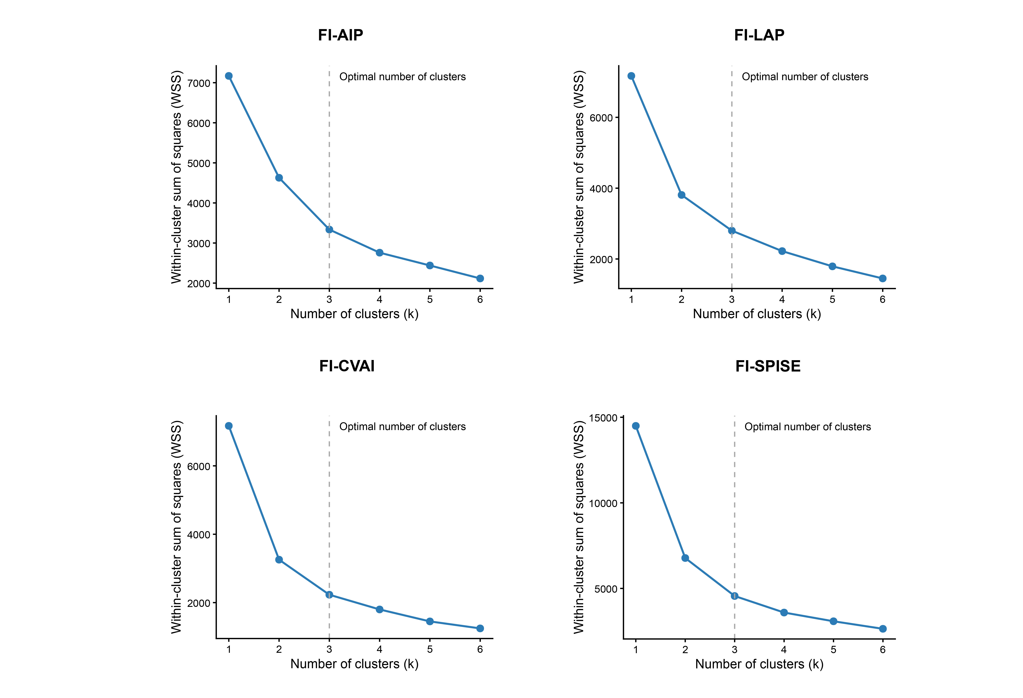
Figure S1. Elbow method to identify the appropriate number of clusters.

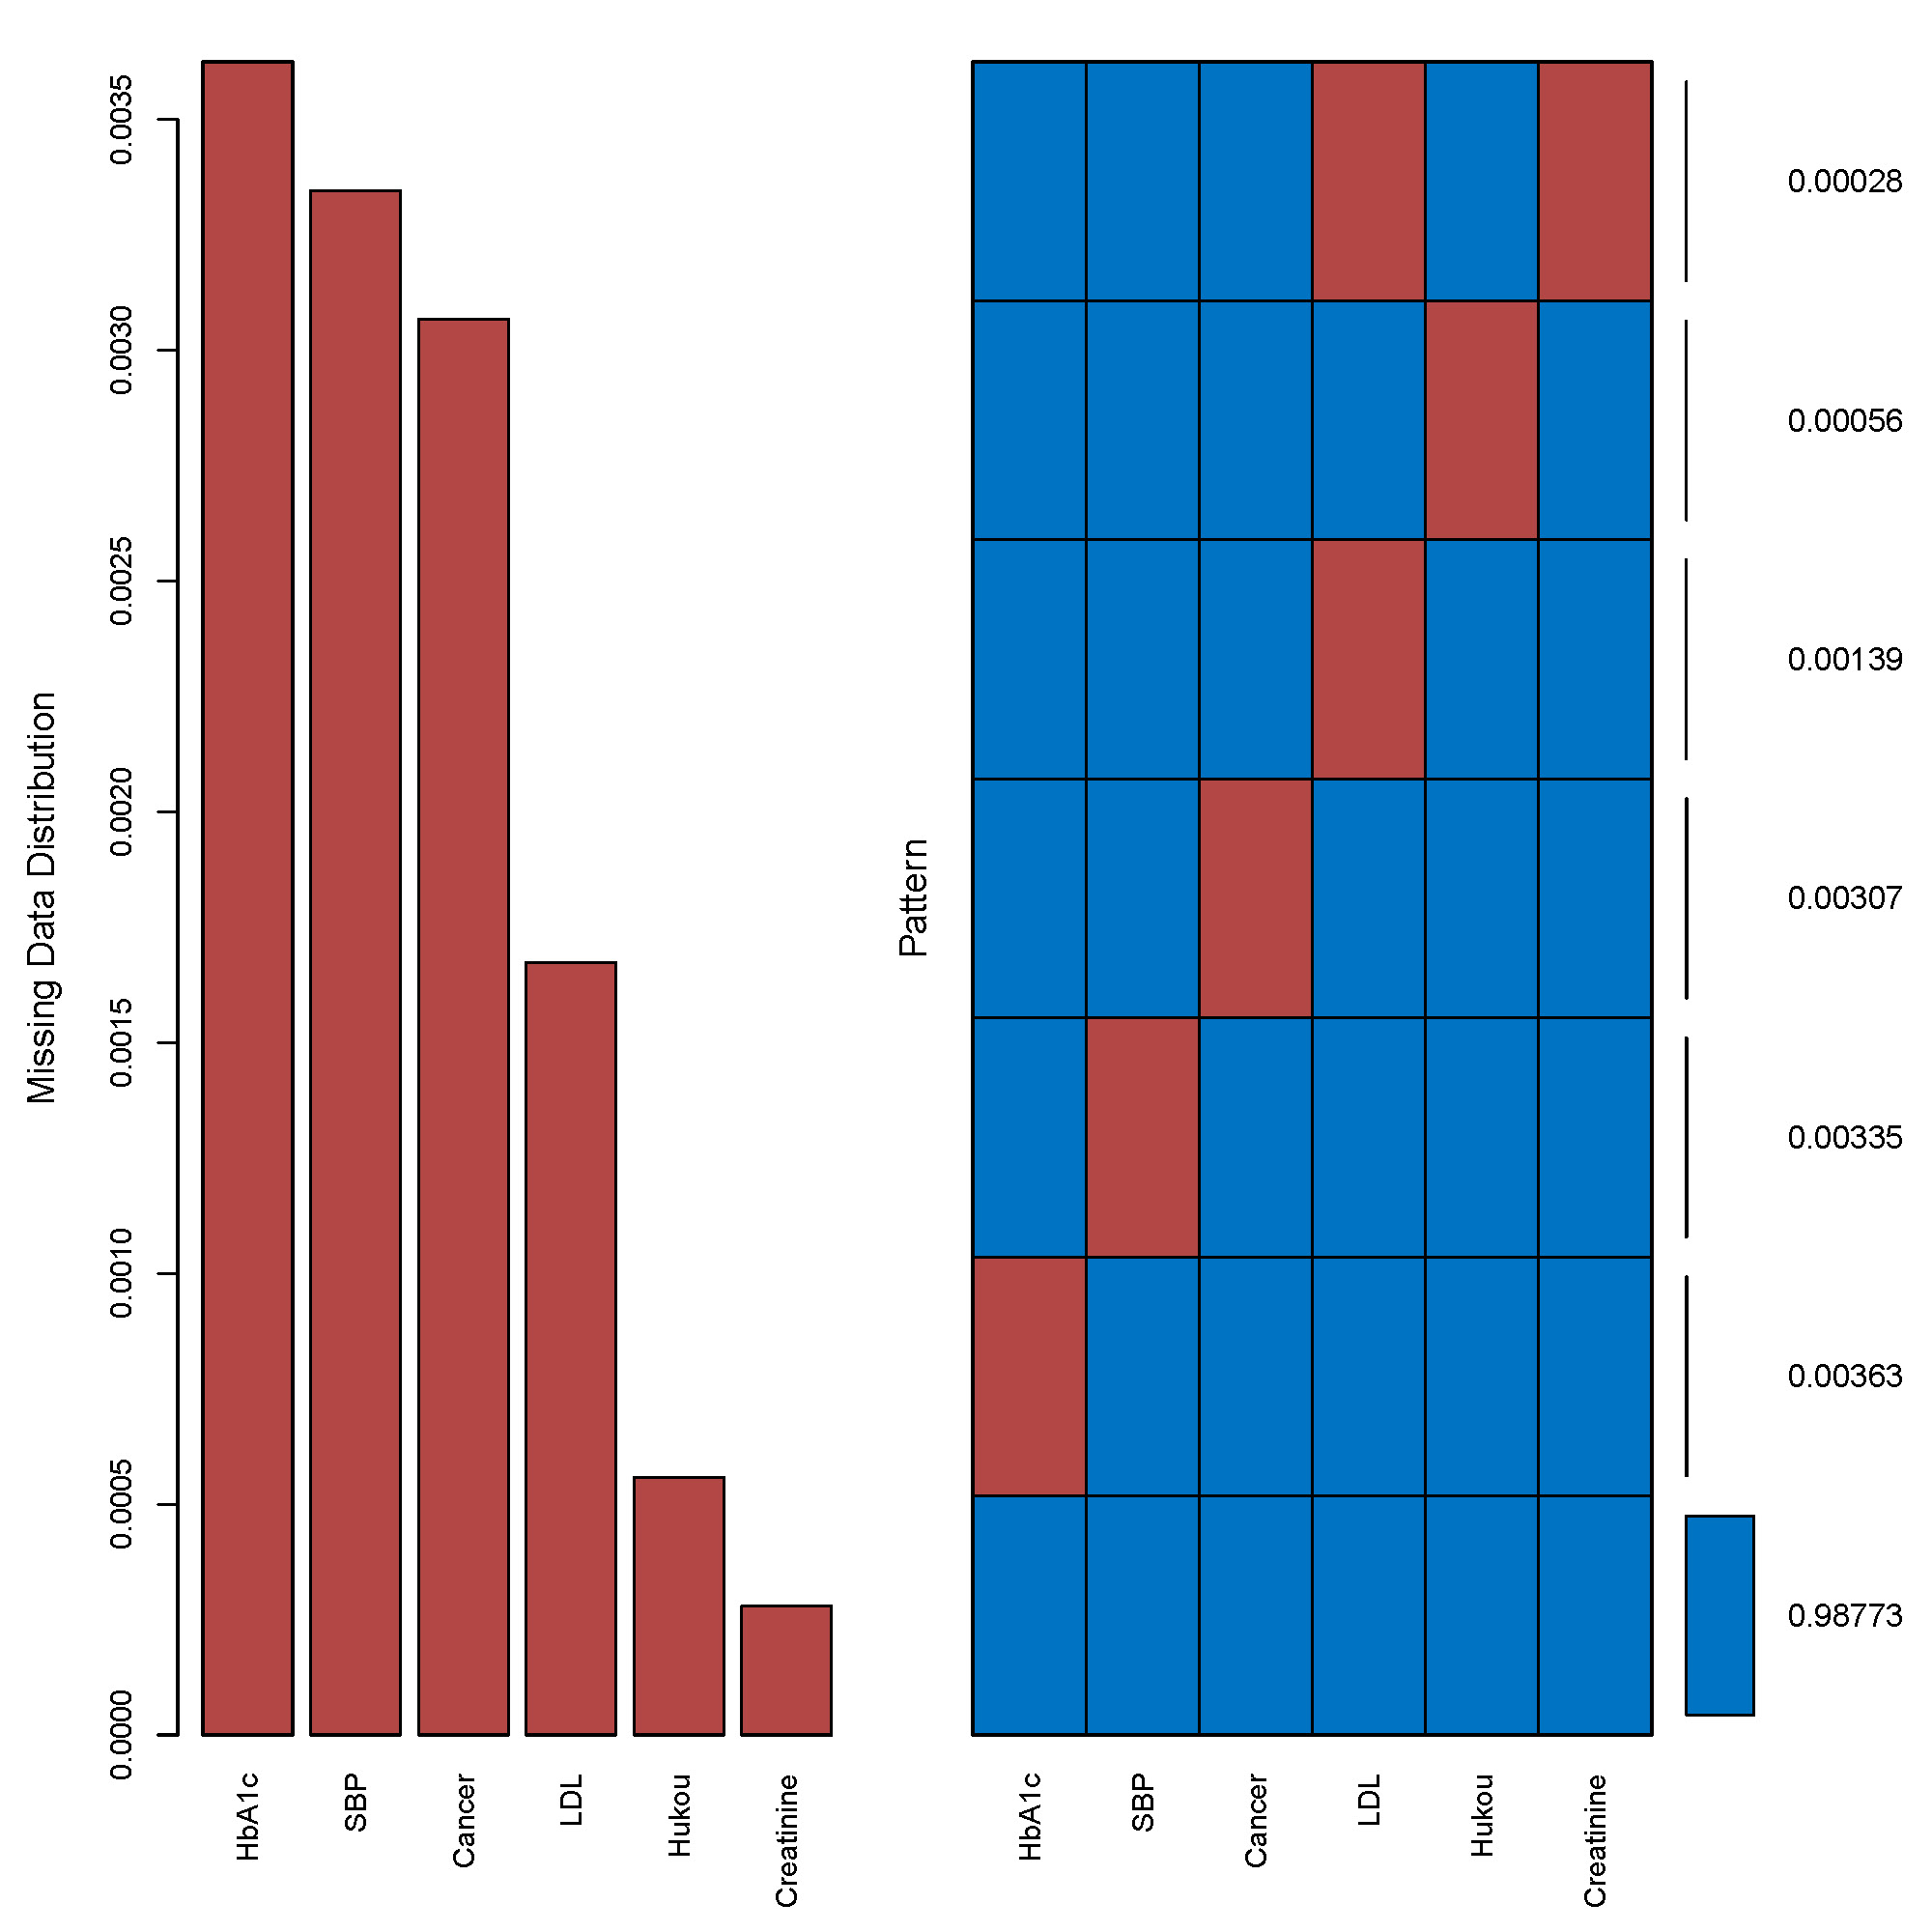
Figure S2. Missing data cross-information diagram.
SBP: systolic blood pressure; LDL: low density lipoprotein.

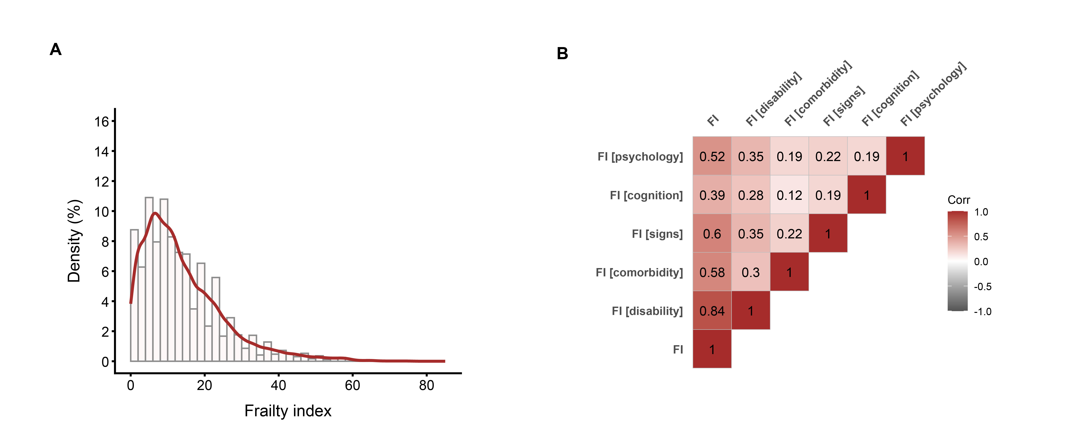
Figure S3. Frailty index and its individual components.
A Distribution of the frailty index (FI) in the study population. B Correlations between FI and indices of its individual domains, including disability, comorbidity, signs, cognitive and psychological abnormalities. Values in the figure are spearman correlation coefficients.

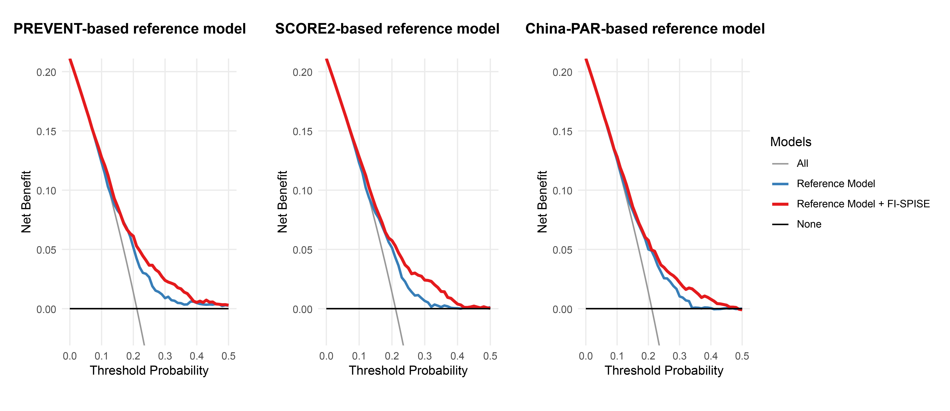
Figure S4. Decision curve analysis of FI-SPISE added to PREVENT-, SCORE2-, and China-PAR-based reference models

Table S1. Detailed description of the 29 items used to construct the frailty index in CHARLS and their corresponding cut-off values.
No | Description of the items | Cut-off value
No | CHARLS | Cut-off value
1 | Self-reported physician diagnosed hypertension | Yes = 1, No = 0
2 | Self-reported physician diagnosed cancer | Yes = 1, No = 0
3 | Self-reported physician diagnosed arthritis | Yes = 1, No = 0
4 | Self-reported physician diagnosed chronic lung disease | Yes = 1, No = 0
5 | Self-reported physician diagnosed asthma | Yes = 1, No = 0
6 | Self-reported physician diagnosed any emotional, nervous, or psychiatric problems | Yes = 1, No = 0
7 | Self-reported physician diagnosed memory-related disease | Yes = 1, No = 0
8 | Self-reported vision problems | Yes = 1, No = 0 in the CHARLS
9 | Self-reported hearing problems | Yes = 1, No = 0 in the CHARLS
10 | Self-reported general health status | Poor or fair = 1, excellent, very good, or good = 0
11 | Difficulty with dressing | Yes = 1, No = 0
12 | Difficulty with bathing or showering | Yes = 1, No = 0
13 | Difficulty with eating | Yes = 1, No = 0
14 | Difficulty with getting in and out of bed | Yes = 1, No = 0
15 | Difficulty with using the toilet | Yes = 1, No = 0
16 | Difficulty with managing money | Yes = 1, No = 0
17 | Difficulty with taking medications | Yes = 1, No = 0
18 | Difficulty with shopping for groceries | Yes = 1, No = 0
19 | Difficulty with preparing meals | Yes = 1, No = 0
20 | Difficulty with doing housework | Yes = 1, No = 0
21 | Mobility: difficulty with walking 100 yards | Yes = 1, No = 0
22 | Mobility: difficulty with getting up from a chair after sitting for long periods | Yes = 1, No = 0
23 | Mobility: difficulty with climbing several flights of stairs without resting | Yes = 1, No = 0
24 | Mobility: difficulty with lifting or carrying weights over 10 pounds/jins | Yes = 1, No = 0
25 | Mobility: difficulty with picking up a coin from the table | Yes = 1, No = 0
26 | Mobility: difficulty with stooping, kneeling, or crouching | Yes = 1, No = 0
27 | Mobility: difficulty with reaching arms above shoulder level | Yes = 1, No = 0
28 | Depression: CESD-10 questionnaire | CESD-10 >10 =1, ≤10 =0 in the CHARLS
29 | Cognition: (memory test score + orientation test score) / 14 | Continuous, ranging from 0 to 1
Memory-related disease indicates Alzheimer’s disease or dementia, organic brain senility, or other serious memory impairment.
Depression is evaluated using Center for Epidemiologic Studies Depression Scale (CESD). In the CHARLS, CESD-10 is used, and the total score ranges from 0 to 30. The higher score indicates more severe depressive symptoms.
The memory score is the average of words that are not recalled in the immediate and delayed word recall tasks. The memory score ranges from 0 to 10. The orientation test comprises four questions about the day of the week, the month, the date of the month, and the year. One point is given for each wrong answer, and the range is from 0 to 4.

Table S2. Comparison of the discriminative performance of different forms of FI-SPISE for incident CMM
Index | C-index | ΔC-index compared with FI/SPISE | AIC
FI/SPISE | 0.7296 |  | 4258.5
FI | 0.7133 | 0.0162 (0.0069,0.0248) | 4280.4
SPISE | 0.7139 | 0.0157 (-0.0078,0.0340) | 4271.4
FI minus SPISE | 0.7204 | 0.0092 (0.0027,0.0146) | 4270.9
Z_{FI}-Z_{SPISE} | 0.7337 | -0.0041 (-0.0138,0.0039) | 4244.7
Interaction with FI and 1/SPISE | 0.7376 | -0.0080 (-0.0199,-0.0013) | 4245.2

Table S3. Average silhouette coefficients for K-means solutions with 2–6 clusters based on FI-SPISE
k | silhouette coefficient
2 | 0.451
3 | 0.389
4 | 0.353
5 | 0.329
6 | 0.326

Table S4. Characteristics of the three K-means-derived two-point longitudinal patterns of FI-SPISE
Cluster | n | FI-SPISE at wave 1 | FI-SPISE at wave 3 | Mean change
Cluster 1 | 1,120 (31.2%) | -1.46 ± 0.77 | -1.42 ± 0.79 | 0.037
Cluster 2 | 1,677 (46.8%) | 0.13 ± 0.69 | 0.087 ± 0.68 | -0.039
Cluster 3 | 789 (22%) | 1.81 ± 1.02 | 1.84 ±1.02 | 0.032

Table S5. Stability and robustness validation of the three-cluster K-means solution for FI-SPISE
Validation | Metric | Result
Bootstrap stability, Cluster 1 | Mean Jaccard similarity | 0.961
Bootstrap stability, Cluster 2 | Mean Jaccard similarity | 0.967
Bootstrap stability, Cluster 3 | Mean Jaccard similarity | 0.964
Bootstrap stability | Cluster dissolution counts | 0/0/0
Alternative clustering: GMM | Adjusted Rand index vs K-means | 0.430
1st–99th percentile Winsorization | Adjusted Rand index vs primary K-means | 0.974

Table S6. Comparison of the discriminative performance of different FI-SPISE clustering solutions for incident CMM
Index | C-index | ΔC-index compared with 3 clusters
3 clusters | 0.7303
2 clusters | 0.7177 | 0.0126 (-0.0001,0.0300)
4 clusters | 0.7283 | 0.0020(-0.0106,0.0132)

Table S7. Collinearity Diagnostics (Variance Inflation Factors)
Variable | GVIF | Df | GVIF^(1/(2*Df))
Two-waves FI-SPISE | 1.25 | 1 | 1.12
Age | 1.62 | 1 | 1.27
Gender | 2.31 | 1 | 1.52
Education | 1.31 | 2 | 1.07
Marry | 1.12 | 1 | 1.06
Hukou | 1.11 | 1 | 1.05
Smoking | 2.03 | 1 | 1.42
Drinking | 1.37 | 1 | 1.17
Hypertension | 1.1 | 1 | 1.05
Dyslipidemia | 1.14 | 1 | 1.07
Cancer | 1.02 | 1 | 1.01
CRP | 1.01 | 1 | 1
eGFR | 1.37 | 1 | 1.17
LDL-C | 1.09 | 1 | 1.04

Table S8. Assessment of the proportional hazards assumption for the continuous and cluster-based exposures using Schoenfeld residuals
Exposure | χ² | df | P value | Global P value
FI-SPISE cluster | 1.381 | 1 | 0.501 | 0.464
Two-wave FI-SPISE | 1.702 | 1 | 0.192 | 0.411

Table S9. Akaike information criterion (AIC) values for restricted cubic spline models with 3–5 knots
RCS knots | 3 | 4 | 5
FI-AIP | 4293.137 | 4282.022 | 4283.603
FI-LAP | 4246.282 | 4244.731 | 4246.557
FI-CVAI | 4250.242 | 4251.008 | 4253.057
FI-SPISE | 4246.754 | 4248.081 | 4249.816

TableS10. Comparing baseline characteristics of participants with and without missing FI and blood sample in wave 1 and wave 3
Characteristic | Overall  (n=4,683) | FI-SPISE
Characteristic | Overall  (n=4,683) | Missing  (n=1,097) | Non-Missing  (n=3,586) |  | p-value
Age (mean (SD)), years | 58.07 (8.36) | 57.78 (8.62) | 58.17 (8.28) |  | 0.178
Gender, n (%) |  |  |  |  | 0.211
Male | 2636 (56.29) | 599 (54.60) | 2037 (56.80)
Female | 2047 (43.71) | 498 (45.40) | 1549 (43.20)
Education, n (%) |  |  |  |  | 0.423
Primary school | 3249 (69.42) | 764 (69.84) | 2485 (69.30)
Middle school | 1363 (29.12) | 310 (28.34) | 1053 (29.36)
High school or above | 68 (1.45) | 20 (1.83) | 48 (1.34)
Marital status, n (%) |  |  |  |  | 0.666
Married | 4247 (90.69) | 999 (91.07) | 3248 (90.57)
Others | 436 (9.31) | 98 (8.93) | 338 (9.43)
Hukou, n (%) |  |  |  |  | 0.023
Agriculture | 3997 (85.39) | 913 (83.23) | 3084 (86.05)
Others | 684 (14.61) | 184 (16.77) | 500 (13.95)
Smoking, n (%) | 1719 (36.83) | 436 (40.30) | 1283 (35.78) |  | 0.008
Drinking, n (%) | 1564 (33.51) | 398 (36.82) | 1166 (32.52) |  | 0.010
Hypertension, n (%) | 1684 (36.02) | 333 (30.58) | 1351 (37.67) |  | <0.001
Dyslipidemia, n (%) | 2166 (46.26) | 466 (42.52) | 1700 (47.41) |  | 0.005
Diabetes, n (%) | 590 (12.60) | 126 (11.50) | 464 (12.94) |  | 0.227
Cancer, n (%) | 39 (0.84) | 6 (0.56) | 33 (0.92) |  | 0.345
FBG (mean (SD)), mg/dL | 107.83 (31.52) | 106.95 (27.13) | 108.07 (32.63) |  | 0.319
TG (median [IQR]), mg/dL | 102.66 [73.46, 149.57] | 100.00 [71.24, 148.24] | 103.54 [73.46, 150.23] |  | 0.183
HDL-C (mean (SD)), mg/dL | 51.36 (15.11) | 51.94 (15.81) | 51.20 (14.91) |  | 0.169
LDL-C (mean (SD)), mg/dL | 117.09 (34.47) | 114.89 (33.82) | 117.70 (34.63) |  | 0.023
TC (mean (SD)), mg/dL | 193.60 (38.81) | 190.68 (38.61) | 194.42 (38.83) |  | 0.007
hsCRP (median [IQR]), mg/L | 0.96 [0.53, 1.95] | 0.93 [0.52, 1.83] | 0.97 [0.54, 1.97] |  | 0.316
HbA1c (mean (SD)), % | 5.24 (0.77) | 5.18 (0.68) | 5.26 (0.79) |  | 0.002
Creatinine (mean (SD)), mg/dL | 0.76 (0.18) | 0.76 (0.18) | 0.76 (0.18) |  | 0.925
SBP (mean (SD)), mmHg | 128.87 (20.45) | 129.37 (20.52) | 128.79 (20.44) |  | 0.527
Waist (mean (SD)), cm | 85.27 (9.72) | 83.56 (9.31) | 85.50 (9.75) |  | <0.001
BMI (mean (SD)), kg/m² | 23.58 (3.60) | 23.17 (3.56) | 23.64 (3.60) |  | 0.006
FI, Frailty index; FBG, fast blood glucose; TG, triglyceride; TC, total cholesterol; hsCRP, high sensitivity C-reactive protein; eGFR, estimated glomerular filtration rate; SBP, systolic blood pressure;

Table S11. Distribution of cardiometabolic disease status at baseline among participants included in the analysis
Characteristic | Overall  (n=3,586) | CMM
Characteristic | Overall  (n=3,586) | NO  (n=3,316) | YES  (n=270) |  | p-value
Baseline cardiometabolic disease number |  |  |  |  | <0.001
No cardiometabolic disease, n (%) | 2,824 (78.75) | 2,694 (81.24) | 130 (48.15)
One cardiometabolic disease, n (%) | 762 (21.25) | 622 (18.76) | 140 (51.85)
Baseline cardiometabolic disease status |  |  |  |  | <0.001
None, n (%) | 2,824 (78.75) | 2,694 (81.24) | 130 (48.15)
Diabetes only, n (%) | 464 (12.94) | 337 (10.16) | 127 (47.04)
Heart disease only, n (%) | 270 (7.53) | 260 (7.84) | 10 (3.70)
Stroke only, n (%) | 28 (0.78) | 25 (0.75) | 3 (1.11)

Table S12. Time-dependent AUCs for different models of wave 3, two-waves, cluster FI-related indices

Model | Time | Wave 3 | Two-waves | Cluster
FI-AIP
 | 2 | 0.644 (0.609, 0.680) | 0.642 (0.607, 0.677) | 0.644 (0.609, 0.679)
 | 3 | 0.642 (0.612, 0.673) | 0.641 (0.611, 0.672) | 0.646 (0.616, 0.676)
 | 4 | 0.637 (0.609, 0.666) | 0.638 (0.609, 0.666) | 0.645 (0.617, 0.673)
FI-LAP
 | 2 | 0.665 (0.630, 0.700) | 0.670 (0.636, 0.704) | 0.655 (0.619, 0.691)
 | 3 | 0.665 (0.635, 0.695) | 0.669 (0.639, 0.698) | 0.654 (0.623, 0.685)
 | 4 | 0.665 (0.637, 0.693) | 0.668 (0.640, 0.695) | 0.654 (0.625, 0.682)
FI-CVAI
 | 2 | 0.682 (0.648, 0.717) | 0.691 (0.658, 0.725) | 0.684 (0.650, 0.719)
 | 3 | 0.679 (0.649, 0.708) | 0.683 (0.654, 0.712) | 0.675 (0.645, 0.706)
 | 4 | 0.680 (0.652, 0.707) | 0.684 (0.657, 0.711) | 0.674 (0.646, 0.702)
FI-SPISE
 | 2 | 0.678 (0.643, 0.713) | 0.686 (0.652, 0.720) | 0.683 (0.649, 0.717)
 | 3 | 0.676 (0.647, 0.706) | 0.679 (0.650, 0.708) | 0.676 (0.646, 0.706)
 | 4 | 0.678 (0.651, 0.705) | 0.681 (0.653, 0.708) | 0.678 (0.650, 0.705)

Table S13. Comparison of the discriminative performance of two-waves FI-SPISE, FI-AIP, FI-LAP, and FI-CVAI for incident CMM
Index | Estimate | 95% CI
C-index (FI-SPISE) | 0.7337
C-index (FI-AIP) | 0.6939
C-index (FI-LAP) | 0.7194
C-index (FI-CVAI) | 0.7270
ΔC-index (FI-SPISE vs. FI-AIP) | 0.0398 | 0.0202,0.0581
ΔC-index (FI-SPISE vs. FI-LAP) | 0.0143 | 0.0031,0.0276
ΔC-index (FI-SPISE vs. FI-CVAI) | 0.0067 | -0.0013,0.0158

Table S14. Comparison of AUC differences between the base models and FI-SPISE Extended Models

Model | Year | Base model AUC | Extended model AUC | AUC diff | P value | p_adj
PREVENT
 | 2-Year | 0.662 (0.635, 0.701) | 0.698 (0.670, 0.734) | 0.036 | <0.001 | <0.001
 | 3-Year | 0.657 (0.633, 0.690) | 0.691 (0.670, 0.723) | 0.035 | <0.001 | <0.001
 | 4-Year | 0.654 (0.633, 0.684) | 0.693 (0.671, 0.723) | 0.039 | <0.001 | <0.001
SCORE2
 | 2-Year | 0.638 (0.606, 0.675) | 0.691 (0.661, 0.727) | 0.052 | <0.001 | <0.001
 | 3-Year | 0.637 (0.612, 0.671) | 0.684 (0.660, 0.716) | 0.047 | <0.001 | <0.001
 | 4-Year | 0.637 (0.616, 0.669) | 0.687 (0.664, 0.716) | 0.049 | <0.001 | <0.001
China-PAR
 | 2-Year | 0.668 (0.641, 0.708) | 0.693 (0.667, 0.732) | 0.025 | 0.004 | 0.004
 | 3-Year | 0.663 (0.637, 0.697) | 0.685 (0.663, 0.717) | 0.023 | <0.001 | <0.001
 | 4-Year | 0.657 (0.636, 0.692) | 0.685 (0.666, 0.717) | 0.029 | <0.001 | <0.001

Table S15. Distribution of Stabilized Inverse Probability of Selection Weights Before and After Truncation Across Multiply Imputed Datasets
Weight Type | Imputed dataset | Mean | SD | Median | Min | Max
Stablilized IPW
 | 1 | 1.00 | 0.28 | 0.93 | 0.52 | 4.33
 | 2 | 1.00 | 0.28 | 0.93 | 0.52 | 4.25
 | 3 | 1.00 | 0.28 | 0.93 | 0.53 | 4.22
 | 4 | 1.00 | 0.28 | 0.93 | 0.52 | 4.28
 | 5 | 1.00 | 0.28 | 0.93 | 0.53 | 4.31
Trimmed Stabilized IPW (1st-99th)
 | 1 | 0.99 | 0.26 | 0.93 | 0.62 | 1.91
 | 2 | 0.99 | 0.26 | 0.93 | 0.62 | 1.94
 | 3 | 0.99 | 0.26 | 0.93 | 0.63 | 1.93
 | 4 | 0.99 | 0.26 | 0.93 | 0.62 | 1.91
 | 5 | 0.99 | 0.26 | 0.93 | 0.62 | 1.92

Table S16 (Sensitivity Analysis 1): Association Between FI-SPISE and Incident CMM Before and After Inverse Probability of Selection Weighting
 | Model 1 |  | Model 2 |  | Model 3
 | HR (95%CI) | P value | HR (95%CI) | P value | HR (95%CI) | P value
Unweighted analysis | 1.89 (1.69–2.11) | <0.001 | 1.69 (1.50–1.91) | <0.001 | 1.71 (1.51–1.93) | <0.001
IPSW analysis | 1.80 (1.61–2.02) | <0.001 | 1.62 (1.43–1.84) | <0.001 | 1.64 (1.45–1.86) | <0.001
HRs represent per 1-standard deviation increase in exposure variables.
Model 1 was adjusted for age, gender;
Model 2 was adjusted for age, gender, education, marital status, hukou, smoking status, drinking status, hypertension, dyslipidemia, cancer;
Model 3 was adjusted for age, gender, education, marital status, hukou, smoking status, drinking status, hypertension, dyslipidemia, cancer, LDL-C, hsCRP, Creatinine.

Table S17 (Sensitivity Analysis 2): Association between FI-SPISE and incident CMM among 2,824 participants without cardiometabolic disease at wave 3
 | Model 1 |  | Model 2 |  | Model 3
 | HR (95%CI) | P value | HR (95%CI) | P value | HR (95%CI) | P value
FI-SPISE clusters
Cluster1 | Reference |  | Reference |  | Reference
Cluster2 | 2.45 (1.46–4.12) | <0.001 | 2.17 (1.27–3.70) | 0.004 | 2.20 (1.29–3.75) | 0.004
Cluster3 | 5.58 (3.26–9.57) | <0.001 | 4.58 (2.58–8.10) | <0.001 | 4.80 (2.72–8.49) | <0.001
Two-waves FI-SPISE
Q1 | Reference |  | Reference |  | Reference
Q2 | 2.40 (1.27–4.54) | 0.007 | 2.23 (1.17–4.24) | 0.015 | 2.22 (1.17–4.23) | 0.015
Q3 | 2.53 (1.34–4.80) | 0.004 | 2.15 (1.11–4.16) | 0.022 | 2.20 (1.14–4.24) | 0.019
Q4 | 5.78 (3.19-10.51) | <0.001 | 4.68 (2.49–8.78) | <0.001 | 4.94 (2.64–9.26) | <0.001
Model 1 was adjusted for age, gender;
Model 2 was adjusted for age, gender, education, marital status, hukou, smoking status, drinking status, hypertension, dyslipidemia, cancer;
Model 3 was adjusted for age, gender, education, marital status, hukou, smoking status, drinking status, hypertension, dyslipidemia, cancer, LDL-C, hsCRP, eGFR.

Table S18 (Sensitivity Analysis 3): Association between FI-SPISE cluster membership and incident CMM before and after additional adjustment for baseline FI-SPISE (wave 3)
 | Model 1 |  | Model 2 |  | Model 3
 | HR (95%CI) | P value | HR (95%CI) | P value | HR (95%CI) | P value
FI-SPISE clusters
Cluster1 | Reference |  | Reference |  | Reference
Cluster2 | 2.80 (1.85–4.25) | <0.001 | 2.27 (1.49–3.48) | <0.001 | 2.33 (1.52–3.57) | <0.001
Cluster3 | 6.87(4.53–10.41) | <0.001 | 4.85 (3.12–7.53) | <0.001 | 5.05 (3.25–7.85) | <0.001
Additionally adjusted for baseline FI-SPISE (Wave 3)
Baseline FI-SPISE (Wave 3) | 1.28 (1.13–1.45) | <0.001 | 1.26 (1.11–1.43) | <0.001 | 1.24 (1.09–1.41) | 0.001
Cluster1 | Reference |  | Reference |  | Reference
Cluster2 | 1.95 (1.24–3.07) | 0.004 | 1.63 (1.03–2.59) | 0.039 | 1.71 (1.08–2.73) | 0.023
Cluster3 | 3.07 (1.69–5.57) | <0.001 | 2.32 (1.26–4.27) | 0.007 | 2.55 (1.38–4.71) | 0.003
Model 1 was adjusted for age, gender;
Model 2 was adjusted for age, gender, education, marital status, hukou, smoking status, drinking status, hypertension, dyslipidemia, cancer;
Model 3 was adjusted for age, gender, education, marital status, hukou, smoking status, drinking status, hypertension, dyslipidemia, cancer, LDL-C, hsCRP, eGFR.

Table S19 (Sensitivity Analysis 4): Additional Adjustment for baseline cardiometabolic disease count or diabetes in Model 3
 | Model 4 |  | Model 5
 | HR (95%CI) | P value | HR (95%CI) | P value
FI-SPISE clusters
Cluster1 | Reference |  | Reference
Cluster2 | 2.20 (1.44–3.38) | <0.001 | 2.21 (1.44–3.39) | <0.001
Cluster3 | 4.05 (2.59–6.32) | <0.001 | 4.24 (2.72–6.62) | <0.001
Two-waves FI-SPISE
Q1 | Reference |  | Reference
Q2 | 2.05 (1.23–3.44) | 0.006 | 2.06 (1.23–3.45) | 0.006
Q3 | 2.30 (1.38–3.84) | 0.001 | 2.30 (1.38–3.84) | 0.001
Q4 | 4.02 (2.45–6.59) | <0.001 | 4.22 (2.58–6.91) | <0.001

Model 3 was adjusted for age, gender, education, marital status, hukou, smoking status, drinking status, hypertension, dyslipidemia, cancer, LDL-C, hsCRP, eGFR.
Model 4 was additionally adjusted for baseline cardiometabolic disease count on the basis of Model 3.
Model 5 was additionally adjusted for baseline diabetes on the basis of Model 3.

Table S20 (Sensitivity Analysis 5): Association between longitudinal clusters and two-waves FI-SPISE with CMM events in 3,572 participants with complete data.
 | Model 1 |  | Model 2 |  | Model 3
 | HR (95%CI) | P value | HR (95%CI) | P value | HR (95%CI) | P value
FI-SPISE clusters
Cluster1 | Reference |  | Reference |  | Reference
Cluster2 | 2.78 (1.83–4.21) | <0.001 | 2.23 (1.46–3.42) | <0.001 | 2.30 (1.50–3.52) | <0.001
Cluster3 | 6.82 (4.49-10.34) | <0.001 | 4.78 (3.08–7.43) | <0.001 | 5.01 (3.22–7.79) | <0.001
Two-waves FI-SPISE
Q1 | Reference |  | Reference |  | Reference
Q2 | 2.44 (1.46–4.06) | <0.001 | 2.11 (1.26–3.53) | 0.005 | 2.14 (1.28–3.58) | 0.004
Q3 | 3.00 (1.82–4.93) | <0.001 | 2.26 (1.35–3.76) | 0.002 | 2.33 (1.40–3.90) | 0.001
Q4 | 6.79 (4.26-10.83) | <0.001 | 4.64 (2.84–7.58) | <0.001 | 4.88 (2.99–7.98) | <0.001
Model 1 was adjusted for age, gender
Model 2 was adjusted for age, gender, education, marital status, hukou, smoking status, drinking status, hypertension, dyslipidemia, cancer
Model 3 was adjusted for age, gender, education, marital status, hukou, smoking status, drinking status, hypertension, dyslipidemia, cancer, LDL-C, hsCRP, eGFR.

Table S21 (Sensitivity Analysis 6): Remove Hypertension from the 29-item Frailty Index and recalculate the FI-SPISE
 | Model 1 |  | Model 2 |  | Model 3
 | HR (95%CI) | P value | HR (95%CI) | P value | HR (95%CI) | P value
FI-SPISE clusters
Cluster1 | Reference |  | Reference |  | Reference
Cluster2 | 2.46 (1.86–3.26) | <0.001 | 2.07 (1.55–2.75) | <0.001 | 2.13 (1.60–2.83) | <0.001
Cluster3 | 4.61 (3.29–6.48) | <0.001 | 3.40 (2.38–4.84) | <0.001 | 3.43 (2.40–4.88) | <0.001
Two-waves FI-SPISE
Q1 | Reference |  | Reference |  | Reference
Q2 | 2.08 (1.23–3.49) | 0.006 | 1.95 (1.15–3.28) | 0.012 | 1.94 (1.15–3.27) | 0.013
Q3 | 3.68 (2.26–5.98) | <0.001 | 3.23 (1.98–5.28) | <0.001 | 3.32 (2.03–5.43) | <0.001
Q4 | 6.15 (3.84–9.85) | <0.001 | 4.99 (3.09–8.06) | <0.001 | 5.08 (3.15–8.21) | <0.001
Model 1 was adjusted for age, gender
Model 2 was adjusted for age, gender, education, marital status, hukou, smoking status, drinking status, hypertension, dyslipidemia, cancer
Model 3 was adjusted for age, gender, education, marital status, hukou, smoking status, drinking status, hypertension, dyslipidemia, cancer, LDL-C, hsCRP, eGFR.

Table S22 (Sensitivity Analysis 7): Excluding Patients with cancer and severe renal impairment (eGFR <30 mL/min/1.73 m²) at baseline.
 | Model 1 |  | Model 2 |  | Model 3
 | HR (95%CI) | P value | HR (95%CI) | P value | HR (95%CI) | P value
FI-SPISE clusters
Cluster1 | Reference |  | Reference |  | Reference
Cluster2 | 2.81 (1.85–4.25) | <0.001 | 2.28 (1.49–3.49) | <0.001 | 2.34 (1.53–3.59) | <0.001
Cluster3 | 6.54 (4.30–9.93) | <0.001 | 4.68 (3.01–7.27) | <0.001 | 4.86 (3.13–7.56) | <0.001
Two-waves FI-SPISE
Q1 | Reference |  | Reference |  | Reference
Q2 | 2.43 (1.46–4.04) | <0.001 | 2.12 (1.27–3.55) | 0.004 | 2.15 (1.28–3.59) | 0.004
Q3 | 2.98 (1.81–4.91) | <0.001 | 2.28 (1.37–3.81) | 0.002 | 2.34 (1.40–3.91) | 0.001
Q4 | 6.56 (4.11–10.47) | <0.001 | 4.59 (2.81–7.50) | <0.001 | 4.80 (2.94–7.84) | <0.001
Model 1 was adjusted for age, gender
Model 2 was adjusted for age, gender, education, marital status, hukou, smoking status, drinking status, hypertension, dyslipidemia
Model 3 was adjusted for age, gender, education, marital status, hukou, smoking status, drinking status, hypertension, dyslipidemia, LDL-C, hsCRP, eGFR.

Table S23 (Sensitivity Analysis 8): Competing-risk modeling was carried out using the Fine-Gray subdistribution hazards framework.
 | Model 1 |  | Model 2 |  | Model 3
 | sHR (95%CI) | P value | sHR (95%CI) | P value | sHR (95%CI) | P value
FI-SPISE clusters
Cluster1 | Reference |  | Reference |  | Reference
Cluster2 | 2.80 (1.83-4.27) | <0.001 | 2.29 (1.49-3.54) | <0.001 | 2.04 (1.30-3.19) | <0.001
Cluster3 | 6.88 (4.50-10.50) | <0.001 | 4.91 (3.14-7.69) | <0.001 | 3.85 (2.34-6.32) | <0.001
Two-waves FI-SPISE
Q1 | Reference |  | Reference |  | Reference
Q2 | 2.50 (1.49-4.21) | <0.001 | 2.19 (1.30-3.71) | 0.003 | 2.01 (1.18-3.42) | 0.010
Q3 | 3.04 (1.83-5.06) | <0.001 | 2.34 (1.39-3.95) | 0.001 | 1.98 (1.15-3.40) | 0.014
Q4 | 6.99 (4.34-11.26) | <0.001 | 4.89 (2.96-8.07) | <0.001 | 3.68 (2.12-6.38) | <0.001
Model 1 was adjusted for age, gender
Model 2 was adjusted for age, gender, education, marital status, hukou, smoking status, drinking status, hypertension, dyslipidemia, cancer
Model 3 was adjusted for age, gender, education, marital status, hukou, smoking status, drinking status, hypertension, dyslipidemia, cancer, LDL-C, hsCRP, eGFR.
Death information was retrieved from the year of death reported in the 2018 sample survey and the 2020 exit questionnaire.

Table S24 (Sensitivity Analysis 9): E-values for the association between FI-SPISE and CMM.
 | Model 3
 | Adjusted HR (95% CI) | E-value (Point Estimate)
FI-SPISE clusters
Cluster1 | Reference
Cluster2 | 2.33 (1.52-3.57) | 4.09
Cluster3 | 5.05 (3.25-7.85) | 9.57
Two-waves FI-SPISE
Q1 | Reference
Q2 | 2.14 (1.28–3.59) | 3.70
Q3 | 2.39 (1.43–3.99) | 4.21
Q4 | 4.95 (3.03-8.09) | 9.37
Model 3 was adjusted for age, gender, education, marital status, hukou, smoking status, drinking status, hypertension, dyslipidemia, cancer, LDL-C, hsCRP, eGFR.

