Additional file 1

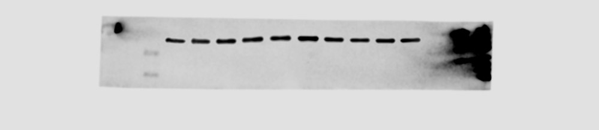

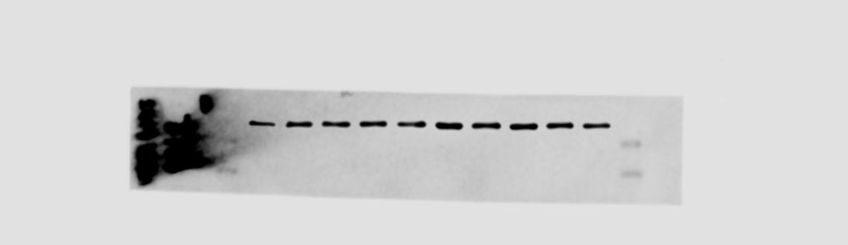

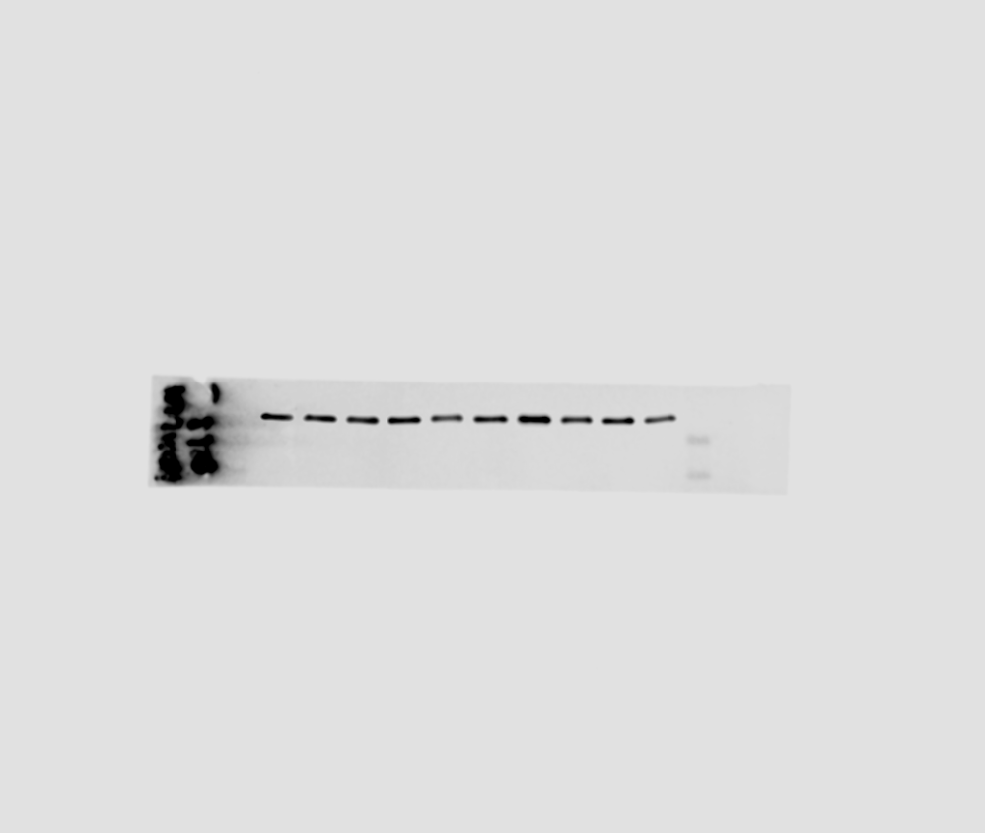

A

B
C
D
E
F
Additional figure 1. Uncropped immunoblots of GAPDH blots. Chemiluminescence channel of C57Bl/6J blot (A), BALB/c blot (C) and C57Bl/6N blot (E). Chemiluminescence and 700 nm channel merge of C57Bl/6J blot (B), BALB/c blot (D) and C57Bl/6N (F), to visualize ladder. Ladder size is indicated.

30 kDa
25 kDa
30 kDa
25 kDa
30 kDa
25 kDa

